Integrated modelling of Concentrated Solar Power plants networks: Electricity production, storage, conversion and distribution in Spain
José A. Luceño Sánchez,^{a*} Mariano Martín,^{b} Sandro Macchiettoª
ªDepartment of Chemical Engineering, Imperial College London, South Kensington Campus, London SW7 2AZ, United Kingdom
^{b}Departamento de Ingeniería Química y Textil, Universidad de Salamanca, Pza. Caídos 1-5, 37008 Salamanca, Spain
j.luceno-sanchez@imperial.ac.uk
Abstract
A multiperiod MILP model is proposed for the optimal location, sizing and operation of a sustainable energy production network based on Concentrated Solar Power (CSP) plants, energy storage and transmission, and use of H₂ as an energy vector. The model takes into account time and region-dependent variables (e.g., direct normal irradiance, land, regional electricity demand), technical and economic variables of the facilities (e.g., production capacity, investment), energy storage (CAES or H₂), the potential social impact (e.g., economic development, population ratios, and unemployment). A case study is presented where 5 potential Spanish locations are evaluated over a year of operation. Results highlight the importance of locating CSP plants considering technical, economic and social aspects. The impact of prices on policies related to energy self-sufficiency indicates that incentives are required for the development of cheaper storage solutions.

Keywords: Concentrated Solar Plant, optimal location, social impact, energy distribution and storage, energy network.
  - Introduction
Green energy transition is one of the most ambitious key tasks for countries to achieve the Net-zero policies goals. Concentrated Solar Power (CSP) plants employ solar radiation to produce electricity in a renewable, sustainable way, and have a leading role in the selection of national energy mixes (Shi, 2016; Ainou et al., 2023). The construction of these plants is influenced by the location, as the achievable production capacities is affected by factors such as distribution of solar radiation, and water and land availability, energy distribution infrastructure, and the social impact of the facility, in terms of economic development or jobs creation (Heras and Martín, 2020). Previous work (Luceño Sánchez et al., 2023) optimized the location and capacity of CSP plants at national scale based on techno-economic and socio-environmental models, but did not consider the distribution of electricity, the possibility of storing energy surplus or converting it to other energy vectors, which could also be transported to other regions. In this work, a new mathematical model is proposed to address simultaneously the location of CSP facilities, the distribution of energy to satisfy the regional demand, the possible strategies that should be followed for energy storing in case of electricity surplus, and the techno-socio-economic evaluation related to these aspects. Potential locations and distribution strategies are evaluated, together with the possibility to use compressed air storage as energy storage system (ESS) and the production of green H₂ for fuel-cell applications.
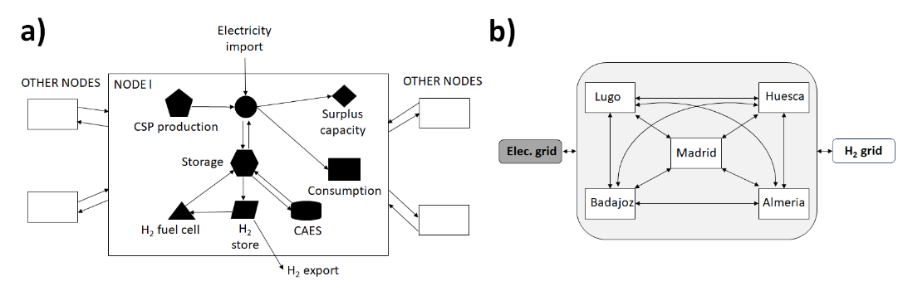
Figure 1: a) Node representation; b) Five nodes network.
  - Problem formulation
A territory is subdivided in regions, each represented by a node as depicted in Figure 1a, which is connected to all other nodes in a network superstructure (see Figure 1b for the 5-node case study used later). Each node (region) is characterized by a CSP plant for electricity production and the electricity demand (consumption). Energy may be stored in the form of compressed air (CAES) and H₂ and returned back to the node as electricity. Excess unused electricity, labelled “surplus”, may be transmitted to other nodes or otherwise must be disposed of. Additional electricity requirements may be met by transmission from other nodes or import from external sources. Demands and factors such as irradiation and water availability vary both over time and location. We wish to calculate the location and capacity of CSP plants, as well as the type and size of storage at each node and the energy transmitted between nodes in the form of either electricity or H₂, that optimize overall economic, social and environmental impacts. The existence of each facility is represented by binary variables, and their capacity or utilization by continuous variables. The model is divided into four sections:
-Node energy balances: each region is presented as a node of a network, with the energy balance for node l given in eq. 1. Each node includes the electricity production (${EnPr}_{t,l}$ [GWh]), the charge (${EnSto}_{t,l}$ [GWh]) and discharge from storage (${EnDch}_{t,l}$ [GWh]), the electricity imported or exported from node l to other nodes n in the network (${EnDis}_{t,n,l}$ [GWh]), consumed (${EnCon}_{t,l}$ [GWh]), unused (${EnSurplus}_{t,l}$ [GWh]), and that which must be bought from other sources (${EnImport}_{t,l}$ [GWh]). This formulation enables to calculate all energy transmission between nodes at each time-step, and the energy to be stored and to be discharged in each node.

$${EnPr}_{t,l}+{EnDch}_{t,l}+\sum_{n=1}^{Nod}{{EnDis}_{t,n,l}}+{EnImport}_{t,l}=={EnCon}_{t,l}+\sum_{n=1}^{Nod}{{EnDis}_{t,l,n}}+{EnSto}_{t,l}+{EnSurplus}_{t,l}$$ | (1)
-Energy storage and energy vectors: Using the values of ${EnSto}_{t,l}$ and ${EnDch}_{t,l}$, the storage requirements are evaluated, including their size and costs. Two types of storage were considered: compressed air energy storage (CAES), and hydrogen. Thus, both ${EnSto}_{t,l}$ and ${EnDch}_{t,l}$ present two terms related to each technology (${CAESSto}_{t,l}$ and ${HydroSto}_{t,l}$), which are involved in a node balance to determine the available energy stored; for example, the CAES energy stored (${CAESAva}_{t,l}$ [GWh]) is given by eq. 2.
$${CAESAva}_{t,l}={CAESAva}_{(t-1),l}-{CAESDch}_{t,l}+{CAESSto}_{t,l}$$ | (2)
In addition, hydrogen generation and distribution between nodes is also considered, together with the use of hydrogen fuel cells in each node for electricity generation, and the scenario where hydrogen could be sold externally (in a similar way than node energy balances).
-Economic and social evaluation: The cost of the facilities in each region (production, storage, and hydrogen conversion) is modelled, as well as the cost of hydrogen distribution if applicable. The social impact related to the investment in each region is evaluated based on creation of new jobs, following the methodology proposed by Heras and Martin (2020) and previous work (Luceño Sánchez et al., 2023).
-Objective function: A multi-period MILP optimization problem is formulated whereby several aspects of network structure are chosen simultaneously: production variables (e.g., location, number and size of CSP plants), storage solutions (e.g., CAES or hydrogen technologies), energy transportation solutions (as electricity and H₂ vectors within the network and their external import-export), and social impact of new facilities. Inputs include location-dependent parameters (e.g., direct normal irradiance and available land) and costs and bounds on various quantities. The objective (eq. 3) is to minimize the annualized capital cost of all facilities ($z_{cost}$ [M€/y]), the annual net cost of total external import and export of electricity ($z_{ener}$[M€/y]), the annual cost of hydrogen (distribution and/or sale) ($z_{H2}$ [M€/y]), and the related economic effect of social impact (SI) ($z_{SI}$ [M€/y]):

$$\min\left(z_{cost}+z_{ener}+z_{H2}-z_{SI}\right)$$ | (3)
  - Solution procedure and Case Studies
Five regions across Spain (Almería [south-east], Badajoz [south-west], Madrid [middle], Huesca [north-east], and Lugo [north-west]) are chosen as potential production locations (CSP plants) and/or storage locations (Figure 1b). The timeframe selected for this study is 1 year of operation with 12 monthly intervals. The monthly direct normal irradiance (DNI) for each region is obtained from EU PVGIS database (PVGIS, 2023). The regional energy demand was calculated using monthly average national demand data and population/social statistics from Spanish governmental databases (INE, 2023). Table 1 shows electricity demand for two locations: Madrid and Lugo. The model is applied for two case studies: 1) a scenario where all the electricity needed is to be produced from renewable CSP sources alone, with no imports at any time (${EnExtra}_{t,l}$=0, $∀t,l$); and 2) a scenario where it is possible to buy electricity from the outside grid to meet the demand.
The following assumptions are made: 1) 20 years of operation (for annualizing costs); 2) electricity and H₂ are distributed using existing networks; 3) electricity transmission losses are neglected; 4) the external electricity export is calculated at network level; 5) the maximum plant area for a CSP plant is 0.5% of a region area; 6) the hydrogen sale price is 3€/kg, same as grey hydrogen (IRENA 2022); 7) the penalty for exporting electricity is 150€/MWh, and the cost of external purchase is 500€/MWh (higher than market prices to impose an economic penalty); 8) CAES and fuel cells have an efficiency of 70%; 9) CSP plants use dry-cooling systems.

Table 1. Monthly average electricity demand for two regions [GWh] over 1 year.
Month | 1 | 2 | 3 | 4 | 5 | 6 | 7 | 8 | 9 | 10 | 11 | 12
Madrid | 2,226 | 1,956 | 1,880 | 1,627 | 1,660 | 2,132 | 2,492 | 2,391 | 2,248 | 2,038 | 1,730 | 1,837
Lugo | 106 | 93 | 89 | 77 | 79 | 101 | 118 | 114 | 107 | 97 | 82 | 87
  - Results
    - Case Study 1: Optimal CSP green energy production to meet the full demand
The results shown in Table 2 indicate that the optimal solution is to build CSP plants in the south of Spain: Almeria and Badajoz present the maximum capacity allowed, while Huesca has a lower design capacity. Electricity is distributed to the other regions such as Madrid, which receives around 50% of electricity from Almeria and 50% from Huesca in August (see Figure 2). This result is because southern regions i) have larger DNI values, which means larger production, and ii) new plants there result in a more significant impact on social development (e.g. salaries, unemployment reduction).
Regarding the energy storage, no energy storage system is selected in any region and the electricity surplus was exported, as seen in Figure 3 – Case Study 1. The reason is related to the price of storage technologies and the assumed selling price of H₂. The green H₂ from CSP would have a larger cost and cannot compete against grey H₂ production cost (3€/kg). Furthermore, energy surplus during summer results from the need to over-design the network so as to meet the peak demand during winter.

Table 2. Production capacity, storage, SI, and investment for both Case studies.
Region | Capacity (MW) | CAES (GWh) | H₂ (GWh) | SI (M€) | Investment (M€)
Case Study 1
Almeria | 2,844 | 0 | 0 | 209.12 | 6,537.41
Badajoz | 7,454 | 0 | 0 | 523.06 | 13,636.42
Madrid | 0 | 0 | 0 | 0 | 0
Huesca | 2,261 | 0 | 0 | 95.10 | 5,639.38
Lugo | 0 | 0 | 0 | 0 | 0
Case Study 2
Almeria | 2,844 | 0 | 0 | 209.07 | 6,537.41
Badajoz | 5,696 | 0 | 0 | 412.94 | 10,928.86
Madrid | 0 | 0 | 0 | 0 | 0
Huesca | 0 | 0 | 0 | 0 | 0
Lugo | 0 | 0 | 0 | 0 | 0

Figure 2. Electricity transmission in Case study 1.
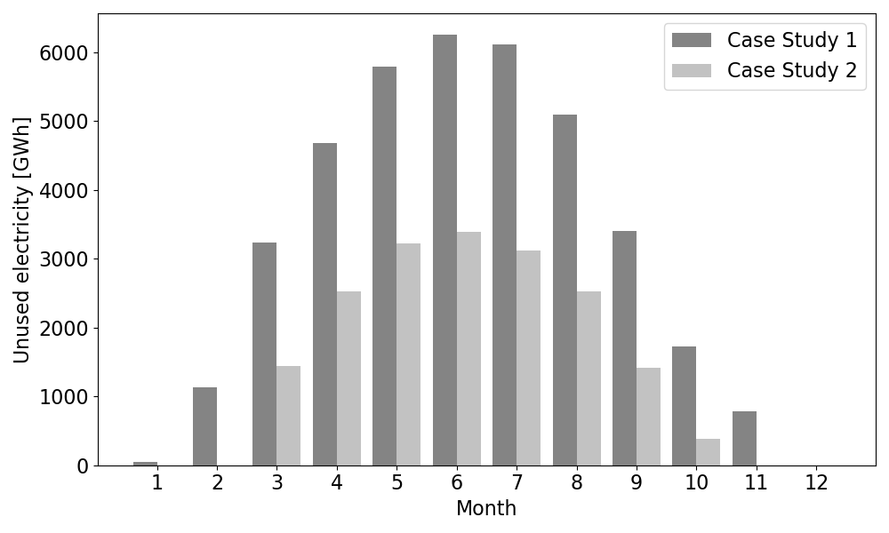
Figure 3. Surplus unused capacity for both scenarios.

    - Case Study 2: Optimal energy production and distribution with external supply
When it is allowed to buy energy from outside the grid to meet demand, again, no storage is selected, but two main differences are noted (Table 2) relative to Case Study 1:
1) A notable reduction of investment is shown (8,347 M€, -32%). In spite of the high penalties, it is still cheaper to build smaller facilities and pay to acquire electricity from the grid than having an unused electricity generation capacity surplus, as can be inferred comparing the value of Figure 3 for Case Study 1 (more than 6,000 GWh) and Case Study 2 (less than 3,500 GWh). That means that additional policies and incentives are required to promote the green transition using CSP plants coupled with hydrogen technologies.
2) The reduction of social impact (SI) values in Case 2 is lower (25%) than the investment reduction but impact is still important. The Huesca CSP plant is no longer built and the one in Badajoz has a lower capacity, but the Almeria plant remains the same. Even though Almeria and Badajoz present similar irradiation, Almeria is the most affected region in terms of social impact, thus it is the region that the model selects as a priority to build a CSP plant.
The comparison of Figure 2 and Figure 4 shows that the volume of electricity transmitted through the grid is lower than in Case Study 1, particularly during winter because it is better to fully meet the energy demand with electricity from the grid in Huesca and Lugo. In addition, the reduction of energy transmission during winter matches the lack of energy surplus from October to February (see Figure 3 – Case Study 2). This shows that there is a trade-off between grid dependency and energy production.

Figure 4. Electricity transmission in Case study 2.
  - Conclusions
A mathematical model is proposed for the integrated modelling of a sustainable energy network based on CSP plants, following the Net-zero policies and the goal of decarbonize the energy network. The model includes technical, economic, social, and geographical aspects, which are simultaneously considered to optimize the production, storage and distribution of electricity and H₂ as an energy vector. The social impact model captures the importance and benefits of developing underdeveloped areas with large solar irradiation, and allows analysing the trade-off between investment, production and social impact.
The model formulation is a scalable multi-period MILP, in which the timeframe of 1 year of operation is divided into 12 months. The model was applied to evaluate 5 regions selected through Spain, considering two case studies. The results show that the southern regions (Almeria and Badajoz) are more suitable for production and for meeting the total energy demand using the distribution network, because of larger DNI values and higher social impact of the new facilities. To fully meet demand with no external import, 3 CSP plants are required, over-designed to meet the demand during winter, resulting in an energy surplus and unused electricity during the rest of the year. If external electricity import is allowed, 2 smaller CSP are optimal, because the benefits of producing green energy are not as competitive as purchasing some electricity from the grid during certain months. Both case studies highlight the need for policies and incentives to encourage the use of green hydrogen as an energy vector, if its prices are to compete with grey hydrogen.
References
The authors acknowledge Imperial College London and University of Salamanca for access to scientific sources and databases. The authors acknowledge the Margarita Salas grant, co-funded by the European NextGenerationEU Fund, Spanish “Plan de Recuperación, Transformación y Resiliencia” Fund, Spanish Ministry of Universities, and University of Salamanca (“Ayudas para la recualificación del Sistema Universitario español 2021-2022”), to JA Luceño Sánchez.
References
Ainou, F.Z.; Ali, M.; Sadiq, M. (2023). Green energy security assessment in Morocco: green finance as a step toward sustainable energy transition. Environ. Sci. Pollut. Res., 30, 61411-61429.
Heras, J.; Martín, M. (2020). Social Issues in the Energy Transition: Effect on the Design of the New Power System. Appl. Energy, 278, 115654.
INE, Instituto Nacional de Estadística (Spanish National Institute of Statistics). Last accessed Sep 2023. https://www.ine.es/
IRENA, International Renewable Energy Agency. Hydrogen Overview. 2022 (Last accessed Sep 2023). https://www.irena.org/Energy-Transition/Technology/Hydrogen
Luceño Sánchez, J.A.; Martín, M.; Macchietto, S. (2023). Optimal Concentrated Solar Plant (CSP) location accounting for social and environmental impact: A three location study in Spain. Comput. Aided Chem. Eng. 52, 3031-3036.
PVGIS, Photovoltaic Geographical Information System. Interactive tools. Last accessed Sep 2023. https://re.jrc.ec.europa.eu/pvg_tools/en/
Shi, X. (2016). The future of ASEAN energy mix: A SWOT analysis. Renew. Sust. Energ. Rev., 53, 672-680.

