Hydrogen Trade Scenarios: Impact of Transportation Methods and Geopolitical Dynamics
Dawood Hjeij,^{a*} Yusuf Bicer,ª Muammer Kocª
ª Hamad Bin Khalifa University, Doha, Qatar
dhjeij@hbku.edu.qa
Abstract
In the rapidly evolving hydrogen economy, the means of transportation and geopolitical factors can significantly influence the global hydrogen trade landscape. This research introduces a dynamic analysis of potential scenarios shaping hydrogen trade in medium to long-term horizons, assessing their feasibility based on technological advancements, economic implications, and external factors.
We incorporate various energy scenarios into our analysis using an agent-based model approach in the AnyLogic simulation software. These range from a full-scale transition to hydrogen as a primary renewable energy carrier, a partial transition, to a potential retreat from hydrogen consumption. Each scenario incorporates varying hydrogen production methodologies, storage solutions, and transportation channels. Specific emphasis is placed on contrasting transportation methods: pipelines, liquified hydrogen in ships, and ammonia conversion. Moreover, geopolitical considerations, such as the closure of marine chokepoints, are integrated to visualize their potential impact on hydrogen trade.
In this paper, we provide preliminary results that offer initial insights into the evolving scenarios of the hydrogen trade. These early findings, focusing on diverse aspects of hydrogen transportation and geopolitical influences, introduce more detailed analyses that will be conducted as our research progresses.
Keywords: Agent-based model, Hydrogen economy, Hydrogen market, Trade, Simulation
  - Introduction
The evolution of the global energy landscape is increasingly characterized by a shift towards more sustainable and low-carbon sources. In this context, hydrogen emerges as a pivotal element in the global energy transition, offering a versatile energy storage and transportation solution. The production of hydrogen is achievable through diverse methodologies, such as renewable energy-powered water electrolysis and natural gas-based methane reforming coupled with carbon capture. This versatility and the growing need for cleaner alternatives have positioned hydrogen as a central player in the sustainable energy dialogue.

As the hydrogen sector witnesses exponential growth, significant advancements in production technology and distribution methods are becoming apparent. A substantial increase in investments and technological innovations underpins this growth trajectory. An estimated $ 8 trillion in hydrogen-related investments is needed by 2050 to develop international hydrogen trade (Hydrogen Council and McKinsey & Company, 2023). However, the hydrogen market faces several challenges, including the high costs associated with production, the emerging state of its delivery and storage infrastructure, and the need for more robust policy frameworks to encourage further investments and expansion. Despite these hurdles, the unique advantages offered by hydrogen, notably its clean energy credentials, have spurred considerable interest globally. Numerous countries, especially those rich in renewable resources or natural gas reserves, are actively exploring ways to enhance their hydrogen production and utilization capabilities (IEA, 2023a).

Recent years have seen a surge in interest in the hydrogen market from the research community. While studies on the hydrogen market are still evolving, parallels can be drawn from the extensively researched liquefied natural gas (LNG) market. In LNG market research, various models have been employed to understand the dynamics between market players, including producers and importers (Meza et al., 2021). These studies have yielded crucial insights into energy markets’ workings and growth potential and can serve as a reference for hydrogen market research.

In addition to agent-based modeling, other methodologies have been employed to analyze the hydrogen market. These include market simulations to forecast future hydrogen supply and demand, economic models to examine the impact of policy measures, and life cycle analyses to assess the environmental implications of hydrogen production and usage. These varied methodologies provide a holistic view of the hydrogen market and its growth potential, offering insights ranging from market projections to environmental sustainability assessments.

This study endeavors to explore the hydrogen market, focusing on the role of leading energy exporters. This research projects hydrogen and ammonia supply and demand up to 2050, evaluating market costs and investment opportunities using an agent-based model. The model accounts for various factors, including hydrogen/ammonia producers, importers, delivery contracts, shipping methods, and infrastructure, treating each country as an independent entity. The findings of this study will be instrumental in understanding the growth potential of the hydrogen market and the pivotal role of major energy exporters.

Understanding the dynamics of the hydrogen market is crucial for achieving net-zero targets and transitioning to sustainable energy sources. This research will provide essential insights into the costs and investment opportunities within the hydrogen market, highlighting the significance of key energy exporters in its expansion. The insights gained from this study will aid in shaping policies that foster the development of the hydrogen sector and support the transition toward cleaner energy.

This research presents a novel approach to examining the hydrogen market, utilizing an agent-based model to analyze the interplay among various market participants. By conducting a comprehensive analysis of the hydrogen market and its growth prospects, this study addresses existing gaps in research, contributing significantly to the body of knowledge in this field.
  - Methodology
    - Agent-based model
This model simulates the dynamics of hydrogen production, consumption, and trade among 40 different countries from 2022 to 2050. It integrates various parameters and databases to analyze scenarios under three different conditions. The model’s core components include agents, parameters, databases, variables, and functions.
    - Agents
Each country is an agent in the model with unique characteristics and behaviors. A total of 40 countries were selected based on different criteria to represent the hydrogen trade using manageable computational resources. Initially, countries were ranked using a hydrogen competitiveness index from a previous publication (Hjeij et al., 2023), assessing their potential in the hydrogen market. Additionally, the hydrogen investability index was used to gauge the attractiveness of countries for hydrogen sector investments (Cranmore Partners and Energy Estate, 2021). Insights from Deloitte’s “Green Hydrogen” report, which identified countries actively involved or with significant potential in the green hydrogen sector, were also considered (Deloitte, 2023). This multi-source approach ensured a well-rounded and informed selection of countries.
    - Parameters
      - Hydrogen demand
To project hydrogen demand up to the year 2050, we employed data from the International Energy Agency’s (IEA) World Energy Review (IEA, 2023b). Specifically, we based our projections on three distinct scenarios outlined in the review:
- STEPS (Stated Policies Scenario): Reflects the impact of current policy frameworks and announced policy intentions.
- APS (Announced Pledges Scenario): Takes into account the targets and pledges announced by different countries but not yet implemented as policies.
- NZE (Net Zero Emissions by 2050 Scenario): Envisions a pathway to achieve net-zero global emissions by 2050.

These scenarios provide a comprehensive range of possible futures, with assumptions and outcomes regarding energy consumption and hydrogen demand.

To distribute the projected global hydrogen demand among the 40 countries in our model, we utilized the primary energy consumption data from the Energy Institute’s (EI) Statistical Review of World Energy (Energy Institute, 2023). This approach allowed us to align hydrogen demand with energy consumption and ensure proportional representation.

The projected hydrogen demand, split among the countries based on the methodology above, was then integrated into our agent-based model. This integration is crucial for accurately simulating future hydrogen trade dynamics, production needs, and the overall functioning of the hydrogen market under different global scenarios.

      - Natural gas production
To obtain accurate and current data on natural gas production by country for 2022, we utilized the GlobalData Oil & Gas Upstream Fields Database (GlobalData, 2023a). This comprehensive database provides detailed information on natural gas production across various countries, offering a reliable baseline for our analysis. The data extracted from this source were instrumental in establishing the current landscape of natural gas production globally, serving as a foundation for future projections.

For projecting natural gas production from 2022 to 2050, we referred to the International Energy Agency’s (IEA) World Energy Review. The review’s scenarios provided a structured framework for forecasting, encompassing STEPS, APS, and NZE.
We then calculated the expected annual growth rates of natural gas production based on these scenarios. This enabled us to simulate future scenarios with natural gas production, assessing its impact on hydrogen production and the broader energy landscape.

      - Renewable energy
For our study’s renewable energy generation component, we employed GlobalData’s Power IC – Capacity and Generation Database, a resource that provides extensive data on capacity and generation for 171 countries spanning from 2000 to 2035 (GlobalData, 2023b). This detailed database categorizes information based on various power-generating sources and further segments it according to specific technologies or installations.

To extend our analysis up to 2050, we integrated the International Energy Agency’s (IEA) Global Energy Review, which allowed us to incorporate three distinct scenarios (STEPS, APS, NZE) into our projections of renewable energy generation, providing a comprehensive and forward-looking view of the renewable energy sector.
  - Results and Discussion
This section introduces our preliminary findings, which lay the groundwork for a deeper exploration of the hydrogen trade’s dynamics. The results discussed here highlight key aspects of hydrogen transportation and the influence of geopolitical factors. These early insights are a stepping stone towards a more comprehensive analysis in the subsequent phases of our research.

The global hydrogen demand is expected to evolve significantly by 2050 across three scenarios: STEPS, APS, and NZE. Under the current policy-committed STEPS scenario, demand is projected to rise from 86 million tonnes (Mt) in 2022 to 122 Mt by 2050, reflecting a steady, modest growth. The APS scenario, with more aggressive policy support, anticipates a near tripling in demand to 252 Mt, highlighting the impact of enhanced policies and investment in hydrogen technologies. The most ambitious, the NZE scenario, aiming for net-zero emissions by 2050, forecasts an exceptional increase to 366 Mt, underscoring hydrogen's potential role in achieving a low-carbon economy and meeting environmental objectives.

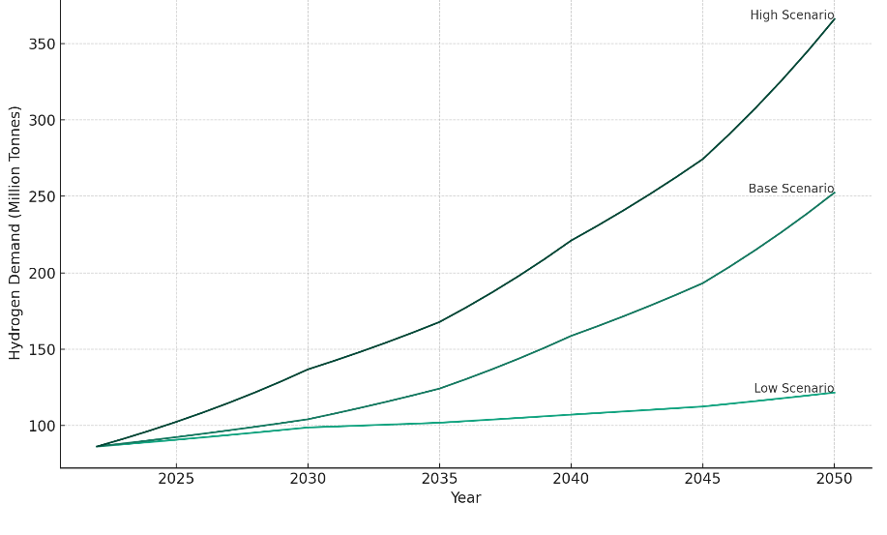
Figure 1: Global hydrogen demand until 2050 according to the different scenarios

The analysis highlights key global demand centers for hydrogen, with China as the largest, followed by the United States and India, especially under the APS and NZE scenarios. This trend indicates a growing reliance on hydrogen as a sustainable energy source, influenced by policy shifts. The evolving energy landscape sees hydrogen as a crucial element, with demand varying significantly based on policy and environmental commitments.

By 2050, a notable misalignment is expected between the locations of major hydrogen demand centers and optimal production sites, presenting opportunities for international hydrogen trade. Regions like Japan, South Korea, and parts of Europe, constrained in hydrogen production by their decarbonization commitments, are likely to become importers. In contrast, areas like South America and the Middle East, with excess production capacity, could emerge as key exporters in the hydrogen market.

Local hydrogen production will often be more cost-effective than imports, especially involving long-distance transportation. This is due to the additional costs incurred in the conversion to intermediaries for transport and re-conversion at the point of use, alongside the costs associated with hydrogen losses and other necessary inputs such as electricity. Consequently, long-distance hydrogen transport is expected to be a less favored option, reserved for cases where local production is not viable.

However, the transportation costs for hydrogen derivatives like ammonia and synthetic kerosene are relatively low compared to the overall product costs due to their higher volumetric densities. This aspect could make long-distance trade in these derivatives from low-cost production centers economically competitive, even in high-cost markets.

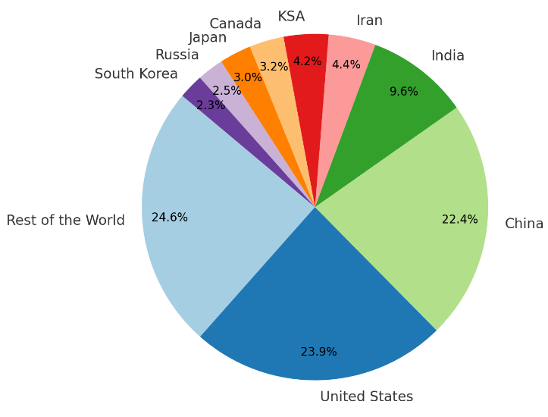
Figure 2: Hydrogen demand in the base scneario by country, 2050

  - Conclusions
The future hydrogen trade landscape will likely be shaped by production costs, the nature of the products being transported, and the availability of local resources. While local production will generally be preferable, long-distance trade in hydrogen and its derivatives will play a crucial role, especially connecting regions with excess production capacity to those with significant demand but limited production capabilities. This global trade in hydrogen and its derivatives could significantly reduce overall investment requirements in the energy sector, fostering a more interconnected and efficient global energy market. The international hydrogen trade will also influence global geopolitics, potentially redefining energy alliances and shifting power balances between nations based on their roles as producers or consumers.
References
Cranmore Partners and Energy Estate, 2021, Hydrogen Investability Index: Emerging Hydrogen Superpowers.
Deloitte, 2023, Green hydrogen: Energizing the path to net zero.
GlobalData, 2023a, Oil & Gas Upstream Fields Database.
GlobalData, 2023b, Power IC – Capacity and Generation Database.
Hjeij, D, Biçer, Y, Al-Sada, M., and Koç, M., 2023, Hydrogen export competitiveness index for a sustainable hydrogen economy, Energy Reports, 9, 5843-5856.
Hydrogen Council and McKinsey & Company, 2023, Global Hydrogen Flows - 2023 Update.
IEA, 2023a, Global Hydrogen Review.
IEA, 2023b, World Energy Review.
IEA, 2023c, Net Zero Roadmap: A Global Pathway to Keep the 1.5 °C Goal in Reach.
Meza, A., Ari, I., Al-Sada, M., and Koc, M., 2021, Future LNG competition and trade using an agent-based predictive model, Energy Strategy Reviews, 38, 100734.
The Energy Institute (EI), 2023, Statistical Review of World Energy.

