An Energy Efficient Process for Integrated Oxidative Propane Dehydrogenation and Hydroformylation
Khande Ajay,^{a*} Maity Pintu,ª Das Rajkumar,ª Thota Chiranjeevi,ª
ªBharat Petroleum CRDC, Plot 2A Udyog Kendra, Surajpur, Greater Noida, Uttar Pradesh 201306, India.
*ajayrajukhande@bharatpetroleum.in
Abstract
Economic analysis based upon energy consumption and capital investment is performed for a sustainably designed process which integrates CO₂ assisted oxidative propane dehydrogenation (OPDH) and propylene hydroformylation (PHF). Refinery grade propylene (50-70 % purity) is produced via CO₂ assisted propane dehydrogenation with syngas as a byproduct. Utilization of CO₂ from carbon capture (CCUS) sources improves its overall sustainability. The dilute refinery grade propylene is directly used as a hydroformylation feed which eliminates the need for any additional separation step in between the OPDH and PHF reaction steps, thereby minimizing energy costs and reducing net carbon emissions. Yet another benefit is that no external source for syngas is required since it is obtained in the OPDH step as a byproduct. The energy consumption of the proposed process is compared with commercial propane dehydrogenation (PDH) processes coupled with PHF. The majority of energy saving is due to the elimination of the propylene purifying step which had significant energy duty. The remaining energy saving is due to preheating and quenching the oxidative dehydrogenation feed and product using heat exchanger integration (HEN). The lower energy requirement translates to lower carbon emissions and taking into consideration the CO₂ being utilized in this process, this process is environmentally and economically sustainable.
Keywords: Propane dehydrogenation, Oxo-synthesis, Sustainable design, CO₂ utilization.
  - Introduction
Butyraldehyde is a crucial precursor in industrial chemistry, facilitating the production of essential compounds like 2-ethylhexanol and pharmaceutical butanol. The primary method involves propylene hydroformylation (PHF) (T = 85−130 °C, P = 1.5−5.0 MPa), projecting a $360 billion market by 2036 with a 6 % CAGR (Liu et al., 2022). In Ponce, Puerto Rico, a thriving plant utilizing low-pressure oxo technology with TPP-modified Rh catalysts, yields 136,000 t/y of butyraldehydes, using high-purity propylene (99.5 %) as feedstock (Tudor and Shah, 2017)
Traditionally propylene production primarily relied on byproducts from steam cracking or fluid catalytic cracking in refineries, driven by ethylene and gasoline markets. These methods yield low-grade propylene due to product variety, low selectivity, and modest yield (up to 20 wt%)(Mujtaba et al., 2023). Propylene purification to polymer grade often involves tall super fractionators with a high carbon footprint (usually diameter = 10 m, height = 80 m).
Emerging "on-purpose" propylene technologies, including Propane Dehydrogenation (PDH), Methanol-to-Propylene (MTP/MTO), and Olefin Metathesis, promise increased yield and purity. Notable commercial PDH processes like CATOFIN and OLEFLEX exhibit high propylene selectivity. However, challenges persist, such as catalyst deactivation, low conversion rates, and elevated reaction temperatures (Won et al., 2010). Thermodynamic constraints and the endothermic nature of the reaction necessitate high temperatures (>550℃), causing coking and sintering issues (Jiang et al., 2015). Catalytic oxidative dehydrogenation, via oxidants like O₂ for propane dehydrogenation (OPDH) will favour low reaction temperature, higher equilibrium conversion but risks deep oxidation thereby impacting propylene selectivity. An alternative involves substituting O₂ with a milder oxidant like CO₂, transforming CO₂ emissions into chemicals sustainably. CO₂ is converted to syngas via the RWGS reaction, which can be used in PHF. Furthermore, CO₂ stabilizes catalysts by eliminating coke through the reverse Boudouard reaction (Yuan et al., 2023; Keller, 2021).
Polymer-grade propylene, while more expensive, may be cost-effective if available on-site. Recently, it was shown that refinery-grade propane/propylene mixtures can be used directly for PHF without prior purification to polymer-grade propylene, offering cost savings. This also enhances the yield by expanding the reaction mixture's volume and favours the exothermic equilibrium (Liu et al., 2018). With refinery-grade feedstock being up to 50 % cheaper than polymer-grade propylene, integrating the OPDH and PHF process offers energy and economic/environmental benefits. This manuscript conducts an economic analysis of the integrated process, comparing it to the commercial method involving distillation.
  - Process Descriptions
Schematics of the three case studies under consideration are shown in Figure 1

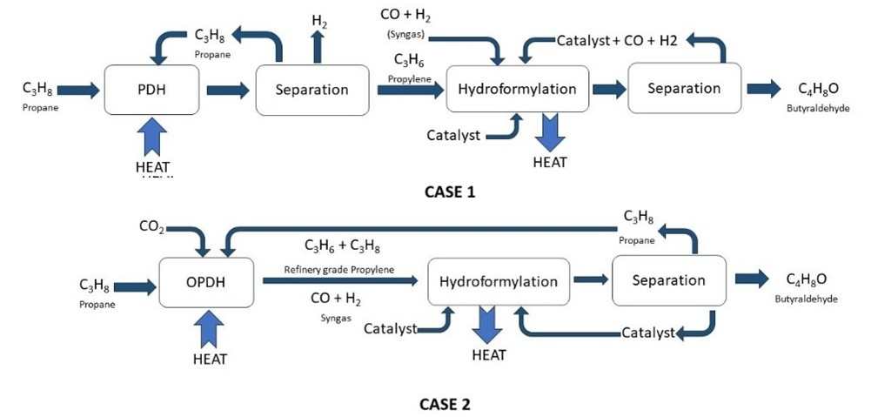

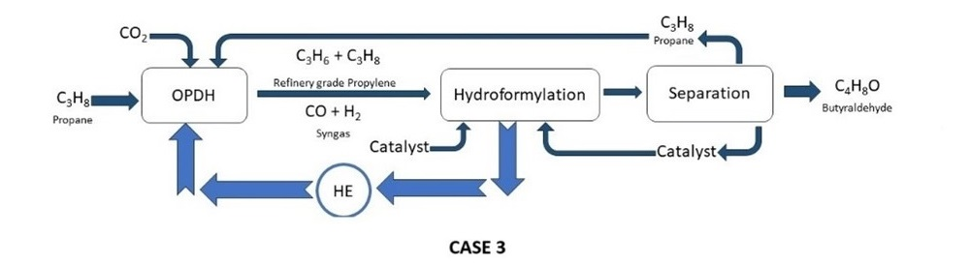.
Figure 1: Schematic of integrated propane dehydrogenation and hydroformylation processes. (Case 1) Conventional process with propane/propylene separation by distillation. (Case 2) Process with oxidative dehydrogenation and direct hydroformylation. (Case 3) Integrated process with heat integration.

Butyraldehyde is synthesized via an integration of propane dehydrogenation and propylene hydroformylation process with pure propane as the primary feedstock. In Case 1, CATOFIN PDH process converts propane to propylene which is purified to polymer grade and unreacted propane is recycled. In Case 2, pure propane and CO2 are co-fed, oxidatively dehydrogenated, producing a mixture of propylene, syngas, and unconverted propane. This stream is cooled and directly sent to the PHF unit without further purification. Case 3 optimizes the heat exchange to utilize excess exothermic heat from hydroformylation, enhancing economic and environmental sustainability in the overall process (detailed in Figure 2).
  - Methodology
The case studies for economic and environmental impact assessment are as follows.
- plant-scale simulations of conventional propane dehydrogenation, followed by separation to polymer grade propylene and subsequent hydroformylation.
- plant-scale simulation of oxidative propane dehydrogenation and subsequent hydroformylation of the product gas mixture.
- plant-scale simulation of oxidative propane dehydrogenation and subsequent hydroformylation of the product gas mixture with heat integration.

3.1 Reactions
The interaction of propane with CO₂ involves various reaction pathways and side reactions Eq. (1) - (9). In non-oxidative propane dehydrogenation Eq. (1), hydrogen production limits propane conversion due to equilibrium. Coupling this reaction with CO₂ in the reverse water-gas shift (RWGS) reaction Eq. (2) overcomes this limitation, increasing propylene yield Eq. (3). However, competing side reactions, like dry reforming of propane Eq. (5) are also observed at these conditions. Depending on the selectivity of the catalyst used, additional side reactions like propane cracking and hydrogenolysis Eq. (6) - (9) also occur. The choice of catalyst and reaction conditions plays a critical role in controlling these pathways (Atanga et.al, 2018). Hydroformylation, also known as oxo-synthesis, is a reaction between an olefin and syngas catalyzed by complexes of transition metals with soluble ligands Eq. (10). Only alpha olefins are active in hydroformylation.

C₃H₈ ↔ C₃H₆ + H₂ | ΔH₂₉₈ _{K} = +164 kJ mol⁻¹ | (1)
CO₂ + H₂ ↔ CO + H₂O | ΔH₂₉₈ _{K} = + 41 kJ mol⁻¹ | (2)
C₃H₈ + CO₂ ↔ C₃H₆+CO+H₂O | ΔH₂₉₈ _{K} = + 124 kJ mol⁻¹ | (3)
CO₂ + C ↔ 2CO | ΔH₂₉₈ _{K} = + 172 kJ mol⁻¹ | (4)
C₃H₈ + 3CO₂ ↔ 6CO + 4H₂ | ΔH₂₉₈ _{K} = + 620 kJ mol⁻¹ | (5)
2C₃H₈ + 2CO₂ → 3C₂H₄ + 2CO + 2H₂O |  | (6)
C₃H₈ → C₂H₄ + CH₄ |  | (7)
C₃H₈ + H₂ → C₂H₆ + CH₄ |  | (8)
C₃H₈ + 2H₂ → 4CH₄ |  | (9)
C₃H₆ + CO + H₂ ↔ C₄H₈O | ΔH₂₉₈ _{K} = -125.5 kJ mol⁻¹ | (10)

3.2 Simulation
Aspen® plus V12 software was employed to perform simulations of the integrated OPDH and PHF processes. The butyraldehyde capacity for the plant scale simulations were set at 70 t/d. The kinetic data for simulating the PDH, OPDH and PHF process were obtained from literature and patents. (Li et.al 2011; Hanna et.al 2012). The data for simulating the process was obtained from laboratory scale experiments. The reactors for PDH and OPDH processes were simulated with RPlug reactor model and PHF reactor was simulated with RCSTR models. The UNIQUAC package available in Aspen software was used to predict the relevant thermodynamic properties.
  - Heat Integration
Heat exchanger networks (HENs) are vital in chemical process design, optimizing energy efficiency and emission reduction. They minimize operating costs through heat recovery and play a pivotal role in achieving sustainable, cost-effective, and environmentally friendly chemical processes.
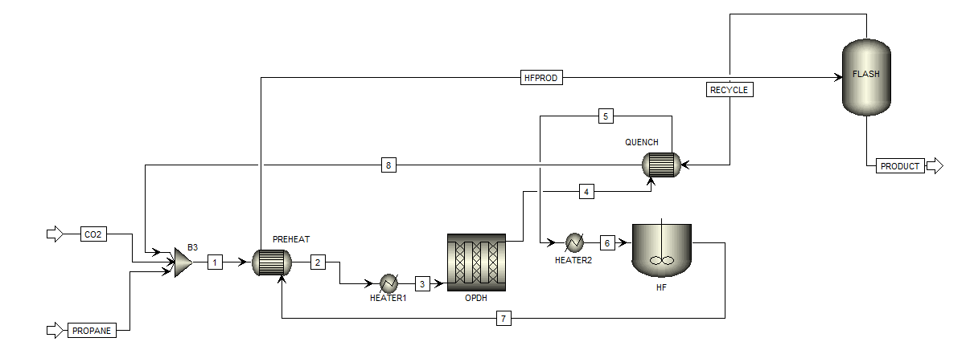
Figure 2. Process Flow Diagram of Heat Exchange Network
The highly endothermic OPDH process (Eq. 3) benefits from preheating the feed by utilizing exothermic HF reaction heat (Eq. 10) to reduce the charge heater (HEATER 1) energy demand. To prevent side reactions, OPDH product quenching is achieved with the propane recycle stream at also reheating the recycle propane. Both heat exchangers (PREHEAT and QUENCH) employ a hot stream on the tube side and a cold medium on the shell side, operating in gaseous phase and are designed by adopting minimal temperature approach.
  - Results and Discussion
Comparative analyses are conducted through the estimation of the total production cost, which is the summation of capital investment and energy demand. The consumption of energy is derived from process simulations, while capital investment is assessed by means of a comparison of unit operations required within these simulations. Key operating parameters that remain consistent across all three cases are presented in Table 1 for the purpose of facilitating straightforward comparisons.
TABLE 1: Key Operating Parameters
OPDH Reactor
Propane (t/d) | 40
Catalyst (t) | 18
Single pass conversion (%) | 35
PHF Reactor
Ligand/Propylene (t/t) | 0.01
Operation temperature (°C) | 80
Operation pressure (kPa) | 1000
The propane flowrate is regulated to maintain a consistent (WHSV) of 53h-1 in the PDH reactor. In Case 1, an optimal single pass conversion of 35 % is achieved to enhance propylene selectivity, and this value is kept constant across all cases for the sake of comparative analysis. Similarly, the Ligand/Propylene ratio for the PHF reaction remains fixed in all three cases.
Typically, propylene is the limited reactant in the PHF process, with syngas supplied in excess. However, to mitigate the necessity for gas separators and prevent saturation of the PDH reactor, syngas is deliberately supplied as the limited reactant by controlling the CO2 supply to the PDH reactor. The CO:H2 ratio is meticulously managed through the regulation of the PDH reaction temperature and the formulation of the catalyst.
TABLE 2: Selectivity Comparison
OPDH Reactor | Case 1 | Case 2 | Case 3
Propylene Selectivity (%) | 90 | 78 | 78
Reaction temperature (°C) | 600 | 520 | 520
PHF Reactor
Butyraldehyde (t/d) | 60.24 | 60.82 | 60.82
Chemo selectivity | 96.2 | 97.8 | 97.8
In oxidative PDH (Cases 2 and 3), propene selectivity decreases attributed to more side reactions (Eq. 2-9). Nevertheless, the same degree of propane conversion as in Case 1 is achieved at a significantly lower temperature. This outcome is facilitated by the in-situ exhaustion of hydrogen through reverse water gas shift, effectively shifting the dehydrogenation equilibrium in favor of propylene production.
Moreover, there is a marginal improvement in butyraldehyde yield in both Case 2 and Case 3. This improvement is attributed to the dilution of the reaction mixture by unconverted propane, acting as a heat sink for the exothermic PHF process (Eq. 10). Additionally, due to the lower partial pressure of propylene in the reaction mixture, its re-saturation reaction equilibrium is governed by the presence of excess propane.
TABLE 3: Energy Demand Comparison
(MJ/h) | Case 1 | Case 2 | Case 3
PDH Charge Heater Duty (HEATER 1) | 1540 | 2094 | 1675
Propylene Purification | 14957 | 0 | 0
PDH Quench Duty (HEATER 2) | 210 | 616 | 336
Energy Saved | Base | 83 % | 88 %
The PDH Charge heater’s heat duty is highest in Case 2, primarily due to the energy required to heat the equimolar feed mixture of propane and CO2. This demand diminishes in Case 3, owing to heat exchange with the PHF product. The predominant energy requirement in the overall process stems from the propylene purification unit. The purification of propylene to polymer grade entails substantial reboilers and condenser duties, which are absent in Case 2 and Case 3. In Case 1, where polymer-grade propylene is obtained from the condenser, the quench duty is minimal. Conversely, in Case 2, the propane-propylene-syngas mixture originates from the PDH reactor operating at temperatures exceeding 500°C, necessitating quenching to prevent secondary reactions such as cracking and saturation, while also enhancing the exothermic equilibrium in the PHF step. In Case 3, the quenching duty is reduced as it is heat exchanged with the recycle propane stream, as illustrated in Figure 2.
The overall energy demand in Case 2 is 83 % lower than in Case 1, and the energy demand in Case 3 is 88 % lower than in Case 1. Moreover, the energy demand in Case 3 is 25 % lower than in Case 2.
TABLE 4: Capital Investment Comparison
 | Case 1 | Case 2 | Case 3
Reactor | 2 | 2 | 2
Separator/Distillation Column | 2 | 1 | 1
Pump/Compressor | 4 | 5 | 6
Heat Exchanger | 4 | 2 | 4_{(2 larger)}
Fired Heaters | 1 | 1 | 1_{(smaller)}
The need for a large propane/propylene distillation column alone contributes more of the total cost in the conventional process and is hence more expensive compared to Cases 2 & 3. Extra turbomachinery is required in Case 3 due to the pressure drops caused by the two heat exchangers. The fired heater in Case 3 can be smaller due to lower heat duty. By estimating capital investment by following the “percentage of purchased-equipment cost”
Method which is based on attributes such as equipment size, the material of construction, weight, or surface area the least capital-intensive Case can be determined.
  - Conclusion
The comparative economic analyses conducted through plant-scale simulations and comparative assessments highlight the advantages of the integrated process (Case 3) over the conventional method involving distillation (Case 1). The key operational factors affecting both economic and environmental impacts have been identified, providing valuable insights for process design and optimization. The results indicate that the proposed integrated process, especially with heat integration (Case 3), stands out as the most economically attractive option, offering a compelling alternative to conventional methods in the production of butyraldehyde.
References
- Agarwal, A., Sengupta D., El-Halwagi M., 2018. Sustainable Process Design Approach for On-Purpose Propylene Production and Intensification. ACS Sustainable Chem. Eng. 6, 2407– 2421.
- Boyang Liu, Yu Wang, Ning Huang, Xiaocheng Lan, Zhenhua Xie, Jingguang G. Chen, Tiefeng Wang, 2022. Heterogeneous hydroformylation of alkenes by Rh-based catalysts. Chem 8, 2630-2658.
- US7935850B2-Process for hydroformylation of propylene.
- David G. Hanna, Sankaranarayanapilla Shylesh, Sebastian Werner, Alexis T. Bell, 2012. The kinetics of gas-phase propene hydroformylation over a supported ionic liquid-phase (SILP) rhodium catalyst. Journal of Catalysis 292,166–172.
- F. Jiang, L. Zeng, S. Li, G. Liu, S. Wang, J. Gong, 2015. Propane Dehydrogenation over Pt/TiO2-Al2O3 Catalysts. ACS Catal. 5, 438–447.
- Haitao Liu, Zhao Zhang, Huiquan Li, Qingze Huang, 2011. Intrinsic kinetics of oxidative dehydrogenation of propane in the presence of CO2 over Cr/MSU-1 catalyst. Journal of Natural Gas Chemistry 20, 311–317.
- Iqbal Mohammed Mujtaba, Yakubu Mandafiya John, Aminu Zakari Yusuf, Raj Patel, 2023. Crude to chemicals: The conventional FCC unit still relevant. Modelling of Chemical Process Systems, Pages 251-267.
- Liu D., Chaudhari R. V., Subramaniam B., 2018. Enhanced solubility of hydrogen and carbon monoxide in propane-and propylene expanded liquids. B. AIChE J. 64, 970−980.
- Liu, D., Chaudhari, R. V., Subramaniam B., 2018. Homogeneous catalytic hydroformylation of propylene in propane-expanded solvent media. Chem. Eng. Sci. 187, 148−156.
- Marktus A. Atangaa, Fateme Rezaeia, Abbas Jawada, Mark Fitchb, Ali A. Rownaghi, 2018. Oxidative dehydrogenation of propane to propylene with carbon dioxide. Applied Catalysis B: Environmental 220, 429–445.
- Martin Keller, Atul Sharma, 2022. Reverse Boudouard reforming produces CO directly suitable for the production of methanol from CO2 and CH4. Chemical Engineering Journal 431, 134127.
- Tudor R., Shah A., 2017. Industrial Low Pressure Hydroformylation: Forty-Five Years of Progress for the LP OxoSM Process. Johnson Matthey Technol. Rev. 61, 246−256.
- US20100249471 - Production of Propylene from Butane.
- US20130158327 - Hydrocarbon Dehydrogenation with Inert Diluent.
- Wangyun Won, Kwang Soon Lee, Seokho Lee, Chansul Jung, 2010. Repetitive control and online optimization of Catofin propane process. Computers & Chemical Engineering 34, 508-517.
- X. Du, B. Yao, S. Gonzalez-Cortes, V.L. Kuznetsov, H. AlMegren, T. Xiao, P.P. Edwards, 2015. Catalytic dehydrogenation of propane by carbon dioxide: a medium-temperature thermochemical process for carbon dioxide utilization. Faraday Discuss. 183, 161–176.
- Yong Yuan, William N. Porter, Jingguang G. Chen, 2023. Comparison of direct and CO2-oxidative dehydrogenation of propane. Trends in Chemistry, 2589-5974.

