The assessment of LNG export scenarios for Qatar in the European Gas Market
Majed M. A. Munasserª, Sabla Y. Alnouriª and Abdelbaki Benamor ^{a,b}
ªGas Processing Center, College of Engineering, Qatar University, Doha, Qatar
^{b}Department of Chemical Engineering, College of Engineering, Qatar University, P.O. Box 2713, Doha, Qatar
sabla@qu.edu.qa
Abstract
The growing energy demand in Europe, combined with strained political relations with Russia due to the ongoing Ukrainian conflict, has prompted the European continent to seek alternative energy sources and reduce its dependence on Russian natural gas imports in the coming years. This need for diversification has become even more critical following disruptions to the pair of offshore pipelines, Nord Streams 1 and 2, which traverse the Baltic Sea and connect Russia to Germany. Therefore, it is imperative to conduct an in-depth analysis of the current situation in the EU to identify viable future strategies for diversifying its gas imports. This paper examines the current state of the LNG market in Europe and identifies the primary gas suppliers and importers in the European gas market. Based on this, a diversification plan which entails the EU establishing competitive, long-term gas import opportunities with Qatar is presented. There are multiple avenues through which Qatar can expand its LNG trade contracts with the EU, involving various routes. To determine the most optimal routes for natural gas exports, a Linear Program (LP) mathematical model was utilized. This model assists in choosing the best LNG export scenarios from Qatar to Europe, taking into account factors such as shipping logistics, European regasification terminals, and the existing network of pipelines for gas distribution throughout the European continent. The primary pipelines considered in this study for distribution are assumed to be under the operation of the European Network of Transmission System Operators for Gas (ENSTOG). Hence, multiple LNG shipping routes from Qatar to Europe in conjunction with major European regasification facilities were explored, followed by a distribution plan utilizing ENSTOG's pipeline infrastructure. The economic viability of the proposed export scenarios was assessed by incorporating several economic factors into the model's objective function. As such, several case studies for LNG export from Qatar to Europe were studied, by identifying the most efficient routes for shipping, regasification, and distribution using Europe's existing pipeline infrastructure. Additionally, introducing regasification routes through intermediary countries, such as Turkey, was also studied.
The results suggest that Qatar has the capacity to meet up to a 50% disruption in Russian gas supplies to the European Union

Keywords: LNG; Europe; Qatar; Regsification; Pipeline
1. Introduction
As the global energy landscape undergoes a transformation, securing a consistent supply of natural gas has become increasingly vital. According to estimates from the International Energy Agency (IEA), natural gas currently contributes to 25% of the world's electricity generation and accounts for 22% of global energy consumption (IEA, 2022). Europe’s natural gas and liquefied natural gas (LNG) consumption has reached 550 billion cubic meters per annum. In order to guarantee a continuous supply of gas resources and meet Europe’s natural gas needs, strategic LNG suppliers must be chosen. Qatar plays a pivotal role in the golabl LNG export market, commanding nearly 35% of the global market share. Over the past decade, the balance of power between Russia and Qatar has been a significant factor in the global energy landscape, as noted Eser et al. (2019). The LNG sector has seen remarkable growth due to a shift toward cleaner energy, particularly natural gas. This trend is driven by increased energy demand and a reduced interest in carbon-intensive fuels. LNG's versatility has made natural gas more attractive on the international stage, enabling it to reach more locations, whereby unused gas reserves are being explored (Meza and Koc, 2021). In 2021-2022, global LNG imports reached 372.3 million tons, marking a 16.2 million-ton increase from the previous year (IEA, 2022). The annual growth rate of LNG imports has been steadily climbing at 4.5%, driven by economic recovery and the growing demand for cleaner, lower CO₂-emitting energy sources (IEA, 2022). LNG imports have the advantage of being less susceptible to political issues and control compared to traditional pipeline systems. However, effective utilization of LNG requires well-established infrastructure, including LNG terminals, regasification units, and pipeline networks for integrating regasified gas into existing transmission networks. Europe has a substantial reliance on external natural gas supplies. Recent challenges have emerged in Europe after 2020 and the beginning of 2021, fueled by increased European demand following the COVID-19 pandemic and the Russian-Ukrainian crisis. The political tensions stemming from the conflict have added pressure, particularly concerning the threat of disruption to pipeline supplies. In 2021-2022, European demand reached between 530 to 560 BCM, with a significant portion supplied by Russia, approximately 230 BCM (a combination of LNG and pipeline sources) (Meza et al., 2021). Pipelines accounted for around 155 BCM, passing through Poland, Nord Stream 1 in Ukraine, and the Turkish Stream. The majority of European gas is produced in Norway and distributed across Europe through an extensive network, covering approximately 22-24% of European demand. Regarding LNG supply to Europe, Qatar and the USA have emerged as primary suppliers, each contributing between 25-30 BCM of LNG. Russia, the US, Algeria, and Nigeria follow closely, supplying 17.8, 13.9, and 14 BCM, respectively. The USA is currently the leading supplier of LNG with 24.1 million metric tons per annum (MTPA), followed by Qatar with 15.9 MTPA (Ashkanani, and Kerbache, 2023). Replacing Russian natural gas is more challenging than substituting oil or coal due to differences in infrastructure, transportation, and storage. Moreover, Europe will continue to require significant natural gas imports, especially as most of Europe's pipeline infrastructure is designed for Russian gas imports (Dorigoni, and Portatadino, 2008). These alternative supplies will primarily need to arrive as LNG by sea. Ensuring supply security also necessitates maintaining sufficient gas storage levels so that European countries can withstand sudden interruptions in gas deliveries. In response to the Russian-Ukrainian conflict, the EU's strategy aims to diversify its natural gas sources by 2030, with a focus on importing more LNG. This presents an opportunity for Qatar, to enter the European market.
2. Methodology
This paper studies the current situation of the LNG market in Europe, and identifies the main gas suppliers and gas importers in the European gas market. Moreover, a diversification plan that involves Qatar taking this opportunity to present itself as a reliable gas supplier to Europe. There exist multiple prospects for Qatar to expand its LNG trade contracts with the EU, via different routes. In order to identify the best possible routes, a Linear Program (LP) mathematical model has been developed to help identify optimal LNG exporting scenarios from Qatar to Europe. The model accounts for shipping, regasification terminals in Europe, and existing network pipe structures that can be used for gas distribution within the European continent operated by the European Network of Transmission System Operators for Gas (ENSTOG, 2023) illustrated in Figure 1. Several LNG shipping routes from Qatar to Europe coupled with major European regasification units and the pipeline infrastructure via ENSTOG were utilized.

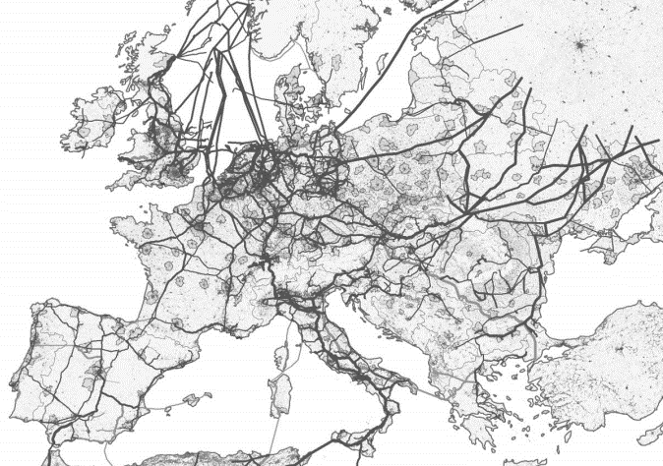

Figure 1: ENSTOG pipeline network via energypost.eu (ENSTOG, 2023)

A linear programming model was utlized in this work. It stands as one of the prevalent deterministic models employed for managing LNG supply and demand. The rationale for selecting this method for optimizing the LNG supply and demand problem is due to the simplicity and transparency that linear programming tools offer (Liberti and Kucherenko, 2005). Moreover, their computational efficiency is crucial for handling large-scale problems (Liberti and Kucherenko, 2005). The model is particularly suited for resource allocation and cost minimization objectives, representing various components of the LNG supply chain effectively. The availability of efficient solver tools, and the balanced trade-off between accuracy and complexity further support its adoption for optimizing LNG distribution networks (Liberti and Kucherenko, 2005). However, it should be noted that that linear programming may not capture all nuances of the real-world LNG market.

Within this model, the intricate interplay of LNG supply and demand is distilled into linear equations. The primary goal was to optimize the allocation of resources, specifically minimizing the overall cost while meeting specified demand constraints. This optimization model incorporates many factors, inclusing shipping expenses,infrastructure costs, and production outlays. As such, the model was formulated according to Eq. (1-4).
$Min. C^{T}x$ (1)
$st. Ax=b$ (2)
$st. Cx≥d$ (2)
$x≥0$ (3)

Where x represents the LNG allocations from Qatar to Europe, as well as the pipeline allocations from regasification terminals across Europe to various destinations, $C^{T}$ represents the various cost parameters (including shipping, regasification, regasification expansion, liquefaction, and storage). A and b were used to represent the demand for natural gas in key European countries, while C and d were used to represent the constrains on the regasification terminals and pipelines across Europe, as well as any constraints on the LNG supply from Qatar. The objective function involves the minimization of the total cost of the gas distribution network from Qatar to Europe. The Linear Program (LP) presented above was implemented using the “Solver” option in MS-Excel 2021 on a Windows laptop with the following specifications: Intel(R) Core i7-7820HQ CPU @ 2.90GHz 2.90 GHz, installed RAM 16.0 GB, and a 64-bit operating System. The code will be available for public access in an extended version of this publication.
3. Case Studies
Four different scenarios were assessed. First, employing the Southern corridor, which connects Turkey, Italy, Greece, and Croatia, as the primary route for delivering natural gas to Europe from intermediary nations receiving LNG from Qatar. Second, utilizing the newly established pipelines extending from Spain to Europe, such as the Midi Catalonia pipeline, for transporting natural gas to Europe from intermediary nations that receive LNG from Qatar. Third, using the Northern corridor, spanning from the UK through Belgium to the Netherlands, as the principal route for the distribution of natural gas to Europe from intermediary nations that acquire LNG from Qatar. Finally, opting for the Baltic Sea corridor, which links Germany, Lithuania, and Poland, as the primary pathway for delivering natural gas to Europe from intermediary countries that source LNG from Qatar. Each of the scenarios described above were conducted by introducing a Russian gas supply disruptions of 50%, and the respective allocations were then attained to meet the European demand based on the gas shortage identified. The capacities of the pipeline networks were acquired from ENTSOG, with a specific emphasis on countries located at cross-border points. Figure 2 below provides a visual representation. Moreover, the regasification capacities of the different countries involved in each scenario were used in the model, as summarized in Table 1.

Table 1: Summary of maximum regasification capacities used for Scenarios 1-4 (BP, 2022) & (IGU 2023)
Country | MTPA | Country | MTPA
Turkey | 838 | France | 650
Italy & Greece | 161 | Belgium | 161
Croatia | 212 | Germany | 490
Spain | 965 | Poland | 43
UK | 219 | Lithuania | 88
Netherlands | 159
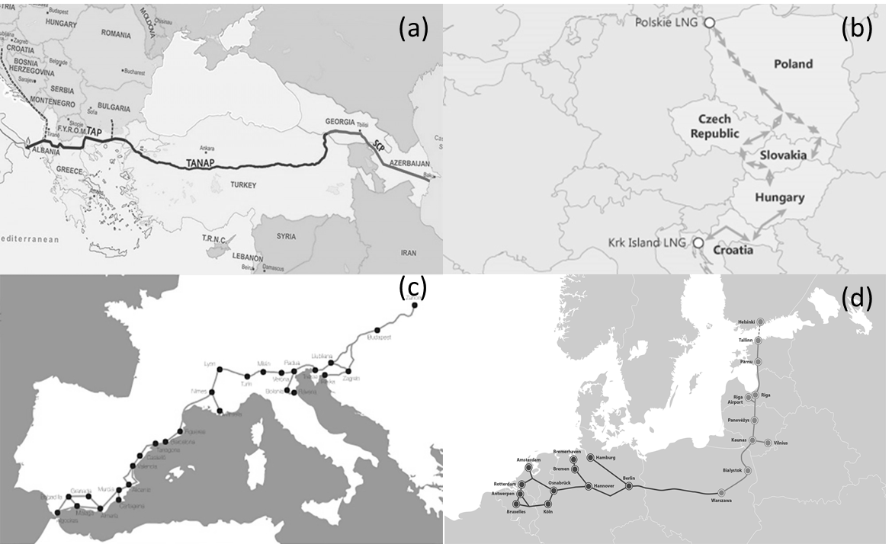

Figure 2: Visual representations of pipe corridors for Scenarios 1-4 including (a) Southern Corridor (b) Northern Corridor (c) Spain Corridor and (d) Baltic Sea Corridor
The model results have yielded preliminary LNG export strategies for Qatar. It has been determined that Qatar has the capacity to meet up to a 50% disruption in Russian gas supplies to the European Union. Figure 3 illustrates the Optimal percentage of LNG allocated per country with respect to the total LNG export preditions from Qatar to Europe for the different scenarios that were investigated.
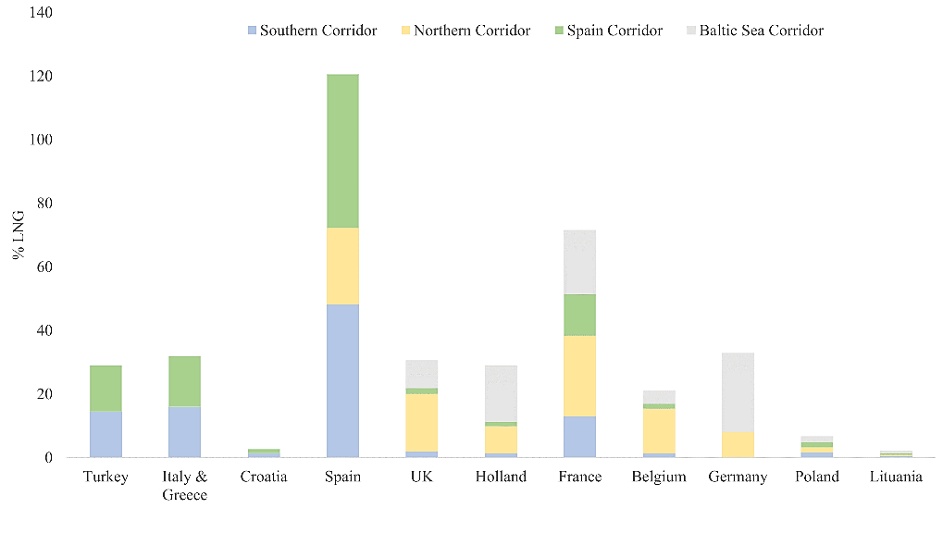
Figure 3: Optimal percentage of LNG allocated per country with respect to the total LNG export preditions from Qatar to Europe for all scenarios combined
To accommodate higher demand, Qatar would need to reconsider its existing contracts in Asian markets. Notably, Case (a) and (Case d) emerged as more cost-effective options when compared to the other scenarios studied. Despite this, Qatar can still utilize the Northern corridor to serve regions with increased demand, including the UK, France, Belgium, and the Netherlands, leveraging the existing ENSTOG pipeline infrastructure. Qatar can also supply LNG to Germany, which, in turn, can distribute it to Baltic Sea countries such as Poland and Lithuania. Case (a) outlines strategic pathways for Qatar to facilitate LNG supply to Europe via nations like Turkey, Italy, Greece, and Croatia. These countries possess substantial gas and LNG infrastructure, linking to major pipelines and intermediate countries in Europe. Furthermore, the southern corridor establishes cross-border connections that interconnect Turkey, Italy, Greece, and Croatia, with extensions reaching Hungary, Austria, Slovenia, and the Swiss border. This region exhibits a promising demand outlook for both natural gas and LNG, with potential for proposed pipeline projects to even reach Germany in the future. On the other hand, the optimum allocations that were attained for Case (b) involve LNG distribution from Qatar to the Northern Corridor nations, encompassing the UK, Belgium, the Netherlands, and France. The largest portion of Qatar's LNG allocation was designated for Spain in Case (c). Finally, Case (d) allocations entailed LNG being sent from Qatar to the Baltic Sea area mainly via Germany and Poland.
4. Conclusion

A comprehensive mathematical model designed to optimize Qatar's natural gas exports to Europe. The model takes into account various critical factors including demand, supply, pricing, and transportation. It successfully integrates both economic and technical aspects of the natural gas industry, offering a holistic solution that minimizes the costs associated with meeting the European market demands. Four distinct case study scenarios for transporting natural gas from Qatar to Europe were explored, and significant implications for Qatar's natural gas industry were discussed.
Aknowlegement
This paper was supported by Qatar university Project No. QUST-2-CENG-2023-1535. The findings achieved herein are solely the responsibility of the authors.
References
A. Meza, and M. Koç, 2021, The LNG trade between Qatar and East Asia: Potential impacts of unconventional energy resources on the LNG sector and Qatar's economic development goals. Resources Policy, 2021, 70, 101886
BP, 2022, Statistical Review of World Energy
D.A. Wood, 2016, Natural gas imports to Europe: The frontline of competition between LNG and pipeline supplies. Journal of Natural Gas Science and Engineering, 36, A1-A4
ENSTOG. 2023, European network of transmission system operators for gas. Available from: https://www.entsog.eu/
IGU, 2023, World LNG Report 2022. International Gas Union
IEA, 2022, International Energy Agency, World Energy Outlook
L. Liberti, and S. Kucherenko, 2005, Comparison of deterministic and stochastic approaches to global optimization, 12, 3, 263-285
P. Eser, N. Chokani, and R. Abhari, 2019, Impact of Nord Stream 2 and LNG on gas trade and security of supply in the European gas network of 2030. Applied Energy, 238, 816-830
S. H. Ashkanani, and L. Kerbache, 2023, Enhanced megaproject management systems in the LNG industry: A case study from Qatar. Energy Reports, 9, 1062-1076
S. Dorigoni, and S. Portatadino, 2008, LNG development across Europe: Infrastructural and regulatory analysis. Energy Policy, 36, 9, 3366-3373

