Onboard or Onsite Hydrogen Production: A Comparative Investigation
Bruna Gava Floriam^{a*}, Aulus R. Romão Bineliª, Rubens Maciel Filhoª
ªVALPET, Scholl of Chemical Engineering, Universidade Estadual de Campinas. R. Josiah Willard Gibbs, s/n, Cidade Universitária, Campinas, SP, Zip code 13417-780, Brazil
brunna.gfl@gmail.com, b219361@dac.unicamp.br
Abstract
The search for measures to deal with problems of greenhouse gas emissions and the energy transition has led to alternatives for cleaner energy production, including the use of hydrogen for transportation and industrial applications. This investigation conducts a comparative analysis of two noticeable hydrogen production methods by process simulation on AspenPlus® software: onboard hydrogen production from ethanol steam reforming and onsite production for high-pressure hydrogen commercialization. The first approach is gaining attention for its potential to allow vehicles with hydrogen fuel cells to generate hydrogen onboard, reducing the need for centralized hydrogen refuelling infrastructures. Through this process, hydrogen and carbon dioxide are formed in a reformer inside the vehicle so that hydrogen is produced locally and fed directly into the fuel cell to produce electricity. In the second approach a dedicated stationary plant produces hydrogen utilizing Ethanol Steam Reforming (ERS) in a centralized, fixed manner. The fuel is liquefied, compressed and transported to stations, where it is stored in a pressurized manner and made available for purchase, usually 700-900 bar for mobility applications. Thus, this investigation compares the two strategies using process simulation, considering their energy efficiency and economic viability. In general, both approaches depend on the context and objectives of hydrogen use, but by focusing the analysis on use in the transport sector in a country like Brazil, where the existing infrastructure and logistics associated with the commercialization of ethanol as a fuel, onboard production stands out and proves to be viable in energy, economic, and environmental terms.
Keywords: Steam Reforming, Hydrogen Production, Comparative Analysis, Process Simulation.
  - Introduction
Producing cleaner energy is an important goal, and hydrogen is being explored as an alternative for industrial and transportation use since it has a great potential as an energy carrier with high energy content (Ruth et al., 2009; Ehteshami and Chan, 2014; IEA, 2023). In the mobility field, hydrogen is used as a raw material for fuel cells, which convert the chemical energy of fuels like hydrogen into electrical energy through electrochemical devices (Du et al., 2021).
However, when considering a new path in the energy transition, one must consider the factors of economic and environmental impact, as well as the maturity of the technology. Presently, the majority of globally produced hydrogen originates from fossil fuels; with only 0.7 % derived from low-emission sources, constituting 1 million metric tons out of the total 95 million metric tons produced in 2022 (IEA, 2023). On the other hand, though water electrolysis is a clean and environmentally friendly pathway, there are improvements in development to it be feasible for commercialization (IEA, 2023), and a cost reduction in its production is an issue. Therefore, one alternative is the use of biofuels, like ethanol, as an interesting strategy with a low carbon footprint. Indeed, US Energy Efficiency and Renewable Energy Office has incorporated biofuels reforming as a mid-term strategy to produce renewable hydrogen while solar conversion technology is in development (Ruth et al., 2009; U.S. Department of Energy, 2020).
From a commercialization perspective, the question arises of how to market and distribute the hydrogen produced by biofuels. Onsite, centralized production for later distribution is a method that has proven to be effective, especially when advanced carbon capture and emissions control technologies are implemented, reducing the environmental footprint of hydrogen production. However, this process requires high energy costs for pressurization and cooling operations for storage and transport, since hydrogen molecule has a relatively low volumetric energy density and low liquefaction temperature (IEA, 2023). Additionally, the use of this approach to transportation requires the vehicle to have storage cylinders able to couple with high pressure and associated problems related to material embrittlement. Onboard hydrogen production from ethanol seems a viable alternative though, with greater efficiency by reducing the energy losses associated with long-distance hydrogen distribution, especially with the advances in fuel cells to accept a lower purity of hydrogen (Du et al., 2021). In fact, in this approach the hydrogen does not need to be storage at high pressure since it is produced on demand.
Bearing this in mind, this study carries out a comparative analysis of two hydrogen production methods using process simulation in AspenPlus® software: onboard hydrogen production from the steam reforming of ethanol and onsite production for the commercialization of high-pressure hydrogen. The study aims to assess the feasibility of producing hydrogen from bioethanol as a way of justifying the development of a technology that meets the demands for cleaner and safer energy.

  - Methodology
In this study, Aspen Plus software was employed to compare a centralized Ethanol Steam Reforming (ESR) plant with onboard production of the same process. The emphasis was on the entire process, encompassing the conversion of ethanol raw material into hydrogen, its purification in accordance with current ISO 14687-2:2012 and SAE J2719-201511 regulations, and the compression of hydrogen for distribution. In general, when ethanol reacts with steam, it forms hydrogen (H₂) and by-products, primarily carbon monoxide (CO), carbon dioxide (CO₂), and methane (CH₄). The first stage of the reaction involves the conversion of ethanol and water into CO and H₂, as shown in Eq. (1). This is followed by the water gas shift reaction (WGS), described in Eq. (2), in which CO reacts with more steam and is converted into hydrogen and CO₂. However, other parallel reactions, such as the methanation of CO and CO₂, as shown in Eq. (3) and (4), can also occur in the reactor.

C₂H₅OH(g) + H₂O ⇌ 2CO(g) + 4H₂(g) | 𝛥𝐻 = 256 kJ/mol | (1)
CO_{(g)}+ H₂O_{(g)} $⇌$CO_{2(g)} + H_{2(g)} | 𝛥𝐻 = -41 kJ/mol | (2)
CO_{(g)}+ 3H2(g)$⇌$ CH₄ (g) + H₂O (g) | 𝛥𝐻 = -206 kJ/mol | (3)
CO_{2(g)}+ 4 H2(g)$⇌$ CH₄ (g) + 2 H₂O (g) | 𝛥𝐻 = - 164,9 kJ/mol | (4)

To use hydrogen in fuel cells, it needs to be purified through additional processes such as membrane separation, pressure swing adsorption (PSA), or other methods to ensure high purity. All simulations are conducted under the following conditions, as assumed by Ehteshami and Chan (2014) and Compagnoni et al. (2017):
- Water and ethanol enter the reforming reactor at a temperature of 25 °C and pressure of 1 atm, with a molar ratio of 1:6 for steam:ethanol.
- The inlet flow temperature for the ERS reactor is 600 °C.
- The hydrogen-rich gas final temperature is 70°C, and its composition meets the international H₂ quality requirements for H₂ PEMFCs: ISO 14687-2:2012 and SAE J2719-201511, with H₂ purity of 99.97 %, CO₂ at 2 ppm, and CO at 0.2 ppm.
    - Process design and modeling
The Peng Robinson equation of state was used as a thermodynamic model to provide satisfactory predictions at high temperature and pressure. The simulation is extended to include downstream processes such as purification and compression, ensuring a holistic understanding of the entire hydrogen production and distribution chain.
      - SR model for onsite production
In the case of the plant with centralized production, the system consisted of series equilibrium reactors for hydrogen production (ESR), followed by the high-temperature water gas shift reactor (HTWGS) and the low-temperature water gas shift reactor (LTWGS). The operating temperatures were 600 °C, 350 °C and 280 °C, respectively (Compagnoni et al., 2017). For purification, a pressure swing adsorption unit is used to separate hydrogen from the other components of the displaced gas stream, mainly unreacted CO₂ and CO, CH₄ and other hydrocarbons (Ruth et al., 2009). After the production and purification of hydrogen, it needs to be liquefied to enable its transportation to filling stations. The compression and cooling process is facilitated using liquid nitrogen until the hydrogen reaches its critical temperature of -253 °C and a pressure of up to 2 bar. In this study, the Linde-Sankey process, as described by Aziz (2021), was simulated for the liquefaction process. Once liquefied, the hydrogen can be transported using appropriate trucks, although losses may occur during transportation, which were not considered in this study. At the hydrogen refueling unit, the fuel is vaporized, compressed again, and stored in tanks of up to 700 bar to comply with the prevailing refueling standards for vehicles (Ruth et al., 2009). Figure 1.a. represents the scheme for an onsite hydrogen production.
      - ERS model for onboard production
In the onboard production process, ethanol is directly fed into the vehicle, avoiding the hydrogen liquefaction and compression stages. The process involves a single reformer that carries out the necessary reactions. However, to meet the fuel cell's specifications, the hydrogen purification stage needs to be incorporated into the process. This requires replacing the PSA with a filter membrane that has hydrogen permeability. With the latest advancements in purification systems and the improved flexibility of PEMFCs, it is now possible to consider adapting the process (Lu et al., 2021; Du et al., 2021).
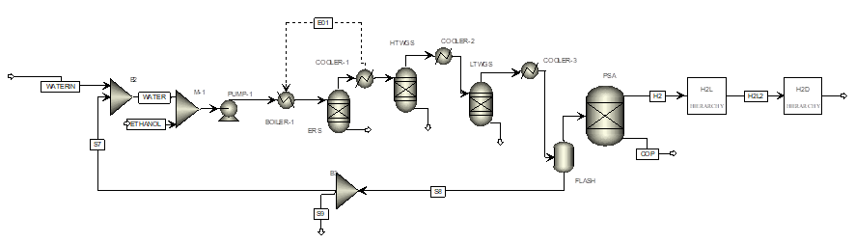
a.
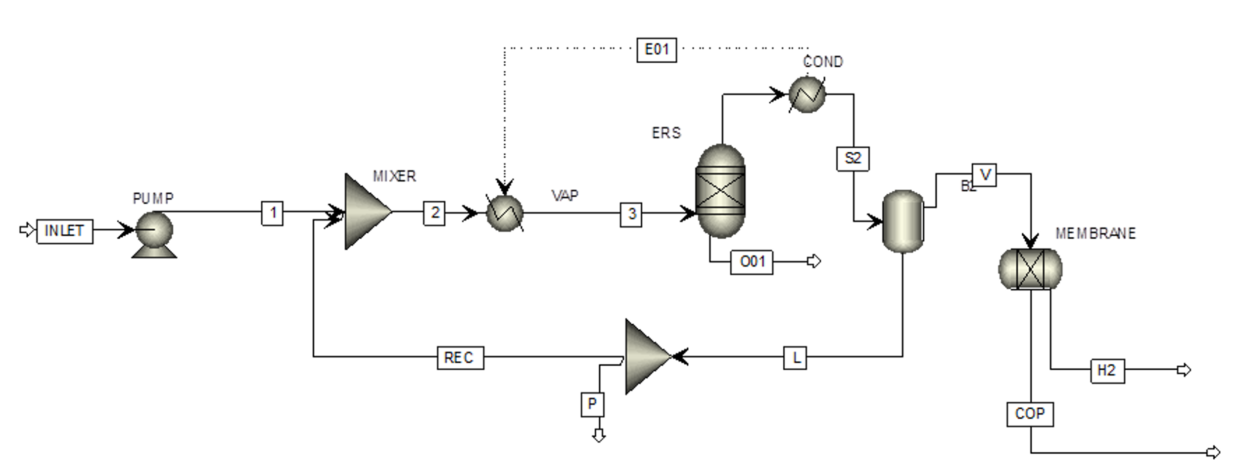
b.
Figure 1: Simulation process scheme a. onsite hydrogen production; b. onboard hydrogen production
    - Energy Analysis
A general energy balance was carried out, considering the energy demand of each operation. The energy demands in each production unit, compression and delivery, and distribution for both processes were compared, as well as the feed and product streams at each stage.
    - Economic Analysis
The aim of the economic study is to compare the viability of the processes studied for the generation and distribution of hydrogen. Thus, the costs related to raw materials and the utilities used in the processes are considered.
  - Results and discussion
Centralized or onsite hydrogen production often involves large-scale processes that are energy intensive. On the other hand, onsite production provides an opportunity for economies of scale. Larger facilities usually can take advantage of more efficient processes, which results in lower energy consumption per unit of hydrogen produced. However, the efficiency gain is counterbalanced by the energy required for liquefaction and pressurization processes, as depicted in Figure 2.
The comparison of the energy efficiency of local and embargoed hydrogen production reveals that the latter offers significant advantages. Embargoed production obviates the need for compression processes, resulting in a lower energy demand of 2.36 kWh/kg H₂, compared to 12.9 kWh/kg H₂ for local production. This represents a tenfold increase in energy efficiency that significantly enhances the feasibility of hydrogen production. The results demonstrate the importance of considering the energy demands of different production methods and the need to prioritize the most energy-efficient options.

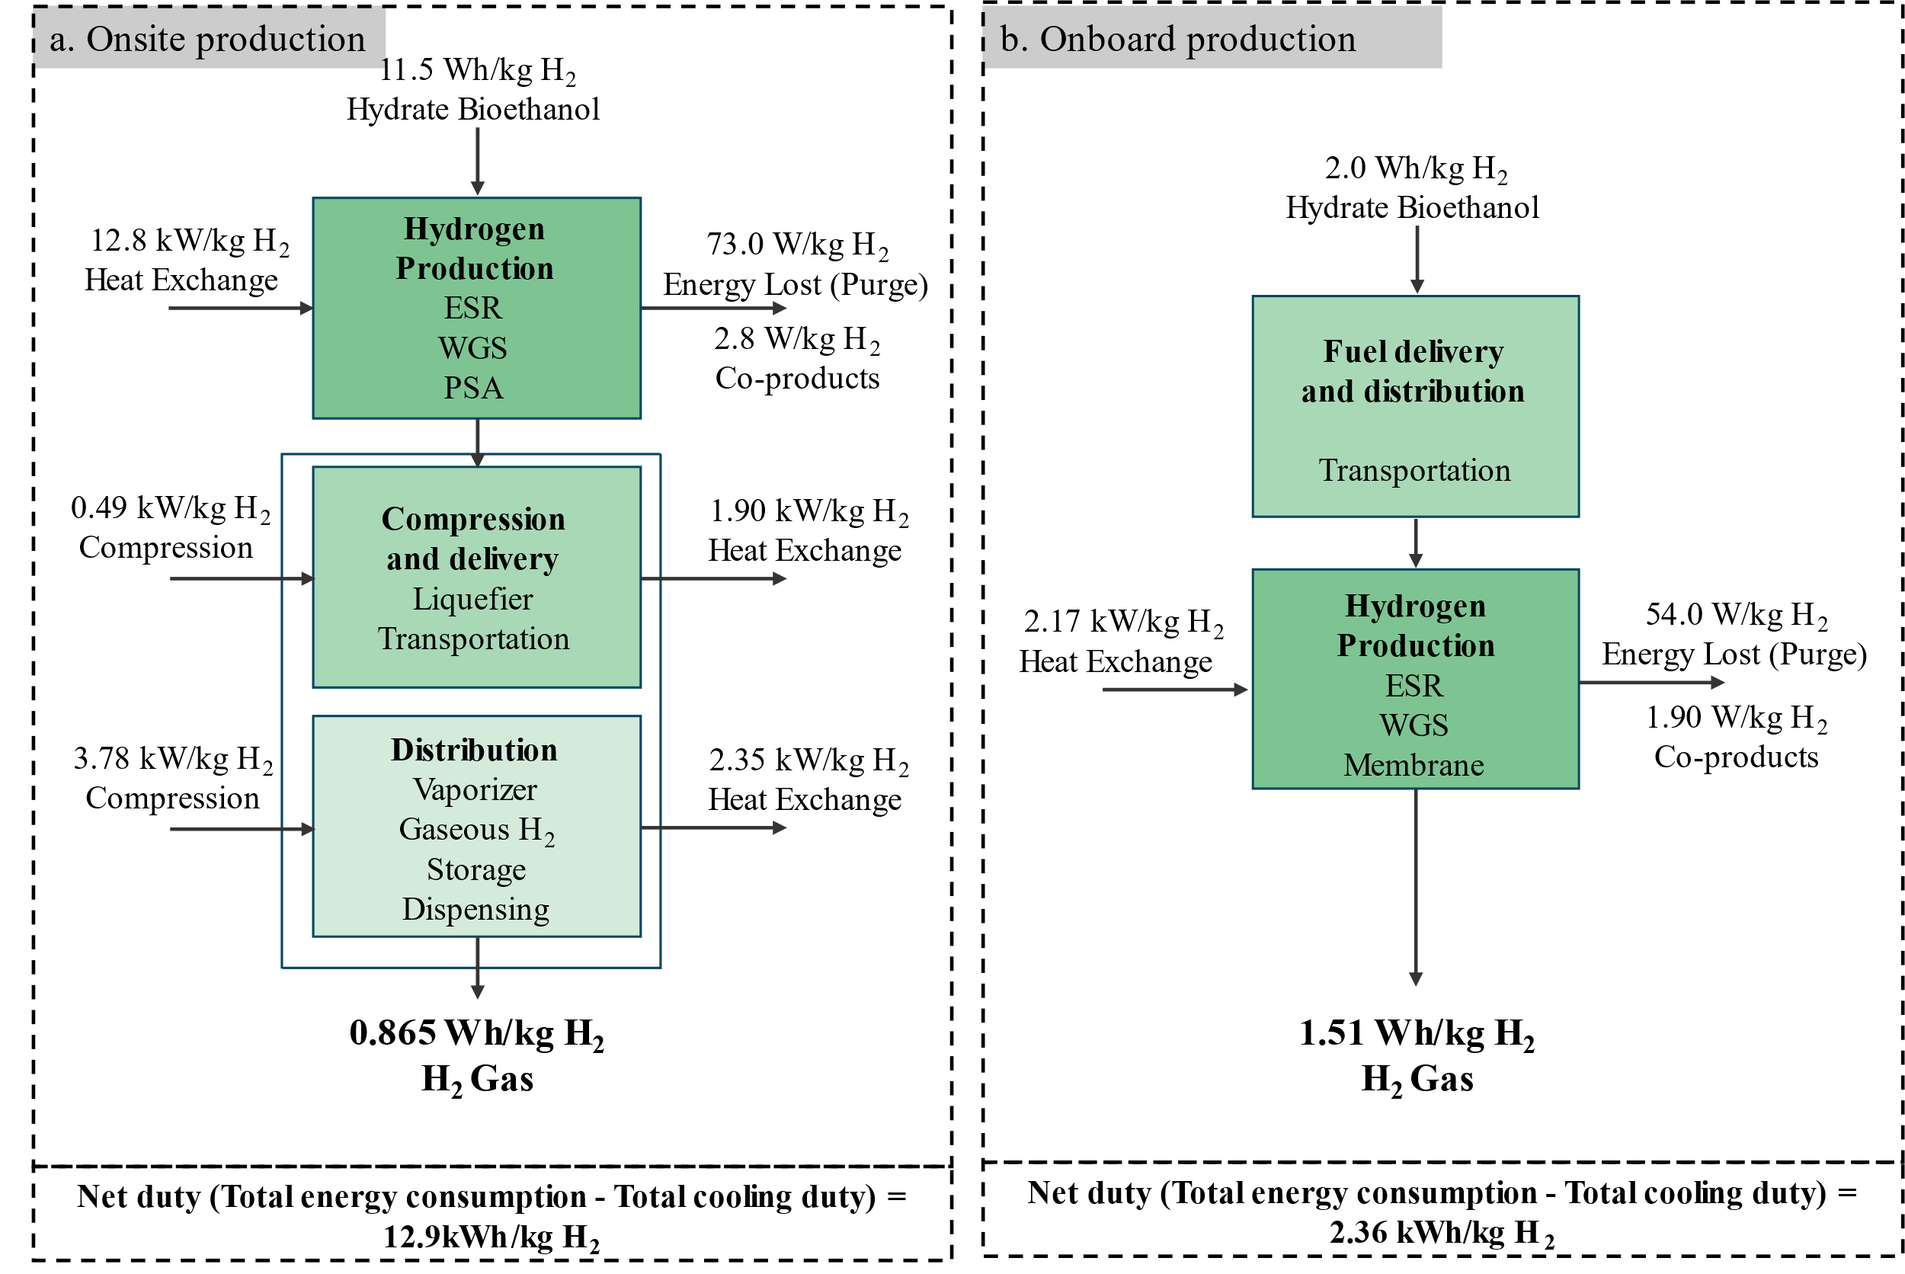
Figure 2: Energy balance resulting from a 6:1steam:ethanol ratio feed normalized by kg of H₂ produced a. onsite; b. onboard.
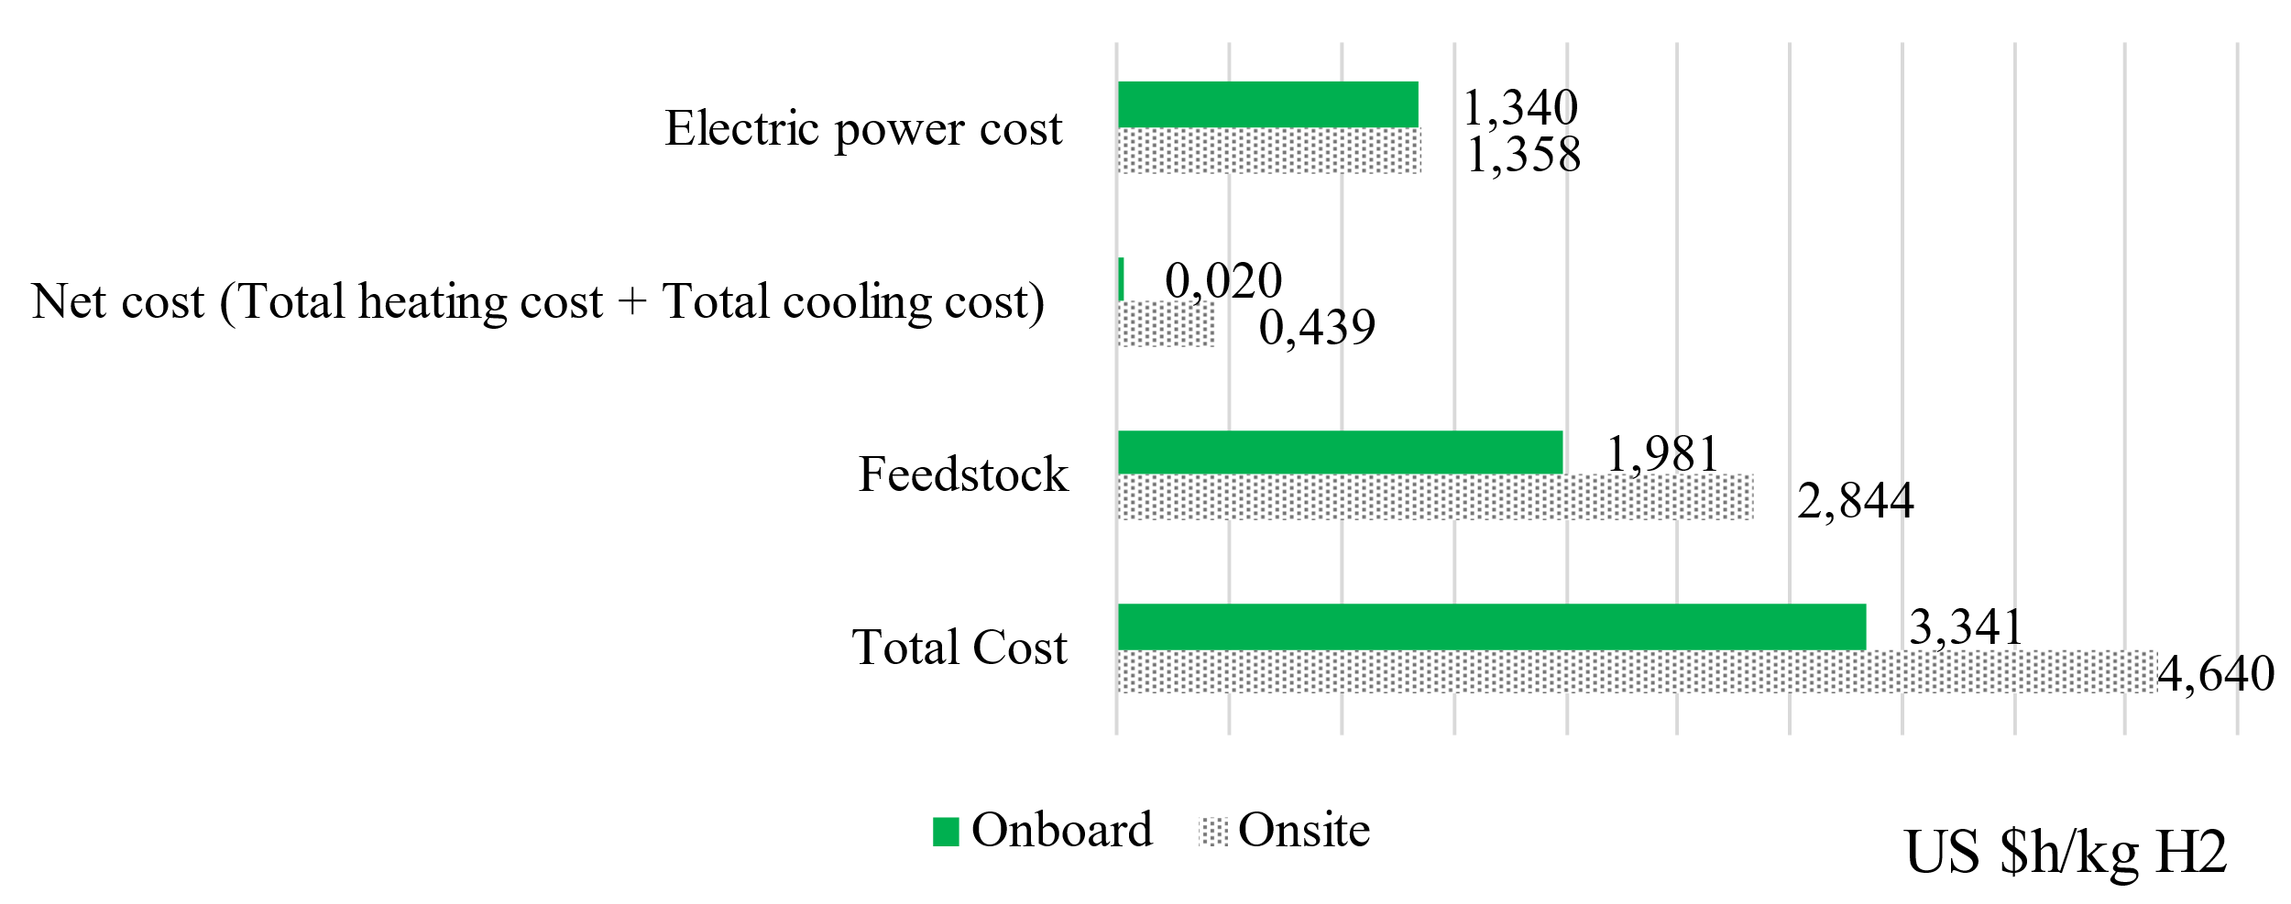
Figure 3: Cost comparison considering utility and feedstock cost.
When examining the costs associated with energy and raw materials, as shown in Figure 3, the process of onboard production holds an advantage as it reduces costs of utilities, and compression and liquefaction operations. Given the recent advances in purification systems for PEMFCs and the intensified processes of microreactors in onboard production, this process appears to be a promising alternative. This is particularly true in countries that have an established distribution and supply network and economy for the production and marketing of ethanol, such as Brazil. Onboard production's viability and competitiveness as an alternative solution depend on its cost-effectiveness compared to other alternatives.
  - Conclusions
Considering the hydrogen production and distribution chain, liquefaction, pressurization and cooling for hydrogen storage and transport are operations with a high energy cost and, consequently, a high associated economic cost. The high cost of infrastructure and maintenance to guarantee stations with large quantities of safely stored hydrogen is another problem that has been pointed out about high-pressure commercialization. Furthermore, with the development of technologies that address the challenges in terms of the capacity of the hydrogen produced onsite and its purity in the fuel cell feed, onboard production has become an even more attractive process. Concerning the environmental aspect, although centralized facilities can implement advanced carbon capture and emissions control technologies, reducing the environmental footprint of hydrogen production, when a renewable source such as ethanol is used, greenhouse gas emissions are reduced in both processes. In addition, the increased efficiency generated by onboard production, by reducing the energy losses associated with long-distance hydrogen distribution, has an impact on the overall balance. In general, both approaches depend on the context and objectives of hydrogen use, but by focusing the analysis on use in the transport sector in a country like Brazil, where there is already an infrastructure and logistics associated with the commercialization of ethanol as a fuel, onboard production stands out and proves to be viable in energy and economic terms.

Acknowledgments
The authors gratefully acknowledge the support from FAPESP (the Sao Paulo Research Foundation, Project Number 2022/10644-1, Grant Numbers 2021/08940-9 and 2023/14455-1).

References
H. T. Lu, W. Li, E. S. Miandoab, S. Kanehashi, G. Hu, 2021, The opportunity of membrane technology for hydrogen purification in the power to hydrogen (P2H) roadmap: a review. Front. Chem. Sci. Eng., 15, 464–482.
IEA, 2023, Global Hydrogen Review 2023, IEA, Paris https://www.iea.org/reports/global-hydrogen-review-2023, License: CC BY 4.0
M. Aziz, 2021, Liquid Hydrogen: A Review on Liquefaction, Storage, Transportation, and Safety, Energies, 14, 5917.
M. Compagnoni, E. Mostafavi, A. Tripodi, N. Mahinpey, I. Rossetti, 2017, Techno-economic analysis of a bioethanol to hydrogen centralized plant, Energy & Fuels, 31(11), 12988–12996.
M. Ruth, M. Laffen, TA.Timbario, 2009, Hydrogen Pathways: Cost, Well-to-Wheels Energy Use, and Emissions for the Current Technology Status of Seven Hydrogen Production, Delivery, and Distribution Scenarios. Springfield, VA: U.S. Department of Energy, 1–277.
S. M. M. Ehteshami, S.H. Chan, 2014, Techno-Economic Study of Hydrogen Production via Steam Reforming of Methanol, Ethanol, andDiesel, Energy Technology & Policy, 1(1), 15-22.
U.S. Department of Energy, Office of Fossil Energy, 2020, Hydrogen Strategy: Enabling a Low-Carbon Economy, DC 20585, 1-24.
Z. Du, C. Liu, J. Zhai, X. Guo, Y. Xiong, W. Su, G. He, 2021, A Review of Hydrogen Purification Technologies for Fuel Cell Vehicles. Catalysts, 11, 393.

