A Novel Optimisation Framework to Design Market-Based Policy Interventions for the Uptake of Alternative Fuels in the UK Chemical Industry
Gbemi Oluleye,^{a,b} Devan Patel,^{c} Pauline Matalon,ª Elisabeth Maya Rosaª
ªCentre for Environmental Policy, Imperial College London
^{b}Sargent Centre for Process Systems Engineering, Imperial College London
^{c}Department of Chemical Engineering, Imperial College London
o.oluleye@imperial.ac.uk
Abstract
Shifting to clean alternatives like biomethane, green hydrogen, and blue hydrogen for industrial heating offers emission reductions, yet their high costs hinder adoption. There is no systematic way to design policy interventions that enable cost reduction at minimum cost to government and industry. This study aims to formulate and apply a novel multi-period Mixed-Integer Market Penetration Optimization Model to fill this gap and inform decisions about transitioning to alternative fuels for heating in the UK Chemical Industry. The model cost-effectively designs a policy pathway whilst accounting for the fuel cost reduction due to demand-pull induced learning effects in the policy design. The model is applied to 490 boilers in the UK chemical industry, the model designs effective policy mixes to reduce the cost of green hydrogen by 60%, blue hydrogen by 36%, and green gas biomethane by 17%, with revenue from taxes supporting subsidies for cost neutrality.
Keywords: market penetration optimisation, clean innovation diffusion, fuel switching, industrial heat decarbonisation, market-based policy.
  - Background
In 2020, the chemical industry accounted for 2.3 Gt of GHG making up 6% of global emissions (IEA, 2021). Of this 86% emissions are from the combustion of fossil fuels to generate heat and power. The UK Chemical industry, consuming 26.3 TWh annually, heavily relies on natural gas for process heating. Shifting to clean alternatives like biomethane, green hydrogen, and blue hydrogen offers emission reductions, yet their high costs hinder adoption. Reducing emissions in the chemical industry is crucial because it is closely interconnected with other societal and technical systems. High mitigation cost associated with alternative fuels has become the biggest challenge for transition (Chung et al., 2023). Implementation of market-based policies can stimulate enough demand pull for the alternative fuel to bring about significant cost reduction. Previous studies focus on the technical feasibility of switching to alternative fuels (Griffin et al., 2018), investigating the emissions and performance of combusting alternative fuels (Cellek and Pinarbasi, 2018) and the possibility of repurposing natural gas infrastructure for alternative fuels (Efthymiadou et al., 2023 and Mertins et al., 2023). Techno-economic assessments (TEAs) have been applied to evaluate the economic impact of fuel switching in the chemical industry with majority of them concluding with the need for policies to make it cost-effective (Hong et al., 2023 and Luh et al., 2018). There is a pressing need to further design market-based policy interventions (consisting of taxes and subsidies). Policies for net-zero in industry have been explored (Chung et al., 2023). However, existing literature on policy primarily focuses on the qualitative aspects and overlook using the quantitative impact on cost reductions from demand pull created to design policy support. No existing study has shown how policy induced cost parity between the heat produced from the alternative fuel and the incumbent can translate into fuel cost reduction for the rest of the economy. This study builds on the Market Potential Assessment concept in Oluleye et al., 2021 and integrates the complexities of time and the interplay of different policies. The novel temporal market penetration optimisation model is a systematic approach to design and assess interventions for fuel switching to biomethane, blue hydrogen and green hydrogen in the UK chemical industry by harnessing the power of learning and leveraging diffusion theory.
  - Methodology
A novel market penetration optimisation framework is developed based on the hypothesis that policy interventions are required to reduce cost and generate sufficient demand pull to achieve cost parity with end use of alternative fuels, and this can lead to reduction in primary fuel price for the entire economy. The problem is formulated as a multi-period mixed integer non-linear problem to determine the policy offering and associated timeline to achieve 100% switch for the three fuels given the end-use technologies and economic factors. The objective function minimises the cost difference between the alternative fuel (j) and the incumbent fuel (natural gas) – Eq.1. A binary variable x is introduced to determine boilers that form part of the market (demand pull) subject to achieving the constraint in Eq. 6. Two policy typologies are explored, a feed-in tariff (FiT) for every MWh of fuel consumed and a carbon tax on every tonne of CO₂ produced (Eq.6 – Eq.9). Eq.2 – Eq.5 estimates the various costs, Eq.10 estimates the new fuel price, and the cost to government and industry is determined using Eq.10 and Eq. 11. The description of all terms is provided in the nomenclature below.
${MC}_{t }= \sum_{i=1}^{495}{x_{i} }* ({ACOH}_{i,j,t} - {ACOH}_{i,natural gas, t})$ (1)
${ACOH}_{i,j,t }= {FC}_{i,j,t} + {VC}_{i,j, t} + {l_{i,j, t}*αCAPEX}_{i,j, t})$ (2)
$l_{i,j,t} = 1 for i= natural gas and 2030≤ t ≤2040$
$l_{i,j,t} = 0 for all other cases$
${CAPEX}_{i,j,t} = CAPEX * \frac{r_{j * }{{(1+r}_{j})}^{n_{j}}}{(1+{r_{j})}^{n_{j-1}}} ∀i, ∀j$ (3)
${VC}_{i,j,t}= c_{i,j,t} x {FP}_{i,j,t}$ (4)
${FC}_{i,j,t} = 0.02 * {αCAPEX}_{i,j,t}$ (5)
${ACOH}_{i,j,t} ≤{ACOH}_{i, natural gas,t}$ (6)
$ε_{i,j,t} = c_{i,j,t} * f_{j,t}$ (7)
${ACOH}_{i,j,t}= {FC}_{i,j, t}+ {VC}_{i,j,t} + {l_{i,j, t}*αCAPEX}_{i,j, t} + ε_{i,j,t} * γ_{t}$ (8)
${ACOH}_{i,j,t}= {FC}_{i,j, t}+c_{i,j,t} x {(FP}_{i,j,t} - τ_{j,t}) + {l_{i,j, t}*αCAPEX}_{i,j, t}$ (9)
${FP}_{i,j,t+1} = {FP}_{i,j,t} * {(\frac{Ο_{t}}{O_{t+1}})}^{LP}$ (10)
$G_{t} =\sum_{i=1}^{497}{x_{i}} * (τ_{t} ) - {(1-x}_{i}) * (Υ_{t} )$ (11)
$I_{t}={MC}_{t} - G_{t}$ (12)
The model was implemented in Python 3.11, Pyomo 6.5.0 and a third party extension Mindtpy MINLP problem solved with CPLEX 22.1.1.0 and IPOPT 3.14.9.

Nomenclature
$i$, boiler
$j$, alternative fuel
$t$, year
$υ$, Availability
$γ_{t}$, Carbon Tax
$c_{i}$, Consumption
$C_{i}$, Capacity
$M_{j}$, Energy Permit Trading
$O_{t}$, Capacity of Alternative Fuel in Year t
$O_{t+1}$, Capacity of Alternative Fuel in Year t+1
$η_{i}$, Efficiency

$ε_{i}$, Emission
$f_{i}$, Emission Factor
$E_{i}$, Energy
${FC}_{i}$, Fixed Cost
$τ_{t}$, Feed-In Tariff
${FP}_{i}$, Fuel Price
$G_{t}$, Government Cost
$I_{t}$, Industry Cost
$l_{i}$, Status of boiler
${VC}_{i}$, Variable Cost
ACOH, Annualised Cost of Heat
CAPEX, Capital Expenditure
LP, Learning Parameter
MC, Mitigation Cost

  - Case Study: Fuel Switching to Green Hydrogen, Blue Hydrogen, and Biomethane for Heat Decarbonisation
The market considered is the existing gas boiler population of the UK chemical industry totalling to 490 natural gas boilers consuming 9.6 TWh per year (Table 1).

Table 1. Number of equivalent boilers per cluster
Clusters (Boiler size) | 1MW | 5MW | 9MW | 15MW | 30MW | 60MW
Number of boilers | 117 | 270 | 44 | 21 | 12 | 26
Policies explored are the carbon tax and an incentive per MWh fuel consumed (feed-in tariff). Assumption on all fuels is provided in Table 2. The fuel prices in Table 2 is without government support.

Table 2. Clean Fuel Assumptions
Item | Natural gas | Green Hydrogen | Blue Hydrogen | Biomethane
Discount rate (%) | 3.5 | 3.5 | 3.5 | 3.5
Lifetime | 30 | 25 | 25 | 30
Efficiency (%) | 90 | 95 | 95 | 90
Capital cost (£/MW) | 166,000 | 199,000 | 199,000 | 166,000
Fuel price (£/MWh) | 31.96 | 110-187.5 | 68.8-84 | 57.44-90
Emission factor (tCO₂/MWh) | 0.184 | 0.02 | 0.06 | 0.0138
Learning rate (%) | - | 19% | 7% | 5%
  - Main Findings
The output of the model is represented in Fig. 1 to Fig. 4. Without policy support end-use heating cost parity between natural gas and the alternative fuels is not achievable. With the optimally designed carbon tax and FiT 100% uptake of alternative fuels for heating is possible in 10 years. The highest mitigation cost is from the sole use of the carbon tax, and industry bears the burden (Fig.1 a – c). The tax would need to be as high as 615 £/t to achieve a 1% green hydrogen uptake in 2024 reducing to 55 $/t with 100% uptake (Fig. 1a). The value of the carbon tax for blue hydrogen and biomethane is lower due to lower fuel costs (Table 1), however green hydrogen requires the lowest tax at 100% uptake due to the having the highest reduction in cost due to demand pull (evidence with the highest learning rate in Table 2). Implementing an incentive like the FiT means government alone bears the burden (Fig. 2). Incentivizing blue hydrogen has the lowest mitigation cost (Fig.2 b), and biomethane has the highest mitigation cost (Fig. 2c).
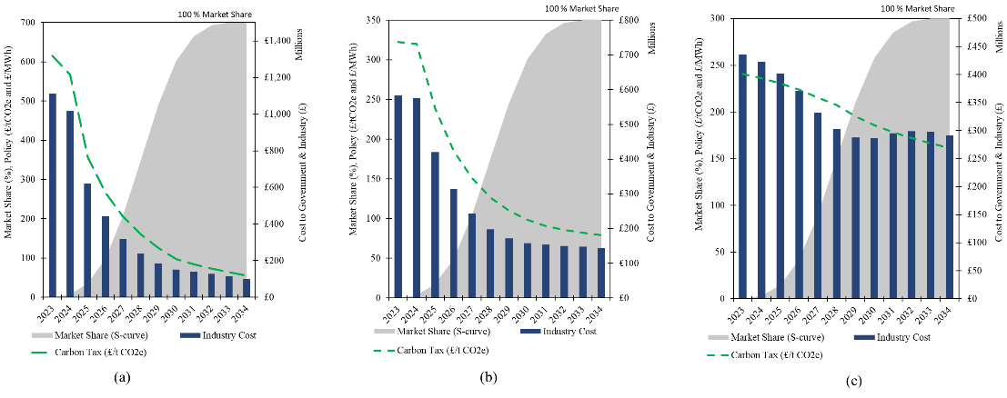
Figure 1 Designed carbon tax and associated mitigation cost to achieve fuel switching to (a) green hydrogen, (b) blue hydrogen and (c) biomethane

The minimum mitigation cost overall (94% reduction compared to single use of a carbon tax) is for a case where a mix of the FiT and carbon tax is applied to achieve end-use heating cost parity; in this case revenue from taxes is used to fund the FiT ensuring cost neutrality for government (Fig. 3). In this case, the maximum carbon tax required is 15 $/t for green hydrogen (Fig. 3a), 9 $/t for blue hydrogen (Fig. 3b) and 19 $/t for biomethane (Fig. 2c).
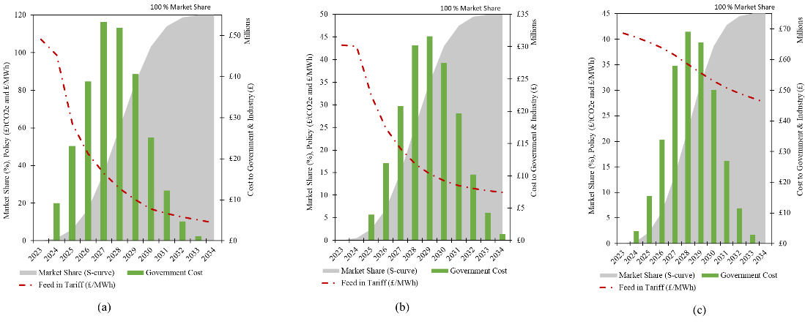
Figure 2 Designed feed in tariff and associated mitigation cost to achieve fuel switching to (a) green hydrogen, (b) blue hydrogen and (c) biomethane
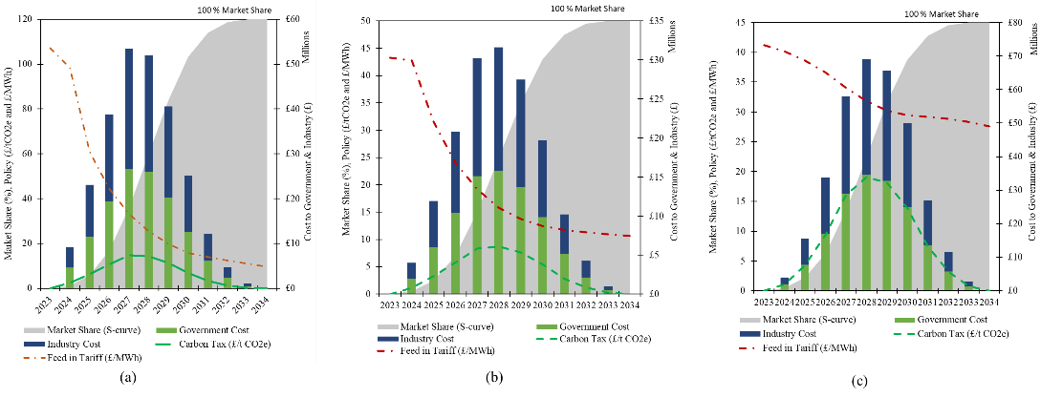
Figure 3 Optimal policy mix and associated mitigation cost to achieve fuel switching to (a) green hydrogen, (b) blue hydrogen and (c) biomethane

The impact of designing policies to achieve end-use heating cost parity for all fuels (subject to Eq. 6) is a positive spillover effect on primary fuel cost reduction for the rest of the economy (Fig. 4).
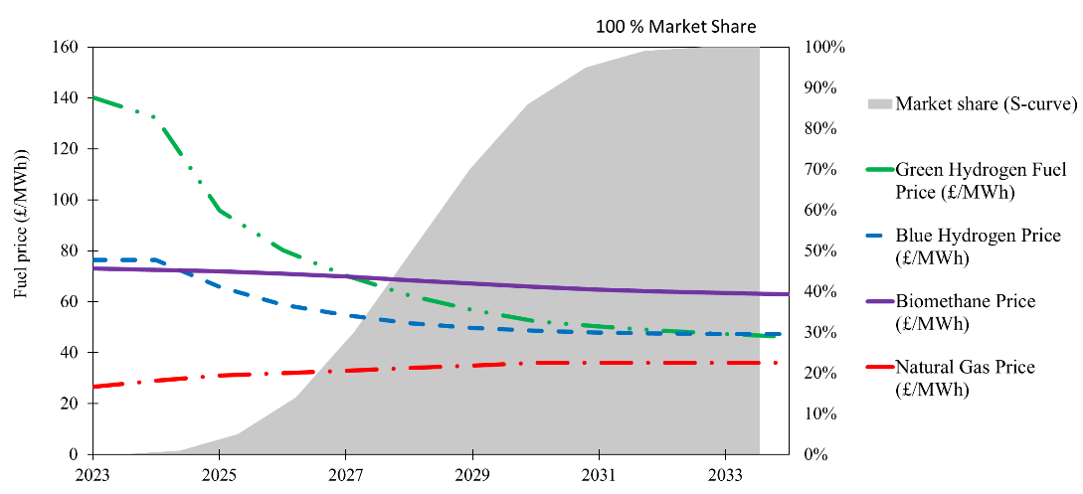
Figure 4 The impact of end-use ‘heat’ cost parity on the fuel cost

  - Conclusions and Future Work
As the shift towards alternative fuels for heating gains momentum, the importance of optimisation-based market penetration models in shaping their policy induced adoption becomes increasingly pivotal. This study has provided valuable insights into the design and effectiveness of policy interventions in promoting the uptake of alternative fuels in the UK's chemical sector. Results confirm that a mix of market-based policies (incentives and taxes) is required to achieve end-use heating cost parity at minimum mitigation cost spilling over to reducing the prices of the alternative fuels. Cost reduction is strongly related to learning effects which differ for the three alternative fuels studied. Blue hydrogen and biomethane offer minor cost reduction compared to green hydrogen. Subsequently, other economy sectors can benefit from cost reduction of the fuels to efficiently transition towards carbon neutral by 2050. These findings provide optimal policies and timelines to drive fuel switching, forming a basis for crucial discussions among academia, the chemical industry, and the government. For further work, the model's robustness could be enhanced by incorporating uncertainties across all parameters, resulting in designing policy packages immune to uncertainty.
References
M. S. Cellek, and A. Pınarbaşı, 2018, Investigations on performance and emission characteristics of an industrial low swirl burner while burning natural gas, methane, hydrogen-enriched natural gas and hydrogen as fuels, International Journal of Hydrogen Energy,. 43 (2), 1194-1207.
C. Chung, J. Kim, B. K. Sovacool, S. Griffiths, M. Bazilian, and M. Yang, 2023, Decarbonizing
the chemical industry: A systematic review of sociotechnical systems, technological innovations,
and policy options. Energy Research & Social Science. 96 102955. 10.1016/j.erss.2023.102955.
E. M. Efthymiadou, V. M. Charitopoulos, L. G. Papageorgiou, 2023, Hydrogen infrastructure
planning for heat decarbonisation in Great Britain, Editor(s): Antonios C. Kokossis, Michael C.
Georgiadis, Efstratios Pistikopoulos, Computer Aided Chemical Engineering, 52, 3025-3030
P. W. Griffin, G. P. Hammond, and J. B. Norman, 2018, Industrial energy use and
carbon emissions reduction in the chemical sector: A UK perspective. Applied Energy.
227 587-602. 10.1016/j.apenergy.2017.08.010.
X. Hong, Z. Liao, Y. Yang, J. Wang, Y. Yang, 2023, Techno-enviro-economic analysis of H2
economy in China from H2 production to utilization, Editor(s): Antonios C. Kokossis, Michael C.
Georgiadis, Efstratios Pistikopoulos, Computer Aided Chemical Engineering, 52, 2959-2964
International Energy Agency (IEA), 2021, Net Zero by 2050 - A Roadmap for the Global Energy
Sector. https://iea.blob.core.windows.net/assets/deebef5d-0c34-4539-9d0c-
10b13d840027/NetZeroby2050-ARoadmapfortheGlobalEnergySector_CORR.pdf accessed 06/09/2023
S. Luh, S. Budinis, T. J. Schmidt, A. Hawkes, 2018, Decarbonisation of the Industrial Sector by
means of Fuel Switching, Electrification and CCS, Editor(s): Anton Friedl, Jiří J. Klemeš, Stefan Radl, Petar S. Varbanov, Thomas Wallek, Computer Aided Chemical Engineering, 43, 1311-1316
A. Mertins, M. Heiker, S. Rosenberger, and T. Wawer, 2023, Competition in the conversion of the gas grid: Is the future of biogas biomethane or hydrogen? International Journal of Hydrogen Energy. 10.1016/j.ijhydene.2023.04.270.
G. Oluleye, M. Gandiglio, M. Santarelli, A. Hawkes 2021, Pathways to commercialisation of biogas fuelled solid oxide fuel cells in European wastewater treatment plants, Applied Energy, 282, 116127

