Enhancing superstructure optimization via embedded neural networks in optimal process design for sustainable aviation fuel (SAF) production
Alexander Klimekª, Caroline Ganzerª, Kai Sundmacher^{a, b, *}
ªMax Planck Institute for Dynamics of Complex Technical Systems, Department of Process Systems Engineering, Sandtorstr. 1, 39106 Magdeburg, Germany
^{b}Otto von Guericke University, Chair for Process Systems Engineering, Universitätsplatz 2, 39106 Magdeburg, Germany
*sundmacher@mpi-magdeburg.mpg.de
Abstract
Superstructure optimization is suitable for identifying optimal raw materials and process pathways for the production of sustainable aviation fuels (SAFs). Mass and energy balances for the individual processes of the superstructure network are often represented by linear input-output relationships between the feedstocks and products, neglecting nonlinear effects. By embedding surrogates in the form of artificial neural networks (ANNs) within our optimization framework, we achieve a more detailed representation of individual processes. Combined with an adjusted superstructure optimization formulation explicitly including mixtures, we are able to determine not only the optimal process routes but also optimal process parameters (e.g., temperature, pressure) as well as the optimal aviation fuel composition.

Keywords: Sustainable Aviation Fuel, Superstructure Optimization, Surrogate Modeling, Artificial Neural Networks.
  - Introduction
In 2019, the aviation sector emitted over 900 million tons of $\text{C}{\text{O}}_{\text{2}}$-eq, contributing around 10-% of transportation-related greenhouse gases (Vardon et al., 2022). Consequently, the global goal of achieving net zero emissions by 2050 necessitates the defossilization of air transport. Whilst ${\text{H}}_{\text{2}}$-powered and battery-driven aircrafts may present viable options at small scale and for niche applications, it is expected that long-chain liquid SAFs are crucial at large scale (Freire Ordóñez et al., 2022). Identifying economically viable SAF
production pathways in which carbon, hydrogen, oxygen, heat, and electricity are sourced and managed to meet environmental requirements, presents a challenge to the engineering community. Potential system configurations are numerous and difficult to investigate. Various alternatives, such as biomass pathways or captured $\text{C}{\text{O}}_{\text{2}}$ combined with water electrolysis for syngas production, as well as methanol or Fischer-Tropsch (FT) liquids as intermediates, are possible options and need to be compared systematically.
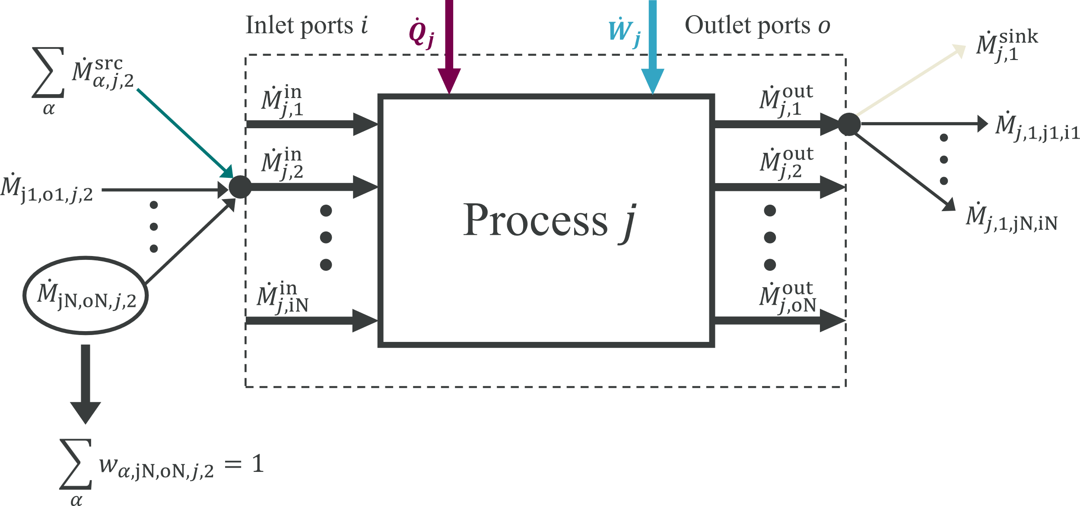
Figure 1: General process representation within superstructure to optimize total mass flows $\dot{M}$ as well as component mass fractions $w_{α}$.

  - Superstructure optimization approach
Superstructure optimization is frequently employed to determine optimal designs of complex process networks. For this reason, we have set up a SAF production superstructure that includes processes such as biomass gasification, direct air capture (DAC), various electrolysis technologies, autothermal reforming of methane, a reverse water-gas shift process, an acid gas removal plant, $\text{C}{\text{O}}_{\text{2}}$ sequestration, a Fischer-Tropsch process and processes for the production of long-chain hydrocarbons based on methanol. A common problem with conventional superstructure optimization formulations is that they typically consider only pure components (Gonzalez-Garay et al., 2022). Since aviation fuels are mixtures of hydrocarbons, we have developed an adapted formulation that allows mixture compositions to be represented and optimized.
In order to optimize mixture compositions, we model all processes within the SAF superstructure by the general process representation shown in Figure 1. A general process $j$ is modeled as a black box, which can have several inlet ports $i$ and several outlet ports $o$, allowing operations such as mixing and separating to be included directly. Through the corresponding ports, total mass flows $\dot{M}$ can enter or leave the process $j$, whereby mass conservation is always satisfied. Total mass flows between the outlet and inlet ports of the various alternatives within the superstructure are used to interconnect all individual processes (e.g., ${\dot{M}}_{j1,o1,j,2}$). In addition, mass flows can enter the process from outside or leave the process across the system boundaries, which is modeled accordingly by ${\dot{M}}^{src}$ and ${\dot{M}}^{sink}$. $\dot{Q}$ and $\dot{W}$ describe heat and work (electricity) flows that either leave or enter process $j$ depending on their sign. By adding decision variables for mass fractions $w_{α}$ for all system components $α$ in each mass flow, component mixtures can be modeled. Partial mass balances of the form
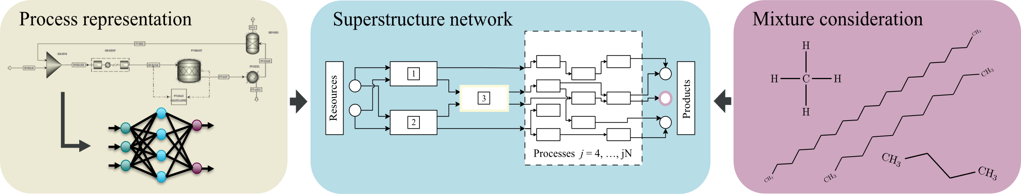
Figure 2: General illustration of the applied methodology, extending superstructure optimization by embedded neural networks and mixture modeling.
$$w_{α,(j,i)}^{in}{\dot{M}}_{(j,i)}^{in}=\sum_{\left(\tilde{j},o\right):(\tilde{j},o,j,i)}{w_{α,(\tilde{j},o,j,i)}{\dot{M}}_{(\tilde{j},o,j,i)}+\sum_{α}{{\dot{M}}_{α,(j,i)}^{src} ∀\left(j,i\right)}},α,$$ | (1)
$$w_{α,(j,o)}^{out}{\dot{M}}_{(j,o)}^{out}=\sum_{\left(\tilde{j},i\right):(j,o,\tilde{j},i)}{w_{α,(j,o,\tilde{j},i)}{\dot{M}}_{(j,o,\tilde{j},i)}+w_{α,(j,o)}^{sink}{\dot{M}}_{(j,o)}^{sink}} ∀(j,o),α,$$ | (2)
are introduced as equality constraints in the optimization problem in order to describe the connection between the total mass flows and their composition. This formulation allows to consider sustainable aviation fuels composed of hydrocarbons of different chain length and structure. It comes at the expense of quadratic terms in the constraints of the superstructure optimization problem. Together with binary variables for discrete decisions on the installation of processes within the superstructure, the product of mass fraction and mass flow leads to a mixed-integer quadratically constrained programming (MIQCP) formulation. It can be solved to global optimality using state-of-the-art solvers such as Gurobi (Gurobi Optimization, 2023).
  - Artificial neural networks as process surrogates
Another simplification often made in superstructure optimization is that chemical conversions are modeled by linear relationships between raw materials and products, neglecting real non-linear effects. Within such a framework, the operating conditions including temperature, pressure, and conversion of the processes encompassed by the superstructure are fixed in advance and thus cannot be simultaneously optimized (Demirhan et al., 2021; Gonzalez-Garay et al., 2022; Niziolek et al., 2017).
This work enhances traditional superstructure optimization by embedding surrogate models in the form of ANNs into the optimization formulation (Fahmi and Cremaschi, 2012; Henao and Maravelias, 2011). As shown in Figure 2, these ANNs are trained on data generated from Aspen Plus® simulations, correlating component outlet concentrations, electricity, and heat requirements with total mass inflow, inlet concentrations, and reaction conditions of individual processes (Aspen Technology Inc, 2023). For the integration of ANNs, we leverage the Python package OMLT, which facilitates the embedding of machine learning surrogates into Pyomo-implemented optimization problems (Bynum et al., 2021; Ceccon et al., 2022). The main advantage of this approach is that the input-output relationships of the ANNs can be represented as mixed-integer linear constraints through the use of ReLU activation functions, allowing the solution of highly nonlinear mass and energy balances while maintaining an MIQCP formulation (Grimstad and Andersson, 2019).
$$T^{*}=235.7 °C$$
$$p^{*}=37.6 bar$$
$$H_{2}:{CO}^{*}=1.73$$
$$T^{*}=226.2 °C$$
$$p^{*}=55 bar$$
$$H_{2}:{CO}^{*}=1.73$$
$$T^{*}=300 °C$$
$$p^{*}=30 bar$$
$$H_{2}:CO^{*}=3.31$$
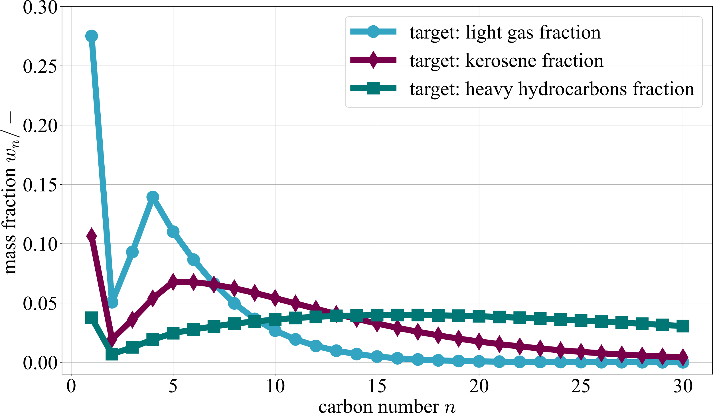
Figure 3: Optimized Anderson-Schulz-Flory (ASF) distribution for ${\text{C}}_{\text{1}}$-${\text{C}}_{\text{30}}$ n-alkanes calculated via ReLU-ANN as output of the FT process depending on reaction temperature, pressure and syngas composition within the superstructure optimization for different targeted hydrocarbon fractions.

For example, we have trained and embedded an ANN that predicts the relationship between reaction temperature, pressure, inlet syngas composition and the distribution of outlet mass fractions for n-alkanes from the FT process (Hamelinck et al., 2004). The FT-ANN, which consists of one hidden ReLU layer with 100 neurons in it, enables a very accurate representation of the outlet mass fraction distribution, but also of the work and heat requirements with an overall $R^{2}$ value of 0.99993. Within the superstructure optimization problem, the outlet concentrations of hydrocarbons of different chain lengths can then be calculated as
$w_{C_{11}H_{24},FT,1}^{out}=f_{FT}^{ANN}({{\dot{M}}_{FT,1}^{in},T}_{FT}, p_{FT}, w_{H_{2},FT,1}^{in})$, | (3)
where $w_{c_{11}H_{24}}$ exemplifies the mass fraction of n-undecane. Figure 3 illustrates the flexibility of our formulation. We can target the desired kerosene-hydrocarbon fraction in the FT output by optimizing within the constraints on required physical properties. Modeling the hydrocarbons of different chain length and structure as components $α$ of our superstructure provides more detailed information about the SAF composition depending on the selected process route and feedstocks.
  - Conclusions
Different feedstocks such as biomass, $\text{C}{\text{O}}_{\text{2}}$, air and water can be used to produce SAFs via different process routes (e.g., FT pathway, methanol pathway). In order to design optimal SAF production systems, we utilize superstructure optimization and overcome some of its classical simplifications. By incorporating decision variables for component concentrations in all network flows, the resulting process network designs yield mixtures of hydrocarbons which meet the stringent physical property requirements for SAFs in terms of specific energy, freezing point, viscosity, etc. Important processes are replaced by ANNs representing non-linear relationships between process parameters and inlet and outlet concentrations. As a result, we obtain Pareto-optimal process configurations that enable optimal SAF production with respect to competing objective functions, such as $\text{C}{\text{O}}_{\text{2}}$ emissions vs. cost. Our preliminary results indicate that the use of biomass-based routes provides the best trade-off between specific costs and $\text{C}{\text{O}}_{\text{2}}$ emissions. Under limited availability of biomass, syngas is additionally produced via electrolysis combined with DAC, leading to significantly higher specific aviation fuel costs with a similar $\text{C}{\text{O}}_{\text{2}}$ footprint.

References
Aspen Technology Inc (2023). Aspen Plus, https://www.aspentech.com/en/products/engineering/ aspen-plus. Accessed 30 November 2023.
Bynum, M. L., Hackebeil, G. A., Hart, W. E., Laird, C. D., Nicholson, B. L., Siirola, J. D., Watson, J.-P., and Woodruff, D. L. (2021). Pyomo - optimization modeling in Python, Cham: Springer.
Ceccon, F., Jalving, J., Haddad, J., Thebelt, A., Tsay, C., Laird, C. D., and Misener, R. (2022). “OMLT: Optimization & Machine Learning Toolkit,” Journal of Machine Learning Research. Volume 23, No. 349: pp. 1–8.
Demirhan, C. D., Tso, W. W., Powell, J. B., and Pistikopoulos, E. N. (2021). “A multi-scale energy systems engineering approach towards integrated multi-product network optimization,” Applied Energy. Vol. 281, p. 116020.
Fahmi, I., and Cremaschi, S. (2012). “Process synthesis of biodiesel production plant using artificial neural networks as the surrogate models,” Computers & Chemical Engineering. Vol. 46, pp. 105–123.
Freire Ordóñez, D., Halfdanarson, T., Ganzer, C., Shah, N., Dowell, N. M., and Guillén-Gosálbez, G. (2022). “Evaluation of the potential use of e-fuels in the European aviation sector: a comprehensive economic and environmental assessment including externalities,” Sustainable energy & fuels. Vol. 6, No. 20: pp. 4749–4764.
Gonzalez-Garay, A., Heuberger-Austin, C., Fu, X., Klokkenburg, M., Di Zhang, van der Made, A., and Shah, N. (2022). “Unravelling the potential of sustainable aviation fuels to decarbonise the aviation sector,” Energy & Environmental Science. Vol. 15, No. 8: pp. 3291–3309.
Grimstad, B., and Andersson, H. (2019). “ReLU networks as surrogate models in mixed-integer linear programs,” Computers & Chemical Engineering. Vol. 131, p. 106580.
Gurobi Optimization (2023). The Leader in Decision Intelligence Technology - Gurobi Optimization, https://www.gurobi.com/. Accessed 30 November 2023.
Hamelinck, C., Faaij, A., Uil, H. den, and Boerrigter, H. (2004). “Production of FT transportation fuels from biomass; technical options, process analysis and optimisation, and development potential,” Energy. Vol. 29, No. 11: pp. 1743–1771.
Henao, C. A., and Maravelias, C. T. (2011). “Surrogate-based superstructure optimization framework,” AIChE Journal. Vol. 57, No. 5: pp. 1216–1232.
Niziolek, A. M., Onel, O., and Floudas, C. A. (2017). “Municipal solid waste to liquid transportation fuels, olefins, and aromatics: Process synthesis and deterministic global optimization,” Computers & Chemical Engineering. Vol. 102, pp. 169–187.
Vardon, D. R., Sherbacow, B. J., Guan, K., Heyne, J. S., and Abdullah, Z. (2022). “Realizing “net-zero-carbon” sustainable aviation fuel,” Joule. Vol. 6, No. 1: pp. 16–21.

