The Role of Biomass in the Swiss Energy Transition: Low-Regret Strategies for an Uncertain Future
Gabriel Wiest,ª Gianfranco Guidati,^{b} Adriana Marcucci,^{b} André Bardowª and Stefano Moret^{a,}*
ªEnergy and Process Systems Engineering, Department of Mechanical and Process Engineering, ETH Zürich, Tannenstrasse 3, 8092 Zürich, Switzerland
^{b}Energy Science Center, ETH Zürich, Sonneggstrasse 28, 8006 Zürich, Switzerland
*morets@ethz.ch
Abstract
Biomass is a versatile resource and, thus, can support the net-zero energy transition in various sectors. However, the limited availability of biomass requires careful allocation and prioritization of its usage. Making good choices in energy system planning becomes challenging when considering future uncertainties. This study introduces a method that streamlines this decision process and identifies low-regret strategies for long-term energy system planning under uncertainty. We apply this approach to biomass usage in Switzerland’s energy system. Our analysis results in four potential biomass strategies. Evaluating the strategies in detail suggests that prioritizing biomass for fuel production reduces the expected regret while focusing on bio-methane production results in the lowest worst-case regret.
Keywords: strategic decision-making, energy systems, biomass, uncertainty, low-regret
  - Introduction
Biomass plays a central role in transitioning to net-zero energy systems, capturing CO₂ during growth and achieving negative emissions when combined with carbon capture and storage. Recent sector-specific studies identify biomass as a cost-effective and versatile resource to decarbonize heating and electricity supply (Ozolina et al., 2022), aviation (Bergero et al., 2023), or the production of chemicals (Meys et al., 2021). However, the limited availability of sustainable biomass prohibits simultaneously satisfying the demands across all these sectors.
Thus, deciding how to utilize the limited biomass resources in the energy system requires strategic prioritization. This decision must be made today to enable a rapid energy transition and mitigate the worst effects of climate change. This planning task relies on uncertain scenarios of future energy demands, fuel prices, and technology costs (Moret et al., 2017). As the optimal solution for one scenario may prove sub-optimal for another, the challenge lies in identifying strategies that yield minimal regret over the set of all possible realizations.
  - Method
The goal of our method is to identify strategies with minimal regret. In the first step, outputs of interest from the energy systems model, e.g., the installed capacity of technologies, are selected. Next, applying latin hypercube sampling (McKay et al., 1979) to the uncertain input parameters, we generate N different scenarios s ∈ Ω = {s₁, …, s_{N}}. Each scenario, corresponding to a different uncertain parameter sample, is then optimized in the energy system model. The potential solution space is obtained by computing the previously chosen outputs of interest. Using k-means clustering, this space is grouped into k clusters. Following the approach by Baader et al. (2023), a decision tree is trained on the outputs of interest to predict the corresponding cluster. The resulting leaves of the tree are denoted as strategies I = {1, …, k}. Ω_{i} is the subset of Ω for which strategy i is optimal.
Next, we calculate the regret for the scenarios where strategy i is not the optimal choice: Each scenario s ∈ Ω \ Ω_{i} is reoptimized while enforcing strategy i, resulting in the cost $C_{i,s}$. Taking the difference between the cost $C_{i,s}$ and the cost of the optimal strategy $C_{s}^{opt}$:
$R_{i, s}∶= C_{i,s}-C_{s}^{opt} ∀i$∈ I, $∀s$∈ Ω \ Ω_{i} | (1)
the regret $R_{i, s}$ of strategy i in scenario s is obtained. Note that, by construction, $R_{i, s}$ is always non-negative. Repeating this computation for all scenarios s ∈ Ω \ Ω_{i} results in a distribution of regrets for strategy i. Last, for each strategy, the mean and maximum of its regret distribution, together with the probability of regret $P^{regret}$, are computed.
  - Case study
We model the Swiss energy system using the open-source whole-energy system framework Energyscope (Limpens et al., 2019) and, for the first time, extend it to include all the possible biomass conversion pathways. Specifically, we consider four types of biomass resources: wood, animal manure, green waste, and fresh sewage sludge. On the demand side, we include the supply of residential and industrial heat, electricity, and mobility. In addition, we integrate the production, demand, and recycling of essential chemicals and plastics based on Meys et al. (2021).
The 27 technologies that use biomass as a resource are grouped by their products into eight categories: Low-temperature heat; high-temperature heat; combined heat and power; fuels; hydrogen; natural gas; charcoal; and chemical products.
The eight outputs of interest of our case study are defined as the amount of energy from biomass that flows into each one of the above categories.
To apply our method, we simulate N = 1000 different scenarios. We identify the required number of clusters k by applying the “elbow method” (Ketchen et al., 1996) concluding on using k = 4 clusters. This choice is in agreement with psychological studies suggesting that for maintaining interpretability and effective communication no more than three to five alternatives should be presented to decision-makers (Cowan, 2001).

  - Results
In all scenarios, we do not observe significant use of biomass (<1 GWh) for production of chemicals or low-temperature heat. Thus, both outputs of interest are discarded from further analysis. Based on the remaining six outputs of interest (energy flow of biomass into high-temperature heat; combined heat and power; fuels; hydrogen; natural gas; and charcoal), the decision tree is trained (Fig. 1) following the method by Baader et al. (2023). At each node of the tree, a radar plot indicates the level of flexibility with respect to each output of interest. Starting from the entire solution space at the top, including all N = 1000 scenarios and hence showing full flexibility across each output of interest, every decision on a given output of interest influences the potential of the remaining ones, thus constraining the solution space. For example, choosing a high use of biomass for fuel production significantly lowers the availability of biomass for all other usages except cogeneration of heat and power.
At the bottom of the tree, we end up with four leaves, which are cost-optimal strategies for biomass usage for different regions of the input space: Strategy 1 focuses on using the available biomass to produce bio-methane, Strategy 2 primarily produces hydrogen and high-temperature heat, Strategy 3 centers around generating biochar, and Strategy 4 focuses on using biomass to produce liquid fuels.

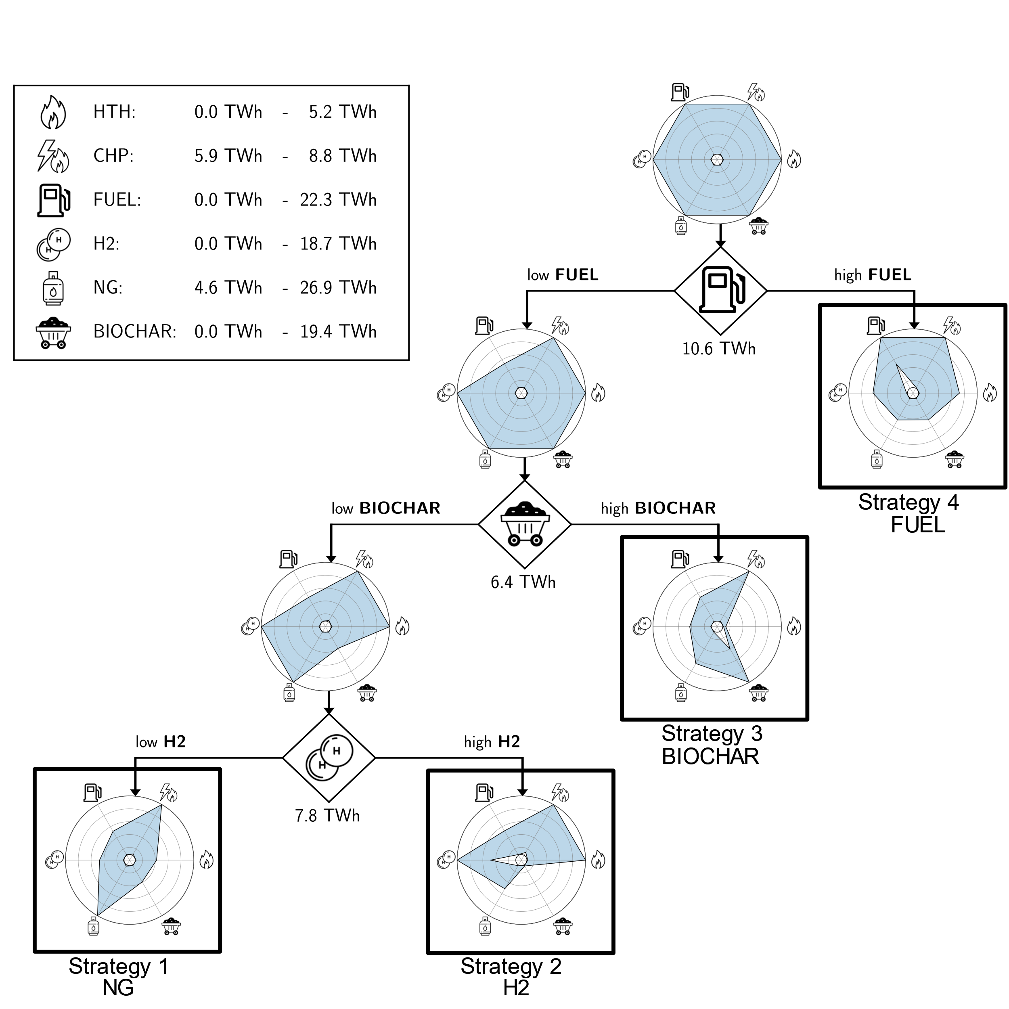
Figure 1: Decision tree on six of the outputs of interest: high-temperature heat (HTH), combined heat and power (CHP), diesel/kerosene (FUEL), hydrogen (H2), bio-methane (NG), and charcoal (BIOCHAR), identifying four potential strategies for the use of biomass in the Swiss energy system.
Only the use of biomass for combined heat and power is present in all strategies independently of the decisions. The reason is that, in all scenarios, the only energy flow into this category is given by all available manure being used in biogas motors. Thus, the energy flow into combined heat and power in our model solely depends on the amount of available manure.
In the next step, we enforce the strategies for the scenarios where they are not optimal and reoptimize the model. Using Eq. (1), the regret distributions for the four strategies are computed, and the results are summarized (Tab.1).
The regrets among the individual strategies differ considerably: The minimal expected regret $P^{regret}$ x $R^{mean}$ results from producing fuels (Strategy 4), followed by bio-methane (Strategy 1), hydrogen (Strategy 2), and biochar (Strategy 3). While Strategy 4 clearly stands out with respect to most metrics in Table 1, if the objective is to minimize the worst-case regret $R^{max}$, bio-methane and hydrogen are preferred over fuel production from biomass. Thus, there is not the one biomass strategy that performs best in all measures. Depending on whether the objective of the decision-maker is minimizing the expected or the worst-case regret, the preferred strategy differs. Furthermore, the sensitivity of the regret of a strategy with respect to the inputs, especially those controllable by the decision-maker, could give valuable insights for the decision process. By ensuring these inputs remain within certain limits potential worst-case scenarios could be avoided.
Table 1: Results from the regret analysis of the biomass strategies in units 10⁶ €. The lowest values of regret are highlighted in bold.
Regret | Strategy 1  Methane | Strategy 2  Hydrogen | Strategy 3  Biochar | Strategy 4 Fuel
$R_{i}^{mean}∶=\underset{s}{mean}\left(R_{i,s}\right)$ | 256 | 425 | 580 | 174
$$R_{i}^{max}∶=\max_{s}\left(R_{i,s}\right)$$ | 781 | 877 | 1,517 | 962
$P_{i}^{regret}∶=\frac{\#(Ω \backslash Ω_{i})}{\#Ω}$ in [%] | 90.5 | 91.1 | 85.5 | 32.9
$$P_{i}^{regret} x R_{i}^{mean}$$ | 232 | 387 | 496 | 57
  - Conclusions
Guiding the energy transition under uncertainty requires the synthesis of multiple plausible scenarios, which is challenging due to the volume and complexity of options resulting from uncertainty studies. Our replicable method streamlines the solution space of an optimization under uncertainty problem, highlighting the key strategies with their potential regret.
We identify four potential strategies for the usage of biomass in Switzerland that are optimal for different regions of the input space. Our analysis reveals that the strategy focusing on using biomass to produce fuels results in the lowest expected regret, while having a high production of bio-methane has the lowest worst-case regret.
Our approach of identifying potential strategies and quantifying their regrets can easily be generalized to other fields of energy system planning. It enhances the accessibility of uncertainty-related results for policymakers, thus encouraging informed decision-making.
Acknowledgment
G.W. and S.M. acknowledge support from the Swiss National Science Foundation under Grant No. PZ00P2_202117.
References
F. Baader, S. Moret, W. Wiesemann, I. Staffell, A. Bardow, 2023. Streamlining Energy Transition Scenarios to Key Policy Decisions. arXiv:2311.06625.
C. Bergero, G. Gosnell, D. Gielen, S. Kang, M. Bazilian, S. J. Davis, 2023. Pathways to net-zero emissions from aviation. Nature Sustainability 6, 404–414.
D. J. Ketchen, C. L. Shook, 1996. The Apllication of Cluster Analysis in Strategic Management Research: An Analysis and Critique. Strategic Management Journal 17(6), 441-45.
G. Limpens, S. Moret, H. Jeanmart, F. Maréchal, 2019. EnergyScope TD: A novel open-source model for regional energy systems. Applied Energy 255, 113729.
M. D. McKay, R. J. Beckman, W. J. Conover, 1979. A Comparison of Three Methods for Selecting Values of Input Variables in the Analysis of Output from a Computer Code. Technometrics 21(2), 239–245.
R. Meys, A. Kätelhön, M. Bachmann, B. Winter, C. Zibunas, S. Suh, A. Bardow, 2021. Achieving net-zero greenhouse gas emission plastics by a circular carbon economy. Science 374 (6563), 71–76.
S. Moret, V. C. Gironès, M. Bierlaire, F. Maréchal, 2017. Characterization of input uncertainties in strategic energy planning models, Applied Energy 202, 597-617.
S. A. Ozoliņa, I. Pakere, D. Jaunzems, A. Blumberga, A. Grāvelsiņš, D. Dubrovskis, S. Daģis, 2022. Can energy sector reach carbon neutrality with biomass limitations? Energy 249, 123797.

