Analysis of Calcium Citrate Salts as Raw Material for Tributyl Citrate Bio-Plasticizer Production: Kinetic Modeling, Process Simulation, and Optimization
Andres F. Cabeza^{a,b}, Alvaro Orjuela^{a*}, David E. Bernal Neira^{b,c,d}
a Universidad Nacional de Colombia, Department of Chemical and Environmental Engineering, Bogotá, Colombia
b Purdue University, Davidson School of Chemical Engineering, West Lafayette, IN, USA
c Universities Space Research Association, Research Institute of Advanced Computer Science, Mountain View, CA, USA
d Quantum Artificial Intelligence Lab., NASA Ames Research Center, Moffett Field, CA, USA
aorjuelal@unal.edu.co
Abstract
This work studied an alternative intensification approach for the downstream recovery of citric acid (CA) and its further transformation into tributyl citrate (TBC) bio-plasticizer. Avoiding several purification steps required to obtain citric acid, solid calcium citrate (CaCiH) was directly used in the production of the citrates. A set of experiments was conducted and proper kinetic modeling was derived for further process simulation. Three scenarios were evaluated in which the conventional TBC production process was compared to a novel simultaneous acidification-esterification process (SAE process). Based on the process simulation, the SAE process was optimized with respect to gross profits with FOQUS software, selecting the best conditions regarding temperature and Butanol (BuOH):CaCiH molar ratio in the SAE reaction stage. Also, a life cycle assessment (LCA) using OpenLCA was conducted to compare the optimal novel process and the current industrial approach for TBC production. Promising results were obtained since a ~ 25% increase in gross profit compared to the conventional process was achieved alongside a decrease of up to 31% in some environmental impact indicators.

Keywords: Esterification, solid-liquid reaction, Tributyl citrate, FOQUS, process intensification, process optimization
  - Introduction
The global plasticizer market keeps growing, driven by the increased use of plastic materials, mainly PVC. Phthalates, petroleum-derived phthalic acid esters, are the most common plasticizers (Godwin, 2017). However, due to their toxic nature and environmental persistence (Wang & Qian, 2021), they have been banned in various applications leading to the search for eco-friendly alternatives. Among such alternatives, citric acid esters, especially tributyl citrate (TBC), are considered viable substitutes for phthalates. However, TBC production is hindered by high costs due to energy-intensive processes and the need for highly purified raw materials. Citric acid (CA) is produced through aerobic fermentation of sugars and it is precipitated from the fermentation broth as calcium acid citrate (CaCiH) by neutralization with lime. This organic salt is filtrated, resuspended in clear water, and acidified with H₂SO₄ to release CA in a clean medium, with calcium sulfate as a by-product. The remaining CA is fed to highly energy-intensive refining stages (e.g., evaporation, crystallization) (Kristiansen et al., 1998). To avoid all these purification stages, an alternative process (SAE) is proposed in which insoluble CaCiH is used as raw material for direct TBC production. By resuspending it in butanol media instead of water, and with the addition of H₂SO₄, a solid-liquid reaction involving the acidification of the citrate salts enables the release of CA and its simultaneous multi-step esterification, yielding TBC and the intermediates, mono and dibutyl citrates (MBC, DBC respectively). As calcium sulfate forms, it precipitates from the reactive medium, simultaneously removing produced water by capturing it in the hydrated form (Figure 1). In order to assess the proposed process, experiments were conducted to determine the behavior of the reactive system and to obtain a kinetic model. This was used to simulate and optimize the proposed process alongside the industrial process used for TBC production (Osorio-Pascuas et al., 2015); (Fonseca et al., 2020). The optimization of the SAE process was achieved via FOQUS software (Papadopoulos & Seferlis, 2017), where a straightforward link between Python, Aspen Plus, and Excel files was performed.
  - Kinetic Modeling
The reactions were studied in two stages to decouple the mechanisms involved in the solid-liquid acidification-esterification in the production of butyl citrates. Initially, the kinetics of esterification between CA and BuOH using H₂SO₄ as a catalyst was evaluated. The effects of temperature, initial molar ratio, and catalyst loading were considered. Then, solid-liquid reaction experiments using CaCiH as raw material were accomplished. Based on the experimental observations, a combined kinetic model for the solid-solid-liquid media was proposed, and the kinetic parameters were regressed. Details of experiments and the proposed kinetic model were previously reported by the authors (Cabeza, 2023).
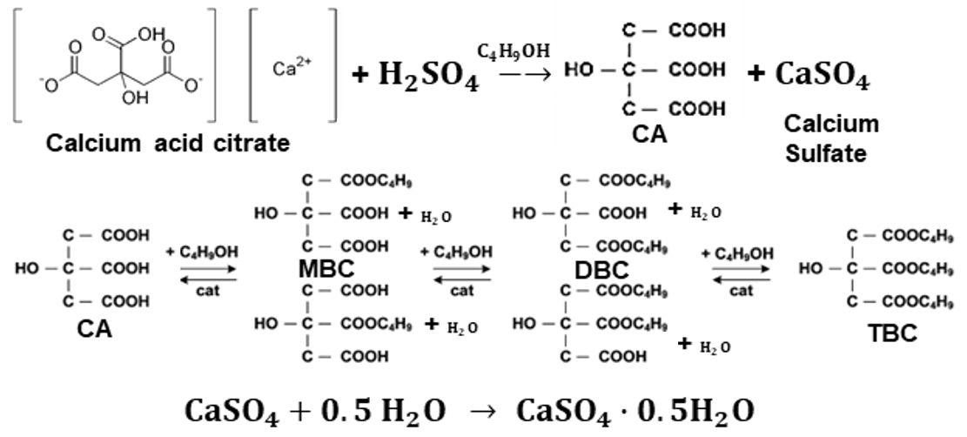
Figure 1: Reaction scheme during Simultaneous Acidification-Esterification

The concentration of involved species was represented in molality (mol compound i per kg of liquid). This representation avoids the uncertainties derived by the change in volume or temperature in the reactive medium along the simultaneous acidification-esterification, under batch operation. Then, change in molality can be described as follows:

$$\begin{aligned}\frac{dC_{i}}{dt}= \sum_{j=1}^{k}{θ_{i,j}r_{m,j}}+ \sum_{l=1}^{p}{θ_{i,p}r_{S,p}} j=\left\{1..3\right\} ,l=\left\{1,2\right\} \#\left(1\right)\end{aligned}$$

Here, index $j=\{1,2,3\}$ corresponds to each of the esterification reaction steps. $l=\{1,2\}$ corresponds to acidification and the calcium sulfate (CaSO₄) hydration reaction, respectively. This last reaction is only dependent on the presence of water. For the remaining rate expressions, in which an Arrhenius-type dependence with temperature is assumed ($k_{cat,j}={C_{cat}k}_{0cat,j}\exp\left({E{a_{cat}}_{j}}/{RT}\right)$), can be expressed as follows:

$$\begin{aligned}r_{m,1}=k_{cat,1}\left(C_{AC}C_{BuOH}-\frac{C_{MBC} C_{H_{2}O}}{K_{EQ,1}}\right)\# \left(2\right)\end{aligned}$$ | $$\begin{aligned}r_{m,2}=k_{cat,2}\left(C_{MBC}C_{BuOH}-\frac{C_{DBC} C_{H_{2}O}}{K_{EQ,2}}\right)\#\left(3\right)\end{aligned}$$
$$\begin{aligned}r_{m,3}=k_{cat,3}\left(C_{DBC}C_{BuOH}-\frac{C_{TBC} C_{H_{2}O}}{K_{EQ,3}}\right)\#\left(4\right)\end{aligned}$$ | $$\begin{aligned}{{ r}_{S}=k}_{0s,1}{\exp\left(-\frac{Ea_{s}}{RT}\right)C_{CiCaH}C}_{H_{2}SO_{4}} \#\left(5\right)\end{aligned}$$
$$\begin{aligned}r_{S,2}=k_{S,2}C_{ACaSO_{4}}C_{H_{2}O}\#\left(6\right)\end{aligned}$$
The corresponding experimentally obtained kinetic parameters are listed in Table 1. For the esterification of citric species in the presence of methanesulfonic acid (MSA), the kinetic model and its parameters are taken from literature (Osorio-Pascuas et al., 2015).
Table 1: Kinetic parameter for the simultaneous acidification-esterification reaction (C.I.: Coinfidencence Interval)
Parameter | Units | Value | C.I |  | Parameter | Units | Value | C.I.
$$k_{0cat,1}$$ | kg²/ (mol·mol_{cat}·s) | 723800 | ±29852 |  | $$Ea_{cat,1}$$ | J/mol | 59459 | ±516
$$k_{0cat,2}$$ |  | 518700 | ±33541 |  | $$Ea_{cat,2}$$ |  | 60358 | ±1298
$$k_{0cat,3}$$ |  | 431020 | ±53585 |  | $$Ea_{cat,3}$$ |  | 62506 | ±1098
$$k_{0s,1}$$ | kg/ (mol·s) | 4907 | ±352 |  | $$Ea_{s}$$ |  | 32173 | ±4520
$$k_{s,2}$$ |  | 0.5605 | ±0.0974 |  | $$K_{EQ,2}$$ | - | 3.56 | -
$$K_{EQ,1}$$ | - | 8.68 | - |  | $$K_{EQ,3}$$ | - | 1.4 | -
Note. Equilibrium constants were obtained from the literature (Osorio-Pascuas et al., 2015).
  - Methodology
    - Process Simulation Considerations
The process to produce CA esters was modeled considering the stages involved in the typical industrial process (Kristiansen et al., 1998). After fermentation and precipitation of the citrate salt, CA is produced by acidification of CiCaH in aquesous solution and fed to purification stages (e.g., evaporation, crystallization, and drying). Part of the produced CA is then dissolved in BuOH for TBC production using MSA as catalyst (Osorio-Pascuas et al., 2015). In the case of the SAE process, it starts by splitting CaCiH into two streams. One part is transformed in CA and the rest is used in the direct acidification-esterification in alcoholic medium with H₂SO₄. Then, to ensure complete conversion to TBC, a further esterification step using MSA as a catalyst was conducted (Figure 2).

Figure 2: SAE process for the production of citric acid (CA) and TBC
Regarding the phase equilibria of the reactive mixture, these were described using the UNIQUAC equation with previously regressed and validated binary interaction parameters (Santaella et al., 2018, 2022). All process simulations were conducted in Aspen Plus® V12.1 using the corresponding RBatch and BatchSep modules for accurate modeling of batch and semi-batch units involved in the conventional and SAE processes.
    - Process Optimization
For process optimization, three scenarios were considered. Each scenario considers the simultaneous production of CA and TBC using fermentative-derivated CaCiH as raw material.
Scenario 1: A non-optimized conventional process for synthesizing tributyl citrate (TBC) is modeled based on industry data (Osorio-Pascuas, 2019)(Finseca et al, 2020). The model assumes a production capacity of 30,000 tons/year of anhydrous CA. About 95% of this CA is sold directly, while the rest is taken to an esterification reaction. Since each batch can process 8000 kg of CA, 180 batches/year can be performed.
Scenario 2: The novel SAE process is implemented in this scenario, considering that 5% of the total citric production plant goes to esterification in calcium citrate. Fixing BuOH loading, the calcium citrate amounts were varied between 8 and 16 BuOH: CaCiH. In this scenario, 180 batches/year are assumed.
Scenario 3: Similar to the second scenario, the SAE process performed the TBC production. As it will be related further in the document, up to 10 hours of savings in batch processing can be achieved in this scenario compared to Scenario 2. In this case, it was possible to perform 230 batches/year.

The optimization of the proposed scenarios was carried out by calculating the gross earnings profits (GEP) (Seider et al., 2017). The acidification-esterification reaction temperature in Kelvin ($T$) and BuOH:C aCiH initial molar relation ($Rmol$) were selected as decision variables for the optimization. The optimization problem was:

$$\begin{aligned}\begin{matrix}\min_{T,Rmol}{-GEP } \\ \begin{matrix}s.t. 313≤T≤353 \\ \begin{matrix}8≤Rmol≤16\end{matrix}\end{matrix}\end{matrix}\#\left(7\right) \end{aligned}$$

The optimization boundaries were chosen regarding the reaction conditions in which the acidification-esterification kinetic parameters were obtained (Cabeza, 2023). The SAE process scenario optimization was performed via the FOQUS (Framework for Optimization and Quantification of Uncertainty and Sensitivity) tool (Papadopoulos & Seferlis, 2017), allowing the link of different types of simulation and data analysis software. In this study, a link among Python (input pre-processing), Aspen Plus (Process simulation) and Excel (condensed production and capital costs) was used.
Scenarios 2 and 3 were optimized using the solver NLopt and its implementation of the Constrained Optimization via Linea Approximation (COBYLA) algorithm through the FOQUS software. A tolerance difference of the objective function between iterations of 1e-9 was used as the stop criteria. Also, the feasible region was screened using randomly generated data in the Uncertainty Module in FOQUS. This analysis helped to propose the initial point for the optimization.
      - LCA Analysis
For the comparative LCA analysis, OpenLCA software was used to establish the performance of the novel SAE processes with respect to the conventional process. Thus, a cradle-to-gate analysis was performed. Agribalyse_v301 was used for inventory, and the ReCiPe 2016 Midpoint (H) method was used for environmental assessment.
  - Results and discussion
  - Process Optimization
Optimization results are summarized in Table 2, and the optimization contour and pathway are shown in Figure 3. Although the contour plots are similar, small changes are visible. Yet, both scenarios implementing the SAE process improve GEP compared to the conventional process for TBC production (8.803 $MUSD/year). This can be attributed mainly to the reduction of up to 60% in heating energy cost demand per kg of produced TBC using the SAE process.

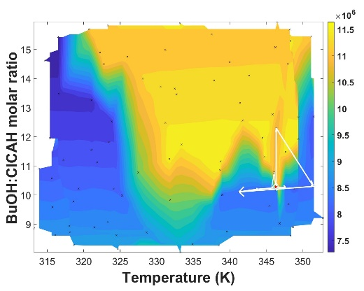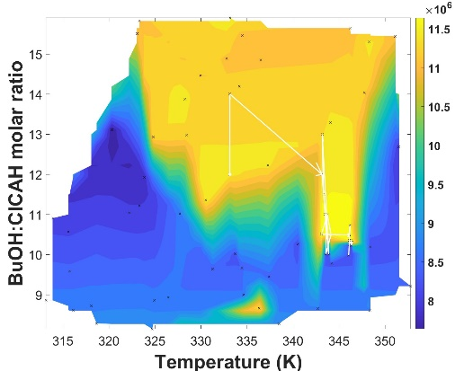
Figure 3: Contour plot and optimization path for the SAE process. Left: Scenario 2, right: Scenario 3. Levels are expressed in $USD/year

Table 2: Results of the optimization of SAE processes
Variable | Scenario 2 | Scenario 3
No. Batch/year | 180 | 230
No. Iterations | 20 | 71
Temperature [K] | 346.32 | 346.35
BuOH:CaCiH molar ratio | 10.29 | 10.29
GEP [$MUSD/year] | 11.150 | 11.775

  - LCA analysis
A comparative LCA analysis between the three scenarios was performed using OpenLCA. Both SAE processes show a reduction in the environmental impact indicators. The five most affected environmental parameters (figure 3) were reduced up to 10% and 30% with respect to the conventional TBC production process. It was also observed a reduction of up to 60% in steam consumption in the SAE processes in comparison with the traditional processes. This resulted in a reduction in 20% in the global warming impacts and and a 31% decrease in fossil resources usage.
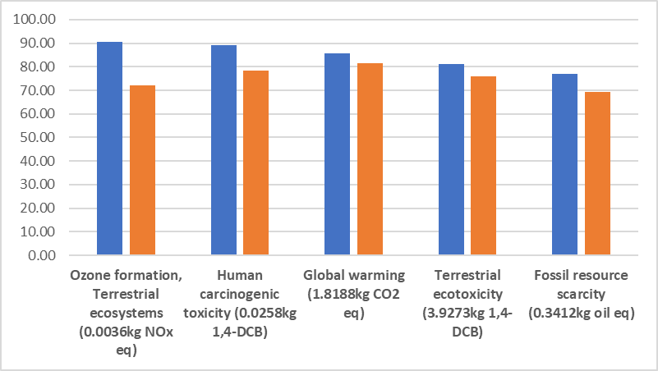
Figure 3: Percentage ratio of environmental impacts with respect to the conventional TBC production process. ■ Scheme 2, ■ Scheme 3
  - Conclusion
The production of TBC from calcium citrate via the novel SAE process was found to be technically feasible and more sustainbale than the conventional process. The optimized SAE process demonstrated significant potential to produce TBC more efficiently with an increase up to 25% in gross earning profits. Also, a relative mitigation in environmental impact indicators (10% to 31%) was achieved. Global warming indicators and Fossil resource scarcity could be reduced by 20% and 31%, which can be associated with a decrease in steam consumption (Up to 60% concerning conventional processes).
References
Cabeza, A. F. 2023. Synthesis of Bio-Plasticizers Derived from Citric Acid from Calcium Citrate (in Spanish). Master’s Dissertation. National University of Colombia.
Godwin, A. D. 2017. Plasticizers. Applied plastics engineering handbook. Elsevier.
Kristiansen, B., Linden, J., & Mattey, M. 1998. Citric acid biotechnology. CRC press.
Osorio-Pascuas, O. M. 2019. Production Of Triethyl Citrate And Tributyl Citrate From The Acid Esterification Of Citric Acid With Ethanol And 1-Butanol (in Spanish). Master’s Dissertation. National University of Colombia.
Fonseca, J. D., Latifi, A. M., Orjuela, A., Rodríguez, G., Gil, I. D. 2020. Modeling, analysis and multi-objective optimization of an industrial batch process for the production of tributyl citrate. Computers & Chemical Engineering 132, 106603
Osorio-Pascuas, O. M., Santaella, M. A., Rodriguez, G., & Orjuela, A. 2015. Esterification kinetics of tributyl citrate production using homogeneous and heterogeneous catalysts. Industrial & Engineering Chemistry Research, 54 (50), 12534–12542.
Papadopoulos, A. I., & Seferlis, P. 2017. Process systems and materials for CO2 capture: modeling, design, control and Integration. John Wiley & Sons.
Santaella, M. A., Suaza, A., Berdugo, C. E., Rivera, J. L., Orjuela, A. 2018. Phase Equilibrium Behavior in Mixtures Containing Tributyl Citrate, Citric Acid, Butan-1-ol, and Water. Journal of Chemical & Engineering Data 63 (9), 3252-3262
Santaella, M. A., Gutiérrez, M. F., & Orjuela, A. 2022. Tributyl citrate production via reactive distillation: Model reconciliation, optimization, scale up and sustainability indicators. Chemical Engineering Journal, 433, 133199.
Seider, W. D., Lewin, D. R., Seader, J. D., Widagdo, S., Gani, R.,Ng, K. M. 2017. Product and process design principles: synthesis, analysis, and evaluation. John Wiley & Sons.
Wang, Y., & Qian, H. 2021. Phthalates and their impacts on human health. Healthcare, 9 (5), 603

