Nonlinear dynamic optimization for gas pipelines operation
Lavinia Ghilardiª, Sakshi Naik^{b}, Emanuele Martelli^{a,*}, Francesco Casella^{c}, Lorenz T. Biegler^{b,*}
ªPolitecnico di Milano, Department of Energy, Milano, 20154, Italy
^{b}Carnegie Mellon University, Pittsburgh, 15232, USA
^{c}Politecnico di Milano, Dipartimento di Elettronica, Informazione e Bioingegneria, Milano, 20133, Italy
* lb01@andrew.cmu.edu, emanuele.martelli@polimi.it
Abstract
Natural gas is one of the major energy resources employed in many sectors, and its transport is guaranteed by large-scale pipelines, which need to be properly managed in order to ensure an efficient operation. This paper proposes a Nonlinear Programming (NLP) algorithm to control the operation of gas networks and minimize the compressor energy consumption, as well as model the discretized dynamic gas transport equations in the pipelines, include detailed performance maps of compressors and their gas turbine drivers, and regulate control valves. This work proposes a nonlinear smoothing approach to model disjunctive operating configurations of the gas system, allowing to preserve the accuracy and exploit the computational speed of nonlinear algorithms. The algorithm is effectively applied to a test network featuring a complex branched topology, and the results are compared with a Mixed Integer Linear Programming (MILP) formulation, thus showing a significant reduction of the computational time, and an improvement in terms of accuracy of optimality of the solution.
Keywords: Gas networks, dynamic optimization, complementarity, nonlinear programming.
  - Introduction
Natural gas is currently one of the key energy resources, and its transport relies on infrastructures consisting of pipes, compressor stations, and valves. These systems are required to operate under time-varying conditions of gas demand and import, while complying with operating pressure limits. Given the complexity of the problem, optimization algorithms are needed to effectively support gas transmission operators in their decisions and suggest an efficient management strategy. From a modeling perspective, pipeline dynamics are governed by the gas transport equations, while the controllable part of the system can be described by nonlinear characteristic curves of the compressors and their drivers, along with valve regulation. The operation of the system is performed by adjusting the continuous load of the compressors, and defining configurations of machines and valves. Different techniques have been proposed to tackle this problem, either focusing on discrete decisions in a mixed-integer linear framework (Ghilardi et al., 2021), or on the formulation of nonlinear equations (Naik et al.,2023; Liu et al., 2020). Nevertheless, the solution of MILP models can be computationally expensive, while nonlinear approaches generally do not include disjunctive behaviors. Complementarity constraints offer an alternative path to bridge the gap between these two approaches, allowing to model disjunctive decisions in a nonlinear framework. In this framework, Schmidt et al. (2016) propose a Mathematical Programs with Equilibrium Constraints (MPEC) formulation with a penalty reformulation to address the validation of booked capacity in the gas market for a stationary model. However, being essentially a feasibility problem, this study does not accurately model the machines’ performance. Meanwhile, Rose et al. (2016) address a continuous reformulation of the cost operational problem with higher level of detail, but they still limit the investigation to the stationary approach.
In this study, we address the dynamic operational problem of gas pipelines, aiming to minimize the energy consumption related to gas compression. The model includes the discretized gas transport equations, the combined operating maps of natural gas compressors and their drivers, and the regulation of control valves. The problem is reformulated with complementarity constraints, which can handle disjunctive decisions, while preserving the accuracy and leveraging the computational efficiency of nonlinear algorithms. The developed algorithm is applied to network instances featuring a branched topology and compared with the Mixed Integer Linear Programming by Ghilardi et al. (2022), thus demonstrating the effectiveness of the approach.
  - Optimization model
Gas pipeline operation is defined by the gas transport equations in pipes and nodes, along with control elements curves, namely compressor stations and control valves. In the following, the mathematical description of each of these components is provided.
    - Pipes and nodes
The transport of the gas in the pipes can be described by conservation equations for compressible fluids. Considering 1D isothermal gas flow in horizontal pipes with uniform composition, the mass and momentum equations depend on time $t$ and axial coordinate $z$, according to gas speed $u$, density $ρ$, friction factor $c_{f}$, and pipe diameter $D$.
$$\frac{∂ρ}{∂t}+\frac{∂\left(ρu\right)}{∂z}=0$$ | (1)
$$\frac{∂\left(ρu\right)}{∂t}+\frac{∂\left(ρu^{2}\right)}{∂z}+\frac{∂p}{∂z}+\frac{c_{f}}{2D}ρ\left|u\right|u=0$$ | (2)
In the framework of pipeline operations, the first two terms of momentum Eq. (2) can be neglected with minor approximations, due to low gas speed speed and time constant less than a few minutes (De Pascali et al., (2022)). In this way, the time derivative term appears only in the mass balance Eq. (1), and a steady solution can be imposed as its initial condition. Meanwhile, the flow reversal term, represented by the term $\left|u\right|u$ in Eq. (2), can be smoothed according to procedure in Section 3.
The resulting system of partial differential equations of Eq. (1) and (2) is discretized in space $z$with the finite volume staggered grid approach by Patankar (1981) applied on a step $∆z$, and in time domain $t$with backward Euler method on the interval $∆t$.
To fully describe the fluid volumetric behavior, the gas transport equations in the pipelines are integrated with nodal mass balances and pressure bounds, along with the nonideal equation of state for natural gas.
    - Control valves
Control valves (CV) decrease gas pressure to a setpoint ${\tilde{p}}_{max}$ to protect downstream lines by means of a degree of opening $θ$, assumed to vary between 0 (closed) and 1 (open). In this work, we adopt an ideal linearized valve model, correlating the pressure drop with the mass flow rate $w_{cv}$ and $θ$ by means of a tuning parameter ${\tilde{K}}_{cv}$.
$$w_{cv}≤{\tilde{K}}_{cv}∙θ ∙\left(p_{in}-p_{out}\right)$$ | (3)
Nevertheless, a switching condition is needed to guarantee that the valve is effectively fully closed ($θ$ = 0) when the outlet pressure $p_{out}$is higher than ${\tilde{p}}_{max}$. This problem is tackled with the smoothed complementarity formulation in Section 3.
Moreover, in real applications, control valves are generally equipped with a reverse-bypass valve, allowing gas to flow in the opposite direction ($w_{cv,by}≤0$) if the outlet pressure is higher than the inlet pressure. The consistency between the pressure drop and flow direction in this bypass is ensured by Eq. (4).
$$w_{cv,by}∙\left(p_{out} {- p}_{in}\right)≤0$$ | (4)
    - Compressor stations
Compressor stations (CS) consist of a set of centrifugal compressors in parallel, each driven by a gas turbine rotating on the same shaft. In this study, we assume the commitment of these units (on/off) to be established a priori. When all units are switched off, the gas can flow through the station through a bypass valve, facing a pressure drop $\left(p_{in}-p_{out}\right)$, or the bypass can be completely closed, preventing gas from flowing into the station. This second mode of operation occurs when the outlet pressure $p_{out}$exceeds $p_{in}$, for example, during a compressor shutdown transient. This behavior is modelled by a linearized flow-pressure drop relationship similar to Eq. (3), where $θ$ is replaced by a switching variable representing the discrete opening/closure of the valve (Section 3).
Once the general configuration of compressor stations is established, it is possible to analyze the performance maps of the single units in more detail. The compressor operation is characterized by the manufacturer’s polynomials with coefficients ($c_{1}- c_{6} and a_{1}-a_{5}$) relating the volumetric flow $Q$ and the rotational speed $N$, with the adiabatic head $H$ and efficiency $η$.
$$H=c_{1}+c_{2}⋅Q+c_{3}⋅N+c_{4}⋅N⋅Q+c_{5}⋅Q^{2}+c_{6}⋅N^{2}$$ | (5)
$$η=a_{1}+a_{2}⋅\left(\frac{Q}{N}\right)+a_{3}⋅{\left(\frac{Q}{N}\right)}^{2}+a_{4}⋅N+a_{5}⋅N^{2}$$ | (6)
The mechanical power required by the compressor can be evaluated from the definition of adiabatic efficiency $η$, while a best-fit function of REFPROP data for natural gas relates the adiabatic head $H$, with inlet gas pressure $p_{in}$and outlet $p_{out}$. To complete the compressor model, we include the choking and surge limits, along with load sharing criteria between different units, thus enforcing parallel compressors to run at the same normalized distance between the choking and surge curves.
In this work, natural gas compressors are assumed to be driven by gas turbines. Therefore, shaft equilibrium constraints and performance maps of the drivers are introduced in the formulation. Gas turbine polynomials provided by manufacturers are usually defined with respect to power ${ P}_{ISO}$, normalized to ISO conditions (15 °C, 101325 Pa) through correction coefficients $f_{WT}$ and $f_{WP}$, which depend on ambient temperature and pressure.
$${ P}_{ISO}=\frac{P}{f_{WT}⋅f_{WP}}$$ | (7)
The ISO power must comply with the maximum load curve $P_{MAX,ISO}$, a second degree polynomial of the rotational speed, while the minimum load is represented by a fraction of this value (typically 50-70%), depending on the required pollutant emission targets.
Once the normalization to standard ambient conditions is established, the heat rate of the gas turbine (equal to the ratio between fuel input and power output) can be evaluated from Eq. (8), depending on rotational speed $N$, power ${ P}_{ISO}$, and a further correction factor $f_{HT}$.
$$HR=f_{HT}⋅{(b}_{1}+b_{2}⋅N+b_{3}⋅{ P}_{ISO}+b_{4}⋅N⋅{ P}_{ISO}+b_{5}⋅N^{2}+b_{6}⋅{{ P}_{ISO}}^{2})$$ | (8)
    - Objective function
The objective of the problem is to minimize the energy consumption of the gas turbines driving the compressors, closely related to the goal of CO₂ emission reduction. An additional term is introduced to penalize the gap between initial and final pressures in each node, in order to avoid the gas depletion in the pipes and to stabilize the final state of the network.
  - Complementarity reformulation and smoothing
The formulation of the problem presented above is based on discrete operations (e.g. valves regulation and flow reversals), which would need binary variables and lead to a Mixed Integer NonLinear Program (MINLP) formulation. However, following the idea of Baumrucker et al. (2008), it is possible to a reformulate such discrete operation using only continuous variables by exploiting the KKT conditions of an auxiliary optimization problem (to be included within the constraints of the overall nonlinear optimization problem). In particular, for the case of the control valves, the auxiliary problem $\min_{θ} ϕ\left(Δp\right)⋅θ,$s. t. 0 $≤ θ ≤ 1$ is related to the following KKT conditions:
$ϕ\left(Δp\right) - λ_{0} + λ_{1}=0, 0 ≤ θ$ ⊥ $λ_{0}$ $≥$0, $0 ≤(1-θ)$ ⊥ $λ_{1}≥0$ | (9)
Where $θ$ is the valve opening degree, $λ_{0}$ and $λ_{1}$ are the multipliers related to its bounds, and $ϕ\left(Δp\right)$ is the difference between outlet pressure $p_{out}$ and valve setpoint ${\tilde{p}}_{max}$. Therefore, we use Eq. (9) so that the switching variable $θ$ approaches zero when valve outlet pressure $p_{out}$exceeds the required setpoint ${\tilde{p}}_{max}$, or otherwise approaches to 1.
To address these complementarity constraints with NLP solution strategies, Eq. (9) must be reformulated to restore NLP regularity properties (Baumrucker et al. (2008)). Here, we apply a relaxation of Eq. (9) according to a smoothing parameter $ϵ$, which retrieves the solution of Eq. (9) by solving a sequence of problems with $ϵ$ approaching zero. With this approach, the control valve complementarity condition is now regulated by the smoothed conditions in Eq. (10)
$λ_{0} + θ-\sqrt{{\left(λ_{0} - θ\right)}^{2}+ ε}$, $λ_{1}+ (1-θ)+\sqrt{{\left(λ_{1}-(1- θ)\right)}^{2}+ ε}$ | (10)
A similar approach is considered for the compressor stations, where the complementarity Eq. (9) and (10) model the opening/closure of the bypass valve on the basis of the pressure drop across the station $p_{out} {- p}_{in}$. With this description, the flow and pressure drop of the bypass can be related with a constraint similar to Eq. (3).
The last reformulation involves the flow reversal in pipelines represented by the term $u \left|u\right|$ in momentum Eq. (2), smoothed by Eq. (11).
$$u ⋅\left|u\right| = u ⋅\sqrt{u^{2}+ ε}$$ | (11)
In this way, the nonlinear smoothed optimization model can be summarized as in (12).
$$\min{\sum_{t}{\sum_{c}{P_{FUEL,c,t}+μ\sum_{pipe}{\sum_{vol}{{|p}_{pipe,vol,t_{0}}- p_{pipe,vol,t_{f}}|}}}}}$$ | (12)
s.t. Discretized gas transport equations (1)-(2) and flow reversals (11)
Nodal mass balances and pressure bounds
Control valves regulation (3)-(4)-(9)-(10)
Compressors and drivers constraints (5)-(6)-(7)-(8)
Compressor station bypass opening/closure (9)-(10)

  - Results
The developed algorithm is applied to a test network (Figure 1), featuring 32 nodes, 29 pipes, 2 control valves, and 4 compressor stations, which is representative of the main features of a high-pressure pipeline. The supply node boundary conditions are defined in Figure 1, while the daily total gas demand profile results from the combination of typical thermal users, industrial and power plant utilities. The pressure in demand nodes can vary between 50 and 75 bar, except for the subnetwork downstream of the 2 control valves, where the bounds are 45-55 bar. In the case study, 2 compressor units are assumed to be committed in station 1, 3 in station 2, 5 in station 3, while station 4 is completely shut down. The discretization scheme of gas transport Eq. (1) and Eq. (2) features a time discretization of 1 hour, and a space discretization of 100 km.
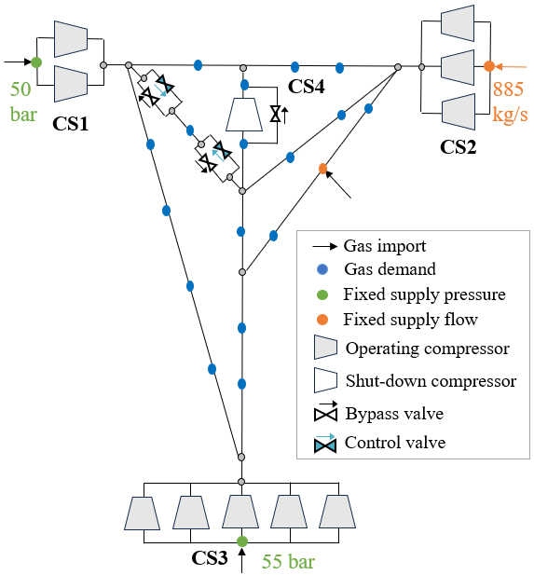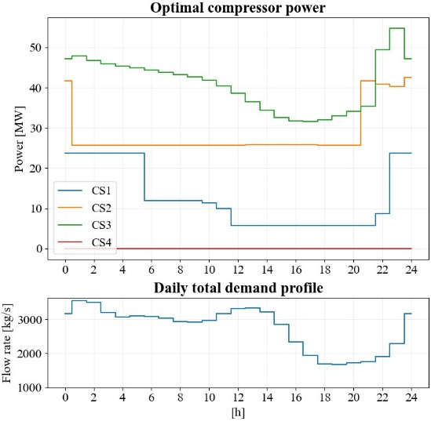
Figure 1. (Left) Gas network topology, (Upper Right) Optimal compressor power profiles, (Lower Right) Gas demand profile.
Under these assumptions, the corresponding MILP model developed by Ghilardi et al. (2022) features 418 binary variables, together with 5297 continuous variables and 10575 constraints. This MILP was solved in 750 CPU seconds to 2.5% MIP gap by Gurobi solver 10.0.3 on a laptop computer with Intel i7 CPU and 32 GB RAM.
Meanwhile, the proposed nonlinear smoothed model, with the same discretization grid of Eq. (1) and (2), exhibits 7460 variables, 7186 equality and 1140 inequality constraints. The NLP problem was solved with Ipopt version 3.13.2 directly, with a smoothing parameter 10⁻⁴; in our experiments, this allows for a sufficiently accurate approximation function, and convergence to the solution without applying a sequence of instances. By initializing the problem to the steady state solution, convergence was achieved in 17.83 CPU seconds, and optimal compressor power profiles are shown in Figure 1. Convergence to the same local solution was also exhibited with a simpler initialization technique (e.g. average pressure across the network, compressors at nominal operating conditions), which only slightly affected the computational time (25.83 CPU s), thus demonstrating the robustness of the NLP smoothed model. Regardless of the initialization technique, the NLP shows a significant gain in terms of computational time with respect to the MILP model. Another advantage of NLP solution strategies lies in their improved accuracy. To investigate this aspect, we simulate the NLP model with fixed compressor loads (NLP-FL) retrieved from the MILP solution. By comparing these case studies, it is possible to investigate the differences in terms of accuracy and optimality of the proposed NLP. The MILP solution overestimates the fuel consumption by 2.1% with respect to NLP-FL, due to the inexactness of the linearization of the compressor polynomials and gas transport equations. Moreover, the NLP solution suggests a slightly better result, showing a 2.1% fuel consumption reduction with respect to NLP-FL.
Table 1. Optimization results of the case study with different modelling approaches
Model | Runtime [CPU s] | Fuel consumption [MWh]
MILP | 750 | 8209 (CS1: 984, CS2: 2614, CS3: 4611)
NLP-FL | 12.83 | 8043 (CS1: 959, CS2: 2586, CS3: 4498)
NLP | 17.83 | 7879 (CS1: 989, CS2: 2448, CS3: 4442)
  - Conclusions
This work presents a nonlinear formulation for the optimal operation of gas pipelines with discrete decisions to minimize compressor energy consumption. The model contains the dynamic gas transport equations, off-design maps of the compressors and their drivers, and control valves regulation. A smoothed complementarity formulation is proposed to bridge the gap between disjunctive and nonlinear approaches by modeling valve configurations and flow reversals. This NLP-based approach is applied to a network representative of the main characteristics of a high-pressure pipeline, and the results are compared with the Mixed Integer Linear Programming model, showing a significant decrease of computational time, and gains in terms of the accuracy and optimality of the solution. Future work will focus on evaluating the scalability of the algorithm on large-scale problems, and developing decomposition strategies for scheduling of the units.
References
B.T. Baumrucker et al. 2008, MPEC problem formulations and solution strategies with chemical engineering applications, Computers and Chemical Engineering, 32, 2903–2913
L.M.P. Ghilardi et al., 2022, A MILP approach for the operational optimization of gas networks, IFAC-PapersOnLine, 55, 321–326.
K. Liu et al., 2020, Dynamic optimization for gas blending in pipeline networks with gas interchangeability control, AIChE Journal, 66.
S. Naik et al., 2022, Multistage Economic NMPC for Gas Pipeline Networks with Uncertainty, Computer Aided Chemical Engineering, 52, 1847–1852.
S. V. Patankar, 1980. Numerical Heat Transfer and Fluid Flow, 1st ed. CRC Press .
M. De Pascali et al., 2022, Flexible object-oriented modeling for the control of large gas networks, IFAC-PapersOnLine, 55, 321–326.
D. Rose et al., 2016, Computational optimization of gas compressor stations: MINLP models versus continuous reformulations, Math Meth Oper Res, 83, 409–444
M. Schmidt et al., 2016, An MPEC-based heuristic, pp. 163-179, in Evaluating Gas Network Capacities, T. Koch et al. (eds.), Society for Industrial and Applied Mathematics

