Multi-period stochastic optimization of integrating carbon capture and storage/utilization (CCS/CCU) for cement industry
Pingping Wang ^{a, *}, Stavros Papadokonstantakis ª
ªInstitute of Chemical, Environmental and Bioscience Engineering, TU Wien, Getreidemarkt 9, 1060 Vienna, Austria
*pingping.wang@tuwien.ac.at
Abstract
This work introduces a comprehensive network to model various CCS/CCU supply chains for the Austrian cement industry. Our framework considers carbon capture, various transportation options, and multiple storage and utilization possibilities, including depleted oil and gas reservoir in Austria and offshore storage sites in the North Sea, as well as utilization in synthetic fuels. An optimization framework is employed to strategically design CCS/CCU systems, accounting for both inherent and external uncertainties including production costs, carbon pricing, storage capabilities, and product pricing within a dynamic temporal framework. The future projections of energy supply from REMIND model are integrated into the prospective life cycle assessment for the overall systems. The optimal design problem is formulated as a multi-period stochastic programming model that finds the trade-off between environmental impacts evaluated by prospective life cycle assessment and total annual profit of the superstructure paths for different emissions reduction pathways over a deployment time horizon of 30 years. The results suggest that the Levelized Cost of Avoided Carbon can be lower than €150 per ton CO₂ stored for Austrian emissions at a baseline scenario. Furthermore, while the adoption of CO2 utilization could potentially enhance system profitability that depends on the competitiveness of synthetic fuel production costs, it also results in diminished CO₂ reduction efficiency due to the increased carbon footprint of the utilization processes.
Keywords: Carbon capture and storage, Carbon capture and utilization, Prospective LCA, Stochastic optimization, Multi-period optimization.
  - Introduction
The cement industry accounts for approximately 7% of global and 4% of European CO₂ emissions, predominantly due to the calcination process of limestone. Austrian cements production, in a global context, reaches the lowest CO₂ emissions, recording 549kg per ton of cement. This notable achievement is attributed to the adoption of cutting-edge kiln technologies, and optimization of clinker content in the cement and a continuously increased use of alternative fuels. However, further reductions in CO₂ emissions are imperative to attain carbon neutrality by 2050. Carbon Capture Storage and Utilization (CCS/CCU) can significantly reduce both the process related and fuel related emissions. It is identified as the single measure that has the largest potential for further overall emission reductions in the cement industry.
Nonetheless, the integration of CCS/CCU technologies into the cement industry faces numerous challenges. This include varying technological readiness levels (TRLs) for carbon capture and utilization technologies, the absence of extensive CO₂ pipeline infrastructures in the EU, and the limited policy support for underground storage. There are doubts about the durability of underground storage for permanent sequestration. Economic barriers also exist, such as high production costs for CO₂-based products compared with fossil-based products, uncertainties regarding future energy prices, and the necessity for future system optimization in tandem with dynamic transition of social-economic systems. Moreover, inconsistences and lack of transparency in input data for techno-economic analysis and life cycle assessment, along with insufficient consideration of time-dependent scenarios and capacities of on-going real-world projects, present significant hurdles for further development in this field.
Process system engineering (PSE) methods and tools are instrumental in bridging the gap and overcome some of the challenges in developing current CCS/CCU systems. Specifically, mathematical programming provides flexible and comprehensive frameworks for designing and optimizing systems. By optimizing supply chain networks and designing integrated processes, the overall system efficiency can be significantly enhanced. Hasan et al. (2014) employed a mixed-integer linear programming (MILP) mathematical model to optimize the supply chain network of CCS in US, assuming revenue generation solely from enhanced oil recovery (EOR), with most CO₂ stored underground. Han et al. (2012) introduced a multi-period stochastic optimization model for CCS/CCU systems accounting for the uncertainties in CO₂ emissions, product prices and operating cost, although they overestimated the available storage capacities in North Sea for South Korea. Tina et al. (2021) proposed a conceptual MINLP approach for developing a CO₂ supply chain in Slovenia, considering the revenue from the avoided tax and selling of products. Viola et al. (2022) devised a novel optimization framework to minimize the total costs while complying with multi reduction pathways over 25 years, capturing emissions from Swiss waste-to-energy sector for storage in the North Sea and a hypothetical Swiss site. Most existing studies have concentrated on the static design of cost-optimal single CO₂ supply chains that achieve specific reduction goals. However, the failure to account for changes in energy systems and technologies improvement over different time periods renders these results insufficiently adaptable to complex and dynamic environments. In this work, we propose a multi-period stochastic optimization model that considers the variation of CO₂ reduction target, production cost of CO₂ capture and utilization technologies, underground storage and transportation capacities, carbon tax prices, and CO₂-based product values in multi-scenario frameworks. This mathematical model is formulated as a MILP problem, which helps in determining the optimal strategies for capturing, transporting, storage, or utilizing CO₂ maximize total net profit while meeting CO2 emissions reduction targets.
  - System Description
The CCS/CCU supply chains developed aim at decarbonizing the Austrian cement production industry. The nine cement plants emit a total 3.22 MtCO₂/year. The reference cement plant is a Best Available Technique (BAT) defined by the European Cement Research Academy. We consider the most mature MEA absorption capture technology derived from the CEMCAP project. Five CO₂ storage sites are considered, which are located at Vienna Basin (SINK 1), Porthos of NL (SINK 2), East UK (SINK 3), Greenland of DK (SINK 4) and Norwegian North Sea (SINK 5). The annual capacities in North Sea is assumed to not exceed 5 MtCO₂/year and storage in Vienna Basin is not larger than 2 Mt/year. The estimation of the capacity of each storage site is based on the maximum theoretical capacity and duration, as well as the relative share of Austrian emissions in the EU. Additionally, we incorporate two transit terminals located in the ports of Rotterdam and Linz. Each site is equipped for CO₂ conditioning to meet the requirements for transportation or storage. Post-capture, CO₂ undergoes one of two pre-treatment processes, resulting in either a pressurized state at 110 bar and approximately 30°C for pipeline transport, or a liquefied form at 6.5 bar and around -52°C for other transportation methods. Our system considers five transportation modes: trucks, trains, barges, ships, and pipelines. Based on the information of the ‘Carbon2ProductAustria’ (C2PAT) project, our chosen utilization technology involves CO₂ refinery concepts coupled with green hydrogen to produce synthetic kerosene fuels by Fischer-Tropsch process.
A unique aspect of our approach is the dynamic integration of CCS/CCU. We consider evolving CO₂ reduction targets over three distinct periods, aiming for 30%, 60%, and 90% reductions, respectively. This phased strategy enables a progressive and feasible shift towards lower emissions. Additionally, we account for expected decreases in CO₂ capture technology costs, based on a learning curve reflecting the anticipated expansion in installation capacities. Regarding the synthetic kerosene, its revenue projection is highly uncertain due to unknown production costs and fluctuating policy incentives. To address this, we employ Monte Carlo sampling to generate stochastic values for production costs and incentives, determining the revenue potential of CO₂-based kerosene. Another critical element of our study is the prospective life cycle assessment (pLCA), which evaluates the environmental impacts of the overall system. The pLCA considers changes in both background and foreground systems. We utilize a tool named 'premise' (Sacchi et al., 2022) to integrate the prospective inventory database from the REMIND SSP2-Base scenario. Under this scenario, we generate pLCA results for our CCS/CCU systems across multiple periods.
  - Mathematical Model
The mathematical model is formulated as MILP with two objective functions: maximize profit and minimize global warming potential impact of CCS/CCU systems.
$max {TAP}_{p,s}(y, Y, Z) = Total Anual Profit(TAP)$ (1)
$min {GWP}_{p,s}(y, Y, Z) = Global Warming Potenial(GWP)$ (2)
$s.t.\begin{aligned}h\left(y,Y,Z\right)=0 \\ g\left(y,Y,Z\right)≥0\end{aligned}\left\{\begin{aligned}Mass balance \\ Facility &and Transporation capacity constraints \\ Reduction target constraints\end{aligned}\right.$ (3)
where y, Y, Z represent the vectors of continuous, binary, and integer variables respectively, while P and S are the sets of time periods and scenarios.
The total annual profit is calculated by the difference between total net benefit (TNB) and total annual cost (TAC).
${TNB}_{p,s}=\sum_{st}{\sum_{ut}{{Carbon}_{p,s,st,ut}{CA}_{p,s,st,ut}}+\sum_{ut}{{UC}_{p,s,ut}{PF}_{p,s,ut}}}$ (4)
where ST and UT represent the sets for CO2 storage and utilization sites, Carbon is the carbon price, CA is the amount of CO2 emissions avoided of the systems, UC is the production capacity of CO2-based product, PF is the price of selling of fuels. TAC is the of total cost of CO2 capture and conditioning, transport (1 stands for in Austria, 2 stands from Linz port to aboard storage sites, see also in Figure 1), storage and utilization costs.
To formulate the multiperiod stochastic model under uncertain production costs and policy incentives, we employ a multi-scenario stochastic programming approach that aims to use a finite set of scenarios to maximize the expected value of the profit.
$max E[TAP]= \sum_{r}{{prob}_{r}{TAP}_{r}}$ (5)
where r is a subscript that represents a particular stochastic scenario and ${prob}_{r}$ is the probability of occurrence of this stochastic scenario.
In our research, we also employ several economic and environmental indicators to evaluate the performance of the overall CCS/CCU systems. The first indicator, the Levelized Cost of Stored Carbon (LCSC), is calculated by dividing the total annual cost by the amount of CO₂ stored at a given time. The second indicator, the Levelized Cost of Avoided Carbon (LCAC), is determined by dividing the Total Annual Cost (TAC) by the amount of CO₂ avoided. Another key metric is the CCS/CCU Efficiency, defined as the ratio of CO₂ avoided to CO₂ stored or utilized. Additionally, we measure CO₂ Reduction, which is calculated by dividing the CO₂ avoided by the total CO₂ emissions emitted.
  - Case Study
In the case study, we explore different scenarios for CCS and CCS/CCU systems in Austria in three time periods (now-2030,2030-2040 and 2040-2050), considering varying policy environments.
- CCS Scenarios:
- Scenario 0 (Pessimistic): Assumes no underground storage or pipeline transportation in Austria across all periods.
- Scenario 1 (Conservative): No underground storage projects in Austria, but pipeline transportation is allowed in periods 2 and 3.
- Scenario 2 (Baseline): Underground storage and pipeline transportation start from period 2 in Austria with a conservative capacity of 1 million tons per year.
- Scenario 3 (Optimistic): CCS projects begin from period 2 with sufficient storage capacity for the cement industry's CO₂ emissions in Austria.
- CCS/CCU Scenario:
Building on Scenario 2 from the CCS-only system, we examine the introduction of CCU projects in Austria. This scenario involves a hypothetical synthetic fuel facility producing kerosene for the European market, priced at typical petroleum kerosene rates. We base our market price projections on the Energy Information Administration's (EIA) jet fuel forecasts. The carbon price is consistent with the baseline scenario in the CCS-only system. For e-kerosene production costs in the EU, we refer to The International Council on Clean Transportation (ICCT) estimates, averaging the lowest and highest cost projections as shown in the Table 1. These values are used in a Monte Carlo simulation for stochastic sampling, assuming a normal distribution with a standard deviation of ±3%.
Table 1. Parameters for Estimating Uncertain Revenue of Synthetic Kerosene
€/liter | Production_min | Production_max | Kerosene Price | Carbon Price (€/tonCO2 avoided)
Period 1 | 1.538 | 3.178 | 0.54 | 150
Period 2 | 1.224 | 2.807 | 0.80 | 175
Period 3 | 0.951 | 2.304 | 1.00 | 200

  - Results and Discussion
    - CCS-only in the system
From Figure 1 (a), we observe that the LCAC consistently surpasses the LCSC, indicating nonignorable emissions associated with CCS systems. In Scenario 2, the capture costs demonstrate a decrease from Period 1 to Period 3. Starting in Period 2, transportation costs in Austria become predominant due to the expensive pipeline installation, which, nonetheless, contributes to improved CCS Efficiency. The most cost-effective transport options to the North Sea involve barges and ships, which are assumed for the transit from Linz to the storage sites. As the capacity for capture and storage in Austria increases in Period 3, there is a potential for cost reduction and further enhancement of CCS Efficiency. The pipeline transportation cost declines closely tied to capacity expansion. If the system only keeps the truck and trains options in Austria for transporting (Scenario 0 and 3), the LCSC is gradually decreased from period 1 to 3 (not shows in the Figure). But the trend of LCAC decay comes weaker as more CO₂ emissions comes from mobilities. Transporting all CO₂ emissions to the North Sea in Period 3 of Scenario 1 is slightly costlier than storing 1 million tons of CO₂ in Austria as outlined in Scenario 2. In the pessimistic Scenario 0 for Period 3, the absence of pipelines and underground storage in Austria allows for keeping LCAC under €100, albeit with the lowest CCS efficiency, but still achieving CO₂ reduction exceeding 70%. Conversely, the optimistic Scenario 3 for Period 3 showcases the highest CCS efficiency and CO₂ reduction, predicated on the availability of at least two storage sites in Austria. This case study underscores that the viability of CCS is a balance between LCAC and the price of carbon emission credits. With robust carbon pricing place (at least €150/ton), the CCS systems could be profitable even without storage or under conservative estimations for underground storage in Austria (S0, S1 and S2). The findings advocate that, despite uncertain policies and the absence of infrastructures (i.e., pipeline), proactive measures are preferable to inaction.
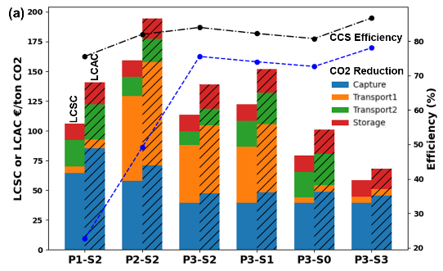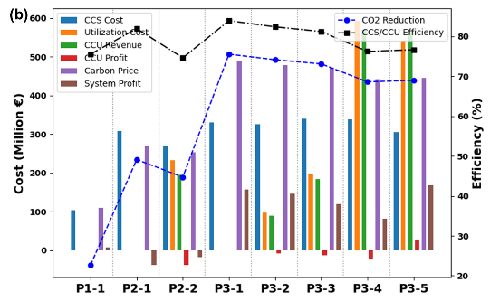

Figure 1. Economic and Environmental Performance Indicators for (a) CCS Systems, (b)CCS/CCU Systems Across Different Scenarios and Periods (S0 to S3 in (a) represents multi scenarios, 1 to 5 in (b) represents r, scenarios with stochastic value of utilization costs)
    - CCS/CCU in the system
Figure 1(b) delineates the cost, revenue, and efficiency metrics of the CCS/CCU systems. In the baseline scenario for the CCS-only framework, system profitability depends upon the value attributed to CO₂ avoided. In the second period (P2-1), the high costs of implementing CCS make it difficult to achieve profit, especially with a carbon price set at €150. However, the anticipated financial gains in the third period (P3-1) with higher carbon pricing are projected to offset the preceding losses. The integration of CCU into the system introduces a dual dependency for profitability: not only the carbon tax avoided from CO₂ reduction is considered, but the economic viability of the utilization system itself is also crucial, hinging on both the reduction of production costs and the policy incentives. During P2-2, the stochastic estimate for synthetic kerosene production costs €0.96/liter emerges as significantly high, though with a minimal likelihood of occurrence, it remains noncompetitive with fossil-based alternatives. By the third period, if the cost of synthetic kerosene falls below that of traditional fossil kerosene (P3-5), the system stands to gain extra profits from the utilization process. However, the integration of CO₂ utilization into the system notably diminishes CCS/CCU efficiency relative to the CCS-only model. As depicted in Figure 2(a), under the assumption that synthetic hydrogen is exclusively derived from wind energy and accounting for the energy transition within the national electrical grid, the prospective LCA reveals a downward trajectory for the GWP impact of kerosene synthesis. Yet, the GWP impact per ton of CO₂ utilized remains significantly higher in period 3 (235 kg eq-CO₂/ton CO₂ saved) compared to only CCS-systems that has a peak in scenario P3-S0 (192 kg eq-CO₂/ton CO₂ stored). Consequently, the supplementary revenue generated, combined with the marginal decline in profits due to augmented emissions from the utilization process, together influence the net benefits of the systems. In scenario P3-5, which boasts the highest system profitability, further multi-objective analysis utilizing the ε-constrained method clarifies the trade-off between GWP and profit, as visualized in Figure 2(b). When profitability in the CCU system materializes in period 3, the decision-making process should navigate the balance between environmental impact and financial return. The Pareto curve illustrates that reducing the CCU share from 47.7% to 29.6% correlates with a decrease in profit, yet concurrently yields benefits from a reduction in CO₂ emissions for the system.
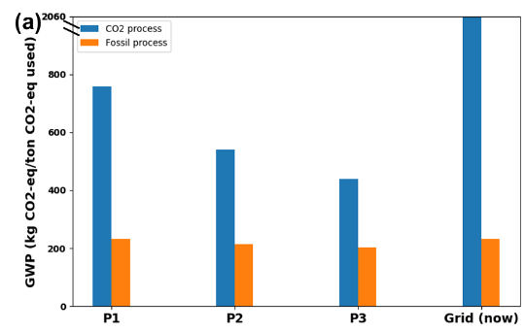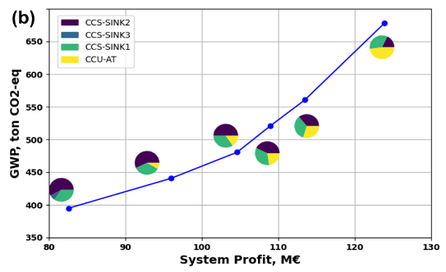
Figure 2. (a) GWP of kerosene production process in multi-periods; (b) Pareto-font curve of the profit and GWP of CCS/CCU systems (the pie charts show the share of storage/utilization capacities at different sites)
  - Conclusions
In summary, this study assesses the economic and environmental impact of integrating CCS/CCU in Austrian cement industry. We find that the feasibility of systems heavily depends on policy and carbon pricing. Even without new infrastructure for underground storage and pipeline transport in Austria, CCS could still achieve over 70% CO₂ reduction efficiency for the cement industry. Allowing underground storage in Austria would significantly boost profitability and reduction efficiency. CCU can additionally enhance profits, conditional on lower production costs and supportive policies. The study underlines the efficiency and profit trade-offs with CCS/CCU adoption and addresses the need for policymakers to adapt to changing environmental and economic landscapes.
References
M. M. Faruque Hasan et al., 2014, Nationwide, Regional, and Statewide CO2 Capture, Utilization, and Sequestration Supply Chain Network Optimization. Ind. & Eng. Chem. Res.53 (18), 7489-7506
J.-H. Han et al., 2012, Multiperiod Stochastic Optimization Model for Carbon Capture and Storage Infrastructure under Uncertainty in CO2 Emissions, Product Prices, and Operating Costs. Ind. & Eng. Chem. Res. 51 (35), 11445-11457.
T. Kegl et al., 2021, Conceptual MINLP approach to the development of a CO2 supply chain network – Simultaneous consideration of capture and utilization process flowsheets. J. Clea. Prod. 314: 128008.
V. Becattini et al., 2022, Carbon dioxide capture, transport and storage supply chains: Optimal economic and environmental performance of infrastructure rollout. Inter. J. Gre. Gas Cont. 117: 103635.
R. Sacchi et al., (2022). PRospective EnvironMental Impact asSEment (premise): A streamlined approach to producing databases for prospective life cycle assessment using integrated assessment models. Renew. Sustain. Energy Rev. 160: 112311.

