Optimal Loading of Porphyrin in Porphyrin@Bi₁₂O₁₇Cl₂ heterojunction: Application in Photocatalysis

Osemeikhian Ogbeifun ^{a*}, Shepherd M. Tichapondwaª, Evans M. N. Chirwaª

ªWater Utilization and Environmental Engineering Division, Department of Chemical Engineering, University of Pretoria, Pretoria, 0002, South Africa
*osemeikhianosi@yahoo.com
Abstract
The recombination of photogenerated electrons (e⁻) and holes (h⁺) and under-utilisation of the visible light spectrum (>420 nm) are significant challenges in photocatalysis involving Bi₁₂O₁₇Cl₂. In this study, the photocatalytic efficiency of Bi₁₂O₁₇Cl₂ was significantly enhanced in the fabrication of novel porphyrin@Bi₁₂O₁₇Cl₂ heterostructure photocatalyst. Aggregated porphyrins have emerged as photosensitisers in light-dependent applications like photocatalysis. The excellence of porphyrin is fully harnessed when combined with inorganic photocatalysts such as Bi₁₂O₁₇Cl₂ to form organic-inorganic junctions, thereby enhancing the visible light absorption, charge separation and transport in the material. Various amounts of aggregated rod-shaped 5,10,15, 20-Tetrakis (4-carboxyphenyl) porphyrin (0.02% wt., 0.1% wt., 0.4% wt., 1% wt. and 10% wt.) were coupled to Bi₁₂O₁₇Cl₂ and the optimum loading of porphyrin in terms of photocatalytic efficiency was determined for Porphyrin@Bi₁₂O₁₇Cl₂ heterostructure. The photocatalytic degradation efficiency of Porphyrin@Bi₁₂O₁₇Cl₂ was tested on Rhodamine B dye as a representative pollutant. The highest and lowest performances were reported for 1% wt. and 10% wt. of porphyrin loading in Bi₁₂O₁₇Cl₂, respectively, representing 3.1 and 0.5 times increases compared to pure Bi₁₂O₁₇Cl₂. The findings offer a new option for improving the photocatalytic performance of Bi₁₂O₁₇Cl₂ through photosensitisation and heterojunction strategies for use in numerous photocatalysis applications.

Keywords: Bi₁₂O₁₇Cl₂, aggregated porphyrin, photosensitisation, heterostructure, charge recombination, photogenerated
  - Introduction
Bi₁₂O₁₇Cl₂ is an attractive semiconductor photocatalyst with comparatively low bandgap energy, visible light or infrared activity (Chen et al., 2013). With these properties, Bi₁₂O₁₇Cl₂ is a choice material for mitigating environmental contamination via photocatalytic degradation technology. However, a drawback to applying Bi₁₂O₁₇Cl₂ in photocatalytic technology is the quick recombination of photogenerated charge carriers (e⁻ and h⁺) as fast as they are produced. (Passi and Pal, 2022). This phenomenon limits the capacity of the material to degrade target contaminants oxidatively (Zheng et al., 2018). To enhance the photocatalytic degradation ability of Bi₁₂O₁₇Cl_{2,} various strategies have been employed, including heterojunction fabrication (Bi et al., 2016), ion doping (Yang et al., 2022), plasmon resonance effect (Zhang et al., 2017), solid solution (Zhang et al., 2020) and photosensitization effect (Ye et al., 2014).

The photosensitization strategy, which is the focus of this study, involves applying a photosensitizer such a porphyrin, to photocatalysts to increase visible light utilization. Porphyrin is a group of organic molecules made of four pyrrole rings that are linked with methine bridges to form a planer macrocyclic structure known as porphyrin ring (Araki et al., 2013). Porphyrin strongly absorbs visible light, producing a photochemical reaction (Joseph and Haridas, 2020), that generates triplet (activated state) that can oxidize contaminants in the medium (Neves et al., 2019). When porphyrin is irradiated, excited electrons move from highest occupied molecular orbital (HOMO) to the lowest unoccupied molecular orbital (LUMO) (Moshari et al., 2016). The LUMO electrons are transferred and injected into the conduction band (CB) of the host material, bringing about the separation of holes and electrons, boosting photocatalytic performance (Zhang et al., 2017).

In this study, self-assembled rod-shaped 5,10,15, 20-Tetrakis (4-carboxyphenyl) porphyrin was prepared and anchored to Bi₁₂O₁₇Cl₂. The photocatalytic activity of the surface modified- Bi₁₂O₁₇Cl₂ was evaluated by measuring the degradation of Rhodamine B under visible light. The optimum composition of porphyrin in the composite and their photocatalytic efficiency was determined.
  - Method
    - Synthesis of Bi₁₂O₁₇Cl₂
Bi₁₂O₁₇Cl₂ was synthesized by dissolving 4.84 g (0.01 mol) of Bi (NO₃)₃·5H₂O in 25 mL of acetic acid solution (acetic acid: H₂O 2:1 v/v) with stirring for complete dissolution. Next, 3.2 g (0.01 mol) of cetyltrimethylammonium chloride (CTAC) was dissolved in 25 mL of deionized water and added to the nitrate solution. The resulting solution was stirred for 30 min. The pH was then adjusted to 13 using a 10M NaOH solution. After an additional 30 min of stirring, the reaction mixture was subjected to microwave treatment (1000 W; 2450 Hz) for 10 min at atmospheric pressure. The resulting product was collected by centrifugation, washed several times with ethanol: water, and dried in an oven at 60 ºC for 18 h.

    - Synthesis of aggregated porphyrin
In a typical synthesis, 0.04 g of porphyrin powder was dissolved in 0.5 mL of 0.2 M NaOH (referred to as the host solution). The “guest’ solution was prepared by dissolving 0.036 g of Cetyltrimethylammonium bromide (CTAB) in 10 mL of 0.01 M HCl. The guest solution was quickly injected into the host solution with vigorous stirring for 30 min in the dark. The resulting precipitate referred to as Porph was collected by centrifugation at 9,000 rpm for 10 min and washed with deionized water several times to remove the surfactant.

    - Synthesis of Poprhyrin@Bi₁₂O₁₇Cl₂
The preparation of Bi₁₂O₁₇Cl₂ containing 0.02% wt., 0.1% wt., 0.4% wt., 1% wt., and 10 % wt. porphyrin was carried out as follows: 0.2 g of as-synthesized BOC was added to 20 mL of methanol containing a certain amount of Porph (0.04 mg, 0.2 mg, 0.8 mg, 2 mg, and 20 mg). The mixture was sonicated for 5 min and then stirred at 60 ºC in the dark to completely volatilize the methanol. The resulting materials were collected and washed with water to remove unattached porphyrin and were labelled as x%Porph@BOC (0.02%Porph@BOC, 0.1%Porph@BOC, 0.4%Porph@BOC, 1%Porph@ BOC and 10%Porph@BOC), where x represents the weight percentage of Porph in BOC.

Scheme 1. shows the synthesis of Bi₁₂O₁₇Cl_{2,} aggregated porphyrin and Poprhyrin@Bi₁₂O₁₇Cl₂ heterostructure.

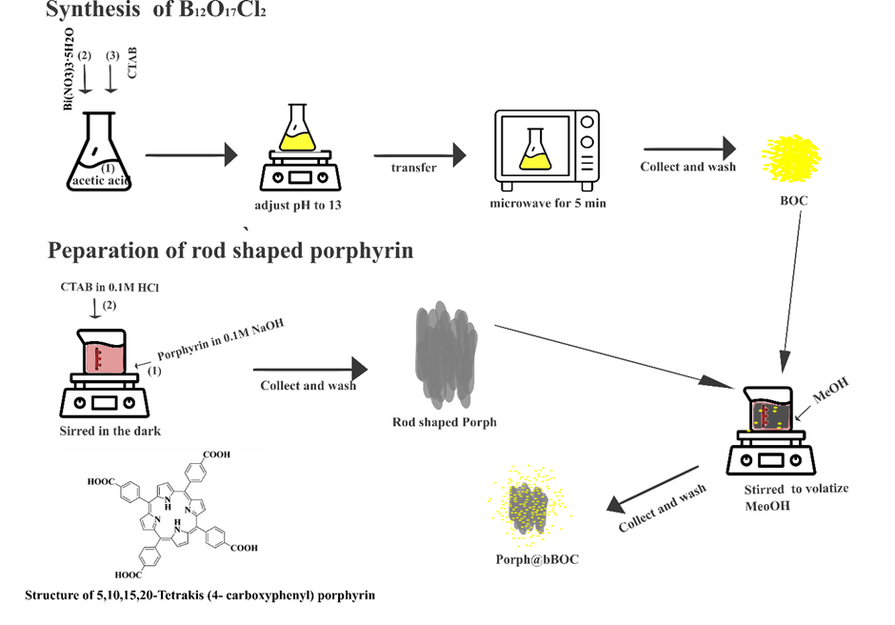
Scheme 1. Synthesis of aggregated porphyrin, Bi₁₂O₁₇Cl₂ and Porph@BOC. and structure of 5,10,15,20-Tetrakis (4- carboxyphenyl) porphyrin
  - Results and discussion
Degradation studies were conducted at room temperature (25ºC) on Rhodamine B as a representative contaminant using the synthesised materials described from the preceding section. In doing that, 60 mL of 20 mg L⁻¹ of Rhodamine B dye was placed in a 100 mL-beaker reactor, and 0.025g of photocatalyst material was added to the solution. The mixture was stirred in the dark for 3 h to achieve adsorption-desorption equilibrium. The solution was then irradiated for 4 h 30 min with visible light from six 16W fluorescent tubes (OSRAM, Germany) having a total intensity of 6300 lux. To monitor the degradation of Rhodamine B, 2 ml of aliquots were withdrawn at 0.5 h intervals. The photocatalyst particles were separated using a centrifuge and the absorbance of the remaining dyes solution were measured with a spectrophotometer at 553 nm absorbance. The concentration of Rhodamine B was calculated from the equation of the standard curve. Photolysis experiments were also performed in the absence of photocatalyst to differentiate photolysis from photocatalysis reaction. The percentage degradation was calculated from the following equation:

$\frac{Co-Ct}{Co}$ x 100%

where C₀ and C_{t} are the initial concentration and concentration at time of Rhodamine B.
From Fig. 2(a), after 120 min of irradiation of light, the degradation efficiency of Rhodamine B on BOC, Porph, 0.02%Porph@BOC, 0.1%Porph@BOC, 0.4%Porph@BOC, 1%Porph@BOC and 10%Porph@BOC were reported to be 31.1%, 16.5%, 41.8%, 52.4%, 60.9%, 71% and 23.6%, respectively. Among the modified materials, 1%Porph@BOC performed the best with an efficiency of 71% while, 10%Porph@BOC was the least performing material with an efficiency of 23.6% efficiency, which is less than that of BOC with an efficiency of 31.1%. At the end of the photocatalytic degradation experiment (4.5 h), 82.6% degradation efficiency was achieved on 1%Porph@BOC. It was also demonstrated that photolysis did not contribute significantly to the removal of Rhodamine B and only achieved a removal efficiency of 3.5% by light irradiation. The kinetics of Rhodamine B degradation was determined from the data obtained in the degradation study to be a pseudo-first-order kinetic equation. First-order kinetic –in C/C_{o} = kt where C₀ and C are the initial and final concentrations of Rhodamine B, k, the rate constant, and t, the time, was used to fit the experimental data. The linear curve in Fig. 2(b) confirmed the pseudo-first kinetic. The R² values for 0.02%Porph@BOC, 0.1%Porph@BOC, 0.4%Porph@BOC, 1%Porph-@BOC, 10%Porph@BOC and BOC were found to be 0.9566, 0.97107, 0.97808, 0.99063, 0.97548, 0.94701, 0.97018, respectively. Overall, the degradation of Rhodamine B on 1%Porph@BOC was 3.1 times faster than on pristine BOC.

Fig. 2(c) shows a gradual increase in photocatalytic degradation of Rhodamine B on the materials in the following order: 0.02%Porph@BOC < 0.1%Porph@BOC < 0.4%Porph@BOC < 1%Porph@BOC. This shows that 1% wt. porphyrin-loaded material is the best-performing material. As observed from Fig. 2(c), there was a sharp decrease in the photocatalytic degradation at 10%Porph@BOC. The decrease in the photocatalytic activity of 10%Porph@BOC was caused by blockage of active sites on Bi₁₂O₁₇Cl₂ surface and low light penetration in the reaction solution at high porphyrin dose in 10%Porph@BOC.

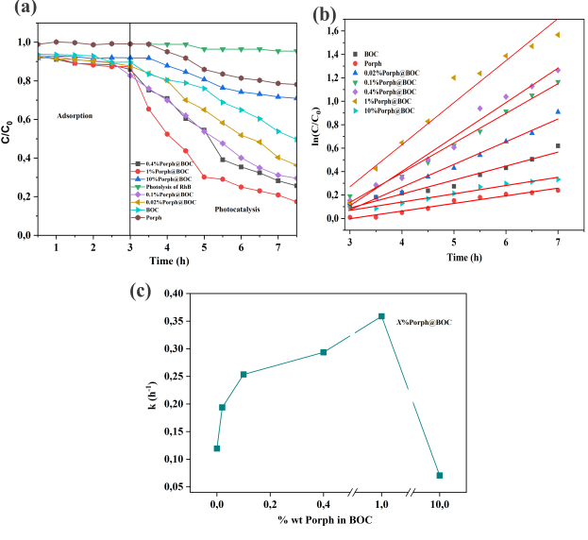
Fig. 2. (a) Photocatalytic degradation of Rhodamine B on x%Porph@BOC. (b) Rate constants of Photocatalytic degradation of Rhodamine B on x%Porph@BOC materials. (c) Percentage weight of aggregate porphyrin, x, in BOC versus kinetic rate constant, k, of degradation of Rhodamine B.

  - Conclusions
The photocatalytic efficiency of porphyrin@ Bi₁₂O₁₇Cl₂ heterostructure was tested at various porphyrin loading of 0.02%, 0.1%, 0.4%, 1%, and 10% w/w. The optimum porphyrin dose in the composite to achieve the highest degradation efficiency of Rhodamine B was determined as 1% w/w, which is 3.1 times higher than that of pure Bi₁₂O₁₇Cl₂. The enhanced performance was attributed to the synergy between the anchored porphyrin and Bi₁₂O₁₇Cl₂. However, at the highest dose of 10%w/w porphyrins, a deterioration of the photocatalytic activity was observed due to blockage of active sites on Bi₁₂O₁₇Cl₂ surface and low light penetration on the reaction solution. Two phenomena were found to be crucial to the photocatalytic activity of the composite: Bi₁₂O₁₇Cl₂ surface area and the photosensitisation effect of porphyrin. Therefore, it is essential to strike a balance between these effects to harness the synergy between porphyrin and Bi₁₂O₁₇Cl₂ in porphyrin@ Bi₁₂O₁₇Cl₂ composite to achieve optimum performance. The optimum activity achieved with 1% wt. porphyrin in porphyrin@ Bi₁₂O₁₇Cl₂ provided for adequate exposure of active sites on the surface of Bi₁₂O₁₇Cl₂ for the photodegradation of Rhodamine B, while still benefiting from porphyrin's photosensitisation effect.
References
Araki, K, Yang, D-H, Wang, T, Selyanchyn, R, Lee, S-W & Kunitake, T (2013) "Self-assembly and imprinting of macrocyclic molecules in layer-by-layered TiO2 ultrathin films" Analytica Chimica Acta, 779 72-81

Bi, C, Cao, J, Lin, H, Wang, Y & Chen, S (2016) "BiOI/Bi12O17Cl2: A novel heterojunction composite with outstanding photocatalytic and photoelectric performances" Materials Letters, 166 267-270

Chen, L, Huang, R, Xiong, M, Yuan, Q, He, J, Jia, J, Yao, M-Y, Luo, S-L, Au, C-T & Yin, S-F (2013) "Room-Temperature Synthesis of Flower-Like BiOX (X═Cl, Br, I) Hierarchical Structures and Their Visible-Light Photocatalytic Activity" Inorganic Chemistry, 52 (19), 11118-11125

Joseph, M & Haridas, S (2020) "Recent progresses in porphyrin assisted hydrogen evolution" International Journal of Hydrogen Energy, 45 (21), 11954-11975

Moshari, M, Rabbani, M & Rahimi, R (2016) "Synthesis of TCPP–Fe3O4@S/RGO and its application for purification of water" Research on Chemical Intermediates, 42 (6), 5441-5455

Neves, CMB, Filipe, OMS, Mota, N, Santos, SAO, Silvestre, AJD, Santos, EBH, Neves, MGPMS & Simões, MMQ (2019) "Photodegradation of metoprolol using a porphyrin as photosensitizer under homogeneous and heterogeneous conditions" Journal of Hazardous materials, 370 13-23

Passi, M & Pal, B (2022) "Recent advances on visible light active non-typical stoichiometric oxygen-rich Bi12O17Cl2 photocatalyst for environment pollution remediation" Journal of Environmental Chemical Engineering, 10 (3), 107688

Yang, Y, Zeng, Y, Jin, T, Zhang, X, Teng, H, Wang, S & Chen, H (2022) "Construction of oxygen vacancy on Bi12O17Cl2 nanosheets by heat-treatment in H2O vapor for photocatalytic NO oxidation" Journal of Materials Science & Technology, 123 234-242

Ye, L, Su, Y, Jin, X, Xie, H & Zhang, C (2014) "Recent advances in BiOX (X = Cl, Br and I) photocatalysts: synthesis, modification, facet effects and mechanisms" Environmental Science: Nano, 1 (2), 90-112

Zhang, M, Bi, C, Lin, H, Cao, J & Chen, S (2017) "Construction of novel Au/Bi12O17Cl2 composite with intensive visible light activity enhancement for contaminants removal" Materials Letters, 191 132-135

Zhang, Z, Liu, H, Xu, J & Zeng, H (2017) "CuTCPP/BiPO4 composite with enhanced visible light absorption and charge separation" Journal of Photochemistry and Photobiology A: Chemistry, 336 25-31

Zhang, Z, Zhao, Y, Shen, J, Pan, Z, Guo, Y, Wong, PK & Yu, H (2020) "Synthesis of 1D Bi12O17ClxBr2−x nanotube solid solutions with rich oxygen vacancies for highly efficient removal of organic pollutants under visible light" Applied Catalysis B: Environmental, 269 118774

Zheng, J, Chang, F, Jiao, M, Xu, Q, Deng, B & Hu, X (2018) "A visible-light-driven heterojuncted composite WO3/Bi12O17Cl2: Synthesis, characterization, and improved photocatalytic performance" Journal of Colloid and Interface Science, 510 20-31

