Renewable Energy Hub Optimizer (REHO) –
A Comprehensive Decision Support Tool for Sustainable Energy System Planning
Dorsan Lepourª, Cédric Terrierª, Joseph Loustauª, François Maréchalª
ªEPFL, Rue de l’industrie 17, Sion 1950, Switzerland
dorsan.lepour@epfl.ch
Abstract
The transition to sustainable energy systems in the face of growing renewable energy adoption and electrification is a complex and critical challenge. The Renewable Energy Hub Optimizer (REHO) emerges as a powerful decision support tool designed to investigate the deployment of energy conversion and storage technologies in this evolving landscape. REHO leverages a Mixed-Integer Linear Programming (MILP) framework combined with a Dantzig-Wolfe decomposition to simultaneously address the optimal design and operation of energy communities, catering to multi-objective considerations across economic, environmental, and efficiency criteria. This paper introduces REHO and highlights its key features and contributions to the field of sustainable energy system planning.
Keywords: Renewable Energy Community, MILP, Multi-Objective Optimization, Open-Source.
  - Context
Cities around the world are moving towards increasing the penetration of local energy harvesting and storage capacities to render their energy consumption more sustainable and less dependent on a geopolitical context. Intensification of renewables deployment is witnessed in the past decade and keeps continuing, leading to important techno-economic-social trade-offs in energy strategy. This transition blurs the boundaries between demand and supply and creates new types of stakeholders. Adopting a district-level approach for energy system planning seems thus particularly relevant, as it promotes the valorization of endogenous resources and enables economies of scale while preserving local governance (Heldeweg, 2020). The emergence of the concept of renewable energy communities is a clear example of this growing interest for energy planning at the neighborhood scale (Dóci, 2015). Energy communities are expected to play a pivotal role in the ongoing energy transition by fostering decentralized, sustainable, and community-driven approaches to energy production and consumption. Through the collaborative efforts of residents, utilities, and institutions, they offer a techno-economic framework to support the paradigm shift from centralized energy systems to a distributed and district-level model (Caramizaru, 2020).
Optimizing an energy community at the district-level is a complex and computationally intensive task due to its network structure and interdependent decision variables. Facing this problem, a common method is to fix some degrees of freedom through assumptions and scenarios based on expert knowledge (Reynolds, 2019; Pickering, 2019). Many studies in literature assumes energy demand profiles (Murray, 2020) or predetermines the energy system configuration (Chakrabarti, 2019; Alhamwi, 2018; Kramer, 2017). The issue with such assumptions is the consideration of energy carriers to be delivered instead of energy end use demands to be satisfied. By assuming a priori some investment decisions into energy capacities, the solution space is reduced, and such model does not unveil the full potential of energy communities. However, modeling subsystems as entities embedded in a larger system should reveal the interdependency of the decision-making and exploit the main benefits of energy communities to coordinate decisions both at the building and district-level.
In addition to addressing the need for a more holistic problem statement, another notable gap in the existing research pertains to the limited generalizability of findings. A predominant trend in the literature involves the examination of singular case studies, within a specific neighborhood. While certain authors have explored the overarching implications of local residential systems, their investigations predominantly hinge on building-level energy systems (Stadler, 2019; Kotzur, 2020).
This gap has motivated the development of Renewable Energy Hub Optimizer (REHO), a comprehensive decision support tool for energy system planning at the district-level, considering simultaneously diverse end use demands, multi-energy integration, and buildings interactions.
  - Districts as energy hubs
The energy hub concept (Mohammadi, 2017) is used to model an energy community where multi-energy carriers can supply diverse end use demands through building units and district units optimally interconnected and operated.
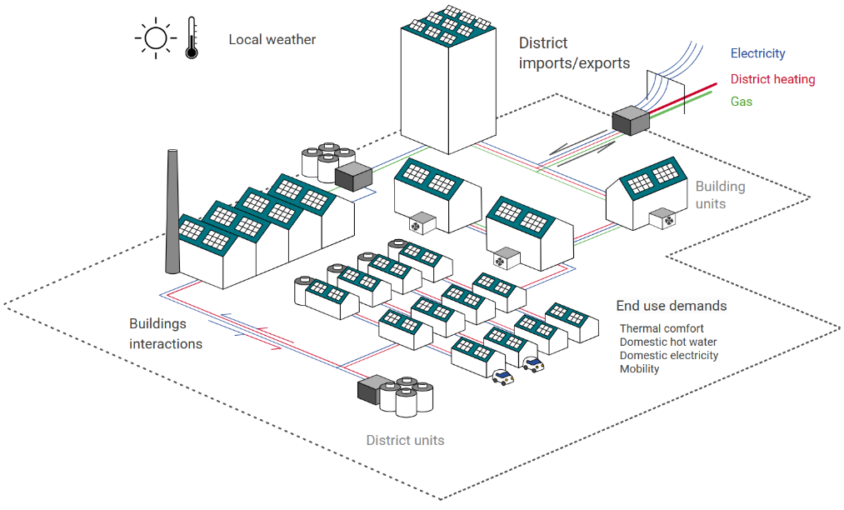
Figure 1: District energy hub model in REHO.
Figure 1 displays the input data necessary to characterize a district-level energy hub to be optimized with REHO:
- the geographic boundaries of the considered territory;
- the end use demands, resulting from the building stock and local weather;
- the technologies available and their specifications regarding cost, life cycle, efficiency;
- the endogenous resources;
- and the energy market prices for district imports and exports.

The optimal solution minimizing the specified objective function will then be fully characterized by the decision variables defining the energy system configuration. These decision variables are the installed capacities of the building and district units among the available technologies, their operation throughout a typical year, and the resulting energy flows (buildings interactions and district imports/exports).
  - The REHO package
    - Model foundations
REHO exploits the benefits of two programming languages to explore the solution space defined by the district energy hub input data. Figure 2 illustrates the tool architecture:
- The data management structure is written in Python and used for input parameters preprocessing, and decision variables postprocessing.
- The optimization model is written in AMPL, encompassing objective functions, modelling equations, and constraints at building-level and district-level.
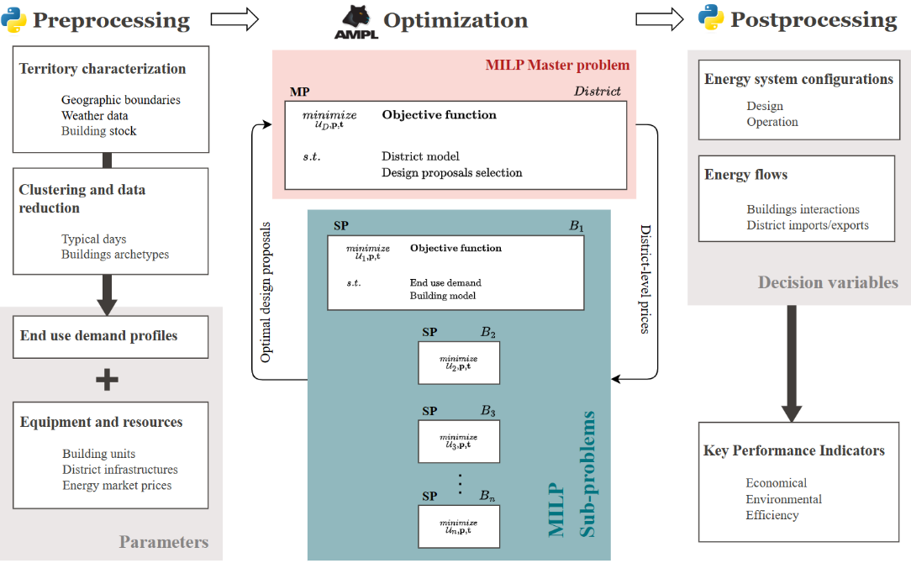
Figure 2: Diagram of the REHO architecture.
      - Data reduction
The task of optimally designing and scheduling energy systems with a high share of renewable energies is complex and computationally demanding. REHO includes machine learning techniques to cluster yearly input data. The model operates in the conventional way with typical periods p of 24 timesteps t, but it can be freely adapted to a finer or coarser granularity as required.
      - MILP formulation with decomposition
A Dantzig-Wolfe decomposition is applied on the district-level problem to define a master problem (MP) and one sub-problem (SP) for each building. Linking constraints allow the problem to iteratively converge to the solution minimizing the global objective function: the MP sends optimal district-level prices to the SPs, which in turn send back optimal building-level design proposals. The building-level optimization model is based on Stadler (2019) and the decomposition methodology is described in Middelhauve (2022).

    - Embedded features
      - Multi-Service Consideration
REHO encompasses a wide range of end use demands, including thermal comfort (heating and cooling loads), domestic hot water, domestic electricity, mobility, and information and communication technologies needs.
      - Multi-Energy Integration
REHO incorporates various energy sources and networks, such as electricity, fossil fuels, biomass, biofuels, district heating and cooling networks, and hydrogen. This holistic approach ensures a comprehensive representation of the energy landscape.
      - Multi-Scale Capabilities
REHO's flexibility spans various scales, from individual buildings to entire districts. The district-scale optimization feature capitalizes on synergies between buildings, allowing them to function as an energy community and enabling energy and financial flows between buildings. In addition, such an approach opens the possibility of deploying district-level infrastructures.
      - Multi-Objective Optimization
REHO’s versatility extends to multi-objective optimization, accommodating objectives related to economic (capital and operational costs), environmental (life cycle analysis and global warming potential), and efficiency criteria. Epsilon constraints provide fine-grained control, enabling decision-makers to explore trade-offs and identify Pareto fronts.
      - PV orientation
Given the pivotal role of photovoltaic (PV) systems in the energy transition, their optimal deployment is of paramount importance and must consider the specific characteristics of the building morphology, the local solar irradiance, and the grid curtailment restrictions. REHO integrates the deployment of solar panels on roofs and facades, with the possibility to take into consideration the orientation of surfaces.
      - Electric mobility
REHO enables the integration of electric vehicles into neighborhoods, including the possibility of smart charging, unidirectional or bidirectional. The fleet of electric vehicles can thus be used to provide an energy storage service.
      - Grid constraints
As the electrification of diverse sectors gains momentum, the demands placed on the electricity grid are expected to further escalate. The existing electrical grid, originally designed for centralized power generation and unidirectional energy flows, now faces new demands and complexities. REHO allows for the consideration of the local grid specifications, through line and transformer capacities, or peak power shaving and curtailment measures.
      - District heating and cooling
REHO enables the deployment of district heating and cooling networks, with consideration of several heat transfer fluids and distribution temperatures. Infrastructure costs are also incorporated, based on the topology of the considered neighborhood.
      - Open-source and interoperability
REHO is available as an open-source and collaborative Python library, supported by comprehensive documentation. It is deployed as a PyPI package, boasting its capability to interface and exchange information with other tools.

  - National-level case study
By providing the relevant input data regarding energy needs and endogenous resources, investigations on energy communities can be carried out in a wide range of urban territories. Such real-world applications demonstrate the significance of REHO’s capabilities and its potential to shape resilient and sustainable energy systems.
The interoperability of REHO also enables extensive studies. As a demonstration, it was combined with the QBuildings GIS database (Loustau, 2023), allowing for the optimization of Switzerland’s entire building stock comprising 2.6 million entities. REHO can run over the 17,844 districts of the country – where is district is defined as the batch of buildings deserved by the same MV/LV transformer (Gupta, 2021).
As an example of the investigation results, Figure 3 displays the gradual electrification and integration of renewables for Switzerland, and the expected performance in terms of annual costs. The values reflect the weighted average of the building stock surface area.
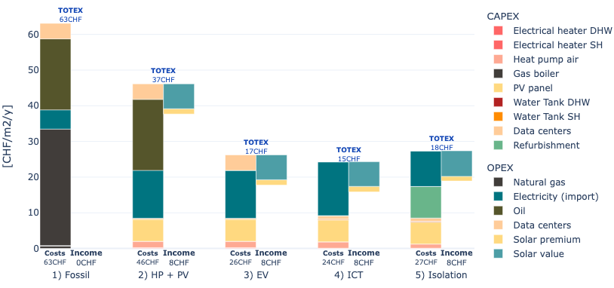
Starting from an energy system based on fossil fuel to satisfy the residents end use demands, the costs are likely to drop by 41% when integrating heat pumps combined with PV panels, and to 73% when enabling electric vehicles. Considering the integration of decentralized data centres into the building stock further stimulates synergies within the neighbourhoods and sets the cost reduction at 76%. Finally, the investigation regarding building isolation shows that an improvement of the thermal envelope translates to staying within a similar range of annual costs, while considerably reducing the demand for heat. These findings could serve as an encouraging benchmark contributing to energy planning towards net zero carbon cities in 2050.
  - Conclusion
Energy communities are poised to play a pivotal role in the generation, distribution, and management of renewable energy resources. In this context of evolving energy landscape, REHO stands as a versatile and indispensable tool for stakeholders in the renewable energy transition. Its MILP framework, consideration of diverse end-use demands, multi-energy integration, multi-scale adaptability, and multi-objective optimization drive informed decision-making in energy system planning.
Relevant links
REHO package: https://pypi.org/project/REHO/
REHO documentation: https://reho.readthedocs.io/en/main/
References
Alhamwi Alaa et al. “Modelling urban energy requirements using open source data and models”. Applied Energy 231 (Dec. 2018), pp. 1100–1108. ISSN: 03062619.
Caramizaru, Aura. “Energy communities: an overview of energy and social innovation.” European Commission - Joint Research Centre for Policy Report, 2020.
Chakrabarti Auyon et al. “Optimisation and analysis of system integration between electric vehicles and UK decentralised energy schemes”. Energy 176 (June 2019), pp. 805–815. ISSN: 03605442.
Dóci Gabriella, Vasileiadou Eleftheria, Petersen Arthur. “Exploring the transition potential of renewable energy communities”. Futures, Volume 66, 2015, Pages 85-95, ISSN 0016-3287.
Gupta Rahul, Sossan Fabrizio, and Paolone Mario. “Countrywide PV hosting capacity and energy storage requirements for distribution networks: The case of Switzerland”. Applied Energy (Jan. 2021), p. 116010. ISSN: 03062619.
Heldeweg Michiel, Saintier Séverine. “Renewable energy communities as ‘socio-legal institutions’: A normative frame for energy decentralization?”. Renewable and Sustainable Energy Reviews, Volume 119, 2020, 109518, ISSN 1364-0321.
Kotzur Leander and al. “Bottom-up energy supply optimization of a national building stock”. Energy and Buildings 209 (Feb. 2020), p. 109667. ISSN: 03787788.
Kramer Michael, Jambagi Akhila, and Cheng Vicky. “Bottom-up Modeling of Residential Heating Systems for Demand Side Management in District Energy System Analysis and Distribution Grid Planning”. 2017, p. 8.
Loustau Joseph, Lepour Dorsan, Terrier Cédric, and Maréchal François. “Clustering and typification of urban districts for energy system modelling”. Proceedings of the 36th International Conference on Efficiency, Cost, Optimization, Simulation and Environmental Impact of Energy Systems (June 2023).
Middelhauve Luise. “On the role of districts as renewable energy hubs”. PhD thesis. EPFL, 2022.
Mohammadi et al. “Energy hub: From a model to a concept – A review”. Renewable and Sustainable Energy Reviews 80 (Dec. 2017), pp. 1512–1527.
Murray Portia, Carmeliet Jan, and Orehounig Kristina. “Multi-Objective Optimisation of Power-
to-Mobility in Decentralised Multi-Energy Systems”. Energy 205 (Aug. 2020), p. 117792. ISSN: 03605442.
Pickering B. and Choudhary R.. “District energy system optimisation under uncertain demand: Handling data-driven stochastic profiles”. Applied Energy 236 (Feb. 2019), pp. 1138–1157. ISSN: 03062619.
Reynolds Jonathan and al. “Operational supply and demand optimisation of a multi-vector district energy system using artificial neural networks and a genetic algorithm”. Applied Energy 235 (Feb. 2019), pp. 699–713. ISSN: 03062619.
Stadler Paul. “Model-based sizing of building energy systems with renewable sources”. PhD thesis. EPFL, 2019.

