Robust Scheduling of Energy Systems Under Forecasting Uncertainty – A Multi-Parametric Optimization Approach
Rahul Kakodkar^{a,b}, Dustin Kenefake^{a,b}, Harsh Shah^{a,b}, Iosif Pappas^{c}, C. Doga Demirhan^{d}, Mete Mutlu^{d}, Xiao Fu^{c}, Efstratios N. Pistikopoulos ^{a,b,*}
ªArtie McFerrin Department of Chemical Engineering, Texas A&M University, 3122 TAMU, College Station, TX 77843, USA
^{b}Texas A&M Energy Institute, Texas A&M University, 1617 Research Pkwy, College Station, TX 77845, USA
^{c} Shell Technology Center, Shell Global Solutions International B.V., Amsterdam, Netherlands
^{d} Shell Technology Center, Shell International Exploration and Production Inc., Houston, TX
*stratos@tamu.edu
Abstract
Energy systems are affected by uncertainty at many scales; in the short term, scheduling energy systems with a high penetration of renewables can be challenging owing to the intermittency of solar and wind. Predictive frameworks can provide some insight through forecasts of weather and demand patterns. However, the forecasts themselves can introduce uncertainty. Nevertheless, methods exist to quantify the distribution and spread of forecasting error. To this end, we present a framework which leverages from quantified forecasting error to generate robust schedules at varying levels of conservativeness that is tunable by the decision-maker. Here the problem is cast as a multi-period robust optimization problem, then the robust deterministic equivalent is generated wherein our uncertainty in forecast is parameterized resulting in a multi-parametric formulation of the robust energy scheduling problem. This allows for an explicit representation of not only the robust schedule decisions, but also the exact relationship between the cost and forecasting uncertainty. The framework is demonstrated on a robust energy system scheduling problem involving a wind farm with uncertain availability and small modular nuclear reactor for power generation, and lithium-ion batteries for energy storage.

Keywords: forecasting, optimal scheduling, robust programming, multi-parametric optimization
  - Introduction
Renewable solar and wind energy has been proposed as an alternative energy source to support the push towards decarbonization. However, solar and wind are both available intermittently which presents a significant challenge in terms of planning and scheduling of energy systems (Kakodkar et al., 2022). It becomes important for decision makers to be aware of, even hedge against, the uncertainties that systems are affected by. In the multiscale multiperiod approach variabilities such as renewable intermittency, resource demand, costing parameters for resources and technology are treated through the consideration of time-series data at various scales (Zhang and Grossman, 2019) (Demirhan et al. 2020). Renewable intermittency is captured through historical weather data such as wind speed, solar irradiance, cloud cover, etc. While such frameworks provide considerable insight into integrated design and scheduling, resulting networks do not necessarily guarantee robustness.
Forecasting of weather-related phenomena and demand can be helpful to schedule the dispatch of power. However, the actual realizations can differ considerably from forecasts. To an extent, it is possible to estimate the uncertainty in predictions via methods such as Monte Carlo Dropout (MCD) which provides a more robust estimate of predictions by quantifying uncertainty or confidence. This allows quantitative insight into the extent of predictive error which decision makers can utilize to hedge against uncertainty in predictions. Such risk aware approaches can also be applied to determine the trade-off between cost and robustness. Additionally, multi-parametric optimization allows the generation of explicit algebraic solutions as a function of parameters, allowing to generate closed form solutions of optimization problems over a set of parameter realizations; further and more detailed information can be found in (Pappas et al., 2021).
To this end, we propose a multi-parametric optimization methodology that leverages the error bounds of forecasts to allow decision makers to generate the family of parametric robust schedules. The problem is first modelled as a parametric robust scheduling optimization problem, where the range of forecasting realizations is parameterized. This is then transformed into the parametric robust equivalent, which allows for the explicit solution as a function of the uncertainty in the forecast. This is then solved to recover the explicit algebraic relationship between uncertainty and the resulting robust schedule. This methodology is applied to a 24-period scheduling problem of an energy system with the option to meet a constant power demand for hydrogen production through uncertain wind forecasts and dispatchable nuclear energy, with an option for battery storage.
  - Methodology
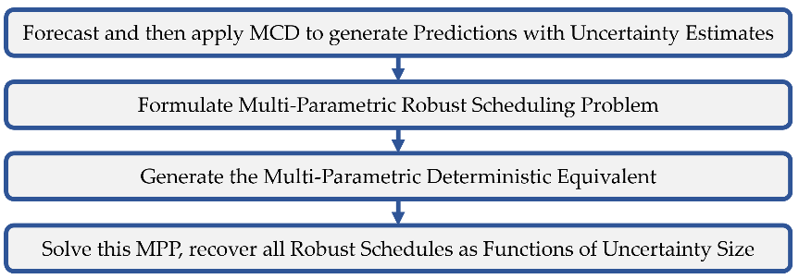
Figure 1: Overview of proposed methodology
The methodology of generating the parameterized set of robust schedules is described in this section. It is a four-step process, firstly the forecast and the forecast uncertainty are quantified, secondly the multiparametric robust scheduling problem is formulated, then this is converted into a deterministic equivalent where the uncertainty set for each forecast is parameterized, finally this is solved to recover the explicit algebraic relationship between uncertainty in the forecasts and the accompanying robust schedule. The overall flow of this methodology is summarized in Figure 1.
Recurrent Neural networks (NN) can be used to predict model outputs when modelling the underlying phenomena is elusive. One such method, Long Short-Term Memory (LSTM) takes time and sequence into account making it especially good at predicting weather patterns. The MCD model is applied during the model training which provides the distribution of the predictions, allowing the error surrounding the predictions to be inferred. This gives us the uncertainty bands around the predictions based on the alpha choice level, which is the chosen level of significance that determines the width of the confidence interval. Figure 2 illustrates these predictions and the confidence intervals surrounding these forecasts at chosen levels (99%, 95%, 90%, 85%).
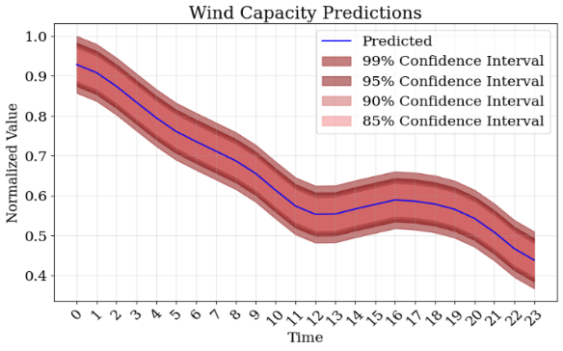
Figure 2. Short term wind forecast with error bounds using LSTM and MCD
A robust scheduling optimization problem is then formulated to model an energy system.
The formulation considers consumption ($C$), inventory ($Inv$), discharge ($S$) for resource ($r∈R$), and production levels ($P$) for processes ($i∈I$) as variables, while ${Cap}_{}^{Pred}$ is the predicted production capacity for a process in the time period ($t∈T$). The demand is fixed at a constant ($D$). The associated costs in the objective are purchase cost of resource ($C^{purch}$) and variable operation cost ($V_{opex}$). A diminishing cost factor, $δ$, is applied to prioritize decisions taken earlier in the scheduling horizon. Inventory can be transferred between different periods, which is captured in the inventory balance constraints (7). The range of the uncertainty, $σ⋅ϵ$, in the prediction is bounded by the parametric variable, $θ$. By modifying $θ$, the size of the uncertainty set also changes, and thus the level of robustness. Such that when $θ=0$, this is simply the nominal case, where no error is considered in the forecasted variables, ${Cap}_{}^{Pred}$. More generally, each uncertainty, $ϵ$, can be parameterized separately, here we model them together, so that all uncertainties share the same confidence intervals.
$$min \sum_{t∈T}{\sum_{r∈R}{δ^{t}{⋅C}^{purch}⋅C_{r,t}}}+\sum_{t∈T}{\sum_{i∈I}{{δ^{t}⋅V}_{opex}⋅P_{i,t}}}$$ |  | (1)
$${Inv}_{r,t}≤{Cap}_{i,t}^{Store-Max}$$ | $$∀ r∈R^{store}, t∈T$$ | (2)
$$P_{i,t} ≤{Cap}_{i,t}^{Pred}+ σ_{i,t}^{i}ϵ_{i,t}^{i}$$ | $$∀ i∈I, t∈T,∀ ϵ_{i,t}^{i}∈[-θ,θ]$$ | (3)
$$-S_{r,t}≤-D_{r,t}+ σ_{r,t}ϵ_{r,t}$$ | $$∀ r∈R^{sell}, t∈T, ∀ϵ∈[-θ, θ]$$ | (4)
$$C_{r,t }≤{C^{max}}_{r,t}$$ | $$∀ r∈R^{purch}, t∈T$$ | (5)
$$-S_{r,t }+\sum_{i ∈I}{P_{i,t}⋅η(i,r)} = 0$$ | $$∀ r∈R^{sell}, t∈T$$ | (6)
$$-{Inv}_{r,t-1 }+{Inv}_{r,t }-\sum_{i∈I}{P_{i,t}⋅η(i,r)} = 0$$ | $$∀ r∈R^{store}, t∈T$$ | (7)
$$C_{r,t }+\sum_{i∈I}{P_{i,t}⋅η(i,r)} = 0$$ | $$∀ r∈R^{cons}, t∈T$$ | (8)
The deterministic equivalent of the robust problem is then formulated with the uncertainty in the forecast resulting in a multi-parametric linear program (mpLP). This is done by robustifying constraint 3 by taking the worst-case realization of $ϵ_{i,t}^{i}$, which is simply $-θ$ in this case, as shown in eqn. 9 (Ben-Tal and Nemirovski, 1998). This transformation results in a mpLP containing only a single parameter, and thus can be efficiently solved to generate an explicit solution of the schedule as a function of the parameterized uncertainty. Schedules for any choice of robustness can then be generated by varying the $θ$ parameter.
$$P_{i,t} ≤Ca{p_{i,t}}^{Pred}-σ_{i,t}^{i}θ$$ | (9)
  - Case Study and Discussion
We consider a simple energy system as seen in Figure 3, which seeks to meet a constant demand of power for a hydrogen production unit. The demand is met through generation from a wind farm (WF); a small modular nuclear reactor (SMR) is able to supplement power generation at a higher cost, and a lithium ion battery (LiI) is available for energy storage. The demand for power is assumed to be constant, while the availability of wind varies with time periods. An initial inventory of power is provided, where maximum inventory is capacitated.
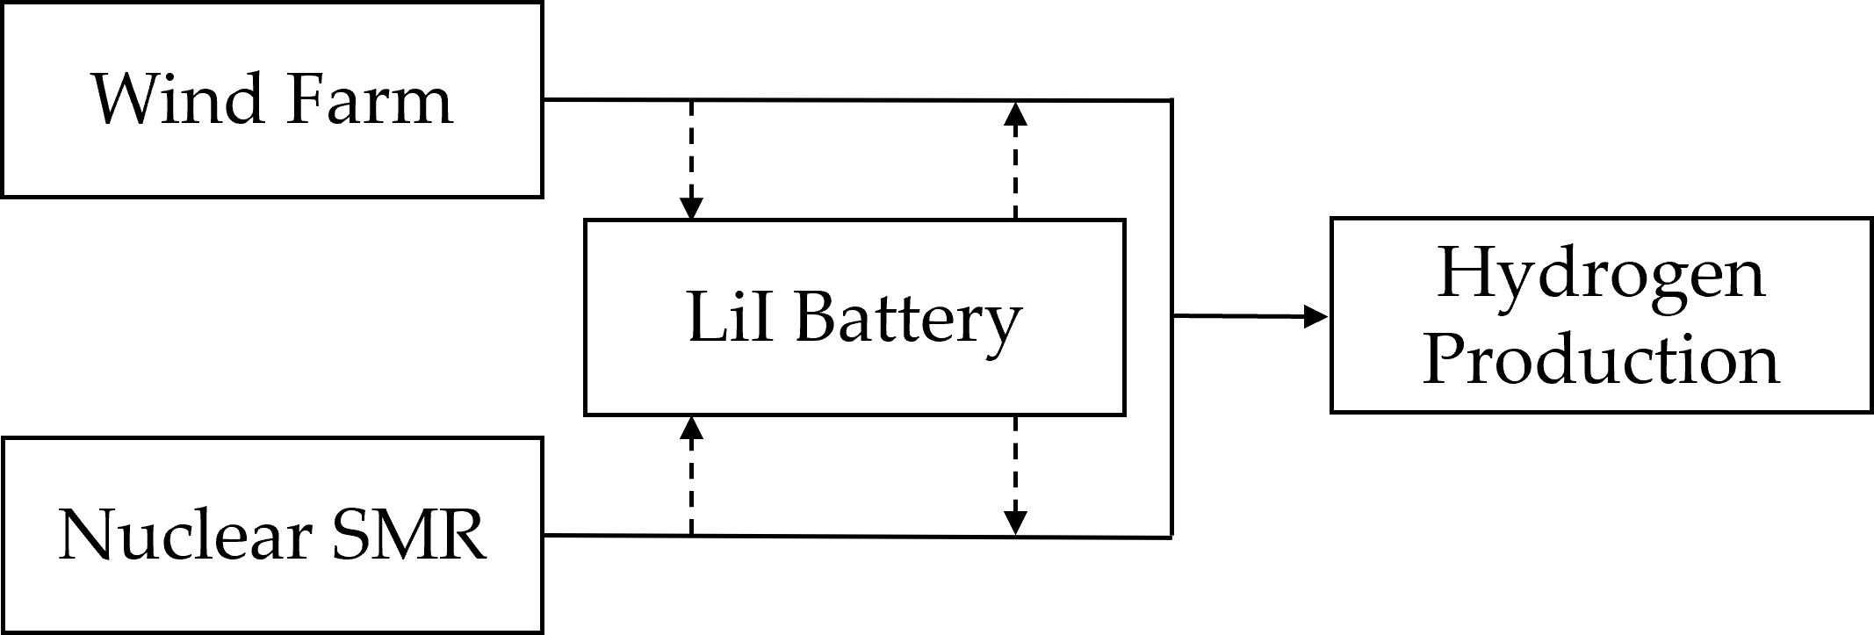
Figure 3. Schematic representation of the considered process
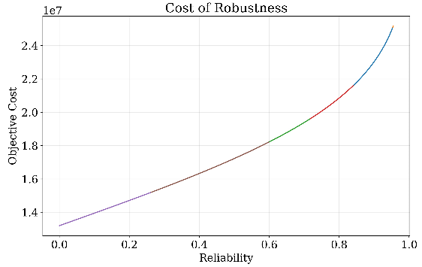
LSTM with MCD is used to generate a 24 hour weather forecast with quantified uncertainty. The model is trained on Houston (USA) wind speeds, which serve as a proxy for capacity factors. The model is found to fit well (RMSE: 0.056, MAPE: 2.105, R-squared: 0.971, MDA: 0.663). The wind predictions are used as the parameter ${Cap}_{i,t}^{Pred}$ with $σ_{i,t}^{i}ϵ_{i,t}^{i}$ representing the range of the uncertainty in forecast. As we do not consider uncertainty in any other process or demand besides WF, we consider $σ=0$ for the rest. The system is modelled in the energiapy python package (Kakodkar and Pistikopoulos, 2023), to generate the initial robust formulation, and the deterministic robust equivalent.
Figure 4. Cost and Reliability Trade-off

The resultant mpLP is solved to generate the explicit solution containing six critical regions. This was done utilizing PPOPT (Kenefake and Pistikopoulos, 2022), a general purpose multi-parametric optimization solver, using the geometric algorithm. The solution is obtained within 0.5 seconds. The size of the uncertainty set, $θ$, captures varying degrees of robustness, and the associated schedules are generated along with the objective cost. A comparison of costs over different levels of robustness allows the determination of the cost of robustness as shown in Figure 4.
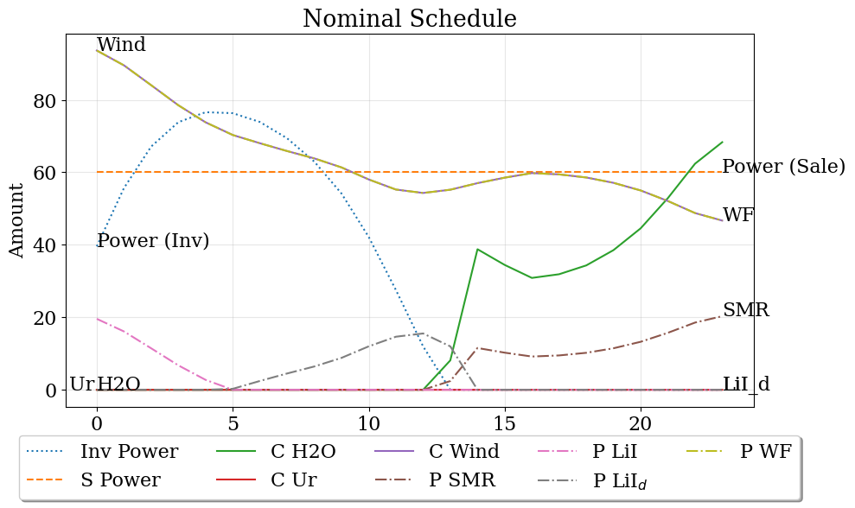 | 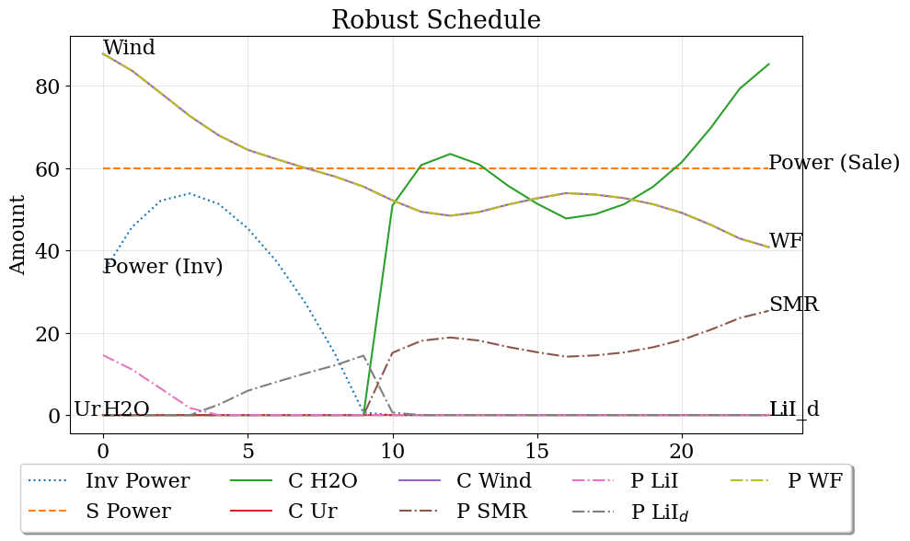
Figure 5. a) Schedule for nominal case study without considering uncertainty b) Robust schedule immunizing against 95% of uncertrainty realizations
The objective cost of the scheduling solution is plotted for two standard deviations ($θ=2$) which covers a 95% confidence interval. Further, schedules can be generated for any choice of $θ$. Figure 5a, shows the schedule for the nominal case, i.e. $θ=0$. The robust schedule (Figure 5b), for a 95% confidence interval, maintains a lower inventory level as compared to the nominal case. This is due to the expectation of a lower wind forecast which leads the system to rely on more expensive dispatchable power (SMR). In contrast, the nominal schedule utilizes a larger inventory sourced through wind production; nuclear power is also utilized relatively later in the planning horizon.
  - Conclusions and Future Directions
A risk-aware framework for the scheduling of energy systems under uncertainty was proposed, where the level of robustness is parameterized. Given that the explicit robust solution is found as a function of the uncertainty, it can be used to determine cost optimal schedules under varying degrees of robustness at a given time step. The cost v. reliability curve for schedules was produced, in this case showing a nonlinear relationship between reliability and cost. One of the robust schedules was compared to the nominal solution to visualize the effect of introducing robustness into the scheduling problem. The robustness levels were found to prefer more expensive dispatchable sources of power to uncertain renewables. This in turn affects the inventory levels which are lower for the robust scenario. The system was modelled and optimized in the energiapy and PPOPT python packages respectively. In future iterations, the framework will be augmented to include discrete decisions resulting in robust multi-parametric mixed integer linear programs (mpMILPs), an increase in the size of the energy system that is being analysed, operational constraints such as ramping constraints for dispatchable energy sources, and uncertainty in demand realizations alongside intermittency of renewables, and multiple locations.
  - Acknowledgements
We would like to thank Shell Plc., the Texas A&M Energy Institute, and the Artie McFerrin Department of Chemical Engineering for their generous support and funding.
References
R. Kakodkar, G. He, C. D. Demirhan, M. Arbabzadeh, S. G. Baratsas, S. Avraamidou, and D. Mallapragada, 2020, A review of analytical and optimization methodologies for transitions in multi-scale energy systems., Renewable and Sustainable Energy Reviews, 160, 112277.
Ben-Tal, A., & Nemirovski, A. (1998). Robust convex optimization. Mathematics of operations research, 23(4), 769-805.
Zhang, Q., Martín, M., & Grossmann, I. E. (2019). Integrated design and operation of renewables-based fuels and power production networks. Computers & Chemical Engineering, 122, 80-92.
Demirhan, C. D., Tso, W. W., Powell, J. B., Heuberger, C. F., & Pistikopoulos, E. N. (2020). A multiscale energy systems engineering approach for renewable power generation and storage optimization. Industrial & Engineering Chemistry Research, 59(16), 7706-7721.
Kenefake, D., & Pistikopoulos, E. N. (2022). Ppopt-multiparametric solver for explicit mpc. In Computer Aided Chemical Engineering (Vol. 51, pp. 1273-1278). Elsevier.
Kakodkar, R., & Pistikopoulos, E. (2023, November). Energiapy-an Open Source Python Package for Multiscale Modeling & Optimization of Energy Systems. In 2023 AIChE Annual Meeting. AIChE.
Pappas, I., Kenefake, D., Burnak, B., Avraamidou, S., Ganesh, H. S., Katz, J., ... & Pistikopoulos, E. N. (2021). Multiparametric programming in process systems engineering: Recent developments and path forward. Frontiers in Chemical Engineering, 2, 620168.

