An Optimization Model for the Maximization of Crop Productivity, Biodiversity, and Ecosystem Services
Caleb H. Geissler^{a,b}, Christos T. Maravelias^{a,b,c*}
ªDepartment of Chemical and Biological Engineering, Princeton University, Princeton, NJ 08540, USA
^{b}DOE Great Lakes Bioenergy Research Center, USA
^{c}Andlinger Center for Energy and the Environment, Princeton University, Princeton, NJ 08540, USA
maravelias@princeton.edu
Abstract
Agricultural expansion has led to significant losses in biodiversity and ecosystem services. Empirical studies have shown that integrating strips of native prairie into croplands can improve biodiversity and ecosystem services, and that these improvements increase with the amount of prairie and the length of edges between the prairie and crop. Researchers have developed models to balance profit and biodiversity or ecosystem services at large landscape scales. However, at such large scales, these models are often limited to coarse resolutions and cannot consider edge effects. Furthermore, they must be solved with local-search techniques or other heuristics that do not guarantee an optimal solution. We present a multi-objective mixed-integer optimization model for cropland design consider crop production, biodiversity, and ecosystem services. To illustrate the model, we apply it to a case study of a field in central Michigan, USA.
Keywords: Conservation planning, biodiversity, ecosystem services, mixed-integer optimization
  - Introduction
Increasing industrial agriculture has provided the high crop yields needed to feed a growing population but has come with significant degradation to the natural environment. One element of this degradation is a loss of native wildlife. In an effort to counteract this, many studies have developed models for conservation planning, which select planning units in a landscape to protect or revert to natural cover. These models often seek to minimize the area or cost of establishing a reserve that adequately protects either a specific species or a group of endangered species (Billionnet, 2013). To correlate habitat area with species survival, models of species persistence have been developed, which may include the size of individual habitats, distances between them, and the dispersal of each species. One such model developed by Polasky includes a penalty for habitat fragmentation but does not support any potential benefit from habitat fragmentations that some species may have (Polasky et al., 2008).
Another aspect of the natural environment impacted by agriculture is the delivery of ecosystem services, such as greenhouse gas (GHG) sequestration. Detailed models have been developed to predict some ecosystem services based on crop data, soil type, weather, and terrain. However, these models are computationally demanding to run and typically can only simulate results when the land cover type is specified, making them difficult to incorporate into models for the design of the cropland (Basso and Ritchie, 2015).
Some researchers have examined the design of large landscapes considering economic, biodiversity, or ecosystem services objectives. For example, Williams et al. (2020) used a simple allocation model with static agriculture production, biodiversity, and ecosystem services values for planning units in Colombia. Another study built on the biodiversity model developed by Polasky et al. and used it to study agricultural profit, biodiversity, and water quality in Brazil (Kennedy et al., 2016). However, these and other studies in the literature have a few key limitations. Because they involve binary decisions variables and highly nonlinear interactions, they are solved using local search techniques which cannot guarantee optimal, or even near-optimal, solutions. These studies also typically ignore field management decisions such as fertilization. Furthermore, even the models with a fine spatial resolution do not include edge effects for any objectives, which have been shown to impact biodiversity and ecosystem services (Robinson et al., 2009).
In this paper, we present a mixed-integer linear multi-objective optimization model to design a cropland while simultaneously considering crop production, biodiversity, and GHG emissions. We include field management decisions and the impact that edges between different plants can have on these objectives, which previous studies have ignored. To highlight the capabilities of the model, we examine a case study on a real field in central Michigan, USA for which we have experimental data.
  - Cropland Model
    - Model Overview
A summary of the key elements in the model is given in Fig. 1.
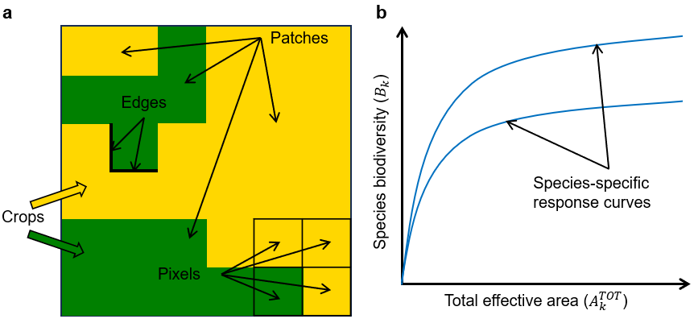
Figure 1. a) summary of the key elements in the model b) example of the species response curves used for calculating biodiversity.
The cropland is split up into a grid of pixels $i∈I$. Given that real data for yield is available as square pixels, we assume square pixels in the model. In each pixel, one crop $j∈J$ can be established, controlled by the binary variable $X_{i,j}$,
$$\sum_{j}{X_{i,j}}=1 ∀i∈I$$ | (1)
The model we present includes constraints for biomass production, biodiversity, and GHG emissions. Each of these aspects is briefly discussed in the following sections.
    - Biomass Production
It is assumed that it is known how much of each crop would be produced if it is established in a given pixel ($ψ_{i,j}$), and how much the production would increase if that pixel is fertilized ($ψ_{i,j}^{F}$). The additional yield from fertilization is assumed to have a linear response. Therefore, the amount of crop production in a pixel, $P_{i,j}$, can be calculated,
$$P_{i,j}=ψ_{i,j}X_{i,j}+ψ_{i,j}^{F}N_{i,j} ∀i∈I, ∀j∈J$$ | (2)
where $N_{i,j}$ is the amount of fertilizer applied to a crop in a pixel. The total amount of fertilizer applied to a pixel is also bounded,
$$N_{i,j}≤β_{i,j}^{N}X_{i,j} ∀i∈I, ∀j∈J$$ | (3)
where $β_{i,j}^{N}$ is the upper bound of fertilizer application to a crop in a pixel. The total profit of the cropland, $R$, can be calculated,
$$R=\sum_{i,j}{π_{j}^{S}P_{i,j}}-\sum_{i,j}{π_{i,j}^{C}X_{i,j}}-\sum_{i,j}{π^{N}N_{i,j}}$$ | (4)
where $π_{j}^{S}$ is the sale price or a crop, $π_{i,j}^{C}$ is the total cost of planting and harvesting a crop, and $π^{N}$ is the price of purchasing and applying fertilizer.
    - Biodiversity
Biodiversity can be difficult to quantify, and therefore we must make some simplifying assumptions. We use flow-based constraints to group contiguous pixels with the same crop established into patches. Flows go between pixels within the same patch and go towards a sink. Different crops provide varying qualities of habitat for different species $k∈K$. The area of a patch of crop $j$ with its sink at pixel $i$, $A_{i,j}^{P}$, is multiplied by a species-specific habitat compatibility score ($η_{j,k}∈[0,1]$) and the area of a pixel to determine the adjusted area of a patch for a given species, $A_{i,k}^{ADJ}$,
$$A_{i,k}^{ADJ}=α\sum_{j}{η_{j,k}A_{i,j}^{P}} ∀i∈I, k∈K$$ | (5)
The adjusted areas of each patch are added together, with an adjustment for each type of edge, to find the total effective area for a given species, $A_{k}^{TOT}$,
$$A_{k}^{TOT}=\sum_{i}{A_{i,k}^{ADJ}}+\sum_{j,j^{'}<j}{η_{j,j^{'},k}^{E}E_{j,j^{'}}} ∀k∈K$$ | (6)
where $η_{j,j^{'},k}^{E}$ is the parameter for the impact of an edge between two crops on the biodiversity of a species and $E_{j,j^{'}}$ is the number of edges between two crops in the cropland. We note that $η_{j,j^{'},k}^{E}$ can be positive, negative, or zero for each combination of species and edge between two different plants. From the total effective area, species-specific saturating response curves are used to generate a biodiversity score for each species, $B_{k}$.
    - Ecosystem Services
GHG emissions are generated from planting, maintenance, and harvesting of each plant, and some crops sequester emissions in the form of soil organic carbon. The balance of these emissions for each crop in each pixel, $ϕ_{i,j}$, is assumed to be known. Additional emissions are generated if fertilizer is added, both from producing and applying the fertilizer. Further, in some cases edges between crops can affect emissions. Therefore, the balance of GHG emissions in the cropland, $G$, can be calculated,
$$G=\sum_{i,j}{\left[ϕ_{i,j}X_{i,j}+ϕ_{i,j}^{F}N_{i,j}\right]}+\sum_{j,j^{'}<j}{ϕ_{j,j^{'}}^{E}E_{j,j^{'}}}$$ | (7)
where $ϕ_{i,j}^{F}$ is the additional emissions from the application of fertilizer and $ϕ_{j,j^{'}}^{E}$ is the change in emissions from an edge between two plants.
    - Overall objective
From these three different objectives, we evaluate the total objective ($OBJ$),
$$OBJ=ξ^{P}R+\frac{ξ^{B}}{|K|}\sum_{k}{B_{k}}+ξ^{G}G$$ | (8)
where $ξ^{P}$, $ξ^{B}$, and $ξ^{G}$ are weights for profit, biodiversity, and GHG emissions, respectively.
  - Case Study
    - Input Parameters
We use experimental data for crop yield from the long-term scale-up experiment by the Great Lakes Bioenergy Research Center (GLBRC) at Marshall farms, with each pixel having a 20x20 meter resolution. Habitat compatibility scores for ants and butterflies in corn and prairie grass and the species-specific saturating response curves are generated from experimental data from the Biofuel Cropping System Experiment, also performed by the GLBRC. Additional data are taken from the literature. In all instances, the model is implemented in GAMS 45.2 and solved with Gurobi 10.0 to a 0.1% optimality gap on 2.6 GHz Linux cluster machines. For the following sections, the epsilon-constraint method was used to generate results, for which equal weights are applied to all objectives.
    - No Edge Impacts
First, we present results for designing the cropland without considering edges. In this case, the model consists of 11,461 continuous and 2,964 binary variables. Using the model, a pareto frontier of profit and biodiversity was generated. For a given minimum value of profit and biodiversity, the optimal GHG balance was determined similarly. These results are shown in Fig. 2a.
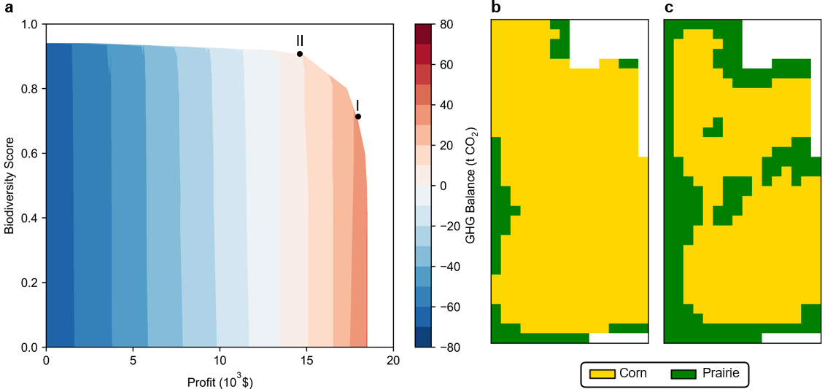
Figure 2. a) Plot showing the pareto frontier of profit, biodiversity, and GHG balance. Note that a positive GHG balance indicates net emissions. Resulting cropland designs for two example points (I and II) on the pareto curve are shown in panels b and c, respectively.
When only profit is maximized, the biodiversity score of the cropland is at most 0.36. However, with minor decreases in profit, biodiversity can be greatly increased, reaching a score of 0.8 for only a 10% reduction in profit. This occurs because there are pixels, often on the perimeter of the field, where corn yield is very low, allowing them to be replaced with prairie at only a small financial cost. Further, the biodiversity benefit of prairie is assumed to depend on area instead of yield, so even low-yielding areas contribute to biodiversity. Figs. 1b-c show how with increasing prioritization of biodiversity, more prairie is planted in pixels around the perimeter of the cropland and other low-yielding pixels. Fig. 1a also shows that GHG emissions largely scale linearly with the amount of land dedicated to corn. When profit is maximized, there are net emissions of 32 tCO₂e/y. This can be improved to net sequestration of 67 tCO₂e/y if there is no constraint on profit. Generally, the GHG balance is not strongly influenced by a minimum biodiversity score. The exception is that when maximizing biodiversity with a constraint on a minimum profit, it becomes optimal to fertilize pixels with prairie to meet the profit requirement. Fertilization increases emissions, leading to a minor increase in the GHG balance at the upper limit of biodiversity score for a given minimum profit.
    - Edge impacts
With the additional consideration of edges, the model can include the impact of patch shape on biodiversity, as well as the impact of edges on the GHG balance. The impact of edges can affect species in different ways. In this section, we highlight different croplands designs that would be obtained based on the inclusion of edge effects for butterflies and ants when maximizing biodiversity subject to no more than a 10% reduction in maximum profit. Here, the model consists of 10,937 continuous and 6,105 binary variables. The results are shown in Fig. 3. As seen when comparing Fig. 3b to 3a, penalizing the presence of edges results in a decrease from 6 patches of prairie to 4, reducing the number of edges between prairie and corn. The patch of prairie along the outside of the cropland does not become more compact (thus reducing the number of edges) because to do so would require planting prairie in pixels that have high corn yield. Comparing Fig. 3b to 3c shows that when there is a biodiversity benefit of edges, a marked change in the optimal cropland design can appear, with many more small patches of prairie being planted.
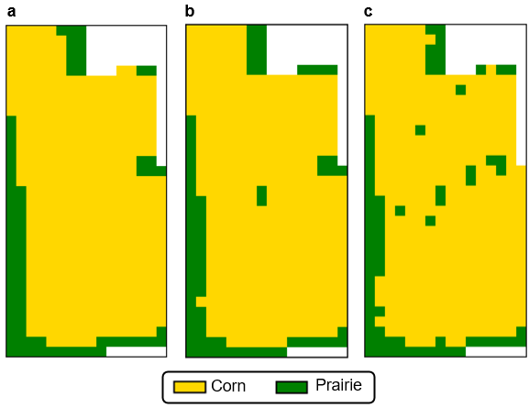
Figure 3. Example cropland designs for when the edges between corn and prairie a) decreases biodiversity b) has no effect on biodiversity c) increases biodiversity.
  - Conclusions
We present a multi-objective optimization model that considers crop production, biodiversity, and ecosystem services. Unlike other models in the literature, our model 1) considers edge effects 2) includes fertilization as a decision variable and 3) can be solved to global optimality. To highlight the capabilities of the model, we apply it to the design of a field for which experimental yield data is known. We show that dramatic increases in biodiversity can be obtained for relatively minor decreases in profit and demonstrate how species response to the presence of edges can affect the optimal cropland design.
References
B. Basso, J.T. Ritchie, 2015, Simulating crop growth and biogeochemical fluxes in response to land management using the SALUS model, The Ecology of Agriculutral Landscapes: Long-Term Research on the Path to Sustainability, Oxford University Press, New York, USA, 252-274.
A. Billionnet, 2013, Mathematical optimization ideas for biodiversity conservation, Eur. J. Oper. Res., 231, 3, 514-534.
C.M. Kennedy, P.L. Hawthorne, D.A. Miteva, L. Baumgarten, K. Sochi, M. Matsumoto, J.S. Evans, S. Polasky, P. Hamel, E.M. Vieira, P.F. Develey, C.H. Sekercioglu, A.D. Davidson, E.M. Uhlhorn, J. Kiesecker, 2016, Optimizing land use decision-making to sustain Brazilian agricultural profits, biodiversity, and ecosystem services, Biol. Conserv., 204, 221-230.
S. Polasky, E. Nelson, J. Camm, B. Csuti, P. Fackler, E. Lonsdorf, C. Montgomery, D. White, J. Arthur, B. Garber-Yonts, R. Haight, J. Kagan, A. Starfield, C. Tobalske, 2008, Where to put things? Spatial land management to sustain biodiversity and economic returns, Biol. Conserv., 141, 6, 1505-1524.
D.T. Robinson, D.G. Brown, W.S. Currie, 2009, Modelling carbon storage in highly fragmented and human-dominated landscapes: Linking land-cover patterns and ecosystem models, Ecol. Model., 220, 9-10, 1325-1338.
B.A. Williams, H.S. Grantham, J.E.M. Watson, S.J. Alvarez, J.S. Simmonds, C.A. Rogéliz, M. Da Silva, G. Forero-Medina, A. Etter, J. Nogales, T. Walschburger, G. Hyman, H. Beyer, 2020, Minimizing the loss of biodiversity and ecosystem services in an intact landscape under risk of rapid agricultural development, Environ. Res. Lett., 15, 1, 014001.

