Utilization of Solid Wastes to Satisfy Energy Requirements of LNG Process
Ahmed AlNouss, Gordon Mckay, Tareq Al-Ansari*

College of Science and Engineering, Hamad Bin Khalifa University, Qatar Foundation, Doha 34110, Qatar
Talansari@hbku.edu.qa
Abstract
All across the world, governments struggle to diversify their energy supply with an appropriate and sustainable replacement for fossil fuels while reducing the environmental effects of discharged waste. Due to the potential for increased fuel production and downstream electricity while reducing greenhouse gas emissions, the conversion of industrial wastes has drawn a lot of interest. Solid waste holds the highest potential as a biomass source due to the rapid increase in industrial expansion. The most significant solid waste is oily sludge, a combination of hydrocarbon, sand, clay, and certain metals that is pasty, dense, and semi-solid. However, the solid waste generation specifically from industrial operations possess environmental concerns related to waste management being addressed insufficiently. This study presents an overview on industrial solid waste (ISW) generated from different plant’s operation that has the potential to be used as a source of bioenergy in the Liquefied Natural Gas (LNG) process to satisfy energy requirements. Moreover, the study presents additional solids waste that can be potentially utilized to fulfil the power demand of the LNG process. Aspen software is utilized to simulate the gasification of ISW as a biomass feedstock in the power generation flowsheet. Waste-to-energy gasification technology, which recovers energy from discarded and difficult-to-treat ISW and generates electricity and/or steam for heating, is recognized as a renewable energy source and is becoming more and more significant in waste management. Oily sludge is significant solid waste in the LNG process that is produced from multiple units such as; pig receiver, slug catcher, condensate separation, wastewater treatment, tank cleaning and chemical regeneration processes. The power analysis of a 3.12 million metric tons per annum LNG production facility indicates that the gasification of industrial solid waste (ISW) can fulfil only 0.43% of the energy demands within the LNG production process. Nevertheless, this energy integration results in an 18% reduction in utility emissions, thereby decreasing the reliance on plant utilities and associated emissions. Additionally, it addresses the disposal of rejected and challenging-to-treat industrial wastes.
Keywords: Industrial Solid Wastes, LNG, Simulation, Sustainability.
  - Introduction
With each passing day, the need to mitigate the detrimental effects of global climate change becomes more pressing. As a result, a growing number of countries and businesses are declaring to become carbon neutral by 2050, and the supply and demand for fossil fuels, notably oil and gas, are expected to fall. Gas appears to be more resilient in the coming years, particularly liquefied natural gas, although even LNG will eventually be replaced by renewable energy sources or undergo emissions reductions to satisfy the needs of a 1.5-degree trajectory (Agosta et al., 2021). Human activity is primarily responsible for climate change owing to greenhouse gas (GHG) emissions from fossil-fuel consumption according to the Intergovernmental Panel on Climate Change (IPCC). Following the Kyoto Protocol commitment, several climate change mitigation measures were implemented in the EU to reduce anthropogenic GHG emissions, and incentives were provided to develop renewable power plants to reduce reliance on fossil fuels. Renewable energy sources have a variable and intermittent nature, with peak output often falling short of demand. As the use of these sources develops in the energy power source scenario, grid balancing without regulating the RES power plant is required (Morosanu et al., 2018). Globally, access to electricity has grown, from 60 million more users per year in 2000-2012 to 100 million per year in 2012-2016. Despite this expansion, roughly 675 million people will still lack access to power in 2030, showing that demand for energy will continue to rise (Indrawan et al., 2020). As a renewable energy source, biomass for energy provides commercially viable options with high dispatch-ability. Biomass application is only economically viable in locations where biomass resource density is high and there is a demand for both heat and power, allowing combined heat and power (CHP) plants to be used (Pihl et al., 2010). Solid waste holds the highest potential as a biomass source due to the rapid increase in industrial expansion. The most significant solid waste is oily sludge, a combination of hydrocarbon, sand, clay, and certain metals that is pasty, dense, and semi-solid. However, the solid waste generation specifically from industrial operations possess environmental concerns related to waste management being addressed insufficiently (Lahlou et al., 2023). This study presents the potential of solid biomass gasification generated from different plant’s operation to be used as a source of bioenergy in the Liquefied Natural Gas (LNG) process to satisfy energy requirements. The aim is to find the potential of industrial solid wastes (ISW) that maximizes the power production and satisfy highest portion of LNG power and heat demands. Scholars in literature have studied power to LNG from different perspectives. Morosanu et al. (2018) created a unique power-to-liquefied-methane design for a 200 kW demonstration plant, completed with process simulations. Water electrolysis to create hydrogen, CO₂ extraction from air using solid adsorption materials, catalytic CO₂ methanation, gas separation, and a single mixed refrigerant (SMR) liquefaction process are all part of the proposed system. The study yielded process efficiency of up to 46.3% (electric to chemical). The findings of the process modeling also demonstrated that the influence of the gas pretreatment and liquefaction process on plant energetics is 4% of total power input. Indrawan et al. (2020) developed a review that focuses on recent technological developments in seven power generation technologies (i.e. fuel cell, organic rankine cycle generator, Stirling engine, steam turbine, micro gas turbine, gas turbine, and internal combustion engine) that are suitable for distributed power applications and can operate independently using syngas derived from biomass and MSW gasification. The major obstacles that these power production technologies face in their future development and commercialization are explored. Pihl et al. (2010) conducted a techno-economical analysis of possibilities for integrating biomass thermal conversion with existing CCGT power facilities. The software Ebsilon Professional and Aspen Plus are used to model simple cycle biomass steam plant, indirect gasification of biomass and hybrid combined cycles (HCC). It was discovered that integrating biomass with CCGT power plants can result in significant efficiency gains and potential cost savings when compared to stand-alone facilities. Recently, Shahbaz et al. (2023) examined three types of waste streams arising from the oil and gas industry: liquids (produced water), flue gases (CO₂ and SO₂), and solid waste (oil sludge). The review addressed their potential emergent prospects current problems, treatment technologies and characterization. There is also information on the resource recovery and reuse possibilities of all three types of wastes studied. Finally, a case study from the State of Qatar is presented in order to evaluate the theoretical resource recovery and market/economic potential of chosen trash.
  - Methodology and Data
The oil and gas industry produces two types of solid waste: organic and inorganic waste. Inorganic wastes include un-combustible waste, such as sand, drilling fluid and metal scraps from sites, which is also produced during drilling, site construction, petroleum refining industry, and transportation. Organic waste is combustible and includes hydrocarbon waste, such as plastic scrap and oil sludge, which is the most important component for waste to energy conversion. The oil sludge is produced during the washing of equipment, hydrocarbon cracking, reforming section, storage tank and the effluent treatment solution. According to a study, 500 tons of oil produces one ton of OS (Shahbaz et al., 2023). In LNG process, oily sludge is significant solid waste that is produced from multiple units such as; pig receiver, slug catcher, condensate separation, wastewater treatment, tank cleaning and chemical regeneration processes (Coffey, 2022).
In this study, Aspen software is utilized to simulate the gasification of oily sludge as a biomass feedstock in the power generation flowsheet. The characteristics of the oily sludge are summarized in Table1. In addition, Aspen is utilized to simulate the LNG process in order to estimate the requirement of power and heat for each section and match it with relevant production from oily sludge gasification.
Table 1: Characteristics of oily sludge
Att. | Moist | Fixed Carbon | Volatile  Matter | Ash | C | H₂ | N₂ | S | O₂
% | 8.3 | 19.41 | 8.83 | 71.76 | 19.08 | 2.32 | 1.1 | 0.09 | 5.65
Figure 1: BIGCC process flow diagram
The power generation process from oily sludge is simulated following the Biomass Integrated Gasification Combined Cycle (BIGCC) design illustrated in Figure 1. The assumptions include steady-state conditions, a 13% of overall process efficiency with 1676 kg per MWh biomass to power ratio, and 1620 kg per MWh emissions to power ratio for oxygen-based gasification. The hot effluent syngas from the biomass gasification unit is first cooled to recover the heat, and then enters the combustion reactor. The combustion gases expand in a gas turbine to generate electrical power before it enters the steam generation unit to produce additional power through a series of heat exchangers and steam turbines. The BIGCC design is modelled based on earlier published work on biomass gasification (AlNouss et al., 2023b, 2023a; AlNouss et al., 2022) and BIGCC (Ghiat et al., 2020).
The simulated LNG onshore process illustrated in Figure 2 consist of two main sections: the cold section and the hot section. The hot section encompasses the pre-separation, dehydration, acid gas removal (AGR), and sulfur recovery unit (SRU). In contrast, the cold section comprises units for natural gas liquids (NGL) recovery and fractionation, helium extraction (HeX), gas liquefaction, and nitrogen removal (NR). The process begins with the pre-separation unit, which initially separates sour water and condensate from the sour natural gas (NG) feedstock. The sour NG is then treated to remove dehydration water to prevent hydrate formation and downstream corrosion. The sweetening unit follows, which takes the sour NG and removes undesirable components, including benzene, methylene, xylene (BTX), mercaptans, H₂S, and CO₂, collectively known as acid gases. The SRU unit receives streams from the sweetening unit and utilizes them to produce elemental sulfur allotropes from H₂S. The combustion of acid gas also leads to the creation of SOx. The NGL recovery and fractionation unit play a crucial role in separating residual condensate and providing propane and ethane as refrigerants when needed for liquefaction, while also meeting standard LNG specifications. The primary fractionation plant employs the propane pre-cooled mixed refrigerant (C3MR) liquefaction and cooling process. This process involves compressing vapor in two cycles, which sub-cools, condenses, crushes, and regulates the refrigerants, with the evaporation process providing primary cooling. After liquefaction, the high-pressure LNG undergoes treatment in integrated NR and HeX units to recover helium and meet LNG product purity requirements, such as higher heating value (HHV) and nitrogen content. Subsequently, the LNG can be loaded onto tankers or stored in tanks. The LNG process is modelled based on earlier published work (Fouladi et al., 2023; Al-Yafei et al., 2022; Shaikh et al., 2022).
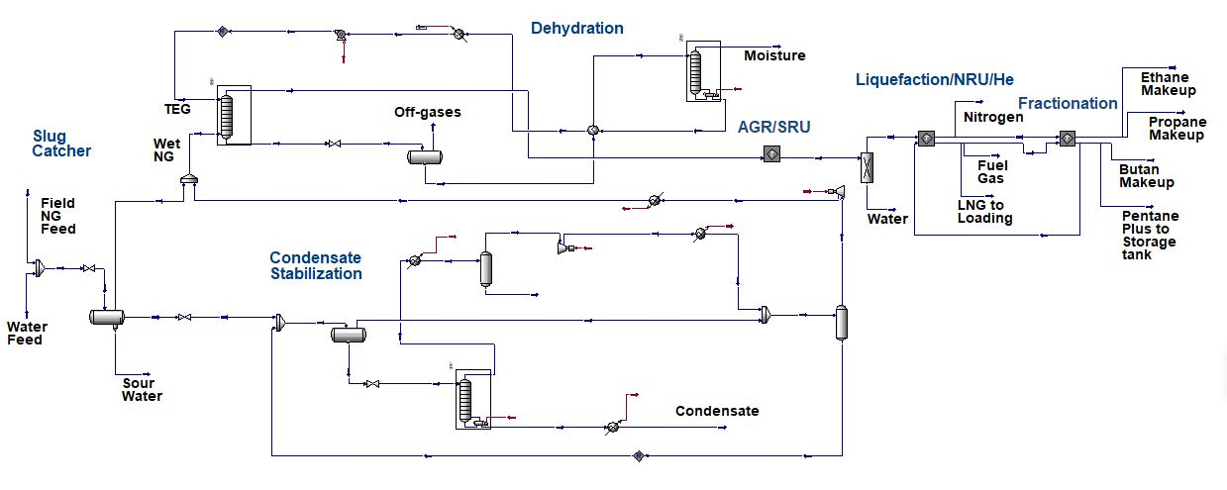
Figure 2: LNG process flow diagram
  - Results
The simulated LNG process produces 3.12 MMTPA of LNG which is associated with around 6250 TPA of oily sludge according to literature (Shahbaz et al., 2023). The results of the Aspen simulation is divided into two parts. The power and heat production from oily sludge gasification and the energy requirement by LNG process. The oxygen-based gasification of oily sludge generates power and heat quantities as illustrated in Table 2.
Table 2: Power and heat production from oily sludge gasification
Oily Sludge (TPA) | Power (kW) | Heat (kW) | Emissions (kg/h CO₂-e)
6250 | 1900 | 900 | 457

The energy requirement of LNG process is illustrated in Figure 3 for each section of the plant along with the associated emissions. The overall requirement of LNG process is 632 MW that is associated with a total of 130,239 kg/h of CO₂-e.
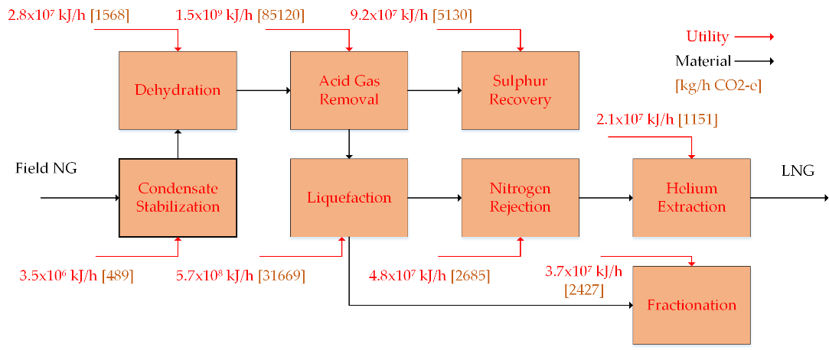
Figure 3: Energy requirement of LNG process
Based on the comparison of oily sludge gasification and LNG process requirement, the power results from biomass gasification demonstrate very small coverage of 0.43% of the energy requirement in the 3.12 MMTPA LNG production facility. However, this small energy integration reduce the associated utility emissions by 18%, hence sustainably reducing the requirement for plant utilities and associated emissions in addition to treating the discarded and difficult-to-treat industrial wastes.
  - Conclusions
Governments all around the globe are struggling to diversify their energy source with a suitable and sustainable substitute for fossil fuels while lowering the environmental impact of discharged trash. The conversion of industrial wastes has sparked a lot of attention because to the possibility for increased fuel output and downstream energy while lowering greenhouse gas emissions. Because of the fast growth in industrial expansion, solid waste has the most potential as a biomass source. The most major solid waste is oily sludge, a pasty, thick, and semi-solid mixture of hydrocarbon, sand, clay, and some metals. However, solid waste creation, particularly from industrial operations, raises environmental issues due to inadequate garbage management.This paper provides an overview of industrial solid waste (ISW) generated from various plant operations that has the potential to be used as a source of bioenergy in the LNG process to meet energy requirements. In the power generation flowsheet, Aspen software is used to simulate the gasification of ISW as a biomass feedstock. Waste-to-energy gasification, which recovers energy from discarded and difficult-to-treat ISW and creates electricity and/or steam for heating, is regarded as a sustainable energy source and is becoming increasingly important in waste management. Oily sludge is a substantial solid waste produced by many units in the LNG process, including the pig receiver, slug catcher, condensate separation, wastewater treatment, tank cleaning, and chemical regeneration operations. The results obtained from the power analysis of a 3.12 MMTPA LNG production facility indicate that the gasification of ISW can fulfill only 0.43% of the energy demands in the LNG production process. Nevertheless, this integration of energy leads to an 18% reduction in emissions from associated utilities. This not only diminishes the necessity for plant utilities and their associated emissions but also addresses the treatment of rejected and challenging-to-treat industrial wastes.
References
A. Agosta, G. Boccara, G. Bresciani, N. Browne, and B. Heringa, 2021, The Impact of Decarbonization on the Gas and LNG Industry, McKinsey & Company, June, 30, 2021.
H. Al-Yafei, A. AlNouss, S. Aseel, M. Kucukvar, N.C. Onat, and T. Al-Ansari, 2022, How sustainable is liquefied natural gas supply chain? An integrated life cycle sustainability assessment model, Energy Conversion and Management: X, 15, 100246.
A. AlNouss, M. Alherbawi, G. McKay, and T. Al-Ansari, 2023a, Integrated Techno-Economic and Sustainability Assessment of Value-Added Products Generated from Biomass Gasification: An Energy–Water–Food Nexus Approach, ACS Sustainable Chemistry & Engineering, 11, 10, 3987-98.
A. AlNouss, M. Alherbawi, G. McKay, and T. Al-Ansari, 2023b, Superstructure optimisation of blended-biomass hybrid poly gasification and utilisation system, Journal of Cleaner Production, 414, 137667.
A. AlNouss, G. McKay, and T. Al-Ansari, 2022, Evaluation of Oxygen and Steam Fed Biomass Gasification Within Energy, Water, and Food Nexus, Springer International Publishing,
Coffey, 2022, Environmental Impact Statement - PNG LNG Project, Coffey Natural Systems,
J. Fouladi, A. AlNouss, and T. Al-Ansari, 2023, Sustainable energy-water-food nexus integration and carbon management in eco-industrial parks, Journal of Cleaner Production, 418, 138071.
I. Ghiat, A. AlNouss, G. McKay, and T. Al-Ansari, 2020, Modelling and simulation of a biomass-based integrated gasification combined cycle with carbon capture: comparison between monoethanolamine and potassium carbonate, IOP Conference Series: Earth and Environmental Science, 463, 1, 012019.
N. Indrawan, A. Kumar, M. Moliere, K.A. Sallam, and R.L. Huhnke, 2020, Distributed power generation via gasification of biomass and municipal solid waste: A review, Journal of the Energy Institute, 93, 6, 2293-313.
F.-Z. Lahlou, A. AlNouss, R. Govindan, B. Hazrat, H.R. Mackey, and T. Al-Ansari, 2023, Water and sludge resource planning for sustainable agriculture: An energy-water-food-waste nexus approach, Sustainable Production and Consumption, 38, 130-48.
E.A. Morosanu, A. Saldivia, M. Antonini, and S. Bensaid, 2018, Process Modeling of an Innovative Power to LNG Demonstration Plant, Energy & Fuels, 32, 8, 8868-79.
E. Pihl, S. Heyne, H. Thunman, and F. Johnsson, 2010, Highly efficient electricity generation from biomass by integration and hybridization with combined cycle gas turbine (CCGT) plants for natural gas, Energy, 35, 10, 4042-52.
M. Shahbaz, N. Rashid, J. Saleem, H. Mackey, G. McKay, and T. Al-Ansari, 2023, A review of waste management approaches to maximise sustainable value of waste from the oil and gas industry and potential for the State of Qatar, Fuel, 332, 126220.
A.A. Shaikh, A. AlNouss, and T. Al-Ansari, 2022, A heat integration case study for the dehydration and condensate stabilization units in LNG plants for economic and energy savings, Computers & Chemical Engineering, 168, 108062.

