Integrated Recycling of End-of-Life Tires through Pyrolysis for Fuels Production with Hydrogen Recovery
Simone Caspani ª, Anna Nova ª, Francesco Negri ^{a, b}, Flavio Manenti ^{a,} *
ªPolitecnico di Milano, Dipartimento CMIC "Giulio Natta", Piazza Leonardo da Vinci, 32, Milano 20133, Italia
^{b}Itelyum Regeneration S.p.A., Via Tavernelle 19, Pieve Fissiraga 26854, Lodi, Italia flavio.manenti@polimi.it
Abstract
Waste tire management is a crucial and actual problem. Exploiting new technologies for their treatment is a key point in an optical of circularity. The objective of this preliminary project is to design and simulate a novel approach for recycling of end-of-life tires. This involves implementing tire pyrolysis, followed by well-known processes to enhance the quality of the resulting gaseous and liquid outputs. Enhancing treatment methods are crucial, given the substantial sulfur content in the feedstock (approximately 2 w.t.%). Indeed, this sulfur can lead to the generation of numerous impurities during pyrolysis.
This contribution is proposing a conceptual process design utilizing Aspen Plus V11 coupled with MATLAB for specific unconventional units. The process is divided into three main blocks: pyrolysis; oil upgrading via hydrotreating; hydrogen recovery system. This allowed to assess the performance of each plant section and make preliminary evaluations regarding hydrogen consumption.
Keywords: Process Simulation, Waste Tire, Chemical Recycling, Pyrolysis, H₂S
  - Introduction
In the context of contemporary production, the management of waste tires has emerged as a significant concern.
Mechanical recycling technologies have attained a high level of industrial readiness, particularly within the construction sector and in the reutilization of tires (retreading). Especially, a substantial volume of end-of-life (EoL) tires is typically consigned to landfill (Valentini and Pegoretti, 2022). To advance towards a comprehensive circular approach, numerous treatment methods are presently under investigation. Of particular interest are the potential thermal processes such as: gasification, pyrolysis and liquefaction, aimed at converting EoL tires into chemicals (Nkosi et al., 2021).
Pyrolysis stands out as the most commonly employed and extensively developed chemical treatment among various options. Waste tires undergo an intense thermal treatment (T > 400 °C) under atmospheric pressure to generate a gaseous and liquid stream (scrap tire pyrolytic oil, STPO) as desired products, together with a solid residue.
Because the feedstock contains a relatively high sulfur fraction (approximately 2 w.t.%), several impurities, such as H₂S and benzothiazole, are detectable in the gas and liquid output. Hence upgrading treatments as sulfur removal and oil cracking are necessary.
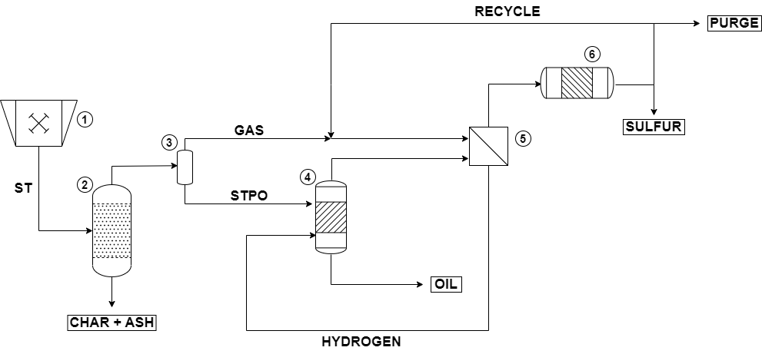
Figure 1: Process flow diagram of the conceptual process for EoL tires recycling.
  - Materials and Methods
The key concept behind this study is to explore the possibility of a fully self-sustainable process for waste tire recycling and following upgrading of the products in terms of hydrogen consumption. A schematic representation of the plant scheme is reported in Figure 1. A stream of 100 kg/h of waste tires, previously treated to remove metals and fibers, is firstly crushed in a miller (Unit 1), to obtain homogenous solid particles distribution (i.e., 0.006 – 0.015 m). The feed stream is a non-conventional solid. Properties and composition are estimated starting from Ultimate, Proximate analysis, as reported in Table 1, in accordance with literature (Ismail et al., 2017). The waste stream is firstly processed in a pyrolysis reactor (Unit 2), operating at 500 °C and atmospheric pressure. Pyrolysis is a complex thermo-chemical process. Its behavior depends on many factors such as temperature, pressure, and the characteristic dimension of the feed, among others. The conducted simulation of this step is a simplification. Indeed, by breaking down the non-conventional solid into its elemental components, it becomes possible to integrate fictitious lumped reactions among these elements according to the conventional product distribution obtained during pyrolysis, without taking into account the effects of other parameters. The unit modelled in Aspen Plus V11. is the combination of a yield reactor and a plug flow reactor (PFR) (Ismail et al., 2017). In the first reactor the non-conventional solid feed is decomposed in a pseudo component, in the form C_{a}H_{b}O_{c}N_{d}S_{e} + ASH, that takes into account only of the atom composition. The fictitious component obtained is then processed in the PFR.
Table 1: Feedstock’s Ultimate Analysisª and Proximate Analysis^{b}.
UAª [w.t.%]
ASH | 13.5 |  | PA^{b} [w.t.%]
C | 75.0 |  | Moisture | 1.5
H | 7.0 |  | Fixed Carbon | 30.0
N | 0.3 |  | Volatile Matter | 55.0
S | 1.5 |  | ASH | 13.5
O | 2.7
Lumped kinetic reactions among the elements occur in the unit, following the kinetic scheme described by Olazar et al. (2008). Kinetics are based on a conventional power law, with Arrhenius’ kinetic parameters estimated in accordance with typical products distribution down pyrolysis for gaseous and liquid output. According to the kinetic scheme adopted the limiting reactant is hydrogen. The characteristic dimension and residence time of the unit have been selected according to a sensitivity analysis in order to obtain a hydrogen concentration in the gaseous stream similar to literature (Kyari et al., 2005). To avoid the presence of unreacted oxygen in the gaseous stream, the kinetic adopted has been slightly adjusted. Indeed, to favor oxygen conversion, water synthesis reaction has been introduced and also CO_{x} synthesis has been favored adopting equilibrium reactions. The solid output obtained, mainly composed by unreacted carbon and ASH, is stored. The liquid and gaseous output is then splitted in an ideal flash (Unit 3) operating at 35 °C.
The liquid output, scrap tire pyrolysis oil (STPO), is an oil composed of C₅ up to C₂₀ molecules. The oil is characterized in cuts, according to carbon atoms number and normal boiling point (N.B.P.), and functional groups. The oil is, then, grouped in Gasoil, Diesel, Naphtha fractions for the cuts and Aromatics, Naphthene and Paraffines according to the different functional groups. Oil upgrading treatments are typically required, due to the significant amount of Aromatics and Gasoil together with the relevant content of sulfur in the oil. Indeed, the liquid stream is processed into a catalytic hydrotreating reactor (Unit 4), operating at 65 bars, 375 °C and an H₂/STPO ratio equal to 1000 Nm³/m³. The reaction occurs in presence of Ni/Mo catalyst over Al₂O₃ support. The time of stream is set equal to 8 h and the space time equal to 0.5 g_{cat} h/g_{feed}. Reaction conditions have been selected in accordance with literature to keep hydrogen content inside the liquid constant in the unit, and to favor the conversion of STPO. Inside the unit three main reactions occurs: Hydrocracking (HC), Hydrodearomatization (HDA) and Hydrodesulfurization (HDS) (Hita et al., 2015). The hydrotreating unit is modelled in MATLAB following the lumped kinetics scheme for HC and HDA. The HDS reaction has not been simulated due to lack in kinetics. Although according to literature benzothiazole, selected as representative sulfur contaminant in the liquid product, is easily converted due to the low amount of carbon atoms. Sulfur conversion has been set equal to 80 w.t.% of the total amount fed. H₂S production has been estimated according to the elemental stoichiometric reaction among hydrogen and sulfur.
Globally an upgraded oil is obtained, by lowering the Aromatic and Gasoil content and increasing the Paraffine and Diesel fraction of the fuel.
The hydrogen consumption in the hydrotreating unit is estimated adopting semi-empirical strategies (Castañeda et al., 2011). Hydrogen consumption is simply a function of the abatement efficiency of the unit. In this first approach, it is based on the amount of sulfur and Aromatics converted.
The gaseous stream obtained down the pyrolysis is mainly composed by H₂, CO_{x}, light hydrocarbons (i.e., C₁-C₄) and H₂S as contaminant. The stream is mixed with a recycle rich in hydrogen, exiting from the hydrogen recovery unit (Unit 6). The mixture is compressed and cooled at 35 °C and 8 bar and sent to a membrane (Unit 5) for the separation of hydrogen. Separation occurs thanks to high selective membrane (i.e., Matrimid 5218), that can perform a complete removal of hydrogen (Scholes et al., 2011). Only CO₂ as contaminant is detected in the filtered stream. In this first analysis no effect of H₂S have been considered. The filtered stream obtained, rich in hydrogen, is then compressed and sent to the Hydrotreating unit (Unit 4). The residual stream, instead, is processed to a hydrogen recovery reactor for H₂S conversion (Unit 6). Hydrogen recovery occurs in a thermal unit operating at high temperature (i.e., around 800 °C) and ambient pressure conditions in which the reaction of dissociation of H₂S into hydrogen and elemental sulfur takes place (Nova et al., 2023). Full conversion of H₂S into element has been considered in this unit.
The solid sulfur residual is then stored, while the gaseous output, rich in H₂ is split: part is recycled back to the membrane separation section (Unit 5) previously described, the remaining part is purged, to avoid the buildup in the cycle loop.
  - Results and Discussion
The simulation carried out a preliminary investigation on the integration of EoL tires pyrolysis with upgrading treatments. In this first study the in-depth simulation have been carried out only for pyrolysis and hydrodesulfurization process. However interesting prime approach results have been obtained.
3.1 Pyrolysis
Down pyrolysis EoL tires feed is decomposed in solid, liquid and gas. As expected, the liquid product represents the majority of the output (i.e., 62.27 w.t.%), the gaseous stream, instead, is the less favored product (i.e., 3.01 w.t.%). The remaining part is the solid residue (i.e., 34.73 w.t.%). The phase products distribution relies with literature results (Kyari et al., 2005). The solid residual obtained is composed by the whole ASH fed, inert in the reactor, the unreacted carbon and sulfur. In accordance with typical results almost the 50 w.t.% of the sulfur present in the feed is trapped in the solid residual. However, no hydrogen content has been detected in the solid. This unusual result can be explained on the base of the simulation model adopted. Indeed, the elemental hydrogen reacting in the pseudo component is a pure gas.
The gas stream is a mixture of light hydrocarbons (i.e., C₁ – C₄), CO_{x}, H₂ and H₂S, as reported in Table 2. Oxygen content in the gaseous output is negligible, as expected. The significant amount of CO_{x} can be justified by the variation adopted in the kinetic model that maximizes their production. Hydrogen content has been established in accordance to literature results. The significant amount of light hydrocarbons is justified by the presence of cracking reactions that occurs at this conditions. To maximize the amount of gas a slow pyrolysis set-up and longer residence time should be adopted. The relevant amount of H₂S can be explained thanks to the adoption of an equilibrium reaction. The liquid output, as mentioned above, is the main product of pyrolysis. By assuming a perfect separation stage after pyrolysis, water is completely condensed in the liquid stream. The relevant amount of water detected is due to the insertion of water synthesis reaction in the kinetics, extremely favored at these conditions.
Table 2: Pyrolysis products distribution, Gasª molar fractions, STPO^{b} mass fractions.
Gasª [mol.%]
H₂ | 22.4 |  | STPO^{b}
CO_{x} | 22.3 |  | Oil Cut [w.t.%] |  | Functional Group [w.t.%]
C₁ | 24.9 |  | Gasoil | 19.4 | Aromatic 2-ring | 26.5
C₂ | 14.1 |  | Diesel | 43.6 | Aromatic 1-ring | 16.3
C₃₊ | 6.1 |  | Naphtha | 31.1 | Naphthenes | 32.2
H₂S | 7.8 |  | Water | 5.9 | Paraffines | 19.1
Others | 2.4
Benzothiazole is selected as representative compound of sulfur species in the oil, its content even though is low is non negligible (i.e., 0.43 w.t.%). STPO has a global H/C ratio equal to 1.45. The results obtained assuming the subdivision based on N.B.P. temperatures and functional groups are reported in Table 2.As can be observed STPO is a light oil that has a wide range of boiling points and a large number of aromatics, as expected for an unrefined oil. The significant amount of aromatics can be justified by the nature of the feedstock, a mixture of natural rubber and synthetic rubber.
3.2 Hydrotreating
Under the above-mentioned operative conditions, the hydrotreating stage provide a sensible improvement in oil composition. Figure 2 and Figure 3 illustrates the variations in mass fractions for both the oil cut and functional groups, by varying the space time velocity. As can be observed after the hydrotreating the content of heavy compounds is drastically diminished. Indeed, the upgraded oil is a mixture of lighter hydrocarbons with Diesel as main cut. The asymptotic conditions are achieved for higher space velocity, due to the higher amount of catalyst used. As can be observed in the plots reported below the two rings’ Aromatics content is drastically decreased. The global number of Aromatic compounds drop of 4.6 w.t.%. Sulfur content is decreased according to the imposed conversion leading to the formation of H₂S. The resulting liquid stream is then a lighter oil with less Aromatics and sulfur components and a higher content of Paraffines.
The amount of hydrogen consumed in the hydrotreating stage is equal to 0.14 kg/h, corresponding to a specific consumption ratio H₂/STPO equal to 22.2 Nm³/m³.
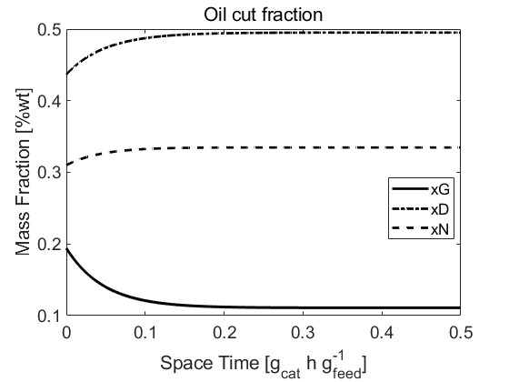
Figure 2: Hydrotreating effects on oil’s cut cut mass fractions of Gasoil (xG) Diesel (xD) and Naphhta (xN).
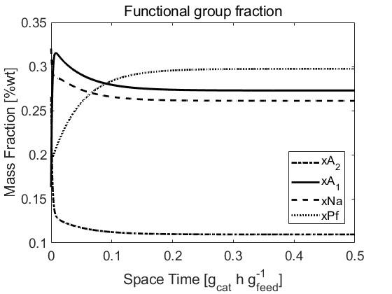
Figure 3: Hydrotreating effects on functional groups fractions of Aromatics 2 and 1 ring (xA₂ ; xA₁), Naphthene (xNa), Paraffine (xPf).
  - Conclusions and Future Developments
The research activity provides a first Aspen Plus V11-MATLAB process simulation filling the literature gap. Promising preliminary results indicate a significant improvement in oil quality down hydrotreating, particularly in reducing heavy and Aromatic fractions, at a hydrogen consumption ratio H₂/STPO equal to 22.2 Nm³/m³. Future developments dealing with an accurate estimation of hydrogen consumption are required.
For a more robust and comprehensive simulation of the process, it is necessary to integrate the presented work with other relevant research. Simulation and accurate estimation of hydrogen, recovered from the thermal unit adopting detailed simulation with more accurate kinetics, should be adopted. Detailed simulation of the distillation and separation units for the refining of the upgrade oil must be integrated. Once obtained a more comprehensive simulation, an energy analysis should be carried out. Further improvements that have to be investigated are a sensitivity analysis on pyrolysis conditions, to get a fully hydrogen self-sustainable system.
The interest in this work is high, indeed the choice of waste tire as feed is in line with the current problematics of waste recycling. The choice of maximizing liquid production is interesting, indeed the production of fuels and base chemicals, avoiding the use of virgin oil, is fundamental.
References
L.C. Castañeda, J.A.D. Muñoz, J. Ancheyta, 2011. Comparison of approaches to determine hydrogen consumption during catalytic hydrotreating of oil fractions. Fuel, Environmental Modeling of Catalytic Reactions in the Oil Refining Industry 90, 3593–3601.
I. Hita, A.T. Aguayo, M. Olazar, M.J. Azkoiti, J. Bilbao, J.M. Arandes, P. Castaño, 2015. Kinetic Modeling of the Hydrotreating and Hydrocracking Stages for Upgrading Scrap Tires Pyrolysis Oil (STPO) toward High-Quality Fuels. Energy Fuels 29, 7542–7553.
H.Y. Ismail, A. Abbas, F. Azizi, J. Zeaiter, 2017. Pyrolysis of waste tires: A modeling and parameter estimation study using Aspen Plus®. Waste Management, Special Thematic Issue: Urban Mining and Circular Economy 60, 482–493.
M. Kyari, A. Cunliffe, P.T. Williams, 2005. Characterization of Oils, Gases, and Char in Relation to the Pyrolysis of Different Brands of Scrap Automotive Tires. Energy Fuels 19, 1165–1173.
N. Nkosi, E. Muzenda, J. Gorimbo, M. Belaid, 2021. Developments in waste tyre thermochemical conversion processes: gasification, pyrolysis and liquefaction. RSC Advances 11, 11844–11871.
A. Nova, F. Negri, F. Manenti, 2023. Multi-scale Modelling and Experimental Investigation of Hydrogen Sulphide Thermal Decomposition, in: Kokossis, A.C., Georgiadis, M.C., Pistikopoulos, E. (Eds.), Computer Aided Chemical Engineering, 33 European Symposium on Computer Aided Process Engineering. Elsevier, pp. 2411–2416.
M. Olazar, G. Lopez, M. Arabiourrutia, G. Elordi, R. Aguado, J. Bilbao, 2008. Kinetic modelling of tyre pyrolysis in a conical spouted bed reactor. Journal of Analytical and Applied Pyrolysis 81, 127–132.
C.A. Scholes, G.Q. Chen, W.X. Tao, J. Bacus, C. Anderson, G.W. Stevens, S.E. Kentish, 2011. The effects of minor components on the gas separation performance of membranes for carbon capture. Energy Procedia, 10th International Conference on Greenhouse Gas Control Technologies 4, 681–687.
F. Valentini, A. Pegoretti, 2022. End-of-life options of tyres. A review. Advanced Industrial and Engineering Polymer Research, Recycling of Rubbers 5, 203–213.

