Optimization of Operating Conditions Using a Crystallizer Model with Local Temperature Control
Saki Iizukaª, Kano Ishikawaª, Sanghong Kimª
ªTokyo University of Agriculture and Technology, 2-24-16, Naka-cho, Koganei-shi, Tokyo, 184-8588, Japan
sanghong@go.tuat.ac.jp
Abstract
In the crystallization processes, our primary topics are the quality and the productivity of crystalline particles. In this study, local temperature control was focused to investigate how much the quality and the productivity can be improved. A two-dimensional distributed parameter system model of a batch cooling crystallizer with local temperature controllers was developed. A multi-objective optimization problem was solved using the model. It was found that local temperature control reduced the operation time and the control error of particle size up to 14.4 % and 44.2 %, compared to constant cooling at 0.30 W, respectively without worsening the other objective function.
Keywords: Modeling, Crystallization, Distributed parameter system, Local control
  - Introduction
Crystallization is a chemical process by which crystals are formed from solution. In chemical and pharmaceutical industries, crystallization has been used for separation and purification. In the crystallization processes, the quality and the productivity of crystalline particles are primary interests. The quality can be characterized by particle size distribution and monodisperse crystalline particles with desired size is preferred.
In order to increase the productivity of particles with desired particle size distribution, Ma (2021) reported pulsed ultrasound enhanced continuous reactive crystallization. When the ultrasonic probe was inserted into single and multistage mixed suspension mixed product removal (MSMPR) crystallizer, particles with narrow particle size distribution could be obtained. In order to increase the productivity without worsening the product quality, Mesbah (2011) reported a model-based control approach of a semi-industrial batch evaporative crystallizer. The heat input to the crystallizer was manipulated by the state estimation in the feedback control system. Pascual (2022) reported that the high yield of particles was produced by properly setting the residence time and the agitation rate in the continuous cooling crystallization using a MSMPR system.
Most studies mentioned that local conditions affect crystallization. However, these previous studies have not focused on manipulation of local conditions in the crystallizer. For example, Mesbah (2011) defined only a heat input for a crystallizer, and it was assumed that the crystallizer was heated uniformly with a heat input. When local conditions are manipulated, monodisperse particles with desired size can be obtained without worsening the productivity. Therefore, in this study, to find better crystallization operations, a simulation system in which local conditions could be manipulated was constructed, and local operations were optimized.
  - Crystallizer model and local operation
Two-dimensional distributed parameter system (DPS) model of a batch cooling crystallizer with imaginary local temperature controllers was constructed.
    - Distributed parameter system model
DPS model is useful to find better crystallization operations, because DPS model can calculate conditions in the crystallizer more accurately than lumped parameter system model. To construct DPS model, a target system was divided into multiple units.
    - Crystallization model
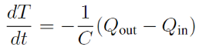 | (1)
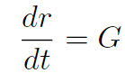 | (2)
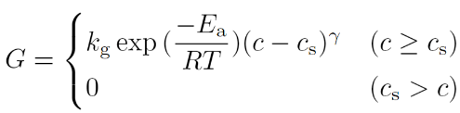 | (3)  (4)
Cooling crystallization is one of typical methods of crystallization. In the developed model, heat transfer and crystal growth were considered. Governing equations of heat transfer and crystal growth shown in Eqs. (1) to (4) (Perry at al., 1997) (Kim et al., 2023) were embedded in each unit.
Here, T [K] is temperature, t [s] is time, C [J/K] is heat capacity, Q_{in} [W] is heat input rate, Q_{out} [W] is heat output rate, r [µm] is particle size, G [µm/s] is crystal growth rate, k_{g} [(µm/min) (g-solute/g-solvent)^{-γ}] is rate constants for the crystal growth, E_{a} [J/mol] is activation energy of the crystal growth, R [J/mol/K] is universal gas constant, c [g-solute/g-solvent] is concentration in the solution, c_{s} [g-solute/g-solvent] is solubility, and γ [-] is exponential parameters on supersaturation for the crystal growth.
    - Local operation
In this study, it was assumed that temperature of each unit can be manipulated by an imaginary controller. To represent the local temperature controller, local heat transfer rate Q_{c} [W] was added to Eq. (1) as shown in Eq. (5). Temperature of each unit can be controlled by Q_{c}. Q_{c} was optimized when optimization problems were solved.
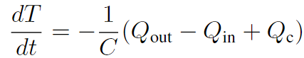 | (5)
  - Case study
The proposed model was evaluated through an example. In this example, a multi-objective optimization problem was solved, because there is a trade-off between the quality and the productivity of particles. One of objective functions f₁ is standardized operation time t_{f}/t_{ref} [-] as shown in Eq. (7), which related to the productivity. t_{f} [s] is operation time. t_{ref} [s] is representative value of operation time: 60 s. The other objective function f₂ is standardized control error of particle size [µm] as shown in Eq. (8), which related to the quality of crystalline particles. r_{ref} [µm] is representative value of particle size: 1 µm. N [-] is the number of particles, and r_{set} [µm] is particle size setpoint. When the problem was solved, scalarizing was used as shown in Eq. (6). w₁ [-] and w₂ [-] are weights.
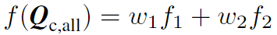 | (6)
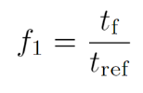 | (7)
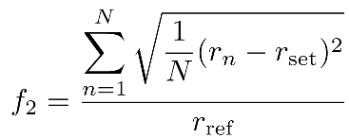 | (8)

    - Simulation conditions
In this example, simulation conditions were set referencing a previous study (Kim et al., 2023). A target system was divided into three units, and each unit is called upper, middle, and lower unit. Initial particle sizes in each unit were set as shown in Table 2. Particles in each unit were monodisperse. Quality of initial particles were low, because the initial particle sizes were different between each unit, and it meant particles in the target system were polydisperse. The range of Q_{c} was from 0 to 0.90 W. The value of Q_{c} was changed every 20 minutes. The values of parameters and other conditions were shown in Table 3.
(9)
Table 2 Initial particle sizes in each unit
Unit name | Particle size r [µm] | Number of particles N [-]
Upper | 100 | 30,000
Middle | 150 | 30,000
Lower | 200 | 30,000

Table 3 The values of parameters and conditions
Parameter name | Value
Target system size  (width, depth, height) | 9 cm, 3 cm, 9 cm
Mesh size (width, depth, height) | 9 cm, 3 cm, 3 cm
Time step of crystal growth and heat transfer calculation | 5 s
Production volume set point | 15.0 g
r_{set} | 500 µm
Initial temperature | 313.15 K
k_{g} | 2.26×10⁸ (µm/min) (g-solute/g-solvent)^{-γ}
E_{a} | 3.62×10⁴ J/mol
R | 8.31 J/mol/K
c | 0.30 g-solute/g-solvent
γ | 1.14
C | 53.04 J/K
    - Results and discussion
Values of the objective functions for feasible solutions, pareto optimal solutions, and solutions with constant cooling rates, which were 0.15, 0.30, 0.45, 0.60, 0.75, and 0.90 W, were shown in Fig. 1. It was found that objective functions became smaller by local temperature control than those with constant cooling rate in all units. Compared to constant cooling at 0.30 W, which was represented by the second dot of solution with constant cooling from the right in Fig 1, local temperature control reduced operation time and control error of particle size up to 14.4 % and 44.2 %, respectively without worsening the other objective function.
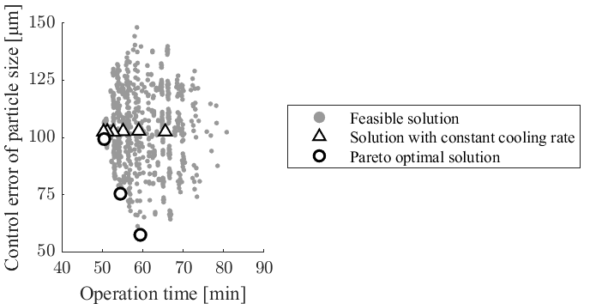
Fig. 1 Values of the objective functions
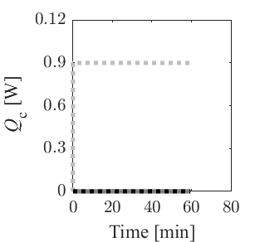 | 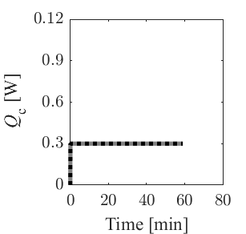
(a) Q_{c} in each unit with the pareto optimal solution of local operation | (b) Q_{c} in each unit with constant cooling at 0.30 W
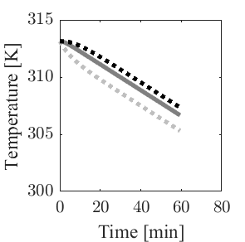 | 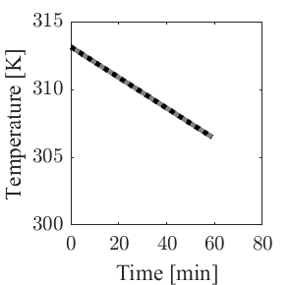
(c) Temperature in each unit with the pareto optimal solution of local operation | (d) Crystal growth rate in each unit with constant cooling at 0.30 W
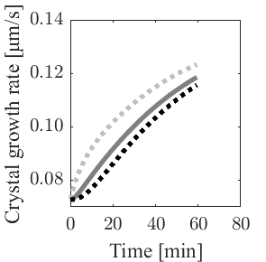 | 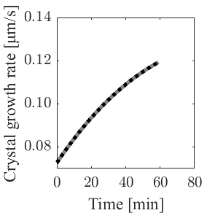
(e) Crystal growth rate in each unit with the pareto optimal solution of local operation | (f) Crystal growth rate in each unit with constant cooling at 0.30 W
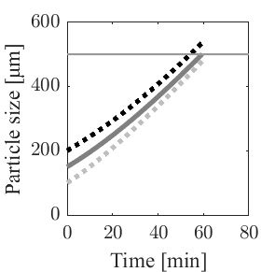 | 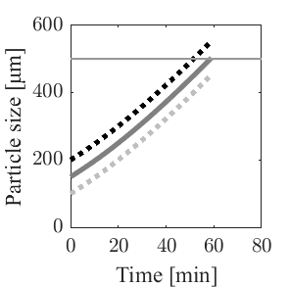
(g) Particle size in each unit with the pareto optimal solution of local operation | (h) Particle size in each unit with constant cooling at 0.30 W
Fig.2 Simulation results of the example
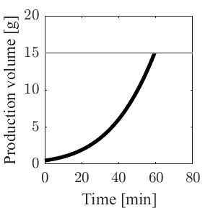 | 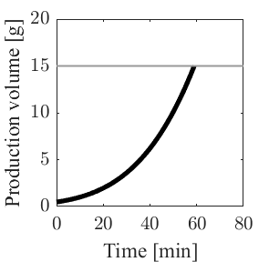
(a) | (b)
Fig. 3 Production volume (a) with a pareto optimal solution of local operation (b) with constant cooling at 0.30 W

Next, the detailed information on one of pareto optimal solutions, which is represented by the first dot of pareto optimal solutions from the right of in Fig 1, and one of solutions with constant cooling at 0.30 W were compared to show the effectiveness of local temperature control. Fig. 2 shows Q_{c}, temperature, crystal growth rate, and production volume. These results confirmed that Q_{c} of the pareto solution at upper unit in which the smallest initial particles existed was the largest, and Q_{c} of the pareto solution at lower unit in which the largest initial particles existed was the smallest. Temperature of each unit changed lower following time variation of Q_{c}. Crystal growth rate of each unit changed with temperature. This is because solubility is decreased with falling temperature and supersaturation ratio was increased. Particle size of each unit changed larger following increasing of crystal growth rate. The difference between maximum size and minimum size of particles at the end of crystallization was 43.0 % smaller than that of initial particles with Q_{c} of the pareto solution. On the other hand, the difference between maximum size and minimum size of particles was constant with Q_{c} of the constant cooling. Then, control error of particle size at the end of crystallization with Q_{c} of the pareto solution was 44.2 % smaller than that with Q_{c} of the constant cooling. Fig. 3 shows production volume, which confirmed that operation times of each simulation result were almost equal. As a result, it was showed that Q_{c} of the pareto solution improved particle size distribution, without worsening the operation time.
  - Conclusion
Two-dimensional DPS model of a batch cooling crystallizer with imaginary local temperature controllers was developed. Operation time and control error of particle size were minimized by optimizing local cooling rates. Compared to constant cooling at 0.30 W, local temperature control reduced the operation time and control error of particle size up to 14.4 % and 44.2 %, respectively without worsening the other objective function.
References
Ali Mesbah, Adrie E. M. Huesman, Herman J. M. Kramer, Zoltan K. Nagy, and Paul M. J. Van den Hof, 2011, Real-time control of a semi-industrial fed-batch evaporative crystallizer using different direct optimization strategies, AIChE Journal, 57, 6, 1557-1569
Gladys Kate Pascual, Philip Donnellan, Brian Glennon, Barbara Wood, and Roderick C. Jones, 2022, Design and optimization of the single-stage continuous mixed suspension-mixed product removal crystallization of 2-Chloro-N-(4-methylphenyl)propenamide, ACS Omega, 7, 16, 13676-13686
Perry, Robert H., Green, Don W., and Maloney, James O., 1997, Perry's Chemical Engineers' Handbook Seventh Edition, New York, America: McGraw-Hill.
Yiming Ma, Zhixu Li, Peng Shi, Jiawei Lin, Zhenguo Gao, Menghui Yao, Mingyang Chen, Jingkang Wang, Songgu Wu, and Junbo Gong, 2021, Enhancing continuous reactive crystallization of lithium carbonate in multistage mixed suspension mixed product removal crystallizers with pulsed ultrasound, Ultrasonics Sonochemistry, 77
Youngjo Kim, Yoshiaki Kawajiri, Ronald W. Rousseau, and Martha A. Grover, 2023, Modeling of Nucleation, Growth, and Dissolution of Paracetamol in Ethanol Solution for Unseeded Batch Cooling Crystallization with Temperature-Cycling Strategy, Industrial & Engineering Chemistry Research, 62, 6, 2866-2881

