MMC RECTIFIER AS AN INTERFACE FOR SUSTAINABLE ENERGIES SOURCES ON MTDC GRIDS

Guillermo Adolfo Anaya-Ruiz^{a*}, Pascual Eduardo Murillo-Alvaradoª, Alejandra Guadalupe Andrade-Partidaª, Gabriela Guadalupe Esquivel-Barajasª, Rogelio Gudiño-Valdezª and Daniel Miranda-Carrascoª.
ª Department of Energy Engineering, Universidad de La Ciénega del Estado de Michoacán de Ocampo. Av. Universidad Sur 3000, Lomas de Universidad, 59103 Sahuayo de Morelos, Michoacán México.
Corresponding author: gaanaya@ucemich.edu.mx
Abstract
Modular multilevel converters (MMC) had been proposed for several applications on middle and high voltage direct current (DC) grids due to its flexibility, modular characteristic and its fault tolerance, This work presents an MMC rectifier composed by half bridge submodules (SMs), voltage equations on each state of communication are presented, the voltage of MMC rectifier is presented with a technique of capacitor balance called carrier rotation algorithm, and in order to ensure the advantages of this technique, a comparison between traditional phase disposition (PD) technique is presented, the use of capacitor balance shows an CD output voltage whit high gain advantages in comparison with PD technique.
Keywords: MMC rectifier, smart grids, power electronics.
  - Introduction
At end of the 80’s The World Commission on Environment and Development declared than humanity have the ability to realize sustainable development, which satisfy present needs without compromise the capacity of satisfy they own future needs (UN. Secretary-General World Commission on Environment and Development, 1987).

In the same way, increase of energy demand and reduction of fossil fuel reserves have triggered the research of alternative solutions (Burhanudin et al., 2022), one of those alternatives are the renewables energies sources (RES) which have the next characteristics, clean sustainable and obtained from inexhaustible resources. Nevertheless, RES are intermittent since there is not a continual production of electrical energies due to natural inherent behavior of RES which can affect the transmission and distribution grid (A. Alneami el al. 2022).

High voltage direct current (HVDC) and multiterminal direct current (MTDC) grids are both, possible solutions of intermittent behavior presented by RES, these technologies use power electronics such as inverters (DC-AC converters), DC-DC converters and rectifiers (AC-DC converters) in order to bring energy since generation grids trough transmission and distribution across the electrical grid. At the same time, in order to decrease the carbon footprint.

Figure 1 presents an example of implementation of converters on HVDC electric grids, the possible connection of several energies sources as conventional as noun conventional is observed. At the same time a series of converter, inverters and rectifiers are required which ensure an output signal on a HVDC CD bus which is connected to the transmission HVDC line.

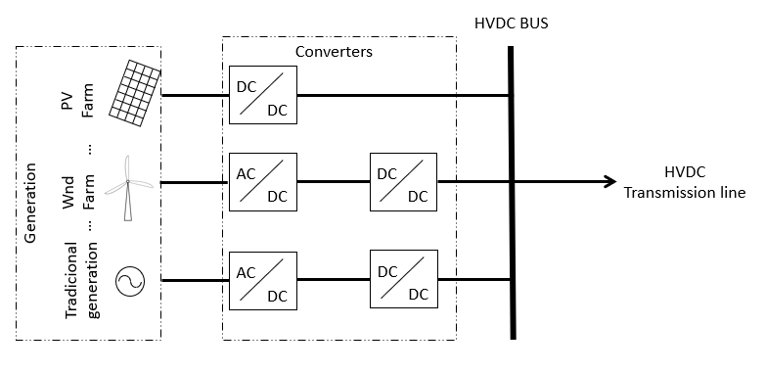
Figure 1. Example of connection of several energy sources to a HVDC transmission line.

One of the key converters on the last decades for such application had been the modular multilevel converter (MMC), as inversion and rectification applications, this converter is formed by an upper and a lower arm, such as legs by every phase, each arm is built by submodules (SMs) composed by half or full bridges of IGBTs o MOSFETs interrupters with antiparallel diodes on each interrupter, and a capacitor in parallel of each bridge, finally the converter has diodes connected on parallel at the output,(Liu et al., 2022). Figure 2 presents an example of this converter as rectifier.

Due to their flexibility and fault tolerance, MMC rectifiers have been proposed for several HVDC systems, producing cost-efficient systems(Hai Nguyen & Thinh Quach, 2021). However, in order to reach HVDC levels an extra DC-DC converter is required increasing those cost-efficient systems.

This work presents a comparison of an MMC rectifier using a traditional phase disposition (PD) modulation technique and a rectifier based on MMC structure, with high voltage gain, which uses a technique of capacitor balance called carrier rotation algorithm (K. Shen et al, 2013). This technique routes the carries signals on each cycle of the modular signal, reducing the switch modulation time of the MMC converter submodules, distribution output voltage in each of submodules, this converter will reduce the number of converters uses for implement Figure 1, grouping together converter AC-DC and DC-DC in just one converter AC-DC, reducing production costs.

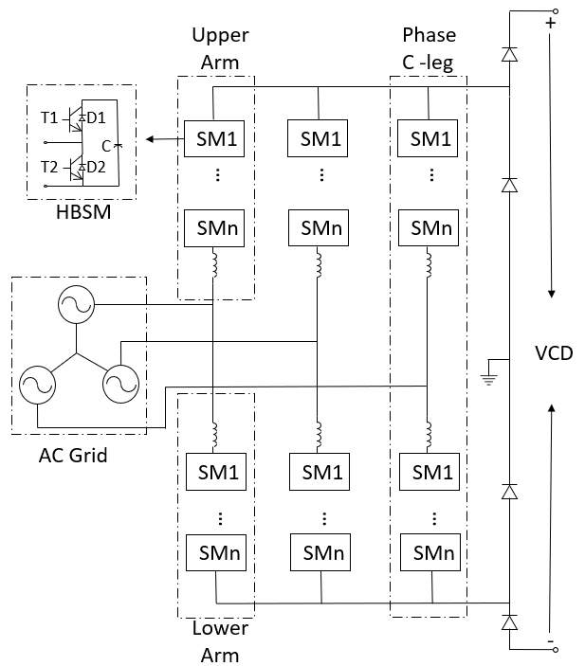
Figure 2. Graphic representation of MMC converter.

  - Operation principal

In order to present the operation principal of device, a single phase is presented on Figure 3, the rest phases will be supposed to work in the same way with a modulation phase shift, VU and VL represents the upper and lower arm´s voltages. Formed by the addition of SMs´ voltages, at the same time, V_{mp} represents the middle point of converter, while $i_{dc_u}$ and $i_{dc_l}$ represents DC currents at output, at the same time, $i_{_u}$ and $i_{_l}$represents the upper and lower currents on arms.

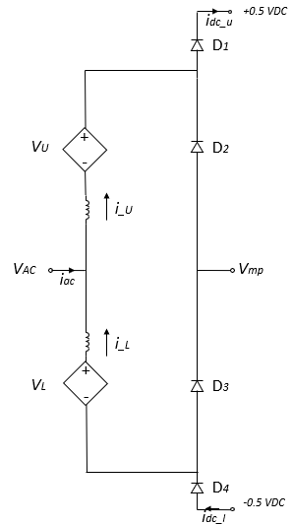
Figure 3 Single phase representation for converter voltage and current obtention.

The four voltage, product of the commutation of SMs in each arm are presents by Eq. (1) to Eq. (4).

$Vp=0.5Vdc-VAC, VL=0.5Vdc+VAC$ | (1)
$Vp=0.5Vdc-VAC, VL=VAC-Vmid$ | (2)
$Vp=Vmid-VAC, VL=VAC-Vmid$ | (3)
$Vp=Vmid-VAC, VL=0.5VDC+VAC$ | (4)
At the same time, the currents flow for the four commutations of SMs in each arm are presented on Table 1.

Table 1 currents at upper and lower arm on each state

Currents at upper and lower arm on each state
$$iu>0, il>0$$ | Currents at first state
$$iu>0, il<0$$ | Currents at second state
$$iu<0, il<0$$ | Currents at third state
$$iu<0, il>0$$ | Currents at fourth state

  - Modulation technique

The presented configuration implements a traditional PD modulation technique, nevertheless this work proposes the implementation of capacitor balance called carrier rotation algorithm, which routs the carrier signal at the end of every cycle of modular signal, the modular signal is always fixed.

Figure 4 presents an example of the rotation algorithm for upper arm, the commutation for lower arm is complementary with upper arm, in which is observed there are four carrier signals and one modular, at the same time, when modulation period is finished, the carrier signal four pass to first position while carrier one pass to second position and successively, in order to finish a rotation cycle of carriers signal four cycles of modular signal must pass.

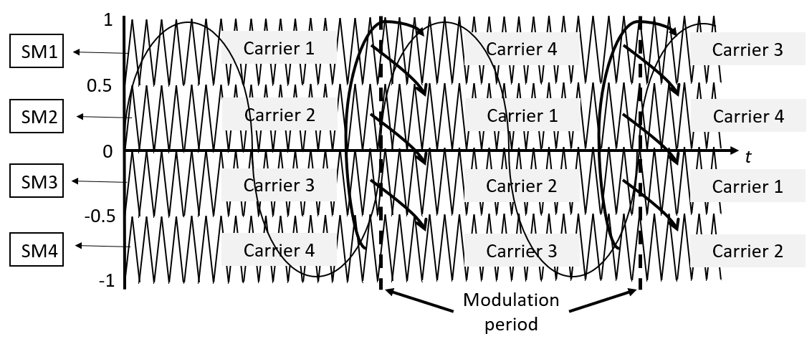
Figure 4. Carrier rotation example.

This technique ensures that voltage across each capacitor on each SMs is stable and equal, reducing the voltage stress product of switching components and increasing the voltage output at the same time, due to the addition of voltage of several capacitors of every SMs, without the addition of sensors on each SMs.

  - Simulation

The rectifier based on MMC on its five-level configuration and a single phase which uses four SMs for upper arm and four SMs for lower arm had been simulated using a regular PD commutation technique, at the same way, the rectifier was simulated using a technique of capacitor balance called carrier rotation algorithm proposed and presented on previous section, using a sinusoidal 100 V, 60 Hz source and 1.8 kHz carrier signals or 30 times the frequency of modulation signal.

Figure 5 presents the output voltage signal of the rectifier, using a traditional PD modulation technique, it is observer than voltage output is approximately twice the voltage peak of input sinusoidal signal.

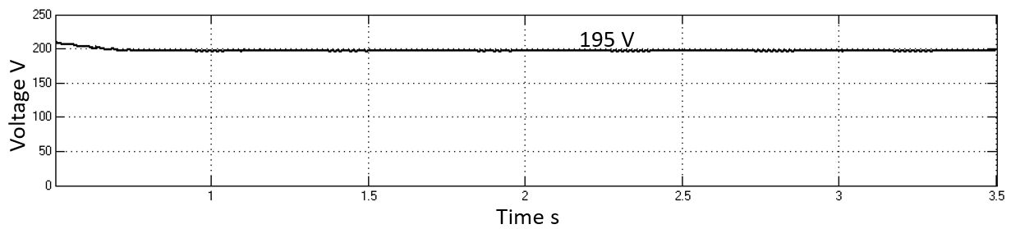
Figure 5 Simulation output voltage of MMC rectifier with PD modulation without capacitor balance.

In the other hand, Figure 6 presents output voltage of MMC rectifier using the capacitor balance technique carrier rotation algorithm, it is observer than voltage gain is around six times the voltage peak of sinusoidal input signal, working as a rectifier with gain.
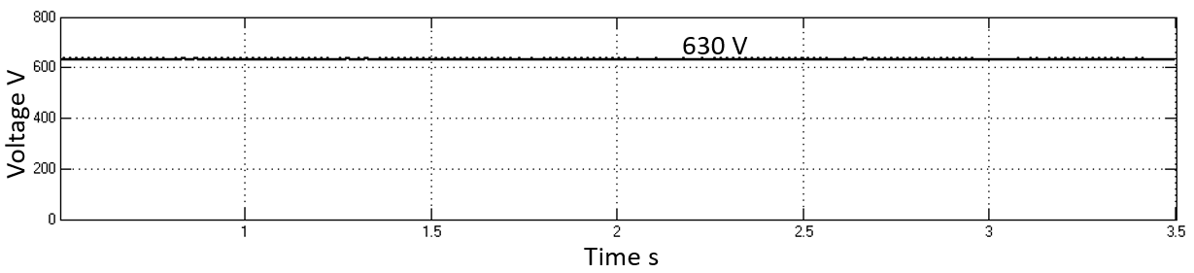
Figure 6. Output voltage of MMC rectifier using the capacitor balance technique carrier rotation algorithm.

Form the comparison of those simulations is important to emphasize than form the implementation of technique carrier rotation algorithm results in an increase of the output voltage of the rectifier without the need to implement other control systems or sensors that would increase the cost of building this device.
  - Conclusions
The uses of converter, as inverters as rectifiers of power electronics for MVDC and HVDC applications have been increased on last years, making them an important research topic for upcoming technologies.
The comparison of MMC rectifiers using a conventional PD technique and with a capacitor balance carrier rotation algorithm simulations was presented, it is observer than the rectifier with capacitor balance has the advantage of obtaining higher levels of gain compared to its counterpart, achieving to reduce the costs that would be necessary for the construction of two converters, one which rectifier and other which increases the voltage to the necessaries transmission and distribution levels.
References

UN. Secretary-General World Commission on Environment and Development (1987). Report of the World Commission on Environment and Development : "Our common future". [New York] UN, 4 Aug. 1987.
A. Alneami, A. Vahidnia and L. Meegahapola, (2022). "Enhancing the Stability of Integrated Power System With Renewable Energy Through Advanced Controls," 2022 32nd Australasian Universities Power Engineering Conference (AUPEC), Adelaide, Australia, 2022, pp. 1-6, doi: 10.1109/AUPEC58309.2022.10215685.
Liu, J., Member, S., Zhang, D., Member, S., & Dong, D. (2022). Analysis of Hybrid Modular Multilevel Rectifier Operated at Non-Unity Power Factor for HVDC Applications.
Hai Nguyen, T., & Thinh Quach, N. (2021). A hybrid HVDC converter based on M2C and diode rectifiers without DC capacitors for offshore wind farm integration. International Journal of Electrical Power and Energy Systems, 133.
J. Burhanudin, A. S. A. Hasim, A. M. Ishak, J. Burhanudin, and S. M. F. B. S. M. Dardin, (2022). “A Review of Power Electronics for Nearshore Wave Energy Converter Applications,” IEEE Access, vol. 10. Institute of Electrical and Electronics Engineers Inc., pp. 16670–16680, 2022. doi: 10.1109/ACCESS.2022.3148319.
K. Shen, Bailu Xiao, Jun Mei, Leon M. Tolbert, Jianze Wang, Xingguo Cai, Yanchao Ji., (2013). “A modulation reconfiguration based fault-tolerant control scheme for modular multilevel converters,” 2013 Twenty-Eighth Annual IEEE Applied Power Electronics Conference and Exposition (APEC), Long Beach, CA, USA, 2013, pp. 3251-3255.

