System identification of an industrial cascade refrigeration system
Jun Changª, Wei Yuª, James Carson^{b}, and Brent Youngª
Ahuora – Centre for Smart Energy Systems
ªDepartment of Chemical and Materials Engineering, University of Auckland, 5 Grafton Road, Auckland 1010, New Zealand
^{b}School of Engineering, University of Waikato, Hamilton 3240, New Zealand
jcha708@aucklanduni.ac.nz
Abstract
The cascade refrigeration cycle, characterized by multiple refrigeration cycles operating at different temperature levels, poses unique challenges for control and optimization. For developing optimisation or control strategies, a robust and reliable model must be developed. This paper presents a study of the system identification of an industrial cascade refrigeration system based on the simulation data from a validated first principles model. The research employs a subspace identification method to develop a data-driven dynamic model that accurately represents the transient behaviour of the cascade system. The identified model incorporates the interactions between the high and low-temperature refrigeration cycles, accounting for variations in operating conditions and load demands. Verification of the identified model is conducted using separate simulation data, demonstrating its capability to predict system behaviour. The insights gained from the system identification process lay the foundation for the development of advanced control strategies aimed at optimizing energy consumption and maintaining operational stability in the industrial cascade refrigeration system.
Keywords: cascade refrigeration, system identification, data-driven model.
  - Introduction
Process utilities, namely refrigeration and heating, account for a significant share of the overall process industry energy usage. Vapor-compression cycles (VCCs) have been widely utilized in industrial refrigeration. This technology is increasingly employed in process heating and heat recovery as an alternative to fossil-fuel-based heating to reduce carbon emissions. For optimal performance across a wider temperature range and maximal energy efficiency, the designs of VCCs tend to become much more complicated, as demonstrated in a case study in this research where a R744 (carbon dioxide)-R717 (ammonia) cascade refrigeration system (-50 °C) is coupled with an R717 heat pump (90 °C). However, a VCC does not always operate at the design operating condition because a coupled process or manufacturing process is not continuous, meaning that there are no constant thermal loads on both the cooling and heating sides. Instead, it is often subject to cyclical on/off operation, which deteriorates energy efficiency and equipment longevity. Controller tuning is also an issue due to the nonlinearity of VCC components (Goyal et al., 2019). Ineffectual control over the complex vapor compression system not only reduces efficiency but also damages the compressor. He et al. (1997) and Rasmussen and Alleyne (2006) pointed out that multiple single-input/single-output (SISO) control loops were less efficient due to the cross-coupling among the variables. Therefore, to maximize the benefits of a vapor-compression system, optimization and advanced control systems are needed, ideally guided by a dynamic process model. Several studies (Rasmussen and Alleyne, 2006; Jain and Alleyne, 2015; Wang et al., 2021) demonstrated the benefits of a multi-input/multi-output (MIMO) control or optimization strategy for VCCs.
System identification involves the development of mathematical models that accurately represent the dynamic behaviour of a system based on input/output data. The resulting data-driven model will be used as an internal model for an adaptive model predictive control (MPC) in a future study. Whilst there is an accurate first principles model available (Chang et al., 2023), data-driven models are preferred implementation format for model predictive control. Data-driven models are favoured over first principles models due to their flexibility and adaptability (Drgoňa et al., 2020), and they also can capture multivariable non-linear dynamics from plant data that necessarily simplified first principles models may not be to.
This study presents a system identification of an industrial R744-R717 cascade refrigeration system as a part of developing a model predictive controller. In prior work (Chang et al., 2023), a validated first-principles-based dynamic model of the industrial system was developed using a commercial process simulator. In this current work, based on dynamic response data from the validated simulation of the industrial process, state-space models were estimated using the System Identification Toolbox in MATLAB. The models were also compared to a validation dataset and evaluated for their prediction performance.
  - System description
The simplified R744-R717 cascade cycle shown in Fig.1 provides 300 kW of cooling at temperatures ranging from -20 to -45 °C. The system has a separate R452a refrigeration unit on the R744 receiver to avoid excessively high pressure. The secondary fluid for the R744 evaporator is a water-ethylene-glycol mixture (thermal fluid) and the flow is manipulated with a variable speed pump.
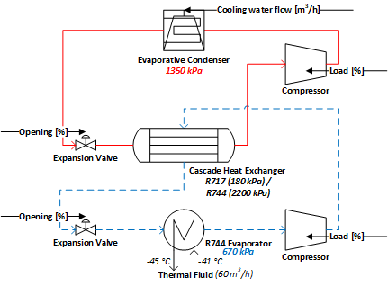
Figure 1. A schematic diagram of the R744 (bottom) - R717 (top) cascade refrigeration system. The design pressures for the heat exchangers and temperatures for the thermal fluid are shown. The manipulated variables are indicated with arrows.
Each cycle in the cascade cycle includes a flooded evaporator with a gas-liquid separator, and oil-flooded screw compressor, an oil separator, a condenser with receiver, and an electric expansion valve. The heat absorbed at the R744 evaporator plus the compressor work is released to the R717 cycle at the cascade heat exchanger. Liquid R717 refrigerant is vaporized at the cascade heat exchanger. The saturated vapor is then compressed at the compressor. The superheated discharge flows through the evaporative condenser while releasing heat to the cooling water.
  - First principles model
To generate simulation data for system identification, the cycle is modelled using dynamic process simulator, Symmetry v2020.4.0.52 (SLB, USA). The model is simple enough to tune the parameters for fitting the plant data, and the model can simulate key system dynamics. Based on the plant configuration, it is assumed that each flooded evaporator (the R744 evaporator and the R717 side of the cascade heat exchanger in Fig.1) is combined with the corresponding gas-liquid separator. Thus, they are modelled as a heat exchanger with an inlet flow of partially evaporated refrigerant and an outlet flow of saturated vapor. The level in the heat exchanger is maintained by the expansion valve. The model from the previous study is also modified in order to drive the operating conditions to desired conditions. The evaporative condenser was initially modelled as a cooler component, but now it is modelled as a heat exchanger with cooling water for more fidelity. The inlet of the cooling water temperature is assumed to be constant, and the flow rate is manipulated to adjust the duty.
  - System identification
    - Input/output variables selection
For output variable selection, the priority is to select the least number of variables that can show the dynamic status of the system. For the purpose outlined in the introduction, the four pressures (evaporation and condensation pressures for each refrigerant) are selected. The pressures intuitively display the status of the system.
In order to determine the input variables for the system identification procedure, the manipulatable input variable candidates were subjected to open-loop step tests to preliminarily analyse the dynamics of the system. The step tests also provide time constants for the output variables which are used for designing an appropriate pseudo random binary sequence (PRBS) signal for MIMO system identification.
The magnitudes of the step change were within a 10 % deviation from the initial values. This was due to the unstable cycle dynamic. In particular, completely drying or flooding the heat exchangers is to be avoided, which generate fluctuating data and can cause the simulation (and the system) to become unstable.
From the preliminary results (Table 1), the R744 condensation pressure exhibits the highest gain from both compressors, which could explain the existing control loop, R744 condensation pressure – R717 compressor load. The step test of the condenser cooling water shows the highest magnitude of the gain on the R717 condensation pressure.
For these valves, the process gains for all outputs are lower than other inputs, and it was impossible to estimate the time constants due to significant fluctuation in the data. The fluctuations could be attributed by numerical errors owing to the static head fluctuation within the heat exchangers and the closed cycle behaviour. It should be noted that the process gains of valve-pressure pairs are expected to be negligible in the actual case due to the system configuration with the gas-liquid separator and the flooded-evaporator. Unlike a direct expansion system where an expansion valve regulates the superheat of refrigerant vapour at the suction of the compressor, the valves in this case only work as ‘liquid make-up’ valves for regulating the separator level. Furthermore, for a stable simulation with a PRBS input signal, it is desired to maintain the levels in the separator.
Table 1. Process gains (Kp) and time constant (in round brackets) for input-output pairs
Kp [kPa/%]  (τ [s]) | R744 evaporation pressure | R744 condensation pressure | R717 evaporation pressure | R717 condensation pressure
R744 compressor | -1.6  (7) | 10.7  (57) | 1.4  (60) | 9.2  (108)
R717 compressor | -0.3  (-) | -7.6  (51) | -1.3  (41) | 0.9  (10)
Cooling water flow rate | -0.6  (109) | -9.4  (83) | -1.5  (70) | -22.4  (136)
R744 valve | 0.5  (-) | 0.4  (-) | 0  (-) | 0.1  (-)
R717 valve | 0  (-) | 1.4  (-) | 0.2  (-) | 0  (-)
The selected input variables are both compressor loadings and the cooling water flow rate. The level control loops between the valves and the separators are kept closed for a stable simulation. The valves actions can affect the pressures, but since the gains are negligible, and they are likely to open and close repeatedly, the impact can be considered a noise.
    - PRBS input signal
In designing a suitable PRBS signal for the particular system, the steps illustrated in Sarath Yadav and Indiran (2019) are followed. The amplitude and the bandwidth are determined based on gain, time constant, and dead time from the step tests. From the preliminary step tests, no dead times were observed. The amplitudes for compressors and cooling water flow were 10 % and 5 % respectively. The bandwidth (Ω) is estimated using the highest time constant in Table 1 as:
$Ω= \frac{1}{τ}$ | (1)
    - MIMO state-space identification
The input variables were subjected to the PRBS signal independently to simulate the output dynamic responses. The simulation data were then processed to have zero mean. With multiple I/O data, subspace identification method (N4SID) was chosen to estimate MIMO state-space models of order 1 through 15. The model was then compared to the validation data set to evaluate model fit. The model fit was evaluated by the normalised root mean squared error (NRMSE).
$fit=100(1-\frac{\left\|y-\hat{y}\right\|}{\left\|y-mean\left(y\right)\right\|})$ | (2)

  - Results and discussion
The model fits for different model orders are summarised in Fig. 2.

Figure 2. Model fit against validation data for models of order 1 to 15.
The models of order 1 to 6 are not sufficient to predict the output dynamics. From 7th order model, the model fit is around 70 %. The models of order 8 and 9 show adequate fits of around 80 % throughout the output variables. From the 10th order model onward, the fit for some output variables deteriorate, which can be attributed overfitting. Using the principle of parsimony, the minimum model order required for the system is 8th order (Fig. 3).
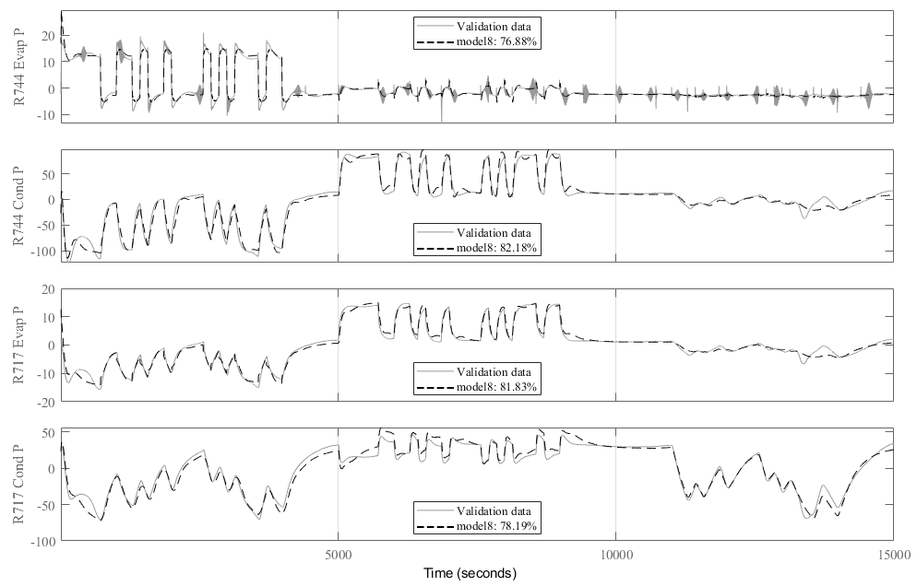
Figure 3. The 8th order model response plotted against the validation data series. The PRBS input is applied to R744 compressor from 0 to 5,000 s, R717 compressor from 5,000 to 10,000 s, and the cooling water flow rate from 10,000 to 15,000 s.
Although 80 % prediction seems promising for controller design, it should be noted that the model is derived from limited simulation data and the model is relatively higher order, compared to Rasmussen and Alleyne (2006).
For practical MPC application, the model needs to predict outputs under changing operating conditions and in the presence of disturbances. To achieve this, the system identification procedure should be expanded to encompass a wider range of conditions, including various thermal loads and ambient conditions, using recursive parameter estimation (Ljung, 1999). Closed-loop identification, as discussed by Valenzuela et al. (2019), can also be considered to incorporate the dynamics of local controllers. A data-driven approach not only offers adaptability and flexibility, but also, demonstrates high computational efficiency, ensuring the tasks can be completed without compromising on computation.
  - Conclusions
The study addresses the system identification of an R744-R717 cascade refrigeration system, employing a subspace identification method based on simulation data from a validated first principles model. The input/output variables are selected based on the step responses, and the PRBS input signal is designed. The 8th order MIMO state-space model exhibits promising prediction accuracy, reaching around 80 % fit against validation data.
However, the authors acknowledge the limitations of the current study, highlighting the need for further exploration under a wider range of operating conditions while employing recursive parameter estimation. Additionally, considerations for closed-loop identification, as discussed in the literature, are suggested for future work.
References
Chang, J., Yu, W., Carson, J., & Young, B. (2023). A dynamic model of an industrial cascade refrigeration system. 26th IIR International Congress of Refrigeration, Paris, France.
Drgoňa, J., Arroyo, J., Cupeiro Figueroa, I., Blum, D., Arendt, K., Kim, D., Ollé, E. P., Oravec, J., Wetter, M., Vrabie, D. L., & Helsen, L. (2020). All you need to know about model predictive control for buildings. Annual Reviews in Control, 50, 190-232. https://doi.org/https://doi.org/10.1016/j.arcontrol.2020.09.001
Goyal, A., Staedter, M. A., & Garimella, S. (2019). A review of control methodologies for vapor compression and absorption heat pumps. International Journal of Refrigeration, 97, 1-20. https://doi.org/https://doi.org/10.1016/j.ijrefrig.2018.08.026
He, X.-D., Liu, S., & Asada, H. H. (1997). Modeling of Vapor Compression Cycles for Multivariable Feedback Control of HVAC Systems. Journal of Dynamic Systems, Measurement, and Control, 119(2), 183-191. https://doi.org/10.1115/1.2801231
Jain, N., & Alleyne, A. (2015). Exergy-based optimal control of a vapor compression system. Energy Conversion and Management, 92, 353-365. https://doi.org/https://doi.org/10.1016/j.enconman.2014.12.014
Ljung, L. (1999). System Identification: Theory for the User. Prentice Hall PTR. https://books.google.co.nz/books?id=nHFoQgAACAAJ
Rasmussen, B. P., & Alleyne, A. G. (2006). Dynamic modeling and advanced control of air conditioning and refrigeration systems.
Sarath Yadav, E., & Indiran, T. (2019). PRBS based model identification and GPC PID control design for MIMO Process. Materials Today: Proceedings, 17, 16-25. https://doi.org/https://doi.org/10.1016/j.matpr.2019.06.396
Valenzuela, P., Ebadat, A., Everitt, N., & Parisio, A. (2019). Closed-Loop Identification for Model Predictive Control of HVAC Systems: From Input Design to Controller Synthesis. IEEE Transactions on Control Systems Technology, PP, 1-15. https://doi.org/10.1109/TCST.2019.2917675
Wang, W., Zhao, Z., Zhou, Q., Qiao, Y., & Cao, F. (2021). Model predictive control for the operation of a transcritical CO2 air source heat pump water heater. Applied Energy, 300, 117339. https://doi.org/https://doi.org/10.1016/j.apenergy.2021.117339

