Economic Optimization of the Synthesis Section of a Small-Scale Biogas-to-Methanol Plant
Marcello M. Bozzini,ª Loretta Salano,ª Carlo Pirola,^{b} Flavio Manenti^{a,*}
ªCMIC Department "Giulio Natta", Politecnico di Milano, Piazza Leonardo da Vinci 32, Milan 20133, Italy
^{b}Dipartimento di Chimica, Università degli Studi di Milano, via Golgi, 19, Milan 20133, Italy
flavio.manenti@polimi.it
Abstract
As global concerns about carbon emissions and the sustainability of energy sources grow, the utilization of biogas has gained significant attention for reducing greenhouse gas emissions and moving away from fossil-based chemicals. Biogas, predominantly composed of methane and carbon dioxide, is generated through the anaerobic digestion of organic materials, such as agricultural residues, municipal waste, and wastewater sludge. To exploit the full potential of biogas and increase its energy density, the conversion of biogas into valuable chemical products seems to be a viable and feasible solution. Specifically, the production of methanol and the development of small-scale biogas-to-methanol plants has received notable recognition. This study focuses on the economic optimization of the synthesis section within such plants. The optimization of this section plays a crucial role in ensuring both the economic viability and the sustainability of the process. The synthesis section is modeled with two reactors arranged in series, where liquefaction of the methanol and water produced takes place after each reactor. To maximize methanol production, unreacted gases are recycled back to the first reactor. This article presents the economic optimization perspective on the reactor’s design and operating conditions, finding a compromise between maximizing methanol yield and minimizing reactor costs. This study highlights the potential for biogas-based methanol in the transition between greener energy alternatives. Moreover, it offers a systematic procedure for optimizing the design of the synthesis sections, which is applied to a typical case study. By addressing the complex factors involved in this process, this research actively contributes to the progress of sustainable energy solutions and provides a valuable baseline for future development.
Keywords: Biogas, Methanol, Economics, Optimization, Modeling
  - Introduction
The current trend in the chemical industry and energy sector is entirely directed toward de-fossilization and, consequently, the exploration of renewable resources. Among these, biogas stands out as one of the most promising. Biogas is a mixture composed mainly by methane and carbon dioxide ($CO_{2}$) produced through the anaerobic digestion of biomasses. While the current valorization of biogas takes place in Combined Heat and Power (CHP) plants to generate electricity and heat, recent investigations have explored new alternatives, especially the production of methanol (MeOH) (Bozzano et al., 2017). MeOH is considered a key component in the energy transition process due to its highly energy-intensive synthesis and significant global production. $CO_{2}$ hydrogenation appears as a highly promising pathway for carbon utilization, contributing to the de-fossilization of the methanol production industry (Prifti et al., 2023). In these plants, biogas is firstly treated and reformed to produce syngas, a mixture of $H_{2}$, carbon monoxide ($CO)$ and $CO_{2}$. Subsequently, the syngas is heated up and passes through a catalytic reactor where three reactions take place: the Reverse Water Gas Shift, CO hydrogenation and the $CO_{2}$ hydrogenation (Bisotti et al., 2022). Recent studies on biogas-to-methanol plants have been lately conducted focusing mostly on process simulation and layout (Moioli and Schildhauer, 2022). Additionally, various works have extensively analyzed different feedstocks and operating conditions (Santos et al., 2018). It is noteworthy that the techno-economic analysis conducted by Rinaldi et al., (2023) provides a comprehensive assessment of such plants, simulating the overall process with different configurations. However, the scale of the plant analyzed is considerably larger compared to the average biogas plant in Europe (Софія, 2020). This study aims to evaluate the economic feasibility and optimize, from an economic standpoint, the synthesis section of such plants through rigorous modeling of reactors and ancillaries.
  - Methods
The primary object of this paper is to assess the economic feasibility of an optimized synthesis section of a small-scale biogas-to-methanol plant. Rigorous modeling and design have been implemented for each unit for economic optimization of the overall section by varying the volume of the reactors. This study specifically focuses on the economic viability and optimization of the synthesis section in these plants. The economic procedure adopted, and the parameter’s database used to estimate the cost of the units, follows the Bare Module Costing technique explained in Turton et al. (2018). The costs have been actualized using the 2023 CEPCI index. The price of MeOH is sourced from Methanex’s regional contracts to estimate the revenues of the plant. The capital expenditures for both the feed compressor and the recycle compressor have been neglected. Respectively, the first one’s cost does not depend on the synthesis section, while the second one’s cost depends on fluid power, which does not significantly change since the compression ratio is limited. It is assumed that the electric boiler's electricity consumption is the only operating expenditure in the system.
    - Syngas Preparation
Biogas-to-methanol simulated plants typically consist of four main sections: capture of carbon dioxide, reforming of methane, methanol synthesis and purification. This study concentrates on the synthesis section of the plant. The feed stream to the synthesis section has been derived from a rigorous simulation in Aspen HYSYS of such a process. The scale of the process is 1 MW equivalent of biogas on Lower Heating Value basis, which corresponds to the average biogas capacity plant in Italy. Table 1 illustrates the feed stream’s parameters, which have been fixed throughout the assessment and optimization procedures.
Table 1. a) Flow and parameters and b) mass fractions of syngas to synthesis section
Operative conditions |  |  | Mass Fraction
Mass Flow | 726.3 [kg/h] |  | $$ω_{CO}$$ | 0.4662
Volumetric Flow | 1433 [STD_m³/h] |  | $$ω_{H_{2}}$$ | 0.1131
Temperature | 25 [°C] |  | $$ω_{CO_{2}}$$ | 0.391
Pressure | 61 [bar] |  | $$ω_{H_{2}O}$$ | 0.0089
SN | 1.85 |  | $$ω_{CH_{4}}$$ | 0.0208

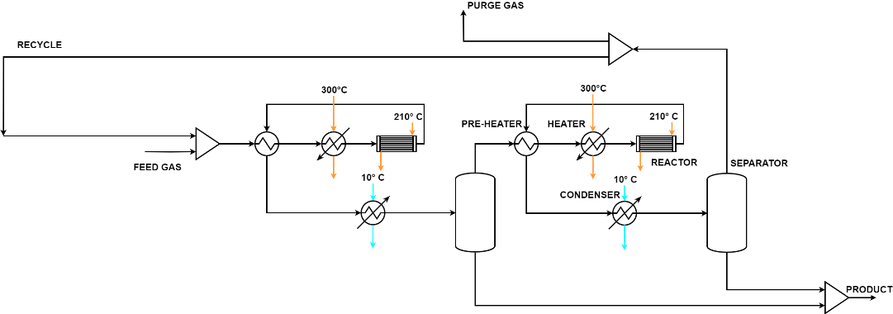
Figure 1. Process Flow Diagram of the synthesis section
    - Modeling of the synthesis section
Figure 1 represents the synthesis section as modeled in this study. The feed gas combines with unreacted gas from the last separator and is fed to the synthesis. Subsequently, the reagent mixture, primarily composed of $CO$, $CO_{2}$ and $H_{2}$, passes through the pre-heater and the heater to reach the reactor inlet temperature. Then, it enters the reactive unit producing MeOH. The resulting mixture is cooled down to extract the main product and the water, while the unreacted gases proceed to the second part of the synthesis, duplicating the first. The products from both reactors are collected for further processing in the purification section, while the unreacted gases are 95 % recycled and 5 % purged. The compressor within the recycle loop has been neglected in this study. Cooling water entering at 10 °C is used to cool down the product stream, while diathermic oil is chosen both to heat up the reagent mixture and to provide refrigeration throughout the reactor length. The pre-heaters and the condensers are modeled as fixed tube heat exchangers solving global energy and mass balances. In contrast, the heaters before the reactors have been designed as double-pipe heat exchangers due to their lower exchange area. The reactors are modeled as oil-cooled multi-tubular reactors, with several assumptions made to replicate the unit over its length. The system of ordinary differential equations for each reactor consists of eight equations with their respective initial conditions. Specifically, five mass balance equations, one for each component, two heat balance equations, one for the shell side and one for the tube side, and the Ergun equations to account for pressure drop along the reactor’s length. The separators have been solved using the $ϕ/ϕ$ method, applying the Soave-Redlich-Kwong equation of state. The design of the units follows the procedure explained by Towler and Sinnott (2012).
The operating pressure is set at 61 bar for the first reactor inlet, while the second reactor’s pressure is determined by subtracting the pressure drop evaluated with the Ergun equation from the initial pressure. The pre-heater inlet temperature of the reactive mixture is estimated through an energy balance. The minimum temperature approach is constrained to 30 °C. Diathermic oil is employed at 300 °C and 210 °C for heating and cooling, respectively, in the heater and reactor units. The multi-tubular reactor’s inlet temperature is fixed at 250 °C, with the constraint that it remains below 300 °C due to catalyst deactivation. The separation of water and MeOH is carried out at 45 °C.

      - Reactor modeling
Synthesis reactors are modeled as multi-tubular heat exchangers with a reactive section within the tube bundle. The pseudo-homogeneous model proposed by Manenti et al. (2011) has been applied to describe the evolution of the reactive mixture along the reactor’s length, maintaining the assumptions made by the original authors. In addition, mass transfer limitations have been neglected and the catalyst particle efficiency value has been fixed equal to 1. This simplifying assumption is made with the consideration that the reactions are limited by thermodynamics. Regarding the description of the kinetic region inside the tube bundle, the Vanden Bussche-Froment kinetic model has been applied (Bussche and Froment, 1996). This kinetic model is extensively implemented in both academic and industrial practice. The kinetic model is characterized by its dependence on partial pressures of each component, and the kinetic structure is composed only by the RWGS and the $CO_{2}$ hydrogenation reactions. The rate of reaction is influenced by catalyst’s density and void fraction. In this work, values corresponding to commercial $CuO/ZnO/Al_{2}O_{3}$ catalyst have been picked, specifically 1170 kg/m³ for the catalyst’s density and 0.4 for the void fraction.
  - Results and Discussion
Figure 2 illustrates the relation between the volume of a single reactor and the $CO_{X}$ conversion through both reactors and the overall synthesis section. The range of the reactor’s volume has been limited within the common range applied in the literature to design the unit. As expected, the conversion of the $CO_{X}$, and, consequently, methanol production, increases with the volume of the reactors. Both curves reach an asymptotic value due to the thermodynamic limit, corresponding to a production rate of MeOH of around 530 kg/h. It must be noted that increasing the volume of the reactors leads to a lower mass flow inside the synthesis loop due to the higher conversion. Both operating and capital expenditures depend more or less significantly with the reactor’s volume. Specifically, the former always increases as the independent variable grows. On the contrary, despite the higher volume and cost of the reactor, the capital expenditure decreases, reaching a minimum due to the lower flow circulating. It then increases as the reactor approaches the thermodynamic limit due to the higher reactor dimensions.
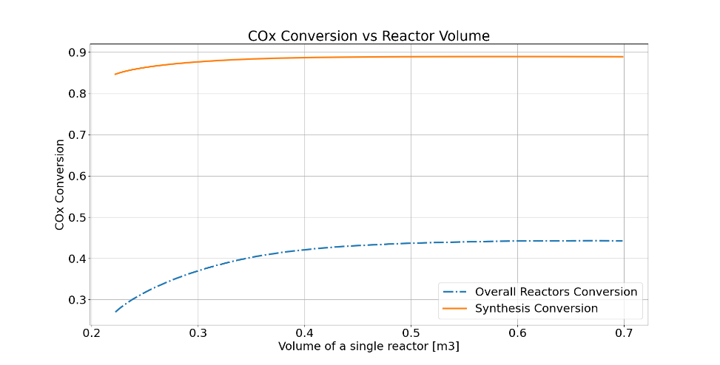
Figure 2. Dependence of $CO_{X}$ conversion on reactor volume
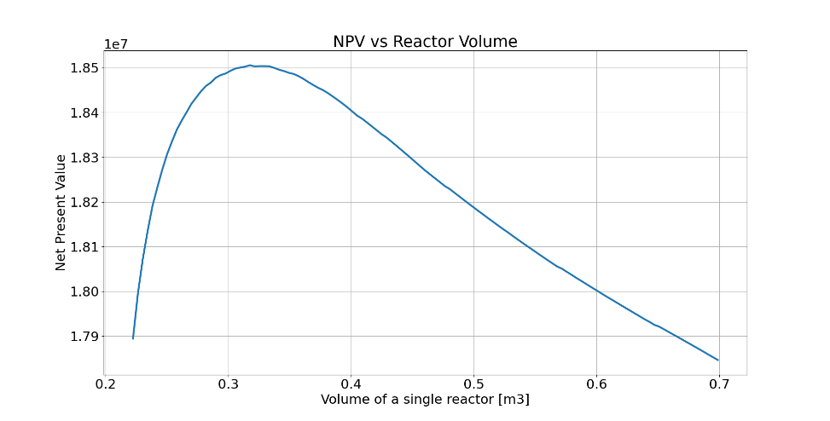
Figure 3. Trends of Net Present Value over reactor volume
The key parameter indicator chosen to assess the synthesis section and determine the optimal volume and its impact on the economics is the non-discounted Net Present Value (NPV). Despite assuming constant costs for both the first section of the plant and the purification section, without specific estimation, NPV has been chosen for its simplicity, assuming a plant lifetime of 10 years. Figure 3. illustrates the NPV with respect to the volume of a single reactor. The trend exhibits a significative peak, corresponding to a volume of each reactor of around 0.3 m³, which aligns with the volume needed to approximately achieve thermodynamic equilibrium. The corresponding optimal conversions of both reactors and the synthesis section are respectively equal to 41 % and 89 %. Figure 4. represents the Gas Hourly Space Velocity (GHSV) and the Stoichiometric Number (SN) concerning the same independent variable. As commonly known in the literature, the corresponding optimal SN has been found to be 2.0, while the optimal GHSV parameter, commonly used in describing the reactive unit, has been estimated at 17,000 h⁻¹. Simultaneously, these results validate the model outlined in Section 2, opening new routes for more advanced and complex optimizations.
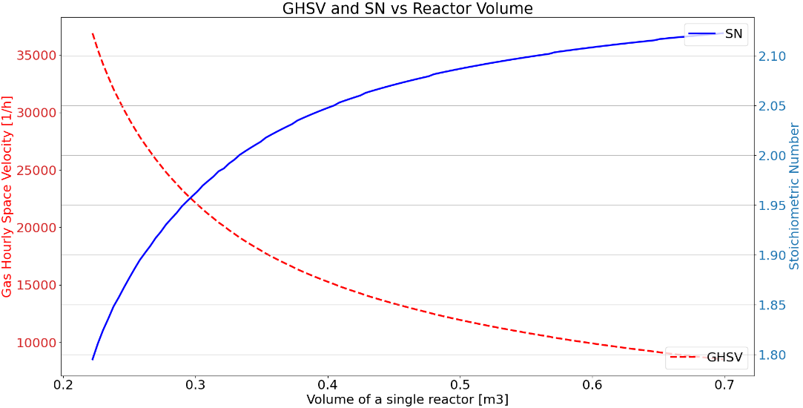
Figure 4. Dependence of GHSV and SN on the volume of each reactor
  - Conclusions and Further Developments
This study focuses on the economic viability and optimization of the synthesis section of a small-scale biogas-to-methanol plant. This section can be divided into two identical parts, each one composed by three heat exchangers for heating and cooling the mixture, a multi-tubular reactor and a separator. The unreacted gases are recycled, with a fraction vented. The plant economics were estimated using a common procedure to assess its feasibility. Subsequently, economic optimization of the NPV by varying the volume of the reactors within its common range of operation was performed to evaluate its impact on the economics of the section. The NPV trend, concerning the volume of each reactor, exhibits a clear peak at around 0.3 m³. The SN and GHSV values at the optimal point, under fixed operating conditions, are 2.0 and 17,000 h⁻¹, respectively, consistent with literature values. Both operating and capital costs are highly sensitive to the chosen independent variable. The capital costs of the reactors and process-to-process heat exchangers are the most impactful, while the operating expenditure related to the synthesis section is relatively less significant due to the energy-integrated process layout. Although this study neglected costs related to pre- and post-processing, the process appears economically feasible, given the considerable methanol production and potential revenues. This work demonstrates the feasibility of small-scale biogas-to-methanol plant. Furthermore, the optimization of such a process significantly influences its economics, addressing the economic disadvantage compared to traditional, less environmentally friendly solutions. As a result, more advanced and exhaustive optimization of the synthesis section, considering operating conditions, and of the overall process will be carried out. In parallel, optimization procedures based on both economic and environmental criteria will be explored.
References
F. Bisotti, M. Fedeli, K. Prifti, A. Galeazzi, A. Dell’Angelo, F. Manenti, 2022. Impact of Kinetic Models on Methanol Synthesis Reactor Predictions: In Silico Assessment and Comparison with Industrial Data. Ind. Eng. Chem. Res. 61, 2206–2226.
G. Bozzano, C. Pirola, C. Italiano, R. Pelosato, A. Vita, F. Manenti, 2017. Biogas: a Possible New Pathway to Methanol?, in: Espuña, A., Graells, M., Puigjaner, L. (Eds.), Computer Aided Chemical Engineering, 27 European Symposium on Computer Aided Process Engineering. Elsevier, pp. 523–528.
K.M.V. Bussche, G.F. Froment, 1996. A Steady-State Kinetic Model for Methanol Synthesis and the Water Gas Shift Reaction on a Commercial Cu/ZnO/Al2O3Catalyst. Journal of Catalysis 161, 1–10.
F. Manenti, S. Cieri, M. Restelli, 2011. Considerations on the steady-state modeling of methanol synthesis fixed-bed reactor. Chemical Engineering Science 66, 152–162.
E. Moioli, T. Schildhauer, 2022. Eco-Techno-Economic Analysis of Methanol Production from Biogas and Power-to-X. Ind. Eng. Chem. Res. 61, 7335–7348.
K. Prifti, A. Galeazzi, F. Manenti, 2023. Design and Simulation of a Plastic Waste to Methanol Process: Yields and Economics. Ind. Eng. Chem. Res. 62, 5083–5096.
R.O. dos Santos, L. de S. Santos, D.M. Prata, 2018. Simulation and optimization of a methanol synthesis process from different biogas sources. Journal of Cleaner Production 186, 821–830.
G. Towler, R. Sinnott, 2012. Chemical Engineering Design: Principles, Practice and Economics of Plant and Process Design, 2nd edition. ed. Butterworth-Heinemann, Boston, MA.
R. Turton, J. Shaeiwitz, D. Bhattacharyya, W. Whiting, 2018. Analysis, Synthesis, and Design of Chemical Processes, 5th edition. ed. Pearson, Boston.
Софія, 2020. European Biogas Association Statistical Report 2020. UABIO.

