Multi-objective Optimization Applied to the Thermal Hydrolysis and Anaerobic Digestion system for Biosludge from the Pulp Kraft Industry
Nicolás Goycoechea^{a*}, Liliana Borzacconiª, Jimena Ferreira^{b,c}, Martin Pedemonte^{c}, Iván Lópezª
ª Biotechnological Processes for the Environment Group, Universidad de la República, 11300 Montevideo, Uruguay.
^{b} Heterogenous Computing Laboratory, Universidad de la República, 11300 Montevideo, Uruguay.
^{c} Chemical & Process Systems Engineering Group, Universidad de la República, 11300 Montevideo, Uruguay.
*: ngoycoechea@fing.edu.uy
Abstract
Anaerobic digestion (AD) is a method for generating energy from renewable sources and mitigating greenhouse gas emissions by replacing fossil resources. Pretreatments are employed to enhance biosludge biodegradability, improving biogas production and waste-to-energy conversion in AD. Although thermal hydrolysis (TH) is a widely used technology with high energy recovery, it can generate recalcitrant compounds, presenting operational and environmental challenges. After TH and AD detectable recalcitrant nitrogen compounds, such as Dissolved Organic Nitrogen (DON), may be present. Usually, TH and AD systems are optimized based on methane production, energy, or economic balances. However, incorporating a multi-objective approach that considers conflicting objectives, including recalcitrant reduction, is beneficial. This study performed a multi-objective optimization, determining the Pareto front for the system energy profit (EP) and the recalcitrant generation quantified as DON in a thermally hydrolyzed cellulose industry biosludge. Results showed a 43 % reduction in recalcitrant generation using multi-objective optimization compared to a single-objective optimization of EP, with only an 8 % reduction in EP compared to the maximum achievable EP.
Keywords: Anaerobic Digestion; Thermal Hydrolysis; Multi-objective Optimization; Recalcitrant; Methane.
  - Introduction
Anaerobic digestion (AD) is a technology used to generate energy from waste, replace fossil resources, and avoid greenhouse gas emissions, but waste used in this process may contain challenging-to-digest fractions (Castro-Amoedo et al., 2021). Therefore, pretreatments can enhance the biodegradability of biosludge, leading to higher biogas production in AD, thus improving waste-to-energy conversion. The cellulose industry sludge has not been studied much, and previous works have shown that degradation can be a challenge. In addition, there is evidence of improvements obtained in biogas production by AD when thermal hydrolysis (TH) is applied, achieving increases of 100 % to 220 % of Biomethane Potential (BMP) (Goycoechea et al., 2023). On the other hand, achieving energy self-sufficiency of the TH and AD process to reduce costs is essential. TH is the most widely used technology for the pretreatment of solid waste and increases energy recovery from waste treated with anaerobic digestion. However, the use of TH can generate recalcitrant compounds, leading to potential operational and environmental problems (Toutian et al., 2020). After TH and AD, detectable recalcitrant nitrogen compounds may be present, such as dissolved organic nitrogen (DON), which affect wastewater disinfection due to the UV absorbance of these compounds.

Therefore, it is crucial to investigate the impact of temperature and time conditions of the TH process on the generation of recalcitrant and take them into account to reduce their production as an objective function to optimize. Typically, TH and AD systems are optimized based on methane production, energy balances, and/or economic balances, which are correlated. However, when the objective is also to reduce the generation of recalcitrant compounds, it is beneficial to follow a multi-objective optimization approach that considers two or more objective functions in conflict. Multi-objective optimization is not limited to finding a single solution but searches for a set of solutions, known as non-dominated solutions. Each solution in this set is considered a Pareto optimum (Deb, 2001), which reflects different trade-offs between the conflicting objectives. Previous studies have presented a multi-objective approach for the revalorization of sludge to obtain energy by incineration, but at the cost of discharges with higher nitrogen contents (Hreiz et al., 2015). In this work, we performed a multi-objective optimization by determining the Pareto front of the energy profit of the TH and AD system and the recalcitrant generation of the TH, which achieves considerable increases in energy profit.
  - Material and Methods
    - Substrate Characterization and Testing
The substrate used was biological sludge from the wastewater treatment of a cellulose industry in Uruguay. The sludge was treated with TH and AD, and biogas and recalcitrant compounds were quantified. Goycoechea et al. (2023) presented the response surface of biogas based on laboratory experiences.
    - Energy Profit
      - Parameters used in the Energy Balance
Table 1 presents the parameters used in the energy balances (EB). These parameters are used to evaluate different TH conditions.
      - Thermal Energy Demand and Recovery for TH
The energy required to increase the sludge temperature to that of the TH reactor is presented in Eq. (1). The Eq. (2) presents the energy recovery of the outlet stream of TH. The energy recovery stage is necessary to not compromise the biological process. Finally, Eq. (3) presents the total energy. Biological sludge contains total solids ($TS$) and water. This is modeled as a binary mixture with its corresponding heat capacity of sludge (${Cp}_{sludge}$) and water (${Cp}_{H_{2}O}$). The calculation and model were performed as it was presented by Barber (2020).
$E_{THdemand}=\left(\frac{TS {Cp}_{sludge}+\left(1-TS\right){Cp}_{H_{2}O}}{TS} \right)\left(T_{amb}-T_{TH}\right) η$ | [1]
$E_{THrecovery}=\left(\frac{TS {Cp}_{sludge}+\left(1-TS\right){Cp}_{H_{2}O}}{TS}\right)\left(T_{TH}-T_{AD}\right) ξ$ | [2]
$E_{TH}=E_{THdemand}+E_{THrecovery}$ | [3]
Table 1: Summary of parameters used for the developed EB.
Parameters
 |  | Symbol |  | Value | Units |  | References
Ambient temperature |  | $T_{amb}$ |  | 20 | °C |  | Assumed
Temperature AD |  | $T_{AD}$ |  | 37 | °C |  | Assumed
Wet sludge density |  | ρ |  | 1000 | kg m⁻³ |  | Xiao et al. 2018
Time of residence AD |  | τ |  | 30 | days |  | Xiao et al. 2018
Energy requirement associated with pumping |  | θ |  | 0.5 | kWh m⁻³ |  | Lu et al. 2008
Energy requirement associated with AD agitation. |  | ω |  | 0.083 | kWh m⁻³ d⁻¹ |  | Lu et al. 2008
Lower calorific value biogas |  | $LHV$ |  | 9.94 | kWh Nm⁻³_{CH4} |  | Metcalf & Eddy, 2003
Energy recovery efficiency |  | $η_{BMP}$ |  | 80 | % |  | Lu et al. 2008
Heat capacity of sludge | ${Cp}_{sludge}$ |  | 4.2x10⁻⁴ |  |  | kWh kgTS⁻¹ K⁻¹ |  | Barber, 2020
Heat capacity of water | ${Cp}_{H_{2}O}$ |  | 1.2x10⁻³ |  |  | kWh kgH₂O⁻¹ K⁻¹ |  | Barber, 2020
Total solids concentration | $TS$ |  | 10.0 |  |  | % |  | This study
Volatile solids concentration | $VS$ |  | 5.1 |  |  | % |  | This study
Heat exchanger efficiency upstream of TH | η |  | 90 |  |  | % |  | Lu et al. 2008
Heat exchanger efficiency after TH | 𝜉 |  | 80 |  |  | % |  | Lu et al. 2008
      - Heat Losses in the AD
Heat losses are calculated in the AD, operating at 37 °C. Heat losses through the digester walls, floor, and roof were considered using the heat transfer coefficient values recommended by MetCalf and Eddy (2003), resulting in the heat loss $E_{loss AD}\left(\frac{kWh}{tonST}\right)$.
      - Energy Benefits of Biogas
The corresponding calculation of the energy generated by the biogas is seen in Eq. (5). Based on a previous work (Goycoechea et al., 2023), the BMP was obtained as a function of pretreatment temperature and time conditions.
$E_{Benefit}=\frac{LHV BPM VS}{TS}η_{BMP}$ | [5]
      - Energy Profit Calculation
Based on the energy flows presented, we proceed to calculate the variable corresponding to the energy profit (EP) in Eq. (6). The EP variable can be positive in the case of having a net generation or negative in the case of having an energy deficit.
$E_{EP}=E_{TH}-E_{loss AD}-E_{Electricity}+E_{Benefit}$ | [6]
    - DON
The objective function associated with DON was based on a Doehlert experimental plan performed for a study domain of TH conditions in a temperature range from 125 °C to 205 °C and times from 15 to 45 min. The resulting function is presented in Eq. (7), where $T$ is the temperature (°C) and $t$ is residence time (min). The methodology was presented in previous work (Goycoechea et al., 2023), where response surfaces based on TH temperature and time conditions were developed for the cellulosic sludge substrate.
$DON\left(ppm\right)=176+0.045 t-2.4 T+0.0043 T t-0.0073 t^{2}+0.0082 T^{2}$ | [7]
    - Multi-Objective Optimization
For multi-objective optimization, the functions generated by the response surfaces of EP and DON were normalized using $Y_{normalized}=\frac{Y-Y_{min}}{Y_{max}-Y_{min}}$, where $Y$ is the vector of values for the corresponding variable. The objective function related to DON concentration is considered as costs in the optimization problem. Therefore, EP was also analyzed as a cost and was defined as (1-EP_{normalized}). Finally, feasible solutions belonging to the Pareto set were evaluated by simulating different TH conditions within the study domain. The study domain was defined based on the validation range of the BMP and DON functions used in previous works. This range is from 125 °C to 205 °C and from 15 min to 45 min. The study domain was subdivided into 1 °C and 1 min to evaluate the different solutions and generate the possible combinations of candidate solutions. We developed algorithms using Matlab to identify the non-dominated solutions of the Pareto front. The solution of the Pareto front whose distance is minimum to a reference point, was identified using the compromise programming method (Deb, 2001). The chosen reference point corresponds to the one that generates the minimum value of both costs, which does not belong to the Pareto front, and corresponds to (0,0) in the normalized ranges. The Euclidean distance was used for the calculation. Eq. (8) shows the multi-objective optimization problem formulation.
$\min_{\left\{T,t\right\}∈Ω }\left\{\begin{aligned}\left(1-{EP}_{normalized}\right) \\ {DON}_{normalized}\end{aligned}\right.$ | [8]
$s.t.: Eq.\left(6\right),Eq.\left(7\right), Ω=\{T∈\left[125 °C,205 °C\right];t∈\left[15 min,45 min\right]\}$
  - Results and discussion
    - Mono-objective Optimization Approach
      - Energy Profit Optimization
Figure 1 shows the obtained values for the different TH conditions within the study domain. The obtained function presents a maximum of 306 kWh tonST⁻¹ at TH conditions of 172 °C and 30 min. The energy balance results are greater than zero for most of the TH conditions, thus denoting an energy self-sufficiency of the AD process when using TH.
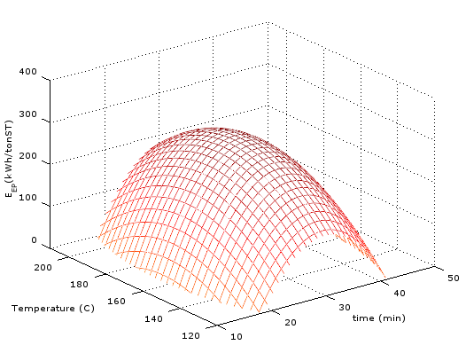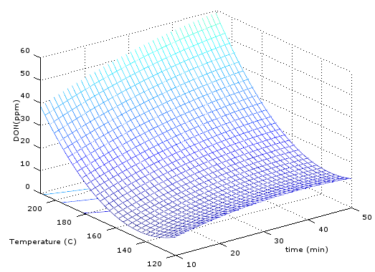
Figure 1: $E_{GE}$(left) and response surface for DON concentration (right) at different TH conditions.
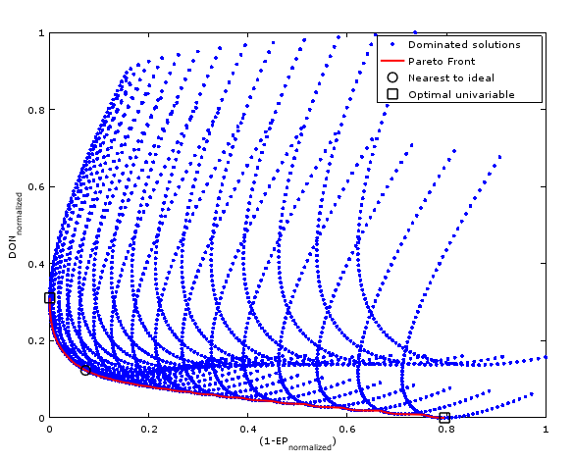
Figure 2: Result of the objective functions within the study domain (blue dots), Pareto front (red solid line), closest point to the ideal (O) and extremes of the front (▢).
      - DON Optimization
Figure 1 presents DON concentration obtained at the end of the AD. The recalcitrant compound has a general increase with increasing temperature. The DON concentration has a local minimum at the boundary of the study domain of 15 min at 143 °C.
    - Multi-Objective Optimization Approach
Figure 2 presents the set of values obtained for the objective functions when evaluating the solutions considering the discretized domain (blue dots). Also, Figure 2 shows the Pareto front in red dots. The extremes of the Pareto front are marked as ▢, these points are solutions that minimize one of the objective functions within the study domain, being the optimal values previously presented as the maximum indicated for the GE ($E_{GE}$) and the minimum DON (${DON}_{opt}$). A solution was selected as the one that belongs to the Pareto front and minimizes the Euclidean distance to the reference point. This solution is marked with O in Figure 2 and represents the nearest point to the ideal solution (0,0). The nearest point translated to TH conditions results in 150 °C and 29 min, corresponding to a value of 280 kWh tonST⁻¹ for the objective function corresponding to$E_{GE}$ and 11.1 ppm DON. Table 2 presents a summary of the values obtained from the single-objective and multi-objective approaches. When comparing the solution selected using the multi-objective formulation with ${DON}_{opt}$, it is found that it is possible to obtain a much higher value of energy recovery (x70) at the cost of doubling the recalcitrant. On the other hand, a 43 % reduction in recalcitrant generation is obtained using multi-objective optimization compared to a single-objective optimization of EP, with only an 8 % reduction in EP compared to the maximum achievable EP.
Table 2: $E_{GE}$ and DON values obtained from the optimizations.
Optimization | TH Conditions |  | $E_{GE}$ | DON
 | Temperature (°C) | Time (min) | kWh/tonST | ppm
Multi-Objective | 150 | 29 | 280 | 11.1
$E_{GE opt}$ | 172 | 31 | 305 | 19.6
${DON}_{opt}$ | 143 | 15 | 4 | 5.6

  - Conclusions
This study performed a multi-objective optimization, determining the Pareto front for the system energy profit (EP) and the recalcitrant generation quantified as DON in a thermally hydrolyzed cellulose industry biosludge. When only energy optimization is considered, the energy profit generates a positive energy balance, therefore, an economic benefit from the sale or use of energy. However, this mono-objective optimization implies a recalcitrant generation of 19.6 ppm DON leading to possible environmental problems.
On the other hand, including a multi-objective optimization based on considering recalcitrant such as DON as a second objective function allows to produce a 43 % reduction in recalcitrant compounds. Consequently, when recalcitrant generation is considered as another objective function, the multi-objective optimization leads to lower temperature optima than $E_{GE opt}$. This allows for the reduction of impacts on UV disinfection of such waters and potential emerging pollutants with nitrogen content, with a scarce reduction of 8 % in energy balance profits.
Also, the multi-objective approach allows to select from the Pareto front solutions with different balances of the objective functions. For instance, if the environmental aspect is more relevant, a different solution can be selected, obtaining a better energy profit than the minimum DON situation, without producing a substantial increment in the recalcitrant concentration.
As a future work, it can be considered the inclusion of other objective functions related to environmental indicators. Also, from the set of Pareto front solutions found in this work, different trade-offs between environmental issues and energy profit can be analyzed.
  - References
Barber, W. (2020). Sludge Thermal Hydrolysis: Application and Potential. In Sludge Thermal Hydrolysis: Application and Potential. IWA Publishing.
Castro-Amoedo, R., Morisod, N., Granacher, J., & Maréchal, F. (2021). The Role of Biowaste: A Multi-Objective Optimization Platform for Combined Heat, Power and Fuel. Frontiers in Energy Research, 9, 718310.
Deb K. Multi-objective optimization using evolutionary algorithms. New York (NY, USA): John Wiley & Sons, Inc.; 2001.
Goycoechea, N., López, I., & Borzacconi, L. (2023). Optimization of anaerobic digestion and solubilization of biosludges from the kraft cellulose industry using thermal hydrolysis as pretreatment. Journal of Environmental Management, 344, 118504.
Hreiz, R., Roche, N., Benyahia, B., & Latifi, M. A. (2015). Multi-objective Optimization of Small-size Wastewater Treatment Plants Operation. Computer Aided Chemical Engineering, 37, 2495–2500.
Lu, J., Gavala, H. N., Skiadas, I. V., Mladenovska, Z., & Ahring, B. K. (2008). Improving anaerobic sewage sludge digestion by implementation of a hyper-thermophilic prehydrolysis step. Journal of Environmental Management, 88(4), 881–889.
Metcalf & Eddy, Inc. (2003). Wastewater engineering : treatment and reuse. Boston :McGraw-Hill.
Toutian, V., Barjenbruch, M., Unger, T., Loderer, C., & Remy, C. (2020). Effect of temperature on biogas yield increase and formation of refractory COD during thermal hydrolysis of waste activated sludge. Water Research, 171.
Xiao, B., Qin, Y., Wu, J., Chen, H., Yu, P., Liu, J., & Li, Y. Y. (2018). Comparison of single-stage and two-stage thermophilic anaerobic digestion of food waste: Performance, energy balance and reaction process. Energy Conversion and Management, 156(August 2017), 215–223.

