Modeling of the coupling of dissolution and crystallization in the digestion tank of a wet phosphoric acid manufacturing process

ªMohammed VI Polytechnic University, 43150 Benguerir, Morocco
^{b}Université de Lorraine, CNRS, LRGP, F-54000, Nancy, France
^{c}Mohammed V University, Rabat, Morocco
abderrazak.latifi@univ-lorraine.fr
Abstract
This work deals with the development of a first-principles model describing the digestion tank of a wet phosphoric acid manufacturing process. Phosphate dissolution and gypsum crystallization, which both occur simultaneously in the tank, are taken into account. The dissolution model is based on the mass balance equations of the reactants and products in the liquid bulk, in the liquid film surrounding the ore particles, and in the particles (Elmisaoui et al., 2024). The gypsum crystallization model is based on a population balance equation involving both crystal growth and nucleation. By means of a global estimability analysis approach, the values of the unknown parameters of the model are determined from experimental measurements. The predictions of the identified model exhibit a good agreement with the experimental data.

Keywords: Dissolution, Crystallization, Phosphoric acid, Modelling and simulation, Global estimability analysis, Parameter identification.
  - Introduction
Optimal design and operation of the digestion tank is of utmost importance to improve the performance of industrial phosphoric acid manufacturing processes. Hence, the understanding of the complex phenomena involved in the digestion tank is therefore necessary to develop fine and accurate models in close and permanent interactions with the experiments. The dissolution of the phosphate ore and the crystallization of gypsum are the two main complex phenomena taking place simultaneously within the digestion tank, and obviously their progress influences the process performances. Indeed, the first one leads to the extraction of P₂O₅ from the phosphate ore particles, while the second one has an impact on the filterability and washing characteristics of the gypsum. Hence, a model combining the two phenomena is therefore required to correctly predict the process performance. It is the objective of the present paper which aims to develop a first-principles model describing the dissolution of ore particles and the crystallization of gypsum formed in the digestion tank.
  - Model formulation
To describe the mechanisms of dissolution and crystallization involved in the digestion tank, four phases are considered: the liquid film, the liquid bulk, a first solid phase constituted by the phosphate particles, and a second solid phase represented by the formed gypsum crystals. Two main reactions occur simultaneously:
- The phosphate dissolution reaction (Van der Sluis et al., 1987):
$${Ca}_{3}{\left({PO}_{4}\right)}_{2} + 4 H_{3}{PO}_{4}→ 3 Ca{\left(H_{2}{PO}_{4}\right)}_{2}$$ | (1)
- The gypsum crystallization reaction (Abu-Eishah et Abu-Jabal, 2001):
$Ca{\left(H_{2}{PO}_{4}\right)}_{2} + H_{2}{SO}_{4} + 2 H_{2}O→ 2 H_{3}{PO}_{4} + {CaSO}_{4}.2H_{2}O$ | (2)
    - Mechanism description
The shrinking core model is adopted to represent the evolution of the particle radius during its dissolution in the digestion tank. The mechanism considered assumes that phosphoric acid $H_{3}{PO}_{4} (ACP$), sulfuric acid $H_{2}{SO}_{4} (ACS$), and water $H_{2}O (W$) diffuse through the film toward the solid, and only $ACP$ adsorbs on the particles of phosphate ore and eventually reacts with the Tri-Calcium Phosphate ${Ca}_{3}{\left({PO}_{4}\right)}_{2}(TCP$). The Mono-Calcium Phosphate $Ca{\left(H_{2}{PO}_{4}\right)}_{2} (MCP$) product takes the opposite path where it desorbs first from the solid surface, then diffuses through the liquid film and transfers to the liquid bulk. It is important to point out that MCP reacts with the sulfuric acid in the liquid film and in the liquid bulk to produce phosphoric acid and dissolved gypsum ${CaSO}_{4}.2H_{2}O (G$). When the liquid bulk is saturated with gypsum, crystals begin to form. They are characterized by a shape and a size distribution.
The model of the tank is based on the following assumptions : (i) the particles are spherical and well dispersed in the liquid bulk, (ii) the digestion tank is perfectly mixed, (iii) the adsorption/desorption and mass transfer steps are non-limiting, (iv) the dissolution reaction (Eq.1) is irreversible, (v) the crystallization reaction (Eq.2) occurs simultaneously in the film and in the liquid bulk, (vi) the transfer of MCP to the liquid bulk is considered to be the limiting step of the dissolution mechanism, (vii) the crystallization reaction rate is proportional to the amount of gypsum produced, (viii) the digestion tank is isothermal. The model is thus provided by the system of mass balance equations below.
    - Liquid film
Fick's second law is used to describe the diffusion of substances in the liquid film with the associated initial and boundary conditions, as:
$\frac{∂C_{i}}{∂t}=D_{i}\left(\frac{∂^{2}C_{i}}{∂r^{2}}+\frac{2}{r}\frac{∂C_{i}}{∂r}\right)+ν_{i}\frac{dC_{G}^{D}}{dt}$ $i=ACP,ACS,MCP,W,G$ |  | (4)
$$r=R$$ | $$\begin{matrix}-D_{i}\frac{dC_{i}}{dr} & =ν_{i}k_{r}C_{ACP}^{b} & & i=ACP,MCP \\ -D_{j}\frac{dC_{j}}{dr} & =0 & & j=ACS,W, G\end{matrix}$$ | (5)
$$r=R+δ$$ | $C_{i}=C_{i}^{b}$ $i=ACP,ACS,MCP,W,G$ | (6)
where $C_{i}\left( mol.m^{-3}\right)$ and $D_{i}\left({ m}^{2}⋅s^{-1}\right)$ are the molar concentration in the liquid film and the diffusion coefficient of substance $(i)$, respectively. $C_{i}^{b}\left( mol⋅m^{-3}\right)$ is the molar concentration in the liquid bulk, $k_{r}\left(m.s^{-1}\right)$ the reaction rate constant, and $δ(m)$ is the thickness of the liquid film.
    - First solid phase
The equation describing the temporal profile of the dissolution rate ($X$) of ore particles (first solid phase) in a solution of phosphoric and sulfuric acids, in the presence of a non-uniform particle size distribution, represented by the Gate-Gaudin-Schuhmann distribution, is written as (Elmisaoui, 2023):
$$\frac{dX}{dt}=\frac{3M_{TCP}D_{MCP}}{x_{TCP}ρ_{s}}\int_{R_{min}}^{R_{max}}{ }\frac{\left[C_{MCP∣r=R}\left(R_{0}\right)-C_{MCP}^{b}\left(R_{0}\right)\right]{\left[1-X\left(R_{0}\right)\right]}^{\frac{2}{3}}f\left(R_{0}\right)}{R_{0}δ\left(R_{0}\right)}dR_{0}$$ | (7)
where $M_{TCP}$ is the molar weight of TCP, $x_{TCP}$ is the mass fraction of TCP in the solid, $ρ_{s}$ is the density of the solid, and $f\left(R_{0}\right)dR_{0}$ is the mass fraction of particles whose size is between $R_{0}$ and $R_{0}+dR_{0}$. The size distribution is characterized by a coefficient of variation $(CV)$ which is a model parameter.
The thickness of the liquid film is expressed by (Elmisaoui, 2023):
$$δ=\int_{R_{min}}^{R_{max}}{ }R_{0}{\left[1-X\left(R_{0}\right)\right]}^{\frac{1}{3}}{\left[1+α{\left(1-X\left(R_{0}\right)\right)}^{\frac{8}{27}}D_{MCP}^{-1}\right]}^{-1}$$ | (8)
where $α$ is a parameter of the hydrodynamic conditions in the stirred digestion tank.
    - Liquid bulk
Taking into account the stoichiometry of the substances in the reactions Eqs. (1) and (2), the concentrations in the liquid bulk are expressed as:
$\begin{matrix}C_{ACP}^{b} & =C_{0ACP}^{b}-4\frac{n_{TCP}^{0}}{V_{L}}X+2C_{G}^{b} \\ C_{MCP}^{b} & =3\frac{n_{TCP}^{0}}{V_{L}}X-C_{G}^{b} \\ C_{ACS}^{b} & =C_{0ACS}^{b}-C_{G}^{b} \\ C_{W}^{b} & =C_{0W}^{b}-2C_{G}^{b}\end{matrix}$ | (9)
where $C_{0i}^{b}\left( mol.m^{-3}\right)$ is the initial molar concentration of substance $(i)$ in the liquid, and $V_{L}\left(m^{3}\right)$ is the volume of liquid in the digestion tank.
    - Second solid phase
The production of gypsum crystals (second solid phase) in the liquid bulk can be described by means of the following equation (Bakir, 2006):
$$\frac{d\left(V_{L}C_{G}^{b}\right)}{dt}+\frac{d\left(V_{T}C_{G}^{S}\right)}{dt}=0 ,with V_{L}=V_{T}\left(1-\frac{M_{G}}{ρ_{G}}C_{G}^{S}\right)$$ | (10)
where $V_{T}\left({ m}^{3}\right)$ is the volume of the suspension, $M_{G}\left(\text{kg.}{mol}^{-1}\right)$ is the molecular weight of gypsum, $ρ_{G}\left({kg.m}^{-3}\right)$ is the density of gypsum, and $C_{G}^{S}\left(mol.m^{-3}\right)$ is the concentration of solid gypsum formed calculated from the crystal size distribution using the following relationship :
$C_{G}^{S}=\frac{K_{v}ρ_{G}}{M_{G}}\left[\int_{0}^{∞}{ } L^{3}NdL\right]$, $K_{v}$ is a form factor (for spherical particles $K_{v}=\frac{π}{6}$ ). | (11)
Calculation of $C_{G}^{S}$ requires determination of the crystal size distribution using the population balance equation. In this work, discontinuous crystallisation without seeding is considered. We also assume that crystal growth does not depend on crystal size $(L)$.
The mono-dimensional population balance is then expressed as (Barbier et al., 2009):
$$\frac{∂N(L,t)}{∂t}+G\frac{∂N(L,t)}{∂L}=0, N\left(0,t\right)= \frac{R_{N_{1}}+ R_{N_{2}}}{G}$$ | (12)
$$R_{N_{1}}=A_{1}×\exp\left(\frac{-B_{1}}{σ^{2}}\right)$$ | (13)
$$R_{N_{2}}=A_{2}×{\left(C_{G}^{b}-C_{G}^{sat}\right)}^{B_{2}}×C_{G}^{S}$$ | (14)
$$G=K_{c}\frac{M_{G}}{2ρ_{G}}η{\left(C_{G}^{b}-C_{G}^{sat}\right)}^{g}$$ | (15)
$$\left[\frac{K_{c}}{K_{d}}{\left(C_{G}^{b}-C_{G}^{sat}\right)}^{g-1}\right]η+η^{1/g}+1=0$$ | (16)
$$S=\frac{a_{SO_{4}^{2-}}a_{{Ca}^{2+}}a_{w}^{2}}{K_{s}} , σ=\ln\left(S\right)$$ | (17)
where $N(L,t)$ (number. $m^{-3}⋅m^{-1}$ ) is the crystal size distribution, $R_{N_{1}}$ is the primary nucleation rate, $R_{N_{2}}$ is the secondary nucleation rate, $G$ is the crystal growth rate, $S$ is the supersaturation ratio which depends on the activities of the sulphate ions $a_{{SO}_{4}^{2-}}$, of the calcium $a_{{Ca}^{2+}}$ and of the water $a_{w}$, as well as of the equilibrium constant $K_{s}$. $σ$ is the relative supersaturation, $C_{G}^{sat}$ is the solubility, the term $C_{G}^{b}-C_{G}^{\text{sat }}$ represents the crystallization driving force, and $η$ is the efficiency factor given by the solution of the equation (16).$k_{r}$, $α$, $D_{MCP}$, $CV$, $A_{1},B_{1},A_{2},B_{2}$, $K_{c},K_{d}$ and $g$ are unknown parameters to be determined from experimental measurements.
  - Results and discussions
The estimability of the unknown parameters involved in the model is first carried out, then the most estimable parameters are identified from existing experimental data, i.e., temporal profiles of crystal size distribution and ACP concentration in the liquid bulk. Matlab environment is used to implement and solve the model equations.
    - Estimability analysis results
The unknown parameters are ranked in decreasing order of estimability as follows:
$g$ > $K_{d}$ > $K_{c}$ > $A_{1}$ > $CV$ >${ k}_{r}$>$B_{1}$>$α$ > $D_{MCP}$ > $A_{2}$ > $B_{2}$. This ranking shows the importance of the growth phenomenon in the gypsum crystallization mechanism, and that the parameter $g$, is the most estimable. This is obvious, since it represents the power of the crystallization driving force. This ranking analysis also shows that the coefficient of variation, $CV$, is more estimable than the kinetic constant,${ k}_{r}$, the MCP diffusion coefficient, $D_{MCP}$, and the hydrodynamic parameter, $α$. To determine the number of estimable parameters, it is necessary to set a value for the estimability threshold. This estimability cut-off allows to distinguish between estimable parameters and non-estimable ones. Using the algorithm of Wu et al. (2011), the optimal value of the estimability threshold allowing the CV parameter to be estimable is 0.016 (Elmisaoui, 2023) . The set of estimable parameters is therefore constituted by: $g$, $K_{d}$, $K_{c},$ $A_{1}$ and $CV$.

    - Parameter estimation
We considered a batch reactor of volume V= 1L, initially containing a mass of 100g of raw phosphate of size between 250 and 500 µm. The ACP and ACS solutions introduced in the digestion tank are characterized by 18% of P₂O₅ and an excess of free sulphates of 2%, respectively. The temperature of the reaction medium was maintained at 70°C, with a corresponding stirring speed of 200 rpm. Crystal size L was assumed to be in the range of 0-100 µm. Table 1 shows the identified values of the estimated parameters of the model with their corresponding 95% confidence intervals (CIs).
CIs show that the optimal values of the global model parameters were determined with good accuracy. These findings were confirmed by the good agreement between the model predictions and the experimental data, as shown in Figure 1. It can be seen that the concentration of ACP in the solution increases over time (Fig. 1.C). This increase is attributed to the production of phosphoric acid as crystallization proceeds, leading to the appearance of gypsum crystals formed simultaneously.

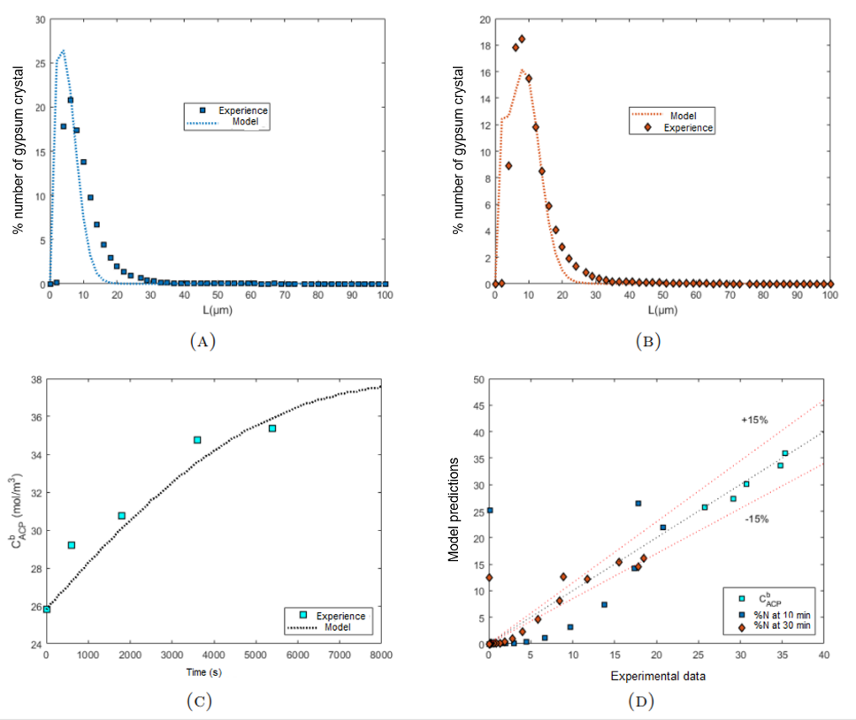
Figure 1: Comparison between experimental measurements and predictions of the number distribution of crystals as a function of their size after (A) 10 min, (B) 30 min, (C) molar concentration of ACP, (D) parity diagram
In addition, the size of the crystals increases from [0-16 µm] after 10 minutes (Fig. 1.A ) to [0-25 µm] after 30 minutes (Fig. 1.B) in the digestion tank. The parity diagram in Figure 1.D shows the comparison between the experimental measurements and the global model predictions. It is clear that the majority of the predictions obtained for phosphoric acid concentration and crystal number after 30 min of digestion are within the range of 15 % of uncertainty, thus showing the good quality of the developed model.
Table 1: Optimal values identified for estimable parameters.
Parameter | Optimal value | 95% CI | Unit
$$g$$ | $$1.96$$ | $$0.05$$ | -
$$K_{d}$$ | $$1.14×{10}^{-3}$$ | $$0.05×{10}^{-3}$$ | $$m.s^{-1}$$
$$K_{c}$$ | $$9.59×{10}^{-4}$$ | $$0.75×{10}^{-4}$$ | $$mol^{-1}⋅m^{4}⋅s^{-1}$$
$$A_{1}$$ | $$2.224×{10}^{8}$$ | $$0.63×{10}^{8}$$ | $$nb.m^{-3}.s^{-1}$$
$$CV$$ | $$1.69×{10}^{-1}$$ | $$0.11×{10}^{-1}$$ | -

  - Conclusions
A first-principles model for the digestion tank of a phosphoric acid manufacturing process is developed and identified from available experimental data. It combines two sub-models : a model for the dissolution of phosphate ore in a phosphoric acid solution, and a model based on population balance for gypsum crystallization. The estimability of the unknown parameters involved in the resulting global model was analysed by means of a global estimability analysis, and the most estimable ones are identified from the available experimental data. The results obtained showed that the model predictions are in good agreement with the experimental data. However, further research still needs to be carried out to improve the accuracy of the model.
References
Abu-Eishah, S. I., & Abu-Jabal, N. M. (2001). Parametric study on the production of phosphoric acid by the dihydrate process. Chemical Engineering Journal, 81(1-3), 231-250.
Elmisaoui, S. (2023). Modélisation, simulation et expérimentation du réacteur de production d’acide phosphorique à partir du minerai de phosphate, PhD thesis, Université de Lorraine, Nancy, France.
Elmisaoui, S., Latifi, A. M., & Khamar, L. (2024). Analysis of the dissolution of phosphate ore particles in phosphoric acid: Influence of particle size distribution. Hydrometallurgy, Vol. 223, pp.106197.
Van der Sluis, S., Meszaros, Y., Marchee, W. G., Wesselingh, H. A., & Van Rosmalen, G. M. (1987). The digestion of phosphate ore in phosphoric acid. Industrial & engineering chemistry research, 26(12), 2501-2505.
Bakir, T. (2006). Estimation d'un procédé de cristallisation en batch (Doctoral dissertation, Université Claude Bernard-Lyon I).
Barbier, E., Coste, M., Genin, A., Jung, D., Lemoine, C., Logette, S., & Muhr, H. (2009). Simultaneous determination of nucleation and crystal growth kinetics of gypsum. Chemical Engineering Science, 64(2), 363-369.
Wu, S., McLean, K. A., Harris, T. J., & McAuley, K. B. (2011). Selection of optimal parameter set using estimability analysis and MSE-based model-selection criterion. International Journal of Advanced Mechatronic Systems, 3(3), 188-197.

