Assessing the Contributions of Process Integration Towards the United Nations Sustainable Development Goals
Safeer Hafeez,ª Elizabeth J. Abraham,ª Dhabia M. Al-Mohannadi^{a*}
ªDepartment of Chemical Engineering, Texas A&M University at Qatar, Education City, PO Box 23874, Doha, Qatar
dhabia.al-mohannadi@qatar.tamu.edu
Abstract
The latest UN Sustainable Development Goals (SDGs) progress report states that we are currently on track to achieve only 12% of the targets. One of the many reasons for this situation is the disconnect between the policy space where the SDGs are and the technical space where some promising solutions to achieve the SDGs exist. One such solution is process integration (PI) which is an essential tool for creating a circular economy where the utilization of energy and resources, and the environmental impact of industrial processes are minimized while boosting economic growth. However, PI research currently lacks the inclusion of social aspects, an important third pillar of sustainability, in optimization problems which is mostly due to a lack of social indicators. Therefore, this work aims to bridge the gap between the policy and technical spheres by evaluating the contributions of PI towards the UN SDGs via a bibliometric analysis of PI literature and reviewing social and sustainability indicators that can be utilized in future research. The analysis revealed that PI contributes to 70% of the SDGs, including all the goals in the economic and environmental pillars of sustainability, and 38% of the goals in the social pillar.
Keywords: process integration, sustainable development goals, circular economy, industrial symbiosis, sustainability indicators
  - Introduction
The 2030 Agenda for Sustainable Development, established in 2015 by all nations, outlines a global commitment to achieving peace and prosperity for both people and the planet (UN, 2015). Comprising 17 Sustainable Development Goals (SDGs), it addresses a spectrum of issues with set targets for accomplishment by 2030 (UN, 2015). Despite progress, a recent SDG progress report reveals a sobering reality: only about 12% of goals are on track, approximately 50% are off track, and around 30% have stagnated or regressed from the 2015 baseline (UN, 2023). The multifaceted nature of SDGs demands collaboration among governmental bodies, NGOs, the private sector, communities, and research centres. However, a significant hurdle lies in the disconnect between policy and technical spheres, hindering the realization of technical solutions' full potential. Process integration (PI), a key solution for fostering a circular economy, exemplifies this challenge.
Circular economy (CE) involves minimizing primary energy and virgin resource consumption by maximizing energy and material recycle and recovery at the macro-level (Geissdoerfer et al., 2017). Several studies have explored CE's potential contributions to SDGs across various industries, including construction, and food (Hassoun et al., 2022; Ogunmakinde et al., 2022; Schroeder et al., 2019). Zooming into the micro-level, industrial symbiosis (IS) emerges as a critical component of CE, facilitating the exchange of resources between industries to minimize overall wastage while maximizing profits (Lawal et al., 2021). PI, a well-established IS-enabling tool, optimizes resource use through resource integration. Several tools for PI have been developed for various applications. The original graphical pinch analysis technique for heat exchanger network design (Townsend & Linnhoff, 1983), has been extended to wastewater minimization (Wang & Smith, 1994), integration of renewable energies (Alizadeh Zolbin et al., 2022), and financial planning for energy conservation projects (Roychaudhuri et al., 2017). Mathematical programming models have also advanced to solve increasingly complex optimization problems, like multi-objective resource integration for industrial clusters (Ahmed et al., 2021), multi-period optimization for CO₂ emissions reduction planning (Al-Mohannadi et al., 2016), and integrated design of waste management systems using P-graph (Fan et al., 2020). PI has even been expanded to the macro-scale with a framework combining elements of PI, IS and CE to increase circular flows in processes, industries and economies (Walmsley et al., 2019).
PI is essential in addressing contemporary global challenges such as energy transition, climate change and sustainable development, which asserts the critical role of PI in achieving the SDGs. As such, there is a need to bridge the gap between the policy and technical spheres to enable greater adoption of PI by assessing the capacity of PI tools and applications to tackle the SDGs and proposing social and holistic sustainability metrics to be used in future research.
  - Methodology
A bibliometric analysis was conducted to map the contributions of PI research to the SDGs. Bibliometric analysis is a quantitative literature review methodology used to explore and map the scientific knowledge of a select domain in existing literature by utilizing large volumes of unstructured data. The scope of this study is to analyze the literature on PI that explicitly identifies the sustainability contributions of their work. As such, the Web of Science database was used to search for publications that contained “process integration” and “sustainable” or “sustainability” in their title, abstract, or keywords. The query retrieved 484 publications, which was narrowed down to 325 most relevant papers after careful review.
A keyword matching exercise was carried out to assign to each paper the SDGs that it contributed towards. This was done by first selecting the relevant keywords for each SDG in the context of PI using the exhaustive search queries developed by Aurora Universities Network as a guide (Vanderfeesten et al.). The presence of these SDG keywords was then checked in the keywords and abstracts of the 325 selected papers. The SDGs 4 (education), 5 (gender equality), 10 (reduced inequalities), 16 (peace and justice) and 17 (partnership for the goals) are not included in this analysis because the keyword search for them gave no matches. Keyword mapping allowed us to determine: 1) how many papers contributed towards each SDG, and 2) how often each pair of SDGs were addressed in the same paper.
  - Results and Discussion
The network map generated from the keyword matching exercise is shown in Figure 1. The map visualizes the relative contributions of the papers towards the SDGs and the relationship between the SDGs in the context of PI research. The keywords pertaining to SDG 12 (responsible consumption and production) were the most common in our set of papers, followed in order by SDG 8 (decent work and economic growth), SDG 13 (climate action) and SDG 7 (affordable and clean energy). These SDGs are also the most interlinked, with an average of 75 papers contributing towards each pair of these four SDGs. However, the interrelation between the SDGs is high in general, with all SDGs commonly addressed alongside the others in most papers. For example, despite being mentioned in only 21 papers, SDG 11 (sustainable cities and communities) is still addressed alongside ten of the total eleven other SDGs in this study. This shows that the SDGs are interlinked and complement each other with respect to PI applications. Overall, Figure 1 exhibits the broad-spectrum impact of PI on the SDGs identified within our small collection of PI publications.
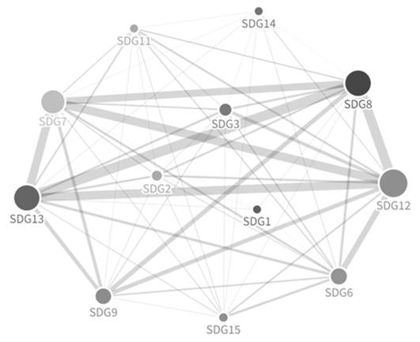
Figure 1: Network map of the SDGs addressed in the set of papers used in this study. Relative size of each node represents the number of papers that contained the keywords of the SDGs in their abstract or author keywords. Relative thickness of lines represents the number of papers that contained keywords of both SDGs connected by the line.
The contributions of the PI publications can also be visualized by the three pillars of sustainable development, namely social, economic and environmental. The pillars are interconnected, and so are the SDGs, which is why some of the SDGs can be categorized within multiple pillars. However, we simplify and categorize the SDGs within the pillars as shown in Figure 2 (Costanza et al., 2016). The greatest contribution is towards the economic pillar because the SDGs and subsequent targets within this pillar have many direct implications for industry. This is a promising outcome for governments as it proves PI can contribute towards economic growth and sustainable development simultaneously. Within the environmental pillar, SDGs 13 (climate action) and SDG 6 (clean water and sanitation) prove to be significant within PI research, with several applications in emissions minimization, development of biorefineries, and water networks optimization, among others. However, there is a need to incorporate the impacts on life below water (SDG 14) and life above land (SDG 15) in PI research.
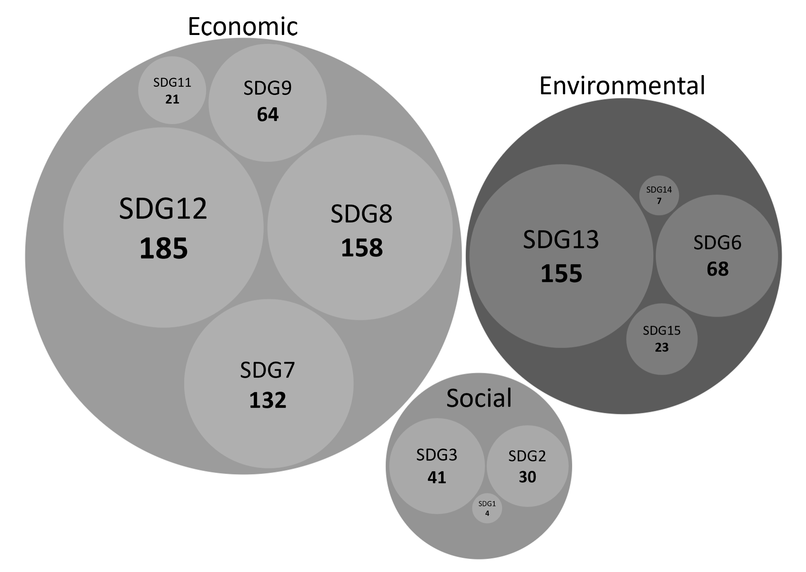
Figure 2: Categorization of the contributions of PI research towards the SDGs by the three pillars of sustainability and the number of papers addressing the respective SDGs.
The contributions identified in PI literature towards the social pillar are relatively lacking, despite the many indirect impacts of PI on these SDGs due to the contributions to economic and environmental pillars. This can mainly be attributed to the fact that social indicators are not widely used in PI research, and that PI doesn’t directly impact some of the social issues that the SDGs address like education (SDG 4), gender inequality (SDG 5), and peace and justice (SDG 16). Nevertheless, there are opportunities to contribute to SDG 1 (end poverty) via efficient and equitable allocation of resources and economic development, SDG 2 (end hunger) by optimizing food production, processing and distribution systems, SDG 3 (Good health and wellbeing) by minimizing pollution, SDG 10 (reduced inequalities) and SDG 17 (partnership for the goals) via multi-stakeholder partnerships and technology transfer. However, to capture the contributions of PI to these SDGs and to optimize processes for sustainability, there is a need to utilize social indicators and holistic sustainability metrics.
The most notable work in this regard was by El-Halwagi with the development of the Sustainability Weighted Return on Investment Metric, or SWROIM (El-Halwagi, 2017). This metric allowed the integration of conventional profitability calculations with an aggregate of multiple sustainability indicators, which can include social indicators. SWROIM was extended to incorporate safety indicators like hazard parameters (Guillen-Cuevas et al., 2018). While safety is a very important social aspect, it fails to represent the broader societal impacts that the SDGs aim to improve. To that end, the SDG framework itself provides a set of indicators for each goal which can be used to evaluate and benchmark the sustainability performance of an optimization problem. Also, the approach developed by Rafiaani et al. can be used to identify the most relevant social indicators for sustainability assessment (Rafiaani et al., 2020). They used a multi-criteria decision-making tool empirically determine relevant indicators to assess social impacts of a CCU operation. Furthermore, a comprehensive review by Messmann et al. covers a wide range of social indicators, including social objective functions and constraints in supply chain optimization which can also be utilized in PI (Messmann et al., 2020). Therefore, the need to assess the social impacts in future PI research can be met by utilizing the available social indicators and aggregate sustainability metrics.
  - Conclusions
PI tools like pinch analysis, multi-objective optimization and p-graph have found a broad range of applications in industry and infrastructure, providing a basis for the holistic design and operations of process systems. From our analysis, it is evident that utilizing PI tools can contribute towards achieving 70% of the UN SDGs. However, several barriers exist that hinder greater implementation of PI in industry stemming from the following three main factors:
- Resistance to change due to risk averse mindset.
- Confidentiality and reliability concerns.
- Increased complexity.
These barriers can mostly be overcome by greater cooperation between industries, government and researchers. Firstly, there needs to be more follow up studies and publications on successful PI implementation projects to increase awareness about the environmental, economic and social benefits of PI. Also, future research should include broader sustainability indicators including social and other SDG indicators to provide a holistic picture of the sustainability contributions of the work. To overcome confidentiality and reliability issues, industrial partnerships to establish central operations for integrated plants could be a solution. Additionally, an independent government platform could be developed for planners and policymakers to have access to the data for industrial planning and identification of PI opportunities. Targeted policies can also incentivize industries to become more resource efficient. Enforcing a carbon or GHG emissions tax and stricter wastewater regulations will incentivize industries to reduce their emissions via carbon and water integration. Economic incentives like tax breaks or subsidies for sustainable integrated industries or industrial parks could be provided based on sustainability ratings like LEED or GSAS developed for the construction industry by the US Green Building Council and Gulf Organization for Research & development, respectively. Indicators based on water and raw material recycling, energy recovery, abated emissions, jobs creation, employee and community satisfaction, and incident rate can be used to assess the environmental and social impacts of industries for the rating.
In order to realize the potential of PI in establishing a circular economy and contributing towards the UN SDGs, there needs to be greater cooperation between the enablers in the policy and technical spheres. With this paper, we bridge that gap by highlighting the contributions of PI towards the SDGs for policymakers and identifying the need to broaden the scope of PI for researchers by assessing the sustainability and SDG implications of future work.
References
Ahmed, R. O., Al-Mohannadi, D. M., & Linke, P. (2021). Multi-objective resource integration for sustainable industrial clusters. Journal of Cleaner Production, 316, 128237.
Al-Mohannadi, D. M., Alnouri, S. Y., Bishnu, S. K., & Linke, P. (2016). Multi-period carbon integration. Journal of Cleaner Production, 136, 150-158.
Alizadeh Zolbin, M., Tahouni, N., & Panjeshahi, M. H. (2022). Total site integration considering wind /solar energy with supply/demand variation. Energy, 252, 123928.
Costanza, R., Daly, L., Fioramonti, L., Giovannini, E., Kubiszewski, I., Mortensen, L. F., Pickett, K. E., Ragnarsdottir, K. V., De Vogli, R., & Wilkinson, R. (2016). Modelling and measuring sustainable wellbeing in connection with the UN Sustainable Development Goals. Ecological Economics, 130, 350-355.
El-Halwagi, M. M. (2017). A return on investment metric for incorporating sustainability in process integration and improvement projects. Clean Technologies and Environmental Policy, 19(2), 611-617.
Fan, Y. V., Klemeš, J. J., Walmsley, T. G., & Bertók, B. (2020). Implementing Circular Economy in municipal solid waste treatment system using P-graph. Science of The Total Environment, 701, 134652.
Geissdoerfer, M., Savaget, P., Bocken, N. M. P., & Hultink, E. J. (2017). The Circular Economy – A new sustainability paradigm? Journal of Cleaner Production, 143, 757-768.
Guillen-Cuevas, K., Ortiz-Espinoza, A. P., Ozinan, E., Jiménez-Gutiérrez, A., Kazantzis, N. K., & El-Halwagi, M. M. (2018). Incorporation of Safety and Sustainability in Conceptual Design via a Return on Investment Metric. ACS Sustainable Chemistry & Engineering, 6(1), 1411-1416.
Hassoun, A., Prieto, M. A., Carpena, M., Bouzembrak, Y., Marvin, H. J. P., Pallarés, N., Barba, F. J., Punia Bangar, S., Chaudhary, V., Ibrahim, S., & Bono, G. (2022). Exploring the role of green and Industry 4.0 technologies in achieving sustainable development goals in food sectors. Food Research International, 162, 112068.
Lawal, M., Wan Alwi, S. R., Manan, Z. A., & Ho, W. S. (2021). Industrial symbiosis tools—A review. Journal of Cleaner Production, 280, 124327.
Messmann, L., Zender, V., Thorenz, A., & Tuma, A. (2020). How to quantify social impacts in strategic supply chain optimization: State of the art. Journal of Cleaner Production, 257, 120459.
Ogunmakinde, O. E., Egbelakin, T., & Sher, W. (2022). Contributions of the circular economy to the UN sustainable development goals through sustainable construction. Resources, Conservation and Recycling, 178, 106023.
Rafiaani, P., Dikopoulou, Z., Van Dael, M., Kuppens, T., Azadi, H., Lebailly, P., & Van Passel, S. (2020). Identifying Social Indicators for Sustainability Assessment of CCU Technologies: A Modified Multi-criteria Decision Making. Social Indicators Research, 147(1), 15-44.
Roychaudhuri, P. S., Kazantzi, V., Foo, D. C. Y., Tan, R. R., & Bandyopadhyay, S. (2017). Selection of energy conservation projects through Financial Pinch Analysis. Energy, 138, 602-615.
Schroeder, P., Anggraeni, K., & Weber, U. (2019). The Relevance of Circular Economy Practices to the Sustainable Development Goals. Journal of Industrial Ecology, 23(1), 77-95.
Townsend, D. W., & Linnhoff, B. (1983). Heat and power networks in process design. Part II: Design procedure for equipment selection and process matching. AIChE Journal, 29(5), 748-771.
UN. (2015). Transforming our world: the 2030 Agenda for Sustainable Development. United Nations Department of Economic and Social Affairs. Retrieved October 2023 from https://sdgs.un.org/2030agenda
UN. (2023). Progress towards the Sustainable Development Goals: Towards a Rescue Plan for People and Planet. https://sdgs.un.org/sites/default/files/2023-04/SDG_Progress_Report_Special_Edition_2023_ADVANCE_UNEDITED_VERSION.pdf
Vanderfeesten, M., René, O., & Spielberg, E. Search Queries for Mapping Research Output to the Sustainable Development Goals (SDGs). 5.0.
Walmsley, T. G., Ong, B. H. Y., Klemeš, J. J., Tan, R. R., & Varbanov, P. S. (2019). Circular Integration of processes, industries, and economies. Renewable and Sustainable Energy Reviews, 107, 507-515.
Wang, Y. P., & Smith, R. (1994). Wastewater minimisation. Chemical Engineering Science, 49(7), 981-1006.

