A Pre-train and Fine-tune Paradigm of Fault Detection and Fault Prognosis for Chemical Process
Yiming Bai,ª Jinsong Zhao^{a,b}
ªDepartment of Chemical Engineering, Tsinghua University, Beijing 100084, China
^{b}Beijing Key Laboratory of Industrial Big Data System and Application, Tsinghua University, Beijing, 100084, China
jinsongzhao@mail.tsinghua.edu.cn
Abstract
With the transformation of industrial production digitization and automation, process monitoring has been an indispensable technical method to realize the safe and efficient production of chemical process. Deep learning methods had a significant impact in chemical process fault detection and fault prognosis. But for each process fault or process variable, a specific deep learning model needs to be trained to solve the problem, which would consume a lot of computing resources and time. Inspired by the pre-trained models in natural language processing and computer vision, we proposed a pre-train and fine-tune paradigm of fault detection and fault prognosis for chemical process to improve the robustness of deep learning model for various process states. Specially, we took a deep attention model pretrained on the raw datasets and fine-tuned models based on fault detection and fault prognosis. The Tennessee Eastman process (TEP) was used to demonstrate the validity of the method. Based on the test results, we discussed the relevant issues in applying the pre-train and fine-tune paradigm to real chemical process data.
Keywords: Pre-training, Fine-tuning, Fault detection, Fault prognosis, Chemical process.
  - Introduction
In recent decades, the digitization and automation reforms in industrial production have resulted in the generation of vast amounts of data across various industrial processes. This surge in data has necessitated an unprecedented level of computing power in machines for comprehensive processing and application (Rehman et al. 2019). In the contemporary chemical industry, the advancements in artificial intelligence technology have significantly contributed to industrial intelligence. However, the simultaneous drive for automation and intelligence has led modern chemical plants to evolve into larger, highly complex entities compared to their historical counterparts.

The escalating complexity inherent in contemporary chemical engineering systems has presented formidable challenges to ensuring process safety within the domain. Instances of faults occurring within these chemical processes can result in profound economic ramifications and human casualties, posing a substantial threat to overall chemical safety (Bi et al. 2022). The process monitoring stands as an indispensable technical methodology critical to the realization of safe and efficient chemical production. Its significant theoretical framework within the chemical industry was visually represented in Fig. 1 (Bai and Zhao 2023a). Within this context, fault detection pertains to the identification of the current system state, while fault prognosis predominantly aims to anticipate potential and forthcoming system faults.
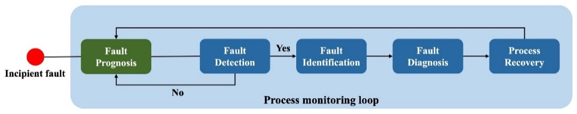
Fig. 1. The process monitoring loop. (Bai and Zhao 2023a)

The prevailing methodologies for process monitoring can be broadly categorized into three main types: model-based methods, knowledge-based methods, and data-based methods. Data-based methods ascertain the system's condition within a specific timeframe by scrutinizing previously gathered data. The progression of automation and digitization has significantly elevated the prominence of data-based models within the process industry (Bai and Zhao 2023b).

Conventional fault detection in the industrial domain primarily relies on established statistical techniques like principal component analysis, partial least squares, and independent component analysis. The advent of machine learning has ushered in a rapid proliferation of sophisticated models such as deep belief networks, convolutional neural networks, and variational recurrent autoencoders. These advanced models demonstrate superior efficacy in handling intricate problems with heightened accuracy (Bi and Zhao 2021). The evolution of fault prognosis methodologies has been intricately tied to the evolving characteristics of industrial data. As data complexity increases, many data-driven methods are flexibly applied in nonlinear scenarios, such as artificial neural networks, autoencoder, support vector machine, and radial basis function network. recurrent neural network, long short-term memory and Transformer model have shown advantages in learning nonlinear features of sequences and extracting long-dependent information (Wen et al. 2022).

However, it typically necessitated the training of distinct deep learning models for effective fault detection and prognosis of each process fault or variable. This process consumed substantial computing resources and time. A prevalent approach involves the training of expansive models on unsupervised or weakly supervised objectives initially, followed by fine-tuning or assessing zero-shot generalization for downstream tasks (Brown et al. 2020). This practice finds widespread application, notably in domains such as natural language processing and computer vision, which inspired the pre-trained models for time series data (Ma et al. 2023).

In this paper, we proposed a pre-train and fine-tune paradigm of fault detection and fault prognosis for chemical process, inspired by the pre-trained models in natural language processing and computer vision. We took a deep masked attention model pretrained on the raw datasets and fine-tuned models based on fault detection and fault prognosis. TEP was used to demonstrate the validity of the method. The results show that the proposed method obtain the strong performance on the chemical process fault detection and prognosis task. Additionally, we discussed the relevant issues in applying the pre-train and fine-tune paradigm to real chemical process data.

The remainder of this paper is organized as follows. Section 2 reviews the basic knowledge of the self-attention structure and Transformer model. Section 3 includes the descriptions of the proposed pre-train and fine-tune paradigm. The applications and discussions are revealed in Section 4. Section 5 gives summary.
  - Methodology
    - Self-attention
The attention mechanism is the most important structure in Transformer model and could overcome the difficulty in modeling long sequential data by learning the weights of input information at different times. We show a version of a commonly used attention in Fig. 2, which was proposed as self-attention (Vaswani et al. 2017).
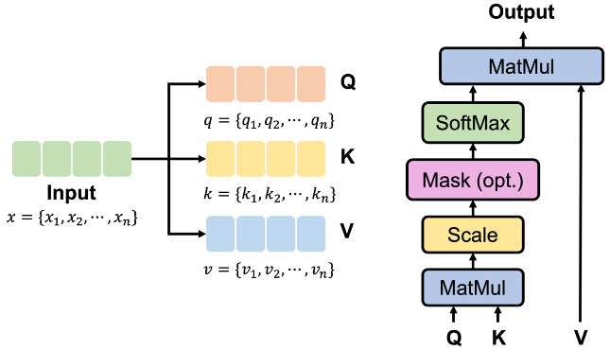
Fig. 2. A schematic diagram of self-attention. (Bai and Zhao 2023a)

Firstly, given an input sequence $x=\left\{x_{1},x_{2},⋯,x_{n}\right\}, x_{i}∈R^{k}$, query, key and value vectors can be obtained by mapped with linear transformations and $q_{i}, k_{i}, v_{i}∈R^{d_{k}}$ are examples to show the calculation process of each element.
$$q_{i}=W^{q}x_{i}, k_{i}=W^{k}x_{i}, v_{i}=W^{v}x_{i}, i=1, 2, ⋯, n$$ | (1)
Where $W^{q}, W^{k}, W^{v}∈R^{d_{k}×k}$ are learnable matrices.
Then, the similarity score of $q_{i}$ and $k_{j}$, which are chosen as examples to show calculation, is calculated through a scaled dot-product function, and the SoftMax function is then used to normalize the scores and obtain the weights.
$$α_{i,j}=\frac{q_{i}∙k_{j}}{\sqrt{d_{k}}}$$ | (2)
$${\hat{α}}_{i,j}=\frac{exp⁡(α_{i,j})}{\sum_{t=1}^{n}{exp(α_{i,t})}}$$ | (3)
Finally, the output is calculated as the weighted sum of values.
$$z_{i}=\sum_{j=1}^{n}{{\hat{α}}_{i,j}v_{j}}$$ | (4)
  - The proposed method
The proposed pre-train and fine-tune paradigm is shown in the Fig. 3. The offline training stage included model pretraining and model finetuning. During the offline modeling stage, the historical data were spilt into large unlabeled dataset and two small labeled datasets for fault detection and fault prognosis. Z-score normalization is utilized for data pre-processing. Then a multilayer Transformer model was designed according to chemical process system. We got the pretrained model on large unlabeled dataset by training model to generate process variables at the next time point. In the model finetuning step, specific detection and prognosis heads were integrated into the pretrained model architecture, and then the modified models were finetuned on the labeled datasets. The online testing included fault detection and fault prognosis. Online data were collected and normalized by the z-score method. Then the data were transformed into the same time window as the offline model training step. For fault detection, we calculated the abnormal score through the finetuned model and compared the abnormal score with the threshold to detect if a fault occurred. For fault prognosis, we predicted multi-step process variables and used the key variables to prognose whether an abnormality occurred.
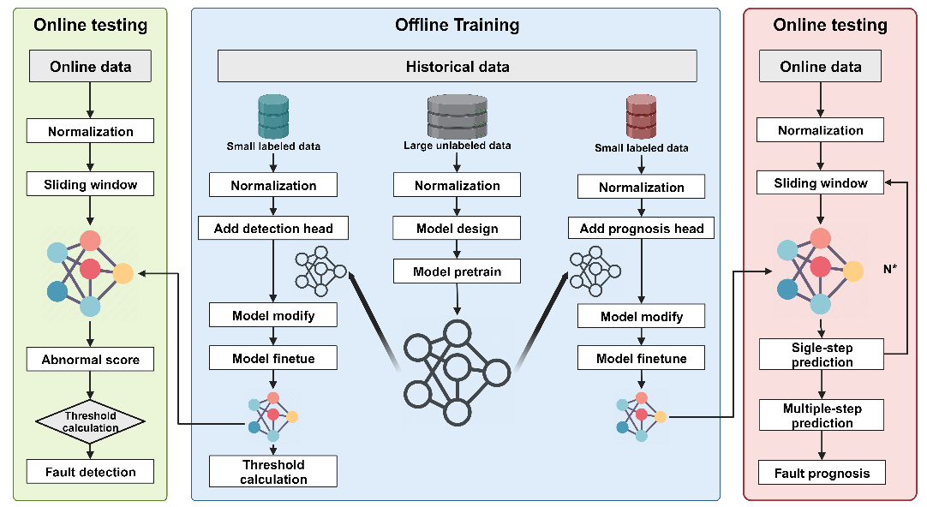
Fig. 3. The diagram of the proposed pre-train and fine-tune paradigm.
  - Applications
TEP is a classical model benchmark for simulating chemical processes, which has been widely used as a study case for FDD and fault prognosis. It is mainly composed of 5 unit operations, including a reactor, a condenser, a recycle compressor, a vapor-liquid separator, and a stripper. The initial version of TEP simulation involves 12 manipulated variables, 41 measured variables and 20 different types of faults. In 2015, Bathelt revised the original TE model and used MATLAB’s Simulink to build a new one, adding 8 measurement variables, 24 component variables, and 8 new process disturbances (Bathelt, Ricker, and Jelali 2015). In our work, the applications are based on the revised version of Bathelt, which is shown in the Fig. 4.
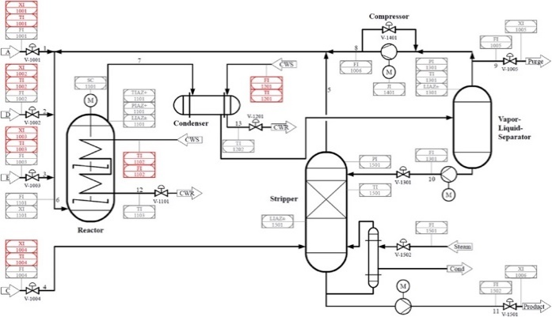
Fig. 4. P&ID of the revised TEP model (Bathelt, Ricker, and Jelali 2015).
Since the sampling frequency of component analysis measurement is much lower, we only choose the process manipulated variables and continuous process measurements for dataset building. Each set of test data included 480 normal samples followed by 600 fault samples, corresponding to 8 h of normal data and 10 h of fault data.
    - Fault detection
We selected and applied 5 distinct step type faults, 5 random variation type faults, and 1 slow drift type fault for our analysis. The results will be compared with LSTM-VAE (Bi and Zhao 2021), an advanced and effective method for fault detection in chemical processes, which originated from published process monitoring study and was evaluated for performance on the same dataset we generated. To assess the efficacy in fault detection, we utilized fault detection rates (FDR). Additionally, we employed fault detection time (FDT) as a metric to gauge the method's timeliness in fault identification. The comparative results between LSTM-VAE and the proposed method are presented in Table. 1.
Table. 1. Detection results of proposed method and LSTM-VAE.
Fault Number | FDR of LSTM-VAE | FDT of LSTM-VAE (min) |  | FDR | FDT (min)
1 | 98.8% | 7 | 99.4% |  | 3
2 | 96.3% | 28 | 97.3% |  | 13
3 | 99.8% | 1 | 99.8% |  | 1
4 | 99.8% | 1 | 99.8% |  | 1
5 | 99.8% | 1 | 99.8% |  | 1
8 | 93.3% | 37 | 95.2% |  | 23
9 | 92.5% | 44 | 95.9% |  | 20
10 | 91.8% | 49 | 85.7% |  | 46
11 | 99.5% | 3 | 96.1% |  | 15
12 | 99.2% | 5 | 94.6% |  | 24
13 | 72.5% | 165 | 81.4% |  | 46

Table 1 reveals that both LSTM-VAE and the proposed method exhibited similar FDR, with both achieving rates approximately exceeding 90%. Notably, in the case of the slow drift-type fault, Fault 13, the proposed method demonstrated a significantly higher FDR compared to LSTM-VAE. Regarding FDT, the proposed method generally outperformed LSTM-VAE in early fault detection, except for Fault 11 and Fault 12. Remarkably, the proposed method showcased a notable advancement of over 100 minutes in detecting Fault 13 compared to LSTM-VAE.
    - Fault prognosis
The accurate prediction of future changes in process variables stands as the fundamental challenge in fault prognosis. We selected faults with long FDT for fault prognosis analysis, which were Fault 8, 9, 10, 13. To comprehensively evaluate the proposed method’s performance across distinct time scales, we examined varied forecast times. Our approach finetuned the pretrained model solely with a batch of simulation data. Employing the autoregression concept, we iteratively predicted process variables at forecast times of 1, 4, 8, 16, 32, and 64 minutes across the four fault types. The accuracy of the forecasts was evaluated using Mean Absolute Error (MAE), with the results detailed in Table 2. The results demonstrated the robust predictive capabilities of the finetuned model across the four fault types. The MAE for short term forecasts is about less than 0.1, while for long term forecasts is around 0.5.
Table. 2. MAE of various faults in different forecast times.
Fault Number | 1 | 4 | 8 | 16 | 32 | 64
8 | 0.014 | 0.052 | 0.163 | 0.412 | 0.256 | 0.505
9 | 0.006 | 0.027 | 0.122 | 0.458 | 0.260 | 0.461
10 | 0.007 | 0.025 | 0.068 | 0.279 | 0.258 | 0.461
13 | 0.009 | 0.028 | 0.076 | 0.331 | 0.230 | 0.533
  - Summary
In the article, we proposed a pre-train and fine-tune paradigm of fault detection and fault prognosis for chemical process. This proposed paradigm exhibited validity and efficacy in both fault detection and fault prognosis across the TEP. Additionally, the capacity to finetune the same pretrained model for different process monitoring tasks related to various fault types suggests considerable potential for conserving computational resources and time. In the future, the widespread application of pretrained models within process monitoring systems and their utilization across real industrial datasets presents an open field replete with several unresolved challenges demanding attention.
References
Bai, Yiming, and Jinsong Zhao. 2023a. “A Novel Transformer-Based Multi-Variable Multi-Step Prediction Method for Chemical Process Fault Prognosis.” Process Safety and Environmental Protection 169 (January): 937–947.
Bai, Yiming, and Jinsong Zhao. 2023b. “A Process Data Prediction Method for Chemical Process Based on the Frozen Pretrained Transformer Model.” In Computer Aided Chemical Engineering, edited by Antonios C. Kokossis, Michael C. Georgiadis, and Efstratios Pistikopoulos, 52:1717–1723. 33 European Symposium on Computer Aided Process Engineering. Elsevier.
Bathelt, Andreas, N. Lawrence Ricker, and Mohieddine Jelali. 2015. “Revision of the Tennessee Eastman Process Model.” IFAC-PapersOnLine, 9th IFAC Symposium on Advanced Control of Chemical Processes ADCHEM 2015, 48 (8): 309–314.
Bi, Xiaotian, Ruoshi Qin, Deyang Wu, Shaodong Zheng, and Jinsong Zhao. 2022. “One Step Forward for Smart Chemical Process Fault Detection and Diagnosis.” Computers & Chemical Engineering 164 (August): 107884.
Bi, Xiaotian, and Jinsong Zhao. 2021. “A Novel Orthogonal Self-Attentive Variational Autoencoder Method for Interpretable Chemical Process Fault Detection and Identification.” Process Safety and Environmental Protection 156 (December): 581–597.
Brown, Tom, Benjamin Mann, Nick Ryder, Melanie Subbiah, Jared D. Kaplan, Prafulla Dhariwal, Arvind Neelakantan, et al. 2020. “Language Models Are Few-Shot Learners.” Advances in Neural Information Processing Systems 33: 1877–1901.
Ma, Qianli, Zhen Liu, Zhenjing Zheng, Ziyang Huang, Siying Zhu, Zhongzhong Yu, and James T. Kwok. 2023. “A Survey on Time-Series Pre-Trained Models.” arXiv.
Rehman, Muhammad Habib ur, Ibrar Yaqoob, Khaled Salah, Muhammad Imran, Prem Prakash Jayaraman, and Charith Perera. 2019. “The Role of Big Data Analytics in Industrial Internet of Things.” arXiv..
Vaswani, Ashish, Noam Shazeer, Niki Parmar, Jakob Uszkoreit, Llion Jones, Aidan N Gomez, Łukasz Kaiser, and Illia Polosukhin. 2017. “Attention Is All You Need.” In Advances in Neural Information Processing Systems. Vol. 30. Curran Associates, Inc.
Wen, Qingsong, Tian Zhou, Chaoli Zhang, Weiqi Chen, Ziqing Ma, Junchi Yan, and Liang Sun. 2022. “Transformers in Time Series: A Survey.” arXiv.

