Investigating Fluid Flow Dynamics in Triply Periodic Minimal Surfaces (TPMS) Structures Using CFD Simulation
Kasimhussen Vhora,^{a,b} Tanya Neeraj,^{b} Dominique Thévenin, ^{b} Gábor Janiga,^{b} Kai Sundmacher ^{a,b,*}
ªMax Planck Institute for Dynamics of Complex Technical Systems, Sandtorstr. 1, 39106 Magdeburg, Germany
^{b}Otto von Guericke University Magdeburg, Universitätsplatz 2, 39106 Magdeburg, Germany
kai.sundmacher@ovgu.de
Abstract
Efficient absorption processes require optimized packed bed column structures, which affect gas-liquid contact, flow distribution, and pressure drop. An optimal setup ensures efficient mass transfer with high surface area while keeping down the pressure drop, which leads to energy savings and better absorption. TPMS structures such as the Gyroid, Schwarz-P, and Schwarz-D were investigated in this study, with a focus on balancing porosity and surface area to achieve reduced pressure drops and optimal phase contact. Single-phase flow simulations were conducted using the commercial software STAR-CCM+, compared to the lattice Boltzmann method (LBM) to provide an alternative perspective on fluid dynamics. Validation, analysis of the results and identification of possible improvements were achieved through these comparisons. According to the results, the Schwarz-D structure with 70% porosity and 2 mm unit cell leads to the best performance, exhibiting a pressure drop of 655 Pa m⁻¹ and a specific surface area of 1776 m² m⁻³ when analysed with STAR-CCM+. The predicted pressure drop was successfully confirmed using LBM simulations, adding robustness to the findings.
Keywords: Computational Fluid Dynamic, TPMS Structure, Pressure Drop, LBM.
  - Introduction
Optimizing packed bed column structures is vital for various chemical engineering and industrial separation processes. Structured packings play a key role in enhancing mass transfer, with success dependent on factors like separation efficiency, minimal pressure drop, and maximal capacity (Lange and Fieg, 2022). Innovations in packing design, such as 3D-printed structured packings made from materials like clear resin and polyamide allow for fine-tuning of geometric parameters to improve performance (Kawas et al., 2021).
TPMS (Triply Periodic Minimal Surface) structures offer low-pressure drops, contributing to energy savings, and possess considerable structural strength for durability. The modern manufacturing method, 3D printing, provides the ability to easily adjust designs, enabling the creation of specialized solutions that meet the particular requirements of industrial separation processes. This makes TPMS a forward-thinking and efficient option for such applications. In the context of packed columns, the optimization variables of high specific surface area and low-pressure drop are intrinsically linked to the performance efficiency of the columns (Rix and Olujic, 2008). Efficiency in packed columns involves a trade-off between high-surface-area packing for efficiency but limited capacity, or low surface area for high capacity but lower efficiency (Jaya and Kolmetz, 2020).
Hawken et al. conducted experimental studies on 3D-printed Schwarz-D TPMS structure, focusing on their impact on pressure drop in chemical engineering applications. Their research measured pressure drop per unit length over two different lengths (46 mm and 89 mm) of Schwarz-D packing with a unit cell size of 3.14 mm and various velocities within the Reynolds number range of 1-1000 (Hawken et al., 2023). Building on this foundation, our study introduces a single-phase Computational Fluid Dynamics (CFD) model for accurately predicting pressure drops in TPMS structures. Successful validation against experimental values enables its later applicability to predict pressure drops and surface areas for Gyroid, Schwarz-D, and Schwarz-P TPMS structures (Hawken et al., 2023). The investigation explores porosity variations within these structures, aiming to identify an optimized structure balancing low-pressure drop and high specific surface area.
The lattice Boltzmann method (LBM) was additionally used in our study to validate the pressure drop of the optimized structure. The documented ability of LBM to handle complex fluid flows in porous media adds robustness to our analysis, ensuring consistent and reliable comparisons.
  - CFD Digital Twin Setup
Figure 1 depicts two selected CFD configurations, each showcasing a column with an 18 mm diameter and the Schwarz-D structural pattern. In CFD Setup 1, the structure spans 89 mm, with designated points (P1 to P4) strategically placed for monitoring pressure gradients. Inlet and outlet boundary conditions are illustrated to aid in simulating airflow through the Schwarz-D structure. CFD Setup 2 presents a more compact structure, measuring 46 mm in length, and incorporates points P5 and P6 for analogous pressure drop measurements.
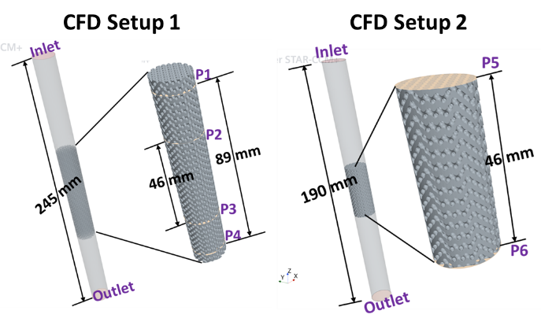
Figure 1: CFD Digital twin setup1 & setup2.
    - CFD Simulation setup
The present study first utilized the commercial CFD package STAR-CCM+ for solving the governing equations. The geometry was created using Autodesk Fusion360, a computer-aided design (CAD) software. The generated mesh consists of unstructured polyhedral grids, with a total of 4.58 million cells (for CFD setup2). For the gas phase, air was selected with a constant density (ρ) of 1.18 kg m⁻³. Typical computational run time for the simulations were around 45 minutes on a system equipped with an 11th Gen Intel(R) Core(TM) i7-11700 processor at 2.50 GHz, 64.0 GB RAM, and running on a 64-bit operating system. For the column inlet and outlet, the boundary conditions were set to velocity inlet and pressure outlet, respectively. The temporal resolution was managed through an implicit unsteady model with an initial time step of 0.001 s, for a total physical simulation time of 1 s. In the post-processing of the simulation, the working pressure is measured by the surface mean average on the 2D plane. This measurement occurs at different points, ranging from P1 to P6, in both CFD setups as shown in Figure 1.
    - Lattice Boltzmann Method
      - Enhanced Central Hermite Multiple Relaxation Time Lattice Boltzmann Solver
The lattice Boltzmann method, introduced for instance by Krüger et al., 2017, stands as a robust solver for the Boltzmann equation, particularly in the hydrodynamic regime. Specifically designed to reconstruct the Navier–Stokes equations, this method initiates with the discretization of the Boltzmann equation in phase space, representing particle degrees of freedom. Utilizing the projection onto Hermite polynomials and Gauss-Hermite quadrature, this discretization results in a system of interconnected hyperbolic equations. Integration along characteristics yields the widely-recognized "stream-collide" equation:
$f_{i}(r+c_{i}δt, t+δt) - f_{i}(r,t) = Ω_{i}$ (i)
Here, $f_{i}$ represents discrete distribution functions, $c_{i}$ denotes discrete particle velocities, $Ω_{i}$ is the collision operator, and $δt$ signifies the time-step.
      - Advanced Boundary Conditions
Solid boundaries in our study are effectively modeled using the half-way bounce-back scheme as described in Hosseini, 2020. The determination of missing distribution functions after collision-streaming steps is succinctly expressed as:
$f_{i}(x,t+Δt)=f_{\underline{i}}^{*}(x,t)$ (ii)
where $f^{*}$represents the post-collision population, and $\underline{i}$ is the index of the particle velocity opposite i. At inlets and outlets , we implement constant velocity and/or constant pressure conditions using the non-equilibrium extrapolation approach (Hosseini, 2020). A notable advantage of the lattice Boltzmann method is its capability to handle solid boundaries with a complex geometry without the need for complex grid adaptation in packed bed structures. Simple, regular, equidistant grids suffice for all simulations.
  - Validation of the CFD Simulations
The pressure drop profiles for the CFD setups 1 and 2 are depicted in Figure 2a. In CFD setup 1, the pressure drop measurements over lengths of 89 mm (P1-P4) and 46 mm (P2-P3) in the Schwarz-D structure yielded similar values of pressure drop per unit length (1571 -1578 Pa m⁻¹). This indicates that a longer structure length is unnecessary for CFD simulations to measure pressure drop, given the periodic nature of the Schwarz-D structure; the impact of inlet and outlet boundary conditions is already negligible for the shorter configuration. This is confirmed by CFD Setup 2, in which the measured pressure drop (P5-P6) is 1588 Pa m⁻¹, nearly identical to that of CFD setup 1 (less than 1% relative difference). Consequently, CFD setup 2 has been chosen for all subsequent simulations and various case studies exploring different levels of porosity and unit cell sizes.
The subsequent CFD simulation maintained the configuration of CFD setup 2, varying only the inlet velocity to measure the resulting pressure drop. Figure 2b presents a graph comparing the pressure drop against inlet velocity for the CFD simulations, alongside experimental data from (Hawken et al., 2023). This comparison underscores a robust correlation between computational predictions and experimental findings. Notably, the CFD pressure drop aligns with the experimentally measured pressure drop from the literature for the same configurations at different velocities. Utilizing this validated CFD model, further simulations were conducted to measure the pressure drop of the Gyroid, Schwarz-P, and Schwarz-D structures.
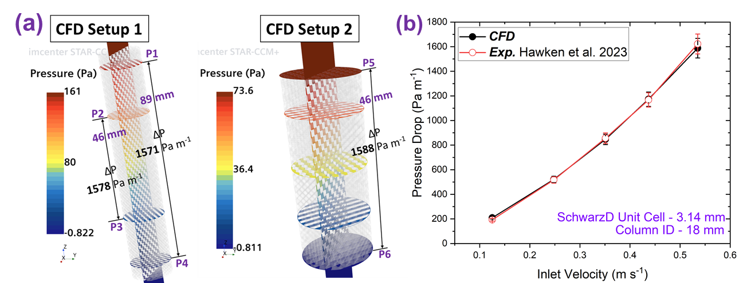
Figure 2: (a) Pressure drop calculation of CFD setup 1 & 2. (b) Pressure drop comparison with experimental literature data at different velocities.
  - Results and Discussion
Figure 3a illustrates the specific surface area and pressure drop characteristics of various porous structures, Gyroid, Schwarz Primitive and Diamond within a column with an internal diameter (ID) of 18 mm and a structure unit cell size of 3.14 mm. The plot reveals that as porosity increases, the specific surface area for each structure initially rises and then decreases, while the pressure drop consistently decreases. The Gyroid and Schwarz-D structures exhibits the highest specific surface area and also a low pressure drop at 80% porosity. For a porosity between 30 and 60%, we observed that the specific surface area remains relatively unchanged for each structure. As expected, low-porosity structures exhibit a higher pressure drop when compared to those with higher porosity. Consequently, for further investigations concentrating on low pressure drops, structures with porosities of 50%, 60%, and 70% were selected. Additionally, the unit cell size within these structures was varied, with sizes of 2.5 mm and 2 mm being examined.
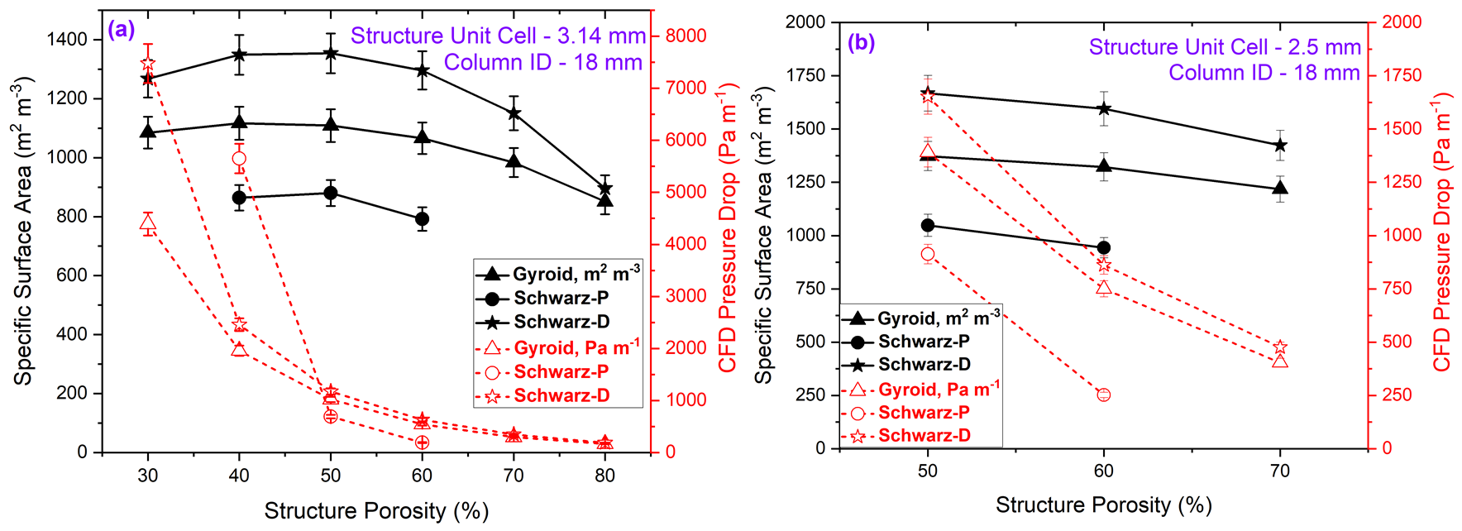
Figure 3: Specific surface area and CFD pressure drop comparison across Gyroid, Schwarz-P, and Schwarz-D structures, with porosity: (a) 30-80%, unit cell size 2 mm; (b) 50-70%, unit cell size 2.5 mm.
Figures 3b and 4a present a clear picture of how structural porosity impacts the properties of different structures. As the porosity increases from 50% to 70%, there is a notable trend: the specific surface area for all structure types tends to decrease slightly. In contrast, the pressure drop demonstrates an inverse relationship with porosity. This indicates that higher porosity correlates with less resistance to fluid flow within the structure. A particularly interesting observation is that both the Gyroid and Schwarz-D structures exhibit nearly identical pressure drops. However, the specific surface area is significantly higher in the Schwarz-D structure compared to the Gyroid.
Therefore, when optimizing for both pressure drop and surface area, the Schwarz-D structure emerges as the superior choice. With 70% porosity and a unit cell size of 2 mm, it achieves an optimal balance, characterized by a pressure drop of 655 Pa m⁻¹ and a specific surface area of 1776 m² m⁻³. These findings are crucial in the optimization of porous media designs across various engineering applications. They highlight the necessity of striking a delicate balance between maximizing surface area and minimizing fluid resistance, which is essential for efficient design and operation. Furthermore, the feasibility of 3D printing the Schwarz-D structure, featuring a 2 mm unit cell size, was assessed through its practical implementation via in-house 3D printing using clear resin as shown in Figure 4b.
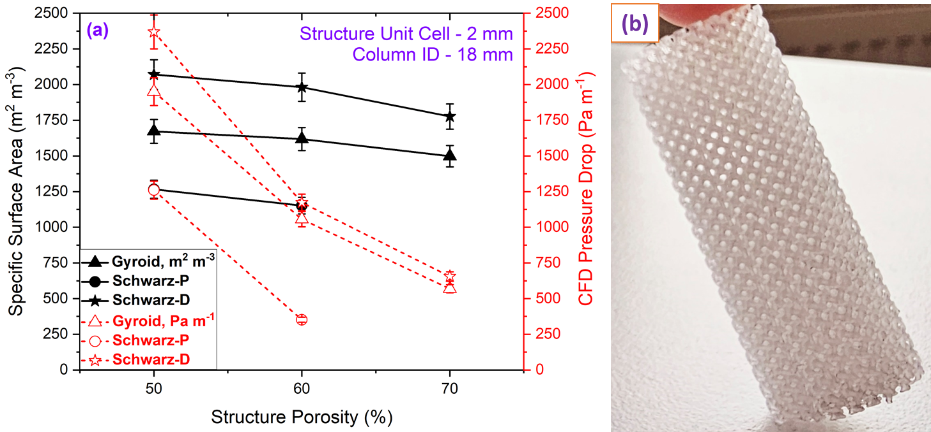
Figure 4: (a) Comparison of surface area and pressure drop in Gyroid, Schwarz-P, and Schwarz-D (50-70% porosity, 2 mm unit cell size). (b) 3D printed Schwarz-D, 70% porosity, 2 mm unit cell size.
  - Comparison between LBM and STAR-CCM+ simulation
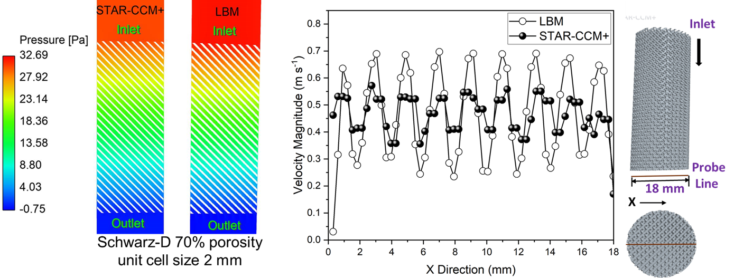
Figure 5: Comparison between LBM and STAR-CCM+ simulation results.
Finally, an LBM simulation was carried out. Figure 5 on the left illustrates the comparison between LBM and STAR-CCM+ pressure drop profiles in the Schwarz-D structure. It reveals minimal discrepancies in the pressure drop, with values of 31.4 Pa for LBM and 30.2 Pa for STAR-CCM+ (less than 4% difference). This good agreement in the pressure drop values underscores the consistency and accuracy of both computational approaches in capturing the macroscopic behaviour of fluid flow through the porous medium of this structure. Further analysis involved studying the velocity profiles along the streamwise direction, as shown in the Figure 5 on the right side. The velocity profile in STAR-CCM+ appears averaged over the domain due to its reliance on the Reynolds-Averaged Navier-Stokes (RANS) model and to a coarser grid. In contrast, LBM utilizes the Direct Numerical Simulation (DNS) approach on a considerably finer, regular grid, revealing large velocity changes.
This fundamental difference in modeling techniques results in distinctive characteristics in the velocity profiles generated by each method. However, LBM comes with a noticeably larger numerical cost. Overall, the close agreement in pressure drop (the target quantity of this study) attests to the robustness of both LBM and STAR-CCM+ as effective tools for simulating fluid flow through porous structures, providing researchers and engineers with reliable insights into the complex dynamics of such systems.
  - Conclusions
The study concludes that the use of TPMS in the design of packed bed columns presents a significant advancement in the optimization of the absorption process. This is established by examining the fluid dynamic behaviours of TPMS structures, including Gyroid, Schwarz-P, and Schwarz-D, through single-phase flow simulations. Notably, the Schwarz-D structure, with 70% porosity and a 2 mm unit cell, demonstrates promising performance, characterized by a pressure drop of 655 Pa m⁻¹ and a specific surface area of 1776 m² m⁻³. The pressure drop comparison of STAR-CCM+ with the LBM simulation provides a good agreement regarding pressure. These findings indicate that TPMS-based structures could significantly enhance the design and efficiency of packed bed columns. The study highlights a research gap in the long-term stability and scalability of TPMS-based structures for industrial use, suggesting future research should focus on their performance, scalability, and economic viability.
Acknowledgment
This research was supported by the International Max Planck Research School for Advanced Methods in Process and Systems Engineering (IMPRS ProEng), Magdeburg, Germany.
References
Hawken, M.B., Reid, S., Clarke, D.A., Watson, M., Fee, C.J., Holland, D.J., 2023. Characterization of pressure drop through Schwarz-Diamond triply periodic minimal surface porous media. Chemical Engineering Science 280, 119039.
Hosseini, S.A., 2020. Development of a lattice Boltzmann-based numerical method for the simulation of reacting flows (PhD Thesis). University of Magdeburg.
Jaya, A., Kolmetz, K., 2020. Distillation Column Packing Hydraulics Selection, Sizing And Troubleshooting, Kolmetz Handbook Of Process Equipment Design. KLM Technology Group.
Kawas, B., Mizzi, B., Dejean, B., Rouzineau, D., Meyer, M., 2021. Design and conception of an innovative packing for separation column – Part II: Design and characterization of a wire based packing. Chemical Engineering Research and Design 169, 189–203.
Krüger, T., Kusumaatmaja, H., Kuzmin, A., Shardt, O., Silva, G., Viggen, E.M., 2017. The lattice Boltzmann method. Springer International Publishing 10, 4–15.
Lange, A., Fieg, G., 2022. Designing Novel Structured Packings by Topology Optimization and Additive Manufacturing, in: Yamashita, Y., Kano, M. (Eds.), 14th International Symposium on Process Systems Engineering, Computer Aided Chemical Engineering. Elsevier, pp. 1291–1296.
Rix, A., Olujic, Z., 2008. Pressure drop of internals for packed columns. Chemical Engineering and Processing: Process Intensification 47, 1520–1529.

