Modelling and Parametric Analysis for Improving Technical Performance of Industrial-Scale Basic Oxygen Furnace Gas Fermentation to Isopropyl Alcohol
Gijs J. A. Brouwer^{a*}, Haneef Shijazª and John A. Posadaª
ªDelft University of Technology, Department of Biotechnology, Van der Maasweg 9, 2629HZ Delft, The Netherlands
*g.j.a.brouwer@tudelft.nl
Abstract
The iron and steel industry is responsible for 30% of all industrial CO₂ emissions, largely emitted via hot Basic Oxygen Furnace (BOF) gas (CO, H₂, CO₂). Gas fermentation can convert the BOF gas into valuable chemicals such as the disinfectant and platform chemical isopropyl alcohol (IPA), which is currently only produced with petrochemical cracking. The goal of this research was to model the state-of-the-art industrial-scale BOF gas fermentation to IPA and identify the key process parameters affecting technical performance. The designed and modelled industrial-scale process was based on the published LanzaTech technology with Clostridium autoethanogenum. In the process model, the IPA is purified through extractive distillation with pure glycerol as an entrainer. During sensitivity analysis, eleven process parameters were investigated for their effect on the eighteen chosen technical Key Performance Indicators (KPIs). These process parameters are (product selectivity (Y_{IPA/CO}), CO volumetric mass transfer rate (VMT_{CO}), CO conversion, reactor dilution rate (D), temperature off-gas condenser, biomass separation liquid loss, extractive distillation glycerol mole fraction, extractive distillation molar reflux ratio, glycerol recycle purge, broth recycle purge and anaerobic digestion waste conversion). The sensitivity analysis identified that the key technical parameters affecting the KPIs are the gas fermentation parameters (CO conversion, VMT_{CO}, Y_{IPA/CO}, and D) as well as the biomass filtration liquid loss. Moreover, increasing CO conversion, VMT_{CO}, Y_{IPA/CO} as well as decreasing D and the biomass filtration liquid loss all individually had the greatest positive impact on the KPIs. Thus, this study has successfully synthesised and modelled a state-of-the-art industrial-scale BOF gas fermentation to IPA process and identified the key process parameters to improve its technical process performance. These findings can be used both to optimise the BOF gas fermentation to IPA process, and perform further economic evaluations and environmental impact assessment.
Keywords: BOF gas fermentation, Isopropyl Alcohol (IPA), process modelling, sensitivity analysis, technical performance.
  - Introduction
The iron and steel industry is responsible for 30 % of all industrial CO₂ emissions (IEA, 2020). A large portion of CO₂ is emitted through flaring of the energy-rich off-gas containing CO, H₂ and CO₂ called Basic Oxygen Furnace (BOF) gas. However, BOF gas can be converted, through gas fermentation, into valuable chemicals such as the disinfectant and platform chemical isopropyl alcohol (IPA) (Liew et al., 2022). Currently, there is no green alternative for the polluting petrochemical production of IPA through cracking. BOF gas fermentation to IPA could serve this growing IPA market with a sustainable alternative.
In 2020, LanzaTech commercialised industrial-scale BOF gas fermentation to ethanol using a genetically engineered and patented (Simpson et al., 2012), prototrophic (Annan et al., 2019), anaerobic acetogen (Clostridium autoethanogenum, C. autoethanogenum) (Kӧpke and Simpson, 2020). Usually, the gas-liquid mass transfer is limiting the reaction rate and volumetric productivity (q_{i}) of gas fermentations. However, alcohols like ethanol have gas-liquid mass transfer enhancing properties (Puiman et al., 2022a), giving a CO volumetric mass transfer rate (VMT_{CO}) up to 8.5 g_{CO}/L/h for the industrial-scale external-loop gas-lift reactor used by LanzaTech (Puiman et al., 2022b). The effect of IPA on the mass transfer was not investigated, but according to Keitel and Onken (1982, p. 94) the mass transfer-enhancing properties of ethanol and isopropanol (i.e., IPA) are similar. More recently, LanzaTech published promising results of a pilot-scale process to produce IPA from BOF gas (Liew et al., 2022). Nonetheless, the industrial-scale IPA process and the key parameters affecting its performance are not yet known. Therefore, the goal of this research was to model the state-of-the-art industrial-scale BOF gas fermentation to IPA and identify the key process parameters affecting technical performance. First, the 46,000 kton_{IPA}/year (Liew et al., 2022) industrial-scale production process was modelled (see section 2) and its technical performance assessed (see section 3). Then, a sensitivity analysis was performed to identify the key process parameters to improve technical process performance (see section 4). Lastly, conclusions and recommendations are given (see section 5).
  - Modelling of Industrial-Scale Basic Oxygen Furnace Gas Fermentation to Isopropyl Alcohol
This section describes the modelling of the industrial-scale state-of-the-art BOF gas fermentation to IPA, including heat integration and recycles, in Aspen Plus V12.0. The most relevant process units and conditions are schematically given (see Figure 1). The property method used is Non-Random Two-Liquid (NRTL), with Mix Non-Conventional (MIXNC) for the gas fermentation and biomass filtration. The model was based on the published LanzaTech technology (Liew et al., 2022; Kӧpke and Simpson, 2020; Handler et al., 2016) with the genetically engineered, prototrophic C. autoethanogenum (Simpson et al., 2012; Annan et al., 2019). The gas fermentation stoichiometry was approached as a black box and obtained through thermodynamics (Heijnen and Van Dijken, 1992), assuming only acetic acid and biomass as by-products. This resulted in an overall black box stoichiometry (see Equation 1) as input for the stoichiometric reactor (RStoich) in the model. Acetone and ethanol were not included as by-products due to their minor fraction produced (Liew et. al., 2022), but were accounted for with the other by-products. Besides, reaction kinetics were not included, since the gas fermentation was assumed limited by the volumetric mass transfer of CO (VMT_{CO}; Liew et al., 2022).

$-8.24 CO-1.58{ H}_{2}-2.63{ H}_{2}O-0.0462 NH_{3}-0.111 NaOH→0.185 CH_{1.75}O_{0.5}N_{0.25}+1.00 IPA+4.83 CO_{2}+0.111 Acetic Acid+0.111 {Na}^{+}$ | (1)
The applied industrial-scale reactor conditions and mass transfer rate were described by Puiman et al. (2022b). The product recovery mentioned by Liew et al. (2022) was split into biomass cross-flow filtration and extractive distillation (Simpson et al., 2012), with pure glycerol as an entrainer (see Figure 1). The purges, to prevent accumulation of impurities, were anaerobically digested (Figure 1; Liew et al., 2022). The biogas resulting from the anaerobic digestion and the fermenter off-gas is combusted with an excess of O₂, to generate heat as a utility for internal use (see Figure 1).
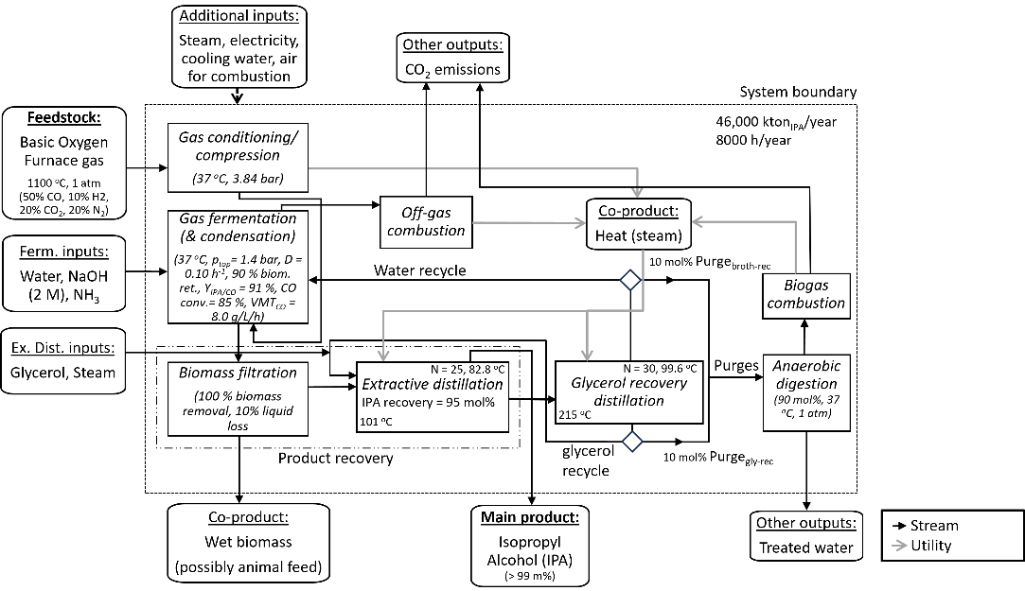
Figure 1: The schematic overview of the Basic Oxygen Furnace gas fermentation to isopropyl alcohol (IPA) adapted and extended from Liew et al. (2022). D: dilution rate, biom. ret.: biomass retention, Y_{IPA/CO}: product selectivity, CO conv.: CO conversion, VMT_{CO}: volumetric mass transfer rate of CO in the reactor, N: number of distillation stages.
  - Technical Performance Assessment of the Industrial-Scale Basic Oxygen Furnace Gas Fermentation to Isopropyl Alcohol
The key performance indicators (KPIs) were selected based on their indication of gas fermentation performance, overall substrate-to-product performance, or technical performance. Besides productivity and carbon efficiency, this leads to KPIs such as the consumption of chemicals/ substrates, the consumption of utilities, as well as the generation of wastes and process-related CO₂ emissions. Moreover, KPIs that influence economics are the required reactor volume (V_{Reactor}) and the IPA titer. Together, these eighteen KPIs indicate the overall technical process performance (see Table 1).
Table 1: Key Performance Indicator (KPI) results of the base case scenario of the BOF gas fermentation to IPA process model. Furthermore, the VMT_{CO}: CO volumetric mass transfer rate, R_{IPA}: IPA production rate, V_{Reactor}: required reactor volume, q_{IPA}: volumetric productivity, and glycerol_{MF-ED}: mole fraction of glycerol at the extractive distillation.
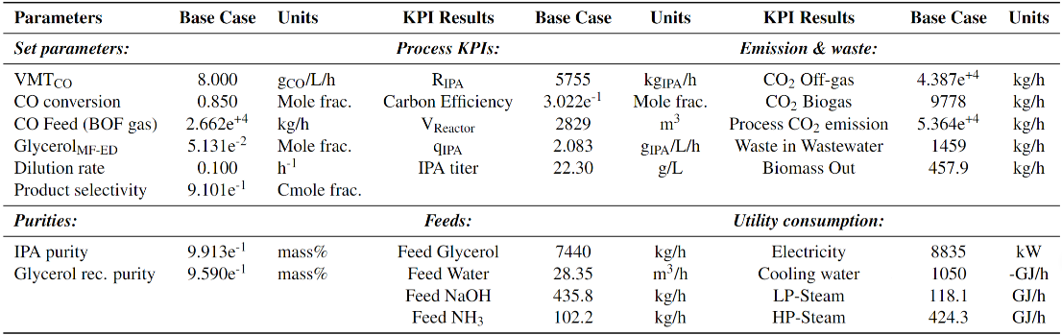
  - Sensitivity Analysis of the Industrial-Scale Basic Oxygen Furnace Gas Fermentation to Isopropyl Alcohol
    - Parameters Investigated During the Sensitivity Analysis
The goal of the sensitivity analysis was to highlight the key parameters of the industrial-scale BOF gas to IPA process (model) (Figure 1) to improve technical performance (see Table 1). The sensitivity analysis was performed on eleven process parameters which were expected most influential on the technical performance or process design choices (see Table 2). During the sensitivity analysis, the process parameter investigated was typically varied ±30 % unless there were theoretical restrictions. At the same time, the other parameters studied and conditions of the process were kept constant (see Table 2).
    - Sensitivity Analysis Results
The overview of the sensitivity analysis results (Table 2) shows which KPIs are sensitive. A KPI was considered sensitive for a parameter, when a parameter change (±Δ%) resulted in at least ±0.90 Δ% for that KPI. For example, q_{IPA} is sensitive to VMT_{CO}, since +30 % VMT_{co} resulted in +30 % q_{IPA}. The sensitivity analysis helped identify five process parameters that show the biggest overall effect on the KPIs across all KPI groups (see Table 2). These key process parameters are the fermentation parameters of CO conversion and product selectivity (Y_{IPA/CO}), the CO volumetric mass transfer rate (VMT_{CO}), and the dilution rate (D), as well as the biomass filtration liq-to-liq phase fraction (= 1 - liquid loss). These key process parameters have the biggest effect on technical performance of the industrial-scale BOF gas-to-IPA fermentation process and are a good focus point to improve technical performance. Based on the sensitivity analyses, the following trends were found:

Higher CO conversion and Y_{IPA/CO} improve technical performance (see Table 2). Both CO conversion and Y_{IPA/CO} influence most KPIs (Table 2) of which the most important economic indicators are R_{IPA}, carbon efficiency and V_{Reactor}. However, V_{Reactor} increases along with R_{IPA} and results in more utility consumption. Therefore, at higher CO conversion the indicated q_{IPA} does not increase, only relatively more BOF gas is used. Besides, technical performance improves at a higher Y_{IPA/CO} and less by-product is formed, consequently reducing the utility consumption, waste and process-related CO₂ emissions (Table 2). Lower dilution rate seems to improve technical performance (see Table 2). Overall, utility consumption, waste and process-related CO₂ emissions increase with increasing D, while the R_{IPA} decreases and vice versa (Table 2). However, the increase in HP-steam, water, and glycerol consumption at a lower D might provide a trade-off against the R_{IPA} and carbon efficiency. Also, at lower D an IPA titer above 25 gIPA/L (Kӧpke et al., 2016) can, in reality, limit process performance due to product inhibition. Additionally, Wang et al. (2023) has shown that an alcohol titer has an optimum mass transfer enhancing effect, where a higher titer reduces the mass transfer. Thus, for this process, the IPA titer likely has an optimum around 25 g_{IPA}/L. Higher CO volumetric mass transfer rate improved technical performance (see Table 2). Overall, at a higher VMT_{CO} the KPIs indicate increased technical performance, generating less waste and relatively more product (q_{IPA}) in a more concentrated process (lower V_{Reactor}) (Table 2). Lower biomass filtration liquid loss seems to improve technical performance (see Table 2). A lower biomass filtration liquid loss (liq-to-liq frac., Table 2) resulted in the KPIs indicating improved technical performance. Because of the reduction of broth loss, consequently less product loss. As a result, the R_{IPA} increased and the consumption of fresh feeds reduced. However, utility consumption increased, possibly giving a trade-off if the utility consumption increases more than the R_{IPA}. Extractive distillation affects technical performance, with a lower molar reflux ratio (RR_{mol,ED}) indicating improved technical performance (see Table 2). The investigated parameters of the extractive distillation (Gly_{MF-ED} and RR_{mol,ED}) showed that the C_{IPA,Reactor}, glycerol feed, and CO₂ biogas are sensitive to the Gly_{MF-ED} (Table 2). Whereas, only the LP-steam consumption is sensitive to the RR_{mol,ED}. A 30 % lower RR_{mol,ED} decreases the LP-steam 1.38 times as much, while R_{IPA} and carbon efficiency only change -1.13 % (Table 2). Combining these insights, the extractive distillation itself is considered important for process performance.
Table 2: Sensitivity analysis results. The lower boundary, base case, and upper boundary results were linearly fitted. If the adjusted R₂ ≥ 0.95, then the linear fit slope is given. Otherwise, the resulting Δ%. VMT_{CO}: CO volumetric mass transfer rate, the liq-to-liq frac.: 1 - liquid loss during biomass filtration, Gly_{MF-ED}: extractive distillation glycerol molefraction, RR_{mol,ED}: molar reflux ratio during extractive distillation. R_{IPA}: IPA production rate, q_{IPA} volumetric productivity, LP-steam: low-pressure steam, and HP-steam: high-pressure steam. A sensitivity > ±0.90 Δ% of the parameter is bold.
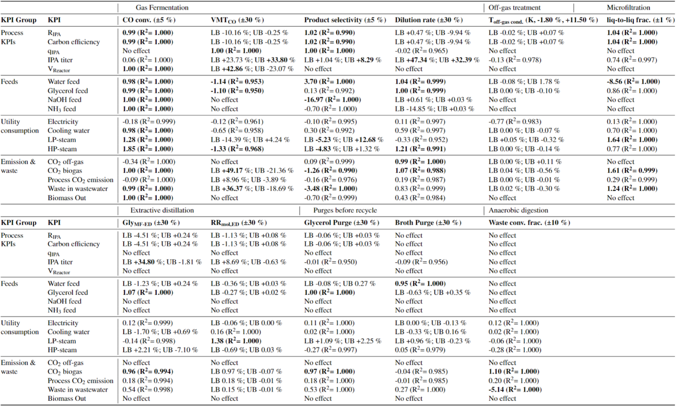
Higher temperature of the off-gas condenser and a lower purified glycerol purge fraction improved technical performance (see Table 2). The off-gas condenser showed less utility consumption and little reduction in performance at increased temperature, thus higher T_{off-gas cond.} could improve technical performance (see Table 2). Whereas, technical performance improved for a lower glycerol purge fraction, giving less glycerol consumption, waste production, and process-related CO₂ emissions (see Table 2). Usually, there is a trade-off in KPIs for each parameter. These KPIs have opposite trends and both affect the technical process performance. This makes the overall effect of a parameter change hard to predict.
  - Conclusions
A state-of-the-art industrial-scale BOF gas fermentation to IPA was modelled based on the LanzaTech pilot reported in the literature. IPA purification using extractive distillation is an energy- and glycerol-intensive process with room for improvement. Besides, the process KPIs (R_{IPA}, carbon efficiency, V_{Reactor}, q_{IPA}, IPA titer), feeds, utility consumption, process-related CO₂ emission, and waste generated could be used to identify the key parameters of the BOF gas fermentation to IPA. The key parameters identified are the gas fermentation parameters (CO conversion, VMT_{CO}, Y_{IPA/CO}, and D) and the liquid loss during biomass filtration. The technical process performance could be improved by increasing either the CO conversion, VMT_{CO}, or Y_{IPA/CO}, and decreasing D or the biomass filtration liquid loss. These key parameters can be used to optimise the technical process performance. However, this is just an indication based on the process KPIs, feeds, utility consumption, process-related CO₂ emissions and waste generated. To further assess the process performance, a Techno-Economic Evaluation and Life-Cycle Assessment should be done. These insights can be combined to assess the overall (i.e., technical, economic and environmental) performance of the BOF gas fermentation to IPA process.
References
F. J. Annan, B. Al-Sinawi, C. M. Humphreys, R. Norman, K. Winzer, M. Kӧpke, S. D. Simpson, N. P. Minton, A. M. Henstra, 2019, Engineering of vitamin prototrophy in clostridium ljungdahlii and clostridium autoethanogenum, Applied Microbiology and Biotechnology, 103, 4633–4648
R. M. Handler, D. R. Shonnard, E. M. Griffing, A. Lai, I. Palou-Rivera, 2016, Life cycle assessments of ethanol production via gas fermentation: Anticipated greenhouse gas emissions for cellulosic and waste gas feedstocks, Industrial and Engineering Chemistry Research, 55, 3253–3261
J. Heijnen, J. Van Dijken, 1992, In search of a thermodynamic description of biomass yields for the chemotrophic growth of microorganisms, Biotechnology and Bioengineering, 39, 833–858
International Energy Agency, 2020, Iron and steel technology roadmap, https://www.iea.org/reports/iron-and-steel-technology-roadmap
G. Keitel, U. Onken, 1982, The effect of solutes on bubble size in air-water dispersions, Chemical Engineering Communications, 17, 85–98
M. Kӧpke, S. Simpson, F. Liew, W. Chen, 6 2016, Fermentation process for producing isopropanol using a recombinant microorganism, US Patent 9,365,868
M. Kӧpke, S. D. Simpson, 2020, Pollution to products: recycling of ‘above ground’ carbon by gas fermentation, Current Opinion in Biotechnology, 65, 180–189
F. E. Liew, R. Nogle, T. Abdalla, B. J. Rasor, C. Canter, R. O. Jensen, L. Wang, J. Strutz, P. Chirania, S. De Tissera, A. P. Mueller, Z. Ruan, A. Gao, L. Tran, N. L. Engle, J. C. Bromley, J. Daniell, R. Conrado, T. J. Tschaplinski, R. J. Giannone, R. L. Hettich, A. S. Karim, S. D. Simpson, S. D. Brown, C. Leang, M. C. Jewett, M. Kӧpke, 2022, Carbon-negative production of acetone and isopropanol by gas fermentation at industrial pilot scale, Nature Biotechnology, 40 (3), 335–344
L. Puiman, B. Abrahamson, R. G. van der Lans, C. Haringa, H. J. Noorman, C. Picioreanu, 2022b, Alleviating mass transfer limitations in industrial external-loop syngas-to-ethanol fermentation, Chemical Engineering Science, 259, 117770
L. Puiman, M. P. Elisiário, L. M. Crasborn, L. E. Wagenaar, A. J. Straathof, C. Haringa, 2022a, Gas mass transfer in syngas fermentation broths is enhanced by ethanol, Biochemical Engineering Journal, 185, 108505
S. D. Simpson, M. Kӧpke, F. Liew, W. Y. Chen, 2012, Recombinant microorganisms and uses therefor, patent Number: WO2012/115527A2
Y. Wang, X. Shen, H. Zhang, T. Wang, 2023, Marangoni effect on hydrodynamics and mass transfer behavior in an internal loop airlift reactor under elevated pressure, AIChE Journal

