Synthesis of heat-integrated distillation sequences considering vapor recompression under the constraint of fossil energy consumption
Fangjun Ye ª, Yiqing Luo ^{a,b,c,*}, Shengkun Jia ^{a,b}, Xigang Yuan ^{a,b,c}
ª School of Chemical Engineering and Technology, Tianjin 300350, China
^{b} Chemical Engineering Research Center, Tianjin 300350, China
^{c} State Key Laboratory of Chemical Engineering, Tianjin 300350, China
luoyq@tju.edu.cn
Abstract
Distillation has been the most widely used separation technology in chemical and petrochemical industries. Typically, they only use energy as separating agent which are mainly provided by fossil fuel combustion with high carbon emissions. Therefore, it is of great significant to study an efficient distillation sequence synthesis method that considers the use of low-carbon green electricity to completely or partially replace traditional fossil energy. In this study, a method of synthesizing heat-integrated distillation sequences using electricity via the vapor recompression (E-HIDSs) under fossil energy constraints is proposed based on stochastic optimization. By introducing heat pumps driven by electricity during the optimal synthesis, the opportunity of heat integration among columns is greatly increased, thereby minimizing fossil energy consumption in reboilers. The example case of separating five-component alkane mixture shows that the proposed method in this study can obtain the corresponding optimal solution under the constraint of fossil energy consumption at different levels.
Keywords: fossil energy constraint, vapor recompression, heat integration, distillation sequence synthesis, stochastic optimization
  - Introduction
It’s widely recognized that the use of fossil energy is the main cause of the greenhouse effect. Fossil fuel combustion accounts for more than 75% of greenhouse gas emissions and nearly 90% of CO₂ emissions (United Nations, 2023). Distillation is a very common separation process in the chemical industry. However，it has low thermodynamic efficiency and its main source of energy comes from the burning of fossil fuels (Sholl et al, 2016). Hence, both the amount and intensity of carbon emissions generated by distillation are at high levels. It has been shown that distillation sequence synthesis is an effective means to achieve distillation system optimization. Researchers often take the economic index represented by the total annual cost (TAC) as the objective function, represent different distillation configurations by matrix method (Shah et al, 2010), super structure (Caballero et al, 2001), binary tree-based method (Zhang et al; 2018, 2021), and use deterministic algorithm or stochastic optimization algorithm to solve the synthesis problem. In this research area, the search domain of the distillation sequences continues to expand progressively. On the one hand, it has evolved from considering only sharp separation in the early stages (An et al, 2009), then to allowing partial intermediate components to exist in non-sharp separation (Wang et al, 2016), and finally to realizing expression of all intermediate components in non-sharp separation (Aggarwal et al, 1990; Shah et al, 2010; Zhang et al, 2021). On the other hand, more and more efficient energy-saving technologies have been considered in the distillation sequence synthesis, such as heat integration (An et al, 2009), thermal coupling (Amminudin et al, 2001), intermediate heat exchangers (An et al, 2008), and heat pumps (Yuan et al, 2021). With the increasing pressure on carbon emissions in the chemical industry, researchers must carefully consider the limits of fossil energy consumption in distillation sequences synthesis. An effective strategy is to continuously apply green electricity derived from renewable sources such as solar energy, wind energy, and biomass energy to effectively substitute for traditional fossil fuels in the distillation sequence synthesis.
The simultaneous consideration of vapor recompression and heat integration is one of effective approaches to reduce distillation column energy consumption, that is, by consuming a small amount of electricity, the total energy consumption is greatly reduced through heat integration. As shown in Figure 1, the vapor from the column top is compressed by a compressor, then the vapor with higher temperature and pressure exchanges heat with the liquid in the reboiler at the bottom of the column. After the heat exchange, the vapor is cooled down and depressurized by a throttle valve, and finally is partially withdrawn as a product or refluxed into the column. This technology, often referred to as a heat pump, is commonly used in distillation system with a single column (Felbab et al, 2013) or known column sequence structures (Wang et al, 2020). In a distillation sequence, there are more opportunities for heat integration due to the presence of more reboilers and more top vapors existing in the sequence. Nevertheless, simultaneous optimization distillation sequence with non-sharp separation, heat integration structure, heat pump setting, as well as operation parameters such as column pressure which is the most critical parameter affecting compressor setting and heat integration, is not a trivial work. It’s necessary to effectively deal with the very difficult problems of superstructure expression, model formulation and optimization of multi-component separation system. Therefore, to realize the optimal design of distillation system by vapor recompression-based heat integration, this study proposes a stochastic optimization-based method for E-HIDSs under the constraint of fossil energy consumption to confine or even eliminate the usage of traditional fossil fuel.
Fig. 1 Heat pump structure in a single column
  - Problem formulation
    - Problem description
Given a non-azeotrope mixture of N components (N≥3), the objective is to synthesize an optimal sharp or non-sharp E-HIDS to obtain N pure components with the minimum TAC under the constraint of fossil energy consumption. To reasonably decrease search space complexity, only basic distillation configurations with N-1 columns are considered in the synthesis (Giridhar et al, 2010). Additional assumptions and specifications for the problem are as follows:
(1) Compressors are driven by green electricity.
(2) Hot utilities needed are all generated from the combustion of fossil energy.
(3) Cooling water as cold utility doesn’t consume fossil energy or electricity.
(4) The prices of refrigerants are determined by the amount of electricity used to produce them.
(5) The minimum temperature approach for hear integration is set to 10K.
    - Representation of E-HIDSs structure
This study adopt the binary tree coding strategy developed in our previous work (Zhang et al, 2021) to represent any sharp or non-sharp distillation sequences structure. The present or absence of a vapor recompression structure in the distillation sequence is represented by variable CR which is compression ratio of a compressor defined by Yuan et al (2022a, 2022b). As shown in Eq. (1), p_{c} and p_{i} represent the compressor outlet pressure and inlet pressure, respectively.
$$CR=\frac{p_{c}}{p_{i}}$$ | (1)
    - Evaluation method for fossil energy consumed
In distillation sequences, the level (grade) of hot utilities used in each column are often not identical, in order to accurately evaluate the amount of fossil energy consumed, this study introduces the standard coal equivalent to measure the amount of fossil energy consumption of distillation sequences. The specific expressions are shown in Eq. (2).
$$K_{coal}=\sum_{k=1}^{M}{S_{k}Q_{k}≤C_{sce}}$$ | (2)
where $K_{coal}$ is the amount of standard coal consumed by an E-HIDS.$Q_{k}$ represents the amount of hot utility of level $k (k=1,2,…,M)$. $S_{k}$ represents the amount of standard coal per unit heat of fossil energy of level k, which can be calculated according to the national standard document (Chinese government, 2014). $C_{sce}$ indicates the upper limit of fossil energy consumption, i.e., the upper limit of standard coal equivalent consumption.
    - Implicit MINLP formulation
In this study, stochastic optimization strategy is used to optimize the synthesis of multicomponent distillation sequences. Therefore, the synthesis problem can be expressed by an implicit MINLP model, as shown in Eq. (3). The objective function $C_{cost}$ is the minimal TAC of an E-HIDS, which is the function of distillation sequence$\{Tree\}$ represented by an array of binary integer variables [Zhang et al, 2021; Yuan et al, 2022a], the operating pressure in each column ($p$), the recovery of light and heavy critical components in each column ($ξ_{LK}$,$ξ_{HK}$), the compression ratio (CR), the ratio of the actual reflux ratio to the minimum reflux ratio ($r$), and the preheat temperature rise in the preheater ($ΔT_{pre}$). Symbolic equation $CSS \left(\left\{Tree\right\},scp\right)=0$ conducts random generation of all feasible column sequence structures, and $scp$ refers to the sequence coding parameter for evolving {Tree} [Zhang et al, 2021; Yuan et al, 2022a]. $T_{out}^{k}$、$T_{c}^{k}$ and $T_{d}^{k}$are defined as the compressor outlet temperature, the critical temperature of the compressed stream, and the dew point temperature for separation task k, respectively.$K$is the set of separation tasks in a distillation sequence.
$$min C_{cost}\left(\left\{Tree\right\},p,ξ_{LK},ξ_{HK},CR,r,ΔT_{pre}\right)$$ | (3)
$$s.t. K_{coal}\left(\left\{Tree\right\},p,ξ_{LK},ξ_{HK},CR,r,ΔT_{pre}\right)≤C_{sce}$$
$$CSS \left(\left\{Tree\right\},scp\right)=0$$
$${T_{d}^{k}≤T}_{out}^{k}≤T_{c}^{k} k∈K$$
  - Optimization framework
This study adopts the simulated annealing-particle swarm optimization (SA-PSO) method [Zhang et al; 2018, 2021; Yuan et al, 2022a] to solve the MINLP problem of synthesizing E-HIDSs. An improvement is made for the PSO where the penalty function is added to the objective function to deal with the additional constraint on fossil energy consumption. Thus the value of particle fitness function φ is the summation of TAC and Penalty. The improved synthesis framework of E-HIDSs based on the improved SA-PSO algorithm is shown in Fig. 2. In the outer layer, the SA algorithm is used to optimize the distillation sequence structure. In the inner layer, the improved PSO algorithm is used to optimize the operating parameters for a given sequence. Thus, the discrete variables ($\left\{Tree\right\}$) and continuous variables ($p,ξ_{LK},ξ_{HK},CR,r,ΔT_{pre}$) can be optimized under the constraint of fossil energy consumption simultaneously.
Fig. 2 The improved synthesis framework of E-HIDSs based on SA-PSO algorithm
  - Case Study
To verify the effectiveness of the proposed method, a five-component alkane separation example (propane, i-butane, n-butane, i-pentane, and n-pentane) which was addressed by Yuan et al [2022b] is studied for synthesizing E-HIDSs. The amount of standard coal consumed by the optimal distillation sequence structure (without considering constraint of fossil energy consumption) in the literature [Yuan et al, 2022b] is equivalent to 1865.59 kg ce/h. Thus, the upper limit of C_{sce} is set to 1,865.59 kg ce/h in the present optimization. To understand the influence of different level constrains on the optimal results, in this study, six values in the upper and lower bounds of C_{sce} are separately used as the constraints for hot utility consumption when synthesizing optimal distillation sequence under each constraint. Note that, due to the limitation of the compressor outlet temperature (${T_{d}^{k}≤T}_{out}^{k}≤T_{c}^{k}$), there will be no feasible solution when C_{sce} is less than or equal to 665.59 kg ce/h. From the results synthesized under the constraint of fossil energy consumption, it can be found when the constraint become tighten, the optimal distillation sequence structure may change. However, there are also cases when the distillation sequence structure remains unchanged and the constraints are still satisfied by optimizing the continuous variables. It is worth noting that in order to accommodate the tightening constraint, the settings for vapor recompression are gradually increase so that the opportunities for heat integration (both the number of heat integration and the depth of heat matching) in a distillation system are increased accordingly.
As with most engineering problems, there is a trade-off between economic cost and environmental benefits (e.g. fossil energy consumption) in distillation sequence synthesis. Fig. 3 shows the relationship of TAC and standard coal consumption (K_{coal}) of the optimal solutions under different constraints of C_{sce}, The red and blue curve refers to K_{coal} and TAC, respectively. The two curves in the figure show significant mutual constraints. TAC shows a monotonically increasing trend with a cumulative increase of 41.93%, while K_{coal} shows a monotonically decreasing trend with a cumulative decrease of 53.67%. Fig. 4 shows the hot utility (Q_{heat}) and electricity (Q_{elec}) consumed in the optimal distillation sequence under different constraints of C_{sce}, where the red and green curve refers to hot utility and electricity, respectively. As the constraints on fossil energy consumption tighten, heat integration opportunities increase due to more vapor recompression is used, resulting in the reduction of hot utilities (i.e., fossil energy consumption) consumed in the reboilers. As a result, the two curves show significant mutual constraints. Electricity consumption shows a monotonic increasing trend, with a cumulative increase of 5658.41%. While hot utility consumption shows a monotonically decreasing trend with a cumulative decrease of 53.67%. In this process, there is a significant substitution relationship between electricity consumption and heat energy consumption (i.e., fossil energy consumption) in the optimal solutions.
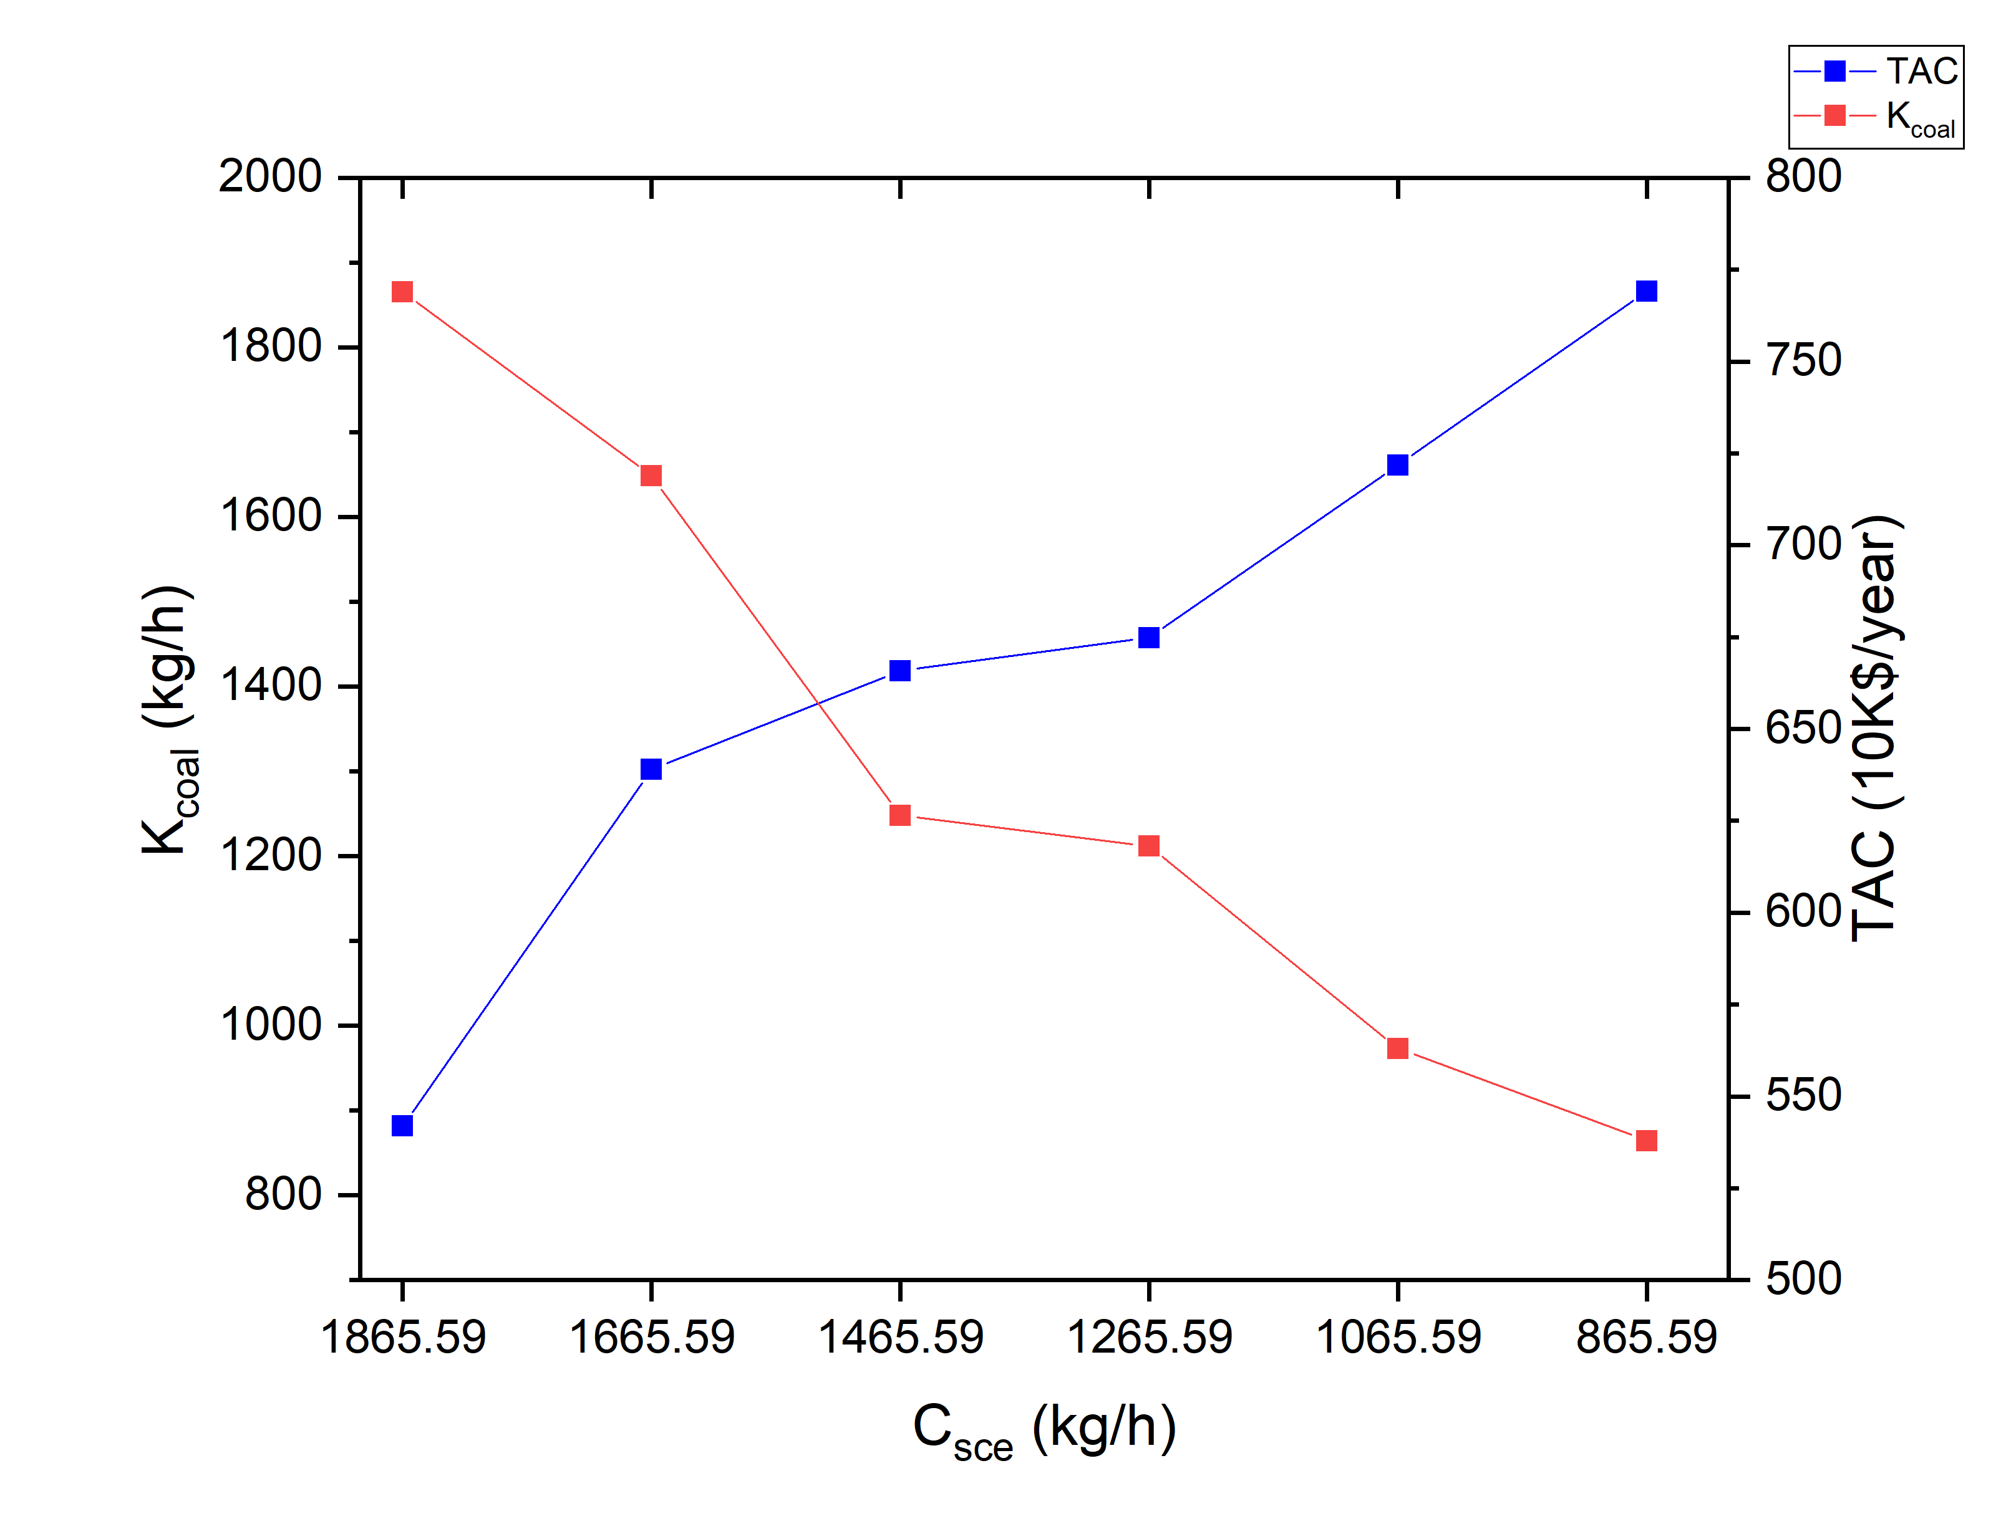 | 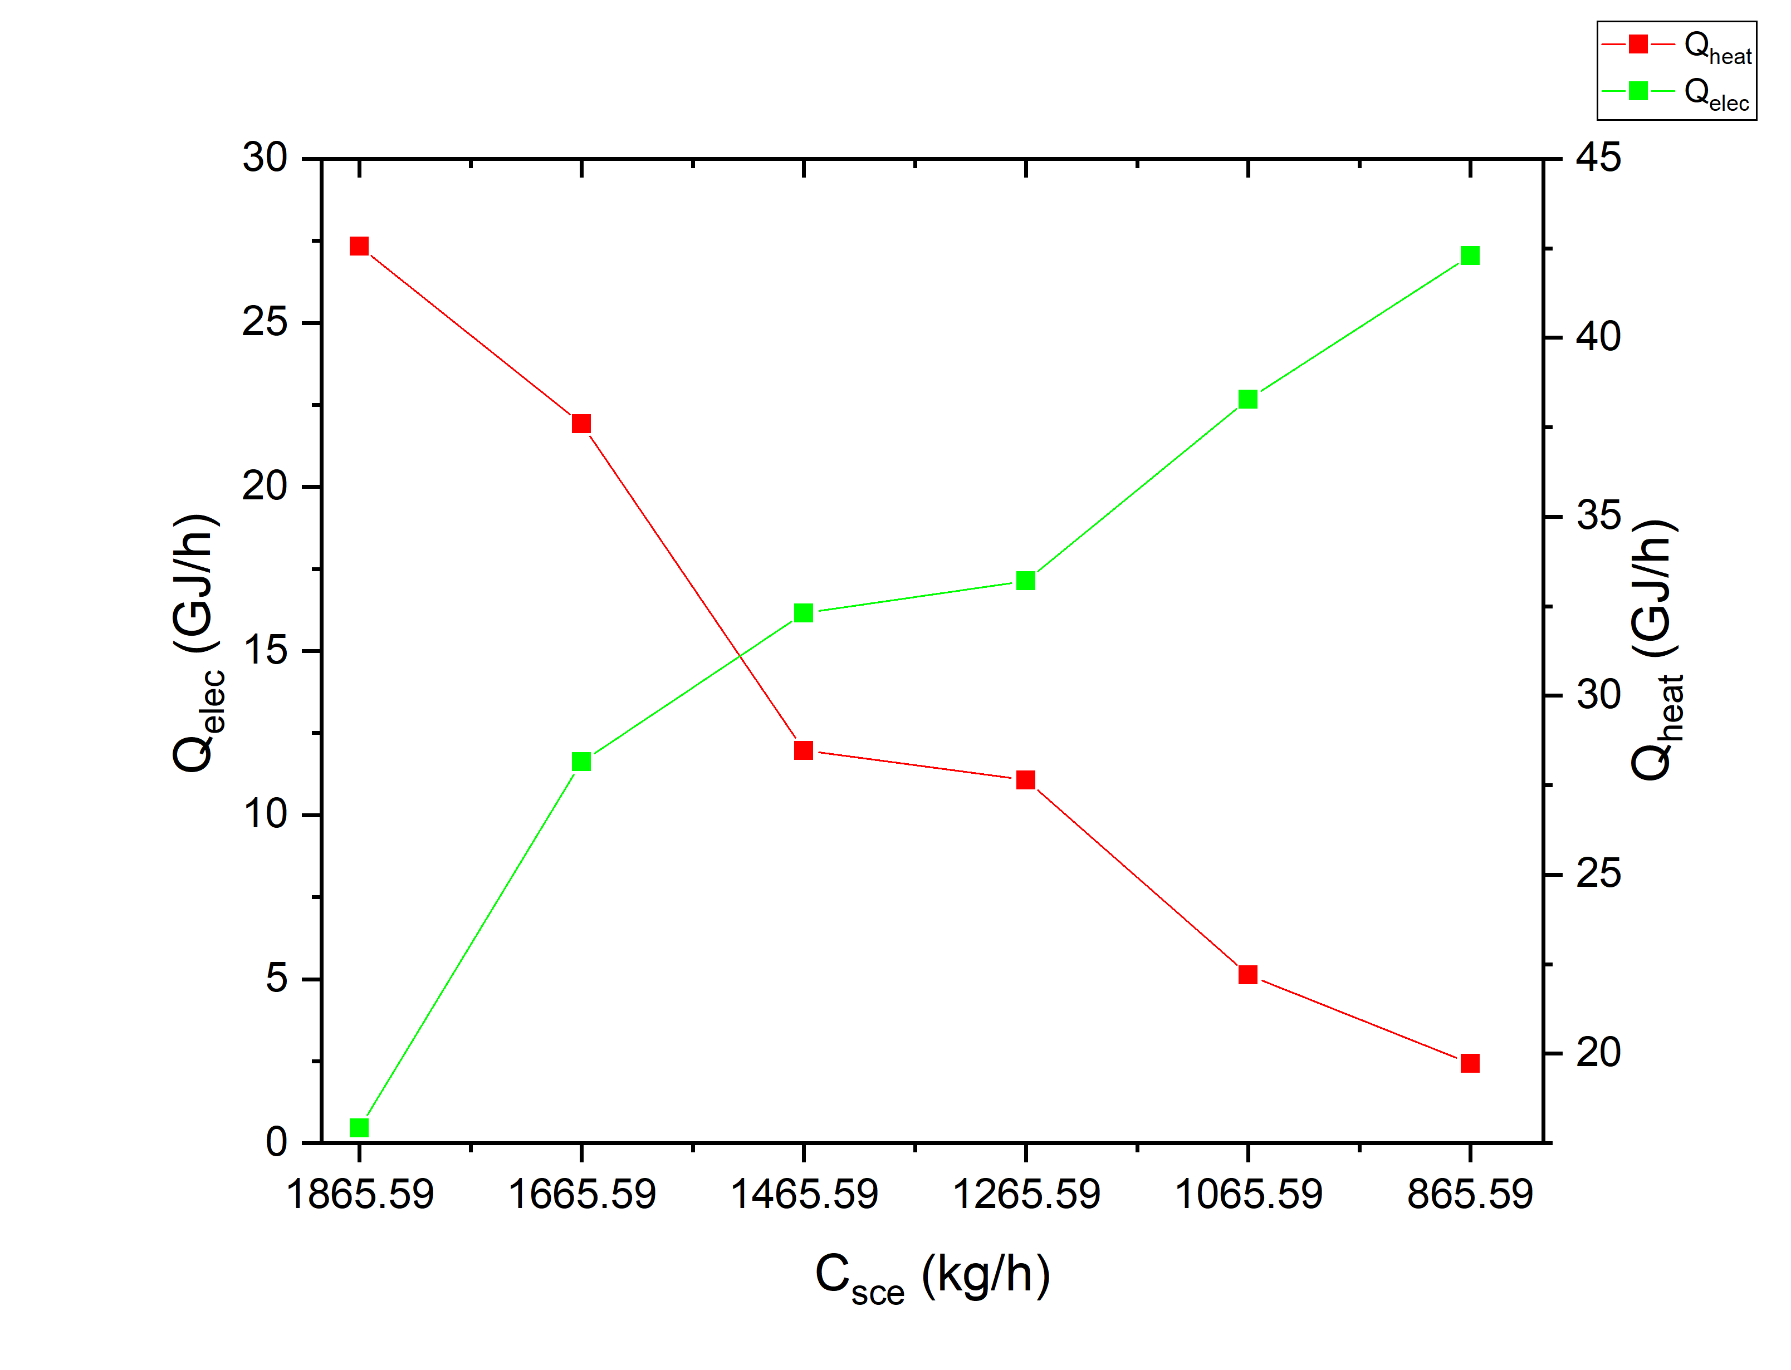
Fig. 3 Relationship between TAC and K_{coal} of the optimal solution under different constraints of C_{sce} | Fig. 4 Hot utility (Q_{heat}) and electricity (Q_{elec}) consumed in optimal distillation sequences under different constraints of C_{sce}
  - Conclusions
In this study, the synthesis method of E-HIDSs considering vapor recompression under the constraint of fossil energy consumption based on the SA-PSO stochastic algorithm is established to pursue the substitution of energy types used in the distillation process. A separation of five-component alkane mixtures is taken as an example to synthesis with the objective of minimum TAC using the proposed method. Results show that the optimal distillation sequence structure and continuous variable parameters under different constraints of fossil energy consumption can be obtained simultaneously.
The relationship of TAC and K_{coal} of the optimal sequences under each constraint shows significant mutual constraints. With the tightening of constraint of fossil energy consumption, electricity consumption and the percentage of electricity in operating costs have been increasing, while hot utility consumption and the percentage of hot utility in operating costs have been decreasing. This demonstrates the feasibility of the idea of "substituting fossil energy with green electricity by considering both vapor recompression and heat integration ". In industry practice, the constraint on fossil energy consumption can be set based on the factory's fossil energy consumption limit or CO₂ emission limit. The optimal distillation sequence is then obtained by the method to drive the energy transition in the distillation process.
References
Aggarwal A, Floudas C. Synthesis of general distillation sequences—nonsharp separations [J]. Computers & Chemical Engineering, 1990, 14(6): 631-653.
Amminudin K A, Smith R, Thong D Y C, et al. Design and optimization of fully thermally coupled distillation columns. Part 1: preliminary design and optimization methodology [J]. Chemical Engineering Research and Design, 2001, 79: 701–715.
An W, Yu F, Dong F, et al. Simulated annealing approach to the optimal synthesis of distillation column with intermediate heat exchangers [J]. Chinese Journal of Chemical Engineering, 2008, 16: 30–35.
An W, Yuan X. A simulated annealing-based approach to the optimal synthesis of heat-integrated distillation sequences [J]. Computers & Chemical Engineering, 2009, 33(1): 199-212.
Caballero J A, Grossmann I E. Generalized Disjunctive Programming Model for the Optimal Synthesis of Thermally Linked Distillation Columns [J]. Industrial & Engineering Chemistry Research, 2001, 40(10): 2260–2274.
Felbab N, Patel B, El-Halwagi M M, et al. Vapor recompression for efficient distillation. 1. A new synthesis perspective on standard configurations [J]. AIChE Journal, 2013, 59(8): 2977-2992.
Giridhar A, Agrawal R. Synthesis of distillation configurations: I. Characteristics of a good search space. Comput. Chem. Eng. 2010, 34, 73–83.
National Development and Reform Commission. Guidelines on Greenhouse Gas Emission Accounting Methodology and Reporting for Petrochemical Enterprises in China [S], 2014.
Sholl D S, Lively R P. Seven chemical separations to change the world [J]. Nature, 2016, 532(7600): 435-437.
Shah V H, Agrawal R. A matrix method for multicomponent distillation sequences [J]. AIChE Journal, 2010, 56: 1759–1775.
United Nations. Climate Action [EB/OL]. https://www.un.org/zh/climatechange/raising-ambition/renewable-energy.
Wang F, Luo Y, Yuan X. A formulation methodology for multicomponent distillation sequences based on stochastic optimization [J]. Chinese Journal of Chemical Engineering, 2016.
Wang N, Ye Q, Ren X, et al. Performance Enhancement of Heat Pump with Preheater-Assisted Pressure-Swing Distillation Process[J]. Industrial & Engineering Chemistry Research, 2020, 59(10): 4742-4755.
Yuan H O, Luo Y Q, Yuan X G. Synthesis of Heat-integrated Distillation Sequences with Mechanical Vapor Recompression by Stochastic Optimization. Computers & Chemical Engineering, 2022a.
Yuan H O. Distillation sequence synthesis based on stochastic optimization for steam recompression energy integration [D]. Tianjin: Tianjin University, 2022b.
Zhang S, Luo Y, Ma Y, Yuan X. Simultaneous optimization of nonsharp distillation sequences and heat integration networks by simulated annealing algorithm. Energy, 2018, 162, 1139–1157.
Zhang S, Luo Y, Yuan X. A novel stochastic optimization method to efficiently synthesize large-scale nonsharp distillation systems [J]. AIChE Journal, 2021, 67(9): e17328.

