Modelling, simulation, exergy and economic analyses of thermal cracking of propane using CO₂ and steam as diluents
Yao Zhang ª, Hui Yan ^{a,b}, Daotong Chong ^{b}, Joan Cordiner ª, *Meihong Wang ª
ª Department of Chemical and Biological Engineering, The University of Sheffield, Sheffield S1 3JD, UK
^{b} State Key Laboratory of Multiphase Flow in Power Engineering, Xi’an Jiaotong University, Xi’an, Shaanxi, China
Corresponding author: meihong.wang@sheffield.ac

Abstract
Introduction of diluents can increase the yield of valuable products and reduce the coking rate during thermal cracking of propane. Use of captured CO₂ as diluent for the ethylene manufacturing is preferred to avoid high cost of CO₂ transport and storage. A 1-dimentional pseudo-dynamic model of plug flow reactor (PFR) was developed and implemented in gPROMS ModelBuilder®. The model was validated with industrial data. Economic and exergy analyses of the PFR using steam or CO₂ as diluent were then carried out. The results indicate that using CO₂ as diluent can increase the run length of PFR by 13.0% and annual profit by 10.20%. When operating at the ratio achieving highest annual profit, using CO₂ as diluent can reduce exergy destruction by 20.53%. The key findings from this study indicate that using CO₂ as alternative diluent has high potential to increase the profit and reduce energy consumption for ethylene manufacturing. Further study will focus on the effects of diluent-to-propane ratio using different diluents and the potential of using mixed diluents.
Keywords: First principles modelling, process simulation, thermal cracking furnace, ethylene manufacturing, economic analysis, exergy analysis
  - Introduction
As one of the most important products in the petro-chemical industry, ethylene has a rapidly increasing demand among the world. Therefore, it is urgent to improve the yearly production of thermal cracking furnace, which is the heart of ethylene manufacturing. However, in the background of global warming, energy consumption and CO₂ emission of thermal cracking furnace are two aspects that have to be focused on.
Several studies aimed to improve the economic benefits of thermal cracking furnace for the ethylene manufacturing. Berreni and Wang (2011a) developed a first principle model of plug flow reactor (PFR) in thermal cracking furnace and carried out dynamic optimization to maximize the annual operating profit. Higher operating profit can be achieved by dynamic optimization but the computation demand also improved a lot. Caballero et al. (2015) carried out an optimization to find out the optimal heat flux profiles along the PFR to improve the ethylene yield. Jarullah et al.(2015) optimized the flow rates of different hydrocarbons feeds to obtain the maximum profit.
Reducing the energy consumption and CO₂ emission of ethylene manufacturing are equally important to improve economic benefit. Yuan et al.(2019) developed a steady state model of whole thermal cracking furnace including radiation section, convection section and quench system. Energy and exergy analyses of the thermal cracking furnace were carried out based on the steady state model to find out the energy saving potential. Zheng et al. (2023) proposed a low-carbon ethylene production system, which can achieve 57.5% CO₂ reduction but 15.92 annual cost increase.
In this paper, using captured CO₂ as alternative diluent for thermal cracking furnace was compared with using steam based on a 1-D pseudo-dynamic model considering both energy consumption and economic benefits.
  - Mathematic modelling and model validation
2.1 Mathematic model
Since the coking rate is extremely slow compared with the reaction rates of thermal cracking reactions, only the coke thickness change with time in this pseudo-dynamic model.
$$\begin{aligned}\frac{∂F_{i}\left(z\right)}{∂z}=\sum_{j=1}^{NR}{s_{ij}}×r_{j}\left(z\right)×M_{wi}×\frac{π×{D\left(z\right)}^{2}}{4}\#\left(1\right)\end{aligned}$$
The reaction rates and coking rate can be calculated by Eq. (2) and Eq. (3) according to the Arrhenius law. The reaction scheme used is from Sundaram and Froment (1979).

$$\begin{aligned}r_{j}\left(z\right)=A_{j}×e^{\frac{{-Ea}_{j}}{RT\left(z\right)}}×\prod_{i=1}^{NC}{C_{i}^{nij}}\left(z\right)\#\left(2\right)\end{aligned}$$
$$\begin{aligned}r_{c}\left(z\right)=A_{c}×e^{\frac{{-E}_{c}}{RT_{c}\left(z\right)}}×C_{C_{3}H_{6}}\left(z\right)\#\left(3\right)\end{aligned}$$
The concentration of each component can be calculated by Eq. (4) based on ideal gas law.

$$\begin{aligned}C_{i}\left(z\right)=\left(\frac{\frac{F_{i}\left(z\right)}{{MW}_{i}}}{N_{diluent}+\sum_{i=1}^{NC}{\left(\frac{F_{i}\left(z\right)}{{MW}_{i}}\right)}}\right)×\frac{P\left(z\right)}{R×T\left(z\right)}×\frac{1}{1000}\#(4)\end{aligned}$$
The coke thickness and PFR internal diameter reduction caused by coke formation can be obtained by Eq. (5) and Eq. (6).
$$\begin{aligned}\frac{dδ\left(z\right)}{dt}=\frac{r_{c}\left(z\right)}{φc}\#\left(5\right)\end{aligned}$$
$$\begin{aligned}D\left(z\right)=Di-2δ\left(z\right) \#\left(6\right)\end{aligned}$$
Energy balance and momentum balance are shown in Eq. (7) and Eq. (8).
$$(\sum_{i=1}^{NC}{F_{i}\left(z\right)×{Cpm}_{i}\left(z\right)+F_{d}(z)×{Cpm}_{d}(z))×\frac{∂T\left(z\right)}{∂z}=\frac{\dot{Q}\left(z\right)}{L}+\frac{π×{D\left(z\right)}^{2}}{4}}×\sum_{j=1}^{NR}{\begin{aligned}r_{j}\left(z\right)×\left({-∆H}_{r,j}\left(z\right)\right)\#\left(7\right) \\ \end{aligned}}$$

$$\begin{aligned}\frac{∂P\left(z\right)}{∂z}=\frac{{მ\left(\frac{1}{Mm\left(z\right)}\right)}/{∂z+}\frac{1}{Mm\left(z\right)}×\left(\frac{1}{T\left(z\right)}×\frac{∂T\left(z\right)}{∂z}+Fr\left(z\right)\right)}{\frac{1}{Mm\left(z\right)P\left(z\right)}-\frac{P\left(z\right)}{{G\left(z\right)}^{2}RT\left(z\right)}}\#\left(8\right)\end{aligned}$$

2.2 Model validation

 | Simulation results | Industrial data | Relative error
C₂H₄ | 35.80% | 34.50% | 3.16%
C₃H₆ | 14.77% | 14.70% | 0.50%
CH₄ | 25.31% | 24.00% | 5.46%
Table 1 Simulation results of propane conversion and main products yields compared with industrial data (clean tube condition).

Run length | Simulation results | Industrial data | Relative error
100 hours | 0.13 cm | 0.14 cm | -7.1%
300 hours | 0.41 cm | 0.44 cm | -6.8%
700 hours | 0.94 cm | 0.98 cm | -4.08%
Table 2 Simulation results of PFR outlet coke thickness compared with industrial data.

This 1-D pseudo-dynamic model was implemented in gPROMS ModelBuilder®. The predication of physical properties used in this model is based on Peng-Robinson equation of state and can be obtained from Multiflash®. Reactor parameters and operating parameters from Sundaram and Froment (1979) are used. As shown in Table 1 and Table 2, the simulation results show good agreement with industrial data from Sundaram and Froment (1979).
  - Exergy and economic analyses
3.1 Methodology
This section aims to compare two kinds of diluents (CO₂ vs steam) at different diluent-to propane ratios. The total inlet mass flow rate of process gas (propane + diluent) is fixed at 1.0689 kg/s and inlet pressure is fixed at 3 bars, which are the same as the base case used to validate the model. The diluent-to-propane ratio varies from 0.2-1.0, which is the operating range reported by Sundaram and Froment (1979).
3.1.1Economic analysis
Annual production of valuable products and anuual profit are two important indicators to compare the economic benefits of using two diffetent kinds of diluents.Annual production of valuable products can be calcuated using Eq.(9) and annual profit can be calculated using Eq.(10-12).
$$\begin{aligned}F_{i annual}=8160×\frac{F_{i total}}{t_{c}{+t}_{d}}\#(9)\end{aligned}$$
$$\begin{aligned}P_{annual}={INC}_{annual}-{COS}_{annual}\#\left(10\right)\end{aligned}$$
$$\begin{aligned}{INC}_{annual}=\sum{F_{i annual}×{COS}_{i}}\#\left(11\right)\end{aligned}$$
$$\begin{aligned}{COS}_{annual}=\frac{t_{c}*8160}{t_{c}+t_{d}}\left(F_{C3H6}×{COS}_{C3H6}+F_{d}×{COS}_{D}+{\dot{Q}}_{annual}×{COS}_{H}+\frac{DCC}{t_{c}}\right) (12)\end{aligned}$$
The cost of CO₂ as diluent is assumed to be 0 since use of captured CO₂ can avoid the extremely high cost of CO₂ transport and storage. Other chemical price factors and costs for decoking can be found in Berreni and Wang (2011b).
3.1.2 Exergy analysis
Exergy analysis can be used to evaluate the energy consumption in quality of using two kinds of diluents.The exergy balance of PFR can be writtern as Eq. (13).
$$\begin{aligned}{\dot{E}}_{Q}+{\dot{E}}_{f,in}={\dot{E}}_{f,out}+{\dot{E}}_{D}\#\end{aligned}\left(13\right)$$
${\dot{E}}_{Q}$ can be determined by Eq. (14) which is the exergy of required heat and ${\dot{E}}_{f,in}$ and ${\dot{E}}_{f,out}$ can be determined by Eq.(15) which are the exergy of inlet and outlet process gas.
$$\begin{aligned}{\dot{E}}_{Q}=\sum_{Z=0}^{L}{\frac{Q\left(z\right)}{L}×\left(1-\frac{T_{we}\left(z\right)}{T}\right)}\#\end{aligned}\left(14\right)$$
$$\begin{aligned}{\dot{E}}_{f}={\dot{E}}^{ph}+{\dot{E}}^{ch}\#\end{aligned}\left(15\right)$$
The rational exergy efficiency is used in this study to analyse the exergy efficiency, which can be calculated by Eq.(16). Since the exergy of required heat is much smaller than the exergy of stream, the conventional exergy efficiency is close to 1.
$$\begin{aligned}ε=\frac{{\dot{E}}_{f,out}-{\dot{E}}_{f,in}}{{\dot{E}}_{Q}}\#\end{aligned}\left(16\right)$$
Considering the run length and shut down of PFR, the annual exergy of required heat$({\dot{E}}_{Q,annual})$, annual exergy destruction$({\dot{E}}_{D,annual})$ and annual average exergy efficiency $(ε_{annual})$ can be used to compare the PFR performance for the whole year.
$$\begin{aligned}{\dot{E}}_{Q,annual}=8160×\frac{{\dot{E}}_{Q,total}}{t_{c}{+t}_{d}}\#\end{aligned}\left(17\right)$$
$$\begin{aligned}{\dot{E}}_{D,annual}=8160×\frac{{\dot{E}}_{D,total}}{t_{c}{+t}_{d}}\#\end{aligned}\left(18\right)$$
$$\begin{aligned}ε_{annual}=1-\frac{{\dot{E}}_{D,annual}}{{\dot{E}}_{Q,annual}}\#\end{aligned}\left(19\right)$$
3.2 Economic analysis
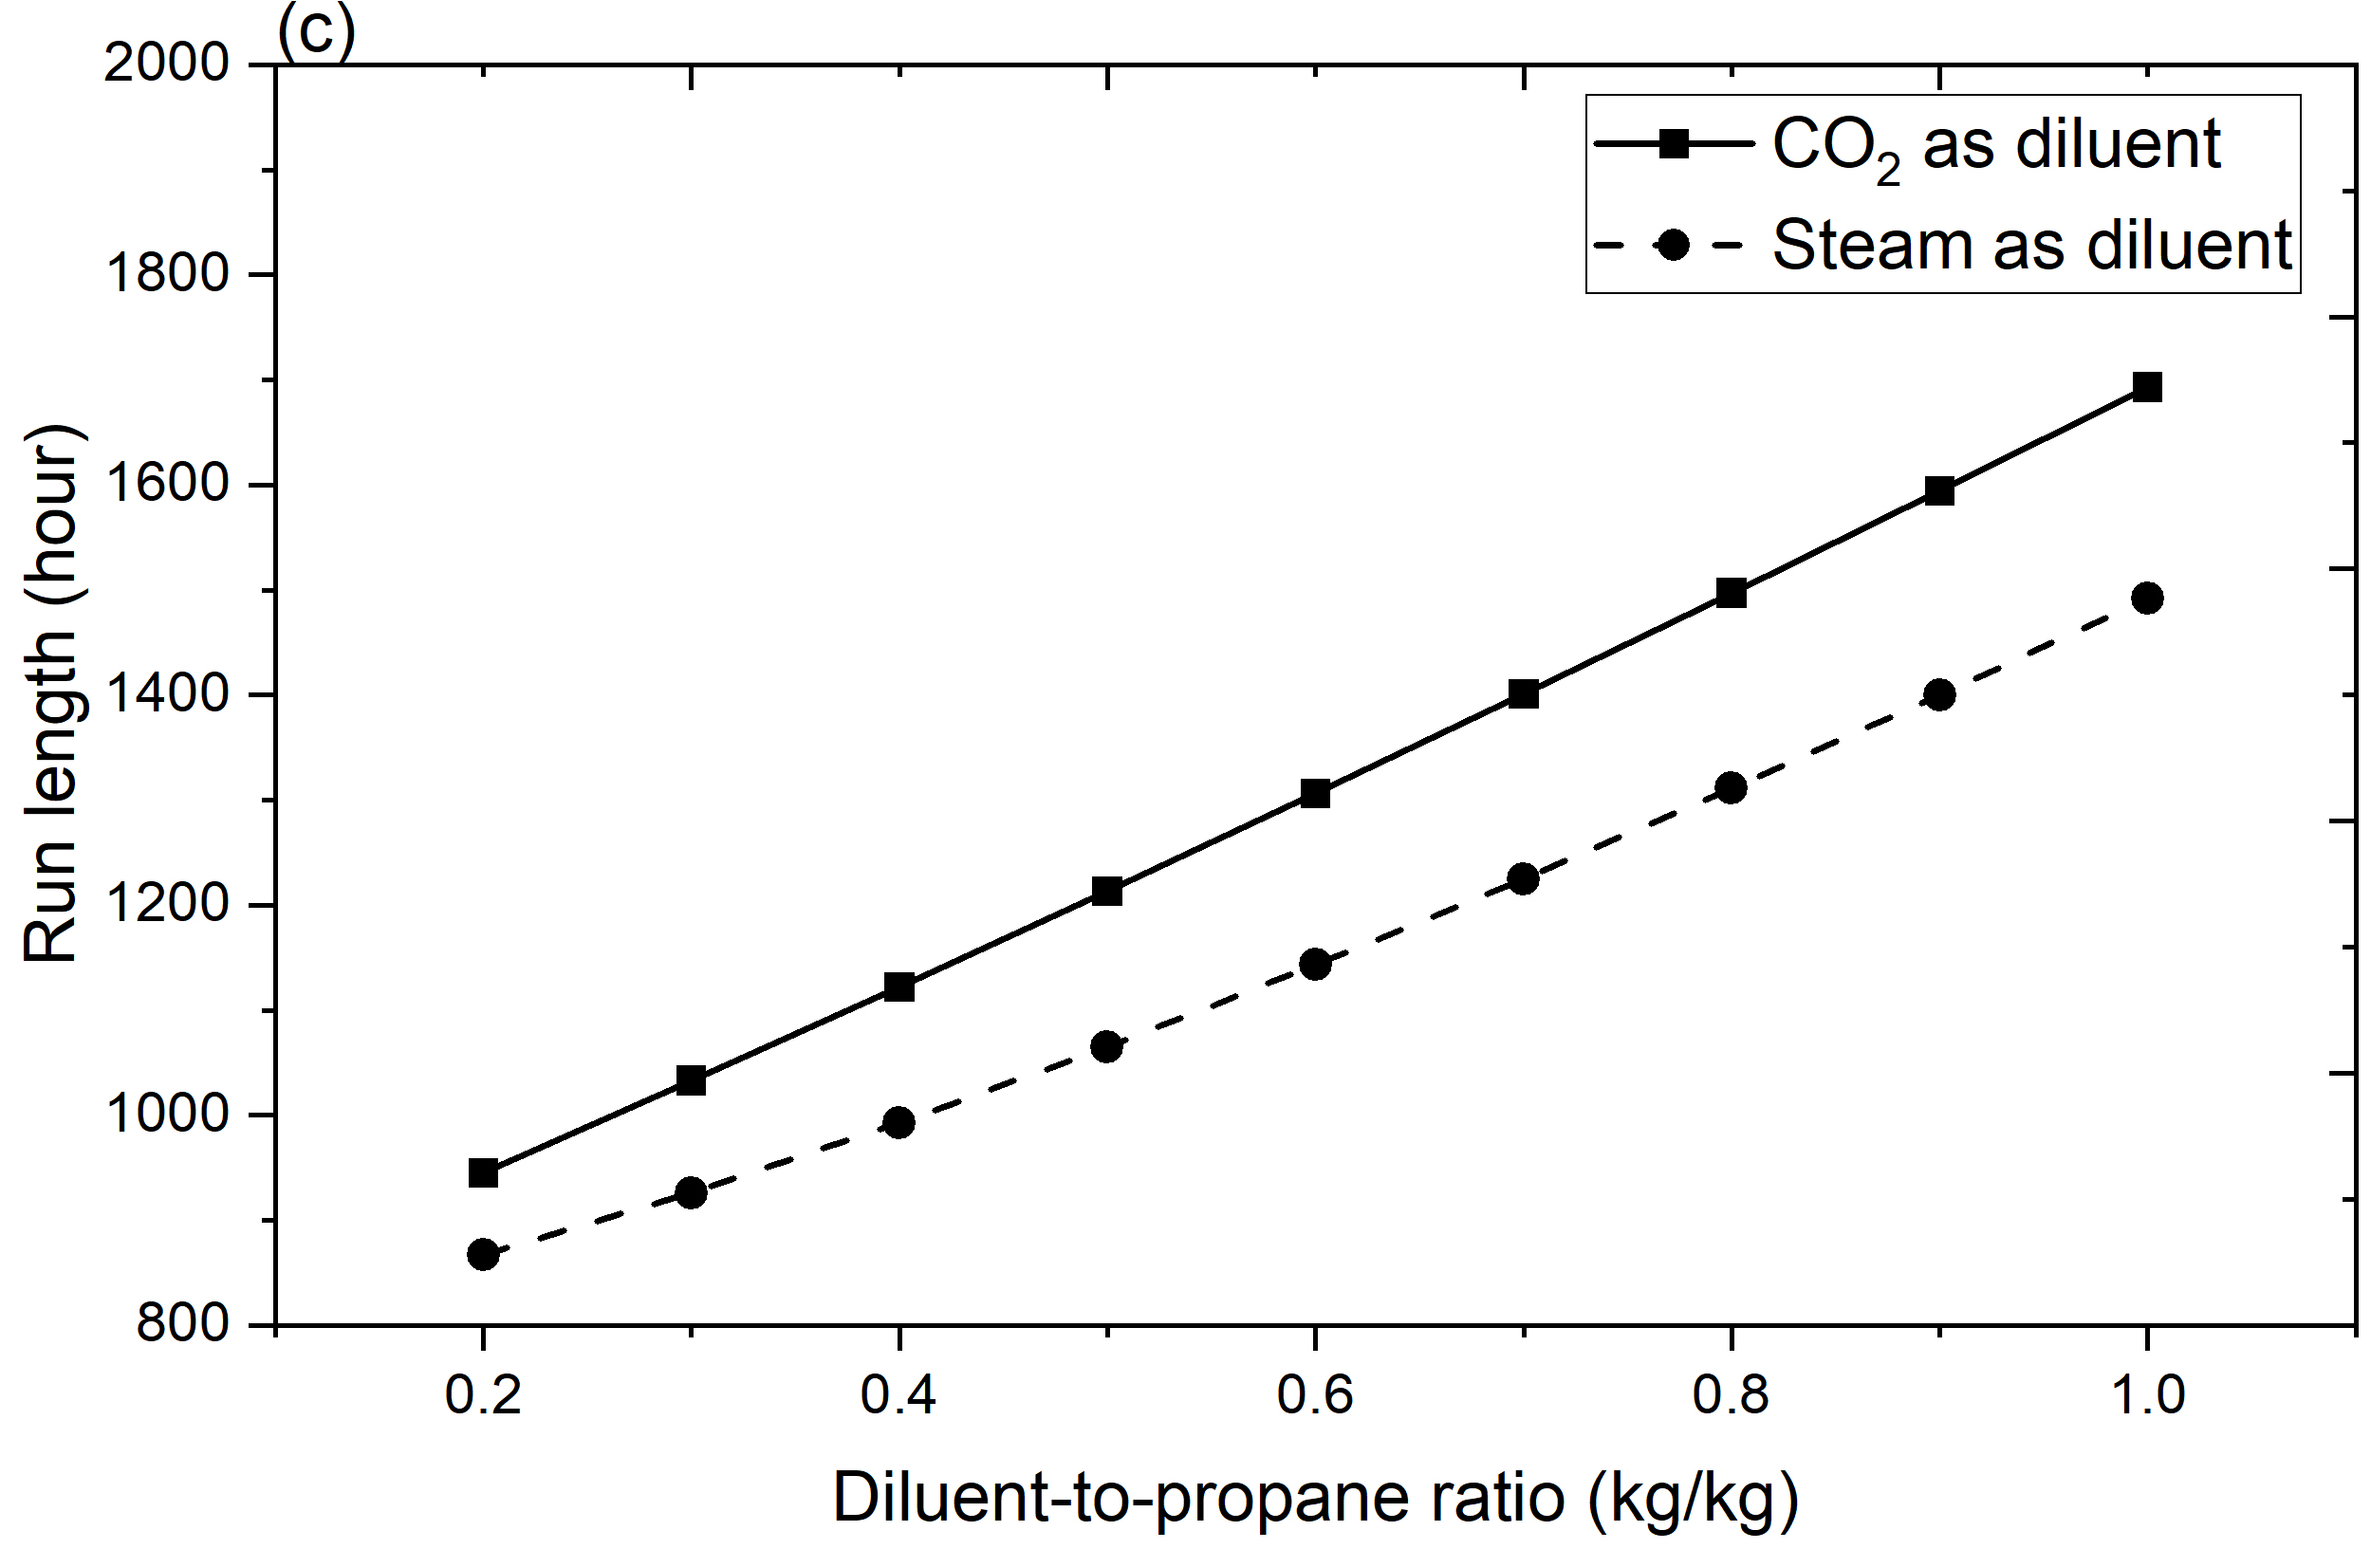
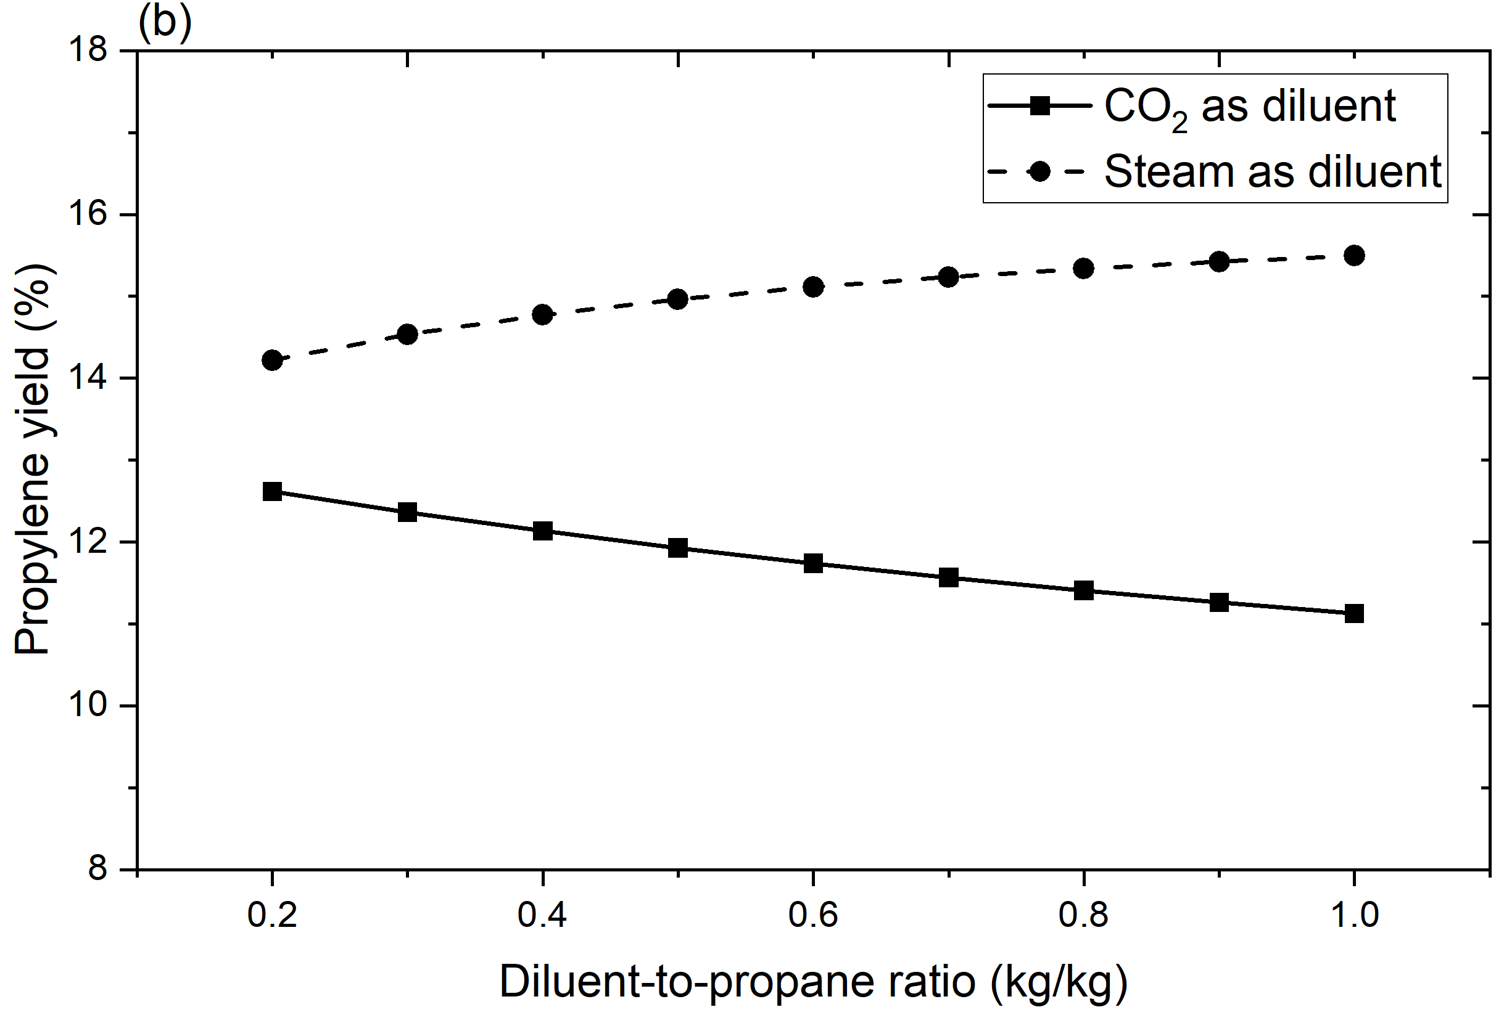
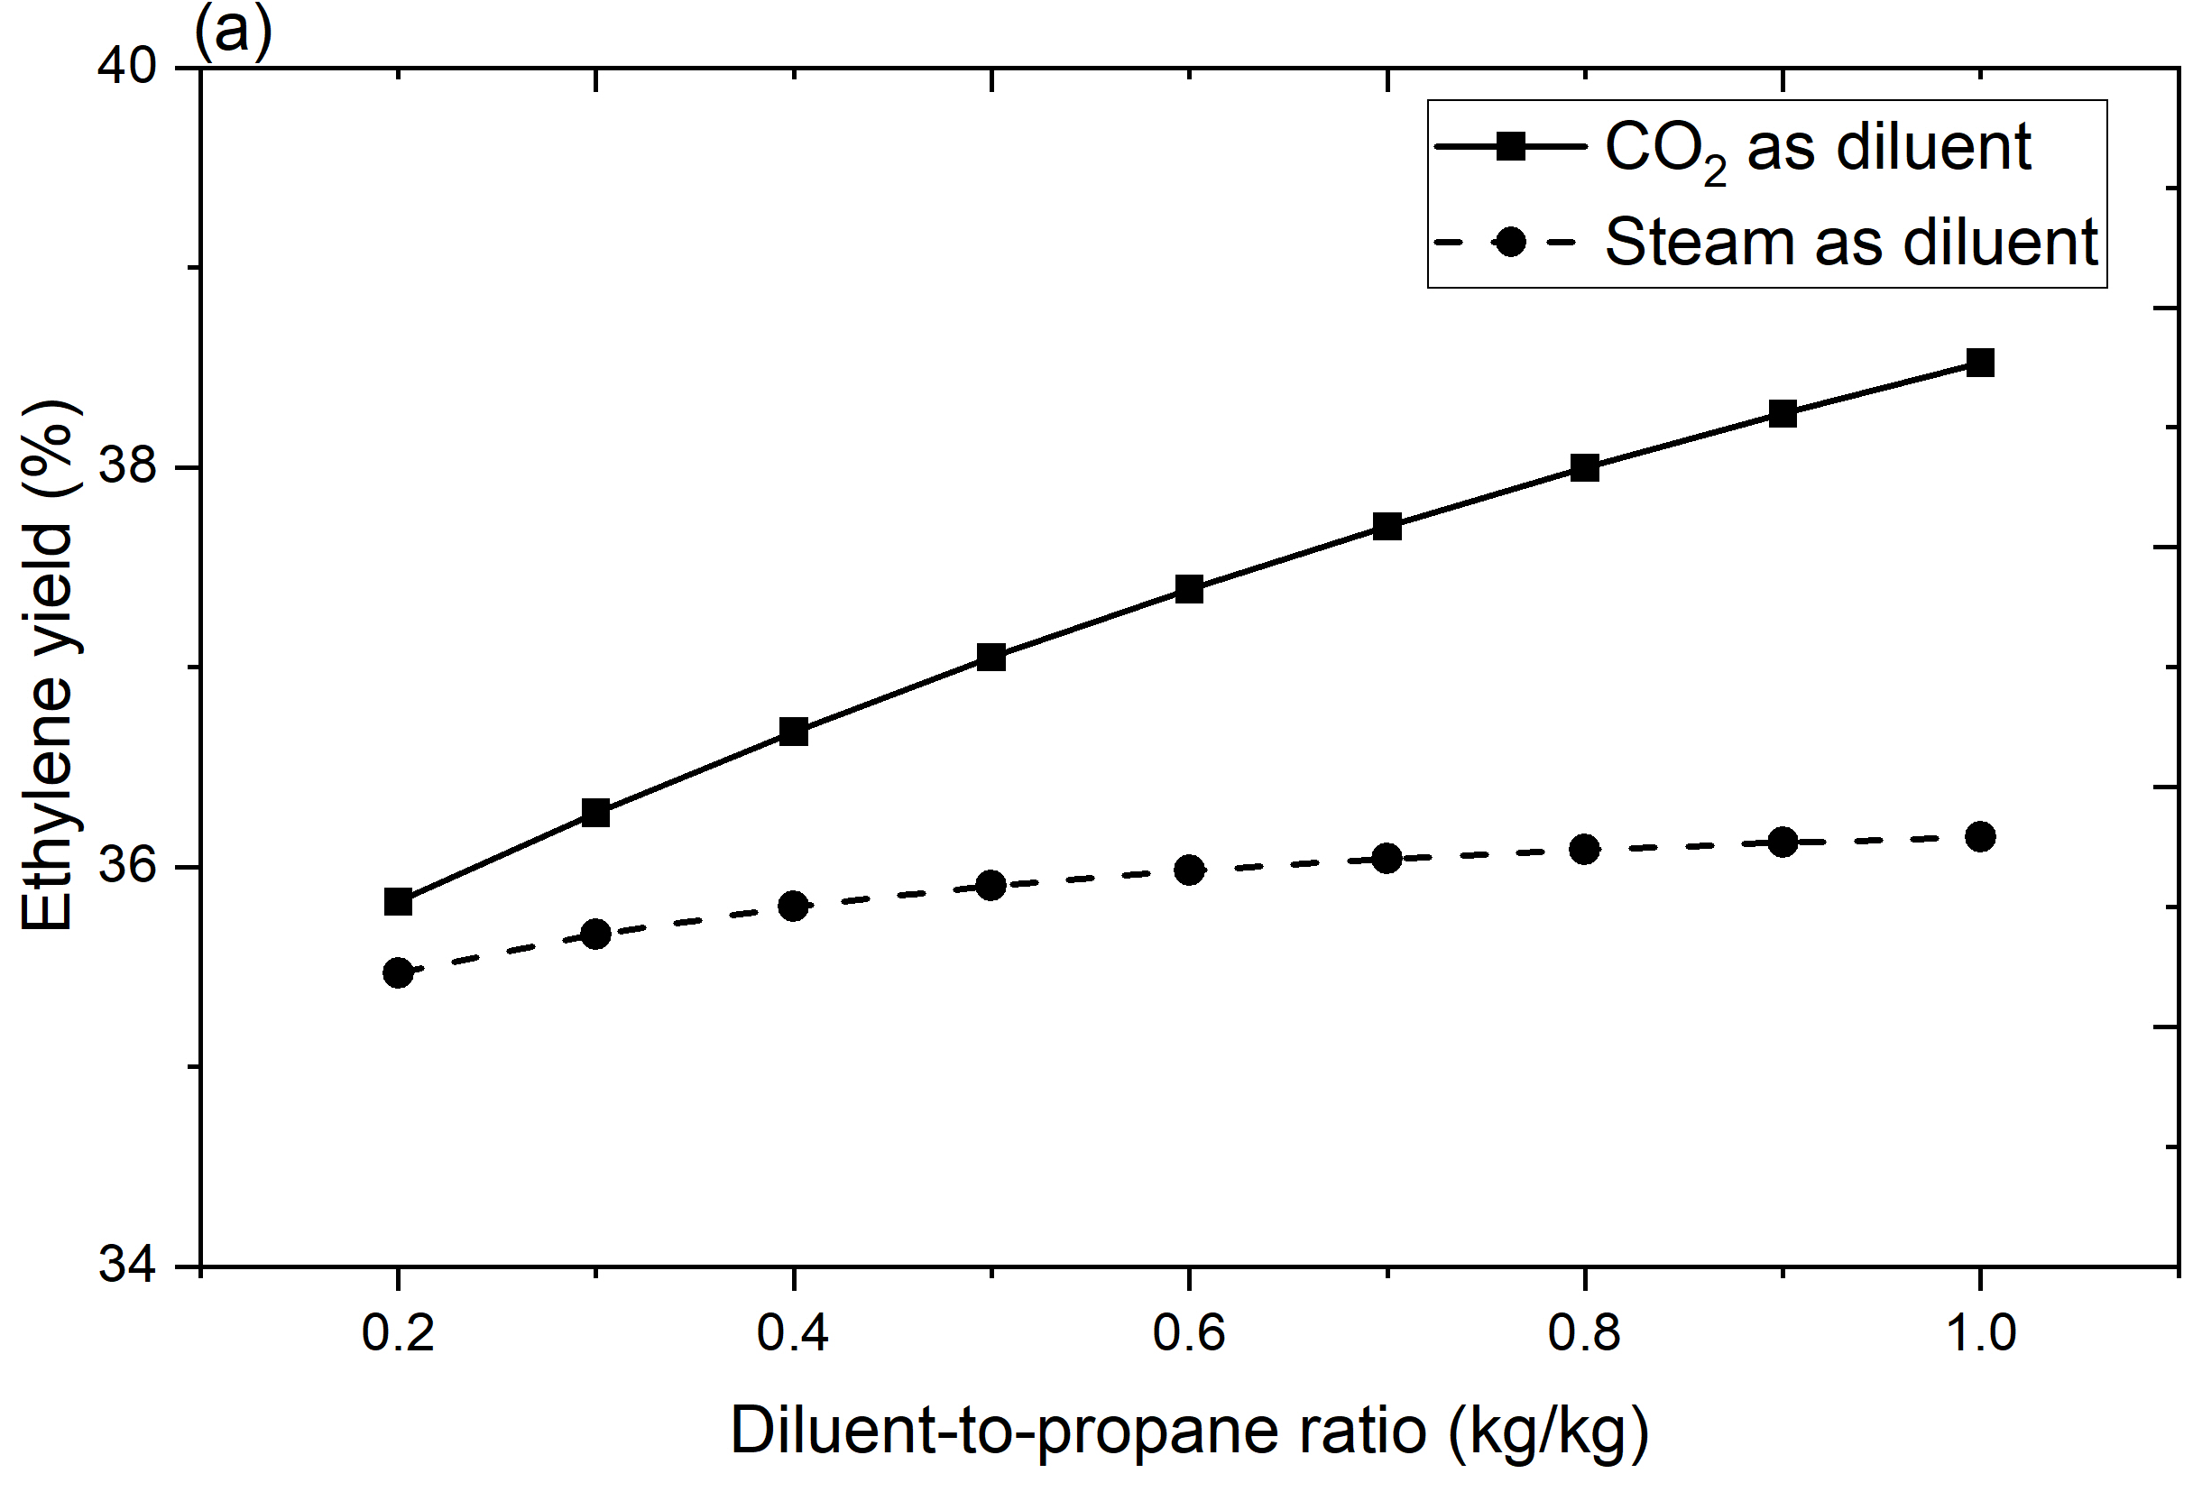
To compare the economic benefits of using two different kinds of diluents, the yield of valuable products under clean tube condition operating at different diluent-to-propane ratios are shown in Fig.1.From Fig.1 (a) and (b), using CO₂ has a higher ethylene yield but lower propylene yield. Compared with steam, CO₂ has a higher molecular weight. Therefore, at the same diluent-to-propane ratio, the molar flowrate of CO₂ is smaller. It leads to a higher partial pressure of propylene and more propylene participates in the reaction to produce ethylene and methane. Using CO₂ as diluent also has a longer run length, which is shown in Fig.1(c). This can be explained by that using CO₂ as diluent will lead to a lower coking rate because of lower coke surface temperature.

Fig. 1. Comparison of (a) Ethylene (b) Propylene yield under clean tube condition and (c) Run length using CO₂ and steam
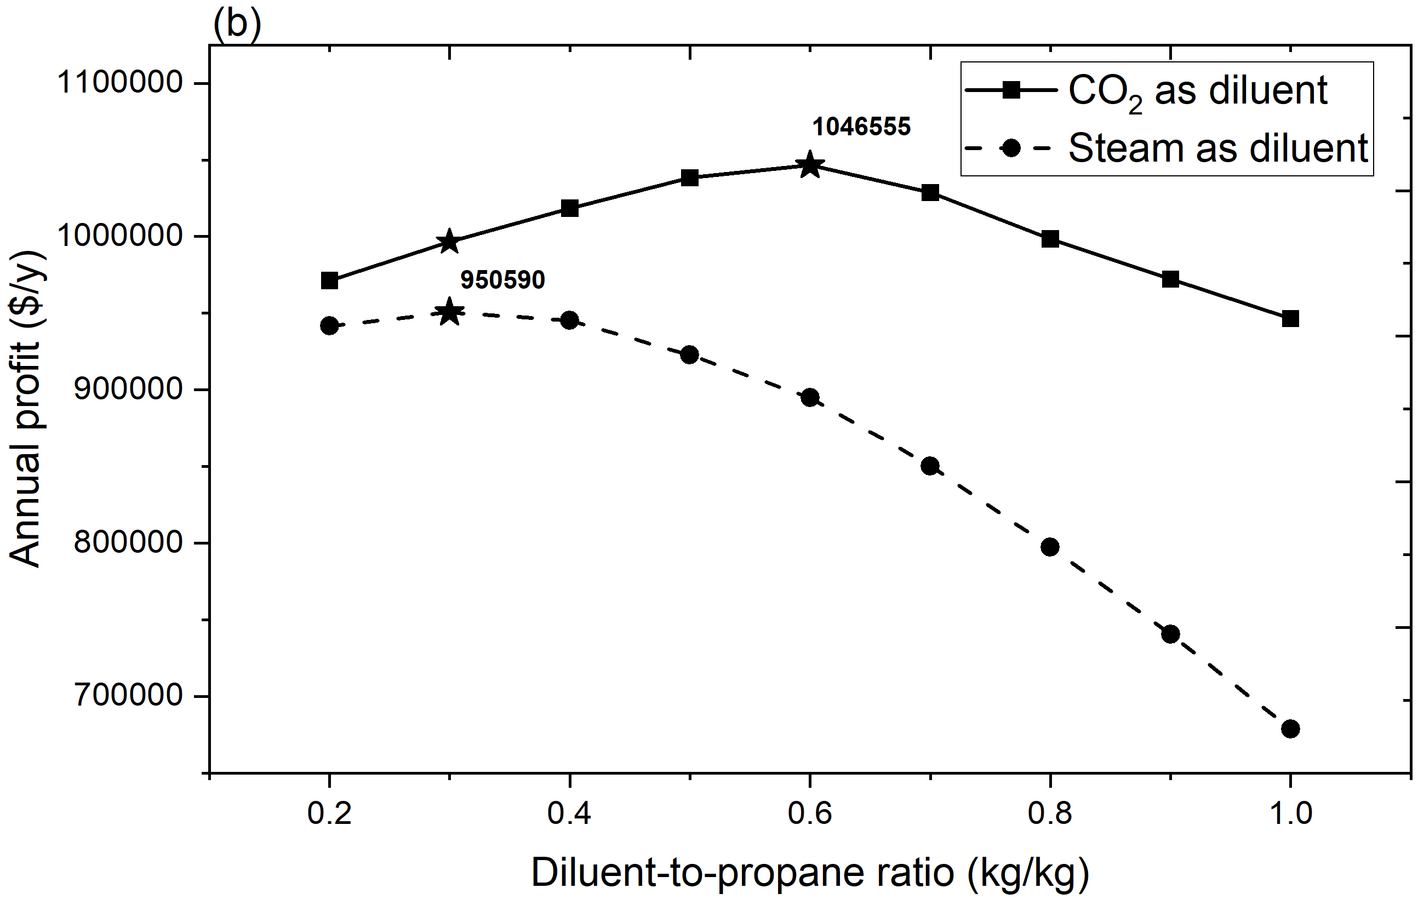
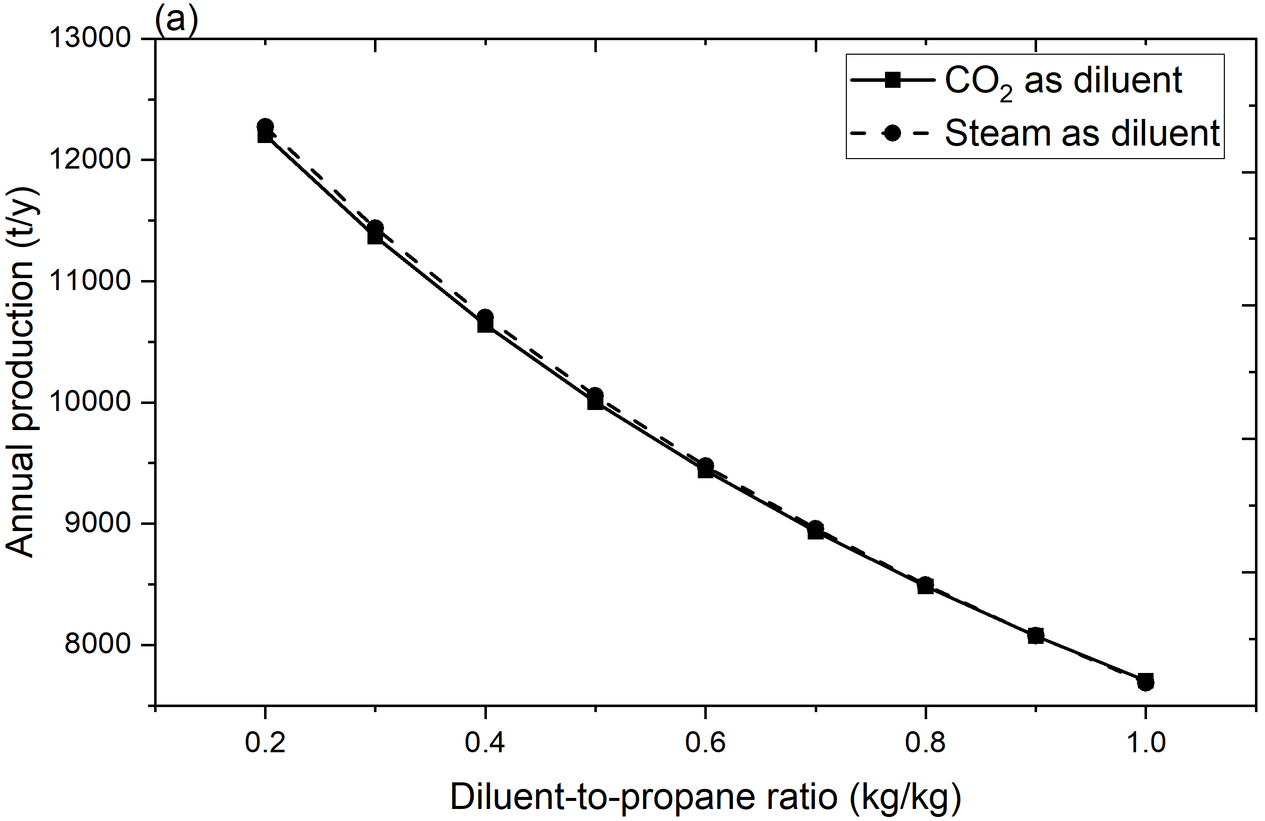
Fig. 2. Comparison of (a) annual production and (b) annual profit of PFR using CO₂ and steam

The total annual production and annual profit using CO₂ and steam are compared to evaluate the economic benefits of using two different kinds of diluents. As shown in Fig.2 (a), the annual production of valuable products are quite close using CO₂ and steam. This is because using CO₂ has a higher ethylene yield but lower propylene yield, which are both considered as valuable products. As shown in Fig.2 (b),using CO₂ has a much higher annual profit since longer run length, lower energy consumption and lower cost for diluent. Using CO₂ can increase the highest annual profit from 950,590 $/y (operating at steam-to-propane ratio 0.3) to 1,046,555 $/y (operating at diluent-to-propane ratio 0.6).
3.3 Exergy analysis
When operating at the diluent-to-propane ratio achieve the highest annual profit, the annual exergy of required heat, annual exergy destruction and annual average exergy efficiency were compared using CO₂ as diluents.
As shown in table 3, when achieving the highest annual profit, using CO₂ as diluent can reduce annual required exergy by 16.16% , reduce annual exergy destruction by 20.53% and increase annual average exergy efficiency by 1.5%. This is because using CO₂ can reduce the temperature difference between tube outer wall of PFR and process gas compared with using steam.
  - Conclusion
A 1-D pseudo-dynamic model for PFR in thermal cracking furnace was developed to compare using CO₂ and steam as diluents. The model was validated with industrial data from literature. The results indicated that using CO₂ as diluent can increase the run length of PFR and increase annual profit by 10.10%. When operating at the ratio achieving highest annual profit, using CO₂ as diluent can reduce exergy destruction by 20.53%. The key findings of this study demonstrate that using CO₂ as alternative diluent has high potential to increase the profit and reduce energy consumption in ethylene manufacturing.

Table 3 Comparison of annual exergy utilization when PFR operating at the diluent-to-propane ratio with highest annual profit using CO₂ and steam
 | Run length  (h) | Annual exergy of required heat  (GJ) | Annual exergy destruction  (GJ) | Annual average exergy efficiency  (%)
Steam as diluent | 926 | 49896 | 10872 | 78.18
CO₂ as diluent | 1307 | 41832 | 8640 | 79.36
Absolute difference | 381 | -8064 | -2232 | 1.18
Relative difference | 29.15% | -16.16% | -20.53% | 1.50%

$$δ(z)$$ | Coke thickness [m] | F_{d} (z) | Mass flowrate of diluent [kg/s]
φ_{c} | Coke density [kg/m³] | F_{i} (z) | Mass flowrate of component i [kg/s]
$$ε$$ | Rational exergy efficiency [-] | F_{i annual} | Annual production of component i [kg/y]
$$ε_{annual}$$ | Annual average rational exergy efficiency [-] | F_{i total} | Total production of component i in a cycle of run length [kg]
A_{c} | Pre-exponential factor for coking reaction [kg m³/(kmol m² s)] | Fr (z) | Friction factor [m⁻¹]
A_{j} | Pre-exponential factor for reaction j [s⁻¹] or [m³/(kmol s)] | G (z) | Total mass flow rate [kg/m² s]
C_{i} (z) | Molar concentration of component i [kmol/m³] | INC_{annual} | Annual income [$/y]
COS | Annual cost [$/y] | L | Reactor length [m]
COS_{D} | Price factor of diluent [$/kg] | MW_{i} | Molecular weight of component i [kg/kmol]
COS_{H} | Price factor of heat [$/kg] | N_{diluent} | Molar flowrate of diluent [kmol/s]
COS_{i} | Price factor of component i [$/kg] | NC | Number of components [-]
Cpm_{d} | Specific heat capacity of diluent [kJ/(kg K)] | NR | Number of reactions [-]
Cpm_{i} (z) | Specific heat capacity of component i [kJ/(kg K)] | n_{ij} | Reaction order [-]
D(z) | Internal diameter of PFR with coke formation [m] | P (z) | Pressure [Pa]
DCC | Decoking cost per cycle [$] | P_{annual} | Annual profit [$/y]
Di | Internal diameter of PFR under clean tube condition [m] | $${\dot{Q}}_{annual}$$ | Annual energy consumption [GJ/y]
Ea_{j} | Activation energy of reaction j [kJ/kmol] | R | Ideal gas constant [J/ (K mol)]
E_{c} | Activation energy of coking reaction [kJ/kmol] | r_{c} (z) | Reaction rate of coking [g /(m² s)]
$${\dot{E}}^{ch}$$ | Chemical exergy [kj/s] | r_{j} (z) | Reaction rate of reaction j [kmol/(s m³)]
$${\dot{E}}^{ph}$$ | Physical exergy [kj/s] | $$s_{ij}$$ | Stoichiometry coefficient [-]
$${\dot{E}}_{D}$$ | Exergy destruction of PFR [kJ/s] | T (z) | Process gas temperature [K]
$${\dot{E}}_{f,in}$$ | Exergy of PFR inlet stream [kJ/s] | t_{c} | Run length [h]
$${\dot{E}}_{f,out}$$ | Exergy of PFR outlet stream [kJ/s] | t_{d} | Decoking time per cycle [h]
Nomenclature

References
Berreni, M. and Wang, M. (2011a) ,Modelling and dynamic optimisation for optimal operation of industrial tubular reactor for propane cracking, Computer Aided Chemical Engineering, pp. 955–959.
Berreni, M. and Wang, M. (2011b) Modelling and dynamic optimization of thermal cracking of propane for ethylene manufacturing, Computers &amp; Chemical Engineering, 35(12), pp. 2876–2885.
Caballero, D.Y., Biegler, L.T. and Guirardello, R. (2015) Simulation and optimization of the ethane cracking process to produce ethylene, 12th International Symposium on Process Systems Engineering and 25th European Symposium on Computer Aided Process Engineering, pp. 917–922.
Sundaram, K.M. and Froment, G.F. (1979) Kinetics of coke deposition in the thermal cracking of propane, Chemical Engineering Science, 34(5), pp. 635–644.
Jarullah, A.T. et al. (2015) Optimal operation of a pyrolysis reactor, 12th International Symposium on Process Systems Engineering and 25th European Symposium on Computer Aided Process Engineering, pp. 827–832.
Yuan, B. et al. (2019) Assessment of energy saving potential of an industrial ethylene cracking furnace using advanced exergy analysis, Applied Energy, 254, p. 113583.
Zheng, C., Wu, X. and Chen, X. (2023) Low-carbon transformation of ethylene production system through deployment of carbon capture, utilization, storage and Renewable Energy Technologies, Journal of Cleaner Production, 413, p. 137475.

