An Economic Assessment Framework for Intelligent Process Monitoring Systems
Fangyuan Maª, Cheng Jiª, Jingde Wangª, Nan Zhang^{b,*}, Wei Sun^{a,*}
ªCollege of Chemical Engineering, Beijing University of Chemical Technology, Beijing 100029, China
^{b}Department of Chemical Engineering, The University of Manchester, Manchester M13 9PL, UK
Corresponding Author’s E-mail: Nan.Zhang@manchester.ac.uk, sunwei@mail.buct.edu.cn
Abstract
In this work, an economic assessment framework for intelligent process monitoring systems is proposed to quantify benefits brought by the application of the systems. To address the issue that the systems do not directly generate economic benefits, a benefit estimation method based on the losses caused by historical faults is described. A stability index is employed to label economically impactful faults in historical data. Then, based on the fault detection results of the systems, the economic losses avoided due to the application of the systems can be calculated, which include those caused by reduced product quality, lower productivity, increased energy consumption, increased labor costs, etc. The framework is then applied to a case study of an ethylene unit.
Keywords: IPDASs, Process Monitoring, Economic Evaluation.
  - Introduction
Maintaining the steady operation of a process is one of the goals of continuous operation in the chemical industry, which requires the timely detection of process upsets. Study on data-driven process monitoring was thus motivated and has attracted extensive attention from both academic and industrial societies, which can be employed to realize fault identification, fault diagnosis, etc. (Ge, 2017). Based on these methods, several Intelligent Process Data Analysis Systems (IPDASs) have been developed and successfully applied to existing industrial processes (Ma et al., 2019; Li et al., 2020). In academia, fault detection rates (FDR), false positive rates (FPR), and alarm time are commonly applied to evaluate these IPDASs (Ma et al., 2023). However, for the industry, whether the economic benefits can be directly accessed due to the application of IPDASs is of great concerned, which has not been specifically studied yet.
The application of economics to industry is not uncommon for similar systems. For example, the economic assessment of advanced process controls (APCs) has been studied for decades (Bauer & Craig, 2008). By analyzing the increased benefits of the process after using APCs, such as improving the process stability and reducing energy consumption, the application benefits of APCs can be calculated. However, unlike APCs, IPDASs do not directly generate economic benefits but rather avoid economic losses from further development of faults by detecting them in advance. Therefore, it is hard to obtain the economic benefits of an IPDASs by direct calculation. To address this problem, the economic losses caused by process deviations that IPDASs can identify are employed to evaluate the economic benefits. In this work, an economic assessment framework for IPDASs is proposed, which can be employed to provide a reference for decision-making in the industry. At first, a stability index (SI) based on the variance of normalized key quality variables is defined to quantify changes in product quality. The control limits of the SI can be calculated using the key quality variable under normal operating conditions. If the SI exceeds the control limit, it means that the process has deviated from the pre-set operating conditions and the product quality has been affected. Process data are entered into IPDAS to obtain fault detection results. Combined with the fault labeled results using SI, the economically impactful fault samples that IPDAS detected will be obtained. Assuming that IPDASs are employed, these fault samples can be identified and eliminated in advance, and the losses caused by the fault can be avoided. Therefore, the losses caused by these identifiable faults are the economic benefits of IPDASs, which can be calculated using data such as product prices, yields, and financial data of enterprises. Data from a refinery enterprise are investigated to validate the proposed economic assessment framework.
The remaining sections of this article are organized as follows: Section 2 contains a detailed introduction to the proposed economic assessment framework for IPDAS. In Section 3, an industrial cracking furnace is investigated as a case study. Finally, a conclusion is present in Section 4.
  - Economic Assessment Framework for IPDASs
The objective of the proposed economic assessment framework in this work is to conduct a systematic and comprehensive economic evaluation of the IPDASs, thereby providing a reference for decision-maker in the industry. To this end, an economic assessment framework as shown in Figure 1 is proposed, and the steps of the proposed framework are explained in detail in the following text.
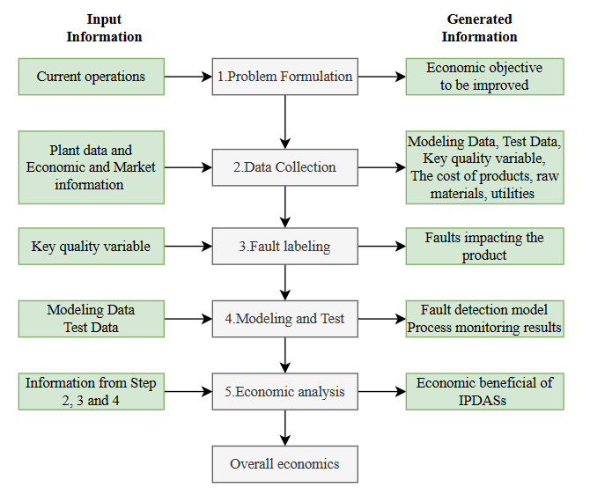
Figure 1. Proposed economic assessment framework for IPDASs.
    - Problem Formulation
Process deviations and faults in the chemical industry may threaten the profitability of a company. If these faults can be detected and eliminated in time, the economic losses caused by them can be effectively reduced. For example, the economic losses may be caused by reduced product quality, lower productivity, increased energy consumption, increased labor costs, increased maintenance costs, etc. Therefore, in this work, it is proposed that the economic benefits of IPDASs depend on the economic losses caused by faults that can be detected by IPDASs in historical data.
    - Data Collection
In this step, Plant data and economic information need to be collected for calculations in subsequent steps. The content and purpose of the collected data are as follows:
Historical process data: The data collected by DCS are used to develop and test IPDAS.
Key quality variables: Key indicators of production process used to mark process faults.
Internal accounting information: the cost of products, raw materials and utilities for subsequent economic analysis.
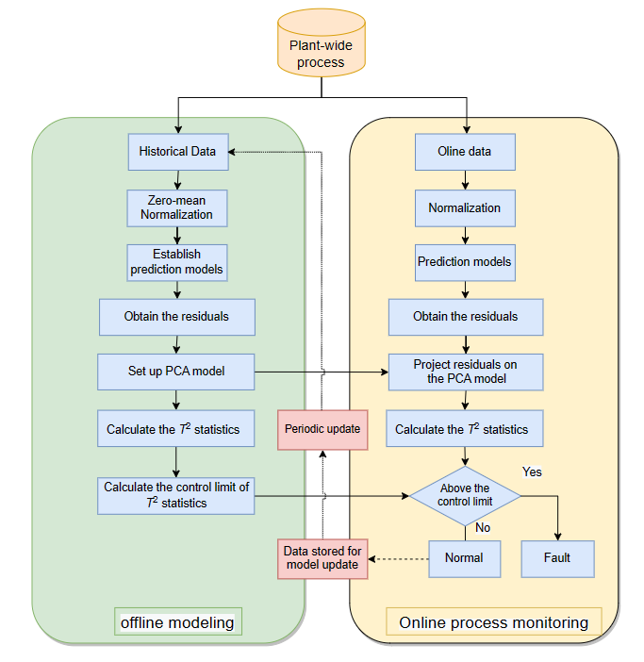
Figure 2. The schematic diagram of adopted fault detection method.
    - Fault Labeling
A prerequisite for evaluating the economic benefit of an IPDAS is to identify faults that cause economic losses. In actual production, engineers usually expect key quality variables to be maintained within a pre-set range. When there are abnormal fluctuations in key quality variables, it means that a process fault that impacts economic benefits may have occurred. For this reason, a SI based on the variance of key quality variables is defined to quantify changes in product quality. Given a time series of key quality variable $y(y_{1},y_{2},...,y_{t})$, the SI of the process at time t can be calculated as follows:
(1)
(2)
where l represents the window length. The method of selecting the window length l is described in detail in Section 3. Then, the SI of the normal samples (l-d) group can be calculated. Based on this, the control limits of SI can be determined as follows:
(3)
where mean() and std() represent the average value and standard deviation of the SI. When the SI of a process exceeds the control limits, it means that a fault may have occurred, causing economic losses.
    - Modeling and Test
The other prerequisite for evaluating the economic benefit of an IPDAS is to obtain the fault detection performance of its process monitoring method. In this work, an improved fault detection method based on the method from the literature (Ma et al., 2023) is employed as the core algorithm of the IPDAS. The schematic diagram of adopted fault detection method is illustrated in Figure 2. The difference from the method in the literature is the addition of a module that regularly updates the model, making it suitable for monitoring under various conditions of actual industrial processes. More information on the initial fault detection method can be obtained from the literature (Ma et al., 2023).
    - Economic Analysis
Based on the fault labelling information obtained in Section 2.3 and the fault detection information provided by the model in Section 2.4, the faults impacting product quality that can be identified by IPDAS will be determined. Then, the economic loss caused by these faults can be expressed by the difference in net profit value between the fault conditions and normal conditions, as illustrated in Eq. (4).
(4)
where $ΔL$ represents the economic loss, $Δr_{normal}$ and $Δr_{fault}$ represent the net profit under normal conditions and fault conditions, respectively, which can be calculated by Eq. (5).
(5)
Where p_{p}, p_{m} and p_{e} represent the prices of products, raw materials and energy, respectively; t_{p} represent the yield of products, t_{m} and t_{e} represent the amount of raw materials and energy, respectively. When calculating$Δr_{normal}$, the average value of normal conditions is used for t_{p}, t_{m} and t_{e}. For calculating $Δr_{fault}$, the actual operating value during the fault condition is utilized. s represents labor cost, and represents other costs, such as environmental costs.
  - Case study
In this work, data from an industrial cracking furnace of an ethylene unit are employed for the economic evaluation of IPDAS. The cracking furnace is the key piece of equipment for the ethylene unit. In the cracking furnace, naphtha and steam are mixed for a cracking reaction to produce olefine, alkanes, and coke. Among them, ethylene and propylene are the target products of primary concern to engineers. Meanwhile, Propylene/Ethylene (P/E) is commonly used to evaluate the operation of cracking furnaces. Therefore, in this case study, P/E is utilized as a key quality variable to calculate the SI of the process.
Since the value of SI can be affected by the window length, 1000 data samples were utilized to obtain the appropriate window length. As illustrated in Figure 3(a), when the window length is increased to 400 data samples, the SI value does not change significantly with the increase in the window length. Therefore, 400 is determined as the optimal window length in this work. Then, 5000 data samples are used to calculate the SI value and the 6-sigma control limit of the process under normal operating conditions. Data for one complete production cycle are collected for calculating the economic benefits of IPDAS, covering 118,377 samples with a 1-minute interval. The SI values of the production cycle are shown in Figure 3(b). The SI values for six segments of data samples in the production cycle significantly exceed the control limits, indicating that faults affecting product quality occurred during these six periods of time.
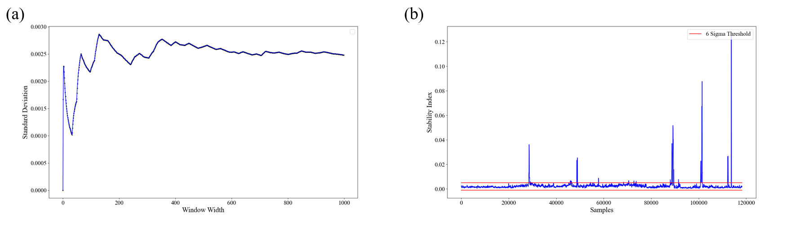
Figure 3. The results of fault labeling. (a) The Standard Deviation calculated with different window widths. (b) The SI values of one complete production cycle.
Following the modelling method described in Section 2.4, a CNN-based fault detection model is established and applied to the process monitoring of the complete production cycle. The process monitoring result for the complete production cycle is illustrated in Figure 4(a). Most faults affecting products can be detected by IPDAS. Taking one of the faults as an example, the fault detection result is shown in Figure 4(b). As can be seen, IPDAS provides an alarm 8 minutes in advance, which can remind operators to detect and eliminate the fault in time. By comparing the fault marking results, fault samples that can be identified by IPDAS and affect the economy can be obtained, as shown by the red scattered in Figure 4(b).
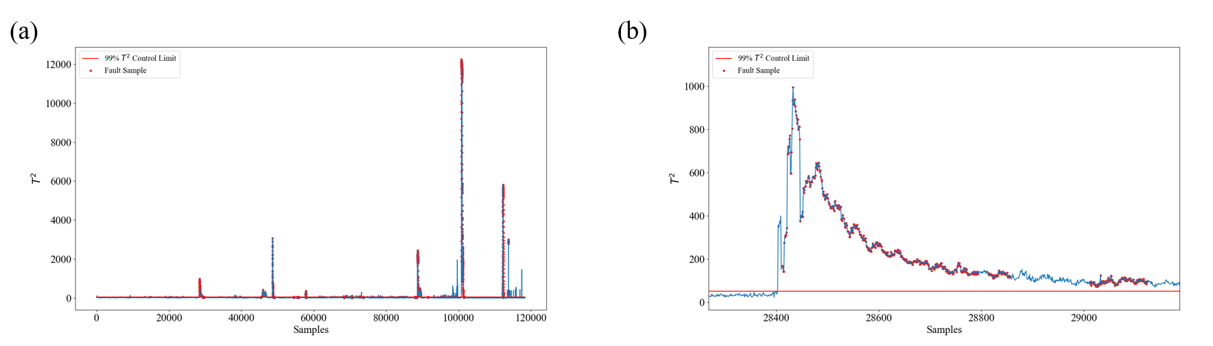
Figure 4. Process monitoring result provided by IPDAS.
However, IPDAS was not used in the actual production process, so the fault could not be detected in advance, and the product yield dropped from 77400 kg/h under normal conditions to 71000 kg/h, with a duration of 3.5 hours. The consumption of naphtha, steam, and fuel oil dropped from 52000 kg/h, 25400 kg/h, and 505 kg/h under normal conditions to 47600 kg/h, 23400 kg/h, and 500 kg/h, respectively. Meanwhile, the mass percentage of ethylene in the product dropped from 30.1% under normal conditions to 28.9%, and the mass percentage of propylene increased from 16.7% under normal conditions to 17.2%. According to internal accounting information, the prices of naphtha, steam, fuel gas, ethylene, and propylene are 3.809 RMB/kg, 0.098 RMB/kg, 2.656 RMB/kg, 7.556 RMB/kg, and 6.944 RMB/kg, respectively. The $Δr_{normal}$ and $Δr_{fault}$can be calculated by Eq. (6) and Eq. (7). Since the labor cost and other costs are the same for both normal and fault conditions, the economic loss caused by the fault can be calculated using Eq. (8).
(6)
(7)
(8)
Similarly, the economic losses caused by other faults can be calculated using the proposed framework. By calculating the sum of losses caused by each fault, the application of IPDAS can save economic losses totalling 177,156.48 RMB for one complete production cycle (about 3 months) of the ethylene unit.
  - Conclusions
In this work, an economic assessment framework for IPDASs is proposed to comprehensively calculate the economic benefits brought by the application of IPDASs. The framework addressed the issue that existing evaluation indicators cannot quantify the economic benefits of the systems. The application of the proposed framework to a case study of an ethylene unit illustrated its ease of application and the clear results. As such, it can be concluded that the proposed framework can effectively help enterprises make decisions on whether to apply IPDASs.
Acknowledgements
The support of the National Natural Science Foundation of China (Grant No. 22278018) is gratefully acknowledged.
References
Bauer, M., & Craig, I. K., 2008. Economic assessment of advanced process control–a survey and framework. Journal of process control, 18(1), 2-18.
Ge, Z., 2017. Review on data-driven modeling and monitoring for plant-wide industrial processes. Chemom. Intell. Lab. Syst. 171, 16–25.
Li, X., Xue, F., Qin, L., Zhou, K., Chen, Z., Ge, Z., Song, K., 2020. A recursively updated Map-Reduce based PCA for monitoring the time-varying fluorochemical engineering processes with big data. Chemom. Intell. Lab. Syst. 206, 104167.
Ma, F., Han, C., Han, X., Wang, J., Sun, W., 2019. A web-based industrial process monitoring system for ethylene production. In Foundations of Process/product Analytics and Machine learning (FOPAM) 2019, Raleigh NC.
Ma, F., Ji, C., Wang, J., & Sun, W., 2023. Early identification of process deviation based on convolutional neural network. Chinese Journal of Chemical Engineering, 56, 104-118.

