Simulation of Hydrogen-Methane Separation with Pressure Swing Adsorption
Viktor Kalman ª *, Aleksander Makaruk ^{b}, Ezgi Engin ^{c}, Anton Balla ^{c}, Michael Harasek ª
ªTechnische Universität Wien, Institute of Chemical, Environmental and Bioscience Engineering, Getreidemarkt 9/166-2, Vienna 1060, Austria
^{b}Axiom angewandte Prozesstechnik GmbH, Wienerstraße 114, Ebreichsdorf 2483, Austria
^{c}Verbund Green Hydrogen GmbH, Am Hof 6a, Vienna 1010, Austria
*viktor.kalman@tuwien.ac.at
Abstract
The global energy landscape is transforming as it shifts towards sustainability, with a growing emphasis on harnessing renewable energy sources and advancing energy storage technologies. Hydrogen plays a pivotal role in this transition as a versatile and potentially clean energy carrier. To address the seasonal variability of renewable energy generation, surplus renewable energy is converted to hydrogen during the summer, which is subsequently stored in depleted natural gas reservoirs for winter recovery, enabling electricity generation or direct use. A high-pressure, 4-bed Pressure Swing Adsorption (PSA) system was designed to separate hydrogen from the cushion gas containing varying amounts of methane. The main challenge lies in the fluctuating feed conditions encountered during winter recovery, where hydrogen concentration in the stream varies from 70% to 98% at pressures ranging from 25 to 60 bar, as direct feed pressurization is eliminated in favour of energy efficiency. A lab-scale PSA system has been constructed, and its experimental results for hydrogen-methane separation are employed to validate a simulation model and support the scale-up. The simulator, developed as open-source software in MATLAB, accurately captures the dynamic behaviour of the high-pressure PSA system, providing insights into breakthrough curves and system performance under realistic conditions. This research contributes to developing efficient and reliable hydrogen storage solutions that align with the current trends in the evolving energy economy, where hydrogen emerges as a key player in achieving a sustainable and resilient energy future.
Keywords: adsorption, hydrogen purification, modelling
  - Introduction
The need for efficient and scalable energy storage solutions is growing as global efforts intensify to transition towards renewable energy sources. The seasonal intermittency of renewable resources, such as solar and wind, necessitates the development of storage technologies capable of accommodating large quantities of energy over extended periods. Hydrogen has the potential to serve as a clean and versatile energy carrier and offers a promising solution for long-term storage. Subsurface geological formations such as salt caverns, aquifers, or depleted oil and gas reservoirs are being investigated globally for this purpose. Porous rock formations, like depleted oil and gas fields and aquifers, are widely available, so several projects, such as HyUnder and HyStories, have been undertaken in Europe to assess the potential sites for hydrogen storage. (Cihlar et al., 2021) found 80 suitable depleted gas fields around Europe with a total working capacity of 792 TWh. Pure hydrogen or a hydrogen-methane mix can be injected into the porous rock so that the hydrogen content may vary from a few per cent to 100 per cent (Londe, 2021). Ongoing pilot and demonstration projects were collected by (Sambo et al., 2020). Recent projects in Austria and Argentina showed that injection and storage with up to 20 % hydrogen can be safely done. Meanwhile, the storage of pure hydrogen is currently being investigated in Austria in the Underground Sun Storage 2030 project. (Zamehrian and Sedaee, 2022) investigated the effect of cushion gas on underground hydrogen storage in a partially depleted gas reservoir and concluded that the highest purity can be achieved if nitrogen is used as a cushion gas. (Lyssy et al., 2021) showed that different levels of hydrogen injection have different challenges. Pure hydrogen injection resulted in low recovery because most hydrogen remained underground as cushion gas. Recovery can only be increased at the expense of purity, but the impurity levels in the withdrawn gas vary during cyclic operation. (Juez-Larré et al., 2023) used numerical modelling to conduct a feasibility study to quantify the efficiency of different operating strategies at three potential sites for underground hydrogen storage.
Most depleted gas reservoirs are not empty and contain significant amounts of natural gas as cushion gas because the porous structure relies – to some extent – on the gas pressure to prevent the strata from crumbling. The injected hydrogen (pure or mixed form) will blend with the existing cushion gas, especially when stored for an extended period. The hydrogen-natural gas mixture can be withdrawn and injected into the network if local regulations allow it. Alternatively, hydrogen can be separated at the wellhead, for example, using pressure swing adsorption (PSA) technology, to be used directly in mobility applications, transported separately, or transformed into electricity.
PSA is a cyclic separation process with one or more fixed beds going through several pressure-varying and constant pressure steps (Ruthven et al., 1993). The beds are filled with porous material such as activated carbon, molecular sieve, or metal-organic frameworks (MOFs) on which some species are preferentially adsorbed from the gas mixture at high pressure, allowing the light component to be collected as the product. Before the breakthrough of the impurities, the feed is stopped, and the pressure is decreased to regenerate the bed. The number of beds can go up to 12 in Polybed systems, while the number of steps in a single cycle usually ranges from 4 to 12, depending on the complexity and number of pressure equalization steps. Polybed systems are complex, large-scale units that can produce ultrapure H₂ with more than 90 % recovery (Luberti and Ahn, 2022). Hydrogen purification is a common use of PSA but is also used for air separation, biogas upgrading, and spacesuit life support systems (Papale et al., 2006).
In this work, experimental results from (Kalman et al. 2022) are used to validate a simulation model of a 4-bed pressure swing adsorption process to address the challenges from varying hydrogen fractions in the withdrawn gas during cyclic operation, contributing to the development of efficient and reliable hydrogen storage solutions.
  - Models and Methods
The simulations are performed in MATLAB® with the Totally Open Pressure Swing Adsorption Intensification Laboratory (toPSAil) simulation code from (Kim and Scott, 2023) at the Georgia Institute of Technology. toPSAil is an open-source simulation framework for dynamic modeling and simulation of pressure swing adsorption (PSA) processes. The simulator is based on a CSTRs-in-series (CIS) model that describes the adsorbers as a series of continuously stirred tank reactors (CSTRs) in 1-dimensional form. It has a variety of adsorption isotherm models implemented and uses Linear Driving Force approximation for mass transfer description. The resulting system of differential-algebraic equations is solved by built-in solvers from MATLAB®. The complete modelling and simulation framework and its implementation are found in the original publication (Kim and Scott, 2023).
    - Lab-Scale Rig
The breakthrough experiments and PSA cycles were carried out in a self-assembled rig. The flow rates and the mixture ratio of feed gases were controlled by mass flow rate controllers. The high pressure in the bed was maintained by a manual back pressure regulator, and the adsorption columns were custom-manufactured and certified to up to 100 bar. The columns were filled with cylindrical activated carbon from Donau Carbon. The adsorbent and the packed bed properties are listed in Table 1.

Table 1: Packed bed properties
Packed bed height [mm] | 1800
Column internal diameter [mm] | 25
Bed porosity [-] | 0.315
Adsorbent mass [g] | 480
Bulk density [kg/m3] | 795
Particle diameter [mm] | 3
Particle porosity [-] | 0.83

      - Adsorption Isotherm
Desorex C33 (from Donau Carbon) was used to fill the bed. The adsorption isotherms were measured in different pressure ranges at 20 °C with the Dynamic Column Breakthrough method as described by (Malek and Farooq, 1996). The results were fitted with the Extended Langmuir Model as in Eq. 1, where n_{i} is the adsorbed quantity, q_{i}* and b_{i} are isotherm parameters, N is the number of adsorbing species, P is total pressure and y is the mol fraction in the gas phase. The resulting parameters are listed in Table 2.
$$n_{i}=q_{i}^{*}⋅\frac{b_{i}Py_{i}}{1+\sum_{j}^{N}{b_{j}Py_{j}}}$$ | (1)
Table 2: Adsorption isotherm parameters
Langmuir parameters | CH₄ | H₂
q* [mol/g] | 8.9452 | 1.0982
b [1/bar] | 0.00375 | 0.073962

    - Cycle Design
The proposed PSA cycle in this study has 12 steps, including two pressure equalization steps to improve efficiency. The step sequence for all beds is shown in Figure 1.
    - Simulation Conditions
Hydrogen content and overall gas pressure were assumed to decrease through a withdrawal period, and four scenarios in accordance with the four stages from the previously published experimental results were selected (Kalman et al., 2022). The lab-scale columns were assumed to be isothermal, and the mass transfer rate was constant.
The breakthrough curves were evaluated for breakthrough times and compared to experimental results. Breakthrough was defined as the time from feed gas injection to where methane concentration in the product reached 0.1 %. The cyclic simulations were evaluated for hydrogen purity and recovery and compared to experimental results, where applicable. All simulations were conducted on a Lenovo ThinkCentre M75q Gen 2 desktop computer in MATLAB® 2023a.
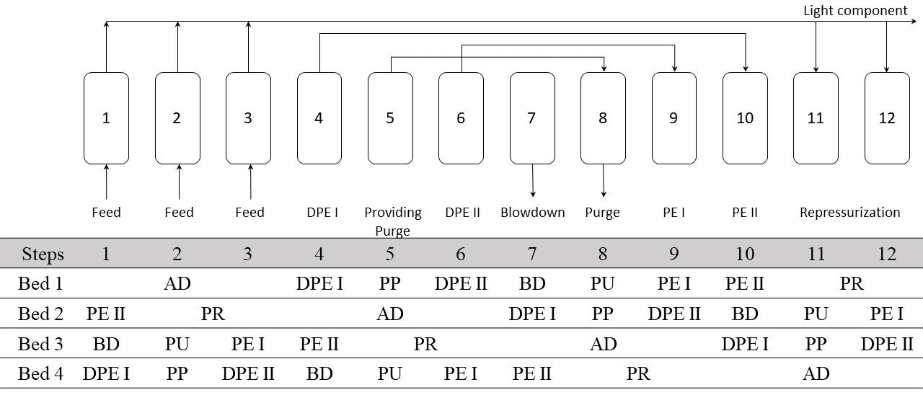
Figure 1: Cyclic configuration of PSA process for hydrogen purification.
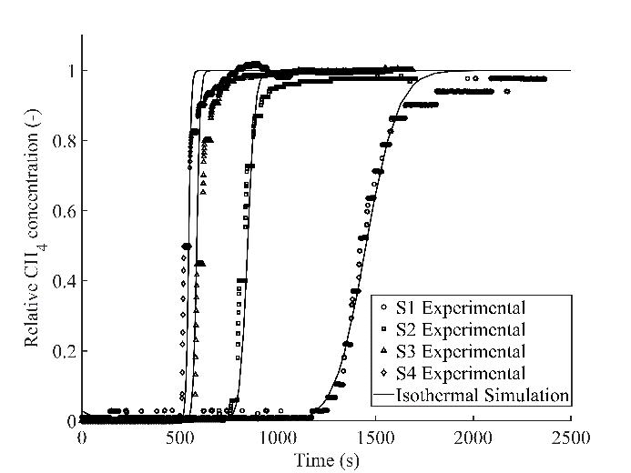
  - Results
    - Breakthrough Results
Breakthrough time [s]
 | Experiment | Simulation
Stage 1 | 1175 | 1106
Stage 2 | 723 | 733
Stage 3 | 521 | 510
Stage 4 | 495 | 489
Results of breakthrough experiments from (Kalman et al., 2022) were used to validate the kinetic and equilibria model of the simulation. In Fig. 2. the experimental breakthrough curves are compared to isothermal simulations. The low mass transfer resistance, indicated by the sharp initial rise (front), is captured accurately in all four scenarios. The isothermal assumption for the lab-scale columns is acceptable, although the experimental values flatten and show slowing kinetics near equilibrium. This could be due to the increased temperature, which favors desorption in the dynamic equilibrium. However, at this scale, the isothermal assumption is valid as it only introduces a small error in the equilibration time but has no effect on the breakthrough times, the focus of this investigation.
Figure 2: Breakthrough curves for all stages; methane concentration at the end of bed.

Table 3: Breakthrough results
    - Results of Cyclic Simulations
After the model validation with breakthrough curves, the cyclic tests from (Kalman et al., 2023) were modelled and correlated well with experimental results. Due to the isothermal solution, a cyclic steady state was reached in tens of cycles. The pressure profile of one column in a full cycle in cyclic steady state (CSS) is shown in Fig. 3a. The rate of pressure decrease in the equalization steps is higher than the theoretical rate. This occurrence could be mitigated by adjusting the valve coefficients. However, this behavior is consistent with the experimental setup where solenoid valves were installed, and precise flow control was unavailable.
Fig. 3b. shows the adsorbed amount of methane along the bed at the end of the adsorption, pressure equalization (PE), and purging steps. Full solid loading and equilibrium are not reached in CSS. At the end of the bed, only 1/6th of the full methane capacity is adsorbed. This allows methane to re-adsorb during the subsequent pressure equalization (PE) steps despite the lowered maximum capacity. It ensures that the connected bed is not contaminated before its adsorption cycle, and by the end of the purging step, no methane is adsorbed, and the clean bed is ready for the next adsorption cycle.
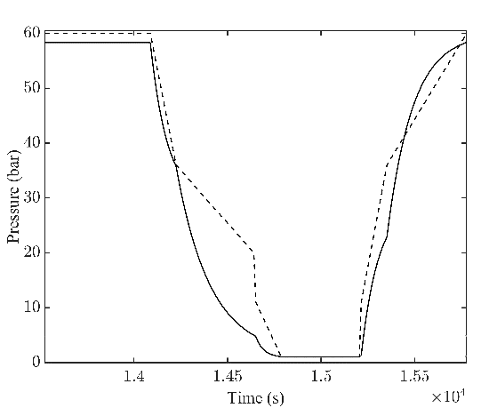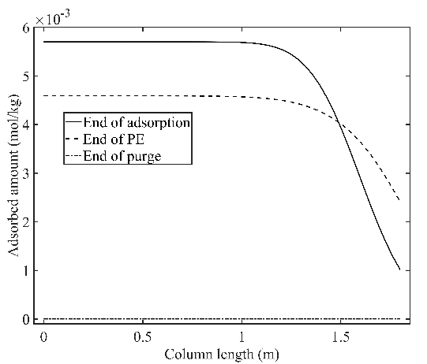
b.
a.
Figure 3: Example results from cyclic simulation. a. Pressure profile of a single column in cyclic steady state. b. Adsorbed amount of methane along the bed.
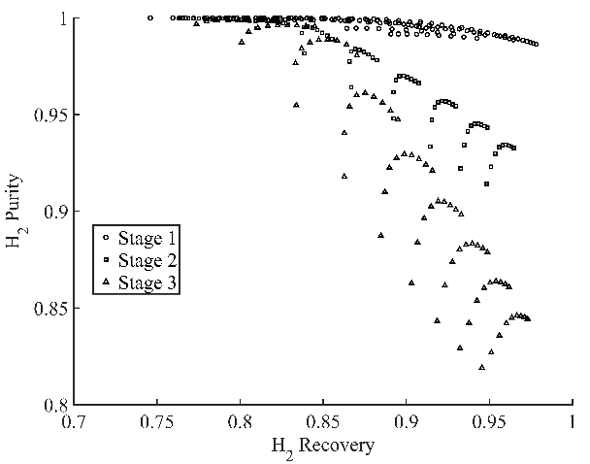
    - Optimization
For all stages, the step times were adjusted from the experimental baseline to find the Pareto front for each stage where purity is the highest possible while maintaining at least 80 % hydrogen recovery. Results are collected in Table 4. and the Pareto front is shown in Fig. 4. The trade-off between purity and recovery is more challenging in scenarios where the feed concentration of the contaminant is high. However, the results show that the performance can be optimized with careful selection of step times, and the target values can still be achieved. Unfortunately, stage 4 results (where feed methane concentration is highest) were not recoverable due to technical issues during the simulation.
Figure 4: Optimization results of the 12-step PSA process for Stages 1/2/3.

Table 4: PSA process optimization results
 | Experimental |  |  |  | Optimization
 | Cycle Time | P/F | Purity | Recovery | Cycle Time | P/F | Purity | Recovery
Stage 1 | 2320 | 0.12 | 99.5 + | 80.9 | 2254 | 0.15 | 99.99 | 80.37
Stage 2 | 1496 | 0.38 | 99.5 + | 73.3 | 1777 | 0.32 | 99.91 | 81.13
Stage 3 | 1152 | 0.30 | 99.5 + | 73.1 | 1644 | 0.36 | 99.88 | 80.51
Stage 4 | 688 | 0.30 | 99.5 + | 76 | N/A | N/A | N/A | N/A
  - Conclusion
This study used the open-source toPSAil software package to simulate hydrogen-methane separation at four pressures (25, 35, 50, 60 bar) with varying methane concentrations (2 – 30 %) in a 4-bed PSA process. Previous experimental results were used to validate the model with breakthrough and cyclic simulations, both of which showed good correlation. The proposed 12-step PSA process was successfully optimized in three out of the four scenarios. This work demonstrates the capabilities of toPSAil, an open-source process simulation package, and contributes to developing efficient and modular separation systems for hydrogen purification.
References
J. Cihlar, D. Mavins, K. van der Leun, 2021, Picturing the Value of Underground Gas Storage to the European Hydrogen System, The Netherlands, Gas Infrastructure Europe
J. Juez-Larré, C.G. Machado, H. Yousefi, T.-K. Wang, R. Groenenberg, S. Van Gessel, 2023, (Pre)feasibility Study of Underground Hydrogen Storage Potential in Depleted Gas Fields and Salt Caverns in the Netherlands, EGU General Assembly 2023, DOI: 10.5194/egusphere-egu23-10005
V. Kalman, J. Voigt, C. Jordan, M. Harasek, 2022, Hydrogen Purification by Pressure Swing Adsorption: High-Pressure PSA Performance in Recovery from Seasonal Storage, Sustainability, 14, 14037, DOI: 10.3390/su142114037
T. Kim, J.K. Scott, 2023, Dynamic Modeling and Simulation of Pressure Swing Adsorption Processes Using toPSAil, Computers and Chemical Engineering, 176, 108309, DOI: 10.1016/j.compchemeng.2023.108309
L. Londe, 2021, Four Ways to Store Large Quantities of Hydrogen, Paper presented at the Abu Dhabi International Petroleum Exhibition and Conference, Abu Dhabi, UAE, DOI: 10/2118/208178-MS
M. Lysyy, M. Fernø, G. Ersland, 2021, Seasonal Hydrogen Storage in a Depleted Oil and Gas Field, Int. J. Hydr. Energy, 46, 25160-25174, DOI: 10.1016/j.ijhydene.2021.05.030
A. Malek, S. Farooq, 1996, Determination of Equilibrium Isotherms Using Dynamic Column Breakthrough and Constant Flow Equilibrium Desorption, J. Chem. Eng. Data, 41, 25-32, DOI: 10.1021/je950178e
W. Papale, H. Paul, G. Thomas, 2006, Development of Pressure Swing Adsorption Technology for Spacesuit Carbon Dioxide and Humidity Removal, SAE Technical Paper 2006-01-2203, DOI: 10.4271/2006-01-2203
D.M. Ruthven, S. Farooq, K.S. Knaebel, 1993, Pressure Swing Adsorption, VCH Publisher Inc., USA
C. Sambo, A. Dudun, S.A. Samuel, P. Esenenjor, N.S. Muhammed, B. Haq, 2022, A Review on Worldwide underground hydrogen Storage Operating and Potential Fields, Int. J. Hydr. Energy, 47, 22840-22880, DOI: 10.1016/j.ijhydene.2022.05.126
M. Zamehrian, B. Sedaee, 2022, Underground Hydrogen Storage in a Partially Depleted Gas Condensate Reservoir: Influence of Cushion Gas, Journal of Petroleum Science and Engineering, 212, 110304, DOI: 10.1016/j.petrol.2022.110304
M. Zijp, S. Nelskamp, H. Doornenbal, 2017, European Unconventional Oil and Gas Assessment (EUOGA): Resource Estimation of Shale Gas and Shale Oil in Europe, Technical Report

