Adjustable Robust Optimization with Mixed-Integer Recourse for the Synthesis of Continuous Rufinamide Manufacturing Process

Taoyu Qiu,a Wenhui Yang,b Zhihong Yuanb*

aTanwei College, Tsinghua University, Beijing, 100084,China

bThe State Key Laboratory of Chemical Engineering, Department of Chemical Engineering, Tsinghua University, Beijing, 100084, China

zhihongyuan@mail.tsinghua.edu.cn

Abstract

Rufinamide, a triazole derivative targeting the cerebral sodium ion channel, provides effective treatment for seizure disorders and has a profitable market prospect. Traditional batch synthesis of rufinamide is subjected to limitations such as depressed yields, complicated procedures, excessive operational expenditure, and high environmental costs. Therefore, a comprehensive scheme for the identification of the best synthesis route and the optimal process design with a systematic evaluation of uncertain factors can accelerate the development and deployment of the pursued advanced manufacturing. In this work, more than 500 possible synthetic routes for continuous rufinamide manufacturing were collected from the existing literature pool and data sources; each route contains a set of design parameters to represent its gains and prices when included in the whole multi-stage synthesis/purification process. Multiple types of uncertainty, such as crucial conversion rate, production goal, running time, and energy consumption, were considered through the two-stage adjustable robust optimization approach represented by the mixed-integer nonlinear programming (MINLP) model. Note that the involved reactions have happened in the flow micro-reactors, which introduces mixed-integer recourse to the robust optimization model. Hence, a nested column-and-constraint generation algorithm was tailored to solve the MINLP model efficiently. The first stage identified the optimal synthetic route, while the optimal number of the flow micro-reactors and the operation conditions were determined in the second stage. The price of the robustness of the adjustable decisions on optimal synthesis of the continuous manufacturing process was finally examined.

**Keywords**: Adjustable robust optimization, rufinamide, process synthesis, MINLP, mixed-integer recourse

* 1. Introduction

Computer-aided pharmaceutical process synthesis plays an increasingly decisive role in the disruptive manufacturing of pharmaceutical molecules because it guides the optimal design for molecular construction and topological structure of manufacturing using efficient computational methods (Westerberg, 2004). In recent research, it usually helps engineers optimize the design toward the goal of long-term effectiveness, reduction of overall energy consumption, and control of production cost and hazard (Jørgensen et al., 2019), which typically involves optimization of mixed-integer nonlinear programs (MINLP) based on manufacturing superstructure containing a set of design parameters to represent gains and prices of certain decisions. However, reducing the costs of real-world plants is challenging due to ubiquitous uncertain parameters within the model. Moreover, there is no further investigation into the manufacturing process optimization and design method under uncertainty.

Noticeably, uncertain parameters in models will impede the search for the optimal design and jeopardize the interpretability of optimal solutions to these models. In order to deal with widespread uncertainties, robust optimization (RO) is widely adopted for its inherent simplicity in linear problems, albeit prone to high conservatism under high-dimensional uncertainties. For a better trade-off between conservatism and system robustness, adjustable robust optimization (ARO) is developed by incorporating recourse decision variables, thus avoiding making all decisions all at once (Ben-Tal et al., 2004). However, ARO models are inclined to be computationally intractable faced with nonlinearity and mixed-integer variables. Therefore, it is preferred to formulate a two-stage ARO for complex decision-making tasks, which off-the-shelf solvers can solve by applying strategies, such as the Benders-dual cutting plane algorithm and the column-and-constraint generation (CCG) algorithm (Shi and You, 2016), which both derive equivalent solvable programs for the nested min-max inner subproblem of two-stage ARO (Zeng and Zhao, 2013). However, these methods cannot be directly incorporated into a wide range of superstructure-based modeling of continuous manufacturing processes including number-up amplification of tubular micro-reactors, the presence of which adds to the second stage of ARO recourse variables taking values of positive integer. Instead of applying linear approximation or tolerating the dual gap in the second-stage optimization, we resolve to find an exact algorithm that handles integer variables as recourse variables.

In our work, a tailored two-stage ARO algorithm with mixed-integer recourse is proposed to optimize the process design and solve the problem of identifying the best synthesis route of rufinamide under multiple uncertainties.

* 1. Methodology
     1. Synthesis Process of Rufinamide

Rufinamide is a new class of antiepileptic drugs that works by regulating sodium ion channels in the people’s brain voltage gate. It can assist in treating a kind of typical epilepsy, Lennox-Gastaut Syndrome (Diab and Gerogiorgis, 2018). The drug Banzel, containing rufinamide as the API, is currently priced at ~ US $3.75 / mg tablet and ~ US $3.90 / mL liquid suspension according to its seller. The traditional synthesis process of rufinamide is a batch process with disadvantages such as low yield, complicated procedure, high labor cost, and poor environmental benefit. In recent years, the synthesis routes of rufinamide have been improved and enriched continuously with innovative development of solvent-free synthesis processes and high-efficacy catalysts. However, each production route at different synthesis stages has its advantages and disadvantages. Clearly, it is of great significance to carefully make a comparison of rufinamide synthesis processes and identify optimal production routes.

The synthesis of rufinamide can be roughly divided into three stages (Borukhova et al., 2016): the halogenation reaction of 2,6-difluorobenzyl alcohol, diazotization, and the Huisgen cyclo-addition reaction at last to produce precursors. The superstructure of continuous synthesis of rufinamide shown in Fig. 1 consists of a total of 507 possible process synthesis routes with corresponding parameters attained from the literature pool.

* + 1. Deterministic Model of Synthesis Process

Based on the superstructure model, the following assumptions are made in our model:

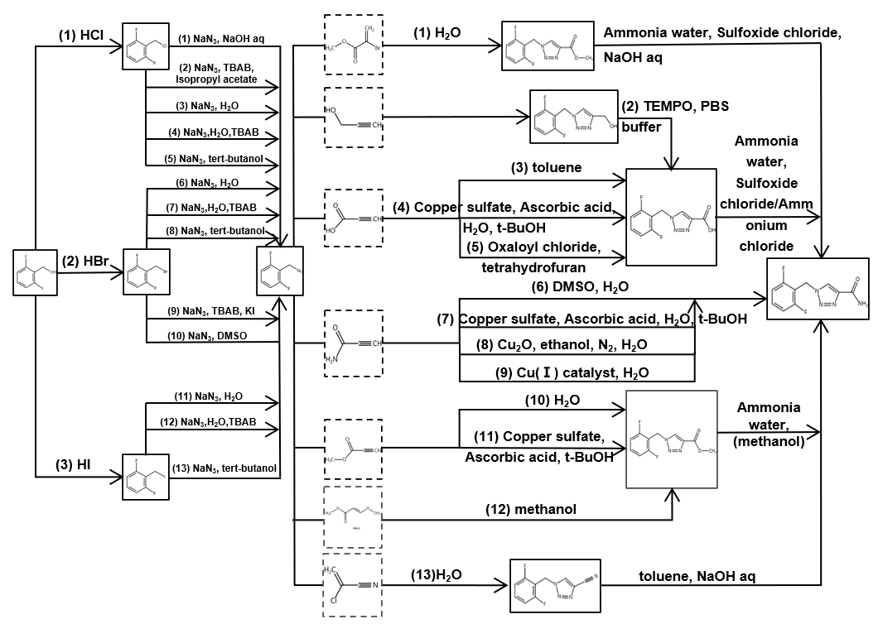

Figure 1 Superstructure of continuous rufinamide synthesis (labeled with subscripts i,j,k)

a) Platform chemicals, solvents, and catalysts required in synthesis pathways are purchased at a steady price level all year round with no shipping and storage costs, b) Given the fixed plant implementation and standardized operating schedule, any identified route permitted in the superstructure can be adjusted to meet uncertain demands of production; c) Operation expenses and utility costs are proportionate to a linear function of volumetric scale and energy consumption for preheating material from surrounding temperature.

The following deterministic mathematical model is established. The objective function represented by Eq. (1) is composed of material cost (the first term), capital expenditure (the second term), and operating expenditure (the third term). Eq. (2) defines the continuous variable L as the space velocity of each reaction, i.e. amount of material processed by one single tubular reactor in unit process time. Eq. (3) is the constraint on production goal. Eq. (4) represents the material balance between these three stages. To ensure that the annual production reaches the target within the upper bound of the specified time, the following constraints, Eq. (5) are enforced. Eq. (7) relates binary variables with continuous decision variables via big-M constraint. Eq. (8) defines the indices of this model in which I=3, J=13, K=13.

|  |  |
| --- | --- |
|  | (1) |
|  | (2) |
|  | (3) |
|  | (4) |
|  | (5) |
|  | (6) |
|  | (7) |
|  | (8) |

2.3 The Uncertainty Set

Global sensitivity analysis (GSA) was performed to recognize and specify the uncertain parameters that are influential to the optimal superstructure design. For instance, results of GSA show that alteration of utility cost coefficient in the nominal deterministic model significantly affects route selection and the objective, where a critical turning point at 0.48 is recognized. Based on our current knowledge of potentially commercialized procedures, the nominal value is predetermined to be 0.40 with a permissible deviation up to 0.2. Besides, Parameter-level uncertainties, including the market demand, the nominal value set at 100 kg and maximum deviation 50 kg) and running time, are modeled.

2.4 ARO Formulation and Solution Strategy

Given the uncertainty set presented in 3.1, we construct ARO to obtain a robust optimal design by distinguishing “here-and-now” variables which are fixed before the realization of uncertainty, and “wait-and-see” variables to be determined after the revelation of uncertainty, hence reformulating a MIP master problem (MP) responsible for the update of superstructure topology and an inner-stage subproblem (SP) for recourse. Here we consider the binary variables aiming at route selection from the superstructure as non-adjustable “here-and-now” variables. The master problem (MP) is responsible for the topology, while in the subproblem (SP), constraints on the other decision variables, including integer variables are incorporated.

It should be noticed that, with the presence of an integer decision variable in the subproblem, the inner-stage problem is again MINLP. Here, we expand the two-stage ARO framework into a tri-level iterative bounding algorithm in pursuit of exact solution for MIP recourse, where a local search for best-so-far integer recourse must be conducted whenever we optimize SP. The mathematical interpretation of bi-level reformed SP is shown below, where z denotes a bounded integer recourse variable, x denotes continuous recourse variables with p dimensions, and u denotes uncertain variables.

|  |  |
| --- | --- |
|  | (9) |
| , | (10) |
| , | (11) |
|  | (12) |

The inner-stage optimization of SP follows the procedure:

1. Initialize the lower bound (LB) and the upper bound (UB), starting from Ns=1.
2. Solve (SP-Outer) as an LP with respect to obtain the optimal solution, update

|  |  |
| --- | --- |
|  | (13) |

1. Pass the optimal solution from (SP-Outer) and call an oracle to solve the MINLP:

|  |  |
| --- | --- |
|  | (14) |

1. Obtain the optimal recourse variable of the present integer limit.

|  |  |
| --- | --- |
|  | (15) |

1. Add the following constraints to (SP-Outer), Update Ns and return to step b)

|  |  |
| --- | --- |
| , | (16) |
| , | (17) |
| , | (18) |

* 1. Results and Discussion

Nominal deterministic optimization suggests the use of HBr as the halogenation agent, TBAB/KI system for diazotization, and DMSO/H2O for cycloaddition (denoted as 2,6,6). Nevertheless, another route that replaces DMSO with Cu(I) catalyst for cycloaddition (denoted as 2,6,9) is chosen by solving ARO to guarantee that the synthesis process retains optimality under the variation of multiple uncertainties as shown in Tab. 1. Under significant deviation from nominal operation point, the superstructure topology switches to a more tolerable one with relatively low cost. To test the superiority of the new robust topology, as is shown in Fig. 2, 50 scenarios randomly drawn from the uncertain set are optimized with the deterministic model and ARO model with fixed nominal topology. The uncertain variables are sampled uniformly from the polyhedral uncertainty box. The objective cost given by deterministic optimization is averagely higher than that of ARO by over 1.5 % according to the sample, because the (2,6,6) route no longer remains the best design under the variation of uncertainties.

Table 1 The comparison of optimal deterministic design and adjustable robust design.

|  |  |  |  |
| --- | --- | --- | --- |
| Model | Chosen Route (subscripts of nonzero Y’s) | Number of micro-reactors | Objective ($/a) |
| Deterministic | 2, 6, 6 | 4, 2, 32 | 7,594,134 |
| ARO | 2, 6, 9 | 5, 3, 10 | 12,448,444 |

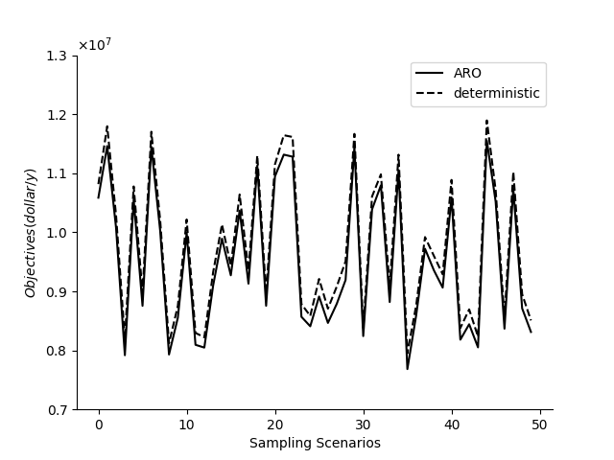

Figure 2 Comparison of deterministic and ARO optimum in 50 random scenarios.

* 1. Conclusion

The present work investigated a novel ARO approach that effectively hedges against multiple uncertainties in process synthesis and meanwhile deal with mixed-integer decision variable. It can be proven that our methods combining traditional two-stage ARO and exact solution algorithm for second-stage MIP serve with full recourse on operation variables in the uncertainty set. There are at least three incentives for using the proposed strategy: the objective optimality, uncertainty, and control of conservatism of superstructure-based process optimization are simultaneously satisfied. We believe that the continuous manufacturing process of rufinamide is just one of the cases where our conceptual design strategy can apply. This can pave the way for other continuous pharmaceutical manufacturing superstructure design optimization problems.

References

A. Ben-Tal, A. Goryashko, E. Guslitzer, A Nemirovski. 2004, Adjustable Robust Solutions of Uncertain Linear Programs. Mathematical Programming, 99(2), 351–376.

S. Borukhova, T. Noël, B. Metten, E. de Vos, V. Hessel, 2016, From Alcohol to 1,2,3-triazole via a Multi-Step Continuous-Flow Synthesis of a Rufinamide Precursor. Green Chemistry, 18(18), 4947-4953.

S. Diab, D. Gerogiorgis, 2018, Process Modelling, Simulation and Technoeconomic Evaluation of Crystallisation Antisolvents for the Continuous Pharmaceutical Manufacturing of Rufinamide. Computer & Chemical Engineering, 111, 102-114.

S. Jørgensen, M. Lind, N. Jensen, 2019, Functional Modeling View on Product and Process Engineering in Design and Operations. Industrial & Engineering Chemistry Research, 58, 11129–11148.

H. Shi, F. You, 2016, A Computational Framework and Solution Algorithms for Two-Stage Adaptive Robust Scheduling of Batch Manufacturing Processes under Uncertainty, AIChE Journal, 62(3), 687–703.

A. Westerberg, 2004, A Retrospective on Design and Process Synthesis, Computer & Chemical Engineering, 28(4), 447-458.

B. Zeng, L. Zhao, 2013, Solving Two-Stage Robust Optimization Problems Using a Column-and-Constraint Generation Method, Operations Research Letters, 41, 457-461.