THE EFFECT OF 3D PRINTING PROCESS PARAMETERS ON NYLON BASED COMPOSITE FILAMENTS: A MODELLING STUDY
Andras Kamanª, Miklos Jakab^{b}, Laszlo Baloghª, Armand Meszlenyiª, Attila Egedyª
aDepartment of Process Engineering, University of Pannonia, 10 Egyetem str., 8200 Veszprém, Hungary
bDepartment of Materials Engineering, University of Pannonia, 10 Egyetem str., 8200 Veszprém, Hungary
kaman.andras@mk.uni-pannon.hu
Abstract
In recent years, additive manufacturing has become exceedingly popular in industrial applications and scientific studies. The rapid development in this field, especially the slicer and machine software, makes research difficult because these can become obsolete due to software improvements. Another limiting aspect is the lack of knowledge and interest in the 3D printing process and materials; primarily, 3D printing is seen as a tool to achieve some results by researchers. Due to these facts, most studies do not adequately dwell on the 3D printing parameters, making the reproduction of results almost unachievable.
This paper discusses four of the major 3D printing parameters that affect the properties of final products made by chopped carbon fibre filled- and unreinforced nylon filaments; these parameters are the printing temperature, nozzle diameter, layer height, and infill orientation. The family of nylon filaments is mainly used for functional 3D printing, especially in replacing aluminium and steel parts, mainly due to their excellent strength/weight ratio.
The simulation and modelling of tensile tests were carried out in ANSYS Mechanics. Modelling parameters were determined based on the real-life tensile tests carried out beforehand.
Keywords: Additive manufacturing, printing parameters, simulation
  - Introduction
3D printing or additive manufacturing is a rapidly developing field, an increasingly popular topic of scientific studies and research. One of the main reasons for this popularity is the untapped potential it still has due to it being so young compared to other manufacturing techniques, which gives researchers a chance to study the different aspects of additive manufacturing relatively uncontested. However, because it is so new and the available software and hardware advancements, not to mention the material aspect, are happening in leaps and at a fast pace, it makes the research in this field difficult regarding longevity and repeatability. Another setback is that many researchers are only familiar with 3D printing in a limited capacity.
Material advancements boomed in variety and quality in recent years, such as continuous fibre reinforcement in different thermoplastics that Chen et al. (2021) studied. New high-performance engineering materials appeared and refined; one such material is the family of nylon filaments, especially the chopped carbon fibre-reinforced filaments (Isobe et al., 2018). The nylon filaments became exceedingly popular among 3D printer enthusiasts due to their strength, resistance to substances and UV, printability, high-temperature resistance compared to other available thermoplastic families, and arguably most important of its properties is its low cost. There are two distinct groups that the commercially available nylon filaments fall in, may that be some fibre-reinforced one or unreinforced thermoplastic; these are the nylon 6/66 and the nylon 12 group. Strangely, the nylon 6/66 group is not distinguished between nylon 6 and nylon 66 most of the time; the manufacturers usually state these filaments are nylon or nylon 6/66 since they may be a blend of the two. However, the group of nylon 12 is stated clearly each time by the manufacturer and is usually available for twice the retail price of the other group. Mainly due to its lower price and similar properties, the nylon 6/66 group usage is much more widespread, which is why this thermoplastic group was chosen for the research of this paper.
The simulation of additive manufacturing processes can help to achieve the desired mechanical properties of products, as the process parameters play a crucial role in almost all of them. Saithongkum et al. (2020) made FEM tensile and flexural tests simulations of 3D printed specimens that show one of the most crucial parameters that determine the mechanical properties is the orientation of fibres inside the 3D printed structure. This study's four main parameters are the infill orientation, temperature, nozzle diameter, and layer height. The tensile strength and Young modulus of printed and simulated parts were compared along these four parameters.
  - Materials and methods
When considering the 3D printer that would be adequate for my research purposes, the main requirements were that the printer must be a modular platform for different types of extruders and hotend, and it must also have high-quality mechanical and electrical parts. The ability to run Klipper firmware was crucial as the advanced calibrations it features make the printed parts higher quality with better material deposition. Klipper also makes altering all aspects of the printer and printing process possible. For these reasons, the choice fell on the Rat Rig V-Core 3 400x400, equipped with a Phateus Rapido hotend and orbiter 1.5 extruder for this study. Before printing samples, the following calibrations were carried out: retraction, skew correction, pressure advance, and flow rate. Furthermore, after calibrating the flow rate, a follow-up calibration, including tensile strength tests, was done to ensure that the best possible flow rate is being used while printing samples. ASTM D638 Type I specimen geometry was chosen for the tensile tests as a standard.
For the 3D printing material eSUN ePA-CF with a chopped carbon fiber content of 20 wt% and nylon 6/66 blend as polymer matrix. It is manufactured in Shenzen, China and is among the most used carbon fibre nylon filaments due to its excellent performance/cost ratio.
For temperature, nozzle diameter, and layer height 4 different values were analysed, while for the infill orientation 2 different values were chosen. These values were the following:
temperature – 240 °C, 260 °C, 280 °C, 300 °C
nozzle diameter – 0.4 mm, 0.6 mm, 0.8 mm, 1.0 mm,
layer height – 25 %, 50 %, 75 %, 100 % (compared to the nozzle diameter used)
infill orientation – 0°, 45°
Furthermore, to reduce the number of specimens needed to be 3D printed an experiment design was carried out.
In order to approximate the values that can be obtained with the adjustment of the studied parameters, a polynomial function was fitted to the measured values in MATLAB.
The simulations of tensile tests were carried out in ANSYS Explicit Dynamics. We specified the material properties; one end of the dog bone-shaped test specimen was fixed in place, while force was applied to the other end.

  - Results
The method of comparing the tensile strength and Young modulus values of simulated and real-life tensile tests was used to evaluate the simulations.
The tensile strength values obtained from MATLAB showed promising similarity except for the four outliers (Figure 1), which showed a significant strength increase compared to their simulated counterparts.
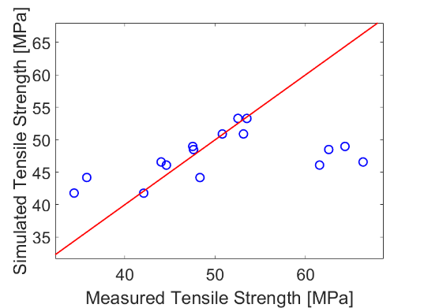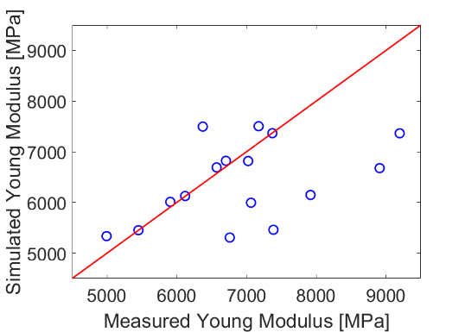
Figure 1: the correlation between the simulated and measured tensile strength/Young modulus values
The same four outliers are also present in the case of Young modulus values (Figure 1); excluding those values, the others show that the values obtained from MATLAB align with measured values. The most influental parameters on strength were the infill orientation ,unsurprisingly considering the nature of the fiber reinforced materials, and the temperature, which can be varied in quite the range as the used material can be printed between 220 – 320 °C with very different results. With the variation of these two parameters the tensile strength values were within a 9-11 MPa range. The nozzle diameter and layer height had a very similar effect on the mechanical properties, with their variance the tensile strength values were between a 5 MPa range. Their effects differed for the Young modulus values, as the most impactful two parameters were the temperature and nozzle diameter, for with their variance the Young modulus values were within a range of 1000-1200 MPa. The layer height had a moderate effect on the Young modulus, with its variance the values were between a 300 MPa range. Lastly, the infill orientation strangely had no effect on the Young modulus values obtained.

Also, the simulations carried out showed remarkable similarity to the real-life test results, as their stress-strain diagrams showed very similar strength and elongation; however, their dynamic was different. The simulated specimens showed a much more linear stress-strain behaviour, while the real-life specimens only showed linear behaviour at the beginning of the testing until it reached approximately 2/3 of its final tensile strength, where it changed to a logarithmic behaviour until it snapped. In one such comparison the simulated specimen reached 2000 N force with enlongation of 3.9 mm, while the real-life specimen reached a force of 2050 N with 3.8 mm elongation. A maximal principal stress map of a simulated specimen can be seen in Figure 2.
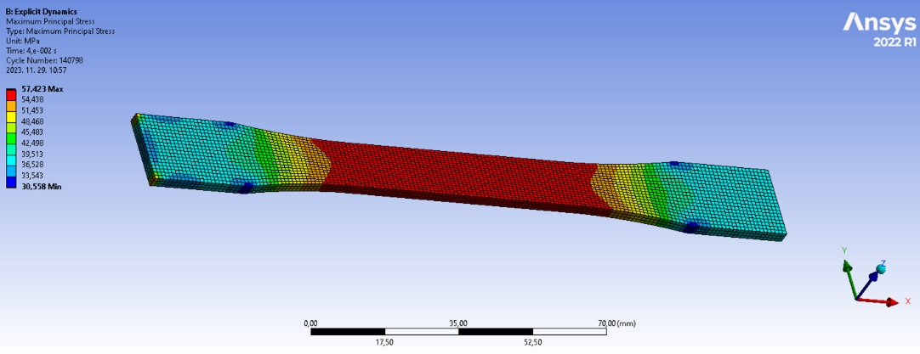
Figure 2.: maximal principal stress map of simulated specimen in ANSYS Explicit Dynamics
  - Conclusions
As the results show, with enough tensile tests, 3D printed parts mechanical properties can be simulated for the examined carbon fibre-reinforced nylon filaments. To manufacture parts with the desired mechanical, be it the highest strength part with little give in terms of elongation or moderate strength but with an elastic failure in order to avoid a catastrophic failure type, these simulations offer a way to credibly predict the properties of an end product without actually printing it first. To achieve this aim, further simulations and real-life tests will be carried out and a boarder range of parameters and material groups will also be studied to further enhance the accuracy of these simulations.
References
- Chen, Wei & Zhang, Qiuju & Cao, Han & Yuan, Ye. (2021). Process evaluation, tensile properties, mathematical models, and fracture behavior of 3D printed continuous fiber reinforced thermoplastic composites, Journal of Reinforced Plastics and Composites. 40.
- Isobe T., et al. (2018). Comparison of strength of 3D printing objects
- using short fiber and continuous long fiber, IOP Conf. Ser.: Mater. Sci. Eng. 406 012042
- Saithongkum, Nathathai & Tuchinda, Karuna. (2020). Mechanical Properties of 3D Printed Carbon Fiber Composite, Solid State Phenomena. 304. 15-23.

