An Ionic Liquid Mixture Design for CO2 Capture through Bayesian Optimization and Molecular Dynamics Simulation

Dulce María de la Torre-Canoa, Miguel Angel Gutiérrez-Limóna*, Antonio Flores-Tlacuahuacb, Mauricio Sales-Cruzc

*aDepartamento de Energía, Universidad Autónoma Metropolitana-Azcapotzalco, Av. San Pablo 420, Ciudad de México, 02128, México*

*bEscuela de Ingeniería y Ciencias, Tecnológico de Monterrey, Campus Monterrey, Ave. Eugenio Garza Sada 2501, Monterrey, N.L, 64849, México*

*cDepartamento de Procesos y Tecnología, Universidad Autónoma Metropolitana – Cuajimalpa, Av. Vasco de Quiroga No. 4871, Ciudad de México, 05348, México.*

*magl@azc.uam.mx

Abstract

CO2 emissions into the atmosphere have become a global concern in recent years. The amount of CO2 generated in post-combustion processes has deserved the attention of the international scientific community. Thus, a variety of processes have emerged that try to address this problem from different points of view, such as the traditional absorption process that uses some type of amine as a solvent. Several other alternatives have been tried to solve the problems presented by this process. One of these alternatives consists of using ionic liquids as solvents in the CO2 absorption process. An important characteristic of ionic liquids is that their vapor pressure is very low, which makes them practically non-volatile. The task of designing ionic liquids for this purpose has gained interest in recent years. In previous work, our group designed ionic liquids using a computer-aided molecular design methodology, posing the problem as a MINLP problem. (Valencia-Márquez, et. al. 2017), (Silva-Beard, et. al. 2022). In this work, we use Molecular Dynamics Simulation (MDS), to calculate the capacity of absorption of a mixture of ionic liquids and propose an approach of experiments guided by Bayesian optimization to find an optimal mixture of ionic liquids that maximizes the amount of CO2 captured. The results suggest that following the procedure proposed it is possible to reduce the number of numerical experiments and therefore, the CPU time.

**Keywords**: Bayesian Optimization, Molecular Dynamic Simulation, Ionic Liquids, CO2 Capture.

* 1. Introduction

A current global challenge is the growth of greenhouse gases (GHG), coming mainly from the burning of fossil fuels and industries. GHG emissions have been increasing since the Industrial Revolution and have not yet reached their peak (Friedlingstein et al., 2022).

All this leads to an increase in temperature on the planet, the thawing of the poles and other typical problems derived from global warming. Carbon capture and storage (CCS) is considered the most practical option for reducing greenhouse gases. CO2 can be used to improve oil processes or as a raw material in some industries. The most studied and used CO2 capture is precombustion because it can be adapted to existing facilities, modifying only the final part of the process (Figueroa et al., 2008).

Current post-combustion technologies use amines to capture CO2; however, these solvents have some drawbacks such as high volatility and corrosion in the treatment units, so it is required to monitor the concentration and solvent flow. This is why in recent years new alternatives have been studied to carry out this task, such as ionic liquids (ILs).

* 1. Problem Statement
     1. Ionic Liquids

Ionic liquids (IL) are considered potential materials for CO2 capture. These are a mixture of a cation and an anion. Given the large number of mixtures, each IL can present unique properties. ILs have negligible vapor pressure, that is, they are liquid at high temperatures, have a low melting point and have high chemical and thermal stability. The solubility of CO2 in ionic liquids can occur both in chemical and physical absorption, with a lower cost in desorption for the first case. (Jia et al., 2022).Investigations on absorption of gases in ionic liquids by Molecular Dynamics Simulation have been carried out with pure ionic liquids and the absorption results have not been very efficient. On the other hand, artificial intelligence has become very popular in recent years. They use some algorithms to predict things, but for all that they must implement some hyperparameters to get better results. These parameters are difficult to decide which ones are good, for this reason they sometimes use Bayesian optimization to guide their search and predict better. Therefore, in this work we aim to evaluate the absorption of CO2 in a mixture of ionic liquids with Molecular Dynamic Simulation. Our experiments are guided by Bayesian optimization to find the optimal combination for maximum CO2 absorption.

* 1. Methodology

*3.1 Molecular Dynamic Simulation*

Molecular dynamics simulation (MDS) is a computational tool that analyzes the behavior of atoms which are treated as particles moving under the influence of classical mechanics. It explains the behavior of fluids and materials at an atomistic level. The software used in this work is LAMMPS (Large-scale Atomic/Molecular Massively Parallel Simulator). Verlet algorithm was used to predict velocities and positions of atoms. To calculate the properties, it is necessary to calculate the forces involved within a molecule, known as the force field. This force field is made up of bonding and non-bonding interactions. On the one hand, on the bonding side we have the forces arising from dihedral twisting, bond stretching and bond bending. And the non-bonding forces consist of the Lennard Jones potential and the Coulomb potential. Table 1 shows the list of ionic liquids found in the literature that have higher solubility in CO2.

Table 1 Ionic liquids investigated (*Ionic liquids chosen)

|  |  |  |  |
| --- | --- | --- | --- |
| Ionic liquid or mixture | Solubility CO2  (mole fraction) | Henry´s constant CO2  (MPa) | Source |
| [BMIM][BF6] | 0.013-0.017 |  | (Blanchard et al., 1999) |
| [BMIM][PF6]* |  | 8-10 | (Lim et al., 2009). |
| [EMIM][B(CN)4] | 0.135 |  | (Babarao et al., 2011) |
| [EMIM][SCN]* |  | 16.2-90.9 | (Liu et al., 2021) |
| [EMPyr][bFAP] |  | 1.74 | (Jia et al., 2022b) |
| [MIM][TF2N]* / [MIM][MeSO4] | 0.3660 |  | (Silva-Beard et al., 2022b) |

Factors that influence the absorption of CO2 have been found, to mention some such as the presence of Fluorine and nitrile in the anion, the longer chains in the cation have a greater absorption capacity. That said, the ionic liquid from Silva's research work was chosen and the cation was modified with a longer chain to have better absorption.

Ionic liquids that appear to be good candidates for further absorption are [BMIM][TF2N] and [EMIM][SCN]. Another ionic liquid mixture tested was [BMIM][TF2N] and [BMIM][PF6]. The MDS solves Newton's equation, in this way we can obtain speed, position and different properties, we only need the force field. The methodology consists of obtaining the Henry constant with MDS and using Bayesian Optimization as a tool to guide us to find a concentration of ionic liquids that achieves the highest CO2 absorption. The procedure will stop until a maximum of the function is found. See Figure 1.

Figure 1 Metodology of this work

The CL&P force field (Canongia, Lopes & Pádua, 2012) was selected and constructed based on the OPLSAA model that has been calculated especially for ionic liquids. The initial configurations for the molecular dynamics simulation were obtained with fftool and PACKMOL software.

*3.2 Solubility and Henry´s constant*

MDS can further help to understand the interactions between CO2 and ILs at the atomic and molecular level, providing insight into the mechanism of CO2 uptake in ILs. The solubility of CO2 in ILs is an important factor in determining the CO2 uptake capacity of ILs. ILs with higher CO2 solubility can absorb more CO2 molecules, making them more effective for CO2 capture. (Jia et al., 2022). The Widom test particle insertion scheme has been used to determine the solubility of small molecules in different systems with good agreement with experimental results in both cases (Hossain et al., 2019). Henry's constant can be calculated by Widom insertion, where the excess chemical potential is calculated by the following equation:

|  |  |
| --- | --- |
|  | (1) |

where µex is excess chemical potential and Vg is the energy experienced by a “ghost” particle that interacts with the rest of the molecules in the system. V represents the volume of the system, while k and T denote the Boltzmann constant and the temperature, respectively. The Henry´s constant of a solute in a solvent, H, is obtained by the following equation:

|  |  |
| --- | --- |
|  | (2) |

*3.3 Bayesian Optimization*

Bayesian optimization (BO) is a technique used to find the best hyperparameter configuration in ML models. It relies on probabilistic methods and Bayes' theorem to guide the search efficiently. BO provides a principled method for making decisions under uncertainty. The objective of BO is to find the global minimum or maximum of a black-box objective function, min X∈F(X). The function F is said to be a black-box function because its explicit functional form is unknown. However, it is assumed that information about the function can be obtained by evaluating it at points in its domain X. However, such evaluations are assumed to be expensive. Therefore, the goal of BO is to minimize F with as few evaluations of the black box function as possible (Močkus, 1975). BO constructs a surrogate (i.e., approximate) function for the objective function and quantify the uncertainty in that surrogate function using a Bayesian machine learning technique, Gaussian process regression, and then use an acquisition function defined from this surrogate function to decide where to sample (Frazier, 2018).

* 1. Results and Discussion

For the MDS, each atom within the molecule was first identified with an ID, as shown in Figures 2 and 3. In MDS, one normally works with zmat coordinates where the bond length, bond angle and dihedral angle of each atom were generated with its ID, the zmat for each anion and cation of the IL mixture. Subsequently, the force field was obtained with zmat and fftool and Packmol. Finally, the script for the Lammps simulation was configured. The Lennard Jones parameters for the interactions between atoms of different molecules are calculated using the Lorentz-Berthelot combination rules given by Eqs. 3 and 4.

|  |  |  |  |
| --- | --- | --- | --- |
| Diagrama, Esquemático  Descripción generada automáticamente  Figure 2 1-butyl-3-methylimidazolium (C4C1im+) | | Imagen de la pantalla de un celular con letras  Descripción generada automáticamente con confianza baja  Figure 3 Bis(trifluoromethane)sulfonimide (TFSI- or NTF2-) | |
|  | (3) |  | (4) |

In this work a force field validation was performed with the selected ionic liquids by calculating the density with the MDS, this was done with the NPT and NVT assemblies. The results are shown in Table 2.

Table 2 Validation of the force field with the density, every simulation was run with 50 molecules, and the mixture was run with 50 molecules of ionic liquid and 5 molecules of CO2.

|  |  |  |  |
| --- | --- | --- | --- |
|  | [EMIM][SCN]- | [BMIM][NTF2]- | [BMIM][NTF2]-/CO2 |
| ρ (g/cm3) Experimental | 1.113 | 1.444 | 1.4345 |
| ρ (g/cm3) MDS | 1.131684 | 1.4149018 | 1.395161 |
| Error | 1.95% | 1.74% | 2.70% |

The excess chemical potential at 298 K and 1 atm was obtained by inserting molecules known as Widom, and then the Henry's constant and Solubility were calculated. The mole fraction of the molecules is a variable that will be modified as indicated by the BO.

The BO was performed in Python with the "bayesian_opt" library with Gaussian processes and the acquisition function "expected improvement" (Fernando Nogueira, 2014). The limits were set between 0 and 1 for the concentration of ionic liquids. BO conducts the experiment and constructs the surrogate function until the maximum point of Henry's constant is known. Bayesian optimisation suggests strategic points by using Gaussian processes and maximising the acquisition function and thus reducing the search space. This is how the surrogate function is constructed. The BO algorithm will stop until the maximum point of the function is known. Figures 4 and 5 show iteration #4 of the BO, with an expected improved acquisition function. The combinations of ionic liquids suggested by the BO and tested in the MDS are shown in Table 3. The two groups that were tested in MSD show that the pure liquid [BMIM][NTF2]- has a greater Henry´s constant, that is, a greater solubility and therefore a greater absorption of CO2 in this mixture of ionic liquids.

Figure 4 Iteration #4 of Bayesian Optimization with [BMIM][NTF2]- and [EMIM][SCN]-

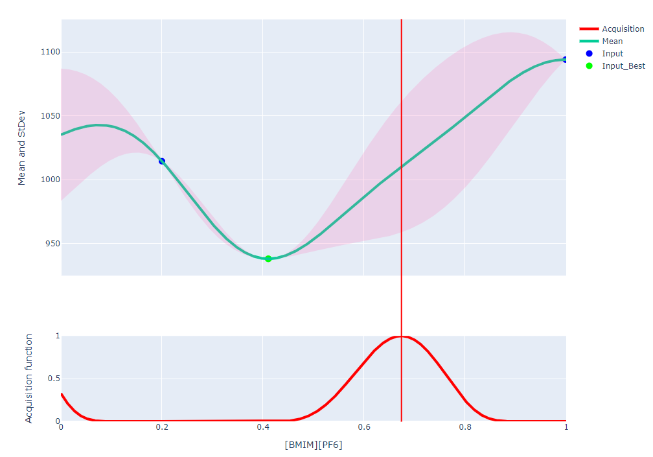

Figure 5 Iteration #4 of Bayesian Optimization with [BMIM][NTF2]- and [BMIM][PF6]-

Table 3 Combination of IL´S suggested by Bayesian Optimization and tested using MDS.

|  |  |  |  |  |  |
| --- | --- | --- | --- | --- | --- |
| [EMIM][SCN]- | [BMIM][NTF2]- | Henry´s constant (atm) | [BMIM][PF6]- | [BMIM][NTF2]- | Henry´s constant (atm) |
| 0.43 | 0.57 | 980.34 | 0.41 | 0.59 | 937.95 |
| 1.00 | 0.00 | 458.37 | 1 | 0 | 738.1 |
| 0.41 | 0.59 | 995.3 | 0.2 | 0.8 | 1014.4 |
| 0.88 | 0.12 | 549.5 | 0.67 | 0.33 | 850.02 |
| 0.00 | 1.00 | 1368.14 | 0 | 1 | 1094 |
| 0.23 | 0.77 | 1159.13 | 0.11 | 0.89 | 1053.62 |

* 1. Conclusions

MDS and BO are useful tools in different fields, such as chemical engineering and ML, on their own. The simultaneous use of these has shown to be useful for the problem posed in this work. From the results, it has been demonstrated that pure IL [BMIM][NTF2] is a good CO2 absorber. The methodology used and the results obtained motivate us to continue in this line and to continue exploring other mixtures of ILs that produce better results. On the other hand, a useful and interesting analysis would be to consider the costs of ILs in order to find an optimal mixture of ILs that absorbs a greater amount of CO2 and also takes into account the costs of each IL. Other known techniques make use of solvation free energy, thermodynamic integration, equations of state, etc. to calculate solubility. These techniques should be explored in the future.

References

Babarao, R., Dai, S., & Jiang, D. (2011). Understanding the High Solubility of CO 2 in an Ionic Liquid with the Tetracyanoborate Anion. The Journal of Physical Chemistry B, 115(32), 9789–9794. <https://doi.org/10.1021/jp205399r>

Blanchard, L. A., Hancu, D., Beckman, E. J., & Brennecke, J. F. (1999). Green processing using ionic liquids and CO2. Nature, 399(6731), 28–29. https://doi.org/10.1038/19887

Canongia Lopes, J. N., & Pádua, A. A. H. (2012). CL&P: A generic and systematic force field for ionic liquids modeling. In Theoretical Chemistry Accounts (Vol. 131, Issue 3, pp. 1–11). Springer New York LLC. https://doi.org/10.1007/s00214-012-1129-7

Figueroa, J. D., Fout, T., Plasynski, S., McIlvried, H., & Srivastava, R. D. (2008). Advances in CO2

capture technology-The U.S. DOE’s Carbon Sequestration Program. International Journal of

Greenhouse Gas Control, 2, (1), 9–20.

Frazier, P. I. (2018). A Tutorial on Bayesian Optimization.

Friedlingstein, P., O’Sullivan, M., Jones, M. W., Andrew, R. M., Gregor, L., Hauck, J., Le Quéré,

C., Luijkx, I. T., Olsen, A., Peters, G. P., Peters, W., Pongratz, J., Schwingshackl, C., Sitch, S.,

Canadell, J. G., Ciais, P., Jackson, R. B., Alin, S. R., Alkama, R., Zheng, B. (2022). Global

Carbon Budget 2022. Earth System Science Data, 14(11), 4811–4900.

Hossain, S., Kabedev, A., Parrow, A., Bergström, C. A. S., & Larsson, P. (2019). Molecular simulation as a computational pharmaceutics tool to predict drug solubility, solubilization processes and partitioning. European Journal of Pharmaceutics and Biopharmaceutics, 137, 46–55.

Jia, X., Hu, X., Su, K., Wang, W., & Du, C. (2022a). Molecular screening of ionic liquids for CO2

absorption and molecular dynamic simulation. Open Chemistry, 20(1), 379–387.

Jia, X., Hu, X., Su, K., Wang, W., & Du, C. (2022b). Molecular screening of ionic liquids for CO2absorption and molecular dynamic simulation. Open Chemistry, 20(1), 379–387. https://doi.org/10.1515/chem-2022-0154

Lim, B.-H., Choe, W.-H., Shim, J.-J., Ra, C. S., Tuma, D., Lee, H., & Lee, C. S. (2009). High-pressure solubility of carbon dioxide in imidazolium-based ionic liquids with anions [PF6] and [BF4]. Korean Journal of Chemical Engineering, 26(4), 1130–1136. https://doi.org/10.1007/s11814-009-0188-5

Mahurin, S. M., Lee, J. S., Baker, G. A., Luo, H., & Dai, S. (2010). Performance of nitrile-containing anions in task-specific ionic liquids for improved CO2/N2 separation. Journal of Membrane Science, 353(1–2), 177–183. https://doi.org/10.1016/j.memsci.2010.02.045.

Močkus, J. (1975). On bayesian methods for seeking the extremum (pp. 400–404). https://doi.org/10.1007/3-540-07165-2_55.

Nogueira, F., Bayesian Optimization: Open source constrained global optimization tool for Python, 2014, https://github.com/fmfn/ByesianOptimization.

Silva-Beard, A., Flores-Tlacuahuac, A., Rivera-Toledo, M., (2022) Computers and Chemical Engineering,157, 107622.

Valencia-Marquez, D., Flores-Tlacuahuac, A., Vazquez-Medrano, R. (2017) Journal of Cleaner Production, 168, 1652-1667.