DESIGN OF A PREDICTIVE FUNCTIONAL CONTROLLER BASED ON COMBINATION OF DATA-DRIVEN TUNING AND PREDICTION METHODS

Yoichiro Ashida,a* Masanobu Obikab

aNational Institute of Technology, Matsue College, 14-4 Nishiikuma cho, Matsue,

690-8518, Japan

bADAPTEX Co., Ltd., 13-60, Kagamiyama 3, Higashi-Hiroshima, Hiroshima, Japan

yashida@matsue-ct.ac.jp

Abstract

PID control has been used for a long time and still one of the most important controllers especially in process control. However, higher performance controllers are requested. Predictive functional controller (PFC) is a simple model predictive controller (MPC), and suitable for replacing PID controllers because it includes PI controller as a special case. This paper proposes a Fictitious Reference Iterative Tuning (FRIT) based two-stage data-driven design of the PFC. Firstly, most of the control parameters are tuned by FRIT. However, a robustness related parameter is not suitable for adjustment with FRIT because FRIT aims to make exact model matching. To tune this parameter, a FRIT based prediction is employed as the second stage. Designer determines the parameter by looking at the predicted waveforms. The effectiveness of the proposed method is verified by a numerical example. The proposed scheme could be applied to various processes.

**Keywords**: predictive functional control, data-driven design, data-driven prediction, fictitious reference iterative tuning.

* 1. Introduction

In process control, well-known PID controllers have been still widely used. Especially for complex controlled system, PID controllers are often employed because of their ease of tuning and high stability. However, control performance has become important to keep competitive power in last some decades. Although Model Predictive Controller (MPC) is famous high-performance controller, it is not easy to replace the PID controllers due to the difficulty of controller parameters tuning. In contrast, simpler MPC, Predictive Functional Controller (PFC) has been proposed by Richalet et al. (2009). Because PFC contains a PI controller as a special case, it is suitable for replacing the PID controller. However, though PFC is simpler than MPC, tuning control parameters of PFC is still a problem.

Among many controls parameter tuning methods, data-driven tuning methods are actively researched. Typical methods are iterative feed-back tuning (IFT) which uses repeated experiment proposed by Hjalmarsson et al. (1998), fictitious reference iterative tuning (FRIT) which uses only off-line optimizations proposed by Soma et al. (2004). The methods can tune controller without any system parameters. Effectiveness of the schemes are verified for experiments. For example, Nakamoto (2003) and Kano et al., (2011) apply IFT and extended-FRIT methods to processes respectively. Thus, this paper utilizes FRIT to tune PFC.

Most control parameters are determined by FRIT, but the coincidence point $h$ is a robustness-tuning parameter, which is impossible to adjust because FRIT aims to exact model matching. In this paper, FRIT based data-driven prediction method proposed by Takahashi et al. (2019) is employed to tune $h.$ The method predicts input and output signals without any actual controls and system models. By using the proposed tuning scheme, operators can determine $h$ which gives an acceptable control result.

This paper proposes a FRIT based tuning scheme of PFC. In the proposed scheme, internal model of PFC is determined by FRIT, and a control parameter named coincidence point is tuned by FRIT based prediction method. Effectiveness of the proposing design scheme is checked by a numerical example. The application is not limited to any particular target, but is considered applicable to various processes.

* 1. Proposed control scheme
     1. Predictive Functional Control (PFC)

In this paper, considering the control of process systems, a high order system without any resonance points is considered as a controlled system, and reference signal is assumed to be stepwise one. In PFC, an internal model is expressed as a superposition of first-order systems shown as

|  |  |
| --- | --- |
| $$\hat{y}\left(t\right)=\sum_{i=1}^{f_{u}}{y_{ui}(t)},$$ | (1) |
| $$y_{ui}\left(t\right)=G_{i}\left(z^{-1}\right)u\left(t\right),$$ | (2) |
| $$G_{i}\left(z^{-1}\right)=\frac{b_{i}z^{-1}}{1+a_{i}z^{-1}},$$ | (3) |

where $\hat{y}\left(t\right)$ and $u\left(t\right)$ are model output and input, and $z^{-1}$ is a delay operator as $z^{-1}u\left(t\right)=u(t-1)$. This model cannot represent a control target with resonance points. Please refer to the literature by Richalet et al. (2009) for such a target. The following model represents only a rational function part excluding the time-delay, and the compensation of the time-delay will be explained later. Eq. (2) can be rewritten as

|  |  |
| --- | --- |
| $$y_{ui}\left(t\right)=-a_{i}y_{ui}\left(t-1\right)+b_{i}u\left(t-1\right).$$ | (4) |

Based on this, the predicted value $y_{ui}\left(t\right)$ of time $t+h$ at time $t$ is calculated as

|  |  |
| --- | --- |
|  | (5) |

Assume that future input is constant because reference signal is also constant, Eq. (5) is

|  |  |
| --- | --- |
|  | (6) |

When the reference signal is a lamp signal, the future input must assume to be a lamp to obtain trackability. Eq. (6) leads the model output $\hat{y}\left(t+h|t\right)$ as

|  |  |
| --- | --- |
|  | (7) |

and amount of change $δ\hat{y}\left(t+h | t\right)=\hat{y}\left(t+h | t\right)-\hat{y}(t)$ is

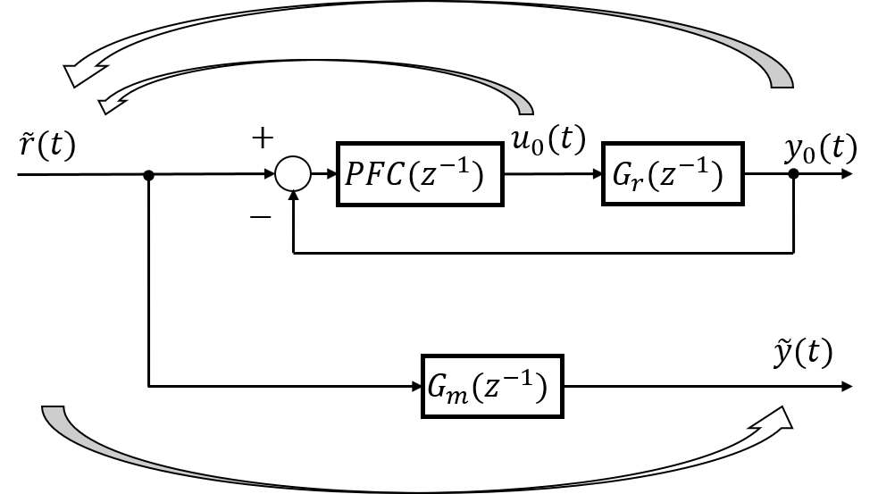

Figure 1: Conceptual diagram of FRIT

|  |  |
| --- | --- |
|  | (8) |

Next, variation of a reference trajectory of a first order model $δy_{m}\left(t+h | t\right)$ is defined as

|  |  |
| --- | --- |
|  | (9) |

where $e\left(t\right)≔r\left(t\right)-y\left(t\right)$. $T_{m}$ denotes 95% settling time and $r\left(t\right), y\left(t\right)$ are a reference signal end an output signal, respectively. When $δ\hat{y}\left(t+h | t\right)$ becomes the same as $δy_{m}\left(t+h | t\right),$ the following equation holds:

|  |  |
| --- | --- |
| $$\sum_{i=1}^{f_{u}}{\left\{{\left(-a_{i}\right)}^{h}-1\right\}y_{ui}\left(t\right)}+\sum_{i=1}^{f_{u}}{b_{i}\frac{1-{\left(-a_{i}\right)}^{h}}{1-\left(-a_{i}\right)}}u\left(t\right)=\left\{1-{\exp\left(\frac{T_{m}}{3}\right)}^{h}\right\}e\left(t\right).$$ | (10) |

Because $h$ is a point of matching the model output and the reference trajectory, it is called “coincidence point”. As a result, $u\left(t\right)$ is calculated by

|  |  |
| --- | --- |
| $$u\left(t\right)=\frac{\left\{1-{\exp\left(-\frac{3}{T_{m}}\right)}^{h}\right\}e\left(t\right)+\sum_{i=1}^{f_{u}}{\left\{{1-\left(-a_{i}\right)}^{h}\right\}y_{ui}\left(t\right)}}{\sum_{i=1}^{f_{u}}{b_{i}\frac{1-{\left(-a_{i}\right)}^{h}}{1-\left(-a_{i}\right)}}}.$$ | (11) |

In order to treat time-delay, $e\left(t\right)$ of Eq. (11) is replaced by

|  |  |
| --- | --- |
| $$e^{'}\left(t\right)=e\left(t\right)-\left\{\hat{y}\left(t\right)-\hat{y}\left(t-k\right)\right\},$$ | (12) |

where $k$ is a number of steps of the time-delay.

* + 1. Fictitious Reference Iterative Tuning (FRIT)

Soma et al. (2004) has proposed data-driven controller tuning named fictitious reference iterative tuning (FRIT) to tune feed-back controllers. FRIT tunes controller parameters based on one set of operating input-output data without system models. This paper applies FRIT to PFC. Conceptual diagram of proposing FRIT is shown in Figure 1.

$PFC\left(z^{-1}\right) is a transfer function of PFC, and u_{0}(t)$ and $y_{0}(t)$ are the initial data. Additionally, $G_{m}(z^{-1})$ denotes a reference model determined by the following equation to be the same as the reference trajectory of PFC.

|  |  |
| --- | --- |
| $$G_{m}\left(z^{-1}\right)=\frac{1-\exp\left(-\frac{3}{T_{m}}\right) }{1-\exp\left(-\frac{3}{T_{m}}\right)z^{-1}}z^{-(k+1)}.$$ | (13) |

If any kind of $PFC\left(z^{-1}\right)$ is determined, $\tilde{r}\left(t\right) and \tilde{y}(t)$ can be calculated as

|  |  |
| --- | --- |
| $$\tilde{r}\left(t\right)=PFC{\left(z^{-1}\right)}^{-1}u\left(t\right)+y\left(t\right),$$ | (14) |
| $$\tilde{y}\left(t\right)=G_{m}\left(z^{-1}\right)\tilde{r}\left(t\right).$$ | (15) |

By minimize the following $J$ with the parameters included in $PFC\left(z^{-1}\right)$ as optimization variables, the feedback loop constructed with $PFC\left(z^{-1}\right)$ and $G_{r}\left(z^{-1}\right)$ becomes the same as a reference model $G_{m}\left(z^{-1}\right)$:

|  |  |
| --- | --- |
| $$J=\sum_{j=1}^{N}{{\left\{G_{m}\left(z^{-1}\right)\tilde{r}\left(t\right)-y_{0}\left(t\right)\right\}}^{2}} ,$$ | (16) |

where $N$ denotes the length of the initial data. As can be seen from the above, FRIT aims to make the closed-loop characteristic the same as reference model’s one. In the parameters of PFC, the coincidence point $h$ is a robustness related parameter. When $h=1$, the control result exactly matches the reference trajectory, and when $h$ is large, the result is sluggish but robust. Thus, FRIT is not suitable to tune $h$. Therefore, h is set as 1 while FRIT, and this paper employs the data-driven prediction method to tune that.

* + 1. FRIT based Data-Driven Prediction

As mentioned before, FRIT aims model matching to reference model, and how to design the model has been a problem. To deal with this problem, a FRIT based data-driven prediction method has been proposed by Takahashi et al. (2019). By using the prediction method, various types of evaluation criterions can be set.

In the data-driven prediction method, minimizing $J$ of Eq. (16) is similar as FRIT, but optimization variables are not $PFC(z^{-1})$ but $G_{m}\left(z^{-1}\right)$. When initial data and $PFC(z^{-1})$ are determined, $\tilde{r}\left(t\right)$ is also fixed. As a result, closed-loop transfer function can be obtained in the form of $G_{m}\left(z^{-1}\right)$ by minimizing $J$. In the proposed scheme, various predicted signals are obtained by calculating $G_{m}\left(z^{-1}\right)$ corresponding to various $h$, and a designer determine $h$ based on these signals.

* 1. Numerical example

This example utilized the following transfer function as a controlled system:

|  |  |
| --- | --- |
| $$G_{r}\left(s\right)=\frac{10}{\left(100s+1\right)\left(80s+1\right)\left(20s+1\right)(0.9s+1)}e^{-10s},$$ | (17) |

and by discretizing it by sampling time $t_{s}=1$, $G_{r}\left(z^{-1}\right)$ was

|  |  |
| --- | --- |
| $$G_{r}\left(z^{-1}\right)=\frac{2.32×{10}^{-6}\left(1+8.03z^{-1}\right)\left(1+0.79z^{-1}\right)\left(1+0.077z^{-1}\right)z^{-11}}{\left(1-0.991z^{-1} \right)\left(1-0.988z^{-1}\right)\left(1-0.329z^{-1}\right)(1-0.951z^{-1})}.$$ | (18) |

Eq. (18) shows that $G_{r}\left(z^{-1}\right)$ has an unstable zero. Firstly, initial operating data was obtained using a PI controller with proportional gain $0.1$ and integral gain $0.001$, and Figure 2 shows the data. Based on this data, FRIT calculated PFC with $h=1$ as:



Figure 3: Prediction results using the data-driven prediction.



Figure 2: Initial data obtained by a PID controller.

|  |  |
| --- | --- |
| $$u\left(t\right)=0.3393e\left(t\right)+0.0755\hat{y}\left(t\right),$$ | (19) |

where the order of the internal model was set as $f_{u}=1$, and 95% settling time $T_{m}=200$. The controlled system was high-order, and the controller was first order, so it was impossible to match the closed-loop to the reference model. For this reason, the data-driven prediction method was used to check a response using Eq. (19) and tune $h$. Figure 3 shows prediction results as $h=1$, $h=10, and h=100$. The result of $h=100$ has smallest overshoot and settling time while rise time was slowest. Although the value of $h$ will depend on the control objective, this simulation selected $h=100$. Without the prediction, $h$ is selected by trial and error, and may take much time and cost.

Figure 4 shows control results of $h=1 and$ $h=100$, and the prediction result of $h=100.$ Clearly, the control result (broken line) and predicted result (solid line) were similar, and likely the same especially with respect to output $y(t)$. Comparing figures using $h=1$ and $h=10$ are omitted for reasons of space but mean absolute error between actual and predicted input and output are shown in Table 1. In all cases, especially prediction error of output is very small. It means that the prediction is good, and the proposed method is useful. Control result itself is not so good in this simulation because the order of internal model of PFC is only first order. In the proposed method, it is considered to change the order and execute FRIT again.

Table 1: Mean absolute error between actual and predicted input and output.

|  |  |  |  |
| --- | --- | --- | --- |
| $$h$$ | $$1$$ | $$10$$ | $$100$$ |
| Output | $$1.72×{10}^{-7}$$ | $$1.36×{10}^{-7}$$ | $$5.26×{10}^{-8}$$ |
| Input | $$1.14$$ | $$1.05$$ | $$0.54$$ |



Figure 4: Control and prediction results using h=100 and h=1.

* 1. Conclusions

This paper has proposed the control scheme using PFC, the data-driven design, and the data-driven prediction method. In the proposed scheme, most of the controller parameters of PFC, expected to replace a PID controller, are determined by using FRIT, a data-driven tuning. In addition, only coincidence point $h,$ the robustness-related parameter is tuned by the FRIT based prediction method. By using the proposed method, more stable control can be realized than the conventional tuning only using FRIT which are forced to set $h$ as 1. A numerical example has verified the effectiveness of the proposed scheme in this paper. To apply the proposed scheme for actual examples and more complex numerical examples, and proposing the unified way of controller parameters determination based on the prediction method are future works. We plan to apply the method for an aluminium block temperature control system by a heater.

References

J. Richalet, and D. O'Donovan, 2009, Predictive Functional Control Principles and Industrial Applications, Springer

H. Hjalmarsson, M. Gevers, S. Gunnarsson, and O. Lequin, 1998, Iterative Feedback Tuning: Theory and Applications, IEEE Control Systems Magazine, 18, 8, 26-41

S. Soma, O. Kaneko, and T. Fujii, 2004, A New Method of Controller Parameter Tuning based on Input-Output Data – Fictitious Reference Iterative Tuning (FRIT) –, IFAC Proceedings Volumes, 37, 12, 789–794

M. Nakamoto, 2003, An Application of Iterative Feedback Tuning for a Process Control, Trans. of the Society of Instrument and Control Engineers, 39, 10, 924-932

M. Kano, K. Tasaka, M. Ogawa, A. Takinami, S. Takahashi, and S. Yoshii, 2011, Extended Fictitious Reference Iterative Tuning and Its Application to Chemical Processes, Proc. of 2011 International Symposium on Advanced Control of Industrial Processes

E. Takahashi, and O. Kaneko, 2019, A New Approach to Prediction of Responses in Closed Loop Systems Based on the Direct Usage of One-shot Experimental Data, Transactions of the Society of Instrument and Control Engineers, 55, 4, 324-330 (in Japanese)