Scaling Up and Down Power-to-Methane Facilities with CO₂ Capture: Towards Modular Design
Diego Santamaría, Antonio Sánchez, Mariano Martín
Department of Chemical Engineering, University of Salamanca, Plz Caidos 1-5, 37008, Salamanca, Spain
mariano.m3@usal.es
Abstract
The scale-up and down of synthetic methane production from H₂ and CO₂ captured is evaluated towards modular design. Hydrogen is obtained from water splitting using renewable energy (wind or solar). For the carbon capture, three technologies are compared: absorption with amines, PSA system and membranes. In addition, two reactors for methanation reaction are considered: isothermal multitubular and adiabatic multi-bed. The combination of all of them results in six different alternatives. Each design is optimized to maximize the methane production. The investment cost and operation cost are evaluated at different CO₂ treatment capacities. The results show that processes with isothermal mulitubular reactors are more profitable than processes with multi-bed reactors. Among processes with isothermal mulitubular reactors there are some differences: for low scales carbon capture by membrane technology is the most profitable option, at medium scales PSA is the most economical and for large scales, the absorption system seems better option, as expected. From a production of 50 kg/h of CH₄ equivalent to the CO₂ treatment of the annual emission of an oil tanker that spends 390 h at the sea, the minimum sale price of methane stabilises at around 40 $/MMBTU. While today, this price is not competitive, in 2022 it could be competitive, as the methane price reached 70.04 $/MMBTU in the European market.
Keywords: Methanation, CO₂ utilization, renewable energy, modular design.
  - Introduction
Methane is one of the most important fuels and raw materials, reaching an annual consumption of almost 4,000 billion cubic meters worldwide in 2022 (Institute Energy, 2023). Methane has traditionally been obtained by extracting natural gas from fields. However, reserves are not only limited, but it may also suffer supply disruptions due to political instabilities. To reduce its effect, synthetic methane production by methanation using carbon dioxide (CO₂) and hydrogen (H₂) as raw materials is one of the most promising ways (Davis & Martín, 2014). This process can generate a clean renewable energy carrier by avoiding the use of a limited resource while reducing greenhouse gas emissions from industrial processes and fossil fuel combustion. The sustainability of the process lies in the origin of the H₂, and the CO₂ used. The hydrogen is obtained from an electrolyzer that runs on renewable electricity (from wind and solar energy). The CO₂ comes from industrial residual gases and to be used it must be captured and separated from other gases. There are different technologies such as: absorption, adsorption, cryogenics, chemical-looping combustion (CLC) and membranes (Olajire, 2010). The three most widely used (absorption, adsorption, and membrane) are considered together with two different types of methanation reactors (isothermal multitubular and adiabatic multi-bed) are studied at different scales. In this work, the various proposed alternatives are subjected to a mathematical optimization followed by a techno-economic analysis. The source of CO₂ is considered from 230 t/y to 130,000 t/y.
  - Methodology
The methodology presents a process level analysis to systematically compare the six different settings to determine the most profitable process at different scales. The settings are created by the combination of the three alternatives for CO₂ capture (absorption, adsorption, and membranes) and two designs of methanation reactors (isothermal and multi-bed), see Figure 1.
    - Process design: technology scaling
All alternatives are modeled using a combination of mass and energy balances, thermodynamic equilibria, experimental data, and rules of thumb. They start from the same feed and are optimized to maximize methane production and minimize costs. The processes are optimized by solving an NLP for each one and all six have the same objective function, eq (1):

$$OBJ=Max(P_{CH_{4}}·CH_{4}-Cost_{utilites}-Cost_{CO_{2}separation})$$ |  | (1)

    - Process description
The process can be divided into four subsections: CO₂ capture, hydrogen production, methane production and methane purification. Each subsection is described below.
      - CO₂ Capture
Three technologies for CO₂ capture are evaluated: absorption, adsorption, and membranes.
Absorption. It takes place via amines. From previous work (Martín-Hernández et al., 2020), the amine suggested is diethanolamine (DEA). Two columns are needed, the first one is the absorption column where the gases are brought into contact with the amine. Then, CO₂ rich amine stream, it is heated, and introduced into the second column. It is a stripping column where the CO₂ is desorbed from the amine, obtaining a pure CO₂ stream. The amine is recycled to the first column and mixed with new amines to make up for losses. This model is formulated based on first principles and industrial data.
Adsorption. A PSA system is used. The gases are fed to a zeolite 13 X bed (Martín-Hernández et al., 2020) where CO₂ is captured in the bed whereas nitrogen can cross the bed mostly. Langmuir solid-gas adsorption isotherm is used to model it.
Membranes. The configuration consists of a single-stage compressor train, two membranes for CO₂ separation and a mixer, where the fresh stream and the permeate of second membrane is mixed. The permeate of first membrane, which is rich in CO₂, is fed into a mixer and the retentate is introduced into a second membrane. The permeated of the second membrane is discharged into the atmosphere whereas the retentate is returned to the mixer. To model this system data of permeability and selectivity of membrane are used.
      - Hydrogen production
This subprocess begins with a PEM electrolyzer where oxygen and hydrogen are produced from water. The oxygen is dried, compressed and finally stored in a tank. The first step of hydrogen line is also water reduction with a phase separator. Next, as the hydrogen stream contains traces of oxygen, it is fed into a deoxygenation reactor to remove them, but water is produced. Finally, to achieve a pure hydrogen, the stream must be dried with a zeolites bed. At this point, hydrogen can be mixed with the captured CO₂ to produce methane.
      - Methane production
The hydrogen, CO₂ and the recirculation stream are introduced in a mixer. Next, the gases mixture is compressed to reach the methanation reactor conditions. There are two possibilities for choosing a type of methanation reactor: multitubular isothermal and multi-bed adiabatic. The isothermal reactor aim is to try to keep the temperature unchanged whereas the multi-bed reactor operates adiabatically and the heat exchangers between the bed reduce the temperature. The reactions for methane production are as follows and their constants are modelled with equilibrium constants.

$CO+3H_{2} ⇄ CH_{4}+H_{2}O$ (2)

$CO_{2}+H_{2} ⇄ CO+H_{2}O$ (3)
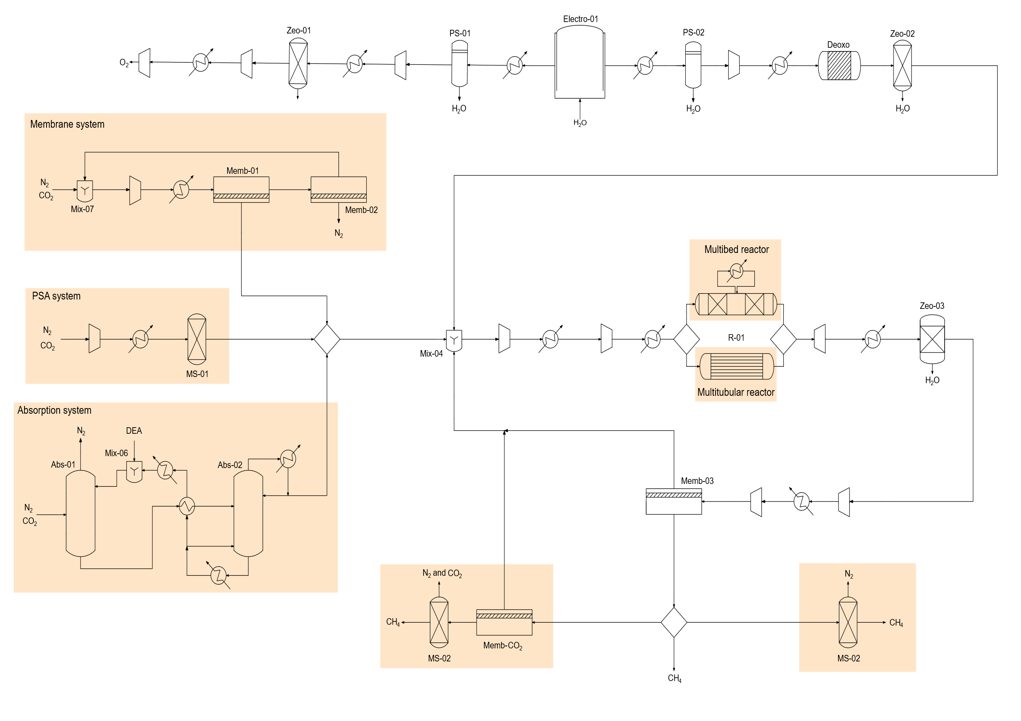
Figure 1. Process flowsheet. The colored areas correspond to the different alternatives for carbon capture, methanation reactors or purification stages.
      - Methane purification
The purification is a key stage because legislation requires methane with a purity over 95 % to be introduced in the natural gas network. The outlet stream of the methanation reactor is dried and finally a membrane separates the hydrogen from the other gases. Up to this point, the purification stage is the same for all alternative processes, but some of them need an extra stage because there are other components, which must be separated. When the carbon capture is performed with a PSA system or a membranes system and the methanation is performed in a multi-bed reactor, the output reactor stream contains methane and hydrogen, but also CO₂ and nitrogen. After the separation of water and hydrogen, CO₂ and N₂ are also removed. CO₂ is separated from the other gases by a membrane, and it is recirculated to the reactor and nitrogen is removed by a PSA system and it is released into the atmosphere. When the carbon capture is performed a membranes system and the methanation is performed in a tubular reactor, the reactor output flow is composed of methane, hydrogen and nitrogen. After hydrogen removal, only nitrogen must be removed, and this is also done by a PSA system.
    - Scale-up/down method
The cost of the units depends on its production capacity. The scale up coefficient changes from unit to unit. The factorial method is used to estimate the investment cost from the units cost (Sinnott & Towler, 2019). Each equipment has a characteristic variable that indicates the range in which it can operate. If the characteristic variable of an equipment exceeds this range, another unit must be installed in parallel (Sánchez & Martín, 2018). To perform the scale analysis, different points of CO₂ treatment capacity of the plant been chosen.
  - Results
This section shows the scale effect on investment and production cost. In addition, the comparison between different processes is also shown.
Figure 2. Investment for the different process to produce methane.

In Figure 2, the equipment investment cost of each technology proposed for different methane production capacity is represented. The best ratio between investment cost and methane production is achieved in processes with isothermal reactors, as a higher conversion rate is reached. Note that only at small scales close to isothermal operation can be achieved. As the processes are very similar to each other, the difference in investment cost is located in the carbon capture stage. Among process with the isothermal reactor, carbon capture using membrane technology shows the lowest investment cost.
In general, the processes with muti-bed reactors require a higher investment cost than processes with isothermal reactors. The multi-bed reactor with CO₂ capture by PSA requires the least investment to this type of reactors. At low scales, when the capture is done with membrane technology or absorption systems, the investment is very close. However, when the methane production excess 70 kg/h, absorption is more economical than membranes.

The evolution of the production cost at different methane production capacities can be seen in Figure 3. The unit of production cost is $/MMBTU because it is the most common unit in the US methane market. The processes using an isothermal reactor show lower production costs. Although, their production costs are very similar, it is possible to determine which is the most profitable at each point of methane production. At low scales, membrane technology is de most suitable process up to a capacity of 100 kg/h of CH₄. This can be equivalent, for example, to the treatment of the annual emissions of a general cargo ship spending 3688.66 h at the sea (EMSA\THETIS-MRV, 2023). For a capacity between 100 kg/h of CH₄ and 950 kg/h of CH₄ (may correspond, for example, to the treatment of annual emission of a hospital with a surface area of 200000 m² such as the University Hospital of Salamanca) (García-Sanz-Calcedo, 2019), PSA technology is the most economic and for larger scales, the absorption system seems better option.
Figure 3. Production cost of methane of each process at different scale.

The processes with multitubular reactors have a higher production cost. On the one hand, as it can see in Figure 2, the investment is higher for these processes. On the other hand, utilities costs are decisive for the production cost. Process with PSA has the lowest utilities costs and therefore a lower production cost is possible.
The results show that the sale price of the obtained methane is around 40 $/MMBTU and it does not reach a competitive level. However, the prices obtained are much lower compared to the European methane market in 2022 which was 70.04 $/MMBTU.
  - Conclusions
An evaluation of six different configurations to producing synthetic methane by a renewable route is presented. Hydrogen is obtained from a PEM electrolyzer while carbon dioxide is obtained by capturing industrial emissions or fossil fuel combustion. Three technologies for carbon capture are analyzed: absorption, PSA system and membranes system while two types of reactors are analyzed: isothermal multitubular and multibed adiabatic. It is important to indicate that although the methanation process in the multitubular reactor is supposed to occur isothermally, achieving this situation is difficult.
The units of the six configurations are modelled and optimized using first principles, thermodynamics equilibria and rules of thumb. Then, the investment and production cost are estimated, and the scaling study is developed.
The processes with isothermal reactors have a lower investment and production cost than multi-bed rectors and it is possible to differentiate which configuration is the most profitable, but the maximum size of such reactor is yet to be defined. Depending on the CH₄ production capacity the most suitable carbon capture technology changes. For low capacities up to 100 kg/h of CH₄ membranes are the technology of choice. For a capacity between 100 kg/h of CH₄ and 950 kg/h of CH₄, PSA technology is the most economical and for larger scales, the absorption system seems to be the best option. The methane production capacity can be translated into CO₂ treatment capacity. A methane production capacity of 100 kg/h of CH₄ may correspond to the treatment of the annual CO₂ emissions of a general cargo ship spending 3688.66 h at the sea (EMSA\THETIS-MRV, 2023) while a production capacity of 950 kg/h of CH₄ may correspond to of a hospital with a surface area of 200,000 m² such as the University Hospital of Salamanca (García-Sanz-Calcedo, 2019).
The minimum sale price of methane stabilises at around 40 $/MMBTU, when its capacity is sufficient to treat the annual emission of a tanker ship spending an annual emission of an oil tanker spending 390 h and producing 50 kg/h of CH₄. In 2023, this price is not yet competitive, but in 2022 it could be competitive, as the methane price reached 70.04 $/MMBTU on the European market.
Acknowledgments
This work was supported by the Regional Government of Castilla y León (Junta de Castilla León) and by the Ministry of Science and Innovation MICIN and the European Union NextGenerationEU / PRTR (H2MetAmo project - C17.I01.P01.S21).
References
Davis, W., & Martín, M. (2014). Optimal year-round operation for methane production from CO2 and water using wind energy. Energy, 69, 497–505. https://doi.org/https://doi.org/10.1016/j.energy.2014.03.043
EMSA\THETIS-MRV. (2023). https://mrv.emsa.europa.eu/#public/emission-report
García-Sanz-Calcedo, J. (2019). Study of CO2 emissions from energy consumption in Spanish hospitals. Vibroengineering Procedia, 26, 46–51. https://doi.org/https://doi.org/10.21595/vp.2019.20965
Institute Energy. (2023). Statistical Review of World Energy.
Martín-Hernández, E., Guerras, L. S., & Martín, M. (2020). Optimal technology selection for the biogas upgrading to biomethane. Journal of Cleaner Production, 267, 122032. https://doi.org/https://doi.org/10.1016/j.jclepro.2020.122032
Olajire, A. A. (2010). CO2 capture and separation technologies for end-of-pipe applications–A review. Energy, 35(6), 2610–2628. https://doi.org/https://doi.org/10.1016/j.energy.2010.02.030
Sánchez, A., & Martín, M. (2018). Scale up and scale down issues of renewable ammonia plants: Towards modular design. Sustainable Production and Consumption, 16, 176–192. https://doi.org/10.1016/j.spc.2018.08.001
Sinnott, R., & Towler, G. (2019). Chemical engineering design: SI Edition. Butterworth-Heinemann.

