Model-Based Assessment of Electrochemical Cells and Systems for Atmospheric CO2 Removal

Guokun Liu, Aidong Yang*

*Department of Engineering Science, University of Oxford, Oxford, OX13PJ, UK*

*aidong.yang@eng.ox.ac.uk*

Abstract

Electrochemical systems utilizing alkali solutions and the pH-swing method demonstrate promising potential for large-scale direct air capture (DAC) applications, addressing the imperative need to remove CO2 from the atmosphere alongside emissions reduction to meet climate goals. However, a consistent and systematic comparison between different electrochemical schemes is still lacking. This research focuses on numerically modelling and simulating electrolysis and electrodialysis cells and systems, with the aim of providing guidance for further system optimization. Considering hydrogen production with a referred efficiency of 80%, the minimum DAC energy of the electrolysis system is obtained as 587 kJ mol-1, while the electrodialysis system consumes a minimum energy of 273 kJ mol-1. The DAC energy of the two systems can be further reduced to 290 kJ mol-1 and 170 kJ mol-1 as the defined CO2 absorption reaches 1. The results highlight the importance of further optimization in CO2 absorber design and system operating parameters.

**Keywords**: CO2 capture; Electrochemical systems; Hydrogen production; Ion exchange membrane, Numerical modelling.

* 1. **Introduction**

Disturbing reports indicate that the world is poised to deplete the remaining carbon budget allocated to limit global temperature rise to 1.5 °C by 2030 (Liu et al., 2023). Responding to this pressing scenario, increasing attention is given to artificial CO2 removal methods as a direct intervention to mitigate atmospheric CO2 levels. Among these methods, direct air capture (DAC) stands out due to its merits of requiring less land, fewer location constraints, and simpler quantification of removal (Hanna et al., 2021), positioning it as a focal point in recent research and development.

Currently, DAC technologies fall into two primary categories: solid adsorption and liquid absorption (Sanz-Perez et al., 2016). The prevalent solid adsorption technique employs amine sorbents through a chemical-thermal process, demanding substantial thermal energy for CO2 liberation and sorbent regeneration (Zhu et al., 2022). Alternatively, wet scrubbing with aqueous alkali hydroxide has emerged as a more energy-efficient alternative with higher productivity (Sabatino et al., 2021). The wet-scrubbing-based DAC plant by Carbon Engineering Ltd, achieving an annual productivity of 1 Mt CO2 (Keith et al., 2018), serves as a testament to the feasibility of the liquid absorption pathway. However, challenges persist, particularly in the high-temperature heating process required for CO2 recovery, introducing complexity and energy demands. In response, an alternative pH-swing concept has been suggested, employing an electrochemical system powered by electricity and conducive to integration with renewable energy sources.

In the realm of electrochemical systems, various methods, including electrolysis, bipolar membrane (BPM) electrodialysis, capacitive deionization, and proton-coupled electron transfer agents, have been explored for DAC purposes (Sharifian et al., 2021). BPM electrodialysis has garnered significant attention due to its capacity to directly dissociate water into H+ and OH- ions, resulting in lower energy consumption for generating pH differences (Eisaman et al., 2011). In contrast, electrolysis systems, generally deemed more energy-intensive, have demonstrated promise with innovative designs and approaches such as hydrogen recycling (Zhu et al., 2023).

Despite the potential demonstrated by both electrolysis and electrodialysis systems for energy-efficient DAC, a comparable evaluation under standardized conditions is lacking. This study aims to bridge this gap through numerical modeling and simulation, considering actual cation exchange membrane (CEM) ion selectivity. By scrutinizing and comparing the impacts of applied current, CO2 absorption ratio, and CO2 recovery ratio, the study endeavors to offer valuable insights into the performance of both systems. The results hold the potential to steer further technological advancements in the pursuit of effective and sustainable DAC solutions.

* 1. **Systems and Models**

Figure 1 presents the electrolysis and electrodialysis DAC systems modelled and simulated in this study. The base solute utilized is K2CO3, and both systems follow a four-step cycle to achieve solution pH-swing and DAC. Firstly, in the alkali generation process (4→1), OH- ions are continuously generated in the alkaline compartment through the cathodic semi-reaction, leading to the alkalization of the solution and the attainment of a high CO2 absorption capacity. Subsequently, in the CO2 absorption process (1→2), the strongly basic solution is directed through the membrane contactor to absorb CO2 from the air, transforming into a CO2-rich solution. Following this, in the acidification process (2→3), the CO2-rich solution undergoes acidification in the acidic compartment, where K+ ions migrate from the acidic to the alkaline compartment through the CEM, replacing K+ ions with H+ ions. Finally, in the CO2 release process (3→4), the acidification leads to a reduction in CO2 solubility, prompting the release of CO2. The purified CO2 gas is separated and collected in the separator, while the solution reverts to its initial state.

While both the electrolysis and electrodialysis systems share similar CO2 absorption processes, the electrochemical reactions responsible for solution alkalization and acidification differ between the two. In electrolysis, the reactions involve hydrogen generation, serving the dual purpose of hydrogen production and partially mitigating the energy consumption of DAC. On the other hand, the electrodialysis system incorporates a crucial component known as the BPM, which includes an anion exchange layer and a cation exchange layer. The BPM facilitates the direct dissociation of water into OH- and H+ ions, creating a pH difference between the two compartments. Unlike water electrolysis, the water splitting reaction in electrodialysis does not necessitate energy for hydrogen and oxygen generation, resulting in a reduced overall energy demand.

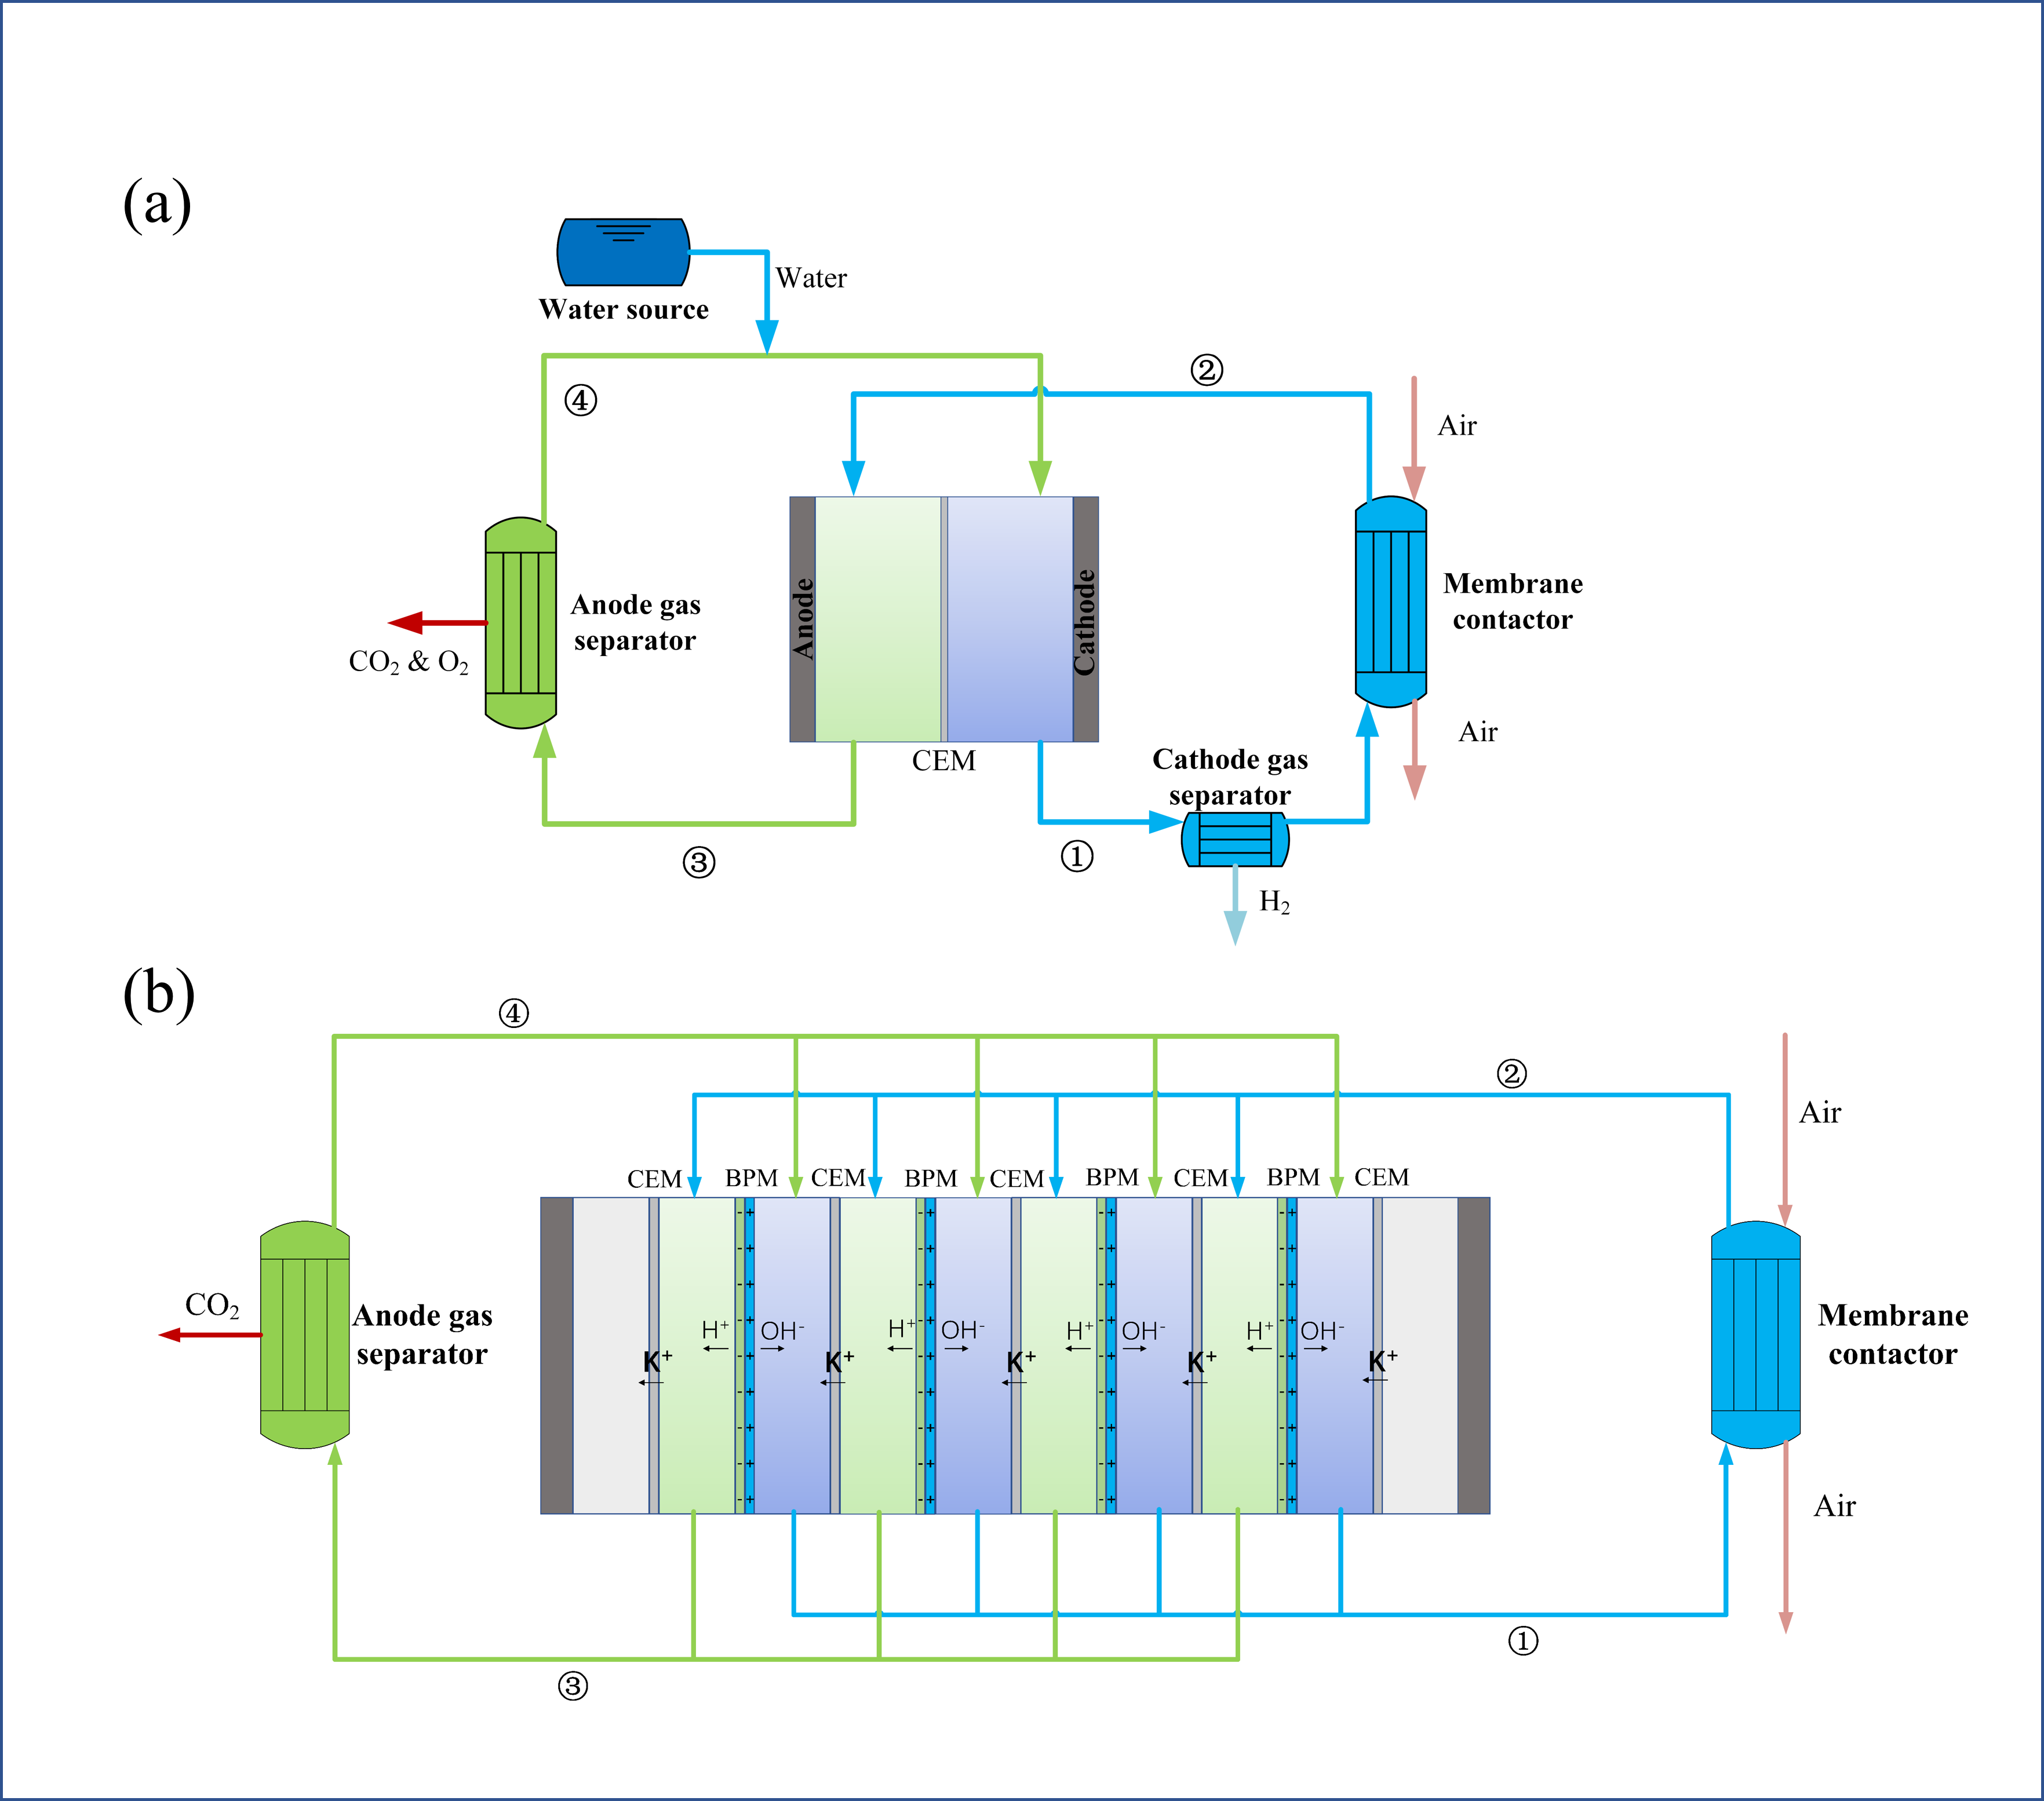

Figure 1: System layouts: (a) Electrolysis systems; (b) Electrodialysis system

The solution's dissolved inorganic carbon (DIC) and total alkalinity (TA) are defined as follows to facilitate numerical analysis:

|  |  |
| --- | --- |
|  | (1) |
|  | (2) |

Achieving full absorption or recovery of CO2 in the membrane contactor and anode gas separator, reaching their respective equilibrium limits, can pose challenges under actual conditions. To quantify the scope of these limitations, the CO2 absorption and recovery ratios are delineated as follows:

|  |  |
| --- | --- |
|  | (3) |
|  | (4) |

where the subscript numbers correspond to the node numbers in Figure 1.

The ideal selectivity of the CEM for K+ ions is typically not achieved, as there could be the crossovers of H+ and OH- ions. However, the crossovers of CO32- and HCO3- ions are disregarded due to their significantly lower concentrations compared to OH- ions. Essentially, competitive transport is acknowledged to exist among K+, H+, and OH- ions in the CEM. To characterize and assess this phenomenon's impact, the K+ transport efficiency is defined as:

|  |  |
| --- | --- |
|  | (5) |

where  is the flux of K+ ions crossing through CEM,  is the overall flux of transported ions,  is Faraday’s constant,  is the applied current. According to Gao et al.’s (2022) experimental study on an electrolysis system, a linear fitting equation was obtained to predict the K+ transport efficiency:

|  |  |
| --- | --- |
|  | (6) |
|  | (7) |

where  is K+ ion concentration at the inlet of acidic compartment, and  is the solution flowrate. When  is equal to or below 671 A min mol-1, the K+ transport efficiency is predicted to be 1.

To calculate the electrical energy consumed by the cells, the electric potentials of an electrolysis cell and an electrodialysis cell are expressed as follows (Sharifian et al., 2021):

|  |  |
| --- | --- |
|  | (8) |
|  | (9) |

where ,  ,  and  are the reversible, anode activation, cathode activation and ohmic potentials, and  is the solution pH difference between the two compartments.

The foundational operational parameters are provided in Table 1. The systems are simulated and iterated, and the results are obtained when the systems reach a steady state.

Table 1: Parameters of electrolysis and electrodialysis systems

|  |  |  |
| --- | --- | --- |
| Parameter | Electrolysis system (Gao et al., 2022) | Electrodialysis system (Iizuka et al., 2012) |
| K+ concentration | 1.54 M | 1.54 M |
| Solution flow rate (single cell) | 1 ml min-1 | 1ml min-1 |
| Single cell effective area | 16 cm2 | 210 cm2 |
| Cell compartment thickness | 0.1 cm | 0.075 cm |
| CO2 absorption ratio | 0.9 | 0.9 |
| CO2 recovery ratio | 0.9 | 0.9 |

* 1. **Results**

Conducting simulations across a range of applied current densities facilitates the determination of optimal conditions and enables the comparison of overall performance between electrolysis and electrodialysis systems. Figure 2 provides an overview of energy consumption trends (per mol of CO2 capture) for both systems. In the case of the electrolysis system, the energy consumption of hydrogen production is deducted by considering a reference hydrogen production efficiency (HPE). The results show that the reference HPE significantly impacts DAC energy consumption evaluation in the electrolysis system. At low applied currents and with a lower HPE (70%), the DAC energy consumption of the electrolysis system can be as low as 121 kJ mol-1. However, assuming an HPE of 80%, the minimum DAC energy consumption of the electrolysis system significantly increases to 587 kJ mol-1 at a current of 2.2 A. On the other hand, the electrodialysis system achieves a minimum DAC energy consumption of 273 kJ mol-1. These findings suggest that the water electrolysis system could be competitive in terms of DAC energy demand when considering the impact of hydrogen production, particularly at a low HPE. Nevertheless, a notable drawback of electrolysis is the mixing of recovered CO2 gas with O2, rather than producing a pure product.

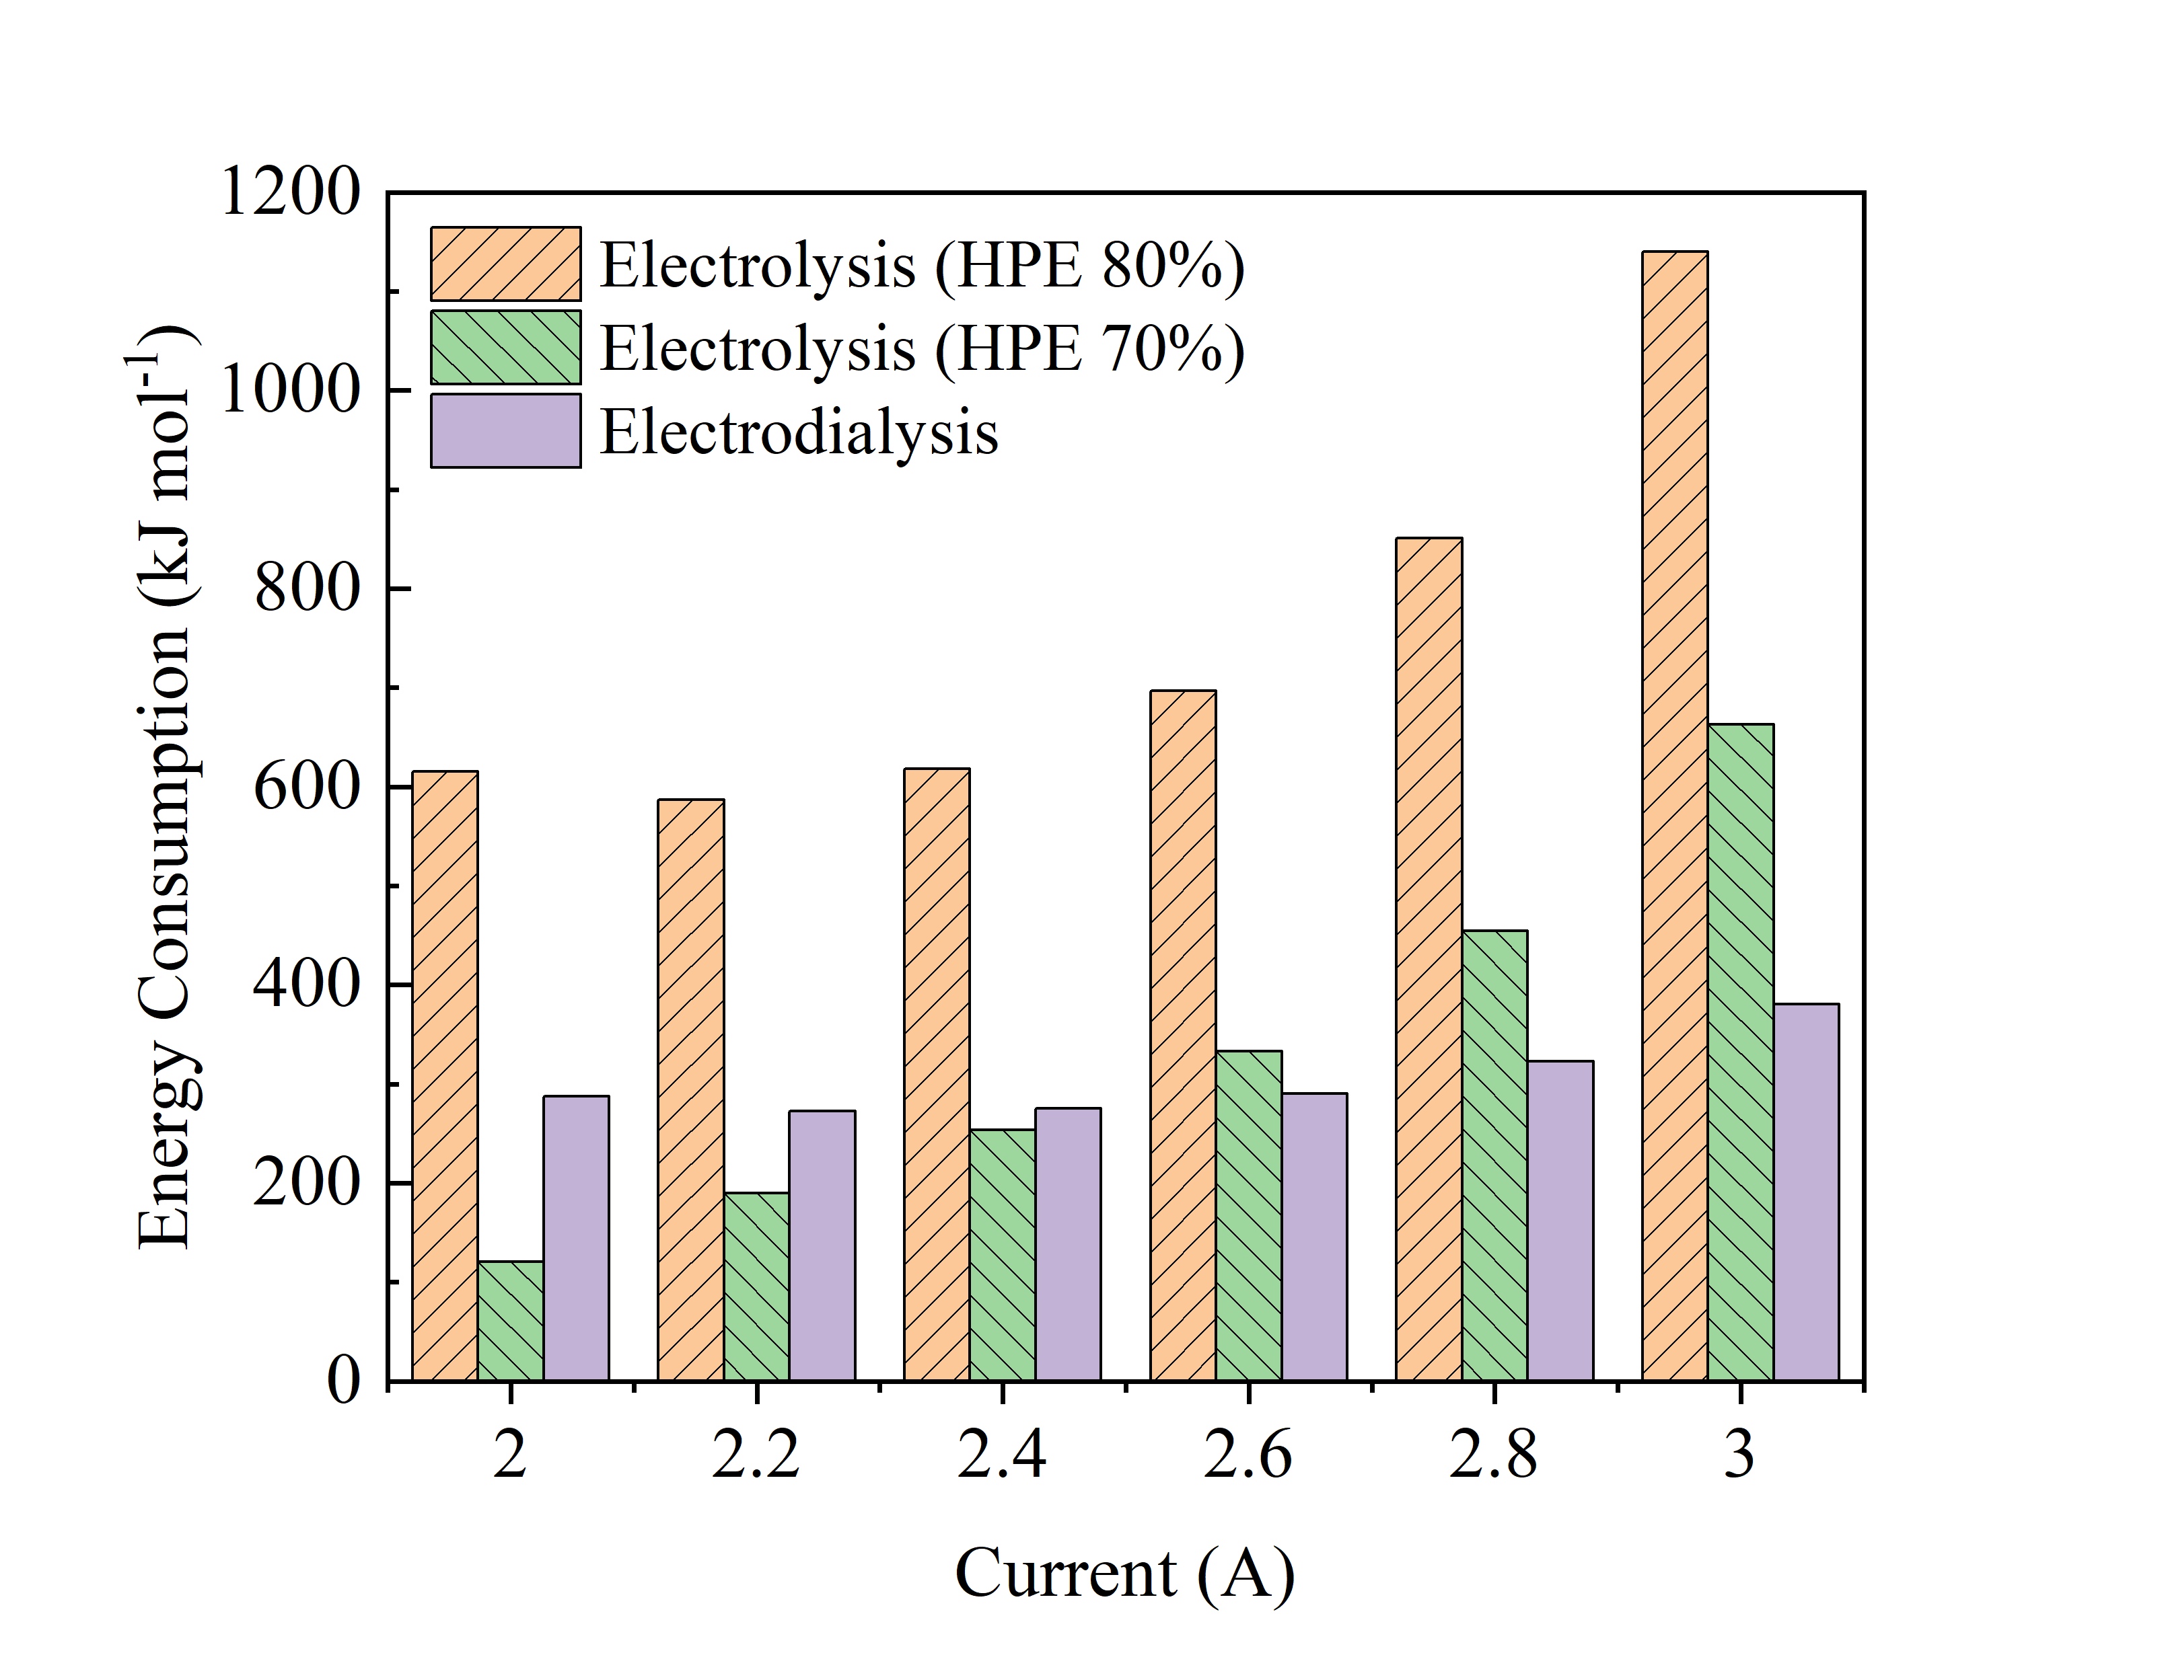

Figure 2: System energy consumption under various single-cell applied current

Figure 3 compares the DAC energy consumption of the two systems under different CO2 absorption and recovery ratios. In Figure 3(a), the DAC energy for both systems can be significantly reduced to 290 kJ mol-1 (electrolysis, 80% HPE) and 170 kJ mol-1 (electrodialysis) as the CO2 absorption ratio increases to 1. This highlights the importance of improving CO2 absorber design and enhancing CO2 absorption performance. Given the low CO2 concentration in the ambient air, achieving this improvement could be challenging and warrants in-depth exploration. In Figure 3(b), an increasing CO2 recovery ratio has a positive effect on saving the DAC energy of the electrolysis system. However, an opposite effect is observed for the electrodialysis system. As the CO2 recovery ratio increases, the pH difference between the compartments rises, elevating the BPM cell potential. Compared with the electrolysis cell, the overall electrical potential of the electrodialysis cells is much lower, and the negative effect of the increasing potential is more significant than the positive effect brought about by the increasing CO2 recovery amount. These results show the significance and necessity of further comprehensive optimization of operating parameters.

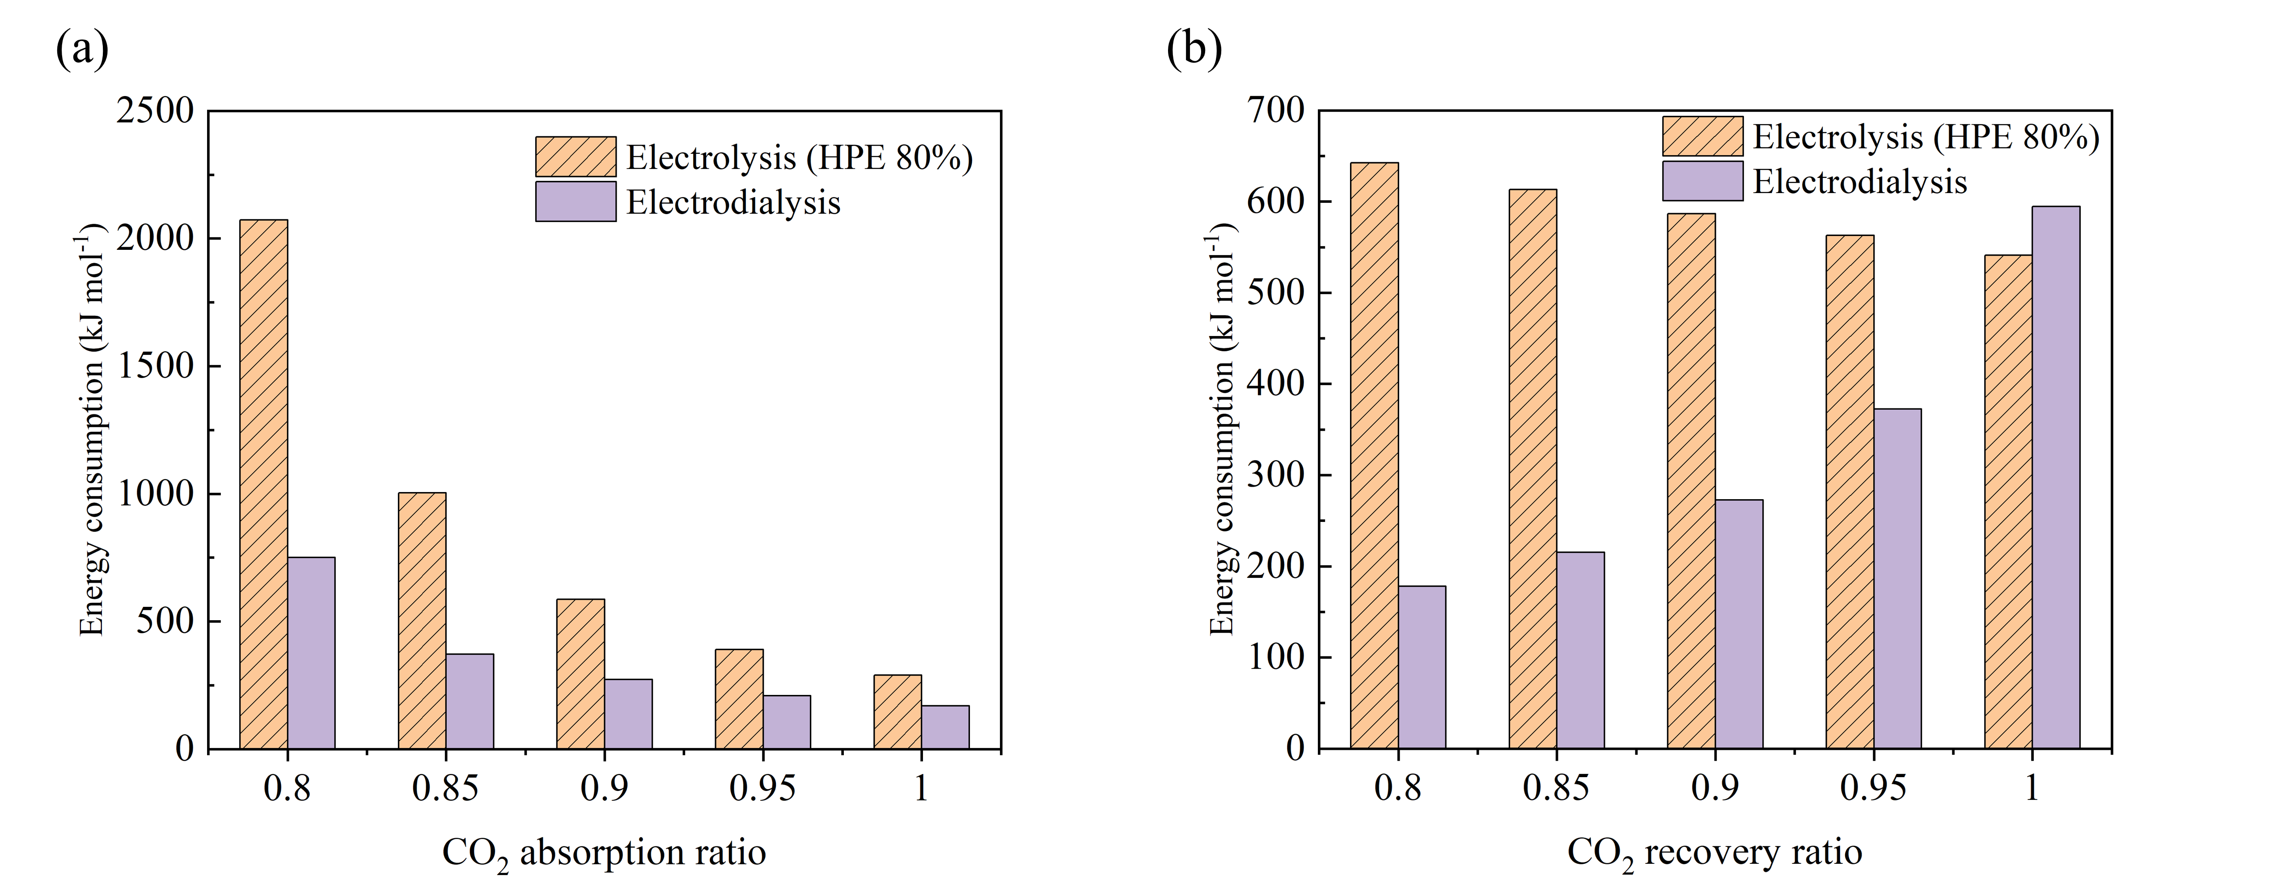

Figure 3: System DAC energy under various (a) CO2 absorption and (b) CO2 recovery ratios

* 1. **Conclusions**

This study conducts a modeling and parametric analysis of electrolysis and electrodialysis DAC systems employing the pH-swing method. The comparison of DAC energy demand for both systems was undertaken, exploring the impacts of applied current, and CO2 absorption and recovery ratios. The results show a minimum DAC energy of 587 kJ mol-1 and 273 kJ mol-1 for the electrolysis and electrodialysis system under the given conditions. These values can be further reduced to 290 kJ mol-1 and 170 kJ mol-1 as the CO2 absorption reaches 1, indicating scope for future technical improvement.

**References**

M. D. Eisaman, L. Alvarado, D. Larner, P. Wang, B. Garg, K. A. Littau, 2011, CO2 separation using bipolar membrane electrodialysis, Energy & Environmental Science, 4(4), 1319-1328.

X. Gao, A. Omosebi, R. Perrone, K. Liu, 2022, Promoting CO2 Release from CO3 2−-Containing Solvents during Water Electrolysis for Direct Air Capture, Journal of the Electrochemical Society, 169(4), 044527.

R. Hanna, A. Abdull, Y. Xu, D. G. Victor, 2021, Emergency deployment of direct air capture as a response to the climate crisis, Nature communications, 12(1), 368.

A. Iizuka, K. Hashimoto, H. Nagasawa, K. Kumagai, Y. Yanagisawa, A. Yamasaki, 2012, Carbon dioxide recovery from carbonate solutions using bipolar membrane electrodialysis, Separation and purification technology, 101, 49-59.

D. W. Keith, G. Holmes, D. S. Angelo, K. Heidel, 2018, A process for capturing CO2 from the atmosphere, Joule, 2(8), 1573-1594.

Z. Liu, Z. Deng, S. Davis, P. Ciais, 2023, Monitoring global carbon emissions in 2022, Nature Reviews Earth & Environment, 4(4), 205-206.

F. Sabatino, A. Grimm, F. Gallucci, M. van Sint Annaland, G, J. Kramer, M. Gazzani, 2021, A comparative energy and costs assessment and optimization for direct air capture technologies, Joule, 5(8), 2047-2076.

E. S. Sanz-Pérez, C. R. Murdock, S. A. Didas, C. W. Jones, 2016, Direct capture of CO2 from ambient air, Chemical reviews, 116(19), 11840-11876.

R. Sharifian, R. M. Wagterveld, I. A. Digdaya, C. Xiang, D. A. Vermaas, 2021, Electrochemical carbon dioxide capture to close the carbon cycle, Energy & Environmental Science, 14(2), 781-814.

P. Zhu, Z. Y. Wu, A. Elgazzar, C. Dong, T. U. Wi, F. Y. Chen, Y. Xia, Y. Feng, M. Shakouri, J. Y. Kim, Z. Fang, T. A. Hatton, H. Wang, 2023, Continuous carbon capture in an electrochemical solid-electrolyte reactor, Nature, 618(7967), 959-966.

X. Zhu, W. Xie, J. Wu, Y. Miao, C. Xiang, C. Chen, B. Ge, Z. Gan, F. Yang, M. Zhang, D. O’Hare, J. Li, T. Ge, R. Wang, 2022, Recent advances in direct air capture by adsorption, Chemical Society Reviews.