Optimization of the catalytic cracking process and biodiesel coproduction supply chain considering seasonal factors
Wenhui Zhangª, Yiqing Luo^{a,b*}, Xigang Yuan^{a, b}
ª Chemical Engineering Research Center, School of Chemical Engineering and Technology, Tianjin University, Tianjin 300350, China
^{b} State Key Laboratory of Chemical Engineering, Tianjin University, Tianjin 300350, China
luoyq@tju.edu.cn
Abstract
The growing demand for energy is driving the vigorous development of renewable energy. Biodiesel reduces harmful greenhouse gases while also providing high-quality performance. As the existing production of biodiesel is not enough to meet the huge fuel market, it is urgent to adopt new production methods to expand production. This study proposes a new collaborative production supply chain model, which integrates the catalytic cracking process in traditional petrochemical production with the biodiesel production process to increase production and the conversion of biomass feedstock to gasoline products. A mixed integer nonlinear programming (MINLP) model of the integrated supply chain of biodiesel and petroleum is developed. The integrated biodiesel and petroleum supply chain makes better use of petrochemical plant idle capacity, and minimizes total annual costs and improves energy supply reliability. Considering the uncertainty of biomass supply, the amount of biomass supply is subdivided by 12 months to improve the reliability of the supply data. A real case in the U.S. state of Illinois is studied. The results show that the seasonal cooperative production supply chain model will respond to the environmental changes in advance, and there are corresponding changes in the model structure.
Keywords: Supply chain, Biodiesel, Seasonal factors
  - Introduction
The intensification of global economic activities has led to a continuous increase in energy demand (Ghelichi et al., 2018). At the same time, environmental issues such as the depletion of fossil fuels and global warming make the development of alternative energy sources imminent (Jun Inumaru, 2021, Serpilkılıç depren, 2022). Today’s biodiesel is a reliable, high-performance fuel that works in any diesel engine without modifications. Biodiesel reduces harmful greenhouse gases while also delivering high-quality performance (Marquardt et al., 2010; Omar Ellabban et al., 2014). Widespread use and high demand for biomass fuels are driving research to more systematically design and optimize the entire bioenergy supply chain (Yue et al., 2014, Daoutidis et al., 2013). Conventional petrochemical plants have some unutilized capacity. Compared to a traditional single supply chain, coupling the bio-diesel supply chain with the petrochemical supply chain (Tong et al., 2014b). It can minimize carbon emissions and improve the robustness of the supply chain network while maximizing production efficiency (U.S. department of energy, 2013).
As existing biodiesel production is not sufficient to meet the huge fuel market, and at the same time, the large investment required for biorefineries may lead to unaffordable production costs and biofuel prices, there is an urgent need to adopt new production methods to expand production.(Espinoza Pérez et al., 2017) In this study, a novel process was used to integrate the biodiesel supply chain with the traditional petrochemical supply chain, co-processing the reduced pressure gas oil (VGO) and bio-oil produced by pyrolysis to reduce biofuel costs through existing refinery infrastructure such as fluidized catalytic cracking (FCC) and HDT processes. The process uses 10% bio-oil and 90% vacuum gas oil to produce gasoline and diesel at the same time (Wu et al., 2020).
One of the key challenges in the operation of biofuel supply chains is the seasonality of biomass supply. The production of soybean biomass is seasonal, and soybeans in Illinois are usually planted in the spring and harvested in the fall (ILSoybean, 2023b; USDA, 2010). Seasonality leads to inconsistent biodiesel production, which adversely affects the efficiency of the biodiesel refinery (Sheel et al., 2021). Some studies have analyzed the seasonal fluctuations of biomass supply (Huang et al., 2014; Omar Ellabban et al., 2014; Tong et al., 2014a; Xie et al., 2014; Yue et al., 2014), but most of the existing studies focus on rough seasonal differences or abstract the supply into fuzzy numbers, and the research on the differences in supply months is still blank.
In this work, we construct an integrated supply chain network. Given the seasonality of biomass supply, the seasonality of fuel demand, the reverse of the seasonality of gasoline and diesel demand, and the fact that the supply of crude oil does not vary with the season, these characteristics create new problems for supply chain optimization. In this study, the time is divided into months, and the mixed integer nonlinear model is used for optimization. In this system, soybeans are used to produce biodiesel. The work takes into account the geographical distribution and moisture content of biomass, as well as the location and size of bio-refineries and petrochemical refineries, and the different conversion pathways. Optimize the design and siting of the pre-treatment plant, optimize the network structure of the supply chain, and optimize the proportion of different conversion paths.
  - Problem background
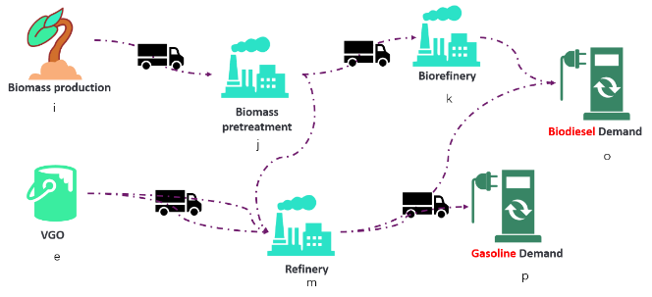
The superstructure of supply chain considered in this study is shown in Figure 1, where biomass collected (i) are transported to pretreatment centers (j). The biomass is processed into bio-oil in the pretreatment plant (j), and then are transported to a bio-refinery (k) for processing into biodiesel, or to a petrochemical refinery (m) in the catalytic cracking process for further co-processing with vacuum gas oil to produce gasoline and diesel. Vacuum gas oil (o) can also be processed directly in petrochemical refineries to produce gasoline and diesel. Bio-refined products can be mixed with petrochemical products. Finally, diesel and gasoline are shipped as products to customers where there is demand.
Figure 1. Supply chain network structure
In order to reflect data fluctuations in the real supply chain, the biomass supply is divided into 12 sub-intervals on a monthly basis, and the 12 sub-intervals are allocated respectively according to the fluctuations of the actual monthly biomass production data on the NSDA. Given where the demand points are, where the biomass feedstock is, the potential locations of pretreatment plants, biorefineries and petrochemical refineries, as well as the product demand and biomass output of each region and the population of each county, the aim is to optimize the number and location of pretreatment plants, biodiesel refineries and petrochemical refineries, and selection of conversion paths, so that minimize annual economic costs by optimizing supply chain network structure. The transportation distance and transportation cost in the supply chain network system can be calculated based on geographical location (Brummelen, 2013). The following assumptions were taken into account in establishing the mathematical model:
- The locations and processing capacities of both petrochemical refineries and bio-refineries are known.
- The processing costs at different stages of the production process are known and directly proportional to the amount of processing.
- The fixed cost of constructing a facility is known.
- A petrochemical refinery can process both diesel oil and VGO by using the co-production process of catalytic cracking.
- The ratio of feedstock produced through the co-production is fixed and must be put into production in the form of 1 part bio-oil and 9 parts vacuum gas oil.
  - Mathematical model
The mathematical model is developed to minimize the total annual cost (TAC), which includes the construction cost of plants, transportation cost between nodes, storage cost and processing fees for each node. The objective function:
$$F=Min(CostT+CostP+CostS+CostF)$$ | (1)
Where, CostT indicates the cost incurred in the transportation process within the supply chain, CostP represents the expenses of processing, CostS represents the cost of warehousing, CostF indicates the fixed cost of constructing factories.
The cost of transportation is directly proportional to the distance and the amount of goods being transported.
$$CostT=\sum_{tϵT}{\left[\sum_{iϵI}{\sum_{jϵJ}{c_{ij}×d_{ij}\text{×}q_{ijt}}}+\sum_{jϵJ}{\sum_{kϵK}{c_{jk}×d_{jk}\text{×}q_{jkt}}}+\sum_{kϵK}{\sum_{oϵO}{c_{ko}×d_{ko}\text{×}q_{kot}}}+\sum_{jϵJ}{\sum_{mϵM}{c_{jm}×d_{jm}\text{×}q_{jmt}}}+\sum_{kϵK}{\sum_{mϵM}{c_{km}×d_{km}\text{×}q_{kmt}}}+\sum_{mϵM}{\sum_{oϵO}{c_{mo}×d_{mo}\text{×}q_{mot}}}\right]}$$ | (2)
The cost of production and storage is calculated by multiplying the quantity by the unit cost. The fixed cost of factory construction is obtained by multiplying the number of factories to be built by the unit fixed construction cost. A detailed description of each variable and constraint is not given for space reasons.
$$CostP=\sum_{tϵT}{\left[\sum_{jϵJ}{CJU×A_{jt}}+\sum_{kϵK}{CKU×A_{kt}}+\sum_{mϵM}{CMU×A_{mt}}+\sum_{mϵM}{CMU×A_{mmt}}\right]}$$ | (3)
$$CostS=\sum_{tϵT}{\left[\sum_{jϵJ}{CJS×S_{jt}}+\sum_{kϵK}{CKS×S_{kt}}+\sum_{mϵM}{CMS×S_{mt}}+\sum_{mϵM}{CMS×S_{mmt}}\right]}$$ | (4)
$$CostF=\sum_{jϵJ}{f_{j}×Y_{j}}+\sum_{kϵK}{f_{k}×Y_{k}}+\sum_{mϵM}{f_{m}×Y_{m}}+\sum_{mmϵMM}{f_{mm}×Y_{mm}}$$ | (5)
  - Case studies and data results
In this supply chain network, location and capacity data for biomass production and refineries in Illinois comes from the official website of the U.S. Energy Information Administration (EIA). The locations of ten biomass points, four crude oil points, seven potential pretreatment plants, seven potential petrochemical refineries, four diesel demand points and four gasoline demand points were selected based on geographic location. Consider storage for pretreatment plants, biorefineries and petrochemical refineries. The MINLP models for all cases are encoded in Lingo 18.0.
As can be seen from the supply chain network in Figure 1, there are three production lines in the network. The production Line 1 is the biomass raw material through the pretreatment plant to produce bio-oil, the bio-oil is transported to the biodiesel refinery to produce diesel, and then transported to the diesel demand point. The production Line 2 is to mix the bio-oil produced by the biomass with the VGO in a certain proportion and then transport to a catalytic cracking petrochemical refinery to produce gasoline and diesel, which are finally transported to the demand point. The production Line 3 is the production of gasoline and diesel by catalytic cracking of VGO directly, and the two products produced are transported to the point of demand.
Seasonality can have an impact on annual costs. Taking into account seasonality, the corresponding annual total costs are shown in the table below. Considering seasonality, there is only a less increase in annual costs (0.002%). This is because when the supply chain is involved in changes in supply and demand, the cheapest production methods may not be able to meet demand at any given time, or other production lines may need to be mobilized to make up for the impact of supply and demand changes over time. Since the supply of raw materials is basically sufficient, the impact of seasonal fluctuations on annual costs is not obvious. When collaborative production is not considered, the supply chain only runs production Line 1 and production Line 3, and the total annual cost of the non-integrated supply chain is higher than that of the integrated supply chain, as shown in the table below. This shows that collaborative production can reduce the annual cost (0.9%) of this supply chain.
Table 1. Annual costs under different circumstances
Type | Annual Cost (Millions of dollars)
Consider seasonality of raw materials and seasonality of demand | 924.38
Do not consider the seasonality of raw materials and demand | 924.36
Non-cooperative production model | 932.91
Cooperative production model | 924.38
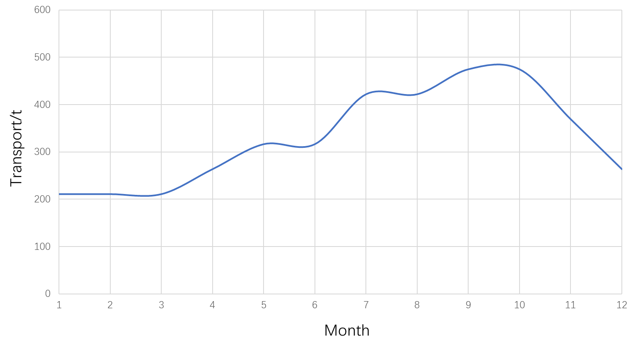  Figure 2. Monthly variation curve of biomass yield | 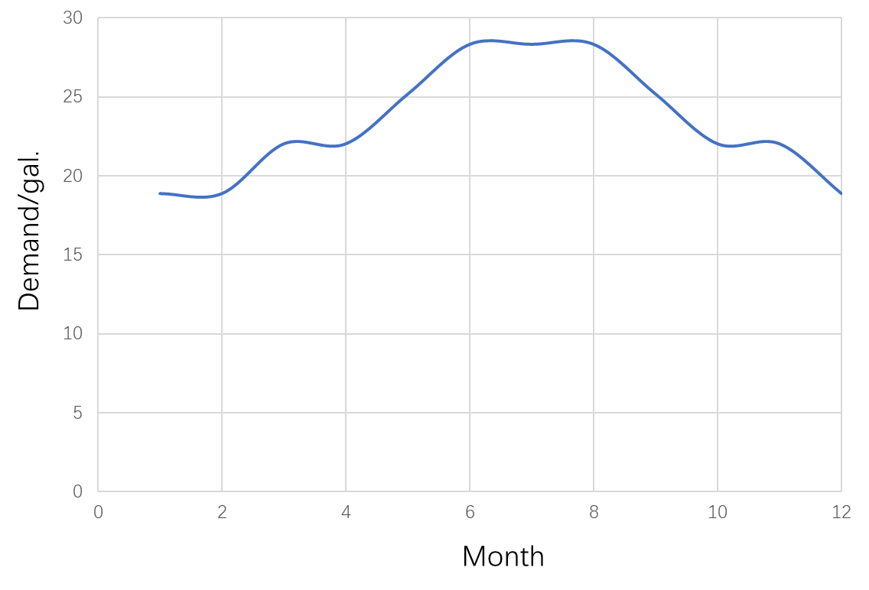  Figure 3. Monthly variation curve of gasoline demand
The supply of biomass is more seasonal, with higher yields generally in autumn. The monthly variation curve of biomass yield is shown in Figure 2. The demand for gasoline is higher in the summer, and the demand curve with month is shown in Figure 3. The rest of the supply and demand are more stable and are not considered in this case. The number of raw materials transported by each production line in different months is shown in Figure 4.
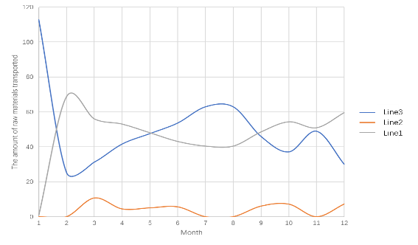
Figure 4. The number of raw materials transported by each production line in different months
As can be seen from Figure 4, at the beginning of the year, due to the low yield of biomass and the long processing cycle (pretreatment is required before it can be put into production), Line3 became the mainstream of production proportion. With the increase in the output of biomass raw materials and the smooth processing of pretreatment links, the biomass production capacity has been increased, and in February, March, April and May, Line1 has become the production line with the largest supply of raw materials. At the same time, the mixed collaborative production Line 2 also gradually occupies a certain production share, and the production share is limited because the economic advantage of this production mode is not as good as that of the traditional model. Since then, the demand for gasoline has increased one after another, and the production capacity of Line1 has not been enough to meet market demand, so Line3 has the highest conversion rate of gasoline, and has once again become the mainstream of production. After September, the demand for gasoline has decreased, and the proportion of production of two production lines with biomass as raw material Line 1,2 has increased. In both cases, the number and location of factories in each node are the same, which indicates that in this model, the addition of seasonality does not affect the optimal structure of the supply chain.
  - Conclusion
This study proposes a new collaborative production supply chain model, which integrates the catalytic cracking process in traditional petrochemical production with the biodiesel production process to increase production and realize the conversion of biomass feedstock to gasoline products. In this paper, a mixed integer nonlinear programming (MINLP) model is proposed to optimize the network model of the integrated supply chain of biodiesel and petroleum. An integrated biodiesel and petroleum supply chain that makes better use of petrochemical plant idle capacity, minimizes total annual costs, and improves energy supply reliability. In order to deal with the complexity and uncertainty of the actual biodiesel supply chain, the biomass supply variance is subdivided into 12-month sub-intervals to improve the reliability of the supply data. The goal is to keep annual operating expenses to a minimum as low as possible. Consider a real case in the U.S. state of Illinois. Co-production can reduce the cost of the supply chain, which is much more environmentally friendly due to the addition of biomass feedstocks. The addition of seasonality adds a small amount to the annual cost of the system, but allows the supply chain to better regulate transportation and distribution at different times. When there is seasonality, the system will optimize the supply chain network structure according to the demand of different months, and change the contribution of each production line. However, the addition of seasonality does not affect the optimal structure of this supply chain system.
References
Z. Ghelichi, M. Saidi-Mehrabad, M.S. Pishvaee, A stochastic programming approach toward optimal design and planning of an integrated green biodiesel supply chain network under uncertainty: A case study, Energy. 156 (2018) 661–687.
S. Depren, Energy consumption and environmental degradation nexus: A systematic review and meta-analysis of fossil fuel and renewable energy consumption, Ecol. Inform. 70 (2022) 101747.
J. Inumaru, Fossil fuels combustion and environmental issues, Adv. Power Boil. (2021) 1–56.
O. Ellabban, enewable energy resources: Current status, future prospects and their enabling technology, Renew. Sustain. Energy Rev. 39 (2014) 748–764.
W. Marquardt, A. Harwardt, M. Hechinger,, The biorenewables opportunity - toward next generation process and product systems, AIChE J. 56 (2010) 2228–2235.
D. Yue, F. You, S.W. Snyder, Biomass-to-bioenergy and biofuel supply chain optimization: Overview, key issues and challenges, Comput. Chem. Eng. 66 (2014) 36–56.
P. Daoutidis, A. Kelloway, W.A. Marvin, S. Rangarajan, A.I. Torres, Process systems engineering for biorefineries: new research vistas, Curr. Opin. Chem. Eng. 2 (2013) 442–447.
K. Tong, F. You, G. Rong, Robust design and operations of hydrocarbon biofuel supply chain integrating with existing petroleum refineries considering unit cost objective, Comput. Chem. Eng. 68 (2014) 128–139.
U.S. department of energy, Replacing the Whole BarrelTo Reduce U.S. Dependence on Oil, (2013).
A.T. Espinoza Pérez, M. Camargo, P.C. Narváez Rincón, M. Alfaro Marchant, Key challenges and requirements for sustainable and industrialized biorefinery supply chain design and management: A bibliographic analysis, Renew. Sustain. Energy Rev. 69 (2017) 350–359.
L. Wu, Y. Yang, T. Yan, Y. Wang, L. Zheng, K. Qian, F. Hong, Sustainable design and optimization of co-processing of bio-oil and vacuum gas oil in an existing refinery, Renew. Sustain. Energy Rev. 130 (2020) 109952.
ILSoybean, Home, Ill. Soybean Assoc. (2023). https://www.ilsoy.org.
USDA, Field Crops Usual Planting and Harvesting Dates, (2010).
A. Sheel, Y. p. Singh, V. Nath, Issues of biodiesel supply chain for public sector transportation in India, Int. J. Bus. Perform. Supply Chain Model. 12 (2021) 27–43.
Y. (Eric) Huang, Y. Fan, C.-W. Chen, An Integrated Biofuel Supply Chain to Cope with Feedstock Seasonality and Uncertainty, Transp. Sci. 48 (2014) 540–554.
K. Tong, M.J. Gleeson, G. Rong, F. You, Optimal design of advanced drop-in hydrocarbon biofuel supply chain integrating with existing petroleum refineries under uncertainty, Biomass Bioenergy. 60 (2014) 108–120.
F. Xie, Y. Huang, S. Eksioglu, Integrating multimodal transport into cellulosic biofuel supply chain design under feedstock seasonality with a case study based on California, Bioresour. Technol. 152 (2014) 15–23
G.V. Brummelen, Heavenly Mathematics: The Forgotten Art of Spherical Trigonometry, Princeton University Press, 2013.

