Hydrogen production from biogas with electrified steam methane reforming: system optimization with renewable generation and storages
Andrea Nava,^{a*} Davide Remondini,^{b} Matteo Lualdi,^{b} Stefano Campanari,ª Matteo C. Romano,ª
ªPolitecnico di Milano, Department of Energy, Via Lambruschini 4, Milano 20156, Italy
^{b}Snam S.p.A., San Donato Milanese, Milano 20097, Italy
andrea.nava@polimi.it
Abstract
Biogas is a renewable resource produced by anaerobic digestion, that had a significant deployment in Europe in the last 20 years for electricity and heat generation. The biogenic CO₂ emission associated with biogas and biomethane utilization in 2020 was 24 Mton in Europe (EBA, 2022). Therefore, introducing alternative pathways such as the production of decarbonised energy carriers from biogas with CO₂ capture and storage would allow to achieve negative emissions and generate significant carbon credits.
This work analyses a process for biogas conversion into hydrogen with CO₂ separation and liquefaction using the novel electrified steam reforming (eSMR) technology. The chemical plant is simulated with Aspen Plus software and consists of two main sections: syngas generation by means of eSMR and water gas shift (WGS); gas separation section, where CO₂ is separated from syngas with MDEA-based absorption process and pure hydrogen is recovered with a Pressure Swing Adsorption (PSA) unit. The whole system is thermally integrated and the only external energy supply is electricity. System integration with renewable sources, battery energy storage system (BESS), gas storages and connection with power grid is optimized with GAMS, that allows to calculate the optimal renewable energy plant and storage system capacity , as well as the optimal equipment size.
The proposed biogas conversion system consumes 18 kWh/kg_{H2} of electricity (1.1 MW with an input of 390 Nm³/h of biogas) and 80% of this consumption is absorbed by the electrified reformer. 96% of the chemical energy of biogas is converted to hydrogen while 75% of the carbon is converted to high purity CO₂. The resulting cost of hydrogen depends on the share of renewable energy used, the renewable capacity factor and the size of the plant: in the short term, the cost varies between 6.2 and 7.1 €/kg on a small scale, while in future scenarios with reduced cost of renewable energy, the hydrogen cost would reduce to 4.2 €/kg. With 10 times larger plant, the cost can be further lowered at 2.5 €/kg.
Keywords: biogas, hydrogen, CO₂ separation, electrified steam methane reforming, economic optimization
  - Introduction
Electrified steam methane reforming is a novel technology that allows to reduce CO₂ emissions and provide flexible and compact heat generation (Wismann et al., 2019), enabling process intensification and design of reactors for syngas production suitable for small-scale applications such as biogas plants. In 2021, Europe produced 159 TWh of biogas and 37 TWh of bio-methane, and potential growth is estimated at 1326 TWh in 2040 (IEA, 2020). It is therefore interesting to evaluate the potential of alternative biogas conversion pathways for the production of decarbonized energy carriers with separation and capture of biogenic CO₂, which are able to yield negative emissions. The scope of this work is to evaluate bio-H₂ production from biogas plants such as those located far from the gas grid and unsuitable for conventional bio-methane production.
  - System design
    - Chemical Island
The conversion system is presented in Figure 1 and exploits 390 Nm³/h of biogas, representative of an average biodigester size in the typical agriculture context of north Italy. Biogas properties and main plant assumptions are reported in Table 1.
Table 1 – Biogas properties (left) and summary of main process assumptions (right).
Mass flowrate |  | 500 | kg/h |  | Saturator | H₂O/CH₄ molar ratio | 3.5 | -
LHV |  | 15.4 | MJ/kg |  | eSMR | Temperature out | 800 | °C
Molar mass |  | 28.6 | kg/kmol |  | eSMR | Pressure out | 7 | bar
Thermal Input |  | 2.14 | MW_{LHV} |  | WGS | Adiabatic, Temperature In | 300 | °C
 |  |  |  |  | CO2 sep. | Capture efficiency | 95 | %
Molar fractions |  |  |  |  | PSA | H2 recovery efficiency | 90 | %
 | CH₄ | 55 | % |  | Compressors | Isentropic efficiency | 70 | %
 | CO₂ | 45 | % |  | Compressors | Mech-electric eff. | 92 | %
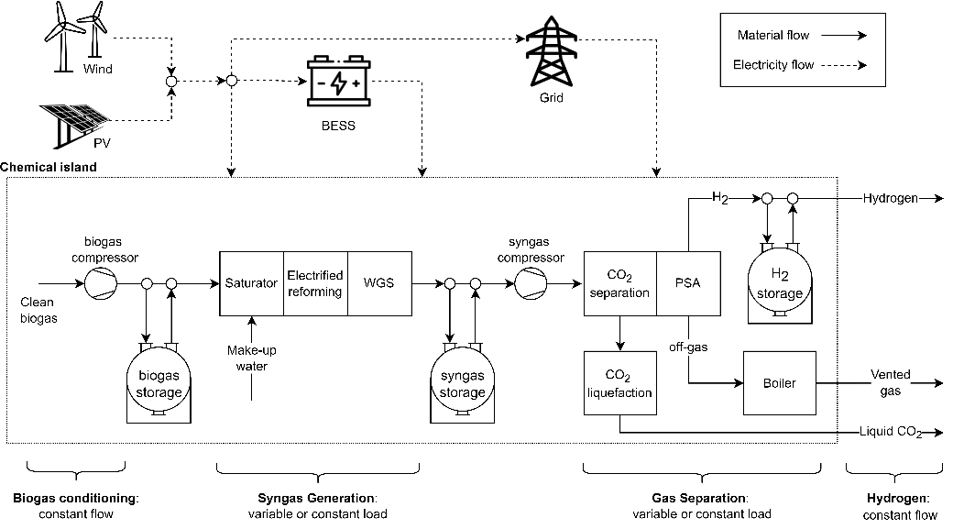
Biogas is compressed to 9 bar and feeds the saturation column, where the amount of circulating hot water is adjusted to reach the desired H₂O/CH₄ ratio. The wet biogas is pre-heated before feeding the eSMR, where syngas is produced at 800 °C and 7 bar. Syngas is cooled to generate saturated steam and is then fed to the adiabatic WGS at 300°C. Shifted syngas is further cooled and heat is exploited for pre-heating reactants and the biodigester water loop. Condensed water from the syngas is recovered and recycled to the saturator, while dry syngas is compressed to 30 bar and CO₂ is separated by means of MDEA-based absorption process. The CO₂ rich stream undergoes a compression and liquefaction process, delivering high-purity CO₂ transportable by truck (15 bar; -31 °C). Hydrogen from clean syngas is purified in a PSA unit. PSA off-gases are burned to generate additional steam. The total amount of steam generated in the plant is used (i) to regenerate the CO₂-enriched solvent in the reboiler of the CO₂ absorption process, (ii) to heat up the water feeding the saturator and the water loop of the bio-digester.
Figure 1 - Schematic of biogas conversion system with power supply and storage units.
    - System integration
The only external energy supply of the chemical island is electricity, which can be supplied to the system via renewable sources (e.g. PV panels, wind) or from the electric grid. BESS is charged when the renewable production is greater than the load and discharged at times of low availability. As shown in Figure 1, the plant is equipped with gas storage units, that allow flexible operation of the chemical island. Syngas generation increases by emptying the biogas storage to take advantage of renewable production peaks, while it decreases in periods of reduced renewable availability by filling the biogas tank. The syngas storage allows to decouple the two sections of the chemical island dedicated to reforming and CO₂ separation, while the hydrogen storage allows delivering a constant hydrogen flow at the plant outlet.
  - Methods and key performance indicators
The chemical island was modelled and simulated in Aspen Plus® for both design and part-load conditions, by using the Peng-Robinson equation of state and the Electrolyte-NRTL model for the amine-based absorption process, the saturation column and the water separation vessels. Columns were modelled with a rate-based approach, while eSMR and WGS reactors are calculated at chemical equilibrium. At part load, the electric power for the eSMR is controlled to keep the outlet temperature constant, while the solvent flowrate is adjusted to keep the CO₂ capture efficiency at 95%.
Heat exchangers area is fixed at design conditions, while the heat transfer coefficients are varied depending on the fluids flow rate with an exponential law (exponent n=0.8 for shell and tube and n=0.67 for plate heat exchangers) as in Eq. (1).
$h_{off}=h_{design}{\left(\frac{{\dot{m}}_{off}}{{\dot{m}}_{design}}\right)}^{n}$; $U_{off} = {\left(\frac{1}{h_{hot,off}}+\frac{1}{h_{cold,off}}\right)}^{-1}$ | $$\left[\frac{W}{m^{2}K}\right]$$ | (1)
Integration with renewable sources, grid and storage units is modelled with GAMS optimization software and mixed integer linear programming (MILP) method, using energy and mass balance equations of the chemical plant from Aspen Plus. Mass balances at gas storages boundaries, energy balance for the state of charge of the battery, energy balances between power production, BESS, grid and electricity absorbed by the plant are computed along the year with hourly resolution. The optimization variables are the capacity of renewable plants, BESS and gas storage units. Nonlinear economic equations coupling gas flow rate with plant cost allow the calculation of the optimal size of chemical island equipment and were linearized with the piecewise method. The objective function is the total annual costs, which is minimized using the CPLEX solver. Wind and solar power distribution is taken from Pfenninger et al. (2016) for different locations.
The key performance indicators are the hydrogen production, the carbon capture ratio, specific electric consumption and the Renewable Energy Share, that represents the percentage of renewable energy used by the chemical plant during the year, as defined in Eq. (2).
Renewable Energy Share | $$RENS= \frac{\sum_{t=1}^{8760}{(E_{renew, to chemical island}\left(t\right))∙∆t}}{\sum_{t=1}^{8760}{{(E}_{chemical island})∙∆t}} ∙100 \left[\%\right]$$ | (2)
The economic analysis was carried out with the methodology of Turton (2012), whose tables were used for estimating the cost of conventional components. The cost of the WGS and PSA units was taken from Rath et al (2010) and the electrified reformer cost was estimated with an in-house model using the technology developed by Politecnico di Milano (Ambrosetti et al., 2023). The currency is updated to €²⁰¹⁹ with the CEPCI index. Costs of renewable technologies were taken from IRENA (2022), gas storages from Apt et al. (2008), while future cost forecasts were derived from Ram et al. (2020). The cost of electricity from the grid was assumed flat and equal to 150 €/MWh in the current scenario and 100 €/MWh in the future scenario. As for CO₂ produced, a credit of 100 €/t and a transport cost of 50 €/t were considered, resulting in a net revenue of 50 €/t.
Emissions from Italian grid, equal to 356 g_{CO2}/kWh (Scarlat et al., 2022) and embedded emission from PV (645 kg_{CO2}/kW_{el} from Müller et al., 2021), wind turbines (500 kg_{CO2}/kW_{el} from Schreiber et al., 2019) and Li-Ion batteries (129 kg_{CO2}/kWh_{el} from Bonalumi & Kolahchian Tabrizi, 2022) are considered for power production.
  - Results
The main results of the chemical island are shown in Table 3, where it can be noted that 96% of the chemical energy of biogas is converted into hydrogen while 75% of the biogenic carbon is available as high purity CO₂. Electric consumption of the chemical island is equal to 17.7 kWh/kg_{H2}, 78% of which goes for the electrified reforming, 13% for biogas and syngas compression and 7% for CO₂ compression (132 kWh/t_{CO2}), while the CO₂ separation thermal duty is equal to 2.15 MJ/kg_{CO2}.
The total CAPEX of the chemical island is 3.5 M€, including 1.4 M€ for CO₂ capture (40 €/t_{CO2}) and 1.4 M€ for syngas generation (0.35 M€ for the eSMR).
Considering a biodigester located in north Italy as a reference, the optimal renewable energy share (RENS) is 27%, as shown in the first column of the optimization results in Table 3, and system emissions are equal to -4.7 kg_{CO2}/kg_{H2}.
Table 3 Main results of the chemical island operating parameters and optimization results.
Chemical island results
H₂O/CH₄ at reformer inlet |  |  |  |  | - |  |  | 3.50
CH₄ conversion in eSMR |  |  |  |  | % |  |  | 95.1%
CO conversion in WGS |  |  |  |  | % |  |  | 73.2%
Biogas input |  |  |  |  | kW_{LHV} |  |  | 2142
Hydrogen output |  |  |  |  | kW_{LHV} |  |  | 2064
CO₂ specific capture |  |  |  |  | kg_{CO2}/kg_{H2} |  |  | -9.42
Carbon capture ratio |  |  |  |  | % |  |  | 75.9
H₂ production |  |  |  |  | MW_{H2}/MW_{BG} |  |  | 96.3%
Electricity consumption |  |  |  |  | kWh_{el}/kg_{H2} |  |  | 17.7
Optimization results (flexible system located in north Italy)
RENS |  | 27% | 40% | 60% |  | 80% | 90% |  | 95% | 100%
PV capacity | MW | 2.01 | 2.61 | 2.57 |  | 3.29 | 3.75 |  | 4.30 | 6.23
Wind capacity | MW | - | 0.47 | 2.42 |  | 3.99 | 4.49 |  | 4.70 | 11.49
BESS capacity | MWh | - | - | - |  | - | 3.21 |  | 6.35 | 17.44
BESS equivalent cycles | - | - | - | - |  | - | 202 |  | 164 | 28
Biogas storage size | m³ | - | 120 | 205 |  | 1036 | 1251 |  | 1367 | 973
Biogas storage hours | h | - | 2.4 | 4.1 |  | 20.9 | 25.3 |  | 27.6 | 19.7
Syngas storage size | m³ | - | 479 | 729 |  | 1411 | 2285 |  | 3370 | 2378
Syngas storage hours | h | - | 2.4 | 3.6 |  | 7.0 | 11.3 |  | 16.7 | 11.8
Hydrogen storage size | m³ | - | - | - |  | 270.7 | 276.5 |  | 187.9 | 102.2
Hydrogen storage hours | h | - | - | - |  | 9.5 | 9.7 |  | 6.6 | 3.6
Syngas generation size | % | 100% | 100% | 132% |  | 165% | 164% |  | 159% | 119%
Gas Separation size | % | 100% | 100% | 102% |  | 147% | 145% |  | 138% | 102%
Captured CO₂ | kg_{CO2}/kg_{H2} | -9.42 | -9.42 | -9.42 |  | -9.42 | -9.42 |  | -9.42 | -9.42
Net emissions | kg_{CO2}/kg_{H2} | -4.69 | -5.44 | -6.64 |  | -7.81 | -8.36 |  | -8.60 | -8.42
By constraining the RENS, the optimal capacity of PV and wind increases, and for RENS greater than 80% a battery has to be installed. The solution with RENS=100% is hardly feasible and leads to slightly higher emissions than the case with RENS=95% due to oversizing of renewable and battery capacity and the curtailment of 60% of electricity.
The hydrogen production cost breakdown is shown in Figure 2, and is equal to 4.7 €/kg in the optimal solution, where the contribution on the hydrogen cost of the chemical island is 0.6 €/kg, PV is 0.3 €/kg and grid electricity accounts for 1.9 €/kg as for biogas.
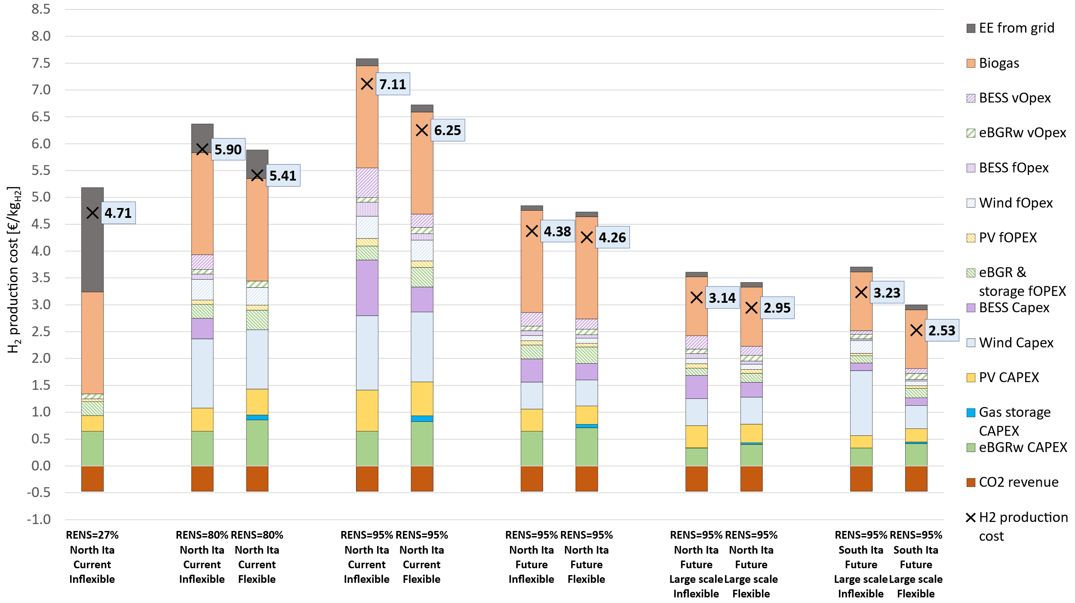
Figure 2 H₂ cost breakdown for different RENS values, plant size and locations
As RENS increases, the lower contribution of grid electricity is not offset by the higher cost of renewables and battery, and consequently the cost of hydrogen production increases to 7.1 €/kg.
In Flexible systems, the CAPEX of the chemical island rises to 0.9 €/kg_{H2}, while the contribution of gas storage units is always very low and at most equal to 0.1 €/kg_{H2}. Therefore, the option of a flexible operation decreases the hydrogen cost, as the economic burden of an oversized chemical island and of the gas storage units is offset by the smaller renewable plant and battery capacity. For example, with RENS=95% it is possible to reduce the cost of hydrogen from 7.1 to 6.3 €/kg by making the system flexible. The difference between flexible and inflexible plants is reduced in the future scenario, due to the reduced specific cost of renewable energy technologies.
Biogas production cost for the small biodigester is equal to 55 €/MWh and represents the largest share on hydrogen cost (1.9 €/kg). By increasing the size of the biodigester, the cost of biogas can be reduced at 32 €/MWh (IEA, 2020). Considering a system with a biodigester capacity of 3900 Nm³/h (i.e. 10 times the size of the reference case), the cost of hydrogen would reduce significantly to 2.9-3.1 €/kg, thanks to the economies of scale. The cost difference between a flexible and inflexible system increases on a large scale, and is greater when the availability of renewable energy increases, as can be observed in the case of south Italy, where flexibility can reduce the cost from 3.2 €/kg to 2.5 €/kg.
  - Conclusions
With the electrification of the reformer, it is possible to intensify the syngas generation process even at small-scale and convert almost all of the energy from the biogas into hydrogen, since no gas needs to be burned to sustain the endothermicity of the process and heat is provided by electrical elements. With the separation and capture of CO₂ from the generated syngas, it is possible to achieve a system with negative emissions of up to -8.6 kg_{CO2}/kg_{H2} through the use of renewable electricity and gas and electricity storage units. Hydrogen production cost was minimized by using results from Aspen as input to an optimization algorithm developed in GAMS. Hydrogen cost increases with RENS because of the higher renewable and BESS capacity required to meet the plant load, and varies between 4-7 €/kg in the short-term scenario for a small-scale plant located in north Italy. Locations with higher solar and wind availability (e.g., south Italy) allow to decrease the renewable capacity required for the same amount of energy, and thus reduce the cost of hydrogen production. Moreover, by increasing the size of the system and taking advantage of economies of scale in the chemical island and biodigester, it is possible to further reduce the cost of production, up to 2.5 €/kg in the most favourable case of high availability of PV and wind as typical of south Italy.
References
Ambrosetti, M., Beretta, A., Groppi, G., Romano, M. C., & Tronconi, E. (2023). Reactor with electrically heated thermo-conductive structure for endothermic catalytic process (Patent No. WO 2023/062591 A1).
Apt, J., Newcomer, A., Lave, L. B., Douglas, S., & Dunn, L. M. (2008). An Engineering-Economic Analysis of Syngas Storage. U.S. Department of Energy’s National Energy Technology Laboratory, January 2015, 143.
Bonalumi, D., & Kolahchian Tabrizi, M. (2022). Re-evaluation of the Global Warming Potential for the Production of Lithium-Ion Batteries with Nickel-Manganese-Cobalt Cathode Chemistries in China. Energy and Fuels, 36(22), 13753–13767. https://doi.org/10.1021/ACS.ENERGYFUELS.2C02204/ASSET/IMAGES/MEDIUM/EF2C02204_0013.GIF
EBA. (2022). Statistical Report 2022 Tracking biogas and biomethane.
IEA. (2020). Sustainable supply potential and costs – Outlook for biogas and biomethane: Prospects for organic growth – Analysis - IEA. https://www.iea.org/reports/outlook-for-biogas-and-biomethane-prospects-for-organic-growth/sustainable-supply-potential-and-costs
IRENA. (2022). IRENA (2022), Renewable Power Generation Costs in 2021, International Renewable Energy Agency, Abu Dhabi. ISBN 978-92-9260-452-3. International Renewable Energy Agency, 160. https://www.irena.org/-/media/Files/IRENA/Agency/Publication/2018/Jan/IRENA_2017_Power_Costs_2018.pdf
Müller, A., Friedrich, L., Reichel, C., Herceg, S., Mittag, M., & Neuhaus, D. H. (2021). A comparative life cycle assessment of silicon PV modules: Impact of module design, manufacturing location and inventory. Solar Energy Materials and Solar Cells, 230, 111277. https://doi.org/10.1016/J.SOLMAT.2021.111277
Pfenninger, S., & Staffell, I. (2016). Long-term patterns of European PV output using 30 years of validated hourly reanalysis and satellite data. Energy, 114, 1251–1265. https://doi.org/10.1016/j.energy.2016.08.060
Ram, M., Galimova, T., Bogdanov, D., Fasihi, M., Gulagi, A., Breyer dena, C., Micheli, M., & Crone, K. (2020). POWERFUELS in a Renewable Energy World. www.dena.de
Rath, Lawrence K and Chou, Vincent H and Kuehn, N. J. (2010). Assessment of Hydrogen Production with CO2 Capture Volume 1: Baseline State-of- the-Art Plants. In Doe/Netl-2010/1434 (Vol. 1). www.netl.doe.gov
Scarlat, N., Prussi, M., & Padella, M. (2022). Quantification of the carbon intensity of electricity produced and used in Europe. Applied Energy, 305, 117901. https://doi.org/10.1016/J.APENERGY.2021.117901
Schreiber, A., Marx, J., & Zapp, P. (2019). Comparative life cycle assessment of electricity generation by different wind turbine types. Journal of Cleaner Production, 233, 561–572. https://doi.org/10.1016/J.JCLEPRO.2019.06.058
Turton, Richard and Bailie, Richard C and Whiting, Wallace B and Shaeiwitz, J. A. (2012). Analysis, synthesis, and design of chemical processes. Prentice Hall.
Wismann, S. T., Engbæk, J. S., Vendelbo, S. B., Bendixen, F. B., Eriksen, W. L., Aasberg-Petersen, K., Frandsen, C., Chorkendorff, I., & Mortensen, P. M. (2019). Electrified methane reforming: A compact approach to greener industrial hydrogen production. Science (New York, N.Y.), 364(6442), 756–759. https://doi.org/10.1126/SCIENCE.AAW8775/SUPPL_FILE/AAW8775-WISMANN-SM.PDF

