Global modelling and simulation of essential oil extraction processes
Zouhour LIMAM^{1,2} , Catherine AZZARO-PANTEL¹ , Noureddine HAJJAJI² , Mehrez ROMDHANE³ , Jalloul BOUAJILA¹
¹ Laboratoire de Génie Chimique, Université de Toulouse, CNRS, INPT, UPS, Toulouse France.
² Laboratory of Catalysis and Materials for Environment and Processes (UR11ES85), National School of Engineers, University of Gabes, Tunisia
³ Laboratory of Energy, Water, Environment and Processes (LR18ES35), National School of Engineers, University of Gabes, Tunisia

Abstract
Traditional essential oil extraction methods using organic solvents such as ethanol, hexane, methanol, acetone, and even water, have raised environmental concerns due to their high energy and solvent consumption. In response, researchers are exploring alternative techniques like ultrasound-assisted, supercritical fluid, and microwave-assisted extractions to reduce the ecological impact. This study aims to develop a comprehensive modeling framework for essential oil extraction, with a specific focus on supercritical fluid and water distillation technologies. The models developed have been successfully validated against experimental data. Supercritical fluid extraction has proven to be the most energy-efficient method. Additionally, this modeling facilitates the transition from laboratory or pilot scale to industrial production. The results obtained from this study will serve as inventory data for conducting environmental Life Cycle Assessment (LCA).

Keywords: Essential oil, Simulation, Aspen plus™, Eucalyptus intertexta, Rosemary.
  - Introduction
Essential oils (EOs) are formed in aromatic and medicinal plants as products of secondary metabolism. Extracting them can be seen as a complex and delicate process to capture and collect the most volatile, subtle, and delicate products that the plant produces, all without compromising their quality. Various extraction methods have been developed for distilling the terpenic molecules from fragrance plants, categorized into ancient and modern technologies. Traditional extraction methods have historically relied on organic solvents such as ethanol, hexane, methanol, acetone, and even water to extract essential oils from aromatic and medicinal plants. However, these methods have raised environmental concerns due to significant energy consumption and solvent usage. In response to these issues, researchers have been actively investigating alternative extraction techniques, including ultrasound-assisted extractions, supercritical fluids, and microwave-assisted extractions, with the goal of mitigating emissions and reducing ecological impacts. According to the state-of-the-art analysis, the majority of research reported to date is focused on investigating specific extraction processes, both through experimental methods and modeling techniques to gain a deeper understanding of the physico-chemical phenomena governing the extraction process. It is noteworthy that there have been relatively few studies focused on simulating essential oil extraction processes from plants thus far. One notable contribution is the work of (Moncada et al., 2016): in this paper, a techno-economic and environmental assessment of the extraction of essential oil from Oregano and Rosemary in Colombia is thus performed with the Aspen Plus™ simulator for process modeling. Only a few investigations have also delved into exploring the essential oil supply chain (González-Aguirre et al., 2020). In this vein, the scientific objective of this study is thus to develop a comprehensive modelling framework for the extraction of essential oils that can serve as a basis for process selection. For this purpose, we will explore two different technologies, namely supercritical fluid extraction and water distillation. The extraction of essential oils from two types of leaves, namely Eucalyptus intertexta and Rosemary plants, has been studied. This paper is divided into four sections. Section 1 covers the essential oil extraction technique. Section 2 is dedicated to the modeling of essential oil extraction processes, including water distillation and supercritical fluid methods. Section 3 provides a detailed discussion and emphasizes key results. Finally, we draw conclusions and outline potential avenues for future research in Section 4.
  - Methodology
    - Traditional vs. emerging method for EO extraction
There are several techniques for extracting essential oils. We will focus on water distillation (WD) (Kant et al., 2022) as a traditional extraction method and on supercritical fluid extraction (SFE) (Kant et al., 2022) as a modern technology for comparison purpose.

    - Modeling of Essential Oil Extraction Processes
      - Modelling principles
The EO from the plant was modeled using Aspen Plus V14 software from Aspen Technology Inc., USA. The thermodynamic models employed include Unifac-Dortmund for calculating activity coefficients in the liquid phase and the Hayden-O'Connell equation of state to model the vapor phase (Moncada et al., 2016). The predictive models UNIFAC have proven their efficiency to obtain reliable results over a large range of applicability (Gmehling et al., 2012). Hayden and O'Connell’s method is well-suited to ideal and non-ideal systems at low pressures. To assess the accuracy and reliability of our modeled process scheme, two approaches were considered. Firstly, the modeling of essential oil extraction from Rosemary (Rosmarinus officinalis) was conducted using the operational data provided by (Moncada et al., 2016) for both water distillation and supercritical fluid extraction for validation purposes. Given that the publication did not explicitly detail the equipment employed, we leveraged insights from other literature pertaining to biomass valorization simulations (Rosha et al., 2022). Simultaneously, we compared the results obtained from the modeled process scheme for Eucalyptus intertexta, with experimental data provided in (Chamali, 2020). This comparison allowed us to evaluate the consistency and agreement between simulation results and laboratory data.

    - Process description
- Water Distillation Extraction (WDE)
The essential oil extraction process through WD involves the intake of 200kg/h of the raw material (RM), which is modeled as a non-conventional compound within the Aspen software. To identify it, it is necessary to determine its composition using proximate and ultimate analyses. To address this, analytical correlations established by (Park et al., 2023) are employed and the composition is solved using MATLAB software.
Subsequently, the plant material undergoes a drying process at a temperature of 30°C in a dryer. The dried solids are then ground to achieve a particle size of less than 0.5 cm in a mill, aiming to expose the oil fraction and increase the extraction yield (due to increased interfacial tension) in line with the observations of (Moncada et al., 2016).
The reduced solid is then directed into an extraction vessel. However, the Aspen software cannot simulate a non-conventional solid in an extraction column. To overcome this limitation, an RYield reactor is utilized to convert the non-conventional compound into a conventional compound, with reference to the compositions of Eucalyptus (Chamali, 2020) and Rosemary (Moncada et al., 2016) essential oils. A splitter is also employed for the extraction phase. Steam is generated within a heat exchanger and then introduced into the extraction column. The steam temperature is kept relatively low (around 90 - 100 ºC) to prevent the degradation of the essential oil compounds. Some authors have suggested using a solid/fluid ratio (kg:kg) for steam extraction. For instance, (Chamali, 2020) experimentally studied the impact of the solvent/dry plant material ratio and found the optimal ratios to be 10, 12, and 14. (Cassel et al., 2009) reported solid/vapor ratios of 2.2, 2.1, and 3.0 respectively for Rosemary, Basil, and Lavender, while Moncada reported a solid (dry)/vapor ratio of 5:1. For our modeling, we adopt Moncada's approach since we are working with a vapor-phase fluid. In this process, utilities included low-pressure steam (3 bars) as well as cooling water for heating and cooling respectively. After extraction, the steam containing the essential oil is rapidly cooled, resulting in two distinct liquid fractions: one rich in oil and the other rich in water. These fractions are separated in a decanter. Figure 1 illustrates the schematic of essential oil extraction through WD and Table 1 provides a description of the equipment used. Additionally, a step of waste recovery was incorporated to facilitate the generation of both heat and electricity (the section surrounded in Figure 1 integrates a waste combustion reactor and a power generation turbine.).

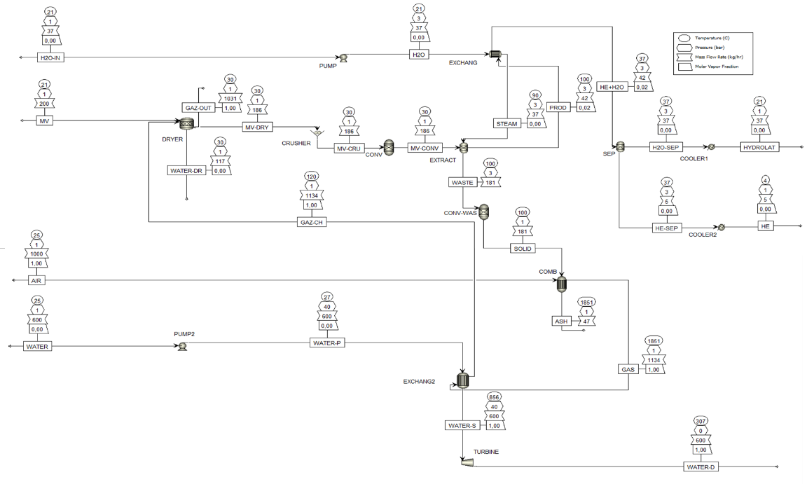
Figure 1. Flowsheet diagram for the extraction of essential oils using water distillation.

Table 1. Equipment used for WDE of essential oils
Step | Aspen reference | Description
Pump & pump2 | Pump | To pump the water.
Dyer | RStoic | Drying process to reduce moisture content, temperature (30°C), and pressure (1 bar).
Crusher | Crusher | To reduce the size of the RM particles.
Conv & conv-was | RYield | To convert non-conventional compounds into conventional ones.
Extract | Splitter | To extract essential oils from eucalyptus using steam at 100°C and 3 bars.
Exchang & Exchang2 | HeatX | To evaporate water using the product from other equipment
Sep | Separator | To separate the essential oil from water.
Cooler1 | Heater | To cool the hydrolat to 21°C (1 bar).
Cooler2 | Heater | To cool the essential oil to 4°C (1 bar)."
Comb | RGibs | To incinerate waste
Turbine | Turbine | To produce electricity.
- Supercritical Fluid Extraction (SFE)
The processes for preparing the raw material follow the same steps as explained for water distillation extraction. However, in this case, the fluid used for extraction is carbon dioxide (CO₂), a non-toxic and environmentally friendly solvent. The primary advantage of SFE lies in its selectivity and the conditions associated with this method reduce the risks of thermal decomposition of the components. Due to the volatility of SFs, it is possible to extract active compounds, which facilitates solvent recovery. SFE ensures high extraction yields in a short amount of time, without generating toxic waste. This process impresses with its solubility, selectivity, and rapid mass transfer. Currently, over 90% of SFE processes use CO₂ due to its accessibility, non-flammability, non-toxicity, and reasonable cost. The solvent is then routed to an evaporator to be transformed into the gaseous phase.
Subsequently, CO₂ undergoes a series of compressions and cooling processes to reach the required supercritical state. In this state, CO₂ exhibits properties intermediate between a gas and a liquid, making it an effective solvent for extracting volatile compounds. The supercritical solvent is then introduced into the extraction vessel where it comes into contact with the plant material. The volatile compounds from the plant are extracted into the supercritical solvent, due to its ability to diffuse through plant cells. After extraction, the solvent-compound mixture is directed to a separator. At this stage, pressure and temperature are adjusted to allow for the separation of the solvent from the mixture, leaving behind the extracted compounds.
These processes, involving the preparation if the raw material and the implementation of supercritical fluid extraction are pivotal steps in producing high-quality essential oils from aromatic and medicinal plants. Figure 2 illustrates the schematic of essential oil extraction through CO₂-sc and Table 2 provides a description of the equipment used.

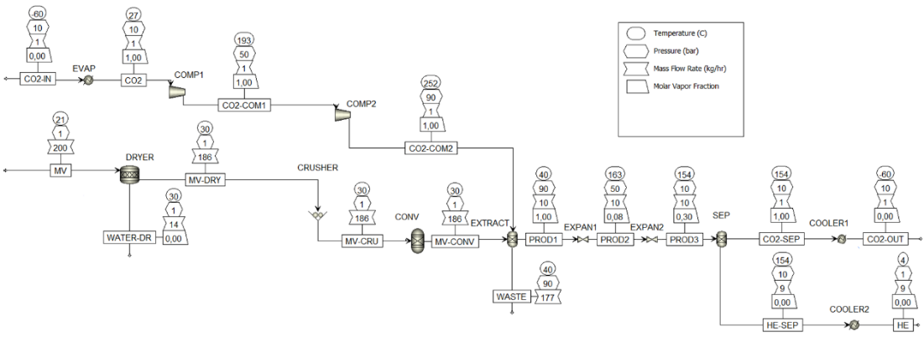
Figure 2. Flowsheet diagram for the extraction of essential oils using CO₂.

Table 2. Equipment used for the SFE of essential oils
Bloc | Aspen | Description
Evap | heater | To raise CO₂ from -60°C to 27°C (phase change) at 10 bars.
Comp1&2 | compressor | To compress CO₂ from 10 bars to 50 and 90 bars successively
Expan1&2 | Valve | To depressurize the mixture produced by the extraction tank from 90 bars to 50 and 10 bars successively.
Cooler1 | Heater | To cool CO₂ to -60°C (10 bars).
Cooler2 | Heater | To cool the essential oil to 4°C (1 bar).
  - Results
The primary focus of the process simulation analysis for extracting essential oil from Rosemary and Eucalyptus intertexta revolves around processing yield, defined as the quantity of essential oil obtained per ton of fresh raw material. Extraction yield is contingent upon both the employed technology and the inherent characteristics of the raw material. Notably, Rosemary, with a moisture content ranging between 60-70%, and Eucalyptus, with a moisture content of 7%, exhibit distinct yield variations. For Rosemary, the yields are recorded at 10.61 kg/t for SFE and 8.95 kg/t for WDE. SFE consistently demonstrates superior yields, with only a marginal impact on energy consumption. In the case of Eucalyptus, SFE yields 8 kg/t, whereas WDE yields 4 kg/t. To check how accurate our model is, we compared our simulation results with those obtained by (Moncada et al., 2016). Significant differences are observed, as shown in Table 3, but our results are within the range of the values obtained by the authors. These variations could be due to different factors such as assumptions, simulation conditions, input data, and calculation methods used by both approaches, regardless of whether they consider energy integration. In summary, supercritical fluid extraction consistently outperforms water distillation extraction in terms of yield for both Rosemary and Eucalyptus intertexta. Additionally, by repurposing the waste (i.e., 181 kg/h) generated after the extraction process for electricity and heat generation, the process can generate 197 kWh of electricity for water distillation, while generating 237 kWh for supercritical fluid extraction from 177 kg/h of waste. This innovative approach not only addresses waste management effectively but also makes a significant contribution to sustainable energy production.

Table 3. Comparison between the results found by Aspen and the results of (Moncada et al., 2016).
 | SFE |  |  | WDE
 | ASPEN | Article of (Moncada et al., 2016). |  | ASPEN | Article of (Moncada et al., 2016).
 |  | Without Integration | With Integration |  | Without Integration | With Integration
 | kJ/kg RM | kJ/kg RM | kJ/kg RM | kJ/kg RM | kJ/kg RM | kJ/kg RM
Heating | 62,71 | 128,94 | 79,87 | 84,08 | 148,43 | 44,56
Cooling | 37,44 | 136,88 | 31,17 | 107,19 | 148,08 | 44,14
  - Conclusion
In conclusion, this study has developed a comprehensive modeling framework for essential oil extraction, specifically emphasizing supercritical fluid and water distillation technologies. The models developed have been successfully validated against experimental data, showcasing their accuracy and reliability. Notably, the interest of this modeling lies in providing access to energy data that were not attainable at the laboratory scale. The findings affirm the superior energy efficiency of supercritical fluid extraction. Furthermore, the modeling approach not only contributes to a deeper understanding of the extraction process but also facilitates a seamless transition from laboratory or pilot scale to industrial production. The results obtained from this study serve as crucial inventory data for conducting environmental Life Cycle Assessment (LCA), thereby enhancing the sustainability assessment of essential oil extraction processes.
References
E. Cassel, R. M. F.Vargas, N. Martinez, D. Lorenzo D., E. Dellacassa , Steam distillation modeling for essential oil extraction process », Industrial Crops and Products, 1 Janvier 2009, vol. 29, no 1, p. 171‑176.
S. Chamali, Extraction et valorisation des principes actifs d'une plante tunisienne : optimisation et modélisation, thèse, Gabes, Tunisie, 2020.
G. Jürgen, X. Zhimin, M. Tiancheng, Reply to “Comments on ‘Comparison of the a Priori COSMO-RS Models and Group Contribution Methods: Original UNIFAC, Modified UNIFAC(Do), and Modified UNIFAC(Do) Consortium’”, Industrial & Engineering Chemistry Research 2012 51 (41), 13541-13543.
A. González, A. José, J. Solarte-Toro A. CardonaCarlos, Supply chain and environmental assessment of the essential oil production using Calendula (Calendula Officinalis) as raw material, Heliyon, 2020. Volume 6, Issue 11, e05606, ISSN 2405-8440.
Kant, Ravi, K. Anil« Review on essential oil extraction from aromatic and medicinal plants: Techniques, performance and economic analysis ». Sustainable Chemistry and Pharmacy 30 December 2022: 100829.
J. Moncada, J. Tamayo A. Cardona Carlos, « Techno-economic and environmental assessment of essential oil extraction from Oregano (Origanum vulgare) and Rosemary (Rosmarinus officinalis) in Colombia », Journal of Cleaner Production, 20 Janvier 2016, vol. 112, p. 172‑181.
S. Park , J. Kim Seok , C. Oh Kwang, H Cho La , D. Kim, « Developing a Proximate Component Prediction Model of Biomass Based on Element Analysis », Energies, Janvier 2023, vol. 16, no 1, p. 509.
P. Rosha , S. Kumar, H. Ibrahim « Sensitivity analysis of biomass pyrolysis for renewable fuel production using Aspen Plus », Energy, 15 March 2022, vol. 247, p. 123545.

