Integrating effort- and gradient-based approaches in optimal design of experimental campaigns
Marco Sandrin^{a,b}, Benoît Chachuat^{a*}, Constantinos C. Pantelides^{a,b}
ªSargent Centre for Process Systems Engineering, Department of Chemical Engineering, Imperial College London, London SW7 2AZ, United Kingdom
^{b}Siemens Industry Software, London W6 7HA, United Kingdom
*b.chachuat@imperial.ac.uk
Abstract
Model-based design of optimal experimental campaigns comprising multiple parallel runs can prove computationally challenging. Effort-based methods can help in overcoming some of these challenges through discretising the experimental design space. However, the quality of the resulting approximate solutions depends heavily on this a priori discretisation. This paper presents a methodology for integrating the appealing features of effort-based methods with those of conventional gradient-based approaches, with a view to computing maximally-informative campaigns of experiments for improving parameter precision. The effectiveness of the methodology is demonstrated on a case study involving a microbial culture dynamic model.
Keywords: model-based design of experiments, optimal experiment design, parameter precision
  - Introduction
Model-based design of experiments (MBDoE) is instrumental to accelerating the development of predictive mechanistic models in Process Engineering (Franceschini and Macchietto, 2008). Much of the work in this area to date has focused on sequential MBDoE aiming to improve parameter precision, where experiments are designed and executed one-at-a-time by maximising an appropriate measure of their information content using gradient-based methods. For nonlinear models, the resulting optimisation problems are typically nonconvex, making them prone to converge to suboptimal solutions or even fail when local optimisation techniques are used.
Effort-based methods (Fedorov and Leonov, 2014; Kusumo et al., 2022) are particularly suited for designing campaigns that comprise multiple experiments to be executed in parallel. They employ a discretisation of the experimental design space into a finite set of candidate experiments, and then determine the number of replicates (the efforts) of each candidate, with a view to maximising the information content of the combined experiments. This leads to a (possibly mixed-integer) convex program that can be solved reliably using state-of-the-art (mixed-integer) nonlinear optimisation techniques. A caveat of this approach is that the quality of the solution is strongly affected by the extent to which the set of candidates covers the experimental design space of interest.
In this contribution, we propose a methodology for integrating the appealing features of effort-based methods with those of conventional gradient-based approaches for designing maximally-informative parallel experimental campaigns. Following an initial discretisation of the experimental design spaces, the values of the efforts are first optimised to determine which candidate experiments should be included in the experimental campaign. In a second step, the selected experiments are refined using a gradient-based search to further increase the information content. The proposed methodology is implemented as a new experiment design solver within the gPROMS modelling framework (Siemens Industry Software, 1997–2023). We illustrate its effectiveness and benefits on a case study involving a microbial culture model.
  - Methodology
    - Problem definition
We consider a system with $n_{x}$ experimental controls $x∈X⊂R^{n_{x}}$ and $n_{y}$ measured responses $y∈R^{n_{y}}$,
$$y=η\left(θ,x\right)+ϵ$$ | (1)
where $θ ∈R^{n_{θ}}$ are the uncertain parameters in the model η. For simplicity, measurements are assumed to be independent, and the measurement error $ϵ∈R^{n_{y}}$ is assumed to have zero mean and uncorrelated homoscedastic covariance $Σ_{y}$.
We consider a campaign comprising $N_{t}>0$ experimental runs to be executed in parallel, with the objective of generating data for the estimation of the model parameters. Such campaigns often include repeated runs with identical experimental controls (replicates), so the experimental design $ξ$ can be defined as (Fedorov and Leonov, 2014)
$$ξ∶=\left\{\begin{matrix}x_{1} & … & x_{N_{c}} \\ p_{1} & … & p_{N_{c}}\end{matrix}\right\}$$ | (2)
where $N_{c}≤N_{t}$ is the number of distinct experiments, and $p_{i}∈\left(0,N_{t}\right]$ the number of replications (also called effort) of the i-th experimental candidate with controls $x_{i}$ for $i=1,…,N_{c}$ so that $\sum_{i=1}^{N_{c}}{p_{i}}=N_{t}$. The set of experimental controls $\left\{x_{i},…,x_{N_{c}}\right\}$ is the support of the experimental design $ξ$, $supp\left(ξ\right)$.
Determining the optimal design $ξ^{*}$ entails maximising some scalar information criterion $ϕ$ over all possible numbers of supports $N_{c}≤N_{t}$, the experimental controls $x_{i}$ and the corresponding efforts $p_{i}$ simultaneously.
$$ξ^{*}∈arg\max_{ξ}{ϕ(ξ)}$$ | (3)
Since our focus is on campaigns which are optimal for model calibration, the information criterion $ϕ$ is based on the Fisher information matrix (FIM), $M∈R^{n_{θ}×n_{θ}}$ computed as (Atkinson et al., 2007)
$$M\left(ξ,θ\right)∶=\sum_{i}^{N_{c}}{p_{i}A\left(x_{i},θ\right)}$$ | (4)
where $A$ is the atomic matrix associated with the experiment candidate $x_{i}$, and is calculated as
$$A\left(x_{i},θ\right)∶=\frac{∂η}{∂θ}{\left(x_{i},θ\right)}^{T} Σ_{y}^{-1} \frac{∂η}{∂θ}\left(x_{i},θ\right)$$ | (5)
    - Integration of effort- and gradient-based approaches
The proposed approach couples sampling- and gradient-based designs. Following a discretisation of the experimental space, the methodology iterates between solving an effort-based design—which provides the optimal number of supports and the values of the experimental efforts—and performing a conventional, gradient-based search over the space of the experimental controls. This approach is similar to that proposed by Vanaret et al. (2021); however, it is crucial to combine the algorithms in an iterative methodology, as optimality cannot be guaranteed after performing each step only once.
One possible way to integrate the two steps is to use the solution of the sampling-based design as the initial guess for the gradient-based design. Then, the refined supports may be added to the initial set of experiment candidates, and the exact design performed again to update the values of the efforts. A variation of the above involves taking only one iteration of the gradient-based algorithm, before returning to the effort-based formulation.
      - Effort-based step
The first optimisation step builds on the continuous-effort approach (Kusumo et al., 2022; Vanaret et al., 2021), in which the experimental design space is discretised into a finite set of experiment candidates $X_{s}∶=\left\{x_{i},…,x_{N_{s}}\right\}⊂X$ with $N_{s}≫N_{t}$, for instance through the application of low-discrepancy sampling (Sobol’, 1967). The search $ξ^{*}$ in Eq. (3) is then reduced to a search over the efforts $p_{i}$ associated with each experiment $x_{i}∈X_{s}$,
$$\left(p_{1}^{*},…,p_{N_{s}}^{*}\right)∈arg\max_{p}{ϕ}\left(p\right)$$ | (6)
where the optimal efforts $\left(p_{1}^{*},…,p_{N_{s}}^{*}\right)$ are allowed to assume zero values. The support of the optimal design $ξ^{*}$ is obtained after the solution of (6) as
$$supp\left(ξ^{*}\right)∶={\{x}_{j}∈X_{s} :p_{j}>0\}$$ | (7)
The optimal exact local design is computed by solving the following integer nonlinear program (INLP), in which the D-optimal design criterion is considered:
$$\max_{p}{\log{\det{\sum_{i=1}^{N_{s}}{p_{i}A}\left(x_{i},θ_{0}\right)}}}$$ | (8)
$$s.t. \sum_{i=1}^{N_{s}}{p_{i}}=N_{t}, p_{i}∈Z_{+},∀i$$ | (9)
Since we are computing a local design, the sensitivities and atomic matrices in (5) are calculated at a nominal parameter value $θ_{0}$. Except for the integrality restrictions $p_{i}∈Z_{+}$, the optimisation problem (8)–(9) is convex since the objective function is concave and the constraint is linear in the efforts $p_{i}$.
Solution of this INLP relies on an outer-approximation (OA) decomposition algorithm (Duran and Grossmann, 1986; Fletcher and Leyffer, 1994) as in Sandrin et al. (2023). The algorithm is initialised by solving a continuous nonlinear program (NLP) obtained by relaxing the integrality restrictions to $p_{i}≥0$. This NLP subproblem provides an upper bound on the exact design optimum, while a lower bound is computed by rounding the optimal efforts of the continuous design via apportionment techniques such as that proposed by Pukelsheim and Rieder (1992). Subsequently, the OA iterates between solving a mixed-integer linear (MILP) master subproblem—which updates the upper bound on the information content and provides a new exact design candidate—and evaluating the D-optimality criterion in lieu of a primal subproblem as there are no continuous decision variables. A single linear cut is added to the master subproblem at each iteration through linearising the convex objective at the solution point $\hat{p}$ from the previous iteration if the corresponding FIM in Eq. (4) is non-singular; otherwise, the integer cut $‖p-\hat{p}{\left.​\right\|}_{1} ≥1$ is appended to the master subproblem.
      - Gradient-based step
The solution of the exact design in (8)–(9) yields the set $X_{c}^{*}=\left\{x_{1}^{*},…,x_{N_{c}}^{*}\right\}⊆X_{s}$ together with the values of the associated efforts $p_{i}^{*}$, $i=1,…,N_{c}$. These can then serve as initial guesses for a gradient-based algorithm aiming to simultaneously design a set of $N_{c}$ distinct experiments.
The gradient-based experiment design problem, based on the D-optimal criterion, makes use of the EXPDES solver in gPROMS which employs the following objective function:
$$\max_{x∈X}{{\left(\det{\sum_{i=1}^{N_{c}}{p_{i}^{*}A}\left(x_{i},θ_{0}\right)}\right)}^{1/{N_{θ}}}}$$ | (10)
The function in (10) is highly nonconvex and therefore global optimality of the solution obtained cannot be guaranteed. However, since the initial guesses were obtained via the solution of the effort-based design problem, they should already be in highly informative regions of the experimental space; and any locally optimal solution obtained starting from these guesses should represent an improvement in the objective function.
The optimal solution $x_{i}^{**}$ of the problem (10) is appended to the original set of experimental candidates i.e. $X_{s}^{*}=X_{s}∪\{x_{1}^{**},…,x_{N_{c}}^{**}\}$. The next iteration of the effort-based approach is based on the augmented set $X_{s}^{*}$. The overall iteration terminates when two successive executions of the effort-based step return identical optimal solutions.
  - Case study
The proposed methodology is tested on a model describing the fermentation of baker’s yeast in a semi-batch reactor. Assuming Monod-type kinetics for biomass growth and substrate consumption, the system is described by the following set of ODEs:
$$\frac{dy_{1}}{dt}=\left(r-u_{1}-θ_{4}\right)y_{1}$$ | (11)
$$\frac{dy_{2}}{dt}=-\frac{ry_{1}}{θ_{3}}+u_{1}\left(u_{2}-y_{2}\right)$$ | (12)
with $r=\frac{θ_{1}y_{2}}{θ_{2}+y_{2}}$ | (13)
where $y_{1}$ [gL⁻¹] is the biomass concentration; $y_{2}$ [gL⁻¹] the substrate concentration; $u_{1}$[h⁻¹] the dilution factor; $u_{2}$ [gL⁻¹] the substrate concentration in the feed; and $θ_{i}$, $i=1,…,4$ the model parameters with nominal values $θ_{0}={\left[0.1, 0.1, 0.1, 0.1\right]}^{T}$.
A campaign comprising $N_{t}=4$ parallel experiments is to be designed. We assume a fixed experiment duration of $τ=10$ h and $N_{sp}=5$ equidistant sampling times for the output measurements $y_{1}$ and $y_{2}$. The initial conditions are $y_{1}\left(0\right)=7$ and $y_{2}\left(0\right)=0.1$. We assume time-invariant profiles for the experimental controls $u_{1}∈\left[0.05, 0.2\right]$, $u_{2}∈\left[5, 35\right]$.
For the effort-based design, we consider two different discretisations of the experimental design space, with $N_{s}=20$ and $N_{s}=100$ respectively. The effort-based optimisation is solved with gPROMS’ mixed-integer nonlinear programming solver MINLPOA. The relaxed NLP is solved using gPROMS’ sequential quadratic programming solver NLPSQP with both feasibility and optimality tolerances set to ${10}^{-9}$. Master MILP subproblems are solved using XPRESS (FICO, 1983–2023) with relative and absolute convergence tolerances of ${10}^{-6}$ and ${10}^{-9}$, respectively. The OA iterations are terminated when the absolute gap between the master solution value and the incumbent is below ${10}^{-6}$. The gradient-based optimisation is solved by NLPSQP with optimality tolerance set to ${10}^{-9}$.
    - Discretisation of the experimental space with 20 samples
The optimal design determined by the effort-based step consists of three supports, $X_{c}^{*}=\{\left(0.1813, 31.25\right),\left(0.0640, 19.06\right),\left(0.1391, 34.06\right)\}$ with corresponding efforts $p^{*}=\{1, 1, 2\}$ and a D-optimality criterion based on Eq. (8) of $43.15$. The improved design after the gradient-based step consists of the following updated supports, $X_{c}^{**}=\{\left(0.1983, 35\right),\left(0.05, 5\right),\left(0.1277, 35\right)\}$. Notice how the supports in the refined campaign move to the boundary of the experimental space $X$ compared to their (sampled) effort-based counterparts. The updated D-optimality criterion is $44.28$, demonstrating that the gradient-based step is effective and can significantly increase the information content of the experimental campaign in the situation where the initial discretisation of the design space is rather sparse. A subsequent run of the effort-based optimisation on the augmented candidate set does not improve the results. Figure 1a shows the distribution of the samples over the experimental design space, together with the supports selected by the effort-based step and those refined through the gradient-based step.
    - Discretisation of the experimental space with 100 samples
The optimal design determined by the effort-based step now includes four supports, $X_{c}^{*}=\{\left(0.1391, 34.06\right),\left(0.1191, 33.83\right),\left(0.1988, 34.77\right), (0.0558, 8.984)\}$ with corresponding efforts $p^{*}=\{1, 1, 1, 1\}$ and a D-optimality criterion of $44.01$. The subsequent gradient-based step refines the supports to $X_{c}^{**}=\{\left(0.1621, 35\right),\left(0.1096, 35\right),\left(0.1897, 35\right),\left(0.05, 5\right)\}$ and increases the D-optimality criterion to $44.33$. As in the previous case, a second effort-based step does not change the solution and therefore the algorithm terminates. Figure 1b plots the distribution of samples, supports of the optimal effort-based design, and refined experiments within the experimental space.
Comparing the results obtained with the case considered above, we note that with higher numbers of samples, the experimental design space is covered more evenly, and therefore the margin for improvement that can be achieved via the gradient-based refinement step is smaller. On the other hand, even with $N_{s}=20$, refinement does succeed in obtaining a solution that is superior to that achieved by the effort-based approach applied to the $N_{s}=100$ case (objective function values $44.28$ and $44.01$ respectively).
  - Conclusions
We proposed a methodology for combining effort- and gradient-based optimisation steps to design more informative parallel experimental campaigns. The addition of a gradient-based search over the experimental space leads to designing more informative campaigns compared to those obtained after a sole effort-based optimisation. We illustrated this methodology on a simple case, where the benefits are particularly significant when the initial discretisation of the experimental design space is sparse. This gives us confidence that the methodology could also be effective in higher-dimensional problems.
Future work will entail investigating various degrees of interaction between the effort- and gradient-based steps, with a view to providing optimality guarantees. Moreover, we wish to extend the work from local designs to more robust approaches which account for uncertainty in the values of the model parameters.
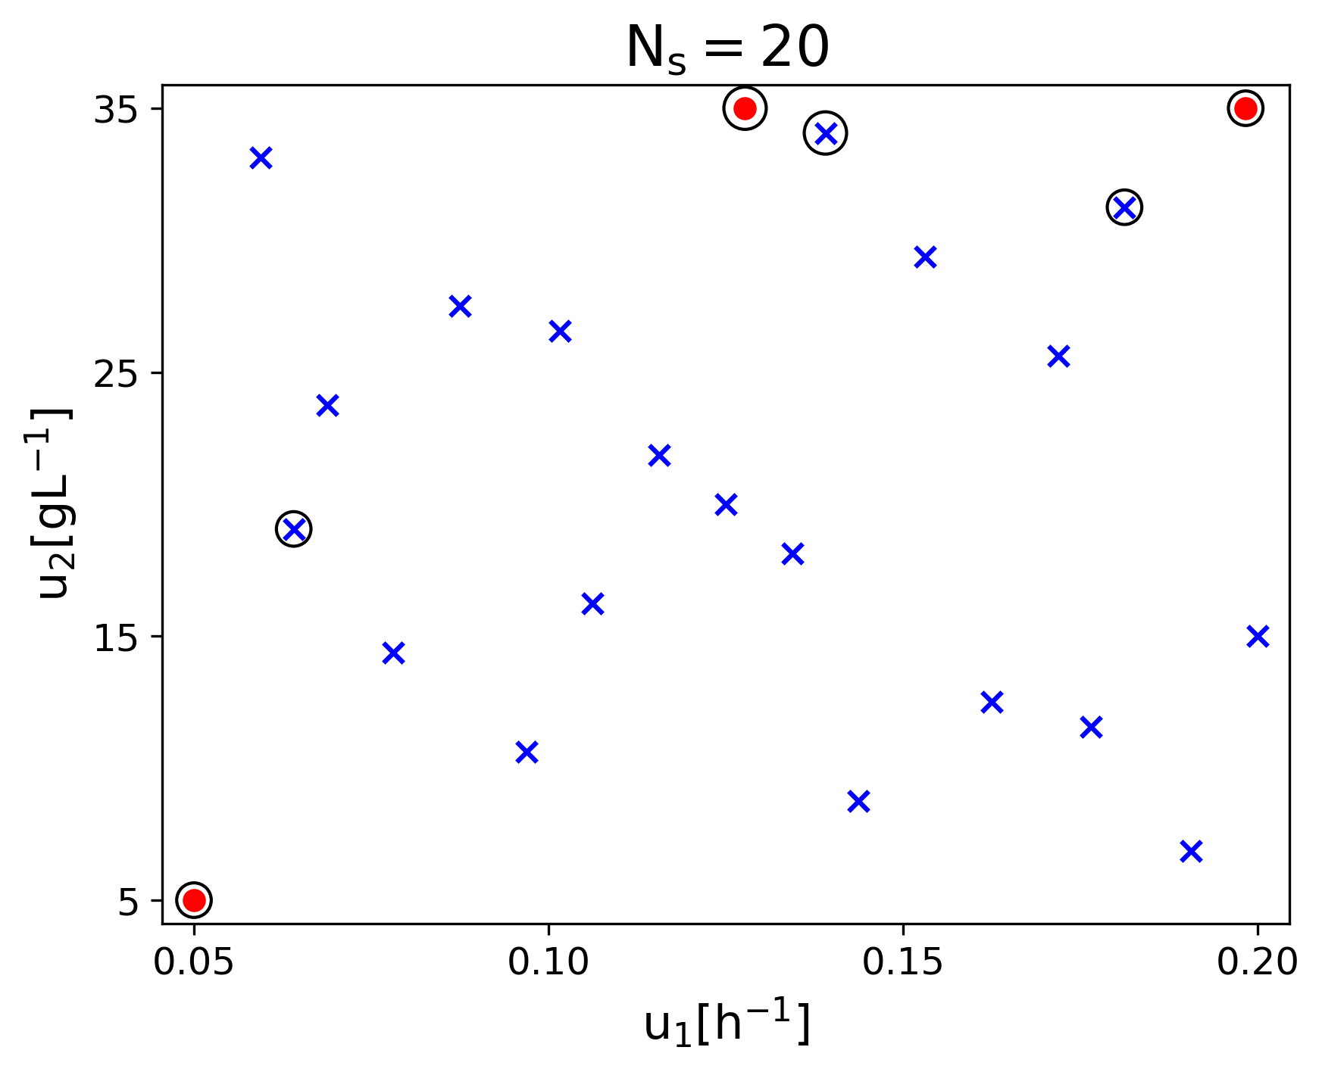 | 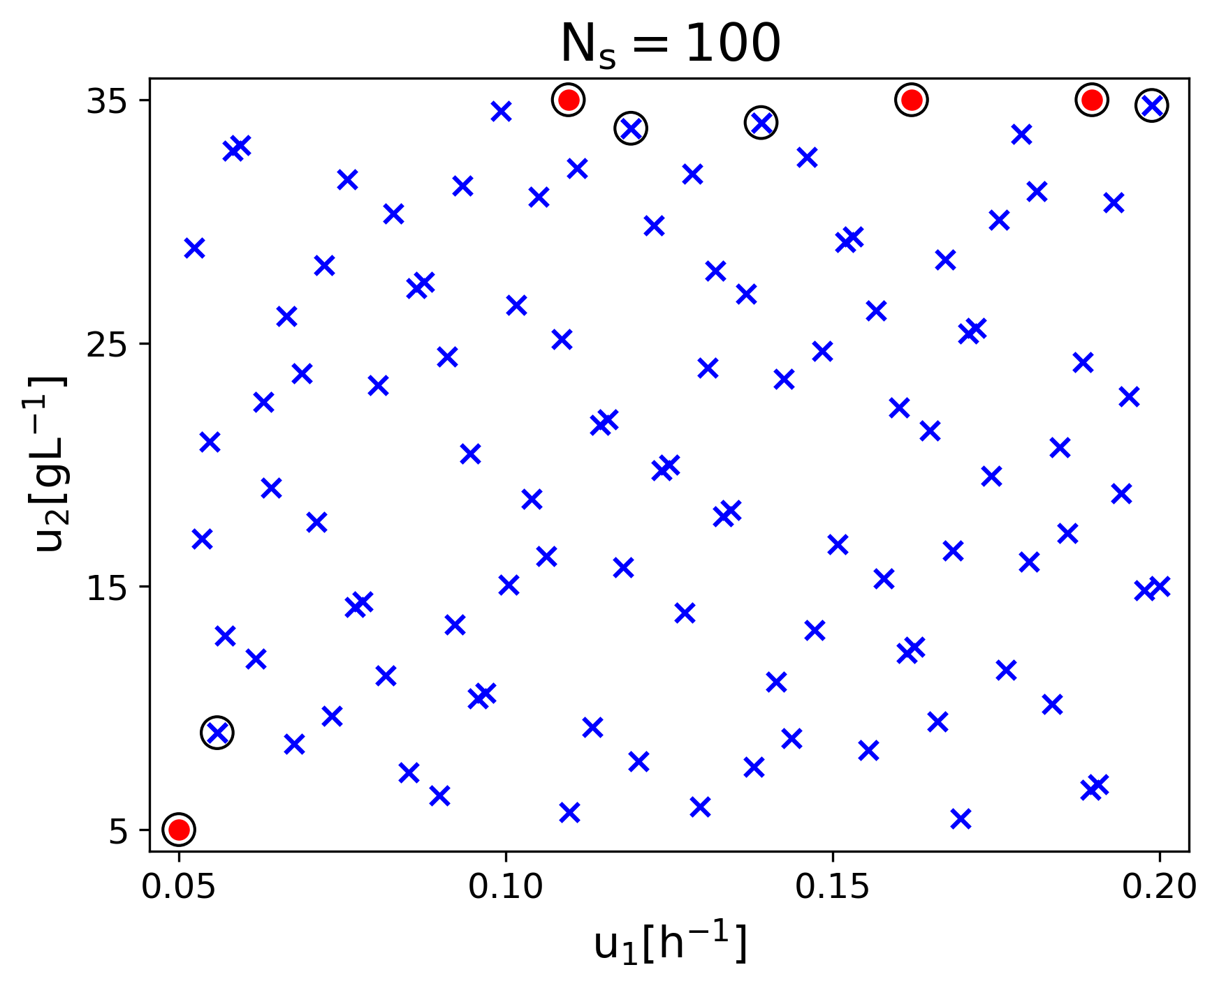
Figure 1. Distribution of the samples over the design space (blue crosses), supports of the optimal design after the effort-based step (circled blue crosses), and refined experiments after the gradient-based step (circled red points).
Acknowledgements
This project has received funding from the European Union’s Horizon 2020 research and innovation programme under the Marie Skłodowska-Curie grant agreement No. 955520 (Digitalgaesation).
References
A.C. Atkinson, A.N. Donev, R. Tobias, 2007. Optimum experimental design, with SAS. Oxford University Press.
M.A. Duran, I.E. Grossmann, 1986. An outer-approximation algorithm for a class of mixed-integer nonlinear programs, Mathematical Programming, 36, 307–339.
V.V. Fedorov, S.L. Leonov, 2014. Optimal design for nonlinear response models. CRC Press.
FICO, 1983–2023. Xpress Solver, https://www.fico.com/en/products/fico-xpress-optimization
R. Fletcher, S. Leyffer, 1994. Solving mixed integer nonlinear programs by outer approximation, Mathematical Programming, 66, 327–349.
G. Franceschini, S. Macchietto, 2008. Model-based design of experiments for parameter precision: State of the art, Chemical Engineering Science, 63, 4846–4872.
K.P. Kusumo, K. Kuriyan, S. Vaidyaraman, S. García-Muñoz, N. Shah, B. Chachuat, 2022. Risk mitigation in model-based experiment design: A continuous-effort approach to optimal campaigns, Computers & Chemical Engineering, 159, 107680.
F. Pukelsheim, S. Rieder, 1992. Efficient rounding of approximate designs. Biometrika, 79, 763–770.
M. Sandrin, K.P. Kusumo, C.C. Pantelides, B. Chachuat, 2023. Solving for exact designs in optimal experiment campaigns under uncertainty [Manuscript submitted for publication to ADCHEM 2024].
Siemens Industry Software, 1997–2023. gPROMS,
https://www.siemens.com/global/en/products/automation/industry-software/gproms-digital-process-design-and-operations.html
I.M. Sobol’, 1967. On the distribution of points in a cube and the approximate evaluation of integrals, USSR Computational Mathematics and Mathematical Physics, 7, 86–112.
C. Vanaret, P. Seufert, J. Schwientek, G. Karpov, G. Ryzhakov, I. Oseledets, N. Asprion, M. Bortz, 2021. Two-phase approaches to optimal model-based design of experiments: how many experiments and which ones?, Computers & Chemical Engineering, 146, 107218.

