Evaluating Potential Replacements for Fossil-based PET in Creating a Circular Bio-economy of Packaging Plastics
Jana Lukicª, Marie J. Jones^{a,b*}, Antoine Astourª, François Maréchalª
ªIndustrial Energy Systems Laboratory, École Polytechnique Fédérale de Lausanne (EPFL), Valais-Wallis, 1950 Sion, Switzerland
^{b}Laboratory of Sustainable and Catalytic Processing, École Polytechnique Fédérale de Lausanne, 1015 Lausanne, Switzerland
marie.jones@epfl.ch
Abstract
Second-generation bio-refineries rely on the use of waste, non-edible lignocellulosic biomass and can be adapted for the production of highly functionalized plastics, such as PET, or its biobased alternatives with higher production efficiencies, but lower technological readiness levels (TRL). Inherent mass and energy losses are detected at an early stage using the Second-law Thermodynamic Analysis and later complemented with the results of detailed modeling, techno-economic assessment (TEA) and life-cycle analysis (LCA). Trade-offs between currently un-optimized biobased processes and the traditional retrofitting pathways are compared on several levels of modeling complexity with the final goal of assessing the real operation of a biorefinery. Our results highlight the potential in production costs and global warming reduction in the case of new bio-polymers compatible with the biomass structure.
Keywords: circular bioplastic industry, lignocellulosic biomass, PET
- Introduction
In the near future, the chemical industry will represent one of the main contributors to GHG emissions due to strong reliance on fossil feedstock (Lange et al. 2021). One of the most resource-intensive products of the chemical industry is plastics, whose properties and low cost are irreplaceable to our society (Gabrielli et al. 2023). The shift towards renewable feedstock is required to reduce the fossil fuel depletion, while recycling enables value and properties preservation. Overall potential of the sustainable plastic sector has been assessed in the previous work by Meys et al. 2021 and Bachmann et al. 2023, where the use of CO₂ and biomass as renewable feedstocks are combined with recycling solutions to close the carbon cycle of plastic. However, new technologies with low TRL aren’t included in the analysis.

Lignocellulosic biomass offers grand potential of naturally available polysaccharides with high structural similarity to polymers used in packaging applications. New conversion routes that avoid biomass degradation and deoxygenation are expected to result in higher production efficiencies. The work by Manker et al. 2022 portrays successful selective depolymerization of waste biomass to produce xylose-based polyesters (such is PHX (poly(hexylene xylosediglyoxylate)), potential bio-based alternative to rigid polyesters. Their monomer (DMGX (dimethylglyoxylate xylose)) is conceptually compared to the monomers of other bio-based alternatives with intermediate TRL (Manker et al. 2023): PTA (purified terephthalic acid) for bio-PET and FDCA (2,5-furandicarboxylic acid) for PEF (polyethylene furanoate) production.
This work aims at providing the first benchmark for the large-scale production comparison of drop-in polymers (bio-PET) and new molecules (PEF, PHX) obtained from waste lignocellulosic biomass, including traditional biomass treatment by gasification. Only chemo-catalytic routes are considered as the most prominent near-term industrial solutions. Understanding the trade-offs that new technologies are facing in their commercialization and industrial implementation is crucial at the process development stage and requires a robust multi-level methodology (thermodynamic, process and system analysis). The way in which the results change across modeling levels is discussed and justifies the use of computational techniques in order to leverage sustainable processes and support decision making.
- Methodology
  - Thermodynamic Analysis
Second-Law Thermodynamic Analysis is performed in this work by following the changes in chemical exergies across the production routes in focus. Considering chemical transformations with 100% stoichiometric efficiency with all the reagents and products being at ambient conditions, maximum exergy efficiencies are obtained (Weber et al. 2022) to which real processes are always inferior (Müller et al. 2020). Even without considering physical exergy, such analysis serves as a powerful tool in performing comparative studies in cases where processes are of different TRL.
BUE (biomass utilization efficiency) is used as an indicator of atom efficiency for the chemical routes as it represents the percentage of the starting feedstock that ends up in the product structure (Iffland 2015). Main material losses caused by the sub-optimal feedstock valorization are identified. Values obtained from the previous work of Manker et al. 2023 are used in the analysis.

  - Process Modelling, Techno-Economic Assessment and Life-Cycle Analysis
Publicly available data from literature and patents (van Putten et al. 2021), (Muñoz De Diego et al. 2013), (Hirsch - Weil et al. 2020), (Masuno et al. 2016), (Hannula and Kurkela 2013), (Manker et al. 2022) has been used to model the processes in Aspen Plus® by extrapolating lab- and pilot-scale conditions to full industrial production. From the mass and energy balances, the capital and operating costs were estimated, for both the process equipment and the auxiliaries (utility generation and waste treatment). The Global Warming Potential (GWP100), expressed in kg CO₂eq/kg of polymer, is used as a sustainability metric to compare the processes. The background inventory is retrieved from Ecoinvent v3.9.1, whilst the foreground data comes from the simulation results. The functional unit is defined as one kg of polymer and the analysis stops at the factory door (“cradle-to-gate analysis”), since recycling is not yet considered. For multi-output processes, the emissions are allocated, on a mass basis, to other high-value products, such as lignin and cellulose pulp. Regarding biogenic carbon accounting, we follow the conservative approach of carbon neutrality, meaning that no carbon credits are awarded to the biobased products but that upon decomposition, the CO₂ released would be counted as zero.
- Results and Discussion
    - Chemical Exergy and BUE Comparison
Each of the four routes is characterized by the change in chemical exergy across its process units (Figure 1). The analysis begins on the level of extracted sugars (glucose in all cases except for PHX which is produced from xylose) and ends with the monomer formation.

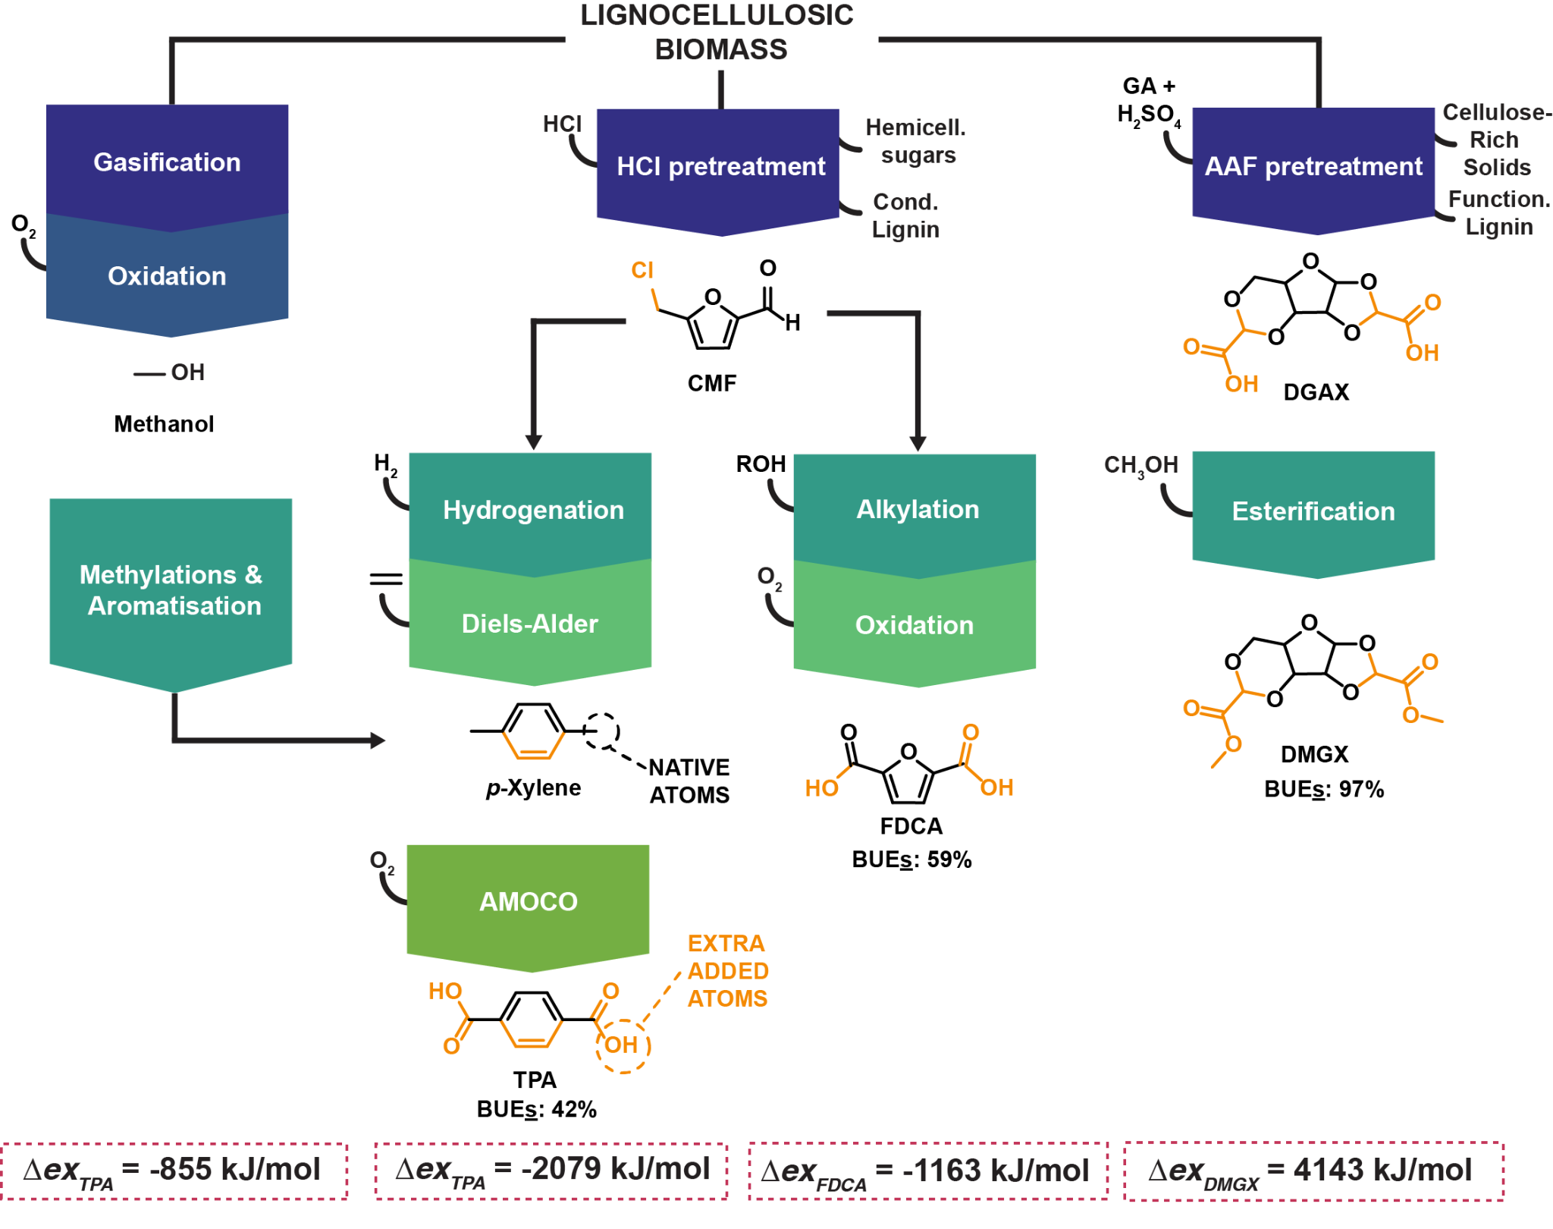
Figure 1:Changes of Chemical Exergy and BUE across the investigated chemical routes; adapted from (Manker et al. 2023)
Negative exergy difference between the starting material and the final product indicates that part of the chemical energy embedded in the starting molecular structure is lost to the environment. This is the case for all synthesis routes except for DMGX, for which additional exergy is required to yield the final product. This result is coherent with the high biomass utilization efficiency achieved by the acetal-protection process: very few biogenic atoms are lost but additional energy must be delivered to the system to drive the protection reaction. From a high-level perspective, energy lost to the environment via atomic rearrangement is wasted, whereas providing extra heat to a process can be done in a controlled manner, thus reducing overall losses. This back-of-the-envelope analysis provides the first argument to the potential of designing biobased molecules retaining as many biogenic atoms as possible, in contrast to retrofitting biomass to poorly oxygenated petrochemicals.
    - Process Modeling Results
Process yields and feedstock allocation are presented in the form of Sankey diagrams (Figure 2). The flows are normalized for each process separately and thus, cannot be directly compared across diagrams. Processing steps are represented as dark-gray vertical lines whose height is a size indicator. Their number is related to processing complexity and, in most cases, to the end product yields. For this analysis, the processes are presented as they are reported in literature, thus starting from the waste biomass until the polymer product.

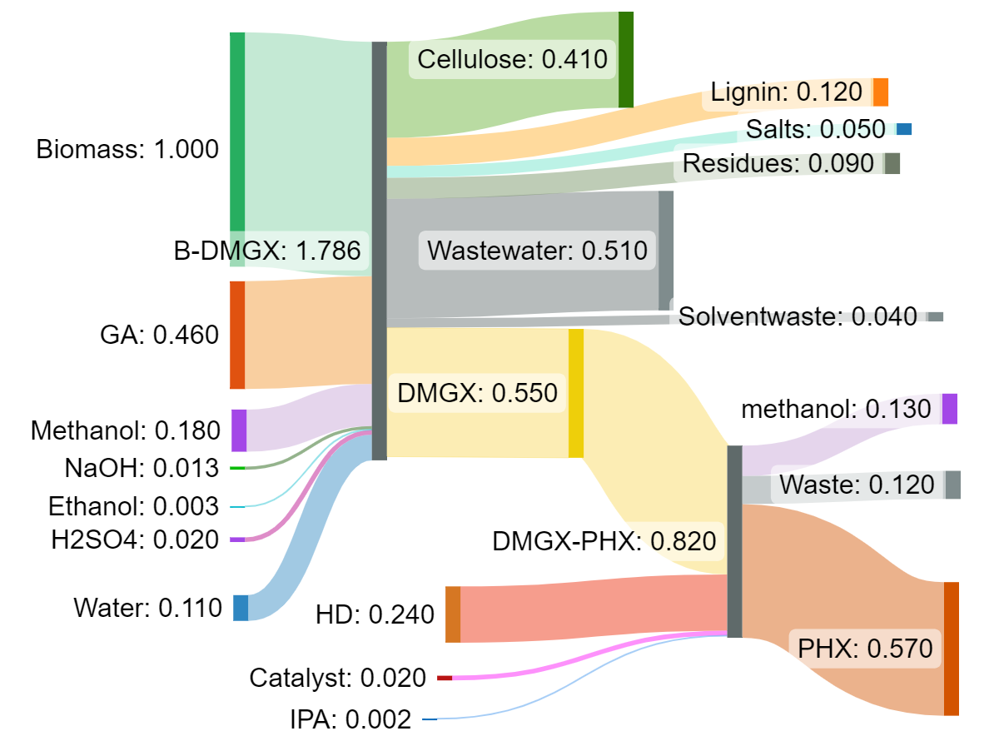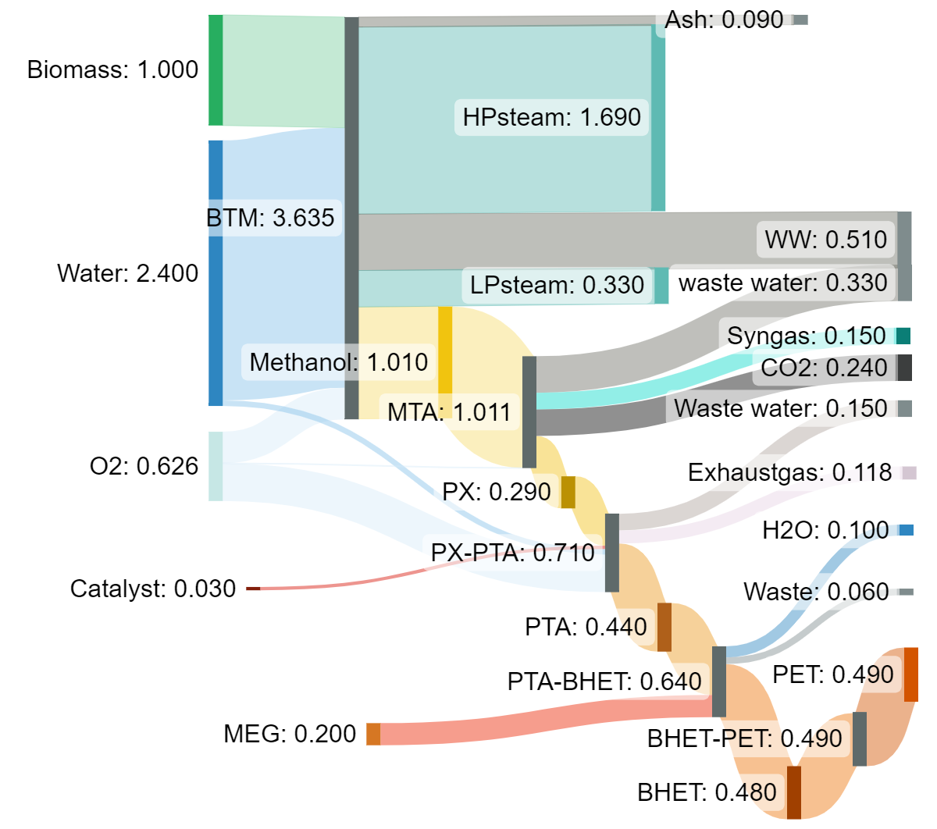
PHX production
PET production (methanol)
PET production (CMF)
PEF production (CMF)

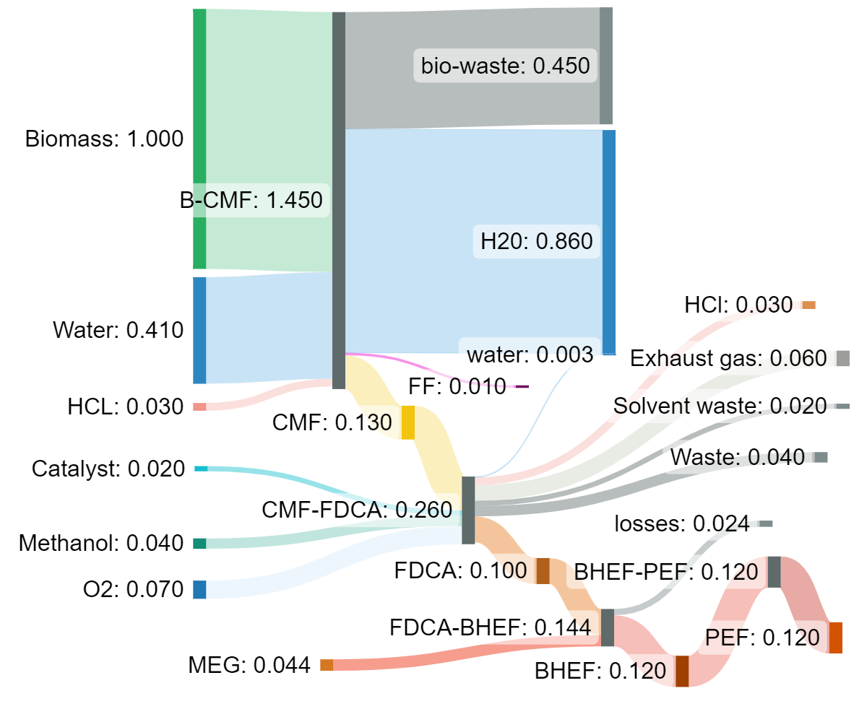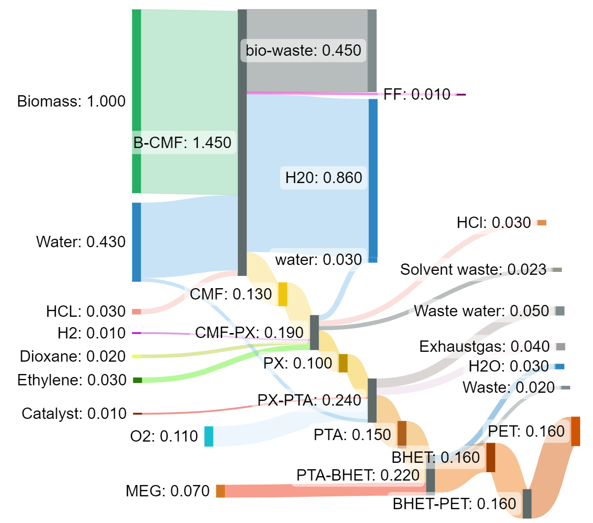
Figure 2: Sankey Flow Diagram - Mass Balance of the analyzed processes
All the routes involved have relatively low material efficiencies, which is in the order of magnitude of second-generation bio-refineries that process recalcitrant lignocellulose structure. The route with the highest product yield and biomass valorization in the form of useful products is the one towards PHX. The routes towards PEF and PET are water-and reagent-intensive and are characterized by an increase in the number of reaction steps. PET formation from methanol is the route with the lowest degree of biomass valorization which comes visible through large amounts of waste formed and the largest material requirements for all the processing steps.
Holistic quantitative assessment of processing routes including both their mass and energy requirements is achieved by translating them into costs and environmental indicators through TEA and LCA. Figure 3 compares the alternatives with respect to the production costs per unit mass of the polymer product (A) and the equivalent CO₂ emissions per kg of all the useful products generated (B). Values presented for PEF and PHX production are subject to a large uncertainty due to scale-up from laboratory or pilot plant results to an industrial scale bio-refinery of 40 ton/h. Another layer of uncertainty to the operating costs is caused by the market price fluctuations.
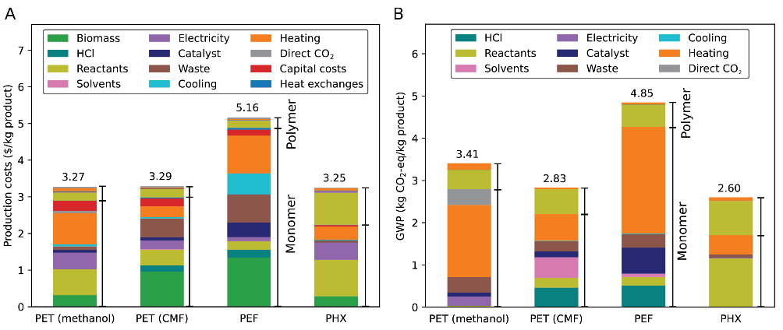
Figure 3: Production costs (A) and Environmental Impact (B) comparison
The most significant contributor to both costs and emissions is monomer production. Material requirements in the form of reagent, feedstock and waste treatment are the most significant cost contributors in all processes, whilst capital expenditures remain in the range of 10 % of the production costs, as expected. PHX production has a substantially different cost distribution compared to conventional gasification route, especially in terms of capital investments. By further optimizing material use in large-scale PHX production, one can envision further reduction in operating costs, which will increase its commercial competitiveness.
The major influence of natural gas in driving the global warming potential across all processes is evident, especially in the case of PEF production. The reason for the excessive heating requirement of PEF compared to PET production through CMF lies in the difference in operating requirements, dilute processing conditions and lower degree of heat integration opportunities. High temperatures required for gasification are on the other hand responsible for high heating demand in PET production through methanol. Key differences in operating conditions between processes arising from the variations in molecular structures are considered as intrinsic process characteristics and are not expected to be overcome by process optimization. Such is the case of PEF whose monomer formation (FDCA) was evaluated potentially more exergy efficient than PTA for PET formation, but experiences additional limitations upon modelling the current production practice.
Some technologies, even though mature, are less likely to be selected in the context of a future bio-refinery due to the high rate of waste formation, energy intensity or even direct CO₂ emissions in the case of gasification. On the other hand, biobased oriented processing is characterized by dilute streams and high material requirements (catalysts etc.) that can be more easily improved. In order to optimize such processes with substantial yields of high exergy content products and superior degree of feedstock valorization in the form of useful products, process intensification needs to complement the scale-up.
- Conclusions
This work aimed at portraying the role of each step in the comparative evaluation of emerging industrial solutions towards more sustainable packaging plastics. Rethinking bio-refining in terms of nature-inspired product development instead of retrofitting biomass structure to conventional petroleum-derived structures comes as a key aspect when considering the use of biomass. Mass and energy performance assessed on three different levels (molecule, process and system) in this work justifies such thinking and provides solid proof for pursuing chemically and energetically more feasible routes. Thermodynamic analysis indicates that preserving the native biomass structure in the end product results in the formation of molecules with increased functionalization and chemical exergy content. Detailed process modeling is required to assess the actual process mass and energy efficiencies and shows the difference in cost and emission drivers across processes. It also shows that by continuously optimizing new processes that are more compatible with the biomass structure (energetically and materially), one might become more competitive, whereas for the mature technologies used for the drop-in polymers, such as PET, little room for improvement remains available.

References
Bachmann M., Zibunas C., Hartmann J. et al. "Towards circular plastics within planetary boundaries." Nature Sustainability, 2023: 599–610.
Gabrielli P., Rosa L., Gazzani M., Meys R., Bardow A., Mazzotti M., Sansavini G. "Net-zero emissions chemical industry in a world of limited resources." One Earth (One Earth), 2023: 2590-3322.
Hannula, I., and E. Kurkela. Liquid transportation fuels via large-scale fluidised-bed gasification of lignocellulosic biomass. VTT, 2013.
Hirsch - Weil et al. Methods of Producing Alkylfurans. Patent US 10,618,880 B2. 2020.
Iffland K., Carus M., Baltus D. W., de Bie F. "Definition, Calculation and Comparison of the “Biomass Utilization Efficiency (BUE)” of Various Bio-Based Chemicals, Polymers and Fuels." Nova Paper 8 on bio-based economy , 2015.
Lange J.-P. et al. "Towards circular carbo-chemicals – the metamorphosis of petrochemicals." Energy Environ. Sci., 2021: 4358-4376.
Manker L. P., Jones M. J., Bertella S., Behaghel de Bueren J., Luterbacher J.S. "Current strategies for industrial plastic production from non-edible biomass." Current Opinion in Green and Sustainable Chemistry, 2023: 2452-2236.
Manker L.P., Dick G.R., Demongeot A. et al. "Sustainable polyesters via direct functionalization of lignocellulosic sugars." Nature Chemistry, 2022: 976–984.
Masuno et al. Methods of Producing Para-Xylene and Terephthalic Acid. Patent US 9.260,359 B2. 2016.
Meys R., Kätelhön A., Bachmann A., Winter B., Zibunas C., Suh S., Bardow A. "Achieving net-zero greenhouse gas emission plastics by a circular carbon economy." Science, 2021: 71-76.
Müller L. J., Kätelhön A., Bachmann M., Zimmermann A., Sternberg A., Bardow A. "A Guideline for Life Cycle Assessment of Carbon Capture and Utilization." Frontiers in Energy Research, 2020.
Muñoz De Diego et al. Method for the Preparation of 2.5-Furandicarboxylic Acid and Esteres Thereof. Patent US 8,519,167 B2. 2013.
van Putten et al. Process For The Conversion of a Solid Lignocellulosic Material. Patent US 2021/0032217 A1. 2021.
Weber J. M., Guo Z., Lapkin A. A. "Discovering Circular Process Solutions through Automated Reaction Network Optimization." ACS Engineering Au, 2022: 333–349.

