Adoption Dynamics of District Heat Networks: An Agent-Based Commercial Model
Thomas Cowley,ª Emma Morris,ª Timothy Hutty,ª Solomon Brownª
ªDepartment of Chemical & Biological Engineering, University of Sheffield, Sheffield,
S1 3JD, England, UK
s.f.brown@sheffield.ac.uk
Abstract
This study uses Agent-Based Modelling to analyse the adoption of District Heating (DH) networks in the commercial sector. It examines the impact of financial incentives and policy changes, demonstrating varied responses based on organizational Social Value Orientations. The findings emphasize the need for targeted policy interventions to accelerate sustainable energy transitions.
Keywords: Agent-based model, DHN expansion, District Heat Network
  - Introduction
The global shift towards renewable and low-carbon energy, emphasized by the 2016 Paris Agreement, aligns with the UK's goal of achieving Net-Zero emissions by 2050 (The Sixth Carbon Budget, 2020). The reliance on natural gas in the commercial sector is seen as unsustainable and policy shifts towards lower emissions, result in increasing gas costs (Gadenne et al, 2011). District heating (DH) is emerging as an alternative for commercial areas, offering efficient heat distribution (Energy Saving Trust, 2018). Its benefits include reduced reliance on natural gas and grid electricity, lower carbon emissions, and cost savings. Expanding DH networks, however, faces challenges like securing reliable heat users, uptake particularly from commercial stakeholders (Busch et al, 2014). Policy interventions can encourage commercial participation (Dowson, 2016). Agent-Based Modelling (ABM) is uniquely suited for simulating commercial adoption and forecasting DH network expansion due to its ability to model individual stakeholder behaviours and interactions in stochastic systems, other methods use a more aggregated approach may not capture emergent. (Busch et al, 2014). Policies promoting DH expansion are critical, with financial support for commercial DH infrastructure being essential (Webb et al, 2015). Empowering local authorities to develop DH strategies can improve uptake. The focus on incentivizing commercial building is vital, as they significantly influence DH network capacity utilization and regional emission reduction. This work is informed by literature on the adoption of renewable technologies like heat pumps and EVs (Vuthi et al, 2022.; Ghorbani et al, 2020) and uses ABM to analyse the commercial expansion of DH networks, assessing the effect of gas price increase, developer engagement, and installation cost subsidy.
  - Methodology
    - Model Framework
The model aims to simulate the decision-making process and outcomes related to connecting to the DH network, integrating empirical data and theoretical constructs. It focuses on decision-making among commercial organizations, defined as entities with more than five employees. These entities are characterized using the IAD framework (Shah et al, 2020), with much of the data derived from Energy Performance Certificates (EPC) (Gov.uk, n.d). The study examines 30 diverse organizations in Royston, Barnsley, capturing spatial dynamics through geographical information system (GIS). Agent interactions within the model include events, transitions, state charts, and action charts. Network extensions will be funded the developer, whilst the retrofit, maintenance and fuel costs will be associated with the organisation (Domestic Building Services Compliance Guide, 2021). Gas, electricity, and district heating costs increase with inflation at 2%. Each agent has a boiler replacement age, based on a distribution for average boiler breakdowns (CDW Engineering, 2022). Each heating system is updated by +1 for each year of simulation. Thus, updating other parameters such as efficiency which decrease with age.
    - Agent Heterogeneity and Classification
Organizations are assumed to have the necessary knowledge for making independent decisions about utilities (Bijvoet, 2017). The challenge in modelling organizations lies in their heterogeneous behaviour, particularly how attitudes and priorities affect decisions. The Theory of Social Value Orientation (SVO) is used to understand this diversity (Ghorbani et al, 2020). SVO, which accounts for varying motives and goals among agents, categorizes them into four types (Fouladvand et al, 2022):
- Altruistic: Maximizes social and environmental benefits regardless of gain.
- Cooperative: Maximize both social/environmental benefits and their own.
- Individualistic: Concentrate solely on maximizing profits.
- Competitive: Strive to maximize their benefits while minimizing others.
All public buildings are altruistic, as they tend to follow government recommendations (Todnem et al, 2005). Commercial organizations with higher revenues can afford cooperative behaviour, while most others behave individualistically (Sharan, 2011). The value orientation of the agent determines the distribution of acceptable payback, and downtime values. It also determines the difficulty factor distribution in acquiring initial CAPEX investment. Each parameter uses a density function PERT-beta distribution. The distributions have been chosen based on standard commercial change management requirements and values defined as ‘cost effective’ when evaluating previous networks (Dowson, 2016).
    - Energy considerations
Organizations are assigned an Energy Performance Certificate (EPC), rated from A (most efficient) to G. Each rating corresponds to a normal distribution of efficiency values, and maintenance costs. Organizations already using green energy sources are less likely to switch, hence, it's assumed these organizations will not opt for DH.
    - Agent Decision-Making
The payback period for each agent takes into consideration the capital, operational cost and monetary savings (Sharan, 2011). The calculated payback needs to be less than the organisation's required payback (a distribution determined by the value orientation) to move onto the next part of the decision-making process. Eq. 1 X describes this:
$$Payback=\frac{({IC}_{1,2}∙A)}{\left(\frac{E_{d}∙A∙C_{1,2}}{η_{1,2}}+M_{1,2}\right)-(\frac{E_{d}∙A{∙C}_{3}}{η_{3}}∙M_{3})}$$ | (1)
Where ${IC}_{1,2}$ (£$m^{-2}$) is the installation cost of gas and electric heating, respectively. A ($m^{2}$) is the floor area of the building, ​$E_{d}$ ($kWhm^{-2}y^{-1})$ is the energy demand. Installation cost has the units $£m^{-2}$. $C_{1,2,3}$ ($£{kWh}^{-1})$ is the cost of gas, electricity, and district heating, respectively. $M_{1,2,3}$ ($£y^{-1})$ is the maintenance cost for gas, electric, and district heating, respectively. $η_{1,2,3}$ is the efficiency of the boiler, electric heater, and district heating, respectively. Variables in this equation are characterised by specific statistical distributions, representing their variability; $η, installation cost, M_{1,2,3}∼Triangular(a, b, c)$, where $a$ is min, $b$ is max, $c$ is mode; $C_{1,2,3}$ $∼ N(μ_{1,2,3}{σ^{2}}_{1,2,3})$, where $μ$ is the mean, $σ$ is the standard deviation.
Another barrier to connecting is the amount of downtime required to implement the change (Todnem et al, 2005). The allowance of downtime varies with the organisation's motivation for change which is dependent on value orientation (Fouladvand et al, 2022), and the actual acceptable downtime calculated for each agent follows a PERT-beta distribution. District heating relies on a densely populated area to be effective (Dowson, 2016). Literature suggests that there needs to be a demand of $260MWh {ha}^{-1}y^{-1}$ (Fouladvand et al, 2022). Therefore, a parameter for the maximum distance from the pipeline is 100m to ensure minimum heat density is met.

There is a decision-making flowchart for each agent in the model that includes 8 transitions and various. Transition 1 is initiated by either a heating system failure, its aging affecting efficiency significantly (Balaras et al, 2005), a surge in gas prices beyond normal inflation or an EPC rating below average (Bush et al, 2017).
Transition 2 reflects the scenarios prompting consideration of district heating (DH). This transition is activated by active policies, such as, installation cost subsidies, gas taxes, or gas price increases. Transition 3 occurs upon direct interaction with the developer, where agents again assess the adequacy of their heating system, but through transition 5 bypass whether location, subsidies or gas price affect the decision. If an agent considers a connection here, surrounding agents are also prompted to consider it (Sharan, 2011).
Stages (transitions 6-8) in the state chart represent the agent's internal change management system. Two Action Charts evaluate the payback period (Transition 6) and installation time (Transition 7). Costs for DH installation vary between £15-82$m^{-2}$ for gas centrally heated buildings and £112-141$m^{-2}$ for electrically heated buildings (Dowson, 2016). DH costs range from £0.0551-0.1491${kWh}^{-1}$, electricity from £0.2191-0.2299${kWh}^{-1}$, and gas from £0.0955-0.116${kWh}^{-1}$, based on a 2019 energy price report (Heat and Buildings Strategy, 2021). Installation times range from 7-365 days (Dowson, 2016). Despite having a management system, change often occurs reactively, discontinuously, and ad-hoc, with a 70% failure rate in change programs (Todnem et al, 2005). A percentage of agents who decide to join DH may fail due to external factors (Transition 9) (Sharan, 2011). The success rate distribution is influenced by the agent's value orientation. Agents that pass these evaluations are considered to have ‘Joined’ the network. If not, they either repair their existing system if it's below the boiler replacement age or purchase a new system.
  - Results
    - Case study
The model includes scenarios that simulate various policy interventions, each configuration was run only once. 'Invitation to Join' indicates the DH network developer inviting all agents within a feasible distance to connect. 'Increase in Gas Cost' simulates a government policy to raise natural gas costs by a certain percentage. 'Decrease in Installation Cost' represents a subsidy from the government or local authority, modelled as a percentage reduction in installation costs.
Table 1 – Scenario and policy configuration
Simulation Run | Invitation to Join | Increase in Gas Cost | Decrease in Installation Cost
1 | No | No | No
2 | Yes | No | No
3 | Yes | No | 20%
4 | No | No | 20%
5 | No | No | 50%
6 | Yes | 50% | No
7 | No | 50% | No

Figure 1 shows organizational decision-making over 10 years, highlighting agent stages with various interventions. Key observations include: 17-27% of agents joining in the first year and 43-57% over 10 years in all simulations; the duration in each decision stage varies; without intervention, many agents remain reluctant to replace heating systems; interventions, such as developer invitations and decreased installation costs, shift more agents to the consideration phase, potentially speeding up decisions to join DH networks; the primary barrier remains the decision to replace heating systems, with financial incentives crucial for adoption; only 4 agents were initially unable to join due to location, reducing as more connected; installation time wasn't a significant barrier in decision-making, overshadowed by policy impacts.
Number of agents
Number of agents
Number of agents
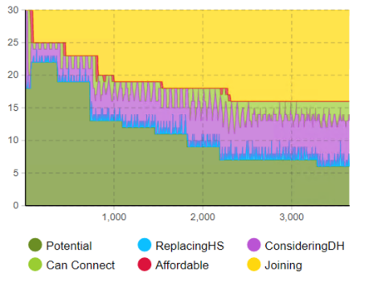  Days | 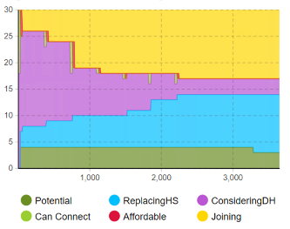  Number of agents  Days
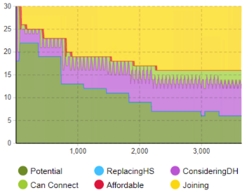  Days | 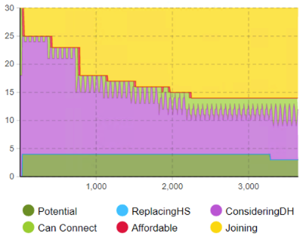  Days
Figure 1 – Number of agents in each state over 10-year period. a; No intervention, b; Invitation from developer, c; 20% Installation subsidy, d; Invitation and 20% installation subsidy

Figure 2 rate at which agents join a district heating network over a 10-year period. Key findings are that the most effective strategy for connecting the maximum number of agents involves sending invitations to all organizations within a feasible area and offering financial incentives. A 20% discount on installation costs proves as effective as a 50% discount over a decade, although the higher subsidy results in faster agent connection, but it may not be economically viable for the developer. Interestingly, a 50% increase in energy bills due to economic or governmental factors significantly increases the rate of agents joining, similar to a 50% subsidy, but with a quicker impact. The study also reveals that a sudden rise in energy bills, could accelerate the rate of agents considering. However, this is contingent upon the availability of other heating systems like heat pumps. The research further indicates that while subsidies appeal to agents with a short-term financial focus, increasing gas prices offer broader benefits.

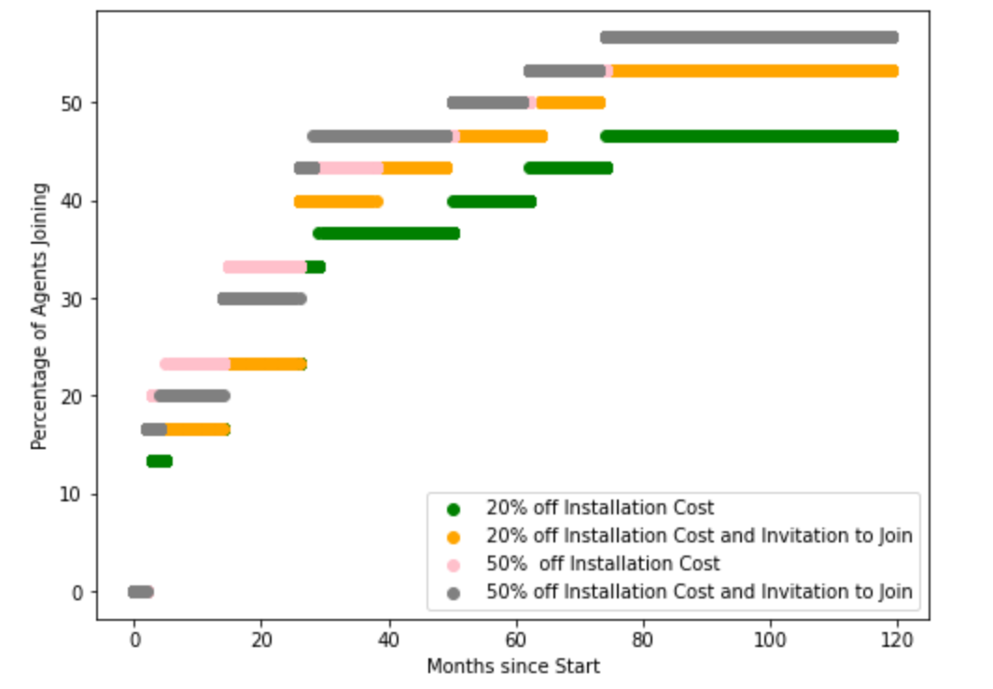 | 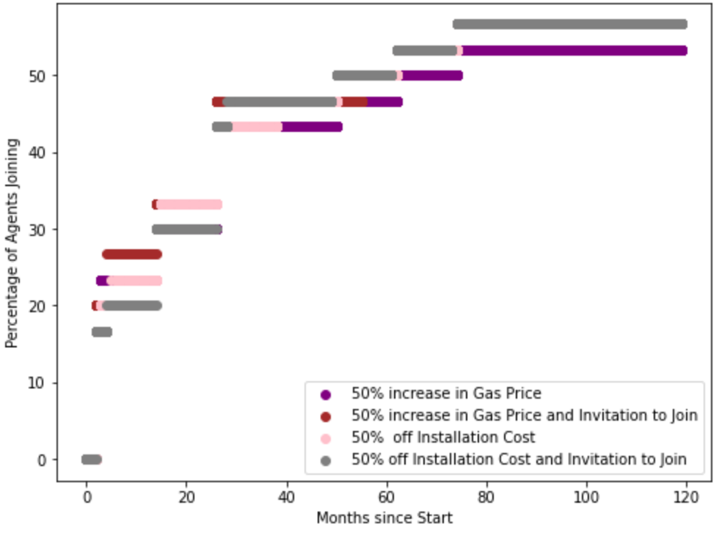
Figure 2 – shows the percentage of agents joining the network over 10-year period with x axis being months. a; Installation subsidy, b; most effective policies

Figure 3 shows the number of agents joining in their SVO category. Over 10 years, up to 63% of Altruistic and 61% of Individualistic joined the network. These participation rates reflect expected behaviours from each SVO type. Findings indicate that gas price increases impact Social and Environmental agents more significantly than Profit agents, who require lower installation costs for immediate investment return. Profit-driven agents prioritize short-term gains over long-term benefits, while socially driven agents are more responsive to economic changes than developer encouragement. Natural gas price fluctuations could lead to a notable increase in network participation, this suggests that profit-driven organizations might need specific policy interventions, especially those with lower energy demands.

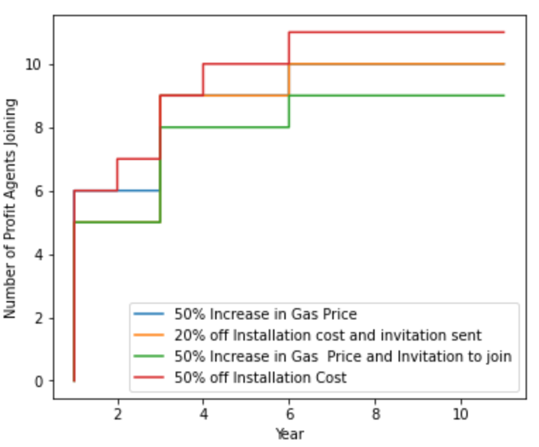 | 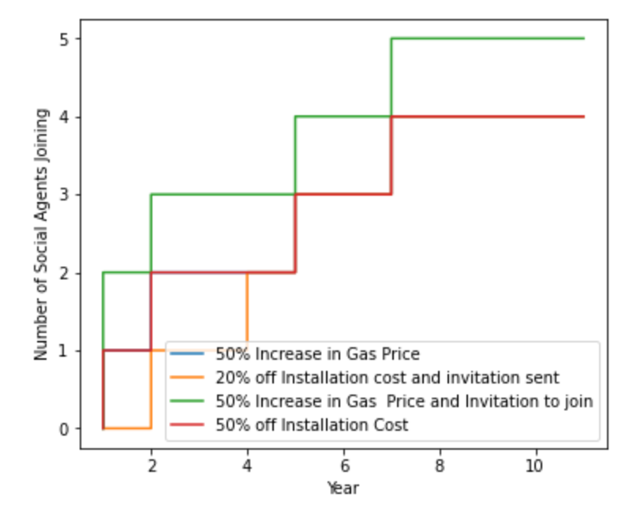
Figure 3 – The effectiveness of different policy interventions with each value orientation. a; Individualistic, b; Altruistic.
  - Discussion & Conclusions
This research, employing an agent-based model within the Institutional Analysis and Development framework, has identified crucial factors that influence commercial entities' decisions to adopt district heating networks. The study underscores the effectiveness of financial incentives tailored to the varied SVOs of organizations. Immediate benefits such as subsidies appeal to individualistic entities, while cooperative and altruistic organizations are inclined towards long-term financial gains like reduced energy costs.
The analysis demonstrates that economic factors, including the prospects of energy price inflation and policy shifts, are pivotal in influencing the adoption of district heating networks. However, the scope of the model does not extend to the potential adoption of alternate renewable technologies or the impact of regulatory changes, like the proposed 'No New Boiler Policy'.
Our findings advocate for the implementation of diverse, organization-specific policy interventions. These policies should account for the varied motivations of different organizational types to effectively promote the transition to sustainable energy solutions. Such a nuanced approach is vital in encouraging a broader adoption of district heating systems, contributing to the overall goal of reducing carbon emissions in line with the UK's Net-Zero targets.
References
Committee on Climate Change, 2020, The Sixth Carbon Budget, The Committee on Climate Change. [Online Available: www.theccc.org.uk/publications]
D. Gadenne et al., 2011, The influence of consumers’ environmental beliefs and attitudes on energy saving behaviours, Energy Policy, Vol. 39, No. 12, pp. 7684–7694.
Energy Saving Trust, 2018, What is District Heating? [Online Available: https://energysavingtrust.org.uk/what-district-heating/]
J. Busch et al., 2015, Emergence of District-Heating Networks; Barriers and Enablers in the Development Process. [Online Available: research.ncl.ac.uk/media/sites/researchwebsites/ibuild/iBUILD%20CP3.pdf]
M. Dowson, 2016, Connecting Existing Buildings to District Heating Networks. [Online Available: www.usdn.org/uploads/cms/documents/161214_-_connecting_existing_buildings_to_dhns_-_technical_report_00.pdf]
J. Webb, 2015, Improvising innovation in UK urban district heating, Energy Policy, Vol. 78, pp. 265-272, doi: 10.1016/j.enpol.2014.12.003.
P. Vuthi et al., 2022, Agent-based modeling (ABM) for urban neighborhood energy systems, Energy Inform 5, 55, doi: 10.1186/s42162-022-00247-y.
A. Ghorbani et al., 2020, Growing community energy initiatives from the bottom up, Energy Research & Social Science, Vol. 70, Dec. 2020, doi: 10.1016/j.erss.2020.101782.
I. Nikolic and A. Ghorbani, 2011, A method for developing agent-based models of socio-technical systems, International Conference on Networking, Sensing and Control, ICNSC 2011, pp. 44–49, doi: 10.1109/ICNSC.2011.5874914.
K. Shah et al., 2020, Application of an IAD-Enhanced IREPP Framework to Island States, Sustainability, Vol. 12, No. 7: 2765, doi: 10.3390/su12072765.
UK Government, n.d., Find an energy certificate. [Online Available: https://www.gov.uk/find-energy-certificate]
UK Government, 2021, Domestic Building Services Compliance Guide. [Online Available: https://assets.publishing.service.gov.uk/media/61b880b4e90e07044462d865/Domestic_Part_L.pdf]
CDW Engineering, 2022, Probability of failure. [Online Available: https://cdwengineering.com/probability-of-failure/]
X. Bijvoet, 2017, Learning and Competitive Behaviour in Open DH Networks. [Online Available: http://repository.tudelft.nl/]
J. Fouladvand et al., 2022, Energy security in community energy systems, J Clean Prod, Vol. 366, p. 132765, doi: 10.1016/j.jclepro.2022.132765.
R. Todnem et al., 2005, Organisational change management, Journal of Change Management, Vol. 5, No. 4, pp. 369–380, doi: 10.1080/14697010500359250.
V. Sharan, 2011, Fundamentals of Financial Management, Pearson.
C. A. Balaras et al., 2005, Heating energy consumption in European apartment buildings, Energy Build, Vol. 37, No. 5, pp. 429–442, doi: 10.1016/j.enbuild.2004.08.003.
R. E. Bush et al., 2017, Empowering innovations to unlock district heating in the UK, J Clean Prod, Vol. 148, pp. 137–147, doi: 10.1016/j.jclepro.2017.01.129.
The Secretary of State for Business, 2021, HM Government – Heat and Buildings Strategy.

