Assessment of Technical and Economic Viability in the Transformation of Refinery Vacuum Residue Waste into Cleaner Fuels

Ammr M. Khurmy a,b , Usama Ahmed a,c , Ahmad Al Harbi d, Taha Aziz *e

aChemical Engineering Department, King Fahd University of Petroleum and Minerals, Dhahran 31261, Saudi Arabia

bPetrochemical and Conversion Industries Sector, Ministry of Investment of Saudi Arabia, Riyadh 12382, SaudiArabia

cInterdisciplinary Research Center for Hydrogen and Energy Storage, King Fahd University of Petroleum and Minerals, Dhahran 31261, Saudi Arabia

dEngineering Department, Sadara Chemical Company, Jubail 35412, Saudi Arabia

e Department of Mathematics, Dammam Community College, King Fahd University of Petroleum and Minerals, KFUPM Box 5084, Dhahran, 31261, Saudi Arabia

* Corresponding Author’s E-mail: [taha.aziz@kfupm.edu.sa](mailto:taha.aziz@kfupm.edu.sa)

Abstract

Methanol and hydrogen, as cleaner fuel options, hold significant potential for decarbonizing the petrochemical industry (Hamid *et al.*, 2020). This study aims to establish a process integration framework for the simultaneous production of methanol and hydrogen from vacuum residue while minimizing sulfur and carbon emissions (Gudiyella *et al.*, 2018). This investigation involves the development of two distinct process models. In the first case, vacuum residue is subjected to gasification using oxygen and steam, with the resulting syngas being processed to yield both methanol and hydrogen. The second case follows a similar process model to the first but places a stronger emphasis on methanol production from vacuum residue. Both models are subjected to a comprehensive techno-economic comparison, considering various factors such as methanol and hydrogen production rates, specific energy requirements, carbon conversion, CO2 emissions, overall process efficiencies, and project feasibility. The comparative analysis reveals that the second case, focused on methanol production, offers several advantages. It reduces the specific energy requirements by 86.01% compared to the first case. Additionally, CO2 emissions are reduced by 69.76% in the second case compared to the first. Overall, the second case demonstrates superior project feasibility, showcasing enhanced process performance and reduced production costs in comparison to the first case.

**Keywords**: gasification; vacuum residue; carbon capture and utilization; methanol synthesis; hydrogen; process integration

* 1. Introduction

The global refining industry is loaded with mounting challenges, including stringent environmental regulations, thin profit margins and evolving demand patterns. The focus on reducing sulfur content in residual fuel oil for domestic use such as heavy fuel oil (HFO) is intensifying due to environmental concerns. The shift toward lower sulfur levels that are reaching 0.5 wt% requires expensive flue gas treatment for HFO combustion and prompting refineries to seek alternative conversion methods for heavy residues. Upgrading these residues to lighter products emerges as a key strategy to enhance refinery margins while addressing environmental standards (Zuideveld et al., 2000). Ships, as major consumers of HFO can contribute significantly to air pollution and greenhouse gas emissions. The shipping industry's share in global CO2, SOx, and NOx emissions is substantial. Reducing carbon emissions is now a global priority. The transition to a green and low-carbon economy will require prompting initiatives for decarbonization across all sectors. The International Maritime Organization (IMO) is actively engaged in reducing greenhouse gas emissions from international shipping, fostering exploration into low-carbon and zero-carbon fuels such as LNG, methanol, biodiesel, hydrogen, and ammonia (Meng et al., 2022). Gasification is a promising technology to convert heavy residues to lighter products, and it could be integrated with various other technologies including water-gas-shift, CCUS and combined heat and power (CHP) to create a more efficient and sustainable process. Syngas, the main product of gasification, can be further processed to produce high-purity hydrogen, methanol or other Fischer Tropsch (FT) chemicals (Alibrahim et al., 2021). (Ahmed, 2020) developed a model for coal conversion to an alternative technology that integrates coal gasification and natural gas reforming. The alternative technology showed 4.28% higher efficiency, 18.3% reduction in greenhouse gases, 13% lower fuel production cost, and 34.3% lower CO2 emissions. Fayez et al. (2021) developed a vacuum residue to methanol (VRTM) process and achieved 90 t/h methanol production with 99.9% purity. The VRTM cycle offers 49.5% energy efficiency which is 1.6% higher than the SRTM (steam reforming to methanol) process and a 14% lower unit cost compared to the conventional SRTM process. The aim of this study is to develop a process model to produce methanol and hydrogen by the gasification of vacuum residue. The second goal is to modify the process model to focus only on methanol followed by performing technical and economic analysis to evaluate the process feasibility of each case.

* 1. Modelling and Simulation:

In the design basis and simulation methodology, Aspen Plus V12 is employed to simulate the proposed process model for four different case studies. The Peng–Robinson with Boston–Mathias alpha function (PR-BM) property package is selected to determine the physical state of the chemical components in the process. The vacuum residue is treated as an unconventional component and is defined based on its elemental composition, including proximate and ultimate analyses. The VR gasification results were validated with the literature (Choi et al., 2007). The dual production of methanol and hydrogen involves several reaction steps, including gasification, water–gas shift (WGS), and methanol synthesis. The simulation involves different reactor models within Aspen Plus. The gasification unit is simulated using two reactor models, namely RYield and RGibbs. The RYield reactor model decomposes the vacuum residue into its elemental components based on the ultimate and proximate analysis of the feed. Subsequently, the RGibbs reactor model determines the yield of the gas product by minimizing Gibbs free energy. Mass yield is linked to the ultimate and proximate analysis using the calculator tool and Fortran code. For modeling the water–gas shift reaction (WGS), the REquil reactor model is employed, which performs phase and chemical equilibrium calculations. However, it is noted that REquil is suitable for equilibrium reactions of known stoichiometry. The methanol synthesis is simulated using the RPlug reactor model with Langmuir–Hinshelwood–Hougen–Watson reaction kinetics. The design specification and operational parameter of major equipment models are summarized in Table 1.

Table 1: Design Specification and operational parameter of the proposed process models.

|  |  |  |
| --- | --- | --- |
| **Equipment** | **Description** | **Aspen Model** |
| Gasification Unit | Temp/Pressure = 1355 oC/ 4 MPa  Steam/fuel ratio = 0.5  Oxygen to fuel ratio = 0.84  VR Flow Rate = 101 kg/sec  Carbon conversion = 99% | RYield, RGibbs |
| Water Gas Shift (WGS) | Sour Catalyst (Co-Mo)  2 Adiabatic reactors  Steam/ CO = 2  CO Conversion = 99.4% | REquil |
| AGR Unit | Rectisol Process (Methanol Solvent)  Temp/Pressure = -45 oC/3.2 MPa  H2S Removal = 100ppbv  CO2 Removal = 99% | RadFrac, Flash |
| Methanol Synthesis | Temp/Pressure = 180 oC /8 MPa  CuO/Al2O3/ZnO catalyst | RPlug |

* 1. Process Description:

Two case studies have been developed in this study dual production of H2 and methanol as represented in Figure 1 and Figure 2. Case 1 focused on the dual production of methnaol and hydrogen, werheas, case 2 focuses mainly on the production of methanol. The ASU employs high- and low-pressure columns to separate oxygen from air at cryogenic condition to supply the gasification unit .

Figure 1: Vacuum residue to methanol and H2 production with CO2 capture (case 1).

Both the processes involve vacuum residue gasification using oxygen and steam, followed by syngas cooling using a gas quenching method. WGS unit is used to adjust the hydrogen-to-carbon ratio for methanol synthesis. The first gas cooling unit cools the shifted syngas for the Acid Gas Removal (AGR) unit utilizing methanol as a solvant to absorb H2S and CO2 . The methanol synthesis unit employs a single reactor with multiple injections of cold recycled streams. This process enhances equilibrium conversion by decreasing the temperature of the exothermic reaction. The process design includes a second WGS unit and a gas cooling unit to maximize CO conversion and produce H2 and CO2.

Figure 2. Vacuum residue to methanol production with CO2 capture (case 2).

* 1. Results and Discussion
     1. Hydrogen and Methanol Production:

Two case studies have been developed in this project to produce methanol and hydrogen from high sulfur content vacuum residue. The methanol production in case 1 and 2 is calculated as 57.49 kg/s and 129.92 kg/s, respectively. On the other hand, the hydrogen production in case 1 and 2 is calculated as 15.92 kg/s and 1.87 kg/s respectively. Furthermore, the net fuel production in case 1 and 2 is calculated as 73.41 kg/s and 131.79 kg/s, respectively. In comparison to the net fuel specific production energy between case 1 and 2, there is a potential of producing 79.6% more fuel when recycling 98.7% of the unreacted syngas to the methanol synthesis unit as in Case 2.

* + 1. Process Performance Analysis:

Another important technical parameter indicator is the process efficiency, which evaluates the utilization of the power requirement in methanol and hydrogen production.

The process efficiency is calculated using the thermal power of the feedstock and products in addition to the power requirement for methanol and hydrogen production as represented in Equation 1.

$$Process Efficiency=\frac{H_{2} thermal energy \left[MWth\right]+{CH}_{3}OH thermal energy \left[MWth\right]}{Feed stock thermal energy \left[MWth\right]+ Energy consumed \left[MWth\right]}x 100\% (1)$$

The thermal power is evaluated by multiplying the heating value by the flow rate. The thermal power of the feed is the same because vacuum residues are used as feedstock for both cases with a higher heating value of 41.88 kg/MJ and flow rate of 101 kg/s. On the other hand, the thermal power of H2 and methanol changes as the production varies. The net fuel (methanol + hydrogen) thermal power in case 1 and 2 is calculated as 3578.52 MW and 3253.18 MW, respectively. Case 2 provides 325.34 MW less thermal power than case 1 because it has 88.25% lower hydrogen production and the heating value of hydrogen (141.7 MJ/kg) is six times the heating value of methanol (23 MJ/kg). The calculated process efficiency for case 1 and 2 is 46.5% and 42.9%, respectively. In a comparison between case 1 and 2, the process efficiency of case 2 is 7.74% lower compared to case 1. Case 2 has a lower process efficiency because it has a 9.1% lower net fuel thermal power and only a 3.48% lower power requirement compared to case 1. Similarly, The specific energy requirement of the net fuel in case 1 and 2 is calculated as 21.23 kg/GJ and 39.49 kg/GJ, respectively, as represented in Figure 3. Moreover, The calculated CO2 specific emission in case 1 and 2 is 2.97 and 0.8974, respectively. The comparative analysis shows that the case 2 design offers a 69.79% lower CO2 specific emission than case 1.

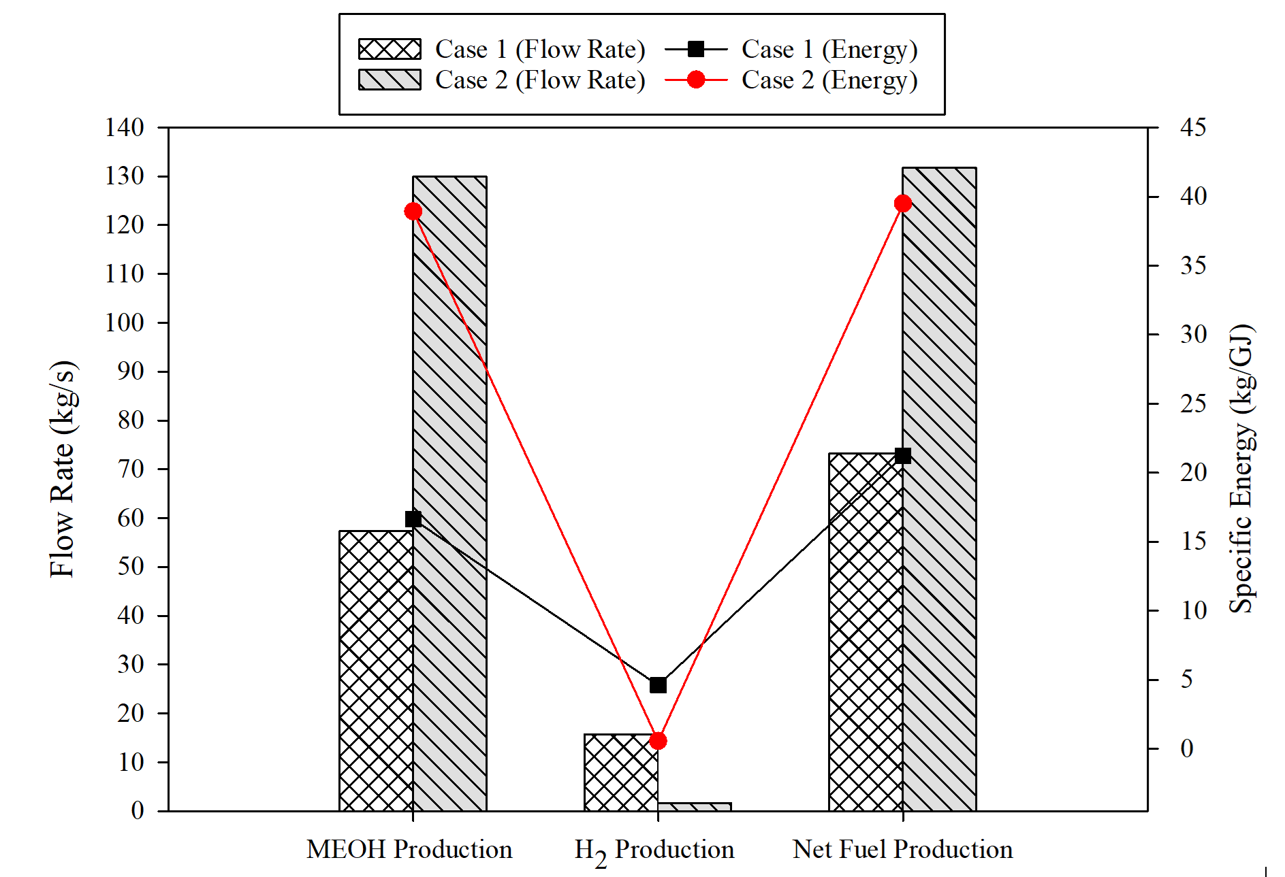

Figure 3: Methanol and hydrogen production rates with specific energy requirements

* 1. Project feasibility:

The economic feasibility analysis of methanol and hydrogen production from vacuum residue reveals promising results. CAPEX and OPEX were calculated to perform economic analysis and finding the total production cost (TPC) and minimum selling price (MSP) which are crucial project feasibility indicators, with considering the fluctuation of vacuum residue price between 0.022 $/kg and 0.11 $/kg. CAPEX includes the cost of land, equipment, machinery, construction, and engineering while OPEX includes the cost of raw material, utility as well as the cost of labor and maintenance CAPEX has been converted to the annualized capital charge (ACC) assuming a project life of 30 years and an interest rate of 10% using the relation shown in the following equation (Eq 2).

$ACC=\frac{\left[i{(1+i)}^{n}\right]}{\left[i{(1+i)}^{n}-1\right]} ×CAPEX$ (2)

Case 2, emphasizing methanol production exhibits a significantly lower TPC, positioning it as a more economically viable option than Case 1. The competitive edge is further evident in a higher product selling price and a shorter payback period.



Figure 4: Project feasibility indicators of Case 1 and Case 2 at different VR feed price.

The net present value (NPV) reinforces the financial attractiveness of Case 2, showcasing a substantial 27.29% increase compared to Case 1 when considering the average vacuum residue price of 0.066 $/kg. Furthermore, the calculated TPC for case 1 and 2 has been calculated as 0.453 $/kg and 0.223 $/kg, respectively. These findings suggest that the proposed process, with its emphasis on methanol production, holds economic feasibility, making it a compelling candidate for further development and implementation. Figure 4 represent the effect of the feed price on the TPC, NPV, and PBP for case 1 and 2.

**Conclusion:**

This research presents two case studies for dual methanol and hydrogen production from vacuum residue. In Case 1, methanol and hydrogen are co-produced from vacuum residue, yielding a process efficiency of 46.5%. Case 2 focuses on methanol production, achieving 42.9% efficiency, with a vacuum residue price of 0.066 $/kg, Case 2 exhibits a lower total production cost (TPC) of 0.223 $/kg, compared to 0.453 $/kg in Case 1. Furthermore, Case 2 demonstrates superior technical and environmental performance, boasting a 50.6% lower production cost, 27.29% higher net present value, and a shorter payback period, indicating enhanced project feasibility over Case 1.

**Acknowledgements**

The authors would like to acknowledge support provided by the Deanship of Research Oversight and Coordination (DROC) at the King Fahd University of Petroleum & Minerals (KFUPM) for funding this work through Project no. INHE2308.

References

Ahmed, U. Techno-economic analysis of dual methanol and hydrogen production using energy mix systems with CO2 capture. Energy Convers. Manag. 2020, 228, 113663.

Alibrahim,H.A.;Khalafalla,S.S.;Ahmed,U.;Park,S.;Lee,C.-J.;Zahid,U.Conceptualdesignofsyngasproductionbytheintegrationofgasificationanddry-reformingtechnologieswithCO2captureandutilization. *Energy Convers. Manag.* 2021, *244*,114485.

Al-Rowaili, F.N.; Khalafalla, S.S.; Al-Yami, D.S.; Jamal, A.; Ahmed, U.; Zahid, U.; Al-Mutairi, E.M. Techno-economic evaluation of methanol production via gasification of vacuum residue and conventional reforming routes. Chem. Eng. Res. Des. 2021, 177, 365–375.

Choi, Y.-C.; Lee, J.-G.; Yoon, S.-J.; Park, M.-H. Experimental and theoretical study on the characteristics of vacuum residue gasification in an entrained-flow gasifier. Korean J. Chem. Eng. 2007, 24, 60–66.

Gudiyella, S. *et al.* (2018) ‘An experimental and modeling study of vacuum residue upgrading in supercritical water’, *AIChE Journal*, 64(5), pp. 1732–1743.

Hamid, U. *et al.* (2020) ‘Techno-economic assessment of process integration models for boosting hydrogen production potential from coal and natural gas feedstocks’, *Fuel*, 266, p. 117111.

Meng,L.;Liu,K.;He,J.;Han,C.;Liu,P.Carbonemissionreductionbehaviorstrategiesintheshippingindustryundergovernmentregulation:Atripartiteevolutionarygameanalysis. *J. Clean. Prod.* 2022, *378*,134556.

Zuideveld,P.L.;Chen,Q.;vandenBosch,P.J.W.M.IntegrationofGasificationwithThermalResidueConversioninRefineries. *Gasif. Technol. Conf.* 2000,1–15