Optimal Control of Industrial Solvent-Based CO₂ Capture Plants
Fredrik Gjertsen,^{a,*} Adriaen Verheyleweghen,ª Svein Olav Hauger,ª Vemund Tjessem,ª Thor Mejdell,^{b} Hanne M. Kvamsdal ^{b}
ª Cybernetica AS, Leirfossv. 27, N-7038 Trondheim, Norway
^{b} SINTEF Industry, P.O. Box 4760 Torgarden, N-7465 Trondheim, Norway
* Corresponding author: fredrik.gjertsen@cybernetica.no
Abstract
Solutions for advanced control of CO₂ capture processes have been developed and tested on pilot scale, with full-height absorber and desorber columns, representative of operation on an industrial scale. This paper presents new results from live demonstrations of non-linear model predictive control (NMPC) in pilot scale, using the HiPerCap solvent HS3 on the SINTEF Tiller CO₂LAB pilot, including ongoing work in the AURORA project, to build on the established results in this field, hereunder published case studies and pilot demonstrations.
The results indicate that industrial deployment of NMPC for solvent-based CO₂ capture processes is imminent, and that it will constitute a valuable tool to automate the operation. The demonstrated outcome for the end-users is energy-optimal operation handling all operating conditions, with less operator interventions. Furthermore, the approach has possible extensions to combat advanced operational challenges.
Keywords: Absorption, nonlinear model predictive control, optimal control, OPEX reduction, flexible operation
  - Introduction
For solvent-based post-combustion carbon capture (PCC) plants, the published literature contains several investigations into the use of advanced process control for optimal operation, albeit mainly for simulated case-studies. Panahi & Skogestad (2011) assessed a PCC process with self-optimizing control, using existing conventional PI(D) controllers for economically efficient operation, where selecting controlled variables that are suitable across a wide range of operating conditions proved challenging. Hereunder, choosing temperature(s) to control for the desorber, and the target values thereof, is a non-trivial task (Mejdell et al., 2017). In a follow-up study, Panahi & Skogestad (2012) compared several control structures with linear MPC. In terms of performance the investigations qualified MPC as a suitable approach for such a capture process, although the MPC was costly to establish compared to effective use of the base-layer controllers. Inspired by these indications, particularly the observed linearity between reboiler heat flux and optimal solvent rate, Arce et al. (2012) studied MPC for a simulated PCC facility, where the reboiler was the focal point of the study. Interestingly, the study found promising potential for cost savings by exploiting time-varying price regimes for energy and CO₂, like the ideas investigated by Kvamsdal et al. (2018). Furthermore, Wu et al. (2020) made a comprehensive review of flexible operation of PCC plants via advanced process control, hereunder considering the use of (N)MPC. They point out an observed gap, where the simple data-driven models are insufficiently accurate, while the rigorous first-principles models are too complex to be calculated efficiently and robustly. The goal of the work presented here is to address the gap in these findings regarding the suitability of (N)MPC for optimization and control of PCC processes. The demonstrated results address the reported challenges with computational efficiency and robustness, to establish NMPC with first-principles models as a viable solution for industrial use in real time.
Recently, NMPC demonstration projects have revealed the possibility of explicit and simultaneous control of capture rates and energy costs (Hauger et al., 2019). CO₂ capture rates were controlled either instantaneously or to average values (e.g., daily), while energy usage was minimized. Applicability was demonstrated for a wide range of flue gas conditions and targeted CO₂ capture rates. The NMPC showed promising results when tested in operation, using the CESAR1 solvent (Mejdell et al., 2022). Kvamsdal et al. (2018) argue that an NMPC will perform similarly or better than an attentive, experienced plant operator, as demonstrated at the Technology Centre Mongstad (TCM) pilot facility. Additionally, Mejdell et al. (2022) reported that the NMPC can maintain acceptable lean loading during periods where the energy input is heavily restricted. This functionality is particularly useful for when optimal use of excess heat as reboiler duty, with varying availability, in accordance with the conclusions of Arce et al. (2012), where the lean solvent loading was declared a key variable of interest for cost optimization. This concept is readdressed in the work presented here.
Chikukwa et al. (2012) reviewed the available literature on dynamic modeling of absorption-based CO₂ capture processes, including identification of knowledge gaps. They highlighted the need for understanding the transient behavior of capture plants when operating conditions change and the role of dynamic models thereof, particularly for power plants as target upstream processes. While they acknowledged the advances in dynamic modeling, they also identified the notable lack of model validation with dynamic data and the observation that most models are based on steady-state data. Nevertheless, headway has been made since, e.g., with the mentioned NMPC demonstration projects.
In the currently ongoing Horizon Europe (HEU) project AURORA, the NMPC models used in previous demonstrations are being further developed and improved to meet industrial requirements, hereunder simplifications for model efficiency and robustness. Pilot-scale demonstrations will be made for both Tiller and TCM pilot facilities using the CESAR1 solvent. Results from preliminary pilot-scale NMPC tests for various operating scenarios are presented in Section 4 and indicate that NMPC is not only viable but can enable improved flexibility and energy efficiency of the operation.
  - Model
While the exact model developed for the PCC process is too detailed to be presented in full in this paper, some fundamental modeling principles that were found to be critical for success are discussed. The NMPC models are mechanistic, dynamic models developed from first principles, including energy balances and mass balances for all process units, such as the absorber, desorber, reboiler, and heat exchangers. Crucially, as highlighted by Chikukwa et al. (2012) and Wu et al. (2020), the model equations must be implemented in a computationally efficient way to get appropriate real-time performance. To achieve this, the models have inherent simplifications to arrive at a level of balanced complexity where both the computational efficiency and the accuracy of the model are adequate.
A module-based strategy has been chosen for implementation of the models, with a tripartite division as shown in Figure 1. The model consists of a generic part, a solvent-specific part, and a plant-specific part. This promotes reusability and versatility of the common, general principles of the capture processes, which eases the deployment of NMPC for a known solvent in a new capture plant, e.g., or the introduction of a new solvent in the NMPC for known plants.
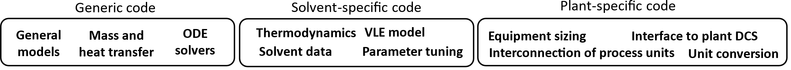
Figure 1: Tripartite, modular approach to process modeling for deployment with NMPC.
  - Advanced Process Control System
For the present work, the Cybernetica CENIT software suite was used. The central building blocks of the CENIT NMPC are shown in Figure 2. The core is the mechanistic process model, as mentioned in Sec. 2, which is formulated in C/C++ for numerical efficiency and compliance with the other components of the framework.
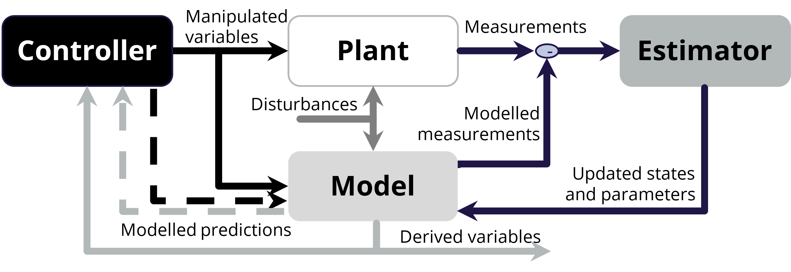
Figure 2: Block diagram illustrating the central components of the NMPC application(s), including the interconnection between them.
    - Nonlinear Kalman Filter
A crucial difference between in-silico studies of PCC processes and industrial implementations is the need for accurate online state and parameter estimation schemes. Without them, any model-based controller may be vulnerable to plant-model mismatch, e.g., caused by changes in amine concentrations due to degradation, loss of solvent through emissions, water balance issues, and other unforeseen process changes. The online estimation scheme is necessary to align the mechanistic process model with the measured plant behavior, to enable accurate predictions for near-future operation.
The Kalman filter estimator is a two-step process where a priori estimates are obtained based on the previous estimate in time by model prediction, after which the a posteriori estimates are found by correcting the model predictions with the measurements. The model predictions for states, parameters and measurements are shown in Eqs. (1)-(3), including process noise (${\overline{υ}}_{k-1}$) and measurement noise (${\overline{w}}_{k}$). The following measurement correction is shown in Eq. (4).
Model prediction:
${\overline{x}}_{k}=f\left({\hat{x}}_{k-1},{\hat{θ}}_{k-1},u_{k-1},{\overline{v}}_{k-1}\right)$ a priori state estimates | (1)
${\overline{θ}}_{k}={\hat{θ}}_{k-1}+{\overline{υ}}_{k-1}$ a priori parameter estimates | (2)
${\overline{y}}_{k}=g\left({\overline{x}}_{k},{\hat{θ}}_{k},u_{k-1}\right)+{\overline{w}}_{k}$ a priori measurement estimates | (3)
Measurement correction:
$\left[\begin{matrix}{\hat{x}}_{k} \\ {\hat{θ}}_{k}\end{matrix}\right]=\left[\begin{matrix}{\overline{x}}_{k} \\ {\overline{θ}}_{k}\end{matrix}\right]+K(k)(y_{M,k}-{\overline{y}}_{k})$ a posteriori state and param. est. | (4)
    - NMPC
The functionality of the CENIT NMPC is described in more detail by Foss & Schei (2007). At its core, it is based on a sequential quadratic programming (SQP) algorithm inspired by the work of Biegler and coworkers (de Oliveira & Biegler, 1995). The general cost function to be minimized is shown in Eq. (5), subject to the conditions specified in Eqs. (6)-(8). This approach will find the optimal input moves for the specified control horizon while penalizing setpoint deviations (Z – Z_{ref}), input moves (ΔU) and constraint violations (ε), each with their respective weights (Q, S, r₁ and r₂).
$$\min_{ΔU}{J=\frac{1}{2}{\left(Z-Z_{ref}\right)}^{T}Q\left(Z-Z_{ref}\right)+\frac{1}{2}(ΔU^{T}SΔU)}+r_{1}^{T}ε+\frac{1}{2}ε^{T}diag\left(r_{2}\right)ε$$ |  | (5)
s.t $x_{k+j}=f(x_{k+j-1},u_{k+j-1},v_{k})$  $z_{k+j}=h(x_{k+j},u_{k+j})$ | Model predictions | (6)
$Z_{min}-ε<Z<Z_{max}+ε$  $0≤ε≤ε_{max}$ | Controlled variables (CVs) soft constraints with slack variables | (7)
$U_{min}≤U≤U_{max}$  $ΔU_{min}≤ΔU≤ΔU_{max}$ | Manipulated var. (MV) constraints, absolute and relative constraints | (8)
For the PCC process, the NMPC has two CVs of central importance. These are the CO₂ capture rate, which is controlled to a specified setpoint, and the specific reboiler duty, which is minimized. Furthermore, the lean loading is constrained in the optimization criterion to avoid build-up of dissolved CO₂ in the lean solvent over time. The available MVs are the reboiler duty and the flow rate of lean solvent into the absorber top, which are both controlled within their respective constraints. In the demonstrated application, the sample time is 30 seconds, with a prediction horizon of 5 hours, hence the strict requirements for computational efficiency.
  - Results
The test scenarios were designed to address the existing shortcomings and research gaps highlighted by Mejdell et al. (2022). Additional tests were performed but are omitted from this work for brevity. The omitted demonstrations include temporary reboiler stops (e.g., for power plant grid stabilization), capture rate setpoint changes and flue gas ramps (both with and without prior knowledge, for feedforward functionality).
    - Scenario I: Energy availability for reboiler is heavily restricted.
A live demonstration of the proposed NMPC during limited availability of energy is shown in Figure 3, Scenario I. As a result of the reduced energy availability, the CO₂ capture rate is reduced temporarily. Whereas a short-sighted controller, i.e., PID or a feed-forward controller, without knowledge of the dynamics and the constraint regions, would attempt to maintain a high capture rate, the NMPC backs down on the capture rate for the time being to prevent an unwanted increase in lean loading. It is observed that regaining the capture rate is relatively quick, given that lean loading is appropriately low compared to what it would take to regain the lean loading once it has escalated. The lean loading was directly constrained in the cost function to motivate this behavior.
    - Scenario II: Load following with large, rapid changes in inlet CO₂ flow rate.
Scenario I: Energy availability for  reboiler is (heavily) restricted | Scenario II: Load following with large, rapid changes in inlet CO₂ flow rate
___ Actual values (solid) | - - - Setpoints (dashed) | …. Constraints (dotted)

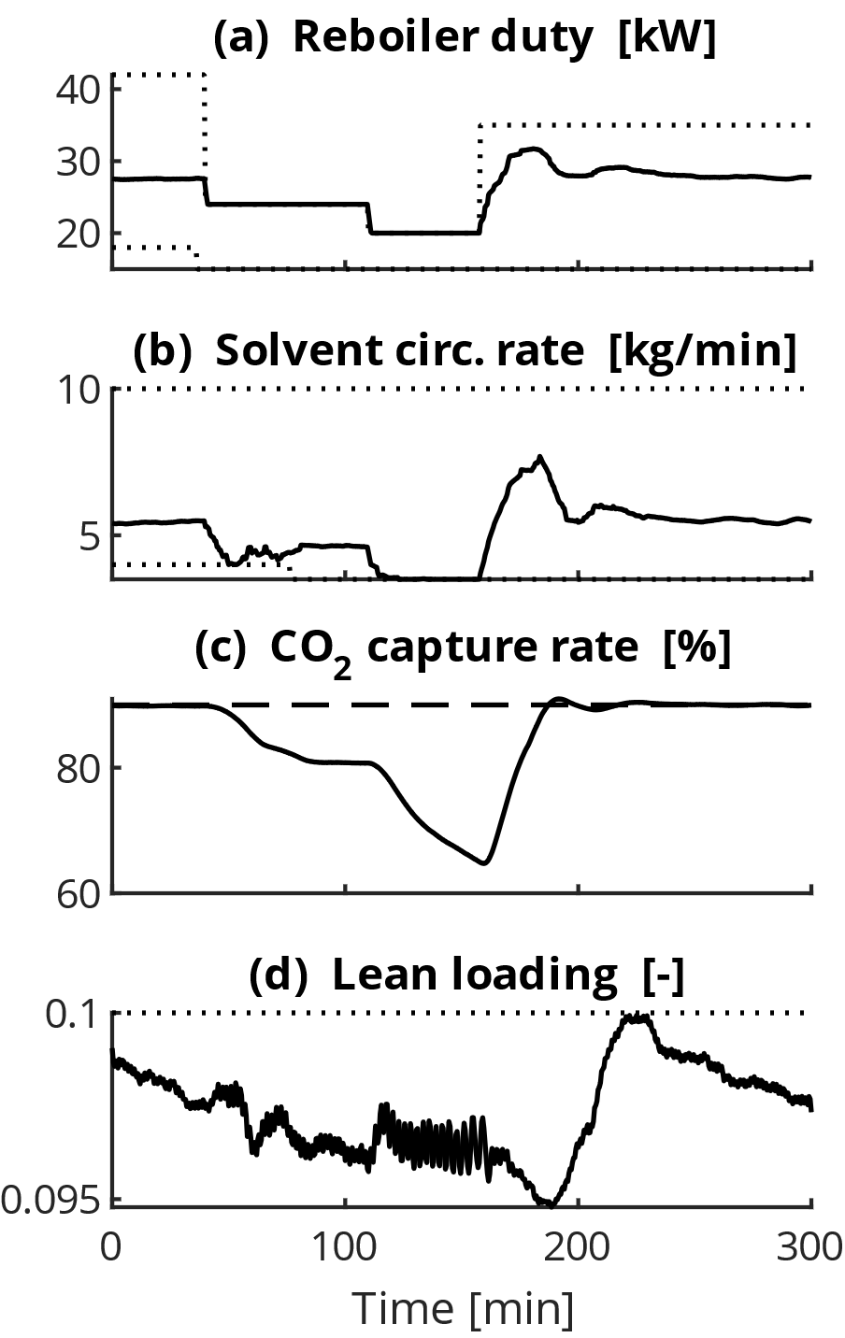 | 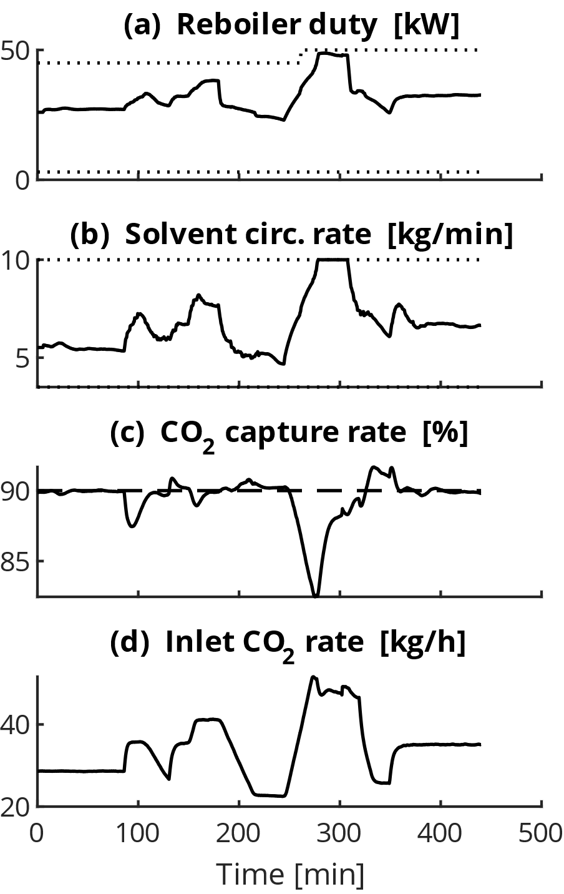
Figure 3: Results from live demonstration of optimal control using NMPC at the Tiller pilot plant, for two separate scenarios with challenging operating conditions.
During another live demonstration, a load following scenario was tested, as shown in Figure 3, Scenario II. In this case, the flue gas is changed rapidly and unpredictably to replicate the behavior of an upstream emitter with changing operating conditions, e.g., a power plant that is required to participate in grid power regulation, as pointed out by Wu et al. (2020), among others. In practice, this will incur changes in the flue gas inlet flow rate, the flue gas CO₂ concentration, or both. The purpose of the NMPC is to obey the specific capture rate setpoint, as prescribed by the plant operator while approaching the point of optimal operation in terms of energy usage. The results indicate that the control system is responsive to large disturbances, even when the capture plant is pushed towards the constraints, i.e., its design- and operational boundaries.
  - Conclusions
NMPC has been demonstrated on pilot scale for a CO₂ capture facility, using mechanistic process models in the Cybernetica CENIT control software. Two scenarios were studied to assess the viability of NMPC for industrial PCC: In the first scenario, reboiler duty was heavily restricted, temporarily. In response, the NMPC reduced the CO₂ capture rate temporarily to prevent an increase in lean loading. In the second scenario, the CO₂ concentration in the inlet stream varied rapidly and unpredictably. The CO₂ capture rate was kept on the setpoint, despite these large deviations. This demonstration is important evidence of the robustness of the NMPC. As demonstrated in these scenarios, NMPC solutions are suitable for industrial application, with versatility for various solvents and plant-specific variations. Concerns regarding robustness and computational efficiency have been calmed after extensive testing in live operation.
Acknowledgements
This work has received funding from the European Union’s Horizon Europe and Horizon 2020 research and innovation programmes under grant agreements No. 101096521 and 884266, respectively.
References
A. Arce, N. Mac Dowell, N. Shah & L. F. Vega, 2012, Flexible operation of solvent regeneration systems for CO₂ capture processes using advanced control techniques: Towards operational cost minimisation, International Journal of Greenhouse Gas Control, Vol. 11, pp. 236-250
A. Chikukwa, N. Enaasen, H. M. Kvamsdal & M. Hillestad, 2012, Dynamic Modeling of Post-combustion CO₂ Capture Using Amines – A Review, Energy Procedia, Vol. 23, pp. 82-91
S. M. Elgsæter, P. Kittilsen & S. O. Hauger, 2012. Designing large-scale balanced-complexity models for online use. IFAC Proceedings Volumes, Vol. 45, Iss. 8, pp. 157–162
A. Emhemed & R. Mamat, 2020, Model Predictive Control: A summary of Industrial Challenges and Tuning Techniques, International Journal of Mechatronics, Electrical and Computer Technology, Vol. 10, Iss. 35, pp. 4441-4459
B. A. Foss & T. S. Schei, 2007, Putting Nonlinear Model Predictive Control into Use, LNCIS, Vol. 358, pp. 407-417, Springer Verlag
S. O. Hauger, N. E. Flø, H. M. Kvamsdal, F. Gjertsen, T. Mejdell & M. Hillestad, 2019, Demonstration of non-linear model predictive control of post-combustion CO₂ capture processes; Computers and Chemical Engineering 123, pp. 184-195
H. M. Kvamsdal, S. O. Hauger, F. Gjertsen, T. Mejdell, N. E. Flø, K. Johnsen & M. Hillestad, 2018, Demonstration of two-level nonlinear model predictive control of CO₂ capture plants, 14th International Conference on Greenhouse Gas Control Technologies, GHGT-14, 21st – 25th October 2018, Melbourne, Australia
T. Mejdell, G. Haugen, A. Rieder & H. M. Kvamsdal, 2017, Dynamic and control of an absorber - desorber plant at Heilbronn, Energy Procedia, Vol. 114, pp. 1231–1244
T. Mejdell, H. M. Kvamsdal, S. O. Hauger, F. Gjertsen, F. A. Tobiesen & M. Hillestad, 2022, Demonstration of non-linear model predictive control for optimal flexible operation of a CO₂ capture plant, International Journal of Greenhouse Gas Control, Vol. 117, 103645N. M. C. de Oliveria & L. T. Biegler, 1995, An extension of Newton-type algorithms for nonlinear process control, Automatica, Vol. 31, Iss. 2, pp. 281-286
M. Panahi & S. Skogestad, 2011, Economically efficient operation of CO₂ capturing process. Part I. Self-optimizing procedure for selecting the best controlled variables, Chemical Engineering and Processing: Process Intensification, Vol. 50, Iss. 3, pp. 247–253
M. Panahi & S. Skogestad, 2012, Economically efficient operation of CO₂ capturing process. Part II. Design of control layer, Chemical Engineering and Processing: Process Intensification, Vol. 52, pp. 112–124
S. J. Qin & T. A. Badgwell, 2003, A survey of industrial model predictive control technology, Control Engineering Practice, Vol. 11, Iss. 7, pp. 733-764
X. Wu, M. Wang, P. Liao, J. Shen & Y. Li, 2020, Solvent-based post-combustion CO2 capture for power plants: A critical review and perspective on dynamic modelling, system identification, process control and flexible operation, Applied Energy, Vol. 257, 113941

