Modelling of a Cartridge-based Fixed Bed Radial Flow Reactor for Methanol Synthesis
Frank Sauerhöfer-Rodrigo,^{a,} Manuel Rodríguez,ª Ismael Díazª
ªDpto. Ingeniería Química Industrial y del Medio Ambiente, Universidad Politécnica de Madrid, C/ José Gutiérrez Abascal, 2, 28006, Madrid, Spain
frank.sauerhofer.rodrigo@alumnos.upm.es
Abstract
A novel mathematical model for a multitubular cartridge-based fixed bed radial flow reactor for methanol synthesis has been developed. This type of reactors has the advantage of having a lower effective bed thickness, resulting in a lower pressure drop and thus, improving the operational costs of the plant. The model has been evaluated using the original and a refitted Van der Graaf kinetics, showing a much better methanol yield using the latter. The sensitivity analysis results show that above 20 cartridges per tube, the methanol yield barely improves. Additionally, there is a trade-off between the pressure drop and the methanol yield. It is suggested to perform a full techno-economic and sustainability assessment including the full recycle loop to compare it with the conventional multitubular fixed bed reactor.
Keywords: methanol synthesis, radial flow reactor, reactor modelling, cartridge-based fixed bed reactor.
  - Introduction
The European Green Deal requires industries to decarbonize the industrial energy systems by achieving net-zero greenhouse gas emissions by 2050 (European Commission, 2019). This entails that conventional fossil fuels and fossil-based commodity chemicals will have to be replaced by non-fossil products. There are many alternatives to fossil fuels, amongst which synthetic fuels seem very promising at an industrial scale. Among all the non-fossil fuel alternatives to conventional fossil fuels, e-methanol from captured CO₂ and green hydrogen from electrolysis is one of the key products industries are currently looking at due to its outstanding combustion properties and the wide spectrum of methanol-derived products.
The main fixed bed reactor technologies used for methanol synthesis are the adiabatic reactor and the isothermal reactor (Bisotti et al., 2022; Bozzano and Manenti, 2016). Adiabatic systems use multiple beds in series with intercooling. Nevertheless, hot and cold spots can be found, leading to low reaction rates, catalyst deactivation or byproducts formation. On the other hand, isothermal reactors are cooled either by boiler feed water (Lurgi steam rising converter) or a cooling gas. However, there are heat transfer limitations, which increase the construction costs. The two main challenges of the fixed bed reactors used in industry are the pressure drop and the heat removal management.
New reactor geometries have arisen in order to overcome some of the challenges that traditional fixed bed reactors suffer from. In 2014, Davy Process Technology patented a novel reactor design for methanol production (Gamlin, 2014). The current assignee of the patent is Johnson Matthey Davy Technologies Limited. The technology consists of a multitubular reactor where each tube is filled with multiple cartridges (up to 200) in series and the shell side contains a cooling medium. Within each cartridge, the catalyst is placed in an annular container. The gas enters at the top of the cartridge to the inner cylindric hole, flows radially outwards and react adiabatically (see Figure 1). Then the gas is collected and cooled down in contact with the tube wall. Then the gas goes to the next cartridge to repeat the reaction-cooling process. This configuration results in a lower effective bed length, which translates in a lower pressure drop, and a high heat transfer.
In this work, a new model for the cartridge-based fixed bed reactor for methanol synthesis is presented. The model contains mass, heat and momentum balances for each cartridge. The model is used to compare the performance of this novel reactor configuration with the conventional multitubular reactor with tubes filled with catalyst particles and a cooling medium contained in the shell side. The performance is compared based on the pressure drop and overall carbon conversion. Additionally, a sensitivity analysis will be carried out to determine the effect of catalyst distribution along different number of cartridges per tube.
  - Reactor model
The reactor model is divided in two sections: the reaction section and the cooling section. The boundaries of the reaction section are limited to the catalyst container walls (see Figure 1). The cooling section boundaries are limited to the volume where the gas flows downwards and it is in direct contact with the tube wall (see Figure 1). The model has been developed in Aspen Custom Modeler V14. The thermodynamic package used is Peng-Robinson.
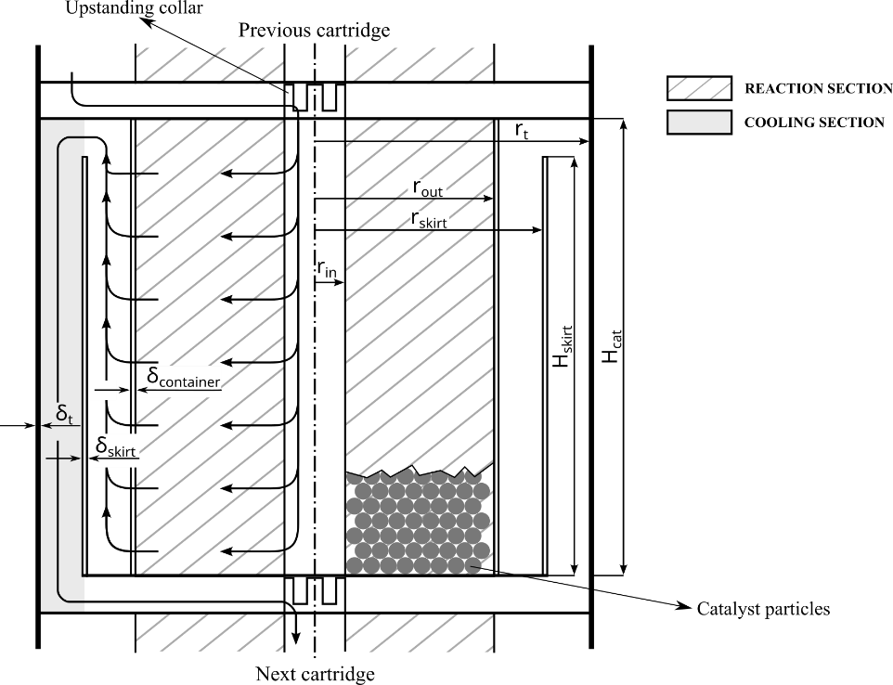
Figure 1. Longitudinal cross-section of a cartridge
    - Reaction section
It is assumed that the gas is well distributed along the entire catalyst bed and that there is no channeling or maldistribution. Axial dispersion is neglected, and the annular catalyst container is adiabatic. The mass balance is shown in Eq. (1), where $F_{i}$ is the molar flow of species i, $r$ is the radial dimension in the catalyst container, $r_{j}\left(s\right)$ is the reaction rate of reaction j at a distance s from the particle centre, $υ_{i,j}$ is the stoichiometric coefficient of species i in reaction j, $V_{p}$ is the particle volume and $ρ_{b}$ is the bed density.
$$\frac{dF_{i}}{dr}=2πrH_{cat}ρ_{b}\int_{0}^{V_{p}}{\sum_{j=1}^{3}{υ_{i,j}r_{j}\left(s\right)}dV_{p}}$$ | (1)
The concentration of each species within the catalyst particle is defined by the mass continuity equation and the Fick’s first law shown in Eq. (2), where $r_{i}$ is the total reaction rate of species i, $J_{i}$is the diffusion molar flux, $C_{i}$ is the concentration of species i and $A_{p}$ is the spherical superficial area. Those equations are subjected to the boundary conditions shown in Eq. (3), where $ρ_{g}$ is the gas density, $M_{g}$ is the molecular mass of the gas and $y_{i}$ is the molar fraction of species i in the bulk gas phase.
$$r_{i}\left(s\right)dV_{p}-d\left(J_{i}\left(s\right)·A_{p}\left(s\right)\right)=r_{i}\left(s\right)dV_{p}-d\left(\left(-D_{e,i}\frac{dC_{i}}{ds}\right)·A_{p}\left(s\right)\right)=0$$ | (2)
$$\begin{matrix}\frac{dC_{i}}{ds}=0 & s=0; & C_{i}=y_{i}ρ_{g}M_{g} & s=R_{p}\end{matrix}$$ | (3)
The energy balance is shown in Eq. (4), where $H$ is the enthalpy flow. The momentum balance is shown in Eq. (5) (Froment et al., 2011), using the friction factor defined by Tallmadge (1970) (Erdim et al., 2015). $d_{p}$ is the particle diameter, $ε_{b}$ is the bed voidage, ${Re}_{g}$ is the Reynolds number and $u_{g}$ is the superficial velocity of the gas.
$$\frac{dH}{dr}=0$$ | (4)
$$\frac{dP}{dr}=-\frac{ρ_{g}u_{g}^{2}}{d_{p}}\frac{1-ε_{b}}{ε_{b}^{3}}\left(4.2{\left(\frac{1-ε_{b}}{{Re}_{g}}\right)}^{\frac{1}{6}}+150\frac{1-ε_{b}}{{Re}_{g}}\right)$$ | (5)
The boundary conditions for each cartridge are as follows:
$$\begin{matrix}F_{i}=F_{i,0}, T=T_{0}, P=P_{0} & r=r_{in}\end{matrix}$$ | (6)
    - Cooling section
It is assumed that the flow is fully developed in the cooling section. The temperature of the external surface of the tube wall ($T_{w}$) is assumed to be the same as that of the cooling media. The mass flow and compositions remain steady and equal to the inlet conditions along the entire cooling section. Additionally, the pressure drop in this section is neglected. The heat balance is shown in Eq. (7). The thermal resistance is calculated with the definition presented by McAdams and Frost (1922) and Steynberg et al. (2004) and shown in Eq. ¡Error! No se encuentra el origen de la referencia.. The wall thermal conductivity of steel ($k_{steel}$) is assumed to be 60 W/(K·m) (Philippe et al., 2009).
$$dH-{\left(\frac{δ_{t}}{k_{steel}2π\left(r_{t}+{δ_{t}}/2\right)dz}+\frac{1}{h2πr_{t}dz}\right)}^{-1}\left(T-T_{w}\right)=0$$ | (7)
    - Model parameters
The wall effects on the bed voidage are neglected, resulting in a uniform porosity of the catalyst bed throughout the entire annulus. The porosity is calculated with the correlation proposed by Sodré and Parise (1998) using the hydraulic diameter (Eq. 15 of the original paper, with $B=0.387$).
The effective diffusion coefficients are calculated using the approach proposed by Loomerts et al. (2000) for a multicomponent system using a combined bulk binary diffusivity and Knudsen diffusion. The Knudsen diffusion is calculated as proposed by Vedrine (1983). A pore radius of 10 nm is taken (Lommerts et al., 2000). The binary gas-phase diffusion coefficient for each species is calculated with Fuller et al.’s method (Fuller et al., 1966). According to Graaf et al. (1990), $ε/τ$ has a value of 0.123.
The heat transfer coefficient in the annulus region with the gas flowing downwards is calculated with the correlation proposed by Gnielinski (2009).
  - Study case
The case to be studied is adapted from the case used by Yusup et al. (2010) and used by Leonzio (2020) to study different kinetic models. The feed conditions and composition are shown in Table 4 of Yusup et al.’s work (2010). The reactor geometry is based on that of the conventional reactor presented in the aforementioned works and adapted to the cartridge-based reactor technology (see Table 1). The number of cartridges is varied in order to check how sensible the results are to the number of cartridges. The height of each cartridge is equal to the total reactor length divided by the number of cartridges per tube.
The performance indicators to be evaluated in this study are carbon conversion per pass and pressure drop. In a full methanol synthesis scheme, the recycle loop would impact the overall carbon conversion as well as the energy expenditure to compress and re-heat the recycled gas. A sensitivity analysis has been carried out to check the impact of the number of cartridges over the two performance indicators using the two kinetics proposed. As seen in Figure 2 (top), the original Van der Graaf kinetics results in a lower methanol yield than the refitted kinetics. However, in both cases there is a higher yield towards methanol than with the conventional methanol reactor, which is ~1 t/(m³-catalyst h) according to Blug et al. (2014). Additionally, there seems to be a plateau when increasing the number of cartridges keeping the same catalyst mass, approaching a quasi-isothermal behaviour at a certain point within the reactor (Figure 2 bottom). Nevertheless, the pressure drop increases when increasing the number of cartridges per tube, as the effective bed thickness through which the gas passes becomes higher. The peak methanol production using the original Van der Graaf kinetics with two cartridges is a result of the gas being heated by the shell fluid after the first cartridge, reaching a temperature sufficiently high to significantly increase the reaction extent in the next adiabatic reaction section. With one cartridge, the temperature is not high enough to have a high reaction rate and produce as much methanol as with two cartridges. With more than two cartridges, the gas cools down in between cartridges, limiting up to some extent the reaction rate.
Table 1. Reactor geometry and design parameters
Parameter | Units | Value | Parameter | Units | Value
Total catalyst loading | kg | 35,778.5 | $$δ_{skirt}$$ | mm | 1
Catalyst density | kg/m³ | 1100 | $$δ_{container}$$ | mm | 0.3
Tube diameter | m | 0.1 | $$d_{p}$$ | mm | 0.5
$$δ_{t}$$ | mm | 3.2 | Number of tubes |  | 1521
$$r_{in}$$ | m | 0.0183 | Reactor length | m | 7.26
$$r_{out}$$ | m | 0.0432 | $${H_{cat}}/{H_{CANS}}$$ |  | 0.95
$$r_{skirt}$$ | m | 0.0675 | $$T_{w}$$ | º C | 250
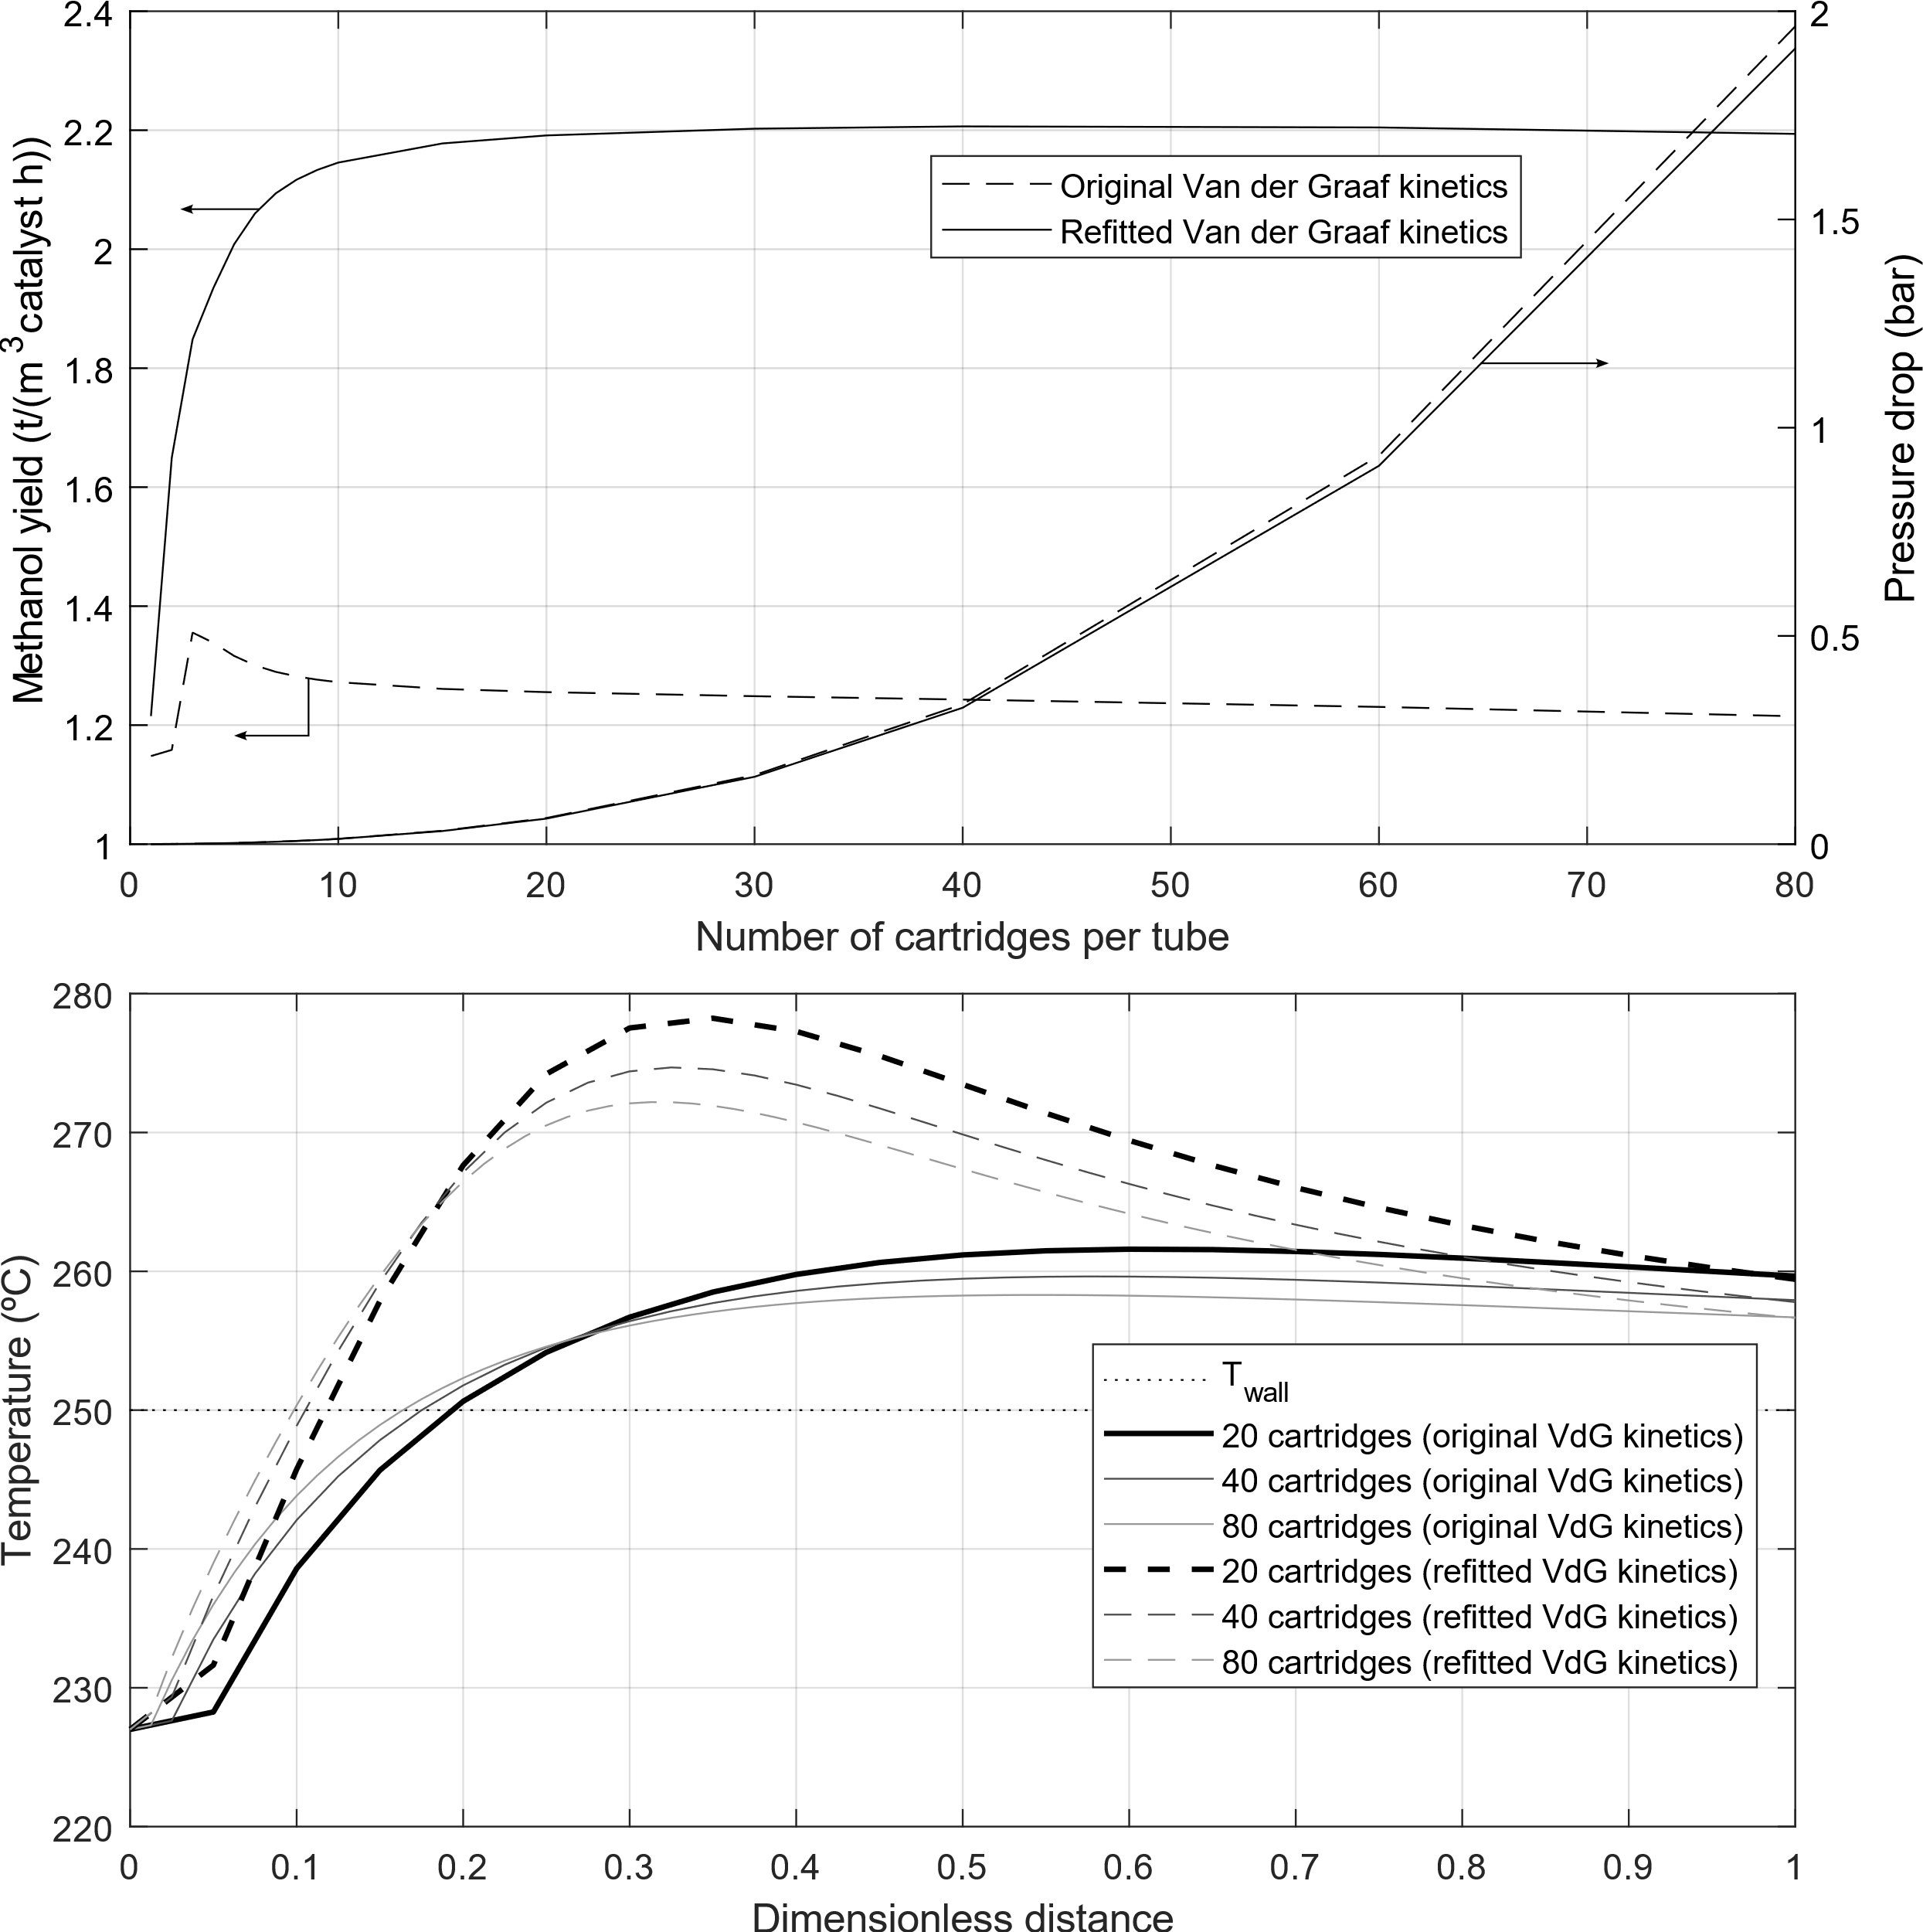
Figure 2. Carbon conversion and pressure drop vs number of cartridges per tube (top figure) and temperature profiles along the reactor (bottom figure)
  - Conclusions
A novel reactor model for methanol synthesis from syngas using a multitubular cartridge-based fixed bed reactor has been presented. Two different kinetics have been used. The results of the sensitivity analysis showed that for a given catalyst loading and a certain reactor length, there is a trade-off between the pressure drop of the reactor and the methanol yield. Above 20 cartridges the pressure drop significantly increases while the carbon conversion barely increases. Additionally, the methanol yield per mass of catalyst is significantly higher than that of a conventional reactor. It is suggested to perform a full techno-economic and sustainability assessment to compare this type of reactor with the conventional reactor including the recycle loop so that the energy consumption and carbon footprint of other pieces of equipment within it are accounted for as well.
  - Acknowledgments
The authors would like to acknowledge Repsol S.A. for supporting this work.
References
F. Bisotti, M. Fedeli, K. Prifti, A. Galeazzi, A. Dell’Angelo, F. Manenti, 2022, Impact of Kinetic Models on Methanol Synthesis Reactor Predictions, In Silico Assessment and Comparison with Industrial Data. Ind Eng Chem Res, 61, 2206–2226
M. Blug, J. Leker, L. Plass, A. Günther, 2014, Methanol generation economics, In: M. Bertau, H. Offermanns, L. Plass, F. Schmidt, H.-J. Wernicke (Eds.), Methanol: The Basic Chemical and Energy Feedstock of the Future: Asinger’s Vision Today. Springer Berlin Heidelberg, Berlin, Heidelberg, 603–618
G. Bozzano, F. Manenti, 2016, Efficient methanol synthesis: Perspectives, technologies and optimization strategies, Prog Energy Combust Sci, 56, 71–105
E. Erdim, Ö. Akgiray, I. Demir, 2015, A revisit of pressure drop-flow rate correlations for packed beds of spheres, Powder Technol 283, 488–504
European Commission, 2019, The European Green Deal, The European Commission - Striving to be the first climate-neutral continent, https://commission.europa.eu/strategy-and-policy/priorities-2019-2024/european-green-deal_en (accessed 11.21.23)
G.F. Froment, K.B. Bischoff, J. De Wilde, 2011, Chemical Reactor-Analysis and Design, 3rd ed., John Wiley & Sons, Inc., Hoboken, NJ
E.N. Fuller, P.D. Schettler, J.C. Giddings, 1966, A new method for prediction of binary gas-phase diffusion coefficients, Ind Eng Chem, 58, 18–27
T.D. Gamlin, 2014, Process for the synthesis of methanol, 8,785,506 B2
V. Gnielinski, 2009, Heat transfer coefficients for turbulent flow in concentric annular ducts, Heat Transfer Engineering, 30, 431–436
G.H. Graaf, H. Scholtens, E.J. Stamhuis, A.A.C.M. Beenackers, 1990, Intra-particle diffusion limitations in low-pressure methanol synthesis, Chem Eng Sci, 45, 773–783
G.H. Graaf, P.J.J.M. Sijtsema, E.J. Stamhuis, G.E.H. Joosten, 1986, Chemical equilibria in methanol synthesis, Chem Eng Sci, 41, 2883–2890
G. Leonzio, 2020, Mathematical modeling of a methanol reactor by using different kinetic models, Journal of Industrial and Engineering Chemistry, 6, 20
B.J. Lommerts, G.H. Graaf, A.A.C.M. Beenackers, 2000, Mathematical modeling of internal mass transport limitations in methanol synthesis, Chem Eng Sci, 55, 5589–5598
W.H. McAdams, T.H. Frost, 1922, Heat Transfer, Journal of Industrial & Engineering Chemistry, 14, 13–18
R. Philippe, M. Lacroix, L. Dreibine, C. Pham-Huu, D. Edouard, S. Savin, F. Luck, D. Schweich, 2009, Effect of structure and thermal properties of a Fischer-Tropsch catalyst in a fixed bed, Catal Today, 147, S305–S312
Sodré, J.R. Parise, J.A.R., 1998, Fluid flow pressure drop through an annular bed of spheres with wall effects, Exp Therm Fluid Sci 17, 265–275
A.P. Steynberg, M.E. Dry, B.H. Davis, B.B. Breman, 2004, Fischer-tropsch reactors, Stud Surf Sci Catal, 152, 64–195
J.A. Tallmadge, 1970, Packed bed pressure drop—an extension to higher Reynolds numbers, AIChE Journal
J.C. Vedrine, 1983, Mass Transport in Heterogeneous Catalysis, In: Bénière, F., Catlow, C.R.A. (Eds.), Mass Transport in Solids, NATO Advanced Science Institutes Series, Springer, Boston, MA, 505–536
S. Yusup, N.P. Anh, H. Zabiri, 2010, A Simulation Study of an Industrial Methanol Reactor Based on Simplified Steady-State Model, International Journal of Recent Research and Applied Studies, 5, 213–222

