Process simulation of BECCS-to-X: Investigating the potential of Hydrogen and Sustainable Aviation Fuel Production
Mathew Dennis Wilkes ª, Solomon Brown ª*.
ª Department of Chemical and Biological Engineering, University of Sheffield, Mappin Street, Sheffield, S1 4LZ, United Kingdom,
s.f.brown@sheffield.ac.uk

Abstract
Bioenergy with Carbon Capture and Storage (BECCS) combined with Biomass-to-X (BtX), BECCS-to-X, is a potential technology for generating power and syngas, which can be further processed into useful chemicals and fuels. Herein, the authors discuss and develop process models for converting biomass into hydrogen and sustainable aviation fuel (SAF) – BECCS-to-H₂ and BECCS-to-SAF, respectively. Both processes use the same biomass input and produce the same amount of power. Results show the higher energy efficiency for producing H₂ (50%) compared to SAF (34%) and total Fischer-Tropsch fuels (47%).
Keywords: BECCS, BECCS-to-X, H₂, SAF

Introduction
Negative Emissions Technologies (NET), such as Bioenergy with Carbon Capture and Storage (BECCS), are essential for achieving Net Zero (DESNZ, 2023). Most scenarios/ pathways to limit global temperature rise to less than 1.5℃ require carbon dioxide removal (CDR) technologies such as BECCS in order to remove CO₂ from the atmosphere (Almena, et al., 2022). The generation of useful products from biomass is referred to as Biomass-to-X or BtX (Poluzzi, et al., 2021). BECCS typically refers to thermo-chemical conversion routes with carbon capture and storage (CCS) (Shahbaz, et al., 2021). Thermo-chemical conversion of biomass via gasification produces heat and syngas, downstream processing coupled with power generation can convert biomass resources into both power and useful products, i.e., BECCS-to-X.
Depending on the processing route, biomass can be converted into ammonia, bio-char, dimethyl ethers, hydrogen, methane, methanol, and Fischer-Tropsch fuels (Poluzzi, et al., 2021; Hanel, et al., 2022). Hydrogen is an energy carrier and chemical building block, it has the potential to decarbonize industry, power, heating, and transportation (Osman, et al., 2021). Fischer-Tropsch synthesis can produce Sustainable Aviation Fuel (SAF), which is an important mitigation strategy for one of the most difficult to abate industrial sectors - aviation (Doliente, et al., 2020). Hanel et al. (2022) performed an energetic and technical evaluation on gasification based BtX processes. Interestingly, no single optimal BtX was presented, the authors showed the key process indicators (KPIs) are subjective to that processing route. Hence, further investigation for specific scenarios is required.

Aims & Objectives
This study is a technical evaluation and comparison of BECCS-to-H₂ and BECCS-to-SAF using Aspen Plus. The analysis highlights key operating parameters (KOPs) and KPIs for each process. Our previous study focused on the production of H₂, whereby hydrogen is separated and purified from bio-syngas alongside CO₂ (CCS) with heat-recovery steam generation to provide power (Wilkes, et al., 2023).

The purpose of this paper is to investigate and showcase:
- Process model development and description for BECCS-to-H₂ and BECCS-to-SAF.
- Process analysis and identification of KOPs and KPIs.
- Technical comparison between the two BECCS-to-X systems.

Process description and modelling
The process models are developed in Aspen Plus® v11.1, the model topology for the BECCS-to-H₂ and BECCS-to-SAF processes are shown in Figure 1 and Figure 2, respectively. Wet biomass enters and DRYER unit and the output moisture content is set to 10.05 wt.%. Within Aspen, biomass is a non-conventional solid and needs to be decomposed (DECOMP) into its constituent elements before gasification (GASI). An RGibbs reactor is chosen for the gasification unit, which calculates chemical equilibrium based on Gibbs free energy minimization (Tauqir, et al., 2019). The syngas produced in the gasification unit needs upgrading to improve the H₂/CO ratio. The syngas upgrading using the water-gas shift (WGS) reaction unit is based on Marcantonio et al. (Marcantonio, et al., 2019) and Moneti et al. (Moneti, et al., 2016), both of which simulated the experiments conducted within the UNIfHY project (UNIfHY, 2016). The WGS reaction (Equation 1) favors the production of CO and H₂O at high temperatures, thus the UNIfHY project looked at high temperature shift (HTS) at 400℃ and low temperature shift (LTS) at 200℃. Both HT-WGS and LT-WGS reactors are operated at 27 bar (Cohce, et al., 2011), and are modelled as REquil reactors representing the WGS reaction (Marcantonio, et al., 2019):
$$CO+H_{2}O⇆CO_{2}+H_{2}$$ | 1
Sulphur within the biomass is converted into H₂S and COS in the gasification unit, and all of the COS is converted in H₂S in the WGS units. Therefore, prior to H₂/CO₂ separation H₂S is removed using Selexol, which also co-captures CO₂. The separation efficiency for H₂S is 100% and for CO₂ it is 95% (Chiesa, et al., 2005). H₂S is removed in the SELEXOL1 unit and CO₂ is removed in the SELEXOL2 unit, both are modelled as separation units. The CO₂ conditioning unit ensures the CO₂ stream is ready for pipeline transportation, it uses sub-critical liquefaction at 66 bar (CO2-COMP) and liquid pumping to 111 bar (CO2-PUMP) which reduces the energy consumption for the conditioning train (Wilkes, et al., 2021). The energy demand for the Selexol process is 0.6 GJe/tCO2 and 0.63 GJth/tCO₂ (Kuramochi, et al., 2012). For the BECCS-to-H₂ process, H2 is separated in a pressure swing adsorption (PSA) unit (85% capture rate and 99.99% purity (Chiesa, et al., 2005). Heat is recovered in the HRSG unit, and the high-pressure steam produces power in the HP-ST, IP-ST, and LP-ST turbines.
BECCS-to-SAF requires additional processing units to convert the syngas into useful Fischer-Tropsch (FT) fuels. The FT reactor model is based on the conversion-based reactor model presented in (Dahl, 2020), using an RStoic reactor in Aspen Plus with conversion data from (Shafer, et al., 2019). The FT-C unit is operated at 220℃ and 27.6 bar (Shafer, et al., 2019). Only Paraffins (alkanes) are considered in this study, the overall reaction is shown in Equation 2 (Hillestad, 2015).
$$CO+U_{1}H_{2}→v_{1,1}C_{1}^{P}+v_{1,2}C_{2}^{P}…+v_{1,\left[21,∞\right]}C_{21+}^{P}+H_{2}O$$ | 2
Where $U$ is the hydrogen stoichiometric coefficient, $v$ is the hydrocarbon stoichiometric coefficient, and the superscript $P$ denotes the paraffin component. The heavy hydrocarbons are lumped into $C_{21+}^{P}$. The ASF distribution underestimates the $CH_{4}$ production, thus Equation 3 is added to the RStoic unit.
$$CO+3H_{2}→CH_{4}+H_{2}O$$ | 3
The stoichiometric coefficients (Equation 4 and 5) follow the ASF distribution (Hillestad, 2015), where the chain growth factor ($α_{1}$) is set to 0.9 (Swanson, et al., 2010; Campanario & Ortiz, 2017). The subscript $i$ denotes the carbon number. The fractional conversion for the paraffin and methanation reactions is set to 0.394 and 0.077 (Dahl, 2020).
$$v_{1,i}={\left(1-α_{1}\right)}^{2}α_{1}^{i-1}$$ | 4
$$v_{1,[21,∞]}={\left(1-α_{1}\right)}^{2}α_{1}^{21-1}$$ | 5

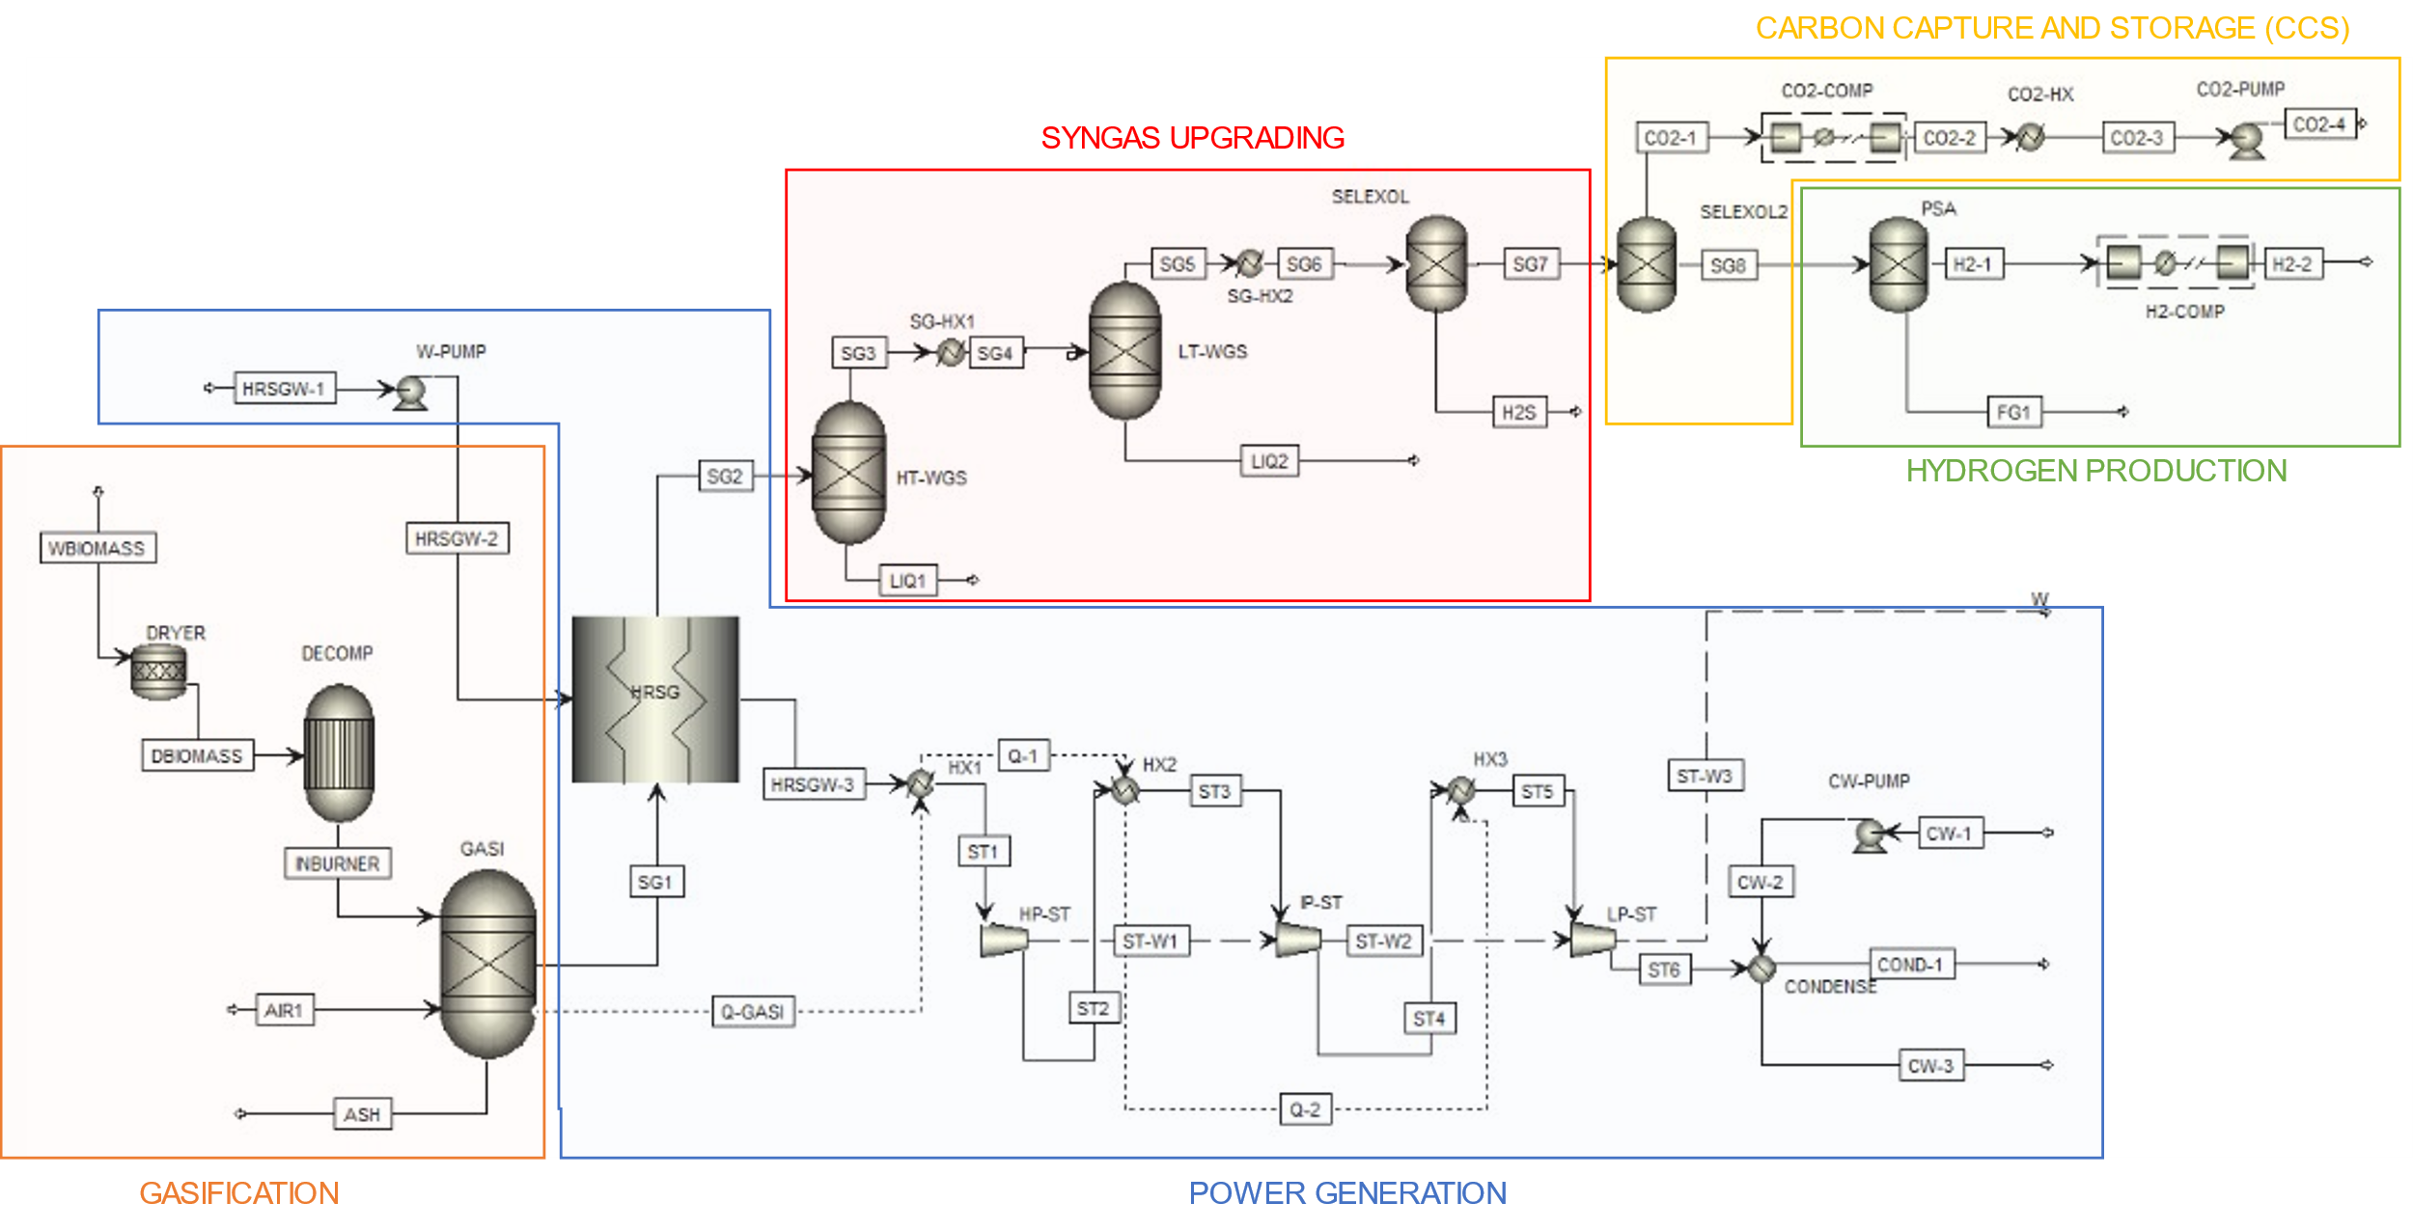
Figure 1: Biomass gasification for H₂ and power production, model topology using Aspen Plus

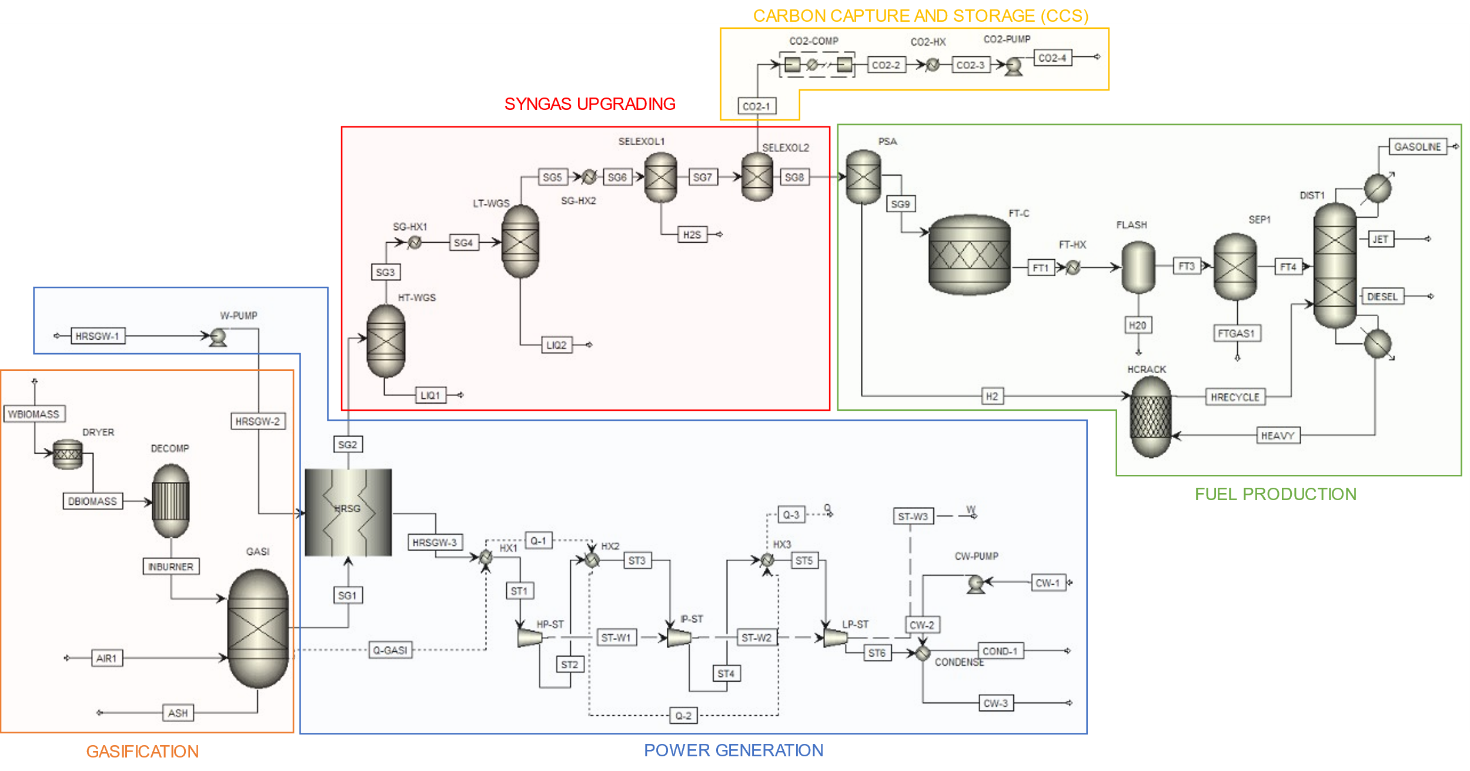
Figure 2: Biomass gasification for SAF and power production, model topology using Aspen Plus
The products from the FT unit are sent to a separation unit (SEP1) to separate gaseous hydrocarbons (C₁₋₄), liquid hydrocarbons (C₅₋₂₁₊), and water. Unreacted syngas and gaseous hydrocarbons are recycled. The liquid hydrocarbons are fractionally distillation (DIST1) at atmospheric pressure, modelled as a distillation column, to produce commercial hydrocarbon products: gasoline fraction (C₅₋₇), jet fuel fraction (C₈₋₁₆), diesel fraction (C₁₇₋₂₀), and heavy hydrocarbons/waxes (C₂₁₊). The heavy hydrocarbons are sent to the hydrocracking unit (HCRACK), modelled using an RStoic reactor, which converts the waxes into 50% jet fuel, 30% diesel, 15% gasoline, and 5% light gases. The hydrocracker is operated at 50 bar and 277℃. The process also uses 1.5% H₂ sent from the PSA unit stationed after the syngas cleaning section and prior to the FT-C. The additional H₂ specification ensures the production of middle distillates (mild hydrocracking) (Michaga, et al., 2022).
As the purpose of these processes is to produce H₂ and SAF, the hydrogen energy efficiency ($η_{H_{2}}$) and jet fuel energy ($η_{SAF}$) efficiency are defined as:
$$η_{H_{2}}=\frac{{\dot{m}}_{H_{2}}×LHV_{H_{2}}}{{\dot{m}}_{dry biomass}×LHV_{biomass}}$$ | 6
$$η_{SAF}=\frac{{\dot{m}}_{SAF}×LHV_{SAF}}{{\dot{m}}_{dry biomass}×LHV_{biomass}}$$ | 7
Where $\dot{m}$ is the mass flowrate in kg/s and the lower heating value (LHV) is in MJ/kg. For the BECCS-to-SAF process there are several useful products that also need to be considered, thus the overall fuel energy ($η_{fuel}$) efficiency is defined as (Michaga, et al., 2022):
$$η_{fuel}=\frac{\left({\dot{m}}_{gasoline}×LHV_{gasoline}\right)+\left({\dot{m}}_{SAF}×LHV_{SAF}\right)+\left({\dot{m}}_{diesel}×LHV_{diesel}\right)}{{\dot{(m}}_{dry biomass}×LHV_{biomass})}$$ | 8
The net efficiency in both cases is the electrical efficiency combined with the thermal energy efficiency of the specified fuel type. In the case of BECCS-to-SAF there are two net efficiencies, one for the overall fuel production and one purely for the SAF production.

Results and discussion
Both models have the same biomass feedstock - hardwood chips proximate and ultimate analysis from (Tauqir, et al., 2019). Both systems process 3,600 kg/hr of biomass with an input energy of 18,850 kW. The air flowrate for the gasification chamber is 6,934 kg/hr (0.214 equivalence ratio). The HRSG unit uses 10,487 kg/hr of steam at a 1:1 syngas/HRSG steam ratio. Validation is carried out against operating conditions for the gasification unit for run #14 from Wei et al. (2009), shown in our previous study (Wilkes, et al., 2021).
Table 1 highlights the KPIs for the BECCS-to-H₂ process and Table 2 shows the KPIs for the BECCS-to-SAF process. The BECCS-to-H₂ process has higher thermal energy output, as H₂ is more energy dense than hydrocarbon fuels (on a mass basis). In both cases the energy demand for the CO₂ separation process (1050 kW) is 6% of the total biomass energy input. Figure 3 highlights the fuel/H₂ efficiency and product flowrates for the two processing routes. Focusing only on fuel efficiencies, the production of hydrogen from biomass is 36% efficient compared to 19% for Jet Fuel production, which increases to 32% with the inclusion of gasoline and diesel fractions. In both cases the additional power generated from the HRSG improves the energy efficiency, to almost 50% in BECCS-to-H₂ and 47% in BECCS-to-SAF if all FT fuels are considered (see Table 1 and Table 2). The results highlight the improved efficiency when incorporating BECCS into BtX processes.
Table 1: BECCS-to-H2 KPIs  KPI BECCS-to-H2  Power demand (kW) 1,475  Power generated (kW) 3,846  Net power output (kW) 2,371  Hydrogen output (kg/hr) 185.3  Hydrogen output (kW) 6,176  Electrical efficiency (%) 13.80  $η_{H_{2}}$ (%) 35.94  Net efficiency (%) 49.74 | Table 2: BECCS-to-SAF KPIs  KPI BECCS-to-SAF  Power demand (kW) 1,274  Power generated (kW) 3,846  Net power output (kW) 2,572  Gasoline output (kg/hr) 88.50  Jet fuel output (kg/hr) 275.6  Diesel output (kg/hr) 99.40  Total fuel output (kg/hr) 463.4  Total fuel output (kW) 5,510  Electrical efficiency (%) 14.97  $η_{SAF}$(%) 19.06  $η_{fuel}$ (%) 32.06  Net SAF efficiency (%) 34.03  Net Fuel efficiency (%) 47.03
Overall, the net efficiency is higher in the BECCS-to-H₂ process; however, the BECCS-to-SAF process produces 150% more product (on a mass basis). Despite the lower efficiency, higher profits could be achieved depending on the cost associated with the FT equipment. Hence, a full techno-economic assessment is required to compare these two biomass utilization pathways.
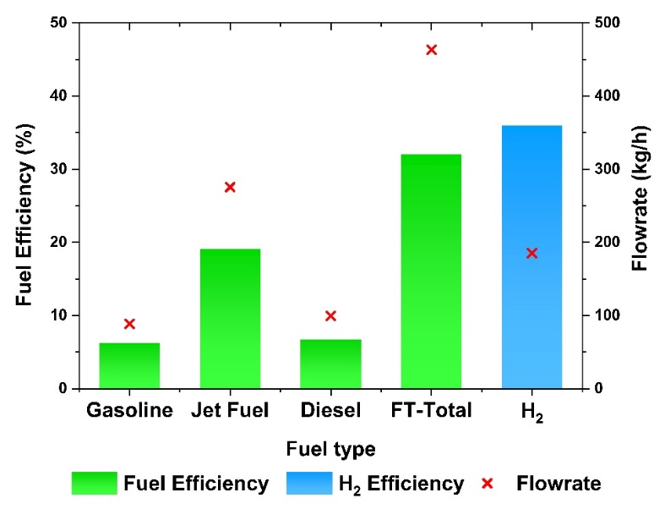
Figure 3: Fuel efficiency and production flowrate for BECCS-to-H₂ and BECCS-to-SAF

Conclusion
Bioenergy with Carbon Capture and Storage (BECCS) and biomass-to-X (BtX) can be combined into BECCS-to-X, a pathway to convert biomass resources into both power and useful products. This paper focuses on the production of hydrogen (H₂) and sustainable aviation fuel (SAF). Herein, BECCS-to-H₂ and BECCS-to-SAF processes are evaluated and compared using process model developed in Aspen Plus. The study highlighted key operating parameters and performance indicators. Interestingly, producing H₂ results in a higher energy conversion, 15.71% points higher than SAF and 2.71% points higher than all FT fuels combined. However, on a mass basis more product is produced in BECCS-to-SAF, hence an economic study is required to ascertain the most cost-effective pathway.

References
A. Almena, P. Thornley, K. Chong, M. Röder, 2022, Carbon dioxide removal potential from decentralised bioenergy with carbon capture and storage (BECCS) and the relevance of operational choices, Biomass and Bioenergy, 159, 106406.
F. J. Campanario, F. J. Ortiz, 2017, Fischer-Tropsch biofuels production from syngas obtained by supercritical water reforming of the bio-oil aqueous phase, Energy Conversion and Management, 150, 599-613.
P. Chiesa, S. Consonni, T. Kreutz, R. Williams, 2005, Co-production of hydrogen, electricity and CO₂ from coal with commercially ready technology. Part A: Performance and emissions, International Journal of Hydrogen Energy, 30, 747-767.
M. K. Cohce, M. A. Rosen, I. Dincer, 2011, Efficiency evaluation of a biomass gasification-based hydrogen production, International Journal of Hydrogen Energy, 36(17), 11388-11398.
R. Dahl, 2020, Evaluation of the new Power & Biomass to Liquid (PBtL) concept for production of biofuels from woody biomass. Norwegian University of Science and Technology, Faculty of Natural Sciences, Department of Chemical Engineering. Stockholm, Sweden: Norwegian University of Science and Technology.
DESNZ, 2023, Biomass Strategy, Department for Energy Security and Net Zero, Crown copyright.
S. S. Doliente, A. Narayan, J. F. Tapia, N. J. Samsatli, Y. Zhao, S. Samsatli, 2020, Bio-aviation Fuel: A Comprehensive Review and Analysis of the Supply Chain Components, Frontiers in Energy Research, 8(1), 10.
A. Hanel, V. Dieterich, S. Bastek, H. Spliethoff, S. Fendt, 2022, Entrained flow gasification-based biomass-to-X processes: An energetic and technical evaluation, Energy Conversion and Management, 274, 116424.
M. Hillestad, 2015, Modeling the Fischer-Tropsch Product Distribution and Model Implementation, Chemical Product and Process Modeling, 10(3), 147-159.
T. Kuramochi, A. Ramírez, W. Turkenburg, A. Faaij, 2012, Comparative assessment of CO₂ capture technologies for carbon-intensive industrial processes. Progress in Energy and Combustion Science, 38(1), 87-112.
V. Marcantonio, M. D. Falco, M. Capocelli, E. Bocci, A. Colantoni, M. Villarini, 2019, Process analysis of hydrogen production from biomass gasification in fluidized bed reactor with different separation systems, International Journal of Hydrogen Energy , 44, 10350-10360.
M. F. Michaga, S. Michailos, M. Akram, E. Cardozo, K. J. Hughes, D. Ingham, M. Pourkashanian, 2022, Bioenergy with carbon capture and storage (BECCS) potential in jet fuel production from forestry residues: A combined Techno-Economic and Life cycle Assessment approach, Energy Conversion and Management, 255, 115346.
M. Moneti, A. D. Carlo, E. Bocci, P. U. Foscolo, M. Villarini, M. Carlini, 2016, Influence of the main gasifier parameters on a real system for hydrogen production from biomass, International Journal of Hydrogen Energy, 41(28), 11965-11973.
A. I. Osman, N. Mehta, A. M. Elgarahy, M. Hefny, A. Al-Hinai, A. H. Al-Muhtaseb, D. W. Rooney, 2021, Hydrogen production, storage, utilisation and environmental impacts: a review, Environmental Chemistry Letters , 20, 153-188.
A. Poluzzi, G. Guandalini, F. d’Amore, M. C. Romano, 2021, The Potential of Power and Biomass-to-X Systems in the Decarbonization Challenge: a Critical Review, Current Sustainable/Renewable Energy Reports, 8, 242-252.
W. D. Shafer, M. K. Gnanamani, U. M. Graham, J. Yang, C. M. Masuku, G. Jacobs, B. H. Davis, 2019, Fischer–Tropsch: Product Selectivity–The Fingerprint of Synthetic Fuels, Catalysts, 9, 259.
M. Shahbaz, A. AlNouss, I. Ghiat, G. Mckay, H. Mackey, S. Elkhalifa, T. Al-Ansari, 2021, A comprehensive review of biomass based thermochemical conversion technologies integrated with CO₂ capture and utilisation within BECCS networks, Resources, Conservation and Recycling, 173, 105734.
R. M. Swanson, J. A. Satrio, R. C. Brown, A. Platon, D. D. Hsu, 2010, Techno-Economic Analysis of Biofuels Production Based on Gasification, Colorado, United States: National Renewable Energy Laboratory.
W. Tauqir, M. Zubair, H. Nazir, 2019, Parametric analysis of a steady state equilibrium-based biomass gasification model for syngas and biochar production and heat generation, Energy Conversion and Management, 199, 111954.
UNIfHY, 2016, Final Report Summary - UNIFHY (UNIQUE gasifier for hydrogen Production).
M. D. Wilkes, O. Asuni, S. Brown, 2023, Bioenergy with carbon capture and storage (BECCS) – power generation coupled with hydrogen production, Computer Aided Chemical Engineering, 52, 2897-2902
M. D. Wilkes, S. Mukherjee, S. Brown, 2021, Linking CO₂ capture and pipeline transportation: sensitivity analysis and dynamic study of the compression train, International Journal of Greenhouse Gas Control, 111, 103449.

