Exergo-Techno-Economic Comparison of Power&Biomass-to-Kerosene Pathways
Simone Mucciª, Dominik P. Goldsteinª, Dominik Bongartz^{b}, Alexander Mitsos^{c,a,d,*}
a Process Systems Engineering (AVT.SVT), RWTH Aachen University, Aachen, Germany
b Department of Chemical Engineering, KU Leuven, Leuven, Belgium
c JARA-ENERGY, Aachen, Germany
d Energy Systems Engineering (IEK-10), Forschungszentrum Jülich, Jülich, Germany
* Corresponding author: amitsos@alum.mit.edu
Abstract
Sustainable kerosene-like fuel can be synthesized from green hydrogen and biomass in so-called Power&Biomass-to-Kerosene plants. Although several kerosene production pathways have been proposed, it is still unclear what plant configuration is most efficient and has the lowest production cost. To answer these questions, a model of kerosene production processes based on either biomass combustion or gasification is built in Aspen Plus. For each of these, two kerosene production pathways are investigated, i.e., via Fischer-Tropsch and methanol-to-olefins processes. An exergy analysis shows that gasification-based processes are more efficient than combustion-based ones due to the lower exergy losses of the gasification unit and the water electrolyzer for hydrogen production. Finally, a techno-economic comparison shows that the gasification-based kerosene production via the methanol-to-olefins pathway results in the lowest specific production cost.
Keywords: Power&Biomass-to-Kerosene, Sustainable aviation fuels (SAF), Exergy analysis, Techno-economic comparison.
  - Introduction
Hydrogen-fueled or electric aircrafts are often proposed as a possible solution to defossilize the aviation sector. However, in the short-to-medium term, they are more suitable for short-haul flights due to the relatively low volumetric or gravimetric energy density of hydrogen and batteries. Instead, sustainable aviation fuels could play a relevant role also in long-haul flights since they are energy-dense kerosene-like fuels and would not require the substitution of the existing aviation fleet.
Such sustainable kerosene can be synthesized from green hydrogen and a carbon source, e.g., carbon dioxide, in Power-to-Kerosene processes (Schmidt et al., 2018). An interesting alternative to carbon dioxide is biomass since it can also provide a valuable energy input to the Power-to-Kerosene process, thus being called Power&Biomass-to-Kerosene (P&B2K) process.
Biomass can be converted via combustion or gasification to supply either CO₂ or syngas (a mixture of mainly CO and H₂) to the kerosene synthesis unit after supplying additional green hydrogen to adjust the H:C ratio. Under idealized assumptions, gasification-based P&B2X processes show clear thermodynamic advantages over combustion-based ones due to the lower demand of additional hydrogen (Mucci et al., 2023). In contrast, combustion-based P&B2X processes have practical advantages due to the lower energy demand and cost of the flue gas cleaning. Therefore, it is not clear whether realistic gasification-based P&B2K processes outperform the combustion-based ones in all the considered key performance indicators, i.e., energy and exergy efficiencies and specific production cost of kerosene.
To answer this question, we model combustion-based and gasification-based kerosene production processes in Aspen Plus by considering two production pathways each, i.e., via Fischer-Tropsch (FT) and methanol-to-olefins (MTO) processes (Schmidt et al., 2018). While the FT pathway is often considered in P&B2K processes (Hillestad et al., 2018; Habermeyer et al., 2021; Nielsen et al., 2022), we are not aware of works focusing on the MTO pathway for kerosene production in the context of P&B2K. The considered processes are then compared via exergy and techno-economic analysis.
  - Process description
In the considered kerosene production processes from biomass and green hydrogen, three key sections can be identified, i.e., biomass conversion (via combustion or gasification), hydrogen production via water electrolysis, and kerosene synthesis sections.
In the combustion-based P&B2K process (Fig. 1, top), biomass is oxidized using oxygen, a side-product of water electrolysis. This choice leads to high concentration of CO₂ in the flue gas. Nevertheless, a carbon capture unit is needed to obtain a pure CO₂ stream since the residual oxygen in the flue gas can be poisonous for the catalyst of the downstream conversion units. The CO₂ stream is mixed with the H₂ produced via low-temperature electrolysis, the most mature electrolysis technology, to adjust the CO₂:H₂ ratio according to the following kerosene production pathway.
In the FT pathway, the CO₂-H₂ stream is first converted to syngas in a reverse water gas shift (RWGS) unit and then supplied to the low-temperature FT unit. The produced hydrocarbon mixture is separated according to the carbon chain length. In particular,C₅₋₇ (gasoline range), C₈₋₁₆ (kerosene range), and C₁₇₋₁₉ (diesel range) hydrocarbons are recovered. Lighter and heavier hydrocarbons are reformed and hydrocracked, respectively, to increase the selectivity of the process to the hydrocarbon range of interest.
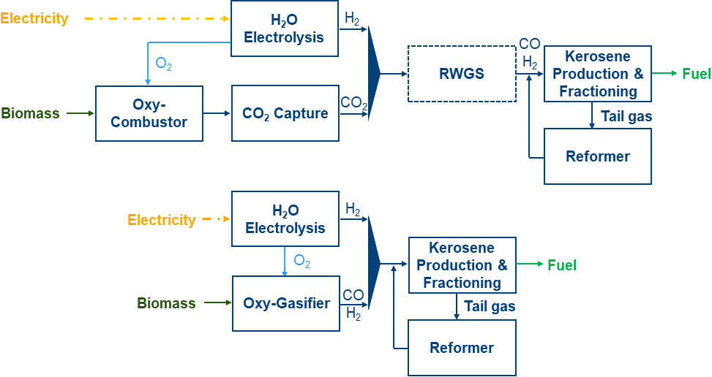
Figure 1. Sketch of the combustion-based (top) and gasification-based (bottom) P&B2K processes for both the FT and MTO pathways. Note: In the combustion-based P&B2K process via the MTO pathway, the RWGS unit (dashed) is not present since direct hydrogenation of CO₂ to methanol is considered.
In the MTO pathway, the CO₂ stream is converted to methanol via direct hydrogenation. The produced crude methanol is converted to short-chain olefins, which are then oligomerized. Finally, the long-chain olefins are converted into alkanes via hydrogenation before fractioning the produced hydrocarbons according to their carbon chain length.
In the gasification-based P&B2K process (Fig. 1, bottom), the main difference stands in the biomass conversion unit: biomass is partially oxidized to produce syngas instead of CO₂. Therefore, the carbon capture and RWGS units are not included.
  - Methodology
    - Process model
A detailed model of the above-described P&B2K processes was built in Aspen Plus.
3.1.1 Biomass conversion
For the biomass combustion unit, an operating temperature of 1000 °C and a biomass conversion factor of 100 % are assumed. Moreover, a partial recycle of flue gases is considered to dilute the reactants and reduce the adiabatic temperature of flame since pure oxygen is the oxidizer. A pure CO₂ stream is then separated from the flue gases via amine washing (Lee et al., 2016). A carbon capture rate of 90% is assumed.
For the biomass gasification unit, an operating temperature of 900 °C and a biomass conversion factor of 95 % are assumed. As CO₂, a side-product of gasification processes, is generally inert in FT processes, a pressure swing adsorption unit (Santos et al., 2023) is included, and the separated CO₂ is recycled into the gasifier to increase the carbon efficiency of the P&B2K process. This additional unit is instead not included in the MTO pathway since CO₂ participates in methanol production.
For both biomass conversion units, no flue gas or syngas cleaning treatment is modeled.
3.1.2 Water electrolysis
For the low-temperature water electrolysis unit, we consider a polymer electrolyte membrane (PEM) technology and we assume an efficiency equal to 60% and 59% (based on the LHV) when H₂ is produced at atmospheric or high pressure (25 bar), respectively, according to the pathway. The size of the unit depends on the considered pathway.
3.1.3 Kerosene synthesis
In the combustion-based kerosene production via the FT pathway, the CO₂ stream is reduced to CO via hydrogenation in a catalytic RWGS unit modeled with Vázquez et al.´s kinetic model (Vázquez et al., 2017). Moderate pressure and nearly stoichiometric H₂:CO₂ ratio are considered to inhibit methanation. Hydrogen is then added to adjust the H₂:CO ratio before supplying syngas to the slurry bubble FT reactor. Long-chain hydrocarbons are synthesized in the FT reactor according to the modified Anderson-Schulz-Flory distribution (Habermeyer et al., 2021) at a relatively low operating temperature and a substoichiometric H₂:CO ratio, as these operating conditions enable high selectivity to the hydrocarbons of interest. The hydrocarbon mixture is then separated via distillation. The light hydrocarbons (less than 5 carbon atoms) are converted into syngas in a steam reformer, modeled as a RGibbs reactor; the produced syngas is then fed into the FT reactor to increase kerosene production. Heavy hydrocarbons are hydrocracked.
In the combustion-based kerosene production via the MTO pathway, CO₂ is converted into methanol via direct hydrogenation (Van-Dal and Bouallou, 2013). Crude methanol is converted into short-chain olefins (Nesterenko et al., 2016), which are then oligomerized. In the absence of a suitable kinetic model, the oligomerization process is modeled by considering experimental data of the oligomerization of pure olefins (ethene, propene, butene, pentene, and hexene) over an acidic zeolite catalyst (Moon et al., 2018; Monama et al., 2020; Díaz et al., 2020; Cowley, 2002), and assuming that these reactions occur in parallel. The long-chain olefins are then hydrogenated (Brooks et al., 2016), before being separated. Similarly to the modeled FT pathway, light hydrocarbons are reformed, and the produced syngas is supplied to the methanol plant.
In the gasification-based processes via FT and MTO pathways, the produced syngas is fed directly into the FT and methanol reactors, respectively.
    - Heat integration
To reduce the hot utility demand to zero thus improving the overall process efficiency, matches between hot and cold streams are identified and heat integration is performed. For instance, the biomass combustion unit supplies heat to the endothermic units, e.g., the RWGS unit. Also, heat integration between the reactant and product streams of the gasification unit allows reducing the injected oxidizer, thus increasing the syngas quality. Further, the residual process heat is supplied to a steam power cycle (or organic Rankine cycle in the gasification-based processes) to reduce the process net electricity demand.
    - Exergetic and techno-economic analysis
The considered P&B2K processes are modeled assuming a woody biomass flow rate of 10 t/y (around 50 MW based on LHV). The size of the other components, e.g., the electrolyzer, is defined according to the modeling assumptions and considered pathway.
The P&B2K pathways are compared concerning their efficiency and the production cost of kerosene. Furthermore, an exergy analysis is carried out to identify the main bottlenecks of the processes.
For the economic analysis, the capital cost (CAPEX) of the main equipment modules is estimated with the cost models proposed by Biegler et al. (1997). The cost of the biomass conversion units, the carbon capture unit, PEM water electrolyzer, and the FT reactor is instead estimated with the correlations from Bridgwater et al. (2002), Lee et al. (2016), Reksten et al. (2022), and Habermeyer et al. (2021), respectively. The correlations were updated to 2021 as the reference year. A replacement for the electrolysis unit in the 10th year is also considered. Further assumptions are collected in Table 1.
Table 1. Main assumptions for the economic analysis.
Plant lifetime | 20 y
Yearly operating hours | 8000 h
Yearly O&M costs | 5 % of initial investment cost (CAPEX)
Interest rate | 5 %
Electricity cost | 60 €/MWh
Biomass cost | 70 €/t
  - Results and discussion
Figure 2 (left) shows the energy efficiency of the modeled P&B2K processes when considering both kerosene and the whole produced liquid fuel (i.e., including the gasoline and diesel side products) as target products. Gasification-based P&B2K processes are significantly more efficient than combustion-based ones. The same holds for the exergy efficiency (not shown in Fig. 2). This result can be explained by analyzing the exergy flows of the processes (Fig. 3). The combustion and electrolysis units contribute significantly to exergy destruction; therefore, the substitution of the combustion unit with the gasification unit as well as the corresponding reduced size of the electrolysis unit of the gasification-based processes lead to higher energy (and exergy) efficiency. Moreover, the electricity production in the steam power cycle of the combustion-based P&B2K processes is not able to offset the higher electricity demand of the electrolysis unit.
In terms of the whole liquid fuel production, the two kerosene production pathways, i.e., FT and MTO, have similar efficiencies (Fig. 2). However, in terms of kerosene production only, the MTO pathway is more efficient than the FT pathway due to the higher selectivity to the C₈₋₁₆ hydrocarbon range. This observation differs from that of Atsonios et al. (2023), who however considered a different design and model of a P2K process.
The P&B2K processes via the MTO pathway also have a lower kerosene production cost than those via the FT pathway (Fig. 2, right). In particular, gasification-based P&B2K processes via the MTO pathway have the lowest production cost (ca. 2 €/kg) thanks to the reduced investment and operating costs for the electrolysis unit, which is the main economic driver. Nevertheless, this pathway has a lower technological maturity and is still missing the certification for producing drop-in fuels suitable for aviation purposes.
The calculated kerosene production costs are in line with other literature works (ca. 3 €/kg of e-kerosene in Schmidt et al., 2018; ca. 1.1 €/L and 1.7 $/L of liquid e-bio-fuels in Habermeyer et al., 2021 and Hillestad et al., 2018, respectively), but, as expected, they are not competitive with the current price of fossil-based kerosene for the considered boundaries. However, considering the sale of side products, e.g., gasoline and diesel, carbon certificates, or subsidies could reduce the price gap.
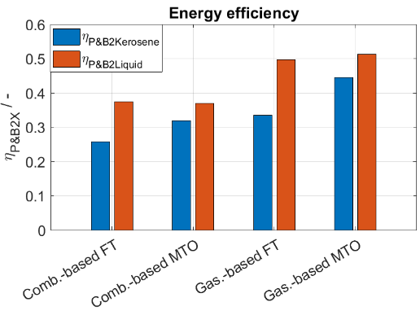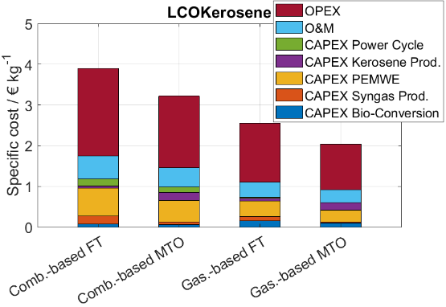
Figure 2. The energy efficiency (left) and the specific production cost of kerosene (right) for the considered P&B2K processes are shown.
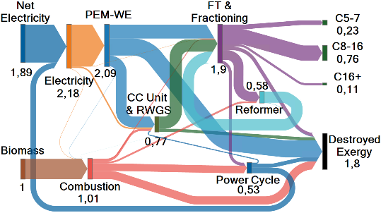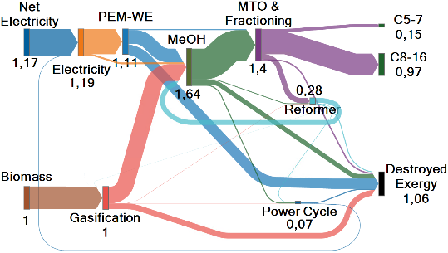
Figure 3. Exergy flows for the least efficient (combustion-based P&B2K process via FT) and the most efficient (gasification-based P&B2K process via MTO) P&B2K processes are shown on the left and right of the figure, respectively. Note: the exergy flows are scaled with respect to the biomass exergy input, which is the same for the considered case studies.
  - Conclusions
Four processes for sustainable kerosene production from biomass and green hydrogen were modeled and compared concerning efficiency and economic indicators: combustion-based versus gasification-based routes and Fischer-Tropsch versus methanol-to-olefins pathways. The exergy analysis shows that gasification-based processes are more efficient than combustion-based ones since the electrolysis and combustion units are the main contributors to exergy destruction. Finally, the techno-economic comparison shows that gasification-based kerosene production via the methanol-to-olefins pathway has not only the highest efficiency but also the lowest specific production cost due to its high selectivity to kerosene.
Acknowledgments
The authors gratefully acknowledge the financial support by the German Federal Ministry of Education and Research (BMBF) within the H2Giga project DERIEL (grant number 03HY122D).
References
K. Atsonios, J. Li, V.J. Inglezakis, 2023, Energy, vol. 278, p. 127868
L.T. Biegler, I.E. Grossmann, and A.W. Westerberg, 1997, “Systematic Methods of Chemical Process Design”, Prentice Hall PTR, Upper Saddle River, New Jersey, Chpt. 4-5, pp. 110–174
A.V. Bridgwater, A.J. Toft, J.G. Brammer, 2002, Renewable & Sustainable Energy Reviews, vol.6, pp. 181-248
K.P. Brooks, et int., J. Plaza, R. Handler, and D. Shonnard, 2016, “Low-Carbon Aviation Fuel Through the Alcohol to Jet Pathway”, in Biofuels for Aviation, Chpt. 6, pp. 109-150
M. Cowley, 2002, “Conversion of n-pentenes over H-ZSM-5”, MSc thesis, Cape Town University
M. Díaz, E. Epelde, Z. Tabernilla, A. Ateka, A.T. Aguayo, and J. Bilbao, 2020, Energy, vol. 207, p. 118317
F. Habermeyer, E. Kurkela, S. Maier, and R.-U. Dietrich, 2021, Frontiers in Energy Research, vol. 9, pp. 1–15
M. Hillestad, M. Ostadi, G.d. Alamo Serrano, E. Rytter, B. Austbø, J.G. Pharoah, and O.B. Burheim, 2018, Fuel, vol. 234, pp. 1431–1451
U. Lee, J. Burre, A. Caspari, J. Kleinekorte, A.M. Schweidtmann, and A. Mitsos, 2016, Industrial and Engineering Chemistry Research, vol. 55, no. 46, pp.12014–12026
W. Monama, E. Mohiuddin, B. Thangaraj, M.M. Mdleleni, and D. Key, 2020, Catalysis Today, vol. 342, pp. 167–177
S. Moon, H.-J. Chae, and M.B. Park, 2018, Applied Catalysis A: General, vol. 553, pp.15–23
S. Mucci, A. Mitsos, and D. Bongartz, 2023, Combustion vs Gasification in Power&Biomass-to-X: An Exergetic Analysis, in preparation
N. Nesterenko, J. Aguilhon, P. Bodart, D. Minoux, and J.P. Dath, 2016, “Methanol to Olefins: An Insight Into Reaction Pathways and Products Formation”, in Zeolites and Zeolite-like Materials, Chpt. 5, pp. 189–263
A.S. Nielsen, M. Ostadi, B. Austbø, M. Hillestad, G. del Alamo, and O.S. Burheim, 2022, Fuel, vol. 321, p. 123987
A.H. Reksten, M.S. Thomassen, S. Møller-Holst, and K. Sundseth, 2022, International Journal of Hydrogen Energy, vol. 47, no. 90, pp. 38106–38113
M.F. Santos, S.F. Interlenghi, A.E. Bresciani, N.L. Ferreira, G.S. Bassani, and R.M. de Brito Alves, 2023, Computer Aided Chemical Engineering, vol. 52, pp. 2069–2074
P. Schmidt, V. Batteiger, A. Roth, W. Weindorf, and T. Raksha, 2018, Chemie-Ingenieur-Technik, vol. 90, no. 1, pp. 127–140
E.S. Van-Dal and C. Bouallou, 2013, Journal of Cleaner Production, vol. 57, pp. 38–45
F.V. Vázquez, P. Pfeifer, J. Lehtonen, P. Piermartini, P. Simell, and V. Alopaeus, 2017, Industrial and Engineering Chemistry Research, vol. 56, no. 45, pp. 13262–13272

