Sustainability and Quality-by-Digital Design of an Integrated End-to-End Continuous Pharmaceutical Process
Timothy J. S. Campbellª, Chris D. Rielly ª, Brahim Benyahia ^{a*}

b.benyahia@lboro.ac.uk
Abstract
An end-to-end mathematical model of a continuous ibuprofen process, which integrates both upstream and downstream processing, was developed to identify optimal and sustainable design and operation options and deliver quality assurance. The main objectives include maximizing productivity, minimizing waste, and developing systematic methods to implement Quality-by-Design (QbD) at the plant-wide level. To achieve these objectives, a set of quality and environmental key performance indicators were considered along with a set of Critical Quality Attributes (CQA). A variance-based Global Sensitivity Analysis (GSA) was used to capture the impact of the uncertainties and variability amongst a large set of process parameters and material attributes to help identify the minimum set of Critical Material Attributes (CMA), and Critical Quality Attributes (CQA). Two methods were implemented and compared, namely the estimability analysis and the Analytical Hierarchy Process (AHP). The design space associated with the CQA was identified based on the minimum set of the CPP and CMA which proved critical, ensuring safe and reliable operating ranges for quality assurance. The plant model was simulated and optimized using gPROMs Formulated products 2.3.1 with data obtained from literature.
Keywords: Integrated Continuous Pharmaceutical Plant, Global Sensitivity Analysis, Estimability, Quality-by-Design, Design Space, Analytical Hierarchy Process.
  - Introduction
The increased adoption of continuous manufacturing in the pharmaceutical and biopharmaceutical sectors has grown the demand for more reliable and robust mathematical models and decision-making tools to improve technology selection, process design and optimization, scale-up and scale-out, and the development of effective process and quality control strategies. However, despite the advantages of integrated continuous pharmaceutical manufacturing, their development is still hampered by the complexity inherent to large sets of interactive units, and lack of systematic methods to deliver build-in quality assurance (Benyahia et al., 2018; Campbell et al., 2022). The implementation of QbD and Quality-by-Control at the plant-wide scale requires an in-depth understanding of the interplay between large sets of CPP, CMA, and CQA. It is crucial to identify the minimum set of CPP and CMA for the determination of the most reliable design space which captures more effectively the CQA variability and allows more robust control strategies.
Continuous manufacturing has many benefits for industry, such as reduced waste and costs, and enhanced operating flexibility and resilience. The Robust digital design tools and high-fidelity mathematical models can be used to build quality assurance that could address these critical needs and enable the other advantages to be realized. The increased adoption of advanced digital technologies such as plant-wide mathematical model and digital twins and advanced enterprise and plant-wide control and optimization strategies are anticipated to foster even further the advantages of immerging technologies in Pharma such as continuous manufacturing and autonomous plants.
However, the development of plant-wide mathematical models for pharmaceutical and biopharmaceutical plants is still very limited and hampered by many technical challenges. Moreover, most of the published plant-wide model-based investigations were limited to economic or techno-economic analysis using shortcut methodologies that require relatively less accurate mathematical models. Only a few examples discussed the optimal operation and plant-wide control of integrated continuous pharmaceutical plant (Benyahia et al., 2018, Lakerveld et al., 2015).
Over the last years, QbD has become a benchmark for quality management in the pharmaceutical and biopharmaceutical industries. However, its implementation at the plant-wide level or in integrated processes is still very limited due inherent challenges, such as the large sets or interactive CPP and CMA that significantly impact the intermediate quality attributes and CQA. The identification of the minimum set of CPP and CMA is paramount in QbD to deliver built-in quality assurance for drug safety and efficacy. Plant-wide mathematical models can play a crucial role in understanding the effect of the different process parameters and therefore identify more reliably the design space. One of the most effective methods to determine the criticality of the process parameters material attributes is based on the sensitivity analysis to help reduce the dimensionality of the design space (Bano et al, 2018). However, a method based solely on the sensitivity analysis and disregards the impact of the correlations between the CPP and CMA may lead to poor design space or/and ineffective control strategies.
In this work, we propose a methodology inspired by our recently developed Quality-by-Digital Design (QbDD) framework where the mathematical models can be fully adopted at all developments stages to address product quality and process operation requirements. Firstly, a variance-based GSA was used to capture the impact of uncertainty and variability amongst a large set of process parameters and material attributes. Two methods were implemented and compared, namely the estimability analysis and the AHP. The design space associated with the CQA was identified based on the minimum set of the CPP and CMA which proved critical, ensuring safe and reliable normal operating ranges for quality assurance.
  - Methods
    - Process description
The end-to-end process to produce ibuprofen tablets from synthesis to tableting is shown In Figure 1, firstly, Ibuprofen is synthesized through three reactions steps conducted in plug flow reactors in series. The first plug flow reactor involves Friedel–Crafts acylation, while the PhI(OAc)2-mediated 1,2-aryl migration occurs in the second reactor, and finally, ibuprofen product is formed by hydrolysis in the third reactor. The reaction outlet stream is then purified in a continuous liquid-liquid extractor to recover most of the ibuprofen in the organic solvent. Next, three mixed-suspension-mixed-product-removal (MSMPR) crystallizers are used to crystallize the ibuprofen, in which the supersaturation point is maintained by the manipulation on the antisolvent flowrate (Water) and the temperature (between 283 K and 313 K). Subsequently, the filtration and wash-filtration stages are applied to separate ibuprofen crystals from the mother liquor and reaction impurities and residues. The next processing step is a wet granulation where the API is combined with the excipients (i.e., glucose and microcrystalline cellulose) in presence of a liquid binder. The liquid is then removed in a spray dryer before the granules are fed to the final tablet press.
    - Proposed digital framework
Figure 2 shows the proposed digital framework. The plant-wide mathematical model of the integrated end-to-end continuous plant for ibuprofen manufacture was first created based on data obtained from the literature. The model was then used to optimize process design and operation options to achieve acceptable quality bounds along with optimal environmental and economic and environmental key performance indicators (KPI). The formulation of the optimization problem is not presented here for the sake of brevity.
The GSA was then performed for all process parameters with respect to all CQA and KPI. The proposed variance-based GSA was performed using a quasi-random sampling technique (Sobol). Subsequently, the effects of the process parameters and material attributes were ranked based on the estimability analysis and AHP. A criticality threshold was then established to identify the minimum set of the CPP and CMA followed by the construction of the design space.
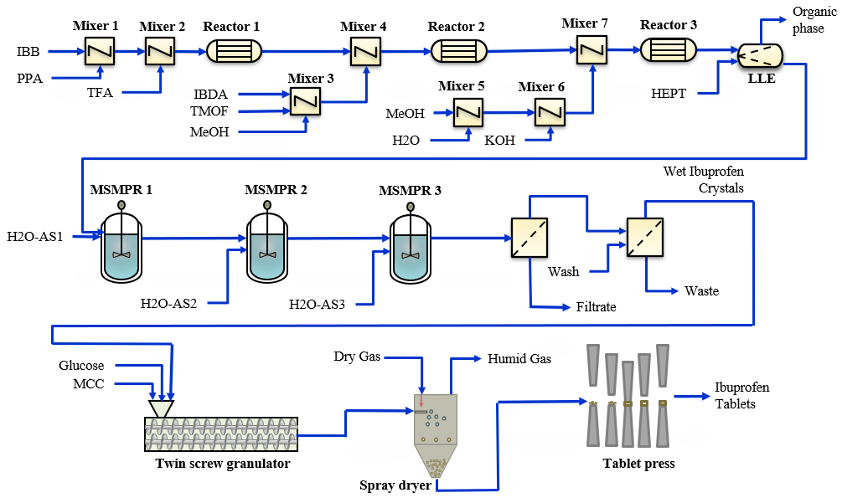
Figure 1. Process flow diagram of the continuous integrated end-to-end manufacturing of Ibuprofen. Isobutyl benzene (IBB), Propanoic acid (PPA), triflic acid (TFA), Iodobenzene diacetate (IBDA), Trimethyl orthoformate (TMOF), Methanol (MeOH), Potassium Hydroxide (KOH), Heptane (HEPT), microcrystalline cellulose.
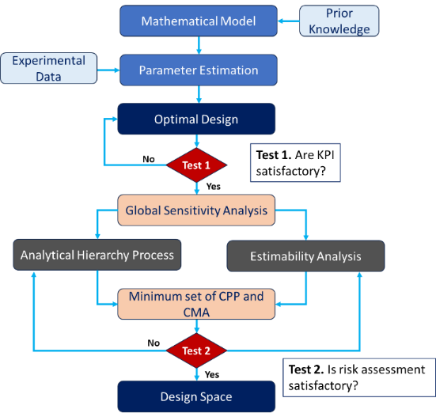
Figure 2. Proposed digital framework.
    - Estimability analysis and AHP
Upon completion of the GSA, two methods were proposed to rank process parameters and material attributes namely the estimability analysis and AHP. Both methods require the matrix of the total order sensitivities. The proposed estimability analysis is based on the orthogonalization algorithm (Yao et al., 2003, Benyahia et al., 2010) which is an effective method to rank the parameters according to their overall impact on the CQA and KPI, captured by the GSA vectors. Most importantly, the method helps identify and exclude parameters with high correlations. As such, only the process parameters with the highest impact and the least correlations appear in the top ranks, which consequently allow more effective identification of the least correlated CPP and CMA. The second method used to rank the process parameters is based on the AHP. Firstly, the relative weights of each of the CQAs and KPI were obtained by estimating their perceived risk base on the risk management matrix (Saaty, 1987). Secondly, the GSA table was normalized for each of the CQA. Subsequently, the AHP weights were combined with the normalized GSA matrix to form a weighted score. The sum of each element in the process parameter row is then calculated as the variability of the CQA with respect to an individual process parameter. Finally, a Pareto plot is created to determine how many process parameters are needed to capture the overall variance in the CQA.
After obtaining an overall criticality ranking for process parameters and material attributes, it is important to define a criticality threshold to identify the minimum set of CPP and CMA, while reducing the risk of overlooking any serious source of variability.
  - Results
The plant model was constructed in gPROMs Formulated Products environment. The model parameters were identified using nonlinear optimizer built-in gPROMS in conjunction with the data obtained from the literature. Firstly, an optimal design problem was addressed to identify the nominal design options including process capacity, feed rates, temperatures etc., at steady state. In the next step, the nominal steady state operating conditions were used to perform GSA using a quasi-random sampling technique available in gPROMS. The matrix of the total order sensitivities was then obtained which allowed the implementation of the estimability analysis and AHP.
The AHP intrinsic weights were estimated based on the relative risk of each of the CQA. These weights were then applied to the normalised GSA matrix to find the weighted sensitivities of all process parameters and material attributes. The total impact was then calculated as the sum of the weighted sensitivities which delivers the relative raking of the process parameters. The outcome of the AHP-based criticality ranking is shown in figure 3a. The results show that 5 CPP are enough to capture the cumulative variability of all CQA. Here, it was relatively straightforward to establish a criticality threshold due the significant difference between the 5th CPP and remaining process parameters.
The proposed second method, which is based on the estimability analysis, was also conducted using the matrix of global sensitivities. As anticipated, the proposed orthogonalization algorithm delivered the relative ranking of the process parameters according to the overall magnitude of their sensitivities and least correlations (Fysikopoulos et al., 2019). In addition, based on a pre-set estimability threshold as shown in figure 3b, the method revealed the need for 3 CPP only to deliver the intended QbDD approach and model-based built-in quality assurance. Moreover, the Pearson’s correlation matrix was calculated to analyse the correlation patterns amongst process parameters. Overall, the correlation matrix proved consistent with the estimability outcomes and revealed that the identified CPP exhibit weak correlations. This part is not presented here for the sake of brevity.
It is worth noting, that despite some relative similarities in the overall ranking of the CPP in both methods, the AHP and estimability, the number of required CPP revealed by each method may be different as it depends on the proposed relative weights of the CQA, in the AHP, and the estimability threshold in the case of ethe estimability analysis.
Based on the proposed minimum set of CPP, a set of reduced dimensionality design sign spaces can be identified where the attainment of the CQA and KPI can be guaranteed. Figure 4 presents a sample of the design pace plots.
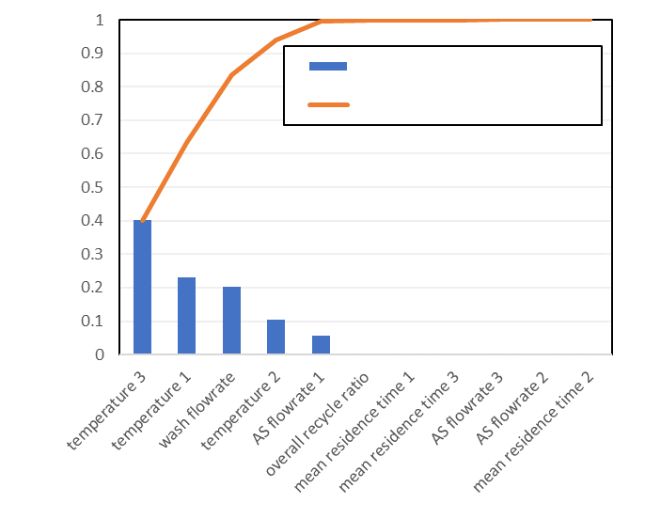
Individual impact on CQAs
Cumulative impact on CQAs
Process parameters
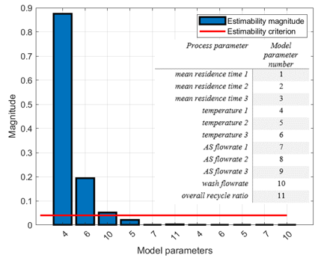

Figure 3. Criticality ranking of the process parameters based on a) the AHP, b) the estimability analysis.
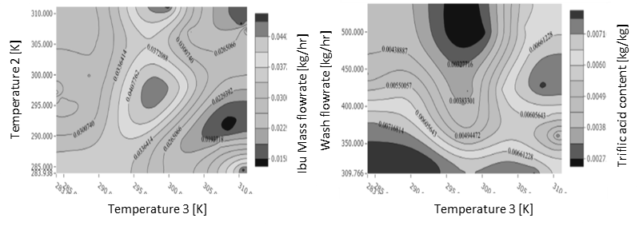
Figure 4. A sample of reduced dimensionality Design Spaces.
  - Conclusions
A plant-wide model of an integrated continuous pharmaceutical process for ibuprofen manufacture was developed as an effective decision-making tool for plant optimization, and most importantly for QbDD. The integrated continuous manufacturing plant involves a large set of interactive process parameters and material attributes that impact several CQA and KPI. Two methods were proposed to identify the minimum set of CPP and CMA, which capture more effectively the set of reduced dimensionality design spaces allowing more reliable built-in quality assurance. The proposed methods were both capable to deliver an overall ranking of the process parameters and material attributes based on their effects on the CQA and KPI. Despite some similarities in the overall ranking, the estimability analysis outperforms the AHP as it systematically excludes highly correlated CPP and CMA, besides the criticality threshold can be fine-tuned to meet more effectively the risk assessment criteria. Nevertheless, the AHP may deliver a fast and computationally cheaper way to rank process parameters and material attributes based on a quantitative approach that captures the variability of the targeted CQA and KPI. However, the method may be limited due the need to introduce a vector of the relative importance weights, which may be biased by the expert opinion. This bias may be potentially minimized with the availability of prior knowledge on the intrinsic risks and impact of deviations in each of the CQA on drug safety and efficacy.
References
Bano, G., Wang, Z., Facco, P., Barolo M. & Ierapetritou, M., 2018. A novel and systematic approach to identify the design space of pharmaceutical processes. Computers & Chemical Engineering, 115, 309-322.
Benyahia, B. (2018). Applications of a plant-wide dynamic model of an integrated continuous pharmaceutical plant: Design of the recycle in the case of multiple impurities. Computer Aided Chemical Engineering, Elsevier B.V. 41, 141-157.
Campbell, T., Rielly, C. & Benyahia, B. (2022). Digital design and optimization of an integrated reaction-extraction-crystallization-filtration continuous pharmaceutical process. Computer Aided Chemical Engineering 51, 775-780.
Fysikopoulos, D., Benyahia, B., Borsos, A., Nagy, Z. K., & Rielly, C. D. (2019). A framework for model reliability and estimability analysis of crystallization processes with multi-impurity multi-dimensional population balance models. Computers & Chemical Engineering, 122, 275-292.
R Lakerveld, B Benyahia, PL Heider, H Zhang, A Wolfe, C Testa, S Ogden, ...(2015) The application of an automated control strategy for an integrated continuous pharmaceutical pilot plant. Organic Process Research & Development 19 (9), 1088-1100
Yao, K.Z., Shaw, B.M., Kou, B., McAuley, K.B., Bacon, D.W. (2003). Modelling ethylene/butene copolymerization with multi catalyst: parameter estimability and experimental design. Polym. React. Eng. 11 (3), 563–588.

