Solar-driven Calcium Looping Cycle for Time-flexible Carbon-free Power Generation with Thermochemical Energy Storage Capability
Calin-Cristian Cormos *, Letitia Petrescu, Ana-Maria Cormos, Simion Dragan
Babes-Bolyai University, Faculty of Chemistry and Chemical Engineering, Arany Janos 11, Cluj-Napoca, Postal code: RO-400028, Romania
calin.cormos@ubbcluj.ro
Abstract
Renewable energy sources represent an important aspect of the solution in deploying low carbon economy. In addition, the Carbon Capture, Utilization and Storage (CCUS) systems are also relevant technological options to be used for overall decarbonization of industrial sectors. In this respect, the integration of renewables and CCUS systems shows promising results for developing energy- and cost-efficient decarbonized applications. The Calcium Looping (CaL) technology is particular promising system showing a high overall energy efficiency as well as thermochemical energy storage capability. In this work, a detailed techno-economic and environmental evaluation was done for the flexible solar-based calcium looping cycle to produce 100 MW net carbon-free power. The thermochemical CaL cycle was evaluated in time-flexible conditions for energy storage using solid sorbent storage (in both calcinated and regenerated conditions) to facilitate the integration of renewable energy sources. As shown, the investigated renewable-based calcium looping system shows promising performances in terms of high overall energy efficiency (around 43 %) and carbon capture rate (90 %) as well as attractive cost elements (e.g., specific capital investments below 3,500 €/kW net, levelized cost of electricity around 75 €/MWh). The flexibility of the investigated system (by exploiting the sorbent and CO₂ storage facilities) is a very attractive feature for an energy- and cost-efficient utilization of time-variable renewable sources (such as solar and wind).
Keywords: Calcium looping cycle, Solar energy, Power generation, Energy storage.
  - Introduction
The energy-intensive industrial sectors (e.g., heat and power generation, iron, steel, cement and chemicals production etc.) are facing significant challenges in short to medium terms in respect to their mandatory decarbonization for achieving the global climate neutrality. For significant reduction of greenhouse gas emissions several options are available: increasing the renewable energy production, improving the overall energy efficiencies of conversion, utilization and storage steps, deployment of CCUS technologies and decarbonized energy carriers (e.g., electricity, hydrogen) etc. This work is evaluating the Calcium Looping (CaL) cycle as an innovative energy-and cost-efficient system having also the thermochemical energy storage capability (Tregambi et al., 2023). This advanced thermochemical cycle involves two separate gas-solid reactors operated in a Circulated Fluidized Bed (CFB) conditions: one carbonator reactor where the CO₂ is captured from the gas phase using a calcium-based sorbent followed by a calciner where carbonated sorbent is thermally regenerated using a heat source (in this analysis, a renewable heat source from a concentrated solar power plant was assessed as shown by Khosravi et al., 2022). The overall chemical reaction of CaL cycle is the following:
$$CaO + CO_{2} ↔ CaCO_{3} ∆H=-178 kJ/mole$$ | (1)
Based on this highly exothermic reaction and utilizes both the solid sorbent (both CaO and CaCO₃) and the CO₂ storage facilities, this thermochemical cycle can be used for energy storage. A detailed techno-economic and environmental evaluation was done for the flexible solar-based calcium looping cycle to produce 100 MW net carbon-free power. In addition, potential utilization of CaL reactive gas-solid system for decarbonization of other energy-intensive applications (e.g., cement and metallurgy) as well as a promising Direct CO₂ Air Capture (DAC) option were also presented in the analysis to show its great potential in developing energy- and cost-efficient low-carbon applications.
  - Plant configuration, design assumptions and thermal integration
The conceptual layout of CaL cycle used in conjunction with a Concentrated Solar Plant (CSP) for time-flexible carbon-free power generation is presented in Figure 1. As noticed, the storage facilities for both solid forms (as carbonated and calcinated sorbent) and gaseous (CO₂) reactants are used for flexible operation. The power block consists of a CO₂ Brayton cycle and a steam (Rankine) cycle to maximize the power generation.

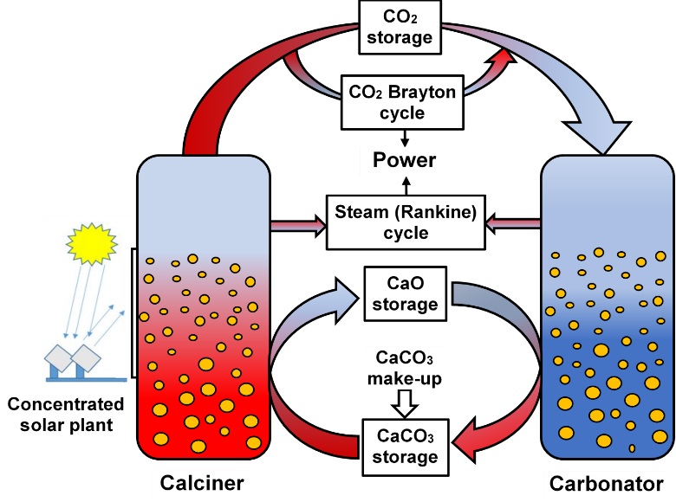
Figure 1. Calcium looping (CaL) cycle integrated with concentrated solar plant (CSP)

The evaluated CSP - CaL power plant has an installed 100 MW net power output. Table 1 presents the main design assumptions of the investigated concept (Carro et al., 2023). The calciner operates 8 h/day but the carbonator works 24 h/day based on reaction heat.

Table 1. Key design assumptions of integrated CSP - CaL power plant
Unit | Design parameters
Solar-based calciner | Operating temperature & pressure: 950 ºC & 1.25 bar  Conversion: 99 %  Operating time (per day): 8 h
Carbonation reactor | Operating temperature & pressure: 650 ºC & 3.5 bar  CO₂ capture rate: 90 %  Operating time: (per day): 24 h
CO₂ storage unit | Pressure: 75 bar  Temperature: 25 ºC
Solid storage units | Pressure: 1 bar  Temperature: 25 ºC
CO₂-based Brayton cycle | Inlet CO₂ pressure: 75 bar  Final CO₂ pressure: 1.25 bar  Compressor efficiency: 88 %  Turbine efficiency: 92 %
Steam (Rankine) cycle | Steam temperature & pressure: 565 ºC & 120 bar  Steam turbine efficiency: 90 %  Final steam expansion pressure: 40 mbar
Heat exchangers | Temperature difference: 10 ºC  Pressure drops: 2 - 3 % from inlet pressure
Thermodynamic package | Predictive Soave-Redlich-Kwong (PSRK)

To optimize the overall energy efficiency, a detailed thermal integration analysis using pinch methodology was performed (Smith, 2016). The correspondent composite curves (HCC - Hot Composite Curve; CCC - Cold Composite Curve) are presented in Figure 2 showing a significant heat recovery (186 MW_{th} HP steam) from available heat sources.

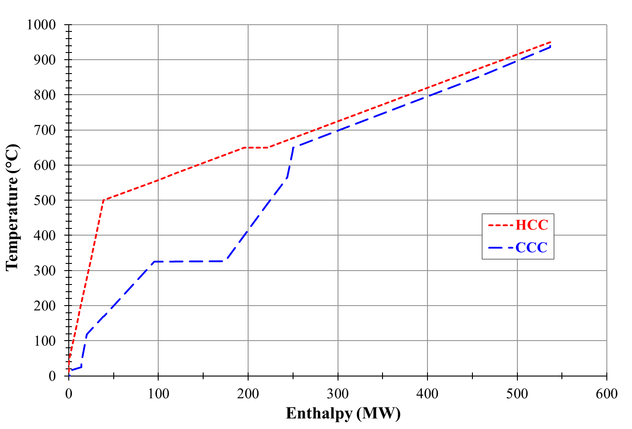
Figure 2. Thermal integration analysis of CaL cycle integrated with CSP
  - Results and discussions
After simulation, the CSP - CaL power plant was validated by comparing key performance indicators to experimental / industrial data. The main simulated indicators of CaL cycle (e.g., calcination and carbonator conversion rates, operating parameters) were fully in line with experimental data (Hornberger et al., 2021; Rodrigues et al., 2023). Following validation, the main technical performance indicators are shown in Table 2.

Table 2. Main performance indicators of CSP-CaL power plant
Parameter | Unit | Value
Solar (thermal) heat to the calciner (A) | MW_{th} | 232.23
Gross power output (B) | MW_{e} | 113.02
Ancillary power consumption (C) | MW_{e} | 13.02
Net power output (D = B - C) | MW_{e} | 100.00
Net power efficiency (D/A * 100) | % | 43.06
As can be observed from Table 2, the overall solar heat to power efficiency is very high (about 43 %). Considering a 11 % heat loss in CSP, the heliostat has to supplies about 261 MW_{th} which corresponds to an area of about 0.28 km² (Khosravi et al., 2022). For the economic evaluation of CSP - CaL power plant, the main economic assumptions used are presented in Table 3. The capital costs of various plant sub-systems (except the heliostat reported in Table 3) e.g., CaL cycle, sorbent / CO₂ storage and power block units were calculated with cost correlation method using the following equation (Smith, 2016):
$$C_{E}=C_{B}*(\frac{Q}{Q_{B}})^{M}$$ | (2)
where: C_{E} - capital cost of specific plant sub-system / equipment with capacity Q, C_{B} - base cost of plant sub-system / equipment with base capacity Q_{B}, M - constant which depends on equipment type. The main assumptions (base cost, capacity and exponent) used for capital cost being presented in a different work (Cormos, 2022).

Table 3. Main economic assumptions
Parameter | Value
Heliostat capital cost | 150 €/m²
Limestone price | 20 €/t
Make-up rate of solid sorbent | 5 %
Boiler feed water (BFW) price | 0.10 €/t
Cooling water (CW) price | 0.02 €/t
Chemical treatment of cooling water | 0.0025 €/m³
Chemical treatment of BFW | 45.00 k€/month
Direct working plant personal | 80 persons
Yearly salary for direct operational personnel | 50.00 k€/person/y
Administrative costs, share of direct personnel cost | 30 %
Maintenance costs, share of capital cost | 4 %
Operational time per year | 7,884 h
Construction time & plant location | 2 years & Southern Europe
Operational life | 25 years

Power production cost was then calculated using annualized investment (capital) cost and operational & maintenance (O&M) costs as well as the installed plant capacity output (100 MW net power) following the Net Present Value (NPV) methodology (Smith, 2016). The calculated power production cost was about 74.80 €/MWh which is competitive for today market. The sensitivity analysis of electricity cost vs. main economic parameters (e.g., capital cost, interest rate, plant capacity factor) are presented in Figure 3.

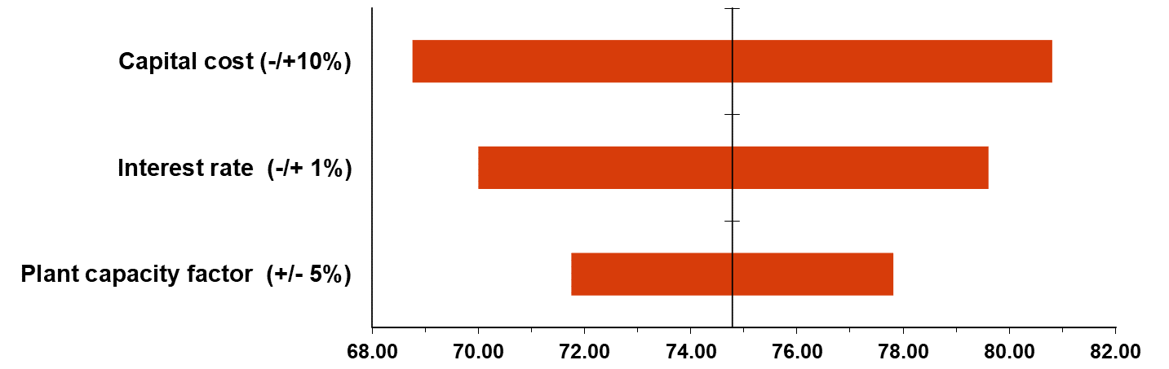
Figure 3. Sensitivity analysis of power production cost
As can be noticed the most important influence on the electricity production cost was recorder for the capital cost (which accounts for about 62 % of electricity cost with a specific capital investment cost of about 3464 €/kW net) followed by the interest rate and the plant capacity factor. The overall conclusion is that the investigated flexible design is able to generate 100 MW carbon-free power 24 h/day based on exothermic carbonation reaction heat exploiting the energy storage of regenerated sorbent during day time (8 h).
  - Other potential applications and development issues
The CaL cycle can be successfully used for decarbonization of other energy-intensive industrial applications (e.g., power generation, cement and steel production etc.) or for direct air capture (DAC). A conceptual layout of the CaL cycle for these applications using renewable energy either solar-based heat (solar operation) or a renewable fuel (thermal operation) is presented in Figure 4 in a Circulated Fluidized Bed (CFB) arrangement of the carbonation and calcination reactors (Ferrario et al., 2023).
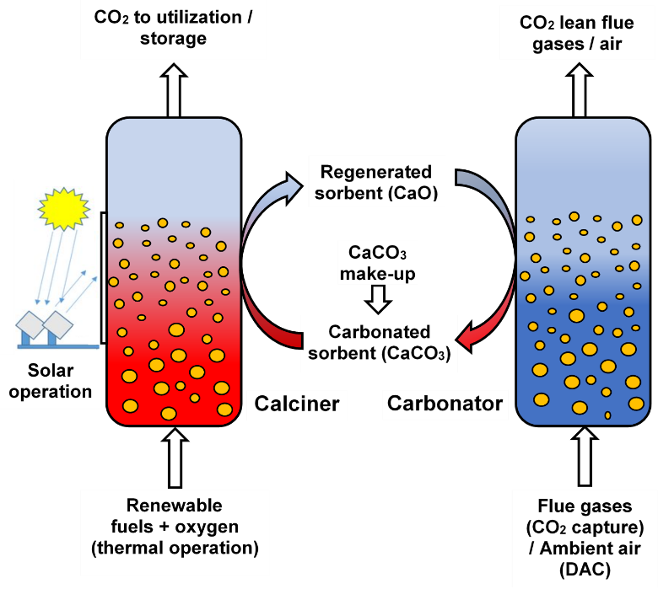
Figure 4. Renewable-based calcium looping cycle for CO₂ capture

As an illustrative example, Table 4 presents the main performance indicators of a decarbonized cement plant using a thermal-based CaL technology with a 90 % carbon capture rate (Case 2) in comparison to the conventional case without carbon capture (Case 1). Both cement plant concepts produce 1 Mt/y cement (IEAGHG, 2008).

Table 4. Integration of CaL technology for cement plant decarbonization
Plant performance indicator | Case 1 | Case 2
Cement production capacity (Mt/y) | 1.00 | 1.00
Coal demand for ancillaries (t/h) | 0.00 | 22.03
Net power production (MW_{e}) | 0.00 | 15.80
Cement plant decarbonization rate (%) | 0.00 | 90.00
Specific CO₂ emissions (kg/t) | 770.44 | 58.37
Cement production cost (€/t) | 80.20 | 124.18
CO₂ avoided cost (€/t) | - | 83.23
As can be observed, the utilization of CaL technology for decarbonization of cement production implies a significant reduction of CO₂ emissions (from 770 to 58 kg/t) coupled with additional decarbonized power generation which can be sent to the grid. From economic point of view, the decarbonization implies an important increase of cement production cost (by about 55 %). The CO₂ avoided cost is comparable to current CO₂ emission tax, a fact which suggests a positive economic potential for implementation.
The CaL decarbonization technology still requires significant development and scale-up activities from the current state of the art (demonstrated up to 10 MW) to full industrial capacities. However, the CFB technology, which is already demonstrated up to 300 - 400 MW sizes (Lockwood, 2013) can help the deployment of CaL technology since there are significant similarities among them. In addition, relevant aspects such as sorbent cyclic capacity and make-ups must be optimized for best techno-economic performances.
  - Conclusions
The present work evaluated the techno-economic and environmental performances of a flexible solar-based CaL cycle to produce 100 MW carbon-free net power. The CaL cycle was evaluated in flexible operational conditions due to time behaviour of solar energy. The flexible design uses solid sorbent and CO₂ storage facilities. The investigated solar-based CaL system shows promising performances in comparison to conventional CSP plant: high energy efficiency (about 43 %), competitive electricity cost (about 75 €/MWh) etc. The flexibility of the investigated solar-based design to generate power 24 h per day based on reaction heat as well as other potential decarbonization applications makes this technology very promising. It worth mentioning that CaL technology still requires significant scale-up from current proven level (up to 10 MW) to industrial relevant sizes.
References
A. Carro, R. Chacartegui, C. Ortiz, J. Arcenegui-Troya, L.A. Pérez-Maqueda, J.A. Becerra, 2023, Integration of calcium looping and calcium hydroxide thermochemical systems for energy storage and power production in concentrating solar power plants, Energy, 283, 128388
C.C. Cormos, 2022, Decarbonization options for cement production process: A techno-economic and environmental evaluation, Fuel, 320, 123907
D. Ferrario, S. Stendardo, V. Verda, A. Lanzini, 2023, Solar-driven calcium looping system for carbon capture in cement plants: Process modelling and energy analysis, Journal of Cleaner Production, 394, 136367
M. Hornberger, J. Moreno, M. Schmid, G. Scheffknecht, 2021, Experimental investigation of the calcination reactor in a tail-end calcium looping configuration for CO₂ capture from cement plants, Fuel, 284, 118927
International Energy Agency - Greenhouse Gas R&D Programme (IEAGHG), 2008, CO₂ capture in the cement industry, Report2008/3, Cheltenham, UK
S. Khosravi, S. Hossainpour, H. Farajollahi, N. Abolzadeh, 2022, Integration of a coal fired power plant with calcium looping CO₂ capture and concentrated solar power generation: Energy, exergy and economic analysis, Energy, 240, 122466
T. Lockwood, 2013, Techno-economic analysis of PC versus CFB combustion technology, IEA Clean Coal Centre, Report CCC/226, London, UK
D. Rodrigues, C.I.C. Pinheiro, R.M. Filipe, L.F. Mendes, H.A. Matos, 2023, Optimization of an improved calcium-looping process for thermochemical energy storage in concentrating solar power plants, Journal of Energy Storage, 72, 108199
R. Smith, 2016, Chemical process design and integration, second edition, Wiley, Hoboken, USA
C. Tregambi, F. di Lauro, S. Pascual, P. Lisbona, L.M. Romeo, R. Solimene, P. Salatino, F. Montagnaro, 2023, Solar-driven calcium looping in fluidized beds for thermochemical energy storage, Chemical Engineering Journal, 466, 142708

